**Linux Training Tasks**

**> User Management Tasks:-**

* Add a User with a Specific Home Directory, Default Shell, and Custom Comment.

**→ Command:-**

sudo useradd -m -d /var/www/shubham01 -s /bin/bash -c "DevOps Training" -U shubham01

**→ Screenshot:-**



* Add a User with Home Directory, Custom Shell, Custom Comment, and UID/GID.

**→ Command:-**

sudo useradd -m -d /var/www/shubham02 -s /bin/sh -c "DevOps Training" -u 1007 -g 100 shubham02

**→ Screenshot:-**



* Add a User with Home Directory, No Shell, Custom Comment, and User ID.

**→ Command:-**

sudo useradd -m -d /var/www/shubham03 -s /usr/sbin/nologin -c "DevOps Training" -u 1008 shubham03

**→ Screenshot:-**



* Add a User with Home Directory, Shell, Custom Skell/Comment, and User ID.

**→ Command:-**

sudo useradd -m -d /var/www/shubham04 -k /etc/custom.skell -s /bin/zsh -c "DevOps Training" -u 1009 shubham04

**→ Screenshot:-**



* Add a User without Home Directory, No Shell, No Group, and Custom Comment.

**→ Command:-**

sudo useradd -M -N -r -s /bin/false -c "DevOps Training" shubham05

**→ Screenshot:-**



**# Terms used in commands:-**

**‘-s’** option adds the default shell or you can assign different login shells to each user **‘-u’** option creates users with custom userid

**‘-g’** optioncreates users with specific group IDs

**‘-M’** option creates users without their home directories

**‘-N’** option tells the system to only create a username (without group)

**‘-r’** option creates a system user

**‘-m -d’** option creates a user with a specified home directory

**‘-k’** option to set the custom skeleton directory

**‘-c’** option allows you to add custom comments

**‘U’** option creates/adds a group with the same name as the user

**> Permission Management Tasks:-**

* Change the permission set of /training/readme.txt so that only the user (owner) can read, write, and execute it. Use absolute mode.

**→ Command:** chmod 700 /home/shubham.dobhal/training/readme.txt

**→ Screenshot:-**

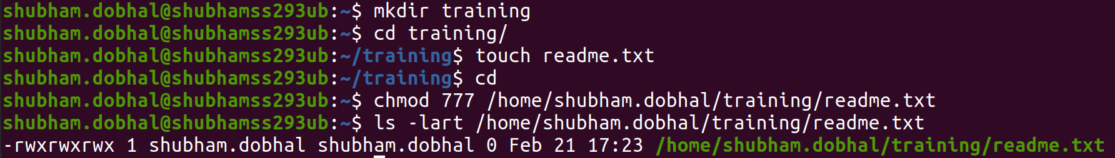

* Change the permission set of /training/readme.txt so that any user can read it, the group can read/write to it and the user (owner) can read/write/execute it. Use absolute mode.

**→ Command:** chmod 764 /home/shubham.dobhal/training/readme.txt

**→ Screenshot:-**



* Change the permission set of /training/readme.txt so that only the user (owner) can read, write, and execute it. Use symbolic mode.

**→ Command:** chmod u+rwx /home/shubham.dobhal/training/readme.txt

**→ Screenshot:-**



* Change the permission set of /training/readme.txt so that any user can read it, the group can read/write to it and the user (owner) can read/write/execute it. Use symbolic mode.

**→ Command:** chmod g+rw /home/shubham.dobhal/training/readme.txt

**→ Screenshot:-**



* Change the permission set of /training/readme.txt so that only the user (owner) can read/write/ execute, group, and any user can execute it. However, whenever anyone executes it, it should run with the privileges of the group. Use absolute mode.

**→ Command:** chmod 2711 /home/shubham.dobhal/training/readme.txt

**→ Screenshot:-**



* Change the permission set of /training/readme.txt so that only the owner can rename or delete this file while maintaining the existing permissions. Use absolute mode.

**→ Command:** chmod 3711 /home/shubham.dobhal/training/readme.txt

**→ Screenshot:-**



**# Absolute/Numeric Mode:** permissions are defined with numerical

Eg:- chmod 777

**# Symbolic Mode:** permissions are defined with symbols

Eg:- chmod u+r