Introduction:
The figures show the distribution and normality assessment of each variable from the Iris dataset for the Setosa and Versicolor Species.
- The histograms with overlaid normal and kernel density curves illustrate the shape and spread of the data,
- The Q-Q plots evaluate how closely the observed values follow a normal distribution.

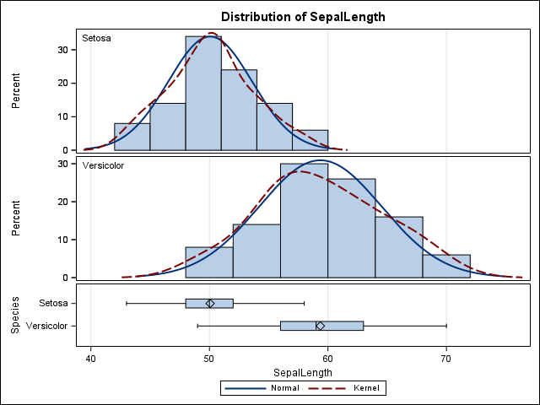
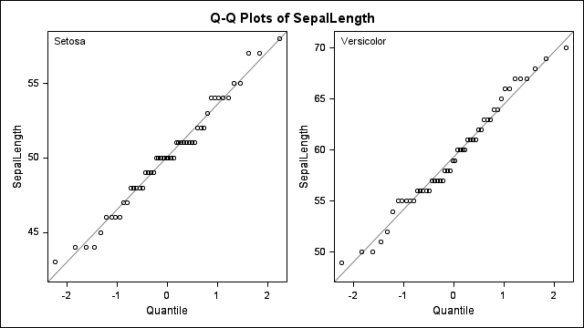
Figure 1 demonstrated clear differences in SepalLength distributions between the two species. Versicolor showed higher SepalLength values and greater variability compared to Setosa, as reflected in both the histograms and boxplots. The distributions for both species appeared relatively symmetric, and the kernel density curves closely followed the fitted normal curves.
Figure 2 demonstrated that the observed SepalLength values for both species closely aligned with the expected normal distribution. Most points followed the reference line in the Q-Q plots, with only minor deviations observed at the tails.
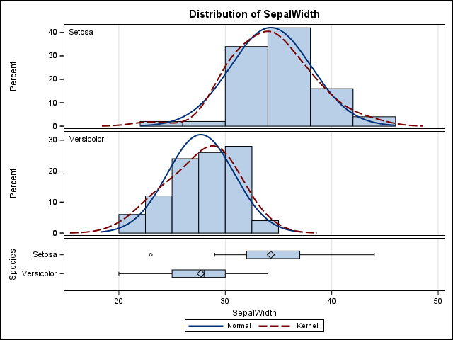
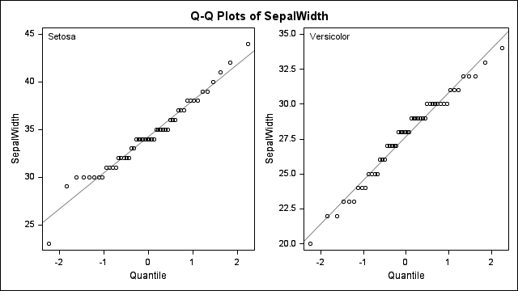
Figure 1 showed differences in SepalWidth distributions between the two species. Setosa demonstrated generally higher SepalWidth values and greater variability compared to Versicolor, as observed in the histograms and boxplots. Both groups displayed relatively symmetric distributions, although slight skewness was visible, particularly for Versicolor.
Figure 2 showed that the observed SepalWidth values generally followed the theoretical normal distribution for both species. Most observations aligned closely with the reference line in the Q-Q plots, with only minor deviations at the lower and upper tails.

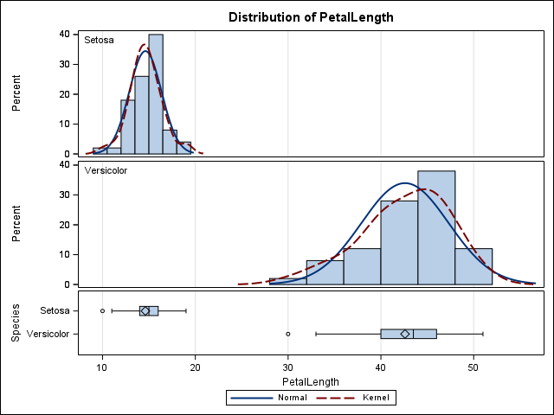
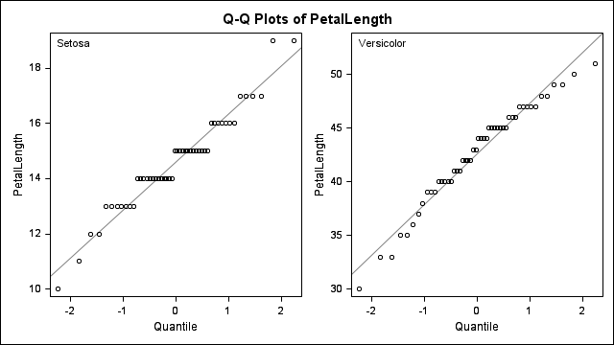
Figure 1 showed substantial differences in PetalLength distributions between the two species. Versicolor demonstrated markedly higher PetalLength values and greater variability compared to Setosa. The distributions for both species appeared approximately symmetric, with the density curves closely following the fitted normal curves. A potential low-value outlier was observed for Versicolor in the boxplot.
Figure 2 showed that the observed PetalLength values closely followed the theoretical normal distribution for both Setosa and Versicolor. Most observations aligned along the reference line in the Q-Q plots, indicating approximate normality, with only slight deviations at the distribution tails, particularly for Versicolor.
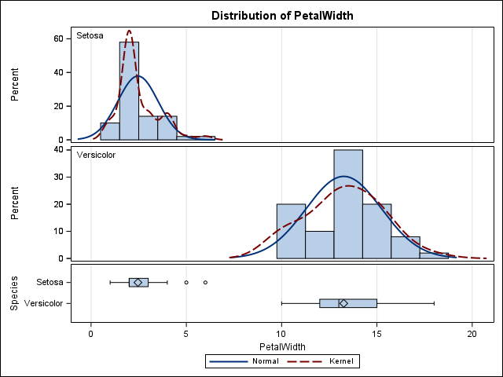
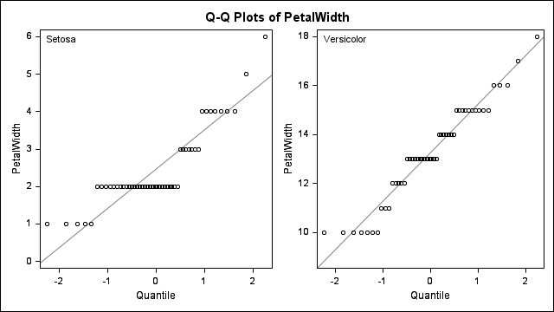
Figure 1 showed clear differences in PetalWidth distributions between the two species. Versicolor demonstrated substantially higher PetalWidth values and greater variability compared to Setosa. The Setosa distribution appeared more positively skewed, with a few higher-value observations visible in the boxplot, while the Versicolor distribution appeared more symmetric. The density curves generally followed the fitted normal curves for both species.
Figure 2 showed that the observed PetalWidth values generally followed the theoretical normal distribution for both Setosa and Versicolor. Most observations aligned with the reference line in the Q-Q plots, although Setosa demonstrated more noticeable deviations and clustering due to the limited range and repeated values. Versicolor showed closer agreement with the normal reference line, with only minor deviations at the tails.

