Introduction
Graphical Assessment of Distribution
Histograms with overlaid kernel and normal density curves, along with quantile–quantile (Q–Q) plots, were used to visually assess the distribution of the data within each group.
The histogram provides a discrete representation of the data by grouping observations into bins, allowing for an initial assessment of shape, spread, and symmetry. The normal density curve represents the theoretical normal distribution based on the sample mean and standard deviation, serving as a reference for comparison.
The kernel density curve is a non-parametric estimate of the underlying distribution, calculated by placing a smooth function (kernel) over each observation and combining these to produce a continuous curve. This approach does not assume a specific distribution and provides a smoothed representation of the data that is less sensitive to binning choices than the histogram.
Q–Q plots were used to assess how closely the observed data follow a theoretical normal distribution. In these plots, the observed quantiles are compared to the expected quantiles under normality; points that fall approximately along a straight line indicate agreement with the normal distribution, while systematic deviations from the line suggest departures from normality.
Together, these graphical methods provide complementary information for evaluating distributional shape and supporting the assessment of normality.
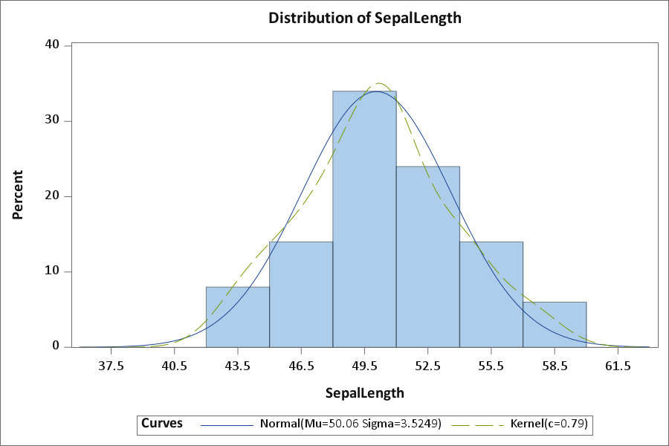

The histogram of sepal length shows a unimodal (single-peaked) distribution centered around 50, with most observations concentrated between approximately 46 and 54. The overall shape appears approximately symmetric, with no visible gaps or irregular clustering of values.
The kernel density curve provides a smooth estimate of the observed distribution and closely follows the shape of the histogram, reinforcing the unimodal and symmetric pattern.
The normal density curve, based on the sample mean (50.06) and standard deviation (3.52), aligns closely with the kernel density, indicating that the empirical distribution is well approximated by a normal distribution.
There are no visible extreme deviations in the tails, and the spread of the data appears consistent with the variability observed in the descriptive statistics. Overall, the graphical evidence supports the assumption that sepal length is approximately normally distributed.
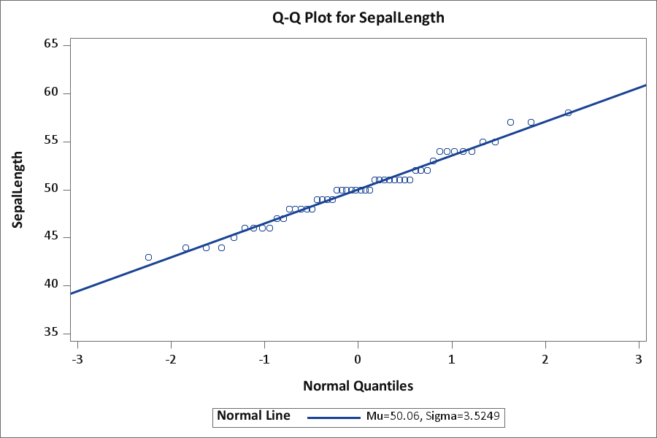

The Q–Q plot compares the observed quantiles of sepal length to the expected quantiles under a normal distribution. The points lie closely along the reference line, indicating strong agreement between the observed data and the theoretical normal distribution.
There are only minor deviations at the lower and upper ends of the distribution, suggesting slight departures in the tails; however, these are small and not systematic. The central portion of the data aligns particularly well with the reference line, indicating that the bulk of the distribution follows a normal pattern.
Overall, the Q–Q plot provides strong visual evidence that the distribution of sepal length is approximately normal.
