**实验2报告**

组员 龚仕奇，潘澳旋，刘欣宇

1. ER图

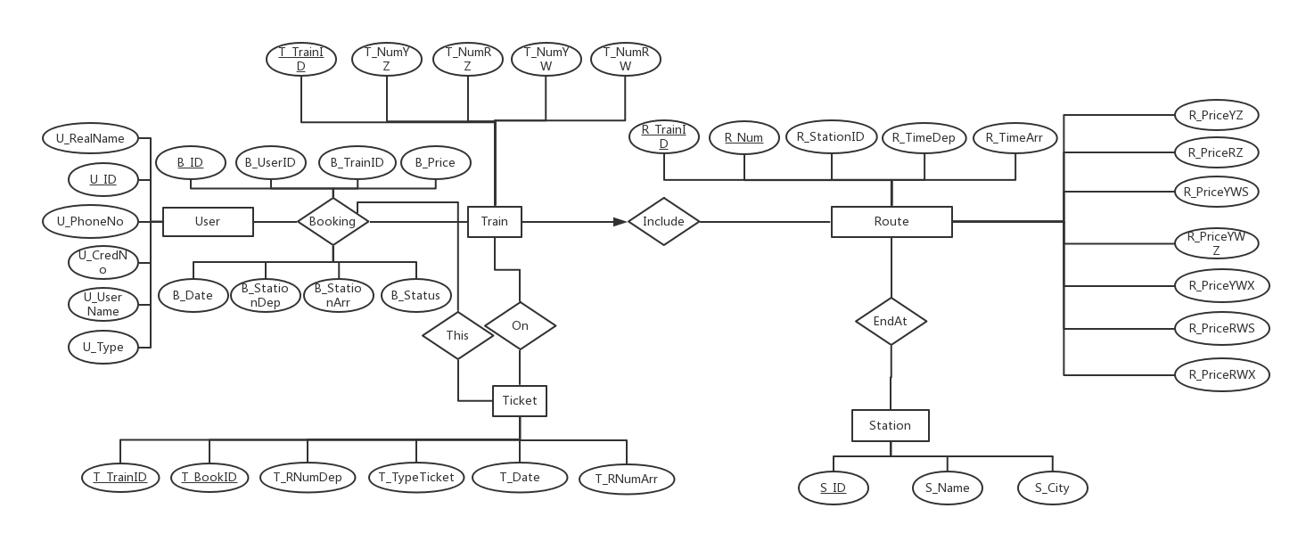

图 1 ER图

1. 关系模式

基本实现：

如ER图所示，我们的基本思路是将

以下为ER图实现为表后的表示：

1. 预订booking表：每条记录为一次订票信息，主键为b_id，即唯一订单号。每增加一个订单，b_id加一; foreign key包括b_userid, b_trainid, b_startsid, b_endsid, 分别与userinfo、train、station表相连。

CREATE TABLE booking (

b_id integer NOT NULL,

b_userid character(18),

b_trainid character varying(5),

b_date date NOT NULL,

b_startsid integer NOT NULL,

b_endsid integer NOT NULL,

b_price numeric(5,1),

b_status status_type

);

1. 车次train表：包括车次的TrainID, 车次的经停站点数，车次的固有车票数（每种座位若本车次有座则为5，若无则为-1，此数在运行的整个过程中为不变的常数，查余票时在本车次的每个区间上，用这个基本常数减去记录下的当前区间已订车票数）。

CREATE TABLE train (

t_id character varying(5) NOT NULL,

t_numyz integer DEFAULT 5,

t_numrz integer DEFAULT 5,

t_numyw integer DEFAULT 5,

t_numrw integer DEFAULT 5,

t_stationnum smallint NOT NULL

);

1. 火车route表：每条记录为一辆列车的经停站（如下示意图所示）。

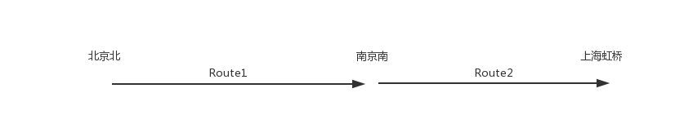

图 2 从始发站开始逐个编号

CREATE TABLE route (

r_trainid character varying(5) NOT NULL, //该线路从属的车次编号

r_num smallint NOT NULL, //经停站编号

r_station integer, //经停站站点编号

r_timedep interval, //当前站点离站时间

r_timearr interval, //当前到站时间

r_priceyz numeric(5,1), //以下为多种座位的票价，从始发站算起

r_pricerz numeric(5,1),

r_priceyws numeric(5,1),

r_priceywz numeric(5,1),

r_priceywx numeric(5,1),

r_pricerws numeric(5,1),

r_pricerwx numeric(5,1)

);

1. 站点station表：包括站点名称、所在城市、站点编号信息。直接从all-stations.txt中读出

CREATE TABLE station (

s_id integer NOT NULL,

s_name character varying(20),

s_city character varying(20)

);

1. 车票ticket表：包括车票从属的车次、订单，车票的起止站点，车票日期和座位类型。

CREATE TABLE ticket (

t_trainid character varying(5) NOT NULL,

t_bookid integer NOT NULL,

t_rnumdep smallint, //车票出发站

t_rnumarr smallint, //车票到达站

t_date date,

t_typeticket seat_type

);

1. 用户userinfo表：包括一切用户信息。

CREATE TABLE userinfo (

u_id character(18) NOT NULL,

u_realname character varying(20) NOT NULL,

u_phoneno character(11) NOT NULL,

u_credno character(16) NOT NULL,

u_username character varying(20) NOT NULL,

u_type user_type DEFAULT 'customer'::user_type

);

1. 范式细化

为满足所有列的原子性，我们将每车次的每两站之间记为一个区间，每个区间单独列为一份记录。如此，则不会出现违反原子性的属性。

由下表可以看出，只有route、ticket表的compoud key有可能产生部分依赖，经过检查，所有非键均需要compound key的组合唯一才能确定；因此不存在部分依赖。

又因为在我们的设计中依赖关系只会依赖于主键，不会依赖于包含非键属性的X，所以不存在非键传递依赖。

表 1 表和它们的键的情况

|  |  |  |  |  |  |  |
| --- | --- | --- | --- | --- | --- | --- |
|  | route | station | ticket | booking | user | train |
| 主键 | R_TrainID  R_Num | S_ID | T_TrainID  T_BookID | B_ID | U_ID | T_TrainID |
| 外键 | R_StationID  R_TrainID | / | T_TrainID  T_BookID | B_UserID  B_TrainID  B_StationDep  B_StationArr | U_PhoneNo  U_UserName | / |
| 非键 | r_timedep  r_timearr  r_priceyz  r_pricerz  r_priceyws  r_priceywz  r_priceywx  r_pricerws  r_pricerwx | S_Name  S_City | T_RNumDep  T_RNumArr  T_Date  T_TypeTicket | B_UserID  B_TrainID  B_Date  B_StationDep  B_StationArr  B_Price  B_Status | U_RealName  U_CredNo  U_Type | T_NumYZ  T_NumRZ  T_NumYW  T_NumRW |

1. SQL查询模板
2. 需求3: 将register.html中的输入读入到register.php中，对输入数据进行处理。将数据按顺序插入userinfo表中。

<?php

$ins = <<<EOF

INSERT INTO

userinfo(u_id, u_realname, u_phoneno, u_credno, u_username, u_type)

VALUES ('**$U_ID**', '**$U_RealName**', '**$U_PhoneNo**', '**$U_CredNo**', '**$U_UserName**', '**$U_Type**');

EOF;

?>

1. 需求4：
2. $qtrain查找$TID对应的车次

$qtrain = <<<EOF

SELECT r_trainid,r_num,s_name,r_timearr,r_timedep,r_priceyz,r_pricerz,r_priceyws,r_priceywz,r_priceywx,r_pricerws,r_pricerwx

FROM

route,station

WHERE

r_trainid = '$TID' and

r_station = s_id;

EOF;

1. $qticket查询当前车次、日期对应的票的初始情况

$qticket = <<<EOF

SELECT

T_Typeticket,T_RNumDep,Count(*) as Number

FROM

Ticket

WHERE

T_TrainID = '$TID' and

T_Date = '$fdate'

GROUP BY

T_RNumDep, T_Typeticket

ORDER BY

T_Typeticket,T_RNumDep;

EOF;

然后相当于是用原有的总票数减去了当前已订的票数，得到余票。

$avlt = 5-$nticket[(string)$crow][$i];

1. 需求5：起止站点查询

<?php

$qroute = <<<EOF

set intervalstyle to iso_8601;

SELECT

RD.R_TrainID,

SD.S_Name as NameL,RD.R_TimeDep,

SA.S_Name as NameR, RA.R_TimeArr,

RD.r_priceyz as yzl,RD.r_pricerz as rzl ,RD.r_priceyws as ywsl,RD.r_priceywz as ywzl ,RD.r_priceywx as ywxl,RD.r_pricerws as rwxl ,RD.r_pricerwx as rwxl,

RA.r_priceyz as yzr,RA.r_pricerz as rzr ,RA.r_priceyws as ywsr ,RA.r_priceywz as ywzr ,RA.r_priceywx as ywxr,RA.r_pricerws as rwsr ,RA.r_pricerwx as rwxr,

to_char( ( date '**$Date**' - extract(day from justify_hours(RD.R_TimeDep) )*(interval '1 day') ),'YYYY-MM-DD') as fdate,

RD.R_Num as numl ,RA.R_Num as numr

FROM

route as RD, route as RA, station as SD, station as SA

WHERE

SD.S_City = '**$CityL**' and SA.S_City = '**$CityR**' and

SD.S_ID = RD.R_Station and SA.S_ID = RA.R_Station and

RD.R_TrainID = RA.R_TrainID and

RD.R_Num < RA.R_Num and

RD.R_TimeDep - extract(day from justify_hours(RD.R_TimeDep) )*(interval '1 day') > interval '**$Time**'

ORDER BY

(RD.R_TimeDep - extract(day from justify_hours(RD.R_TimeDep) )*(interval '1 day')) asc

LIMIT 10;

EOF;

?>

1. 需求6：预订车票：
2. 在之前程序传过来的值中记录下本次订单的TID和起止站点，然后以这些为限制条件进行SELECT操作。

$qtr = <<<EOF

set intervalstyle to iso_8601;

SELECT

R_Num, R_Station, r_priceyz, r_pricerz, r_priceyws, r_priceywz, r_priceywx, r_pricerws, r_pricerwx, S_Name, R_TimeDep, R_TimeArr

FROM

route, station

WHERE

S_ID = R_Station and

R_TrainID = '$TID' and

(R_Num = '$T_RNumDep' or R_Num = '$T_RNumArr')

ORDER BY

R_Num;

EOF;

1. 将计算完成的数据插入到Booking表里，成为历史订单的一部分。

$qorder = <<<EOF

BEGIN;

insert into Booking(B_UserID,B_Date,B_StartSID,B_EndSID,B_Status,B_Price)

values('$UID','$Date','$B_StartSID','$B_EndSID','normal',$TotalPrice);

EOF;

for ($i=0;$i<$data['num'];$i++){

$TID = $data[$i]['TID'];

$T_RNumDep = $data[$i]['L'];

$T_RNumArr = $data[$i]['R'];

$T_Date = $data[$i]['Date'];

$T_TypeTicket = $data[$i]['SeatType'];

$qorder = $qorder. <<<EOF

insert into Ticket

values('$TID',currval('booking_b_id_seq'),'$T_RNumDep','$T_RNumArr','$T_Date','$T_TypeTicket');

EOF;

}

1. 需求7：历史订单查询：

$qorder = <<<EOF

SELECT

B_ID, B_Date,D.S_Name,A.S_Name as snamel,B_Price as snamer,B_Status

FROM

userinfo, Booking, Station as A, Station as D

WHERE

U_UserName = '$FName' and

B_UserID = U_ID and

A.S_ID = B_StartSID and

D.S_ID = B_EndSID $querydate

ORDER BY

B_Date;

EOF;

1. 需求8：管理员界面
2. 查询总订单数，总车票价格

$qbook = <<<EOF

SELECT

count(*), sum(B_Price)

FROM

booking

WHERE

B_STATUS = 'normal' or

B_STATUS = 'expired';

EOF;

1. 查询最热的十个车次

$qticket = <<<EOF

SELECT

T_TrainID, count(*)

FROM

Ticket

GROUP BY

T_TrainID

ORDER BY

count(*) desc

LIMIT 10;

EOF;

1. 查询所有乘客信息

$quser = <<<EOF

SELECT

*

FROM

userinfo

Order By

U_UserName, U_UserName;

EOF;