Syntactic priming task. Syntactic priming was measured using the task developed by Rowland and colleagues (2012). For this task, six dative verbs (gave, passed, threw, showed, sent, and brought) were used in sentences describing four transitive events each with different sets of characters (see Table 1). Each event could either be described using a DOD (e.g., The king gave the queen the baby) or POD (e.g., The king gave the baby to the queen). In this way, 48 sentences were created in total. These sentences described 24 different events, with eight sentences for each verb (four POD and four DOD). A series of practice and filler sentences were also adapted from the study by Rowland and colleagues (see Appendix B). Past studies have been able to successfully prime both children and adults using POD and DOD structures, suggesting that this type of stimuli is likely to produce a robust priming effect.
Each participant was presented with 12 prime/target pair sentences alternating with 12 filler/filler pairs, alternating between DOD and POD primes. The filler/filler pair sentences were used to inhibit priming between pairs. The six verbs appeared twice as a prime sentence (once as a POD, once as a DOD) and twice as a target sentence (once following a DOD, once following a POD). Across participants, each sentence was used as a POD and DOD prime and each prime sentence also appeared as a target sentence. This was to control for any verb or sentence specific DOD or POD preferences.
In the different and same verb conditions, each prime sentence was followed by a target sentence containing a different verb or the same verb, respectively. For both of the conditions, the same restrictions applied as described above. Regardless of the verb match condition, prime and target sentences always consisted of different characters and objects, so that lexical effects could be solely attributed to verb overlap. Each participant was tested with six prime/target pairs under each condition.
Table 1
POD and DOD Sentences for Priming and Responses
Verb | Sentences (POD/DOD) | Verb | Sentences (POD/DOD)
Gave | The king gave a baby to the queen/ the queen a baby. | Showed | Piglet showed a cat to Tigger/ Tigger a cat.
Gave | Dora gave a rabbit to Boots/ Boots a rabbit. | Showed | The boy showed a puppy to the girl/ the girl a puppy.
Gave | Wendy gave a fish to Bob/ Bob a fish. | Showed | The boy showed a rabbit to the girl/ the girl a rabbit.
Gave | The prince gave a puppy to the princess/ the princess a puppy. | Showed | Piglet showed a baby to Tigger/ Tigger a baby.
Passed | The boy passed a fish to the girl/ the girl a fish. | Sent | The prince sent a cat to the princess/the princess a cat.
Passed | Wendy passed a puppy to Bob/ Bob a puppy. | Sent | Piglet sent a baby to Tigger/ Tigger a baby.
Passed | Piglet passed a cat to Tigger/ Tigger a cat. | Sent | Dora sent a puppy to Boots/ Boots a puppy.
Passed | The king passed a baby to the queen/ the queen a baby. | Sent | The boy sent a fish to the girl/ the girl a fish.
Threw | Dora threw a fish to Boots/ Boots a fish. | Brought | Wendy brought a rabbit to Bob/ Bob a rabbit.
Threw | The king threw a rabbit to the queen/ the queen a rabbit. | Brought | The prince brought a rabbit to the princess/the princess a rabbit.
Threw | The prince threw a cat to the princess/ the princess a cat. | Brought | The king brought a puppy to the queen/ the queen a puppy.
Threw | Wendy threw a puppy to Bob/ Bob a puppy. | Brought | Dora brought a fish to Boots/ Boots a fish.

The 24 events were depicted using short animated cartoons created in Anime Studio Pro (see Figure 2). The agents and recipients depicted in the scenes were six pairs of easily recognisable characters, including three pairs of characters with proper noun names (Tigger and Piglet, Dora [the Explorer] and Boots, Bob [the Builder] and Wendy) and three pairs of generic characters labelled with full lexical noun phrases (the prince and the princess, the king and the queen, the girl and the boy). Characters were paired in this way to make it easier for children to create the target sentences (Rowland et al., 2012). The objects being transferred were all animate objects (a puppy, a cat, a rabbit, a fish, a baby) to prevent enhanced priming effects being caused by animacy contrasts between objects and recipients. The videos also controlled for the direction in which the transfer/action occurred (left to right or right to left). An additional 32 cartoons were created to accompany the filler and practice sentences describing intransitive actions. Each of the cartoons depicted plausible events. Stimuli were presented on an Apple Macbook Pro with a 13x8 inch screen
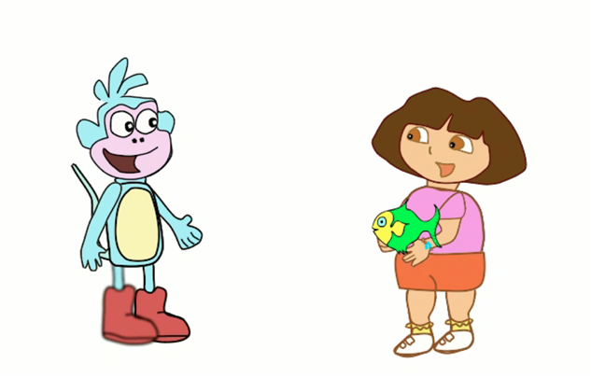
Figure 2. Image from the video clip depicting ‘Dora threw Boots a fish/ a fish to Boots’.
Responses to each prime were encoded using Microsoft Excel and also recorded using a Zoom H2 Microphone in order to check response coding for accuracy.
Syntactic priming task. Participants were first familiarised with the characters and animals in the syntactic priming task. When the experimenter was satisfied that the child knew all of the nouns and verbs being used in the stimuli, the task would commence, beginning with the 8 practice sentences. The children were told that they would be taking turns with the experimenter to describe what was happening in different movie clips.
For prime sentences, the experimenter and the participant both watched the video as the experimenter described the scene using either a POD or DOD prime. The children were asked to repeat the experimenter’s sentence to ensure they had heard it correctly. If the child repeated the sentence incorrectly, they were told that they were almost right, but needed to repeat exactly what the experimenter said. If necessary, the experimenter would repeat the prime sentence. The experimenter then showed the child the next scene and asked them to describe it. Children were prompted by the experimenter beginning the sentence, e.g. “The boy sent…”, so that the child knew which verb was to be used but received no cue as to the form of dative they should use to describe the picture. If the child did not produce a complete sentence, they were prompted to provide further information, as demonstrated below.
Experimenter: “The girl threw…”
Participant: “The girl threw a puppy…”
E: “Can you tell me a bit more? Who else is in the movie?”
P: “The girl threw a puppy to the boy.”
Participant responses would only be excluded if they were unable to form a complete sentence that could be classified as a POD or DOD. Responses were included if participants replaced ‘the’ with ‘a’, e.g. “a princess threw the cat to the prince” instead of “the princess threw a cat to the prince”, as both sentences still conformed to the dative structure. Responses were also included if participants used a different name for one of the actors or objects, as this did not impact on their understanding or description of the event. For instance, many children mistook the queen for the princess and referred to the puppy as a ‘teddy bear’. When this occurred, children were simply told the correct name for future use.
Response coding. Children’s responses to each item were coded in Excel as either a POD (0) or a DOD (1). If a response could not be coded as a dative, the cell was left empty. Coding each response in this way meant that a rich dataset was created consisting of 12 data points for each participant.

Appendix B
Filler and practice sentences used in the syntactic priming task
Table A1
Practice sentence pairs used in the syntactic priming task
Experimenter | Participant
Piglet and Tigger were bouncing | The king and queen waved
The prince was rocking | The princess was rocking
Boots pointed at Dora | Wendy pointed at Bob
The boy waved | The girl waved

Table A2
Filler sentence pairs used in the syntactic priming task
Experimenter | Participant
The King and Queen waved | Dora and Boots waved
Wendy pointed at Bob | Boots pointed at Dora
The Prince was rocking | The Princess was rocking
Wendy was flying | Bob was flying
Wendy and Bob jumped | The Princess jumped
Piglet was rocking | Tigger was rocking
Piglet was washing | Tigger was washing
Dora was swinging | Bob was swinging
Boots was flying | Dora was flying
Piglet and Tigger bounced | The King and Queen bounced
The cat was swinging | Bob was swinging
Dora was washing | Boots was washing

