Two core aims of the psychology of language are to explain adult language processing and child language acquisition. These two questions are intimately intertwined and place complementary constraints on theorizing in the language sciences (Christiansen & Chater, 2016; Dell & Chang 2014). Indeed, all linguistic structures within a language must be both efficiently processable by adults and efficiently learnable by children if they are to withstand cultural evolutionary time (Christiansen & Chater, 2016). However, despite this connection, research on adult language processing and child language acquisition too often precede independent of one another (See Dell & Chang 2014). One domain where these two perspectives are deeply relevant is syntactic priming. The present paper reports on developmental data, from cross-sectional and longitudinal studies, examining the developmental trajectories of priming effects, as a powerful test of the proposal that syntactic priming in adults reflects a form of implicit learning.
One of the most powerful methods in the psycholinguistic tool kit for examining syntactic structure is the syntactic priming paradigm (Bock, 1986; Branigan & Pickering, 1998, 2017). Syntactic priming refers to tendency for speakers to persist in the use a particular syntactic structure after having recently processed it. Priming is observed in both naturalistic speech (Gries, 2005; Jaeger & Snider, 2013) and in experimental contexts (Bock, 1986; Branigan & Pickering, 1998) In a typical experiment, participants are asked to describe a scene that can be construed using either of two grammatical constructions (e.g., the active and passive), after processing a prime sentence using those constructions. If participants are more likely to use the passive (e.g., The boy is being chased the dog) after hearing a separate scene described with the passive (e.g., The monkey is being fed by the lion) than after it described with the active (e.g., The lion is feeding the monkey), this is taken as evidence of priming. Priming effects are considered to indicate shared representations between the prime and target sentence (Branigan & Pickering, 2017).
Priming effects can be reliably observed even when the prime and target sentence share no overlap in open class lexical items (Bock, 1986; Mahowald, James, Futtrell & Gibson, 2016), suggesting that the effect is due to shared abstract representations between the prime and target sentence. These abstract representations appear to be purely syntactic. For example, the magnitude of the abstract priming effect does not appear to depend on whether the prime and target sentence share thematic roles (that is the passive sentence the postman was chased by the dog is primed equally by the passive sentence the 747 was alerted by the control tower and the active locative the 747 was landing by the control tower; Bock & Loebell 1990). Moreover, abstract priming effects appear to be long-lasting, with significant priming effects detectable at lags of up to 10 trials (Bernolt, Collina, & Hartsuiker, 2016; Bock & Griffin, 2000; Hartsuiker, Bernolet, Schoonbeart, Speybroeck & Vanderlest, 2008). However, there is mixed evidence as to whether the magnitude of priming effects remains stable across lags (Bock & Griffin, 2000; Hartsuiker et al. 2008), or whether there is evidence that effect decays (Bernolet, Collina & Hartsuiker, 2016).
While abstract priming effects can be observed independent of lexical items, priming effects can be moderated by lexical variables in two prominent ways. First, priming effects are larger in magnitude when the prime and target share lexical items, the so-called lexical boost effect (Pickering & Branigan, 1998; Harsuiker et al 2008; Mahowald et al. 2016). There is stronger evidence that the lexical boost diminishes across lags to the point of eventually disappearing (Hartsuiker et al 2008; Mahowald et al. 2016), suggesting that it may reflect an additional mechanism beyond that responsible for abstract priming. Second, priming effects are larger when the prime verb is paired with a structure that it occurs in infrequently, the so-called prime surprisal effect (Bernolet & Hartsuiker, 2010; Jaeger & Snider, 2013). For example, while the verb bring can occur in both the prepositional object dative (PD, e.g., she brought the ball to the boy) and the double object dative (DO, e.g., she brought the boy a ball), it occurs more often in the PD than the DOD. In general, a DOD prime will be stronger (that is, it will increase the likelihood that another DOD will be used) when it contains the verb bring than when it contains a verb that is biased to the DOD, such as gave.
While there is widespread agreement about the existence of these empirical phenomena amongst researchers (Mahowald et al. 2016), there is disagreement on the mechanisms underlying them (Chang et al. 2006; Pickering & Branigan, 1998; Reitter, Keller & Moore, 2011). However, one popular explanation, which connects both language acquisition and language processing, is that syntactic priming is a consequence of implicit learning (Bock & Griffin, 2000; Chang et al., 2006; Snider and Jaeger & Snider, 2008). On such an account, exposure to a prime sentence alters the language production system’s knowledge of the relevant construction, thereby increasing the probability that the relevant construction is used again. Such an explanation is attractive because it links two seemingly disparate empirical traditions: studies of adult syntactic priming and studies of child language acquisition.
The most prominent formalized account of the implicit learning explanation comes from the dual-path model of sentence production (Chang et al. 2006; Chang & Fitz, 2014). The model extends the simple recurrent network pioneered by Elman (1990) by including a separate system for representing abstract event roles (similar to thematic roles), which are presumably non-linguistic in origin (Jessop & Chang, 2020). It learns to produce the target language’s syntactic constructions via incremental error-driven learning. As the model is exposed to each word in a sentence, it predicts the subsequent word, and when the subsequent word is encountered the model calculates the prediction error between its expectations and the encountered word, and updates its weights (and therefore future expectations) accordingly.
From the perspective of the dual path model, the abstract priming effect reflects changes in the model’s weights due to processing the prime sentences, a form of implicit learning. Because the model updates its weights on the basis of prediction error, less predictable input will lead to larger changes in the weights than more predictable input, thereby explaining the prime surprisal effect. However, the model cannot simulate the lexical boost. This had led the authors to speculate that the lexical boost may be driven by episodic memory (Chang et al. 2006; Chang, Janciauskas, & Fitz, 2012), which is consistent with the fact that the lexical boost decays more quickly than the abstract priming effect (Hartsuiker et al. 2008; for an evidence that the abstract priming effect may be increased in magnitude at lag 1 by similar processes see Bernolet and Harstuiker et al 2016).
Moreover, because the dual-path model is a model of language acquisition it makes relatively clear predictions about the emergence and development of these effects. First, the model predicts that abstract priming will emerge early, as soon as the child is able to produce the relevant grammatical construction. However, because the model updates its weights on the basis of prediction error, it predicts that priming will be larger for less experienced speakers than more experienced speakers. Specially this means that the priming effect should decrease with increased language development. The model predicts that the prime surprisal effect should emerge in parallel with the abstract priming effect, as the model learns the links between verbs and structures using the same error-based learning mechanism (Peter, Chang, Pine, Blything & Rowland, 2015). While the model’s predictions about the developmental trajectory of the prime surprisal effect are less clear, there is some reason to believe that like the abstract priming effect, it too will diminish with time. In particular, it is common to reduce the plasticity of connectionist models so that they are more sensitive to input at earlier stages than later stages, thereby reducing the effects of catastrophic interference (McClleland, McNaughton & O’Reilly, 1995). Chang et al. 2006 achieved this reduction in plasticity by allowing the model’s learning rate to decrease with time, and Peter et al. (2015) show that reducing the model’s learning rate would reduce the effects of prime surprisal. The dual-path model assumes that the lexical boost is governed by a separate mechanism, most plausibly the episodic memory (Chang, Janciauskas, & Fitz, 2012). If the lexical boost is driven by a separate system entirely from the abstract priming effect, there is no reason to expect them to develop in parallel. Moreover, because of the relatively slow developmental trajectory of episodic memory, it seems reasonable to predict that the lexical boost will develop later than abstract priming and, unlike abstract priming and prime surprisal, increase with development (Chang, Janciauskas, & Fitz, 2012; Peter et al. 2015; Rowland, Chang, Ambridge, Pine & Lieven, 2012). For clarity, these predictions are outlined in Table 1.
A particularly impressive feature of the dual path model is that, without its guidance, none of its predictions about the developmental trajectories of the priming effects are obvious. While alternative formalized developmental accounts of priming do not exist, one could easily speculate, for example, that lexically based priming would emerge before abstract priming, under the assumption that children’s syntactic knowledge is initially lexically constrained (Tomasello, 2002; ). One could also imagine, for example, that the effect of priming would remain stable over time, if it reflects residual activation of the combinatorial pattern used in the prime sentence, rather than learning (Pickering & Branigan, 1998) Therefore, the developmental predictions of the dual-path model offer a very powerful test of the hypothesis that syntactic priming effects are a consequence of the implicit learning of linguistic structure.
The status of these predictions in syntactic priming studies is unclear. While there exists a great deal of literature examining syntactic priming effects in children, many of such studies have examined the abstract priming effect at a single time-point, motivated by the hypothesis that sufficiently young children possess abstract syntactic representations (Bencini and Valian, 2008, XXXXXX) with only a few cross sectional studies comparing different age groups (Rowland et al., 2012; Peter et al. 2015). These results support the prediction that abstract priming emerges early for both passives (Bencini and Valian, 2008) and datives (Rowland et al. 2012; Peter et al 2015; Shimpi, Gámez, Huttenlocher & Vasilyeva, 2007), suggesting that, in many situations, children as young as three and three-and-a-half can be primed in the passive and dative alternations respectively.
Findings on the developmental trajectories of such effects are less clear. Two studies comparing children to adults find priming effects of similar magnitudes (Branigan and McLean, 2016; Messenger, Branigan & Mclean, 2012). In one cross sectional study of datives, Rowland et al (2012) found that effect sizes for three-year-olds were substantially larger than those for older children and adults, though the interaction was not significant. However, in a similar study with datives, Peter et al (2015) observed an increase in the priming effect with age. One complication in studying changes in the magnitude of priming effects across age is inter-individual variability in knowledge of the prime structure. Before children can be primed, they need to have acquired the relevant grammatical construction (that is, they need to be prime-able). If children vary in the age at which they acquire the relevant construction, then within a sample, decreases in priming effects amongst some children could be offset by increases in the number of children who are prime-able. Consistent with this account, in the one longitudinal study of priming conducted to date, Kumarage et al (Submitted), studying passive priming, did not observe a decrease in priming in the entire sample between 36 and 54 months; however, when they tested only children who had produced at least one passive at 36 months, they observed the decrease in the magnitude of the priming effect. In sum, there is some evidence to the support the prediction of the dual-path model’s prediction; however, given the inconsistency of this result with previous studies it will be necessary to replicate this finding with another construction to ensure it reveals something about priming in general and not something idiosyncratic about passives.
Evidence on the emergence and developmental of the lexical boost in children and its relation to age is also mixed, though the majority seems consistent with Chang et al’s (2006) suggestion that the lexical boost is governed by a separate mechanism with different developmental effects. While Branigan and McLean (2016), for example, found evidence for a lexical boost with passives amongst three-year olds that did not differ in magnitude from that of adults, both Rowland et al. (2012) and Peter et al. (2016) found a lexical boost that increased with age and was not significant in the youngest groups tested (three-year-olds) despite the fact that those groups exhibited syntactic priming. Moreover, Kumarage et al’s (Submitted) longitudinal study of passives found similar results, with evidence of an increasing lexical boost that was absent at the earliest age (36 months), even though abstract priming was present at that point. In sum, then, there is moderate evidence for both the late emergence and positive trajectory of the lexical boost for multiple grammatical constructions.
The emergence and development of the prime surprisal effect is less studied. To our knowledge, the only study to examine this effect in children is Peter et al (2015). They found a prime surprisal effect that emerged with the abstract priming effect at 3 years of age, and this effect decreased with age, with only a marginally significant effect in adults. However, given the variability in studies of these other effects, more studies of the development of prime surprisal need necessary.
The right column of Table 1 characterizes the available evidence for the predictions of the dual path model in the development of syntactic priming.
Present Study
Method
Participants
One hundred and forty-five children aged between 3 and 9 years were recruited from kindergartens and primary schools in a medium-sized metropolitan Australian city. Five participants were excluded because of diagnosed of a hearing loss (one child) or an inability/refusal to complete the priming task (four children), resulting in 140 participants in the present analyses (N = 140). Participants were an average of 5.96 years old (SD = 1.31, Min = 3.26. Max = 8.72), with 64 females (46% of the sample) and 75 males (54% of the sample).
Materials
Participants completed a non-verbal intelligence test (Raven’s Progressive Matrices) and the Peabody Picture Vocabulary Test (PPVT), which were not considered in the present analysis, as well as a syntactic priming task.
Syntactic priming task. Our syntactic priming task was an adapted version of that used by Rowland et al. (2012). In this task, participants watched a set of videos with the experimenter and the two took turns describing scenes. Experimenters described half of the scenes (prime trials), and the participant described the other half of the scenes (target trials).
Critical trials for the task were 24 animated scenes that could be described by dative sentences (e.g., Dora threw Boots a fish, or Dora threw a fish to Boots). Scenes were created using Anime Studio Pro (See Figure 1). Each scene depicted one of six actions (brought, gave, passed, sent, showed, and threw), undertaken by one of six pairs of animate characters (three sets of proper nouns: Dora and Boots, Wendy and Bob, Tigger and Piglet; and three sets of common nouns: the boy and the girl, the king and the queen, the prince and the princess) using one of five animate objects (a baby, a cat, a fish, a rabbit, a puppy). See Figure 1 for an example scene. See Table 2 for a full description of all 24 scenes. In addition to these critical scenes, we created a further 30 scenes which depicted transitive and intransitive events with the same characters, to serve as filler (22 scenes) and practice (8 scenes) trials.
Each participant saw all 24 critical scenes over the course of the experiment. Scenes were presented in 12 pairs, wherein the first scene was a prime trial and the second was target trial. Each action occurred four times within participant, twice in prime trials and twice and twice in target trials. Half of the prime trials were described with a DOD sentence and half were described with a POD sentence. Half of the pairs of trials contained the same action (lexical overlap trials) and half contained separate actions (no overlap trials). Each action occurred in one overlap trial (thus as both the prime and target scenes) and two no-overlap trials (in the prime scene for one pair and the target scene for the other). Each pair of critical scenes was separated by a pair of filler scenes with intransitive actions (also to be described by the experimenter and participant).
Eight experimental lists were created to balance the presentation of verbs across each cell from the two factors above (POD-Prime, Overlap; POD-Prime, No Overlap; DOD-Prime Overlap; DOD-Prime, No Overlap). List 1 was created to meet the conditions in the paragraph above. List 2 was created so that the order of the scenes within pair was reversed; that is, the prime scenes from List 1 were the target scenes in List 2 and vice versa. In List 3, the DOD primes from List 1 were POD primes and vice versa. In List 4, the DOD primes from List 2 were POD primes and vice versa. List 5 was created by re-ordering the pairs from List 1. Lists 6, 7 and 8 were created by applying the same steps as Lists, 2, 3 and 4 to List 5. All experimental lists are presented in Table 2.
Syntactic priming procedure.
The experimenter and the participant sat together to watch the videos on a laptop computer. Prior to beginning the task, the experimenter ensured that the participant was familiar with all of the characters and actions. Following this, the experimenter told the participant that they were going to take turns with the experimenter describing what was happening in the video clips. The participant and experimenter then completed eight practice trials, with intransitive actions. After the practice trials, the participants and the experimenter began the test trials the 46 test trials (12 pairs of prime and target trials and 11 pairs of filler trials).
On prime trials, the experimenter said the prime sentence and asked the participant to repeat it. If the participant repeated the sentence incorrectly, they were encouraged to say it again and repeat it exactly. Experimenters repeated the prime sentence if necessary. On the test trials, the experimenter prompted the child with the beginning of the sentence, e.g., “the boy sent”, thereby ensuring the child used the correct verb without biasing them towards either form of the dative. If the child did not produce a full dative, they were encouraged to do so as follows:
Experimenter: “The girl threw…”
Participant: “The girl threw a puppy…”
E: “Can you tell me a bit more? Who else is in the movie?”
P: “The girl threw a puppy to the boy.”
Trials were excluded if the participant produced a non-target response (a non-dative structure), or they produced a verb that either (a) was not one of the six verbs in the study or (b) affected the overlap between the target and prime verb. Trials were also removed if the child was noticeably inattentive, or if there was an error administering the trial or prompt. All other trials were included even if they participant produced an incorrect noun phrase (e.g., misnaming the character).
Analytic Procedures.
We fit a series of mixed effects logistic regressions using brms (VERSION) and STAN (VERSION), in R (VERSION). Inferences about parameters of interest were based on the proportion of the posterior distribution in the hypothesized direction for each parameter (similar to a one-tailed test in frequentist statistics). Because hypothesized age-related changes in the magnitude of the priming effect could be offset by age-related increases in the acquisition of the DOD, we ran all models twice, once including all participants and once including only participants who produced at least one DOD (See Kumarage et al. for a similar approach).
Results
Full results, including some sensitivity analyses not reported in the present text, are available in html format (https://rpubs.com/sdonnelly85/787574) and can also be generated using the RMarkdown file on the osf page for this project.
Missing Data
Of the original 1680 trials (140 participants with 12 trials each), 22 were excluded, for the following reasons: 10 administration errors, 6 verb errors, 4 non-target responses, 1 non-allowable prompt, and 1 failure to attend to the experimenter. Of the total 140 participants, 13 had at least 1 non-valid trial (missing 1 = 6, missing 2 = 6, missing 4 =1).
Analysis of Lexical Boost
To examine the developmental trajectory of the lexical boost and abstract priming effect, we estimated a mixed effects logistic regression with all relevant random intercepts, slopes and correlations by participant and target verb. We included prime structure, lexical overlap, age and their interactions as fixed effects. We sum coded prime structure (-.5, .5), dummy coded lexical overlap (0, 1), and centered age. Coding the variables this way allowed us to interpret our coefficients as follows: The coefficient for the abstract priming effect represented the magnitude of the priming effect without lexical overlap, i.e., the abstract priming effect (hypothesized to be positive); the coefficient for the interaction between prime structure and age represented changes in the abstract priming effect with age (hypothesized to be negative); the interaction between prime structure and lexical overlap represented the lexical boost at the average age in our sample (hypothesized to be positive), and the three-way interaction between prime-structure, lexical overlap and age represented changes in the lexical boost with age (hypothesized to be positive).
Coefficients and 95% credible intervals are available in Table 1 (Model 1). The abstract priming effect was positive with a credible interval that did not overlap with 0, and the lexical boost was also positive with a credible interval that did not overlap with 0. The interaction between prime structure and age was negative with a credible interval that substantially overlapped with 0, and the three-way interaction between prime structure, lexical overlap was positive with a credible interval that did differ from 0. To determine how reliably each of these effects differed from 0 in the hypothesized direction, we calculated the proportion of the probability distribution that was greater than or less than zero, depending on the relevant hypothesis. We found that 99% of the posterior distributions for prime structure and the interaction between prime structure and verb overlap were above 0, revealing robust abstract priming and lexical boost effects. For the interaction between abstract priming and age, 83% of the posterior distribution was negative, and for the interaction between abstract priming, lexical boost and age, 58% of the posterior distribution was positive.
To better illustrate the predictions of this model, we plotted the model-implied probabilities for each condition at each age (on both the logit and probability scale) in Figure 2. The top row depicts the model’s predictions on the logit scale. There was a clear abstract priming effect and this effect was larger with lexical overlap. Moreover, while priming effects for both lexical overlap and non-overlap conditions were slightly smaller in magnitude at older ages than younger ages, this effect was tiny and not reliably detected by our model. Below are the model’s predictions on the probability scale, with empirical means and confidence intervals presented for reference. Note that the non-linear transformation used to map between the probability and logit scale can create the illusion of an interaction on the probability scale, when none exists on the logit scale. This plot suggests that the model provided a reasonable fit to the data.
To quantify the strength of the abstract priming within each condition (with and without lexical overlap), we calculated risk ratios. Risk ratios are an effect size for categorical data, where the probability of an event (e.g., the child produces a DOD) in one condition (after a DOD prime) is divided by the probability of that event in another condition (after a POD prime). Unlike measures such as Cohen’s d, which quantify percentage point increases in the outcome of interest, risk ratios quantify proportional increases in the frequency of an event (i.e., that producing a DOD is X times more likely after a DOD prime than after a POD prime). To calculate risk ratios, we calculated the model’s predictions for the relevant conditions on the logit scale, transformed this to the probability scale, and calculate the ratios using these values. On trials without lexical overlap children were 2.52 times more likely to produce a DOD after a DOD prime than POD prime (95% HPDI: 1.09 : 4.48), and on trials with lexical overlap children were 12.97 times more likely to produce a DOD sentence after a DOD prime than after a POD prime (95% HPDI: 1.46 : 30.18); however, we note that the posterior distribution on this latter estimate is extremely wide. See Accompanying HTML file for the entire posterior distribution of these values, as well as similar values calculated at each age point. Figure 3 depicts the posterior distribution for the risk ratios calculated above (
We, then, re-fit the model above on only the subset of participants who produced at least 1 double object dative over the course of the experiment. Coefficients from this model (Model 2) are presented in Table 1 and were qualitatively similar to coefficients from Model 1. As was the case for model 1, we found strong evidence for an abstract priming effect (posterior probability = .99) and for the lexical boost (posterior probability = 1), but not for the reduction in the priming effect with age (posterior probability = .81) or the increased lexical boost with age (posterior probability = .61). Model predictions were similar to those form Model 1 (See Figure 4 for predicted values). According to the model, children at the average age in our sample (6 years) were 2.28 times more likely to produce a DOD after DOD prime than after a POD prime with no lexical overlap (CI = 1.05 : 3.98), and were 10.89 times more likely to produce to do so when there was lexical overlap (CI = 1.55 : 25.60).
In sum, we found strong evidence for the abstract priming effect and the lexical boost in our cross-sectional sample, and there was little evidence that either of these effects were moderated by age. These findings were unchanged when we removed participants who produced no DODs.
Analysis of Prime Surprisal
Following Peter et al. (2017), we test for prime surprisal effects only on trials without lexical overlap. We used a similar coding scheme as for model 1. Prime structure and age were coded the same as in Models 1 and 2, above). To determine each verb’s preferred prime structure, we calculated the proportion of DOD responses for each verb, and conducted a median split on this value. Showed, gave and brought were more DOD biased (with 41, 37 and 25% DOD responses respectively), and passed, sent and threw were relatively POD biased (with 19%, 14% and 14% DOD responses respectively). Then, for each prime verb/prime structure, we created a variable indicating whether the verb’s bias and the prime structure matched (0) or mismatched (1). Calculating this variable on the basis of children’s responses is somewhat problematic, as we are now controlling for a post treatment variable. However, in Study 2, we used these verb bias estimates in a separate sample of participants from the same community. Note that given this coding scheme, the abstract priming effect refers to the priming effect when the prime structure matches the verb’s bias (at the sample’s mean age); the interaction between prime bias and prime structure reflects how much larger the prime effect was when the verb’s bias mismatched the target structure (at the sample’s mean age), i.e., the prime surprisal effect; the interaction between age and prime structure reflects changes in the magnitude of the priming effect when the verb’s bias matches the prime structure; and the three way interaction reflects how the prime surprisal effect changes with age.
Coefficients and 95% credible intervals are available in Table 1 (Model 3). The abstract priming effect was positive with a credible interval that overlapped substantially with 0, and the prime surprisal effect was also positive with a credible interval that overlapped with 0. Both interactions with age were negative with credible intervals that greatly overlapped with 0. Directional hypotheses tests revealed that 83% of the posterior distribution for the abstract priming effect was positive, while 89% of the posterior distribution for the prime surprisal effect was positive. Only 49% of the posterior distribution for the interaction between prime structure and age was negative, and 78% of the posterior distribution for the three-way interaction was negative. Model implied-probabilities and raw proportions are plotted in Figure 6. Risk ratios indicated that children were 1.68 times more likely to produce a DOD after a DOD prime than after a POD prime, when the verb’s bias matched the target structure (CI = .52 : 3.30) and 4.14 times more likely to do so when the prime verb’s bias mismatched the target structure (CI = .51 : 10.07).
We then re-ran the analyses above, with only participants who produced at least 1 DOD. Coefficients and credible intervals were similar to those in Model 3 (See Table 2). 85% of the posterior distribution for the abstract priming effect was positive and 90% of the posterior distribution for prime surprisal effect was positive. 50% of the posterior distribution for the interaction between prime structure and age was negative and 75% of the three-way interaction was negative. In sum, there was weak evidence for the prime surprisal effect in this subsample, and no evidence for the other effects. Model-implied probabilities are depicted in Figure 8, and show a broadly similar patter of results. Risk ratios indicated that participants were 1.6 times more likely to produce a DOD after a DOD prime than after a POD prime when the verb’s bias matched the prime structure (CI = .55 : 3.05) and 3.69 times more likely to do so when the verb’s bias mismatched the target structure (CI = .52 : 8.17).
In sum, we found weak evidence for the prime surprisal effect, though only when participants who produced at least 1 DOD were included. Though, given the graded nature of statistical evidence in the Bayesian framework, the results in the full sample were essentially the same. Interestingly, there was no evidence of abstract priming when the verb’s bias matched that of the target structure, and no evidence that either of these effects were moderated by age.

Study 2
Method
Participants
Participants came from the Canberra Longitudinal Child Language Project, a longitudinal study of language acquisition and processing from nine to sixty months (Kidd et al., 2018). Families were recruited from a medium-sized city in Australia. Inclusion criteria for the longitudinal study were: (i) full-term (at least 37 weeks gestation) babies born with a typical birth weight (> 2.5kg), (ii) a predominantly monolingual language environment; thus the children were acquiring Australian English as a first language (mean percentage of language other than English = 2%, Range: [0, 40%], Mode = 0), and (iii) no history of medical conditions that would affect typical language development, such as repeated ear infections, visual or hearing impairment, or diagnosed developmental disabilities. Consistent with the demographics of the city, the sample was drawn from families of high socio-economic status. Approximately 75% of the parents had completed a bachelor degree or higher.
Participants completed syntactic priming task at the ages of 42, 48 and 54 months. Of the 124 participants who completed at least one wave of testing, 104 were still participating in the study at 42 months and, therefore completed at least one syntactic priming task. Of these, 2 were excluded because of later developmental diagnoses. As a result, 102 participants were included in the present analyses (N = 102). Of these 102, 91 completed the 42-month session, 92 completed the 48-month session and 88 completed the 54-month session. Moreover, 78 participants completed all three sessions, 13 completed 2 sessions and 11 completed 1 session.
Materials
The syntactic priming task was administered during three hour-long visits to the lab, during testing sessions at 42, 48 and 54 months.
Syntactic priming task. We used the same materials as in the cross-sectional study. Because the sample was so young at the first testing session, we used definite common nouns rather than proper nouns for all actors (e.g., the pairs of actors were referred to as the girl and the monkey, the lady and the man, the tiger and the pig the boy and the girl, the king and the queen, the prince and the princess).

Effect | Emergence | Trajectory | Available Evidence
Abstract Priming | Early | Decrease | Strong evidence for emergence; mixed evidence for trajectory.
Prime Surprisal | With abstract priming | Likely Decrease | Insufficient available evidence for emergence and trajectory.
Lexical Boost | Later | Increase | Moderate evidence both emergency and trajectory.
Table 1. Predictions about emergence and developmental trajectory for each effect from an implicit learning account.
Table 2. POD and DOD Sentences for Priming and Responses
Verb | Sentences (POD/DOD) | Verb | Sentences (POD/DOD)
Gave | The king gave a baby to the queen/ the queen a baby. | Showed | Piglet showed a cat to Tigger/ Tigger a cat.
Gave | Dora gave a rabbit to Boots/ Boots a rabbit. | Showed | The boy showed a puppy to the girl/ the girl a puppy.
Gave | Wendy gave a fish to Bob/ Bob a fish. | Showed | The boy showed a rabbit to the girl/ the girl a rabbit.
Gave | The prince gave a puppy to the princess/ the princess a puppy. | Showed | Piglet showed a baby to Tigger/ Tigger a baby.
Passed | The boy passed a fish to the girl/ the girl a fish. | Sent | The prince sent a cat to the princess/the princess a cat.
Passed | Wendy passed a puppy to Bob/ Bob a puppy. | Sent | Piglet sent a baby to Tigger/ Tigger a baby.
Passed | Piglet passed a cat to Tigger/ Tigger a cat. | Sent | Dora sent a puppy to Boots/ Boots a puppy.
Passed | The king passed a baby to the queen/ the queen a baby. | Sent | The boy sent a fish to the girl/ the girl a fish.
Threw | Dora threw a fish to Boots/ Boots a fish. | Brought | Wendy brought a rabbit to Bob/ Bob a rabbit.
Threw | The king threw a rabbit to the queen/ the queen a rabbit. | Brought | The prince brought a rabbit to the princess/the princess a rabbit.
Threw | The prince threw a cat to the princess/ the princess a cat. | Brought | The king brought a puppy to the queen/ the queen a puppy.
Threw | Wendy threw a puppy to Bob/ Bob a puppy. | Brought | Dora brought a fish to Boots/ Boots a fish.

Predictors | Model 1 | Model 2 | Model 3 | Model 4
Intercept | -1.60  (-2.76 : -0.34) | -1.05  (-2.20 : 0.21) | -1.97  (-3.26 : -0.73) | -1.43  (-2.63 : -0.22)
Prime (DOD) | 1.04  (0.32 : 1.89) | 1.04  (0.30 : 1.90) | 0.47  (-0.54 : 1.50) | 0.48  (-0.50 : 1.50)
Overlap | -0.66  (-1.32 : -0.01) | -0.65  (-1.27 : -0.02)
Age.c | 0.45  (0.00 : 0.91) | 0.35  (-0.08 : 0.78) | 0.55  (0.04 : 1.11) | 0.44  (-0.08 : 0.97)
Prime * Overlap | 1.60  (0.48 : 2.93) | 1.64  (0.61 : 2.90)
Prime * Age.c | -0.19  (-0.64 : 0.25) | -0.20  (-0.65 : 0.23) | 0.01  (-0.69 : 0.76) | 0.00  (-0.74 : 0.78)
Overlap * Age.c | 0.06  (-0.59 : 0.75) | 0.04  (-0.63 : 0.74)
Prime * Overlap * Age.c | 0.07  (-0.67 : 0.81) | 0.04  (-0.71 : 0.76)
Bias Mismatch (POD) |  |  | 0.48  (-0.67 : 1.45) | 0.54  (-0.39 : 1.45)
Prime * Bias Mismatch |  |  | 0.95  (-0.61 : 2.77) | 0.99  (-0.60 : 2.94)
Bias Mismatch * Age.c |  |  | -0.15  (-0.70 : 0.44) | -0.19  (-0.73 : 0.44)
Prime * Bias Mismatch * Age.c |  |  | -0.39  (-1.53 : 0.73) | -0.38  (-1.71 : 0.84)
N | 140 _{Case_ID} | 114 _{Case_ID} | 140 _{Case_ID} | 114 _{Case_ID}
 | 6 _{Trial_verb} | 6 _{Trial_verb} | 6 _{Trial_verb} | 6 _{Trial_verb}
Observations | 1658 | 1348 | 827 | 673
Table 4. Model coefficients and 95% credible intervals for Study 1.



Figure 1. Image from the video clip depicting a scene that could be described with the DOD or POD dative ‘Dora threw Boots a fish
/ a fish to Boots’

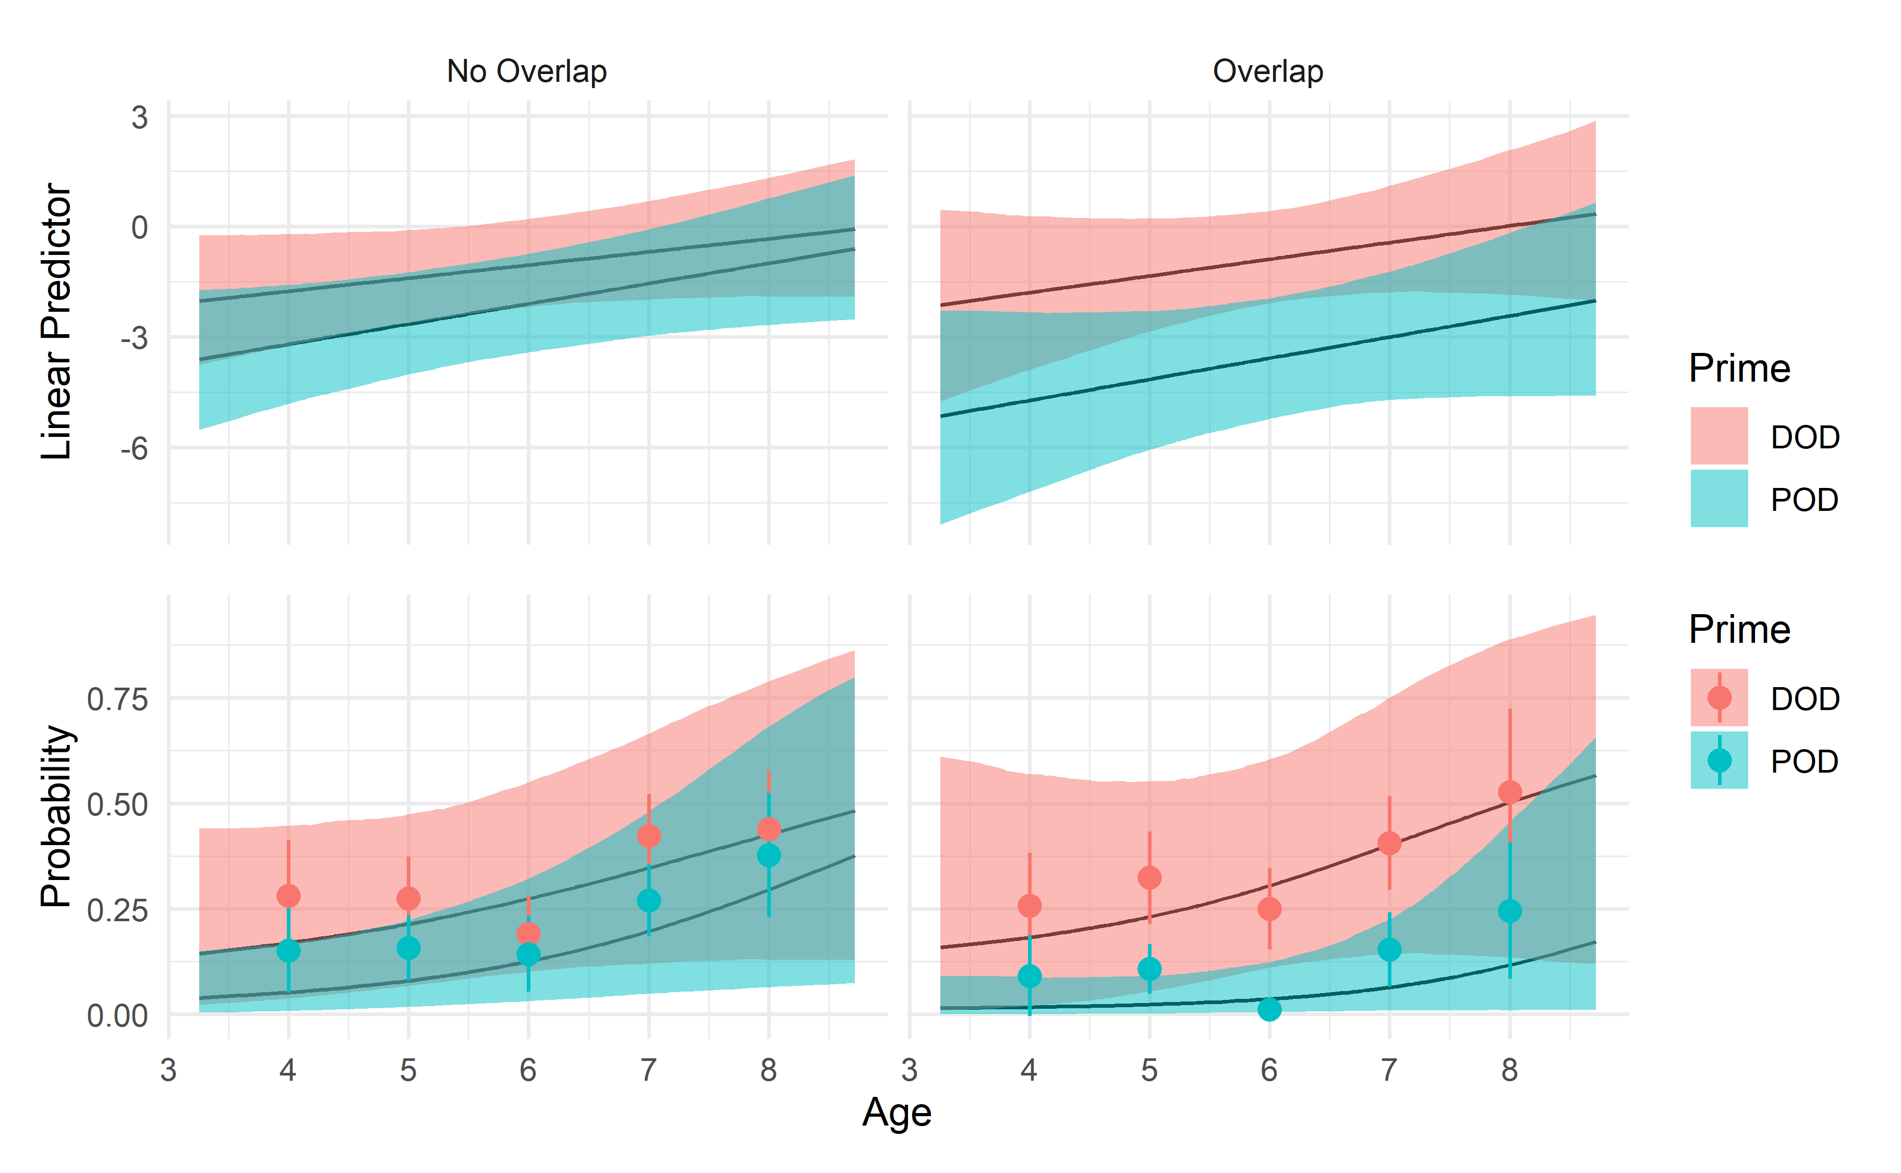
Figure 2. Model implied proportion of DOD responses for the entire sample, on both logit and probability scale. Dots and whiskers on the probability scale are raw proportions (with 95% confidence intervals for each condition).

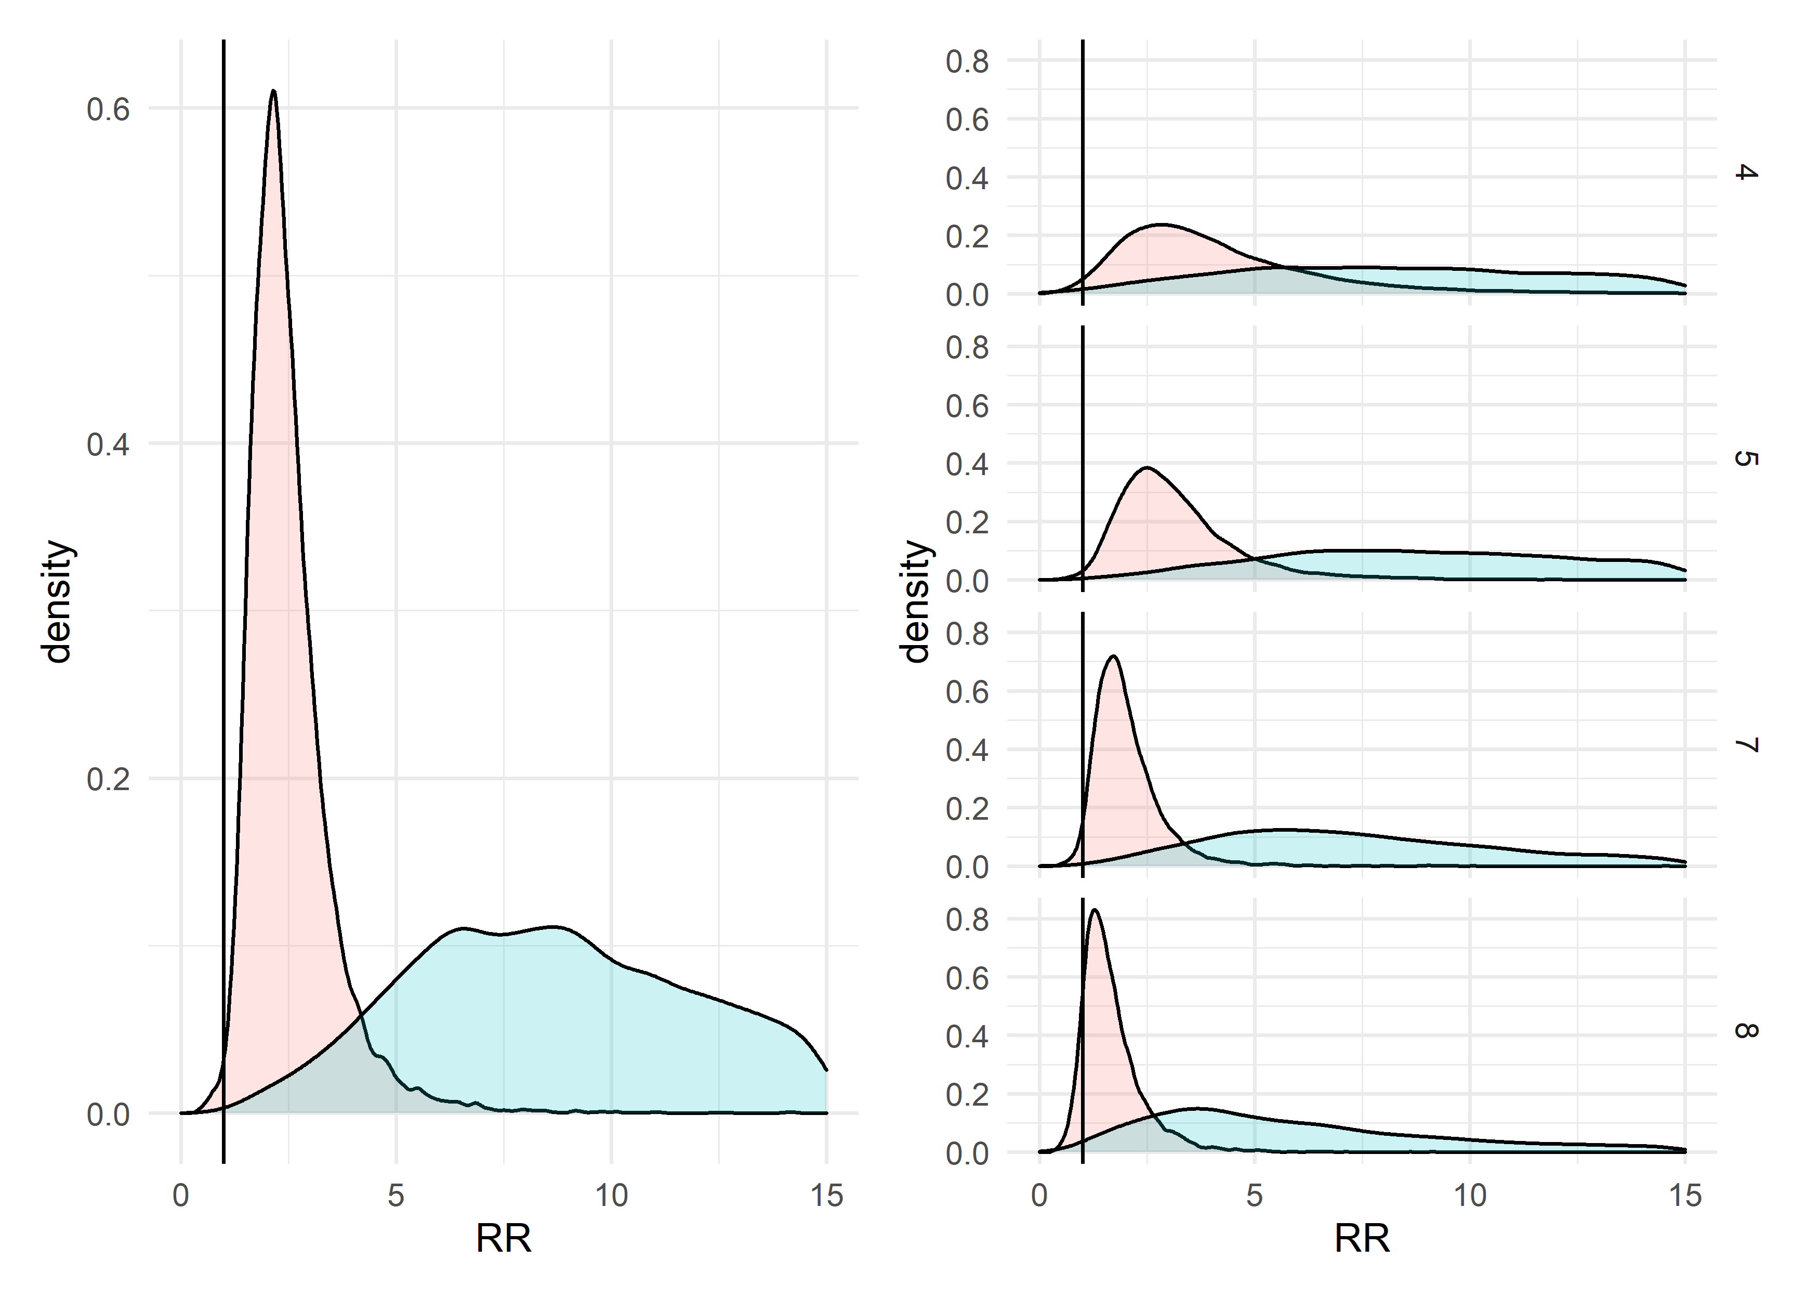
Figure 3. Posterior estimates of risk ratios for abstract priming effect (light red) and priming effect with lexical overlap (light blue). The pane on the left depicts risk ratios at 6 years of age, the sample mean age. The right pane depicts the risk ratios for all other age groups.

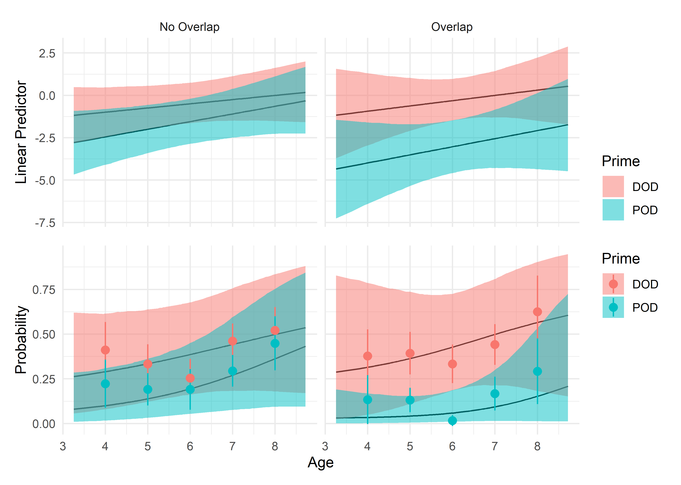
Figure 4. Model implied proportion of DOD responses for only children who produced at least one DOD response, on both logit and probability scale. Dots and whiskers on the probability scale are raw proportions (with 95% confidence intervals for each condition).

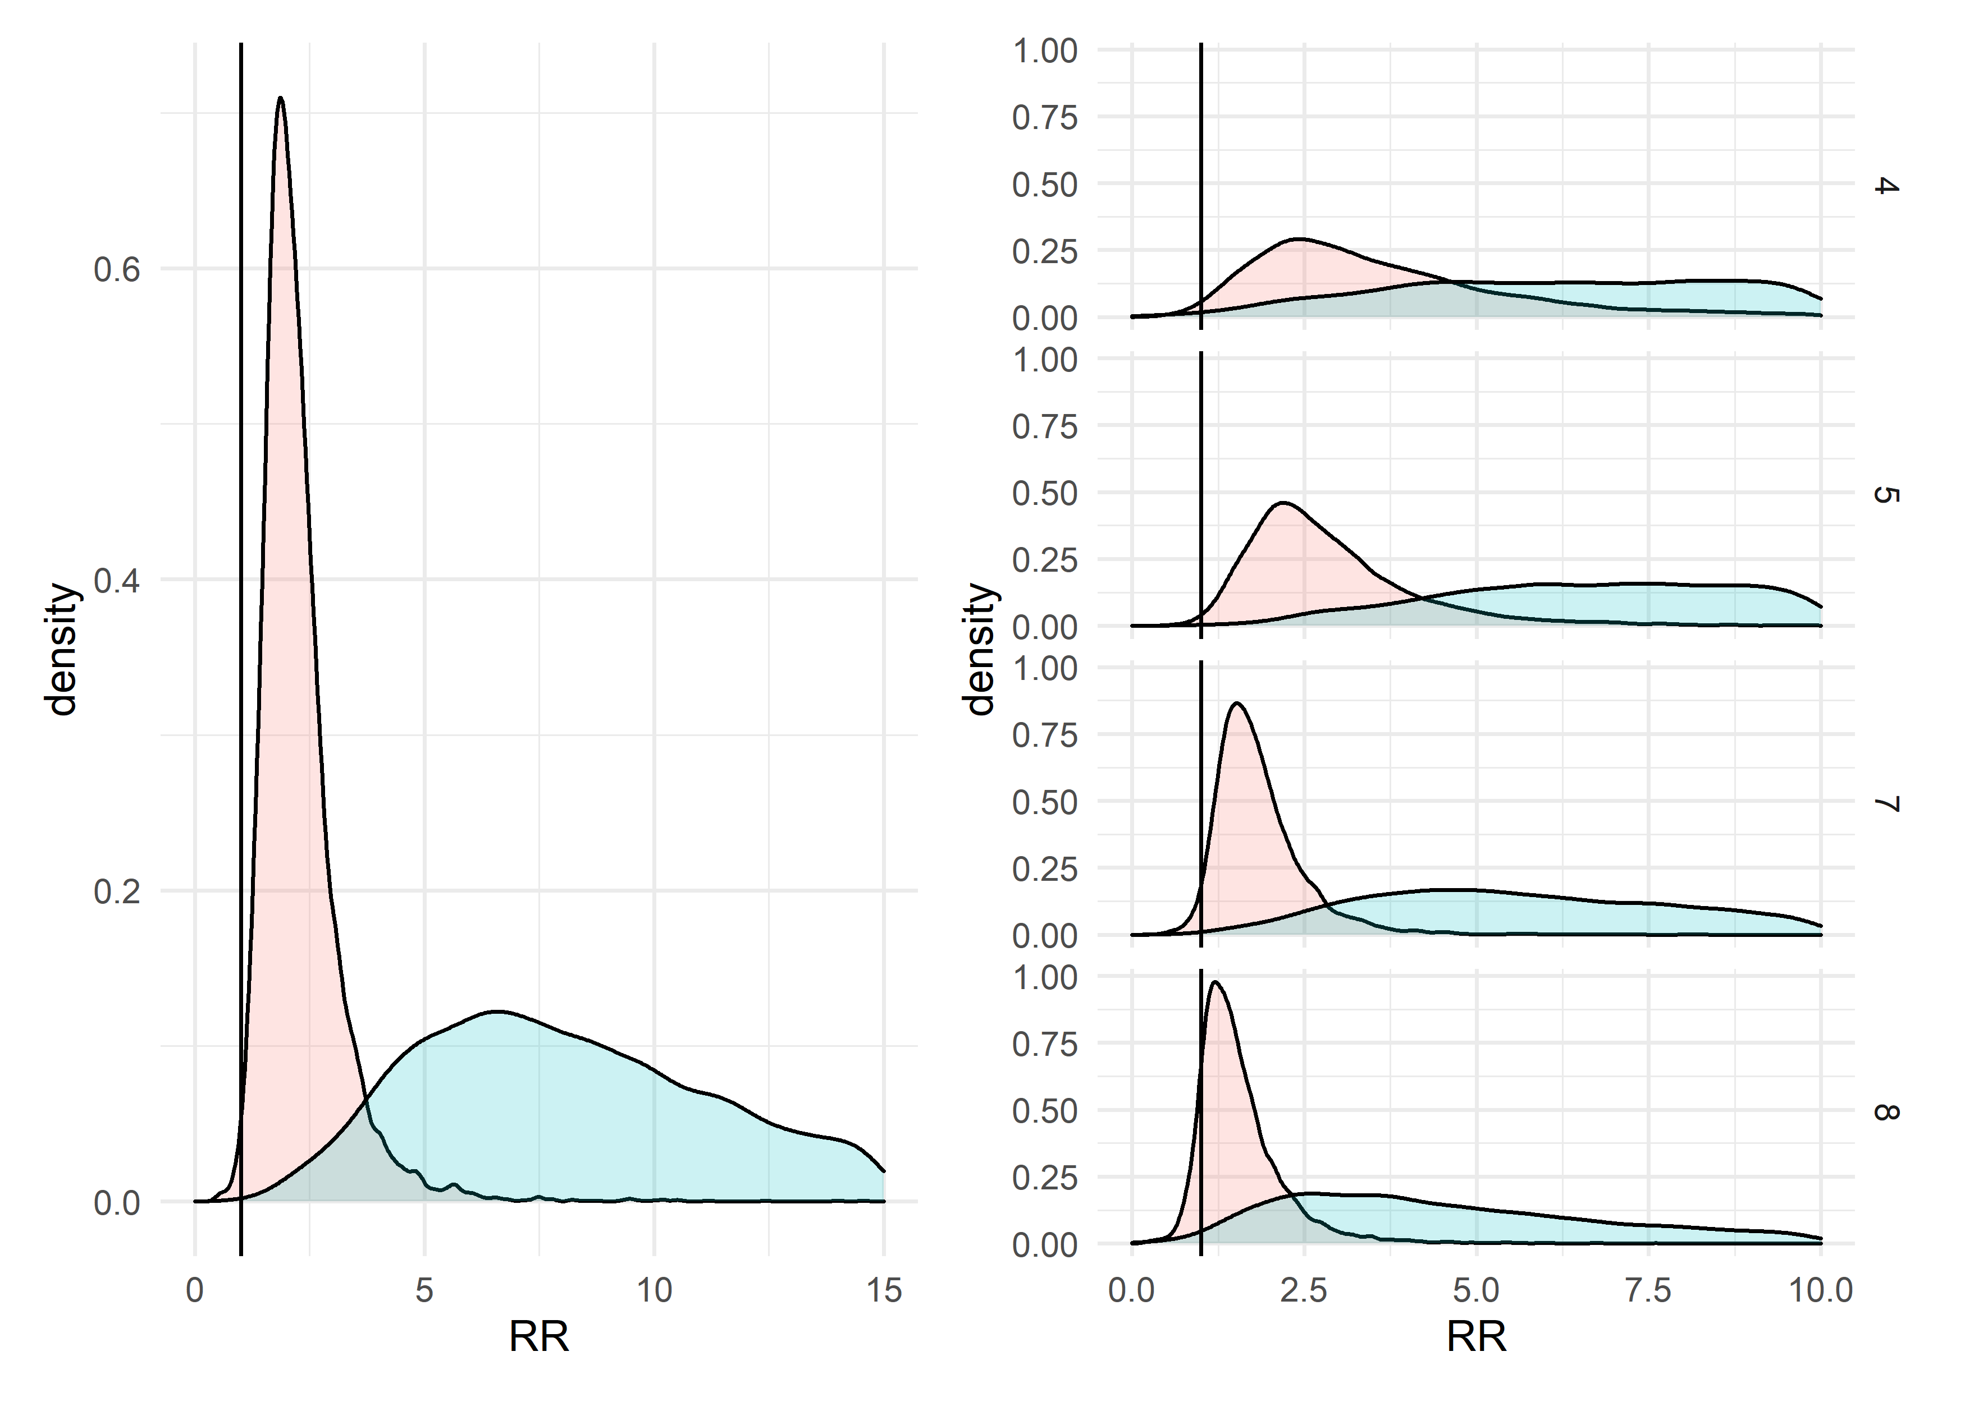
Figure 5. Posterior estimates of risk ratios for abstract priming effect (light red) and priming effect with lexical overlap (light blue) for only participants who produced at least one DOD. The pane on the left depicts risk ratios at 6 years of age, the sample mean age. The right pane depicts the risk ratios for all other age groups.

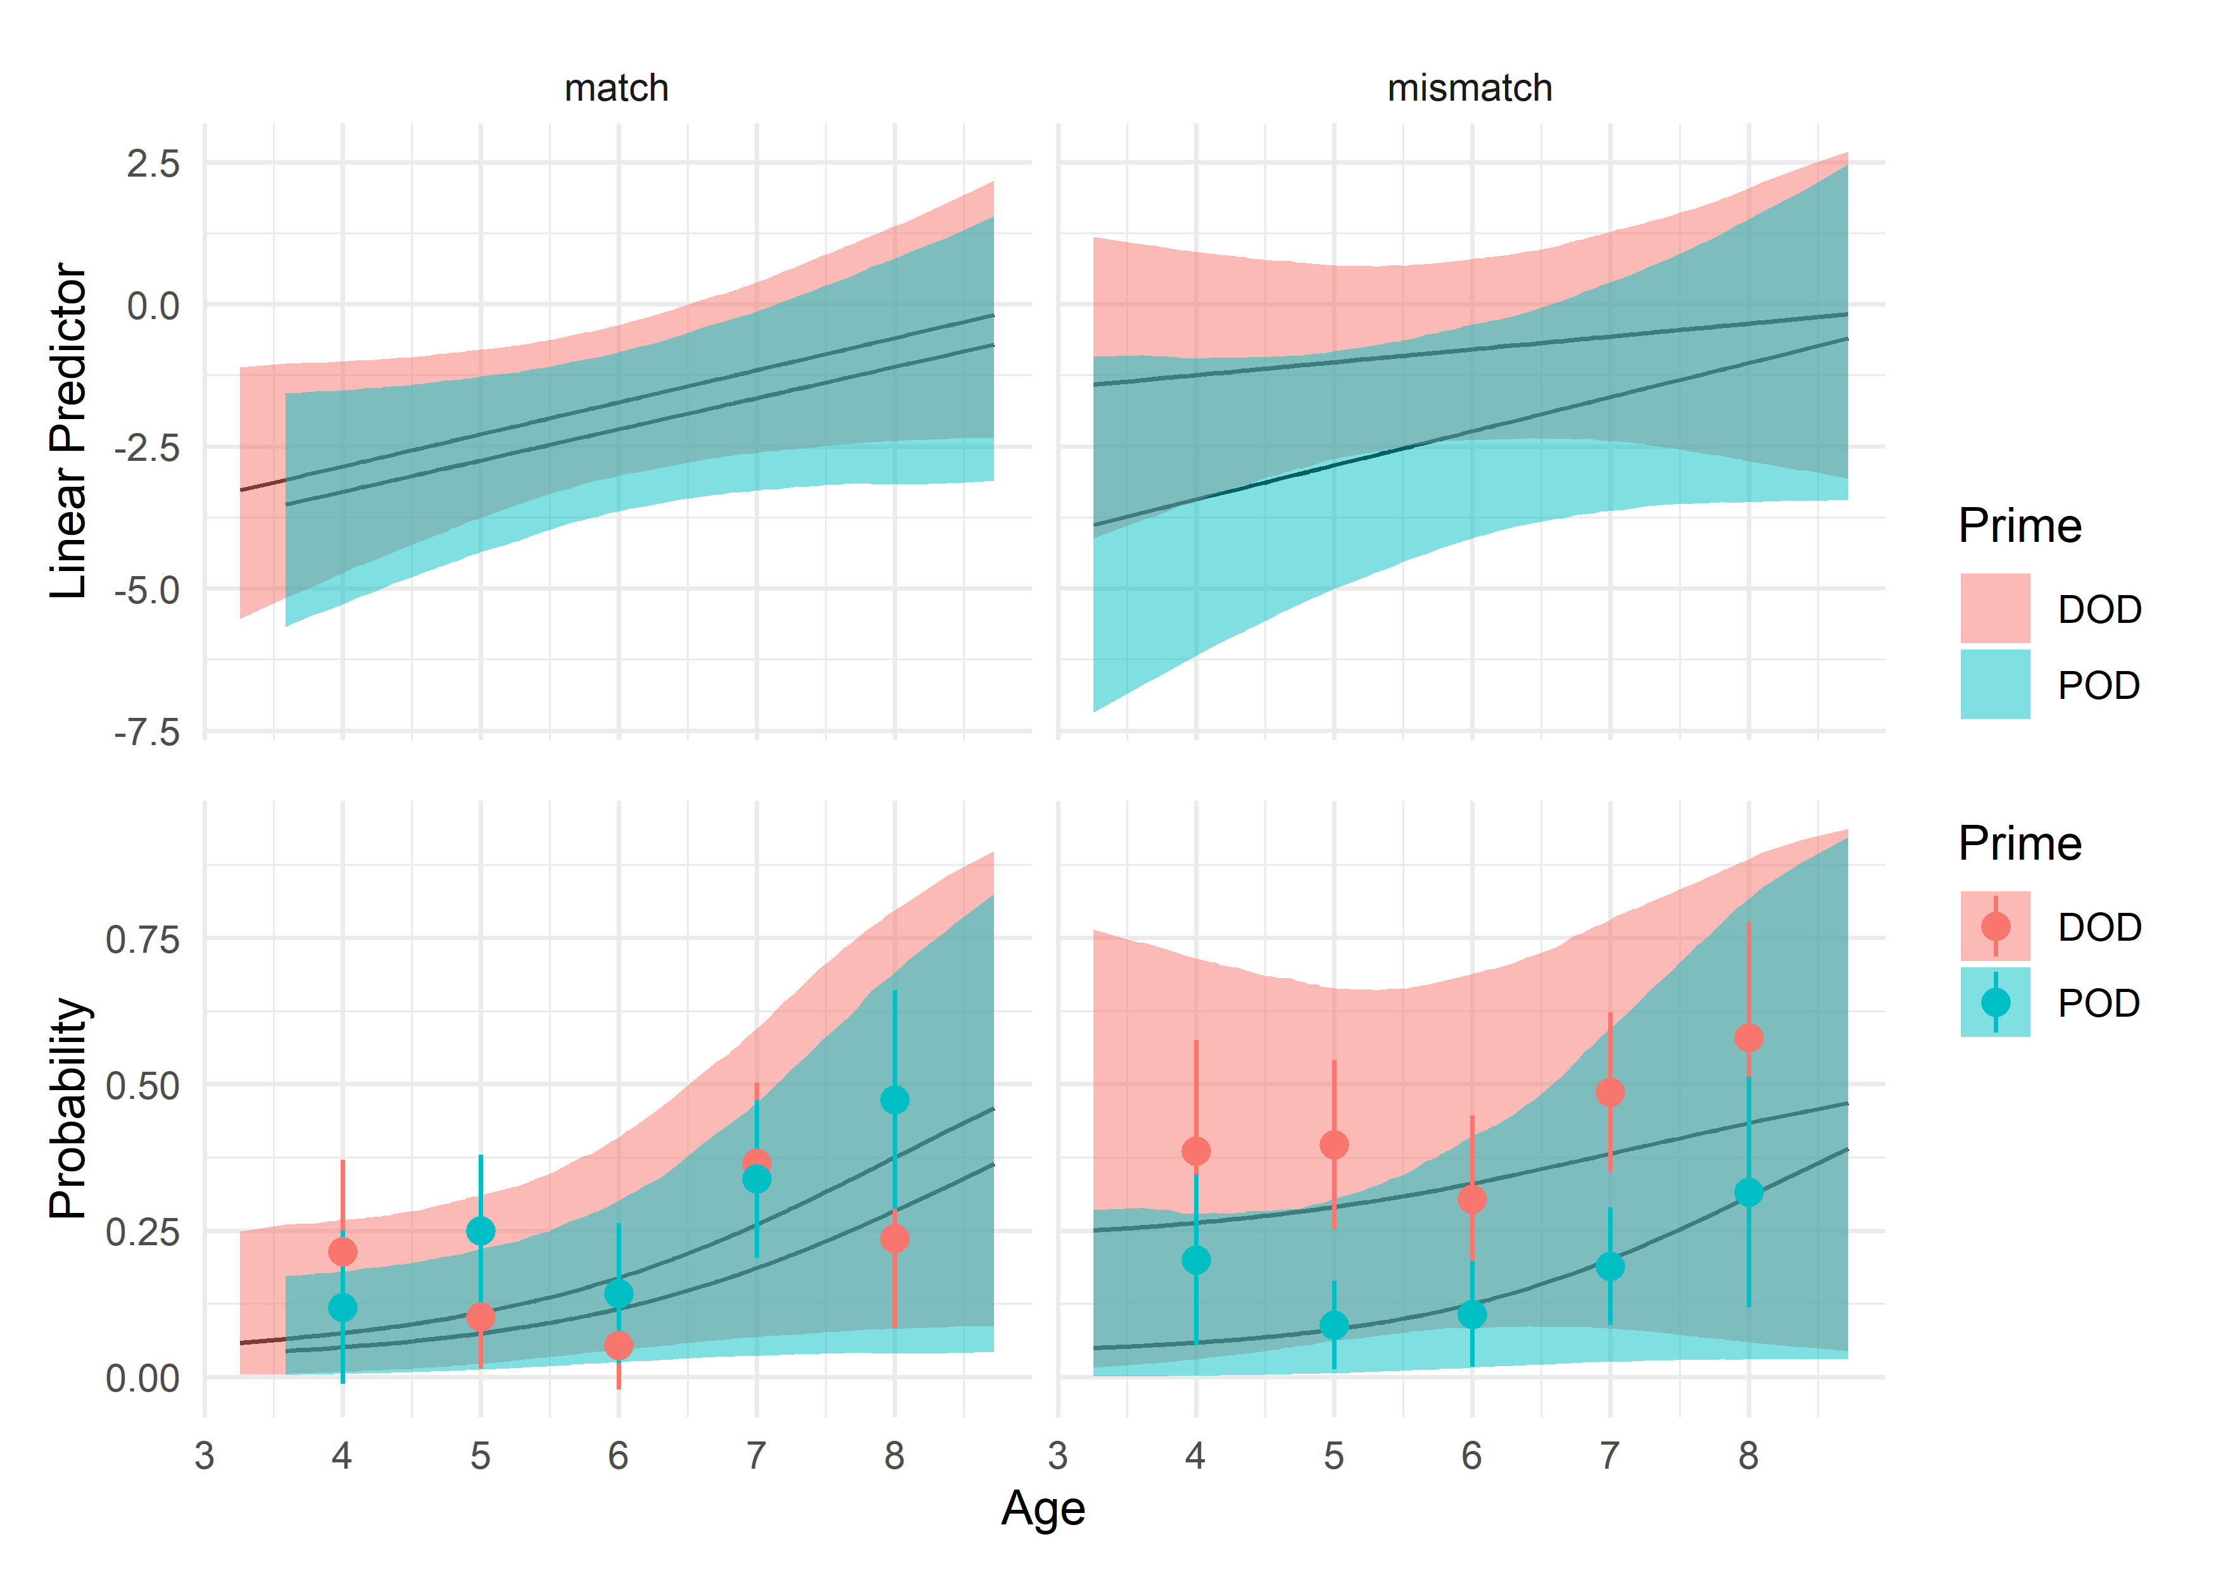
Figure 6. Model implied proportion of DOD responses for only children who produced at least one DOD response, on both logit and probability scale. Dots and whiskers on the probability scale are raw proportions (with 95% confidence intervals for each condition).

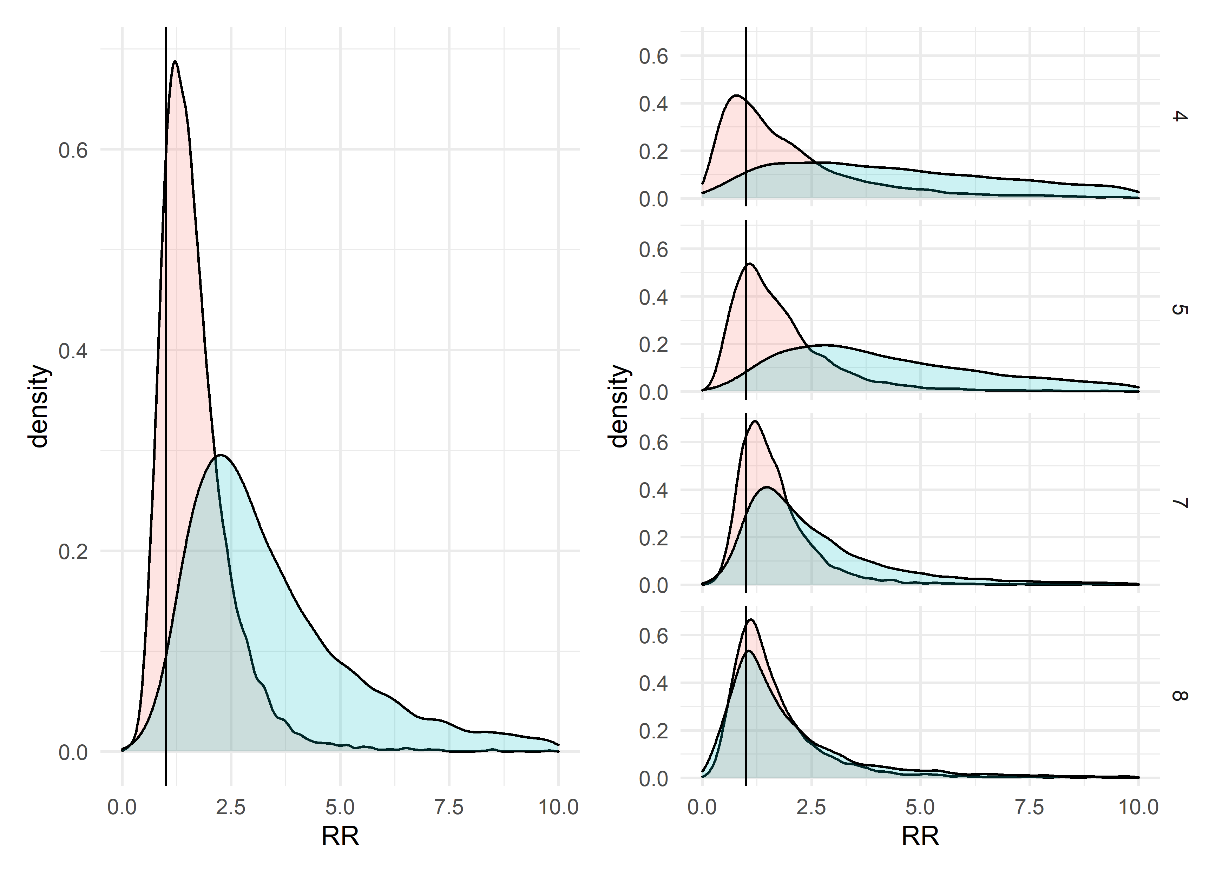

Figure 7. Posterior estimates of risk ratios for priming effect when the verb’s bias matched the prime structure (light red) and the priming effect when the verb’s bias mismatched the prime structure (light blue) for the whole sample. The pane on the left depicts risk ratios at 6 years of age, the sample mean age. The right pane depicts the risk ratios for all other age groups.

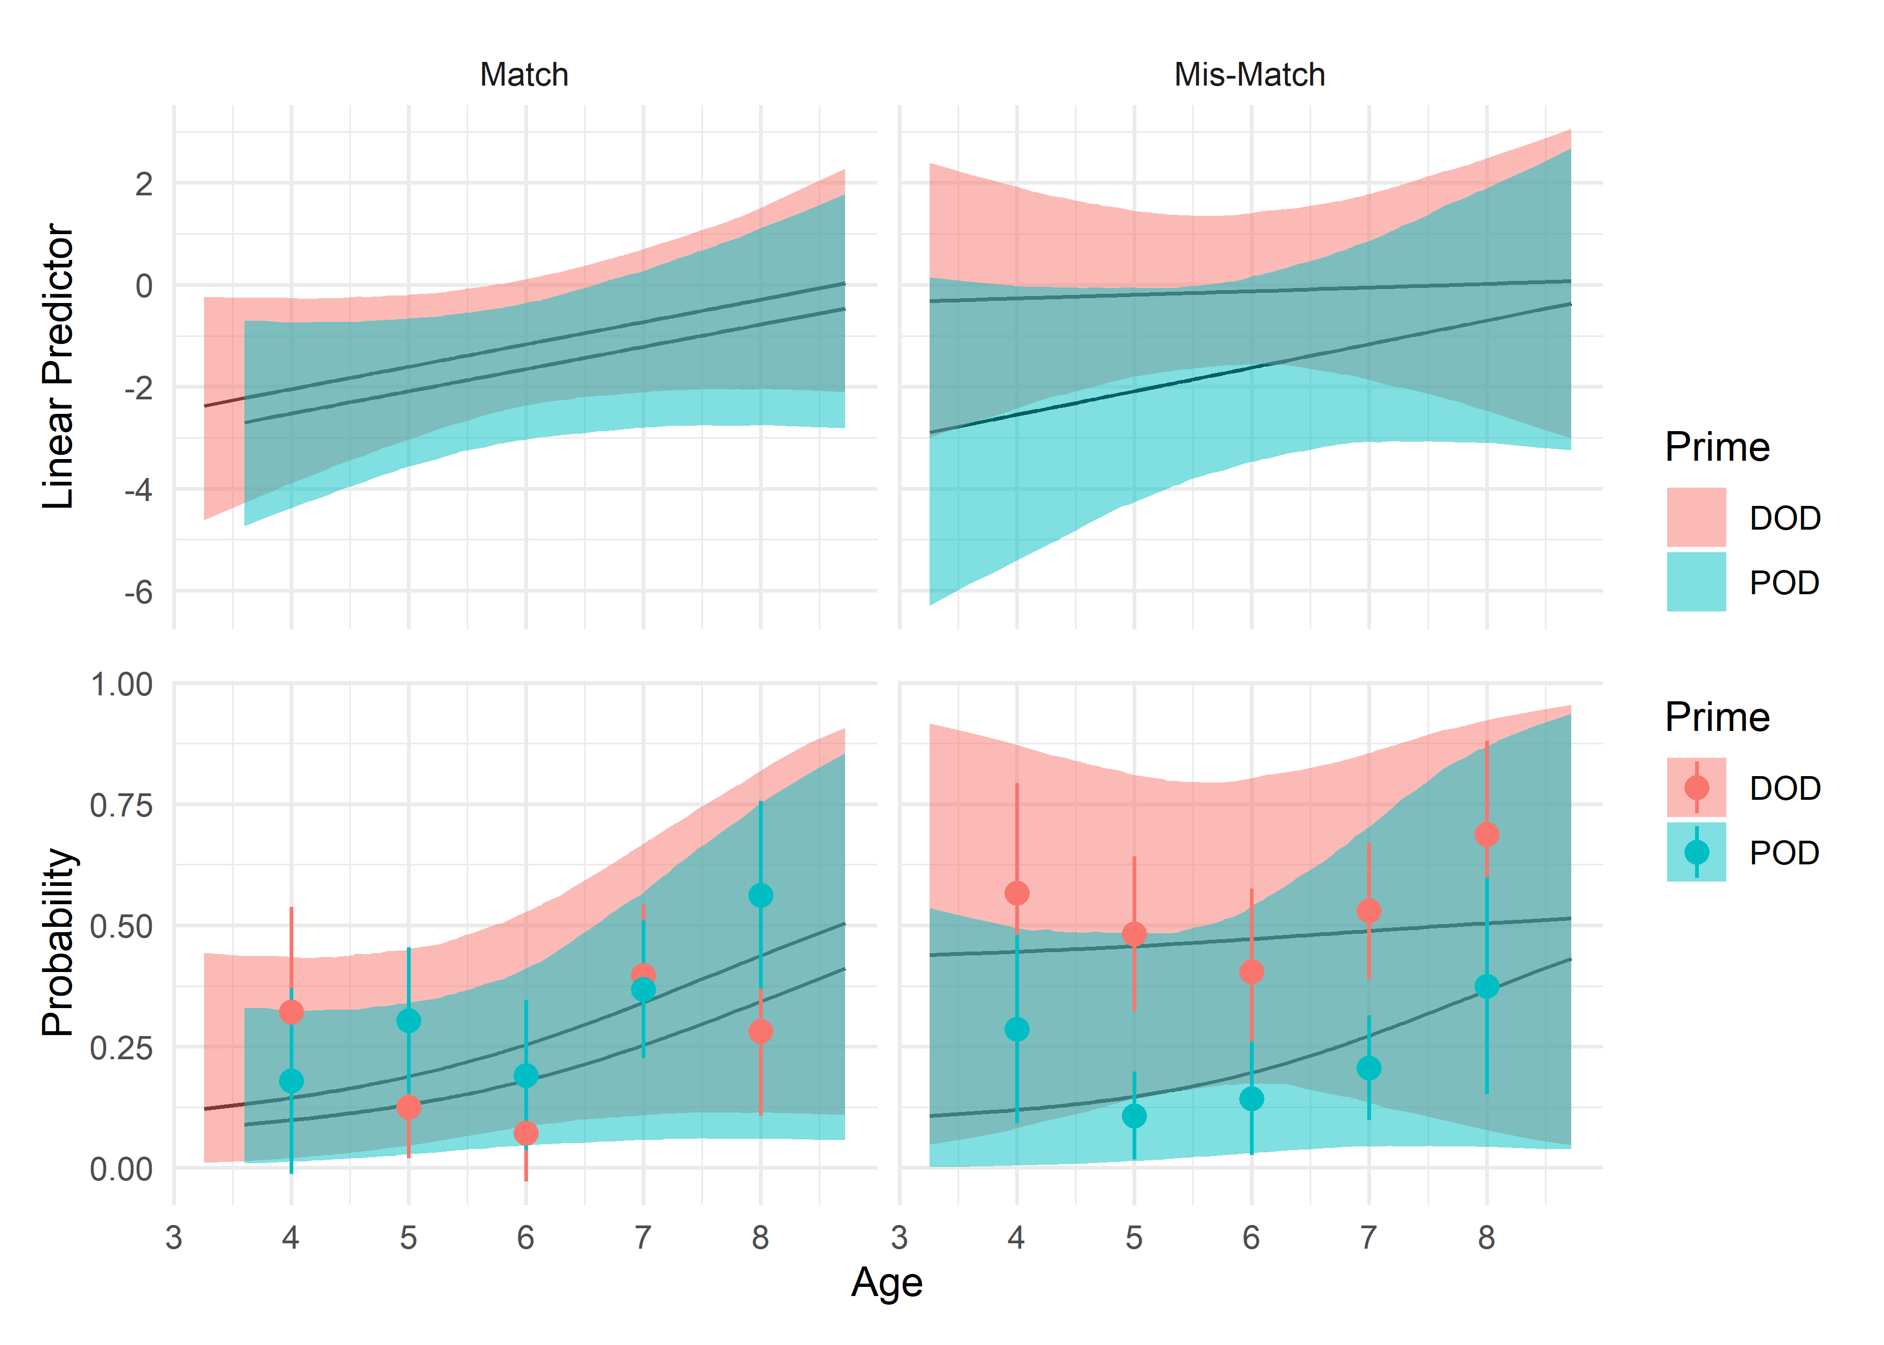

Figure 8. Model implied proportion of DOD responses for only children who produced at least one DOD response, on both logit and probability scale. Dots and whiskers on the probability scale are raw proportions (with 95% confidence intervals for each condition).

Figure 9. Posterior estimates of risk ratios for priming effect when the verb’s bias matched the prime structure (light red) and the priming effect when the verb’s bias mismatched the prime structure (light blue) for only children who produced at least 1 DOD. The pane on the left depicts risk ratios at 6 years of age, the sample mean age. The right pane depicts the risk ratios for all other age groups.

Gender was not reported for one child.
This was done because we included random effects by target verb in our analyses.
In other words, all verb overlap trials in which the participant produced the incorrect verb were removed and non-overlap trials in which the participant produced the same verb as the prime were removed.
Because participants saw each target verb twice, we considered a model with full random effects by participant, target verb and participant x target verb. However, when we compared a variance components model (a model with only intercepts and no predictors) with this structure to a variance components model with random factors by target verb and participant, the latter model fit better. We, therefore, opted for this simpler model. See Accompanying R Markdown file for full details.
The difference in width between these intervals is likely a consequence of the coding scheme for our categorical variables. Recall that we dummy coded verb overlap, so that our coefficient for prime structure would indicate the abstract priming effect without verb overlap. As a result, the predicted values for each abstract priming condition without verb overlap contained two sources of uncertainty (the intercept and the difference between conditions). However, predicted values for priming effects when verb overlap was present reflected four sources of uncertainty (the intercept, the abstract priming effect, the effect of verb overlap and the interaction between verb overlap and priming).

