**When is the chance of buyer voting with the wallet highest?**

Consider a welfare perspective on CSR market signaling -- ignoring for the moment the platform’s strategic CSR perspective. What matters is then, where is the expected signaling cost highest?

The event that makes platform $k$ choose a CSR strategy (${\hat{q}}_{t}>q_{kt}^{*}$) is equivalent to the number of observed votes with the wallet ($X_{t}$) being greater than one of the following values, depending upon buyer $i$’s strategy:

$$X_{t}>\left\{\begin{aligned} h_{kt}^{*}, if σ_{it}^{b}=A \\ h_{kt}^{*}-1, if σ_{it}^{b}=W\end{aligned}\right.$$

where $h_{kt}^{*}=\left\lceil q_{kt}^{*}×\left(N+α_{1t}+α_{2t}\right)-α_{1t}+1\right\rceil$ is *the minimum number of votes with the wallet the platform needs to observe to choose a CSR strategy* (rounded up to integer values in the support of $X_{t}$).

expected signaling cost threshold in Eq. (9):

$$\overline{κ_{kt}^{*}}=\ln\left(\frac{u_{k}+ω}{u_{k}}\right)⋅q⋅Binomial\left(h_{kt}^{*}; N,{ μ}_{kt}\right)$$

interpret $Δm_{kt}≡Binomial\left(h_{kt}^{*}; N,{ μ}_{kt}\right)$ as the probability of persuading the platform to choose CSR. This is then equivalent to *the probability that the platform observes* *exactly its minimum number of required votes with the wallet.*

Using Eq. (10) , $μ_{kt}=\left\{\begin{aligned} q, if κ< \overline{κ_{kt}^{*}} \\ 0 , if κ≥ \overline{κ_{kt}^{*}} \end{aligned}\right.$:

$$\overline{κ_{kt}^{*}}(κ)=\left\{\begin{aligned} \ln\left(\frac{u_{k}+ω}{u_{k}}\right)⋅\left({N \atop h_{kt}^{*}}\right)⋅ q^{h_{kt}^{*}+1}⋅{\left(1-q\right)}^{N-h_{kt}^{*}}, if κ< \overline{κ_{kt}^{*}} \\ 0, if κ≥ \overline{κ_{kt}^{*}}\end{aligned}\right.$$

Higher expected signaling cost and higher chance of voting with the wallet therefore depends upon the “alignment” between $q and q_{kt}^{*}$, as shown in the figures below. This is contingent on prior beliefs and market size (past evidence of voting or abstaining):

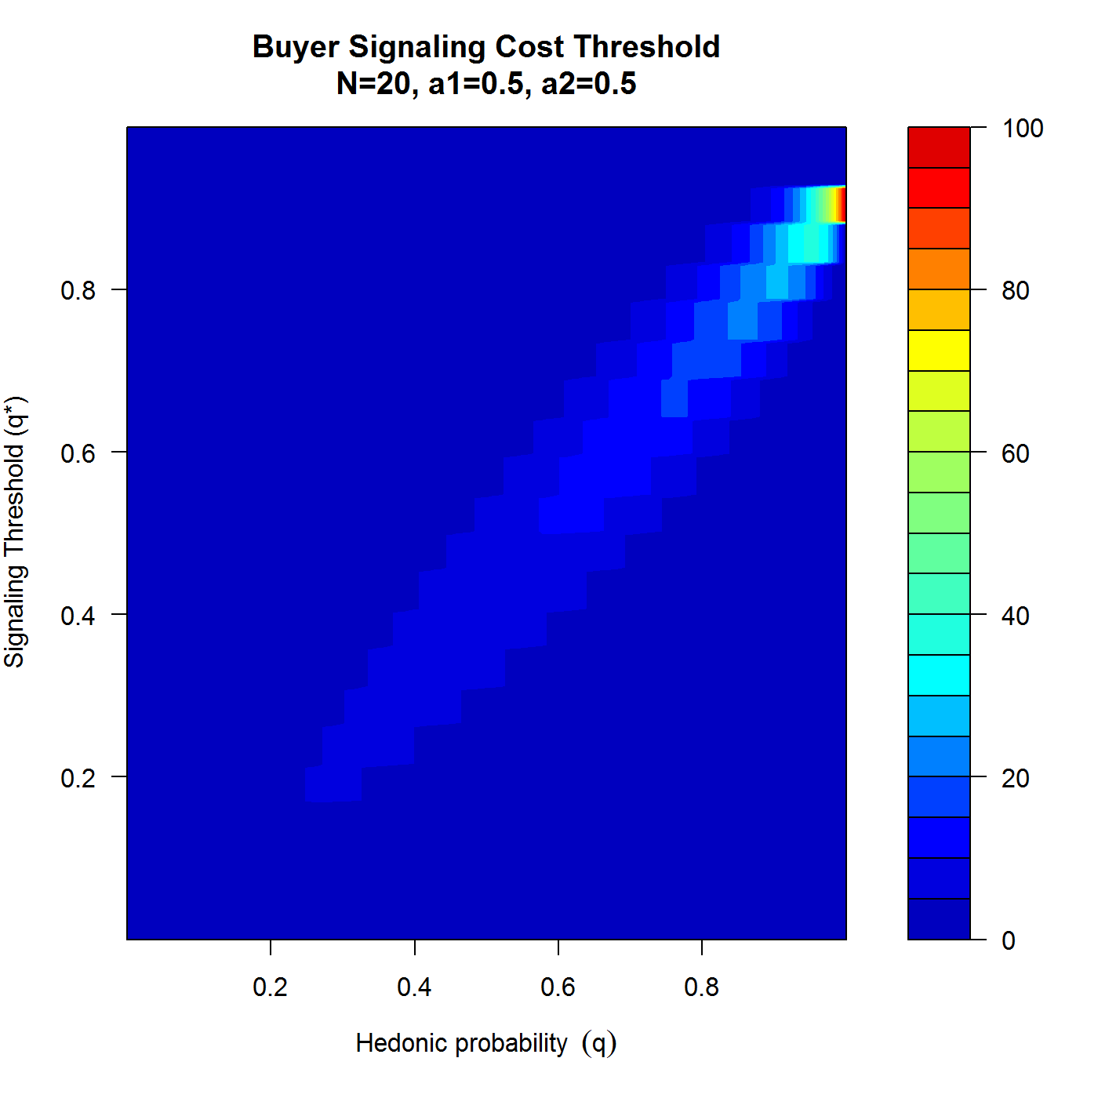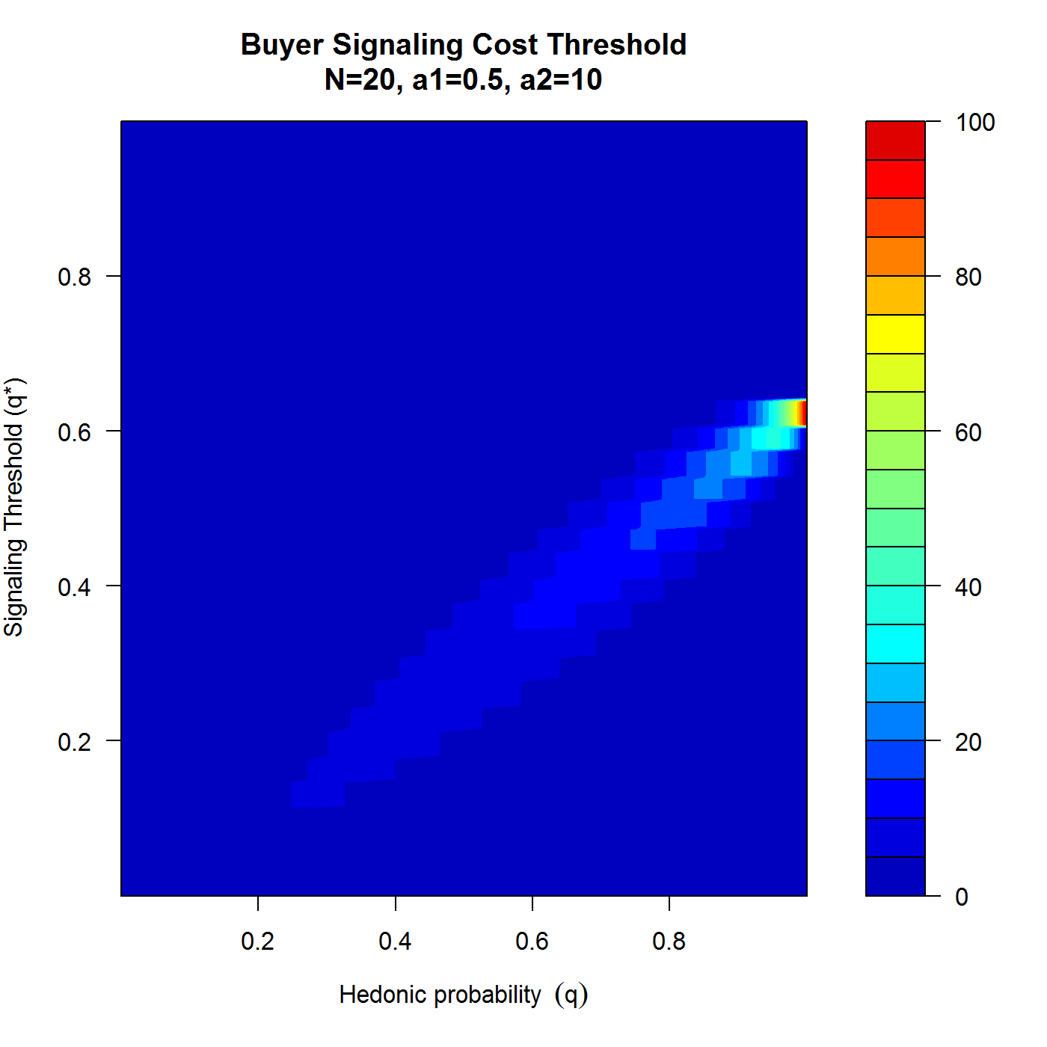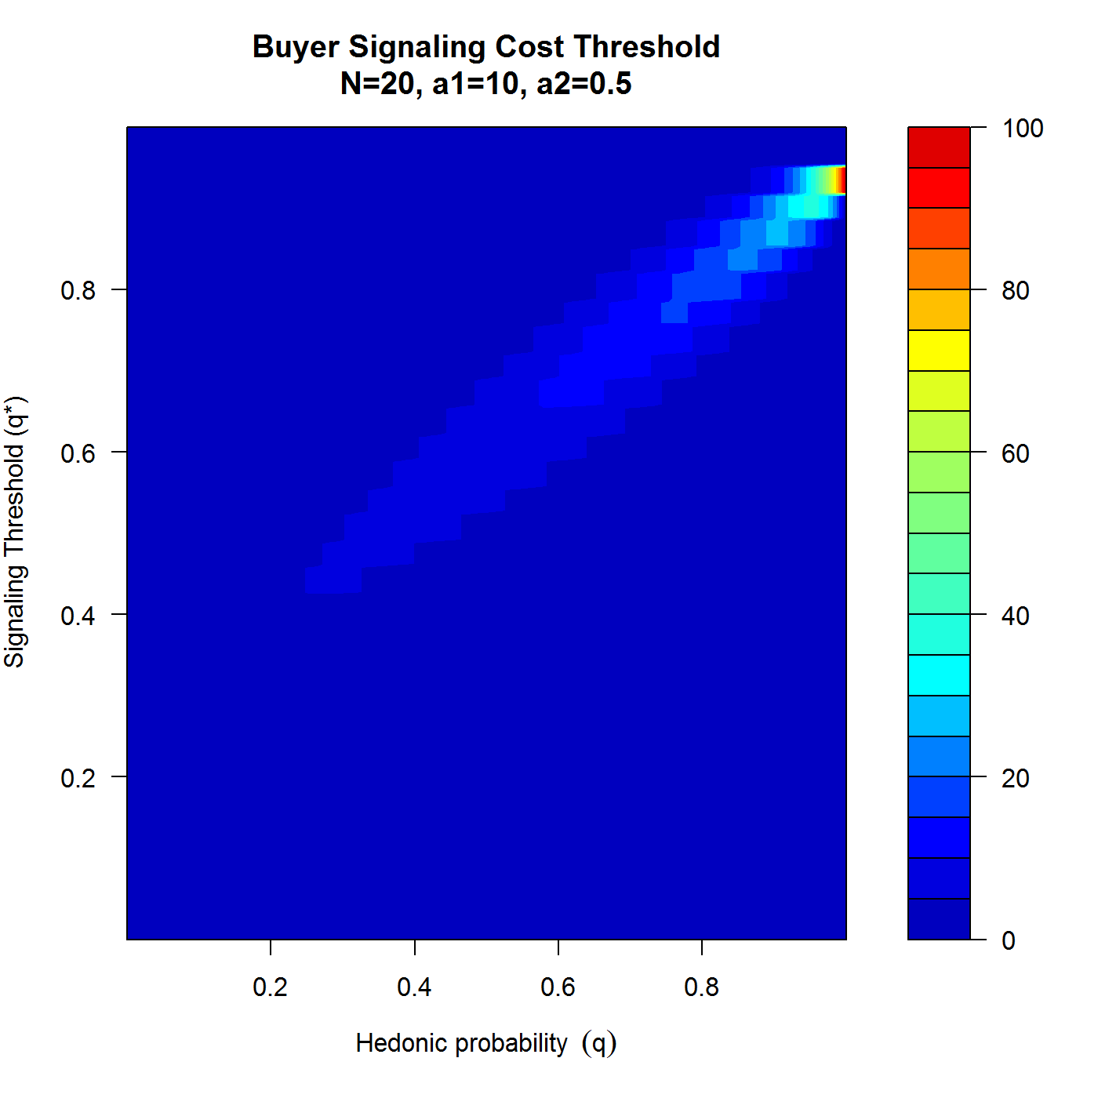

So, counterintuitively, higher *q* does *not* mean more voting with the wallet in the market -- and therefore does not mean more CSR occurring in the market.

What matters is how the hedonic probability ‘aligns’ with the platform’s threshold (based on their CSR cost and potential gains). This is irrespective of the Platform’s strategic choice to engage in CSR and is instead an observation of the equilibrium occurrence of CSR in the market, something like “CSR social welfare” analysis.