**WL-1飞机部分参数**

**机翼几何参数**

|  |  |
| --- | --- |
| 展长 | 12m |
| 机翼面积 | 12m2 |
| 展弦比 | 12 |
| 梢根比 | 0.45 |
| 1/4弦线后掠角 | 0° |
| 起飞质量 | 800kg |

**机翼气动特性数据表**

|  |  |  |  |  |
| --- | --- | --- | --- | --- |
| 增升构型 | alpha | cl | cd | cl/cd |
| 0 | 1.24716 | 0.04832 | 25.8107 |
| 2 | 1.492321 | 0.065685 | 22.71925 |
| 4 | 1.736429 | 0.085559 | 20.29506 |
| 6 | 1.978813 | 0.107743 | 18.36598 |
| 8 | 2.218503 | 0.131975 | 16.81008 |
| 10 | 2.454075 | 0.157893 | 15.54268 |
| 12 | 2.684383 | 0.185113 | 14.50132 |
| 14 | 2.33342 | 0.213375 | 10.93578 |
| 16 | 1.95744 | 0.242183 | 8.08249 |

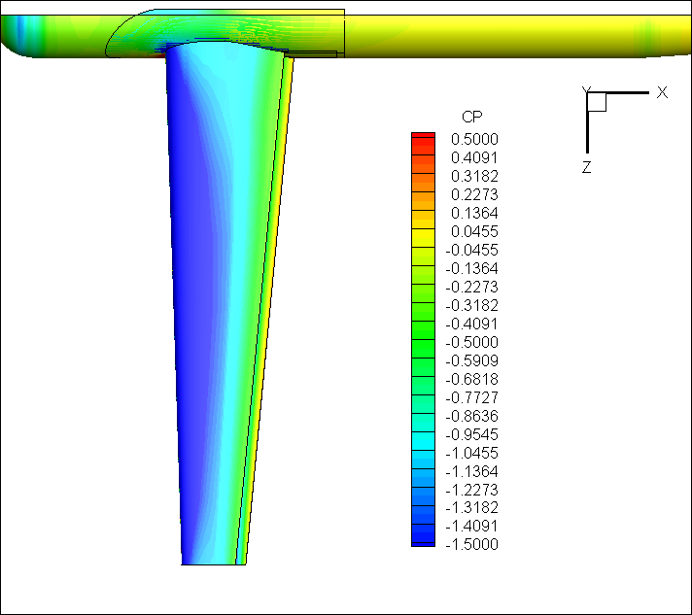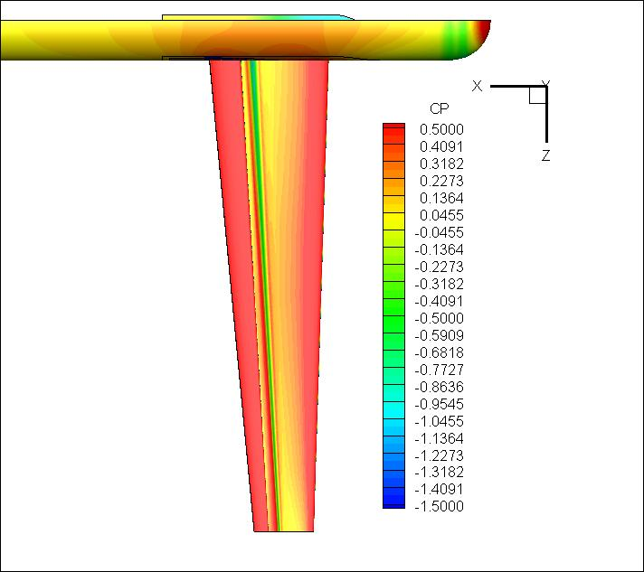

CL=2.125

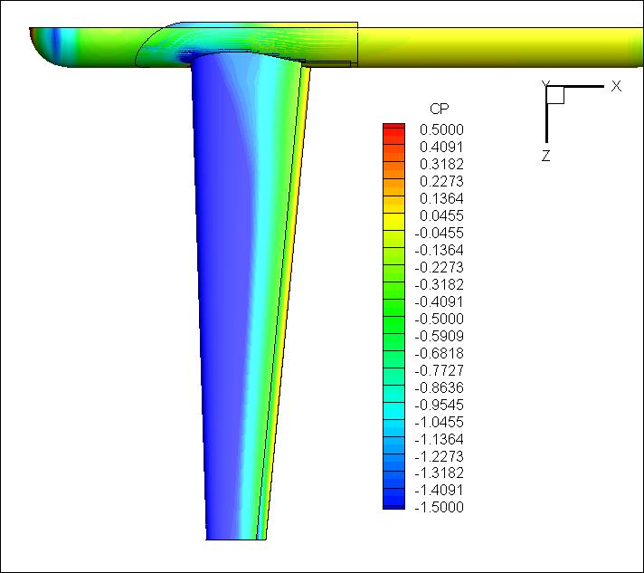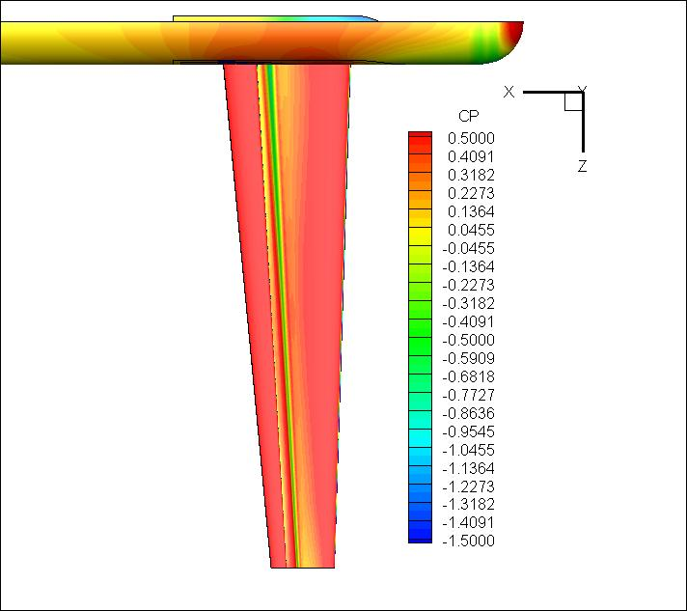

Alpha=12°

**全机干净外形的数据：**

干净构型气动焦点在距机头4.335位置，即焦点位置(4.335，0，0)

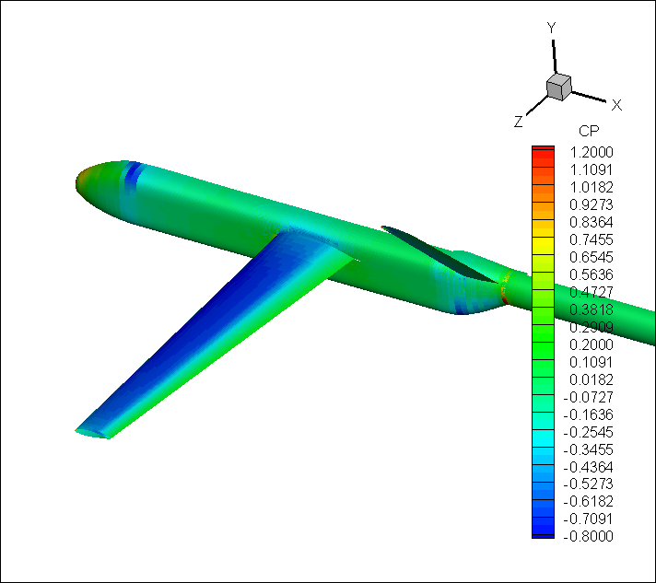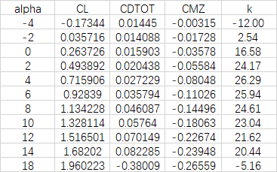

**带襟翼的数据（尾翼未配平）**

襟翼占翼展的60%

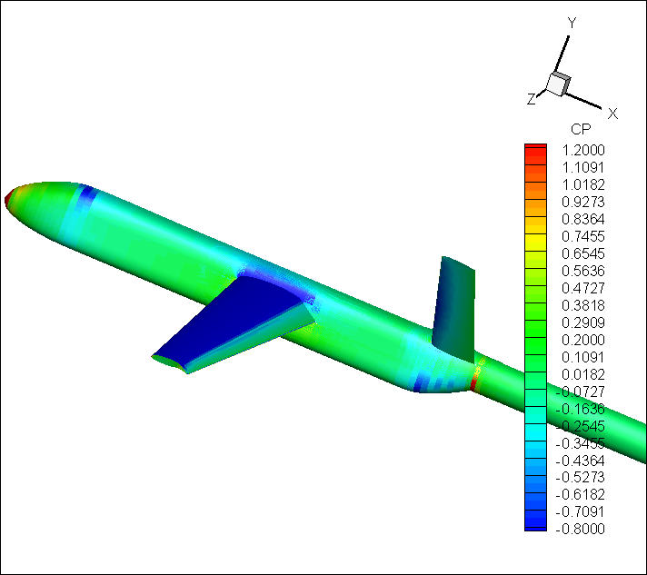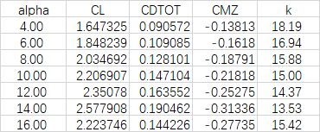

**惯性矩待建模估计**