Emotional information-processing correlates of mental health in adolescence: A network analysis approach

|  |
| --- |
| Sam Parsons1, Annabel Songco1, Charlotte Booth1, & Elaine Fox1 |
| 1 University of Oxford |
|  |
|  |

# Author note

Correspondence concerning this article should be addressed to Sam Parsons, Department of Experimental Psychology, University of Oxford, New Radcliffe House, Radcliffe Observatory Quarter, Oxford, OX2 6AE. E-mail: [sam.parsons@psy.ox.ac.uk](mailto:sam.parsons@psy.ox.ac.uk)

Abstract

The Combined Cognitive Bias Hypothesis proposes that emotional information processing biases associate with each other and may interact to conjointly influence mental health. Yet, little is known about the interrelationships amongst cognitive biases, particularly in adolescence. We used data from the CogBIAS longitudinal study (Booth et al. 2017), including 451 adolescents who completed measures of attention, interpretation, and memory bias, and a positive mental health scale. We used a moderated network modelling approach to examine positive mental health related moderation of the cognitive bias network. Mental health was directly connected to positive and negative memory biases, and positive interpretation biases, but not negative interpretation biases. Further, we observed some mental health related moderation of the network structure. There was a trend for a less connected network with increased mental health. Network approaches allow us to model complex relationships amongst cognitive biases and develop novel hypotheses for future research.

*Keywords:* Combined cognitive bias hypothesis, network analysis, adolescent, positive mental health

Word count:

Emotional information-processing correlates of mental health in adolescence: A network analysis approach

# Introduction

Automatic tendencies to selectively process negative, relative to benign or positive material and environmental events, have been associated with anxiety and depression (for reviews, see Cisler & Koster, 2010; Gotlib & Joormann, 2010; Mathews & MacLeod, 1994, 2005). These biases have been explored in attention, interpretation of ambiguity, as well as in memory. Typically, studies examining selective processing biases in relation to emotional vulnerability have tended to examine these processes in isolation, with few studies examining more than one bias in a single study (Everaert, Koster, & Derakshan, 2012; Hirsch, Clark, & Mathews, 2006). The combined cognitive bias hypothesis (CCBH: Hirsch et al., 2006), however, proposes that cognitive biases are unlikely to work in isolation to influence emotional vulnerability, but rather, they influence each other and interact to influence other variables, including emotional vulnerability. For example, increased attention towards negative stimuli would be expected to influence how negative information is interpreted, which would then influence memory for that stimulus. Such a series of causally related negative biases would be expected to propagate emotional vulnerability. In this way, a greater influence of one bias on another may further help to perpetrate a negative cycle of maladaptive cognitive processing related to emotional dysfunction.

The CCBH has been tested with tasks designed to capture the direct effect of one bias on another. For instance, one study (Everaert, Duyck, & Koster, 2014) used an eye-tracking modification of a scrambled sentences task (Wenzlaff & Bates, 1998). Gaze fixation time on negative words was used to index attention bias, the ratio of negative to total unscrambled sentences was used to index interpretation bias, and a free recall task was used to index memory bias. Two path models were tested, the first omitted relationships between each of the biases, and the second included paths between the biases. The second model better fit the data, supporting the hypothesis that attention bias influenced interpretation bias, which in turn influenced memory bias. A further study in adults investigated the functional relationships among cognitive biases in a subclinical depressed sample and found that while attentional bias was not directly associated with memory bias, there was an indirect association via interpretation bias (Everaert, Tierens, Uzieblo, & Koster, 2013). Thus, the results supported the CCBH, showing that cognitive biases across different domains do not act in isolation. A further study, conducted in adults, concluded that memory bias is likely to be more effectively modified by targeting emotional processing in another domain, such as interpretation bias (Hertel & Mathews, 2011; Vrijsen, Oostrom, Isaac, Becker, & Speckens, 2014).

To our knowledge only two studies have examined the combined cognitive bias hypothesis in adolescent samples (Klein, Voogd, Wiers, & Salemink, 2017; Orchard & Reynolds, 2018). Klein et al. (2017) used three cognitive bias measures; an emotional visual search task, a dot-probe task, and the interpretation recognition task for children to investigate attention and interpretation biases. The results indicate that each cognitive bias predicted unique variance in anxiety and depression, separately, supporting the CCBH proposition that cognitive biases in different domains contribute separately to emotional vulnerability. Similarly, a study by Orchard and Reynolds (2018) in adolescents showed that the combination of cognitive biases, interpretation bias and negative self-evaluation bias, predicted depression severity more strongly than individual biases alone. Both studies suggest that further exploration of adolescent mental health from a CCBH perspective is likely to be highly informative.

In addition, most relevant to the current study, the CCBH suggests we would expect to observe differences in relationships among biases between clinical and non-clinical groups. The implication is that the interrelationships and interactions among biases themselves may contribute to psychopathology. In one study, the factor structure of cognitive bias measures in attention, inhibition, imagery, and memory were found to differ between a formerly depressed, and a non-clinical sample (Vrijsen et al., 2014). Coherence between attention and memory bias was found in the non-clinical sample, but not in the formerly depressed sample. This suggests that relationships among cognitive biases may differ between vulnerable and less-vulnerable groups, in support of the CCBH. In the present study, we examine these interrelationships in a normative sample of adolescents using a standardized measure of mental health ranging from languishing to flourishing (Keyes, 2002, 2005).

## Psychological Network approaches

The CCBH has a striking overlap with a psychological network approach to emotional disorders. A network perspective on psychopathology views emotional disorders, such as anxiety and depression, as a system of interacting symptoms (Fried, 2017; Fried et al., 2017; Fried & Cramer, 2017). As such, rather than individual symptoms acting alone to influence a disorder, the interrelations among them also play a key role. Borsboom and colleagues have been the driving force behind initiating network analyses in clinical psychology (Borsboom, Cramer, Schmittmann, Epskamp, & Waldorp, 2011; Schmittmann et al., 2013), and this has resulted in the application of network analysis approaches to psychopathology (Bernstein, Heeren, & McNally, 2017; Borsboom & Cramer, 2013; Heeren & McNally, 2016; McNally et al., 2015). A common aim of network approaches is to identify plausible, and potentially causal, connections amongst individual symptoms of a disorder (e.g. McNally et al., 2015).

A network theory of mental disorders has been proposed (Borsboom, 2017), including several core principles particularly relevant to the CCBH. These principles are comparable to the, albeit less formal, core elements of the CCBH; namely that we would expect different biases to interact with one another to influence emotional vulnerability and that biases may reinforce one another reciprocally to influence emotional vulnerability. The similarities are such that theoretically applying the principles of the network approach may prove fruitful and provide a more formal and systematic approach to investigate the CCBH. We propose that cognitive biases directly and indirectly influence one another (Borsboom’s direct causal connections principle), and that these interactions among different biases are likely to influence emotional vulnerability as well as emotional wellbeing (Borsboom’s complexity principle).

Network analysis enables the quantification and visualisation of the multivariate dependencies that exist in the dataset. In a psychological network, nodes that represent observed psychological variables (e.g., psychometric tests or indices of cognitive bias) are connected by edges, which represent the observed statistical relationship between them, e.g. regularised partial correlations. The edge colour is a useful indication of the direction of the association; here positive associations are presented in blue and negative associations in red. The edge weight is used to indicate the strength of a relationship; stronger relationships are represented with thicker edges, whereas weaker relationships are denoted with thinner less saturated edges. In this paper, we use a moderated network analysis to investigate mental health related changes in the structure of cognitive bias networks.

Network analyses have been used previously to investigate laboratory measures of cognition and behaviour, going beyond self-report measures (Bernstein et al., 2017; Heeren & McNally, 2016). For instance, the interplay between social anxiety symptoms, attentional bias, and attentional control was investigated by Heeren and McNally (2016). Their analysis indicated that the orienting of attention was strongly linked to self-reported fear of social situations, which in turn was strongly related to avoidance of those situations. This has a potentially important clinical implication in that it suggests that interventions targeting attention orientation would positively influence other processes and propagate those benefits throughout the psychological network, resulting in therapeutic benefits (McNally et al., 2015). Similarly, Bernstein et al. (2017) investigated components of executive control and rumination. Their analysis suggested that self-criticism was central to the network with strong down-stream effects on negativity and brooding. Thus, reducing self-criticism may have a wide reaching beneficial effect on other components of rumination, and represents a potentially useful therapeutic target. Network analysis approaches provide an informative perspective on the interplay between cognitive processes and components of psychopathology and may help to inform the development of novel clinical interventions.

## Cognitive bias approaches to positive mental health and resilience

While information-processing approaches have been widely used to investigate the cognitive mechanisms of emotion dysfunction (for reviews, Gotlib & Joormann, 2010; Lau & Waters, 2017; Mathews & MacLeod, 2005; Yiend, 2010) relatively little research has examined the role of selective information-processing in positive mental health in adults (Carl, Soskin, Kerns, & Barlow, 2013; Parsons, Kruijt, & Fox, 2016) and even less in adolescents. Positive mental health and mental illness are considered to represent two distinct, albeit inversely correlated, continua (Keyes, 2002, 2005). Low mental health has been found to have additive adverse effects on an individual’s functioning in life, including academic impairment and suicidal ideation (Keyes et al., 2012), as well as all-cause mortality (Keyes & Simoes, 2012). An implication of the dual continua model is that positive mental health may be characterised by distinct patterns of selective processing styles or biases, just as the ‘symptoms’ of mental health and mental illness differ from each other. We therefore used Keyes’ Mental Health Continum (MHC; Keyes, 2009) scale which intends to index psychological, social, and cognitive wellbeing as positive mental health.

Some research has examined factors related to positive mental health within a cognitive-experimental framework, as with the CCBH, with the majority of this research being conducted in adults. In the current study we employed a psychological network analysis approach to investigate the CCBH for positive mental health in adolescents. We use data from Wave 1 of the CogBIAS longitudinal study (Booth, Songco, Parsons, Heathcote, & Fox, 2019; Booth et al., 2017), one of the few studies to collect data for multiple cognitive biases in an adolescent sample (for example, Klein et al., 2017; Orchard & Reynolds, 2018) across different time points. Note that these analyses were initially run before the longitudinal data were collected and only wave 1 data were fully available for analyses (wave 2 were yet to be processed and wave 3 were not yet collected). Additionally, recent developments in network approaches to panel data had not been developed at this time. Therefore we present analyses from wave 1 data here. We focused on interpretation and memory biases, to limit the scope to the processes previously implicated in the CCBH (Hirsch et al., 2006). We had intended to include attention bias, but due to poor statistical reliability we opted to omit attention bias from the network analyses, as described briefly in the methods section.

Our primary aim was to explore differences in the structure of cognitive bias networks between young adolescents who reported high and low levels of mental health. We therefore use a moderated network approach, which allowed us to examine the moderating effect of mental health on the relationships between other biases. To our knowledge, this is the first study to use network analyses to examine the role that connections in selective processing of emotional information plays in positive mental health in an adolescent sample.

# Methods

The data analysed and presented in this paper are drawn from the CogBIAS longitudinal study (Booth et al., 2019, 2017), which recruited 504 secondary school adolescents (*M* age = 12.9, *SD* = 0.9) in the UK. Adolescents completed a series of cognitive bias measures (including attention, interpretation, and memory) across three waves of testing. Data from wave 2 (mean age = 14.5, SD = 0.6) and wave 3 (mean age = 15.7, SD = 0.6) were not analysed in this study and will be reported elsewhere. This study is the only one known to the authors to incorporate a longitudinal design, with a range of cognitive biases measured at three time-points in an adolescent sample. The CogBIAS study presents an ideal opportunity to examine the CCBH as it applies to young adolescents, specifically with respect to the role these cognitive biases play in positive mental health. To this aim, we use data from wave 1 of the CogBIAS study.[1]

## Participants

We first excluded all participants without complete data in all of the measures described below (except the dot-probe, see below), from the original sample of 504 adolescents. This resulted in a final sample of 451 adolescents (*M* age = 12.89, *SD* = 0.87, 278 female). In addition, for the first stage of our analysis we selected two groups of participants for the network analyses based on scores on the Mental Health Continuum (MHC). For this, we performed a tertile split to yield low and high Mental Health groups (low-MH and high-MH, respectively). The low-MH group consisted of 145 participants, scoring under 37 on the MHC and the high-MH group consisted of 150 participants scoring above 47 on the MHC. Ethical approval for this study was given by the National Research Ethics Service (NREC; REC reference: 14/SC/0128; IRAS project ID: 141833).

## Measures

As we were interested in differences in network structure of cognitive biases in relation to high and low positive mental health, we analyse only a subset of the measures included in the CogBIAS study. The combined cognitive bias hypothesis typically describes the relationship between attention, interpretation, and memory biases. We therefore analysed data only from tasks targeting these cognitive processes. We present a brief description of these measures below, however, a complete description of the sample, methods, and design used in the study can be found in the protocol paper (Booth et al., 2017).

### Mental health

. The Mental Health Continuum – Short form (MHC-SF; Keyes, 2009) contains 14 items that index emotional, psychological, and social wellbeing, in order to create a composite measure of positive mental health. Participants are asked to rate how often they have experienced each of the items in the past month, on a 6-point Likert scale from “never” to “every day”. The MHC-SF has shown high internal consistency and discriminant validity (Keyes, 2009; Lamers, Westerhof, Bohlmeijer, Klooster, & Keyes, 2011); in the current sample reliability was high (MacDonald’s Omega $ω$ = 0.95, Cronbach’s alpha $α$ = 0.94, 95% CI [0.93, 0.95]). As our focus was on the network of cognitive biases, and because we examined moderation of the network structure by mental health, we used the total score of the MHC in the networks, rather than the individual items.

### Attention Bias

. An emotional face (angry, happy, and pain) dot-probe task was used to index attention bias (MacLeod, Mathews, & Tata, 1986) with stimuli from the STOIC faces database (Roy et al., 2009). As with other papers using data from the CogBIAS study, we have opted to omit the attention bias data from our analyses. The internal consistency reliability of the attention bias indices (n = 448 following removal of three participants for < 70% accuracy) was estimated using the R package *splithalf* (Parsons, 2019) and was below any acceptable threshold, in this sample; angry = 0.02 , 95% CI [-0.14, 0.18]; happy = 0.17 , 95% CI [0.02, 0.31]; pain = -0.07 , 95% CI [-0.22, 0.09]. These outcome measures are unsuitable for any analyses based on correlational measures and were omitted from any further analyses. For full details about the task, see Booth et al. (2019, 2017).

### Interpretation bias

. The Adolescent Interpretation and Belief Questionnaire (AIBQ; Miers, Blöte, Bögels, & Westenberg, 2008) contains ten hypothetical scenarios, five of which are socially oriented and five are non-socially oriented, that are intended to reflect events that are likely to be experienced by adolescents. Participants read the scenario and are presented with a question that addresses a point of ambiguity in the scenario. A positive, a neutral, and a negative interpretation of the scenario are presented and participants rate how likely that interpretation would pop into their mind on a 5-point Likert scale. Participants then choose which interpretation of the scenario they believe to be the most correct. Scenarios are presented in a pseudo-random order. Bias scores were computed by calculating the mean likelihood ratings for positive and negative interpretations of social and non-social situations separately, resulting in four bias indices – social positive; non-social positive; social negative; non-social negative. The reliabilities of each of the bias indices were as follows; social positive ( $ω$ = 0.63; $α$ = 0.55, 95% CI [0.49, 0.60]); Social Negative ( $ω$ = 0.81; $α$ = 0.79, 95% CI [0.76, 0.81]); Non-Social Positive ( $ω$ = 0.49; $α$ = 0.43, 95% CI [0.36, 0.51]); Non-Social Negative ( $ω$ = 0.64; $α$ = 0.58, 95% CI [0.53, 0.63]).

### Memory bias

. In the Self-Referential encoding task (SRET), participants were presented with 22 positive and 22 negative words in a random order (the word lists were drawn from Hammen & Zupan, 1984). Each word was presented for 200ms before a prompt “Describes me?” was presented on screen, after which participants responded ‘yes’ or ‘no’ using the ‘Y’ and ‘N’ keys on the computer keyboard. After all words had been presented, a short distraction task was administered consisting of three simple mathematics questions. Finally, in the incidental recall phase, participants were given three minutes to recall and type in as many words as they could remember. Positive and negative memory bias indices were calculated as the number of positive and negative words, respectively, that were endorsed (participants responded that the word described them) and subsequently recalled (Asarnow, Thompson, Joormann, & Gotlib, 2014). Internal consistency reliability estimates were obtained using the R package *splithalf* (Parsons, 2019): Negative = 0.62 , 95% CI [0.57, 0.68]; and Positive = 0.45 , 95% CI [0.38, 0.51]

## Procedure

Participants were tested in groups ranging between 13 and 50 students in computer labs either in their own school, or at the University of Oxford. Testing consisted of two, one-hour sessions which were either back-to-back or on different days, depending on school and testing space availability. In each session, participants completed three tasks, in the same order, followed by a battery of questionnaires (see Booth et al., 2017, for further information on measures not analysed in this paper). Participants were asked to complete both sessions in exam conditions, i.e. not talking or looking their peers’ computer screens. At least two researchers were present throughout the testing sessions to answer any questions and ensure adequate testing conditions were maintained.

## Data analysis

First, we report a preliminary analysis in which we compared the network structure of interpretation and memory biases for a high-MH and a low-MH group, following a tertile split of the data by mental health. We computed a ‘graphical LASSO’ (gLASSO; Epskamp et al., 2017; also Friedman, Hastie, & Tibshirani, 2008) estimation procedure with EBIC model selection (Foygel & Drton, 2010). The glasso algorithm is implemented in the *glasso* package (Friedman, Hastie, & Tibshirani, 2014), and is called by the *bootnet* package (Epskamp et al., 2017), which we used for this paper. The glasso algorithm estimates a partial correlation network by directly penalising elements of the variance-covariance matrix and removing edges close to zero. We set the tuning parameter gamma to 0.5 to generate a sparser network, due to the removal of potentially spurious associations. We then used the NCT function from the *NetworkComparisonTest* package (van Borkulo et al., 2016) to compare our high mental health and low mental health networks. The function tests for differences in the overall connectivity (as the sum of all edge weights in the network, or global strength) between networks.

For the core analysis, we conducted a moderated network analysis (Haslbeck et al., 2018) using the *mgm* package, treating Mental Health as a moderating variable in the network. This allows us to use the entire sample and to treat mental health as a continuous variable, rather than dichotomising our sample. Moreover, moderated networks examine moderation of individual edges, providing a nuanced perspective on any moderating effects of mental health. This improves on the network comparison test, which only provides information about the difference in global connectivity between the networks. For instance, Haslbeck et al. (2018) demonstrated that a moderated network approach outperforms split-sample methods like network comparison test and fused graphical lasso models. We also obtained predictability indices for each node in the network. We then resampled the estimated network 500 times to obtain confidence intervals around the estimated network structure and moderation effects, thus providing vital information on the stability of the networks. The resampling procedure also allowed us to extract the proportion of non-zero edges and moderating effects. Finally, we computed and visualised three networks conditioned on mental health to illustrate changes in network structure at different levels of mental health.

We have included both analyses in this paper for two reasons. First, we were made aware of moderated network analyses during the revisions of this paper. Therefore, we include this original analysis to present the development of this research. Secondly, the analyses converge on similar conclusions and we felt it would be sensible to present both.

# Results

Supplimentary table 1 presents the descriptive statistics and correlation matrix for all variables included in the network analysis. Supplimentary table 2 presents the descriptive statistics for the high and low groups. Correlation and covariance matrices for the full sample (S3-4), and for the low and high MH subsamples (S5-8) are in the supplemental materials.

### Comparing networks of cognitive biases in a low mental health group to a high mental health group

First we estimated a graphical LASSO network (tuning parameter gamma was set to .5 to generate a sparser network) for the high and low mental health groups separately. Figure 1 presents a visualisation of both networks. In the low mental health network, each node is connected to two or more other nodes; negative and positive biases are negatively associated; and, the strongest edges connect memory biases with social interpretation biases. In contrast, the high mental health network is substantially less interconnected compared to the low mental health network with only three retained edges compared to eleven. In the high mental health network, no negative relationships were retained between the positive and negative cognitive biases. Additionally, the edges retained in both networks appear weaker in the high mental health group. To formally compare the global strength of each network (the sum of edge strengths in the network) we used the NCT function from the *NetworkComparisonTest* package (van Borkulo et al., 2016). We ran 1000 iterations resampling from the networks. The low-MH network (global strength = 1.70) was more strongly connected overall than the high-MH network (global strength = 0.37), and this difference was statistically significant, *p* = .016.

It is possible that low connectivity in the high-MH group could be caused by low variance. We ran Brown-Forsythe tests for equality of variances for each bias to compare the high and low group. For all variables, the high-MH group had significantly less variance (all *p* values < .05). While significant, the differences are small. For example, positive interpretation bias for social scenarios had variances of 0.38 and 0.33 for the low-MH and high-MH groups, respectively. It is unlikely that a lack of variance entirely explains the low connectivity in the high-MH group.

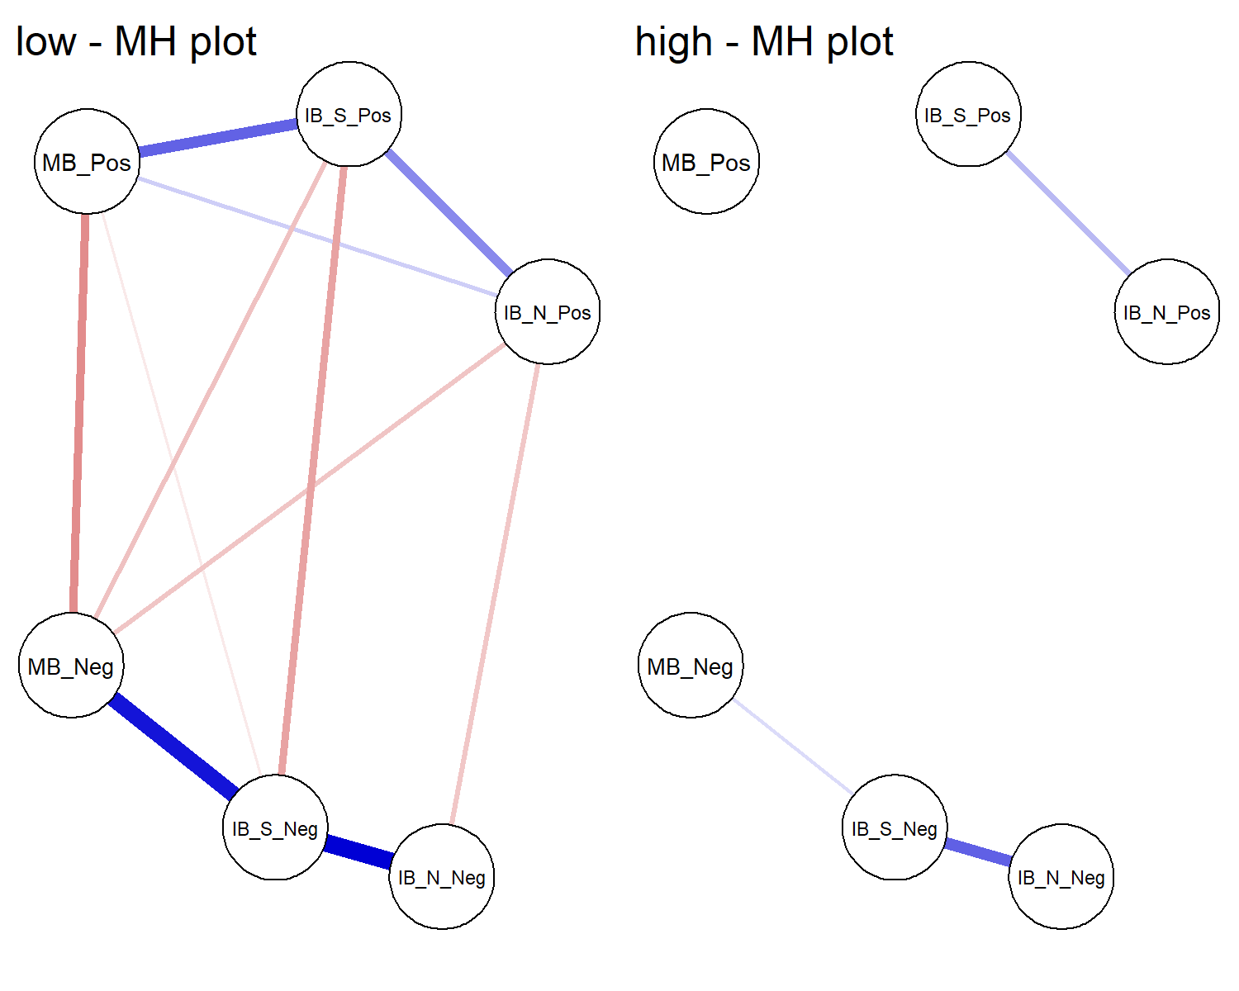

(#fig:unnamed-chunk-1)Graphical LASSO Networks. The left and right panels present the graphical LASSO network from the low mental health group and the high mental health group, respectively. Each node represents a cognitive bias measure and each edge represents the (partial) correlation between the nodes it connects, after controlling for all other variables in the network. Thicker edges represent stronger associations. Blue edges indicate positive relationships, whereas red edges indicate negative relationships. Note. IB_S_Pos = Social Positive Interpretation Bias; IB_S_Neg = Social Negative Interpretation Bias; IB_N_Pos = Non-Social Negative Interpretation Bias; IB_N_Neg = Non-Social; MB_Pos = positive memory bias; MB_Neg = negative memory bias.

### Moderated network analysis

As described in the data analysis section, there are some limitations to the previous analysis. Splitting the sample and comparing the global strength provides some, but limited, information about the moderating effect of mental health on the interrelationships among cognitive biases. Additionally, to address the question of moderation fully we analysed the full data set using a moderated network analysis approach (Haslbeck et al., 2018). We used the *mgm* package (Haslbeck et al., 2018) to estimate the moderated network with positive mental health as the moderating variable. We used cross-validation to select the regularization parameter. Weak edges are shrunk to zero leading to a matrix of regularised coefficients representing conditional dependence relations. For the nodewise regressions k edge weights are obtained for each k-order interaction (e.g. 2 for pairwise interactions and 3 for the moderated effects). We used the OR-rule to combine these weights, which takes the mean of all k parameter estimates, as the default option and because the AND-rule may be too conservative for the 3-way interactions of interest (Haslbeck et al., 2018). We then extracted predictability indices for each variable following Haslbeck & Waldorp (2018). Predictability refers to the proportion of variance explained by all other nodes in the network.

The resulting network of pairwise interactions is visualised in Figure 2 (for ease of interpretation we present the moderation effects separately in Figure 3). Mental health was connected most strongly to memory biases – i.e., a negative association with negative memory and positive association with positive memory. For interpretation biases, only edges connecting mental health to positive interpretation biases (social and non-social) were retained. Edges connecting mental health to negative interpretation biases were not retained. Non-social interpretation biases were not directly connected to memory biases (both positive and negative), but were connected via social interpretation biases. The explained variance (predictability metric) of mental health was 33.40%; the predictability of the cognitive biases ranged from 21.60% (positive memory bias) to 39.20% (negative social interpretation bias).

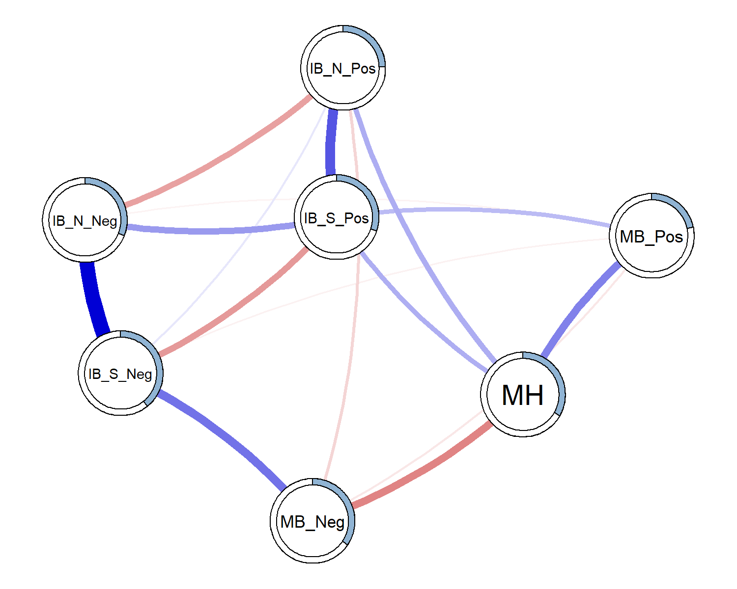

(#fig:unnamed-chunk-3)Estimated moderated network of positive mental health, and interpretation and memory cognitive biases. Blue edges represent positive associations, red edges represent negative associations; the width of the edge indicates the strength of this relationship. The shaded area of the pie surrounding each node represents the predictability of that variable, i.e., the variance explained by all other variables in the network. Note that this figure does not visualise the degree of moderation in the networks. Note: MH = Positive mental health; IB_S_Pos = Social Positive Interpretation Bias; IB_S_Neg = Social Negative Interpretation Bias; IB_N_Pos = Non-Social Negative Interpretation Bias; IB_N_Neg = Non-Social; MB_Pos = positive memory bias; MB_Neg = negative memory bias

We ran 1000 iterations of a spinglass procedure (Reichardt & Bornholdt, 2006) using the R package *igraph* (Csardi & Nepusz, 2006) to examine communalities within the network. In 94.20% iterations two groups were formed, separating the positive and negative biases. In these, mental health was grouped with the positive variables in 99.89% of cases.

To obtain information about the stability of the moderated network we resampled the moderated network 500 times. This allowed us to obtain confidence intervals surrounding each individual edge weight. It further allowed us to examine the strength of moderation for each edge and compute confidence intervals around the moderation estimate and the proportion of moderated edges. Figure 3 presents the mean weight and Confidence Intervals for individual edges. Additionally, Figure 3 presents the degree of moderation due to mental health on each edge as a result. The moderating effect of mental health on most edges follows a similar pattern to the original analysis. Most edges were moderated towards zero with increased positive mental health. Thus, overall we would expect a sparser network at higher mental health, compared to low mental health. The main exception to this trend was the edge connecting social positive and non-social positive interpretation biases. This was the only (likely non-zero) edge to be moderated to be stronger with increases in mental health.

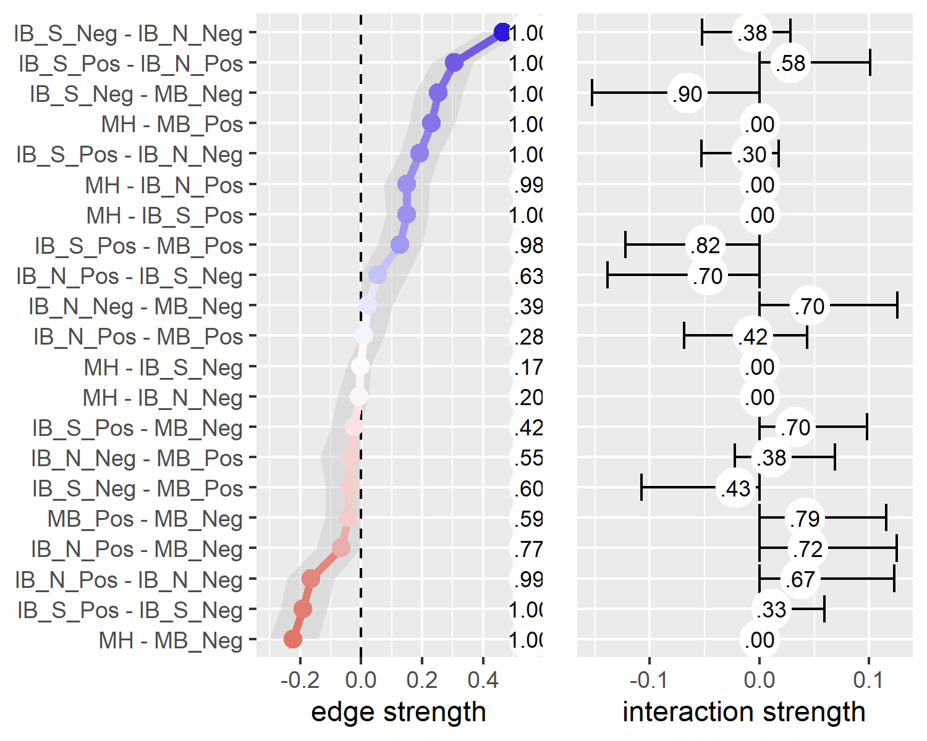

Figure 3: Edge strength and degree of moderation by mental health. The left panel presents the estimated edge weights (these correspond to the network visualization in figure 2) from 5000 resamples of the mgm network estimation procedure. The shaded area represents the 95% CI around the estimate. Numbers running down the centre of the figure represent the proportion of non-zero estimates for each edge. The right panel presents the estimated moderating effect of mental health on each edge; the ticks represent the 95% CI around the estimate. The circled numbers represent the number of non-zero moderation effects arising across the resamples. Note: MH = Positive mental health. From the Adolescent Interpretation and Belief Questionnaire (AIBQ): IB_S_Pos = Positive interpretation bias in social scenarios; IB_S_Neg = Negative interpretation bias in social scenarios; IB_N_Pos = Negative interpretation bias in non-social scenarios; IB_N_Neg = Negative interpretation bias in non-social scenarios. From the self-referential encoding task (endorsed and recalled items): MB_Pos = positive memory bias; MB_Neg = negative memory bias.

## Conditioning the network on Mental Health

To highlight the influence of mental health as the moderator of the networks, Figure 4 presents three networks comparing values of mental health. We used the condition() function from the *mgm* package (Haslbeck & Waldorp, 2016) to condition the estimated moderated network (Figure 2) on the mental health moderator. We conditioned the network to -1 standard deviation from the mean, the mean, and +1 standard deviation from the mean on positive mental health (the left, centre, and right panels in Figure 4, respectively).

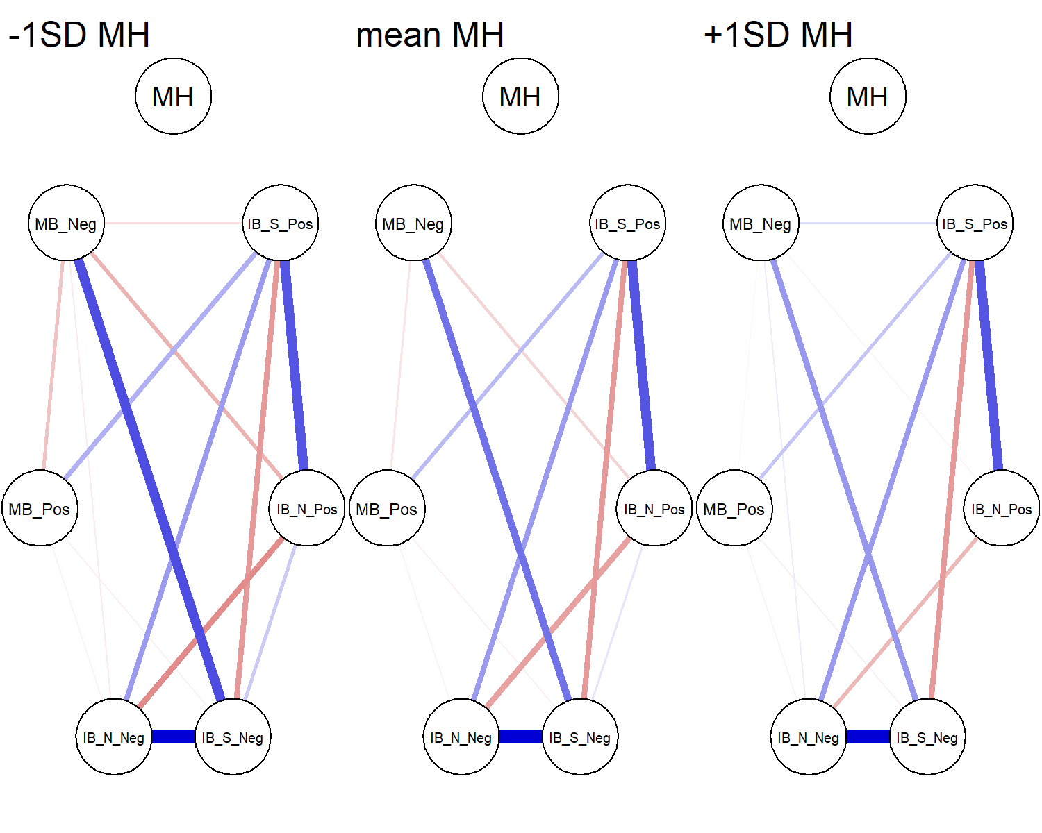

(#fig:unnamed-chunk-5)Networks of cognitive biases conditioned on mental health. Mental health is specified at -1SD (left) and +1SD (right) from the mean, and at the mean MH (centre). Conditioning sets mental health to the specified value, and therefore the edges connecting mental health are set to zero (as there is no variance in mental health). Note: MH = Positive mental health. From the Adolescent Interpretation and Belief Questionnaire (AIBQ): IB_S_Pos = Positive interpretation bias in social scenarios; IB_S_Neg = Negative interpretation bias in social scenarios; IB_N_Pos = Negative interpretation bias in non-social scenarios; IB_N_Neg = Negative interpretation bias in non-social scenarios. From the self-referential encoding task (endorsed and recalled items): MB_Pos = positive memory bias; MB_Neg = negative memory bias.

# Discussion

The present study investigated the Combined Cognitive Bias Hypothesis (CCBH; Hirsch et al., 2006; Everaert et al., 2012) in adolescents using a network approach. We analysed baseline data (at age 12-14 years) from the CogBIAS longitudinal study (Booth et al., 2019, 2017), including interpretation bias and memory bias measures. We excluded attention bias indices from the analyses due to low reliability (we discuss this in the limitations below). First, we split the sample into high and low mental health subsets. We estimated networks of biases for each group and compared the global strength of each network. The low mental health network showed greater connectivity than the high mental health group. We expanded on this analysis with a moderated network approach treating mental health as a moderating variable in the network of cognitive biases. The results suggest some, albeit small, moderation effects. The edge connecting negative social interpretation bias and negative memory bias was the most moderated edge, both in strength of moderation and in the proportion of resamples that included a non-zero moderation effect estimate. Mental health moderated each edge in 30.20% or more of the resamples (see Figure 3). The edge connecting negative social interpretation bias and negative memory bias, and the edge connecting positive social interpretation bias and positive memory bias, showed the strongest evidence of moderation with more than 80% of resamples having a moderation effect (Figure 3). Qualitatively, there was a trend for higher mental health to moderate edges towards zero, and therefore, a more weakly connected network.

## Implications for the Combined Cognitive Bias Hypothesis

The CCBH includes questions of association, causality, and predictive magnitude, concerning how multiple cognitive biases may contribute to mental health (Everaert et al., 2014). We discuss our results in light of each CCBH question.

Our analyses address the CCBH association question in the broadest sense by showing interconnectedness amongst interpretation and memory biases. Memory biases were most strongly connected to mental health. There were no direct edges connecting mental health and negative interpretation biases, although mental health directly connected to positive interpretation biases. Further, our moderation network model suggests that mental health was related to the network structure itself, in addition to individual biases. Our initial analysis suggested moderation of the network; our low mental health network was significantly more strongly connected than the high mental health network (Figure 1). We improved on this with a moderated network model. The moderated network indicates some moderation of the network structure by mental health; for example, the edge connecting social negative interpretation bias and negative memory bias was weaker at higher levels of mental health (Figure 3). This supports the CCBH hypothesis that the interrelationships amongst cognitive biases may influence mental health, in addition to any direct relationships between cognitive biases and mental health.

To address CCBH causality questions, we need experimental tasks that integrate multiple cognitive bias processes (e.g. Everaert et al., 2014), or extensive longitudinal research designs. We cannot make inferences from our networks on the causal relations between biases, nor causal relations between the network structure of biases and mental health. Yet, network analyses are extremely useful for hypothesis generation. One way we can propose causal hypotheses is to examine edges that were not retained in the network. For instance, mental health was not directly connected to negative interpretation biases, when controlling for all other variables in the network. This suggests that negative interpretation biases influence mental health via other biases in the network, e.g. negative memory bias. This follows from the CCBH and suggests a causal chain from negative interpretation bias for social scenarios, via negative memory bias, to influence mental health. Others have argued that it is difficult to modify memory bias directly, and training interpretation bias, with the intent to modify memory biases, may be more effective (Vrijsen et al., 2013). Related to this, our network does not include edges connecting non-social interpretation biases and memory biases. A reasonable hypothesis would be that targeting social interpretation bias in adolescents would be more effective at modifying memory bias, than training non-social interpretation bias. We could further hypothesise that modifying interpretation bias would influence mental health via shifting memory bias. Future work might seek to test these hypotheses directly with an experimental paradigm, or with extensive longitudinal data.

Network approaches also enable us to address the combined cognitive bias hypothesis, albeit via a different lens to traditional approaches. These questions are concerned with whether cognitive biases have additive and/or interactive effects on mental health. For example, previous research has found that combined cognitive biases were more predictive of adolescent depression severity than individual biases alone (Orchard & Reynolds, 2018). Network theory, applied to mental disorders, proposes that highly connected networks are more vulnerable to psychopathology (Borsboom, 2017; also see Kalisch et al., 2019). Strongly interconnected, causally related symptoms may reinforce one another to propagate a disorder. The network approach conceives of mental health problems as networks of connected symptoms that causally influence each other in a highly dynamic way, as opposed to the traditional view that mental health problems can be classified as distinct clusters of symptoms that are likely to have a single underlying cause. This is a paradigm shift that we have applied to the CCBH, allowing us to move beyond examining only additive and interactive effects of cognitive biases on mental health. Specifically, our moderated network model suggests that greater connectivity amongst biases relates to lower mental health. As we have explored in this paper, network approaches allow us to examine the role of interconnectedness amongst cognitive biases (or symptoms) and relate that structure to mental health.

## Limitations

We note several limitations of this study. Larger samples are needed to increase the stability of the moderation effects. Although some edges showed a relatively consistent pattern of moderation by mental health, no edge uniformly showed this moderation across resamples. Moderation effects are typically small (e.g. Haslbeck et al., 2018), which may explain the lack of stability of some moderation effects. We have endeavoured to interpret the moderation effects with some caution.

We were unable to include attention bias indices in our models. The internal consistencies were so low that we would be unable to make inferences using these measures. We were therefore unable to examine the CCBH as is it usually formulated; including attention, interpretation, and memory bias indices. Although we were unaware of psychometric issues with the dot-probe at the start of this study, it is becoming clear that the task is likely unsuitable for individual differences research [for a summary, see (Parsons et al., 2019). In relation to this, our interpretation bias indices did not show optimal reliability. It is possible that this is partly due to the small number of items (5 per bias) that were presented in this task. Similarly, we do not know how reliable the memory bias task is (though the test-retest is good, which is promising, see Booth et al., 2019). Moving forward, an important challenge for researchers in this field is to invest more time and resources into developing valid and reliable tasks to assess emotion-related cognitive biases. Otherwise, low reliability will render many CCBH questions unanswerable.

Another important issue is that our network is likely missing important mental health variables. The explained variance of mental health was only 33%. Thus, up to 67% of the variance would be explained by other variables not included in the model, including; other self-reported mental health factors and life events. We opted to include only cognitive bias measures and mental health in our analyses as this was our primary interest of the present paper. We did not include any of the other psychological, social, or cognitive factors thought to comprise positive mental health (Keyes, 2002, 2005). Future work would benefit from selecting measures based on cognitive models of mental health, including symptom-level psychological outcomes. This would provide a more comprehensive test of the CCBH, and we expect would explain much more variance in the model. We also note that explained variance is limited by the reliability of the measures included, further reinforcing the need for greater psychometric scrutiny of cognitive bias measures.

## Future directions

Psychological Network approaches offer a rapidly developing set of tools for examining the complex interplay amongst symptoms. Indeed, during the revision of this paper, moderated network models were introduced (Haslbeck et al., 2018). This prompted us to reanalyse our data and use the high-low mental health network comparison as a starting point, instead of being our core analysis. Moving forward, we will be able to utilise the full three waves of data in the CogBIAS longitudinal study (Booth et al., 2017). Longitudinal data offers the opportunity to examine the stability of the baseline networks presented in this paper, throughout adolescence. One study in adults found that symptom networks were related to the longitudinal course of depression; more densely connected networks were associated with persistent major depressive disorder two years later (Borkulo, Boschloo, Borsboom, Waldorp, & Schoevers, 2015). Using a similar approach, we will be able to test whether increased network connectivity at baseline, in early adolescence, predicts consistent levels of negative cognitive biases and poorer mental health in later adolescence. Using all three waves of data, we will also be able to use cross-lagged network models (Epskamp, 2019; Rhemtulla, Bork, & Cramer, 2019) to model longitudinal changes in the cognitive bias network. We will also be able to examine whether the strength of network connectivity predicts the future network structure. For example, we might hypothesise that a denser network would become denser over time, as biases reinforce one another. In contrast, a sparse network might be expected to remain sparse, as biases remain relatively independent. Longitudinal network approaches offer the opportunity to model complex interactions amongst cognitive biases over time, and therefore, examine the CCBH in greater detail.

To summarise, we applied a moderated network approach to examine the interconnections amongst cognitive biases in a large normative sample of adolescents. To our knowledge, this is the first empirical study to report moderated network models. We have shown the usefulness of a moderated network approach in moving beyond a static symptom network structure, to examine mental health related changes in the structure. Network analyses offer a valuable tool in examining the Combined Cognitive Bias Hypothesis and a novel approach incorporating the complexity of interacting cognitive biases.

# References

Asarnow, L. D., Thompson, R. J., Joormann, J., & Gotlib, I. H. (2014). Children at risk for depression: Memory biases, self-schemas, and genotypic variation. *Journal of Affective Disorders*, *159*, 66–72. doi:[10.1016/j.jad.2014.02.020](https://doi.org/10.1016/j.jad.2014.02.020)

Auguie, B. (2017). *GridExtra: Miscellaneous functions for "grid" graphics*. Retrieved from <https://CRAN.R-project.org/package=gridExtra>

Aust, F., & Barth, M. (2018). *papaja: Create APA manuscripts with R Markdown*. Retrieved from <https://github.com/crsh/papaja>

Bernstein, E. E., Heeren, A., & McNally, R. J. (2017). Unpacking Rumination and Executive Control: A Network Perspective. *Clinical Psychological Science*, *5*(5), 1–11. doi:[10.1177/2167702617702717](https://doi.org/10.1177/2167702617702717)

Booth, C., Songco, A., Parsons, S., Heathcote, L. C., & Fox, E. (2019). The CogBIAS longitudinal study of adolescence: Cohort profile and stability and change in measures across three waves. *Accepted for Publication in BMC Psychology*.

Booth, C., Songco, A., Parsons, S., Heathcote, L., Vincent, J., Keers, R., & Fox, E. (2017). The CogBIAS longitudinal study protocol: Cognitive and genetic factors influencing psychological functioning in adolescence. *BMC Psychology*, *5*(1). doi:[10.1186/s40359-017-0210-3](https://doi.org/10.1186/s40359-017-0210-3)

Borkulo, C. van, Boschloo, L., Borsboom, D., Waldorp, L. J., & Schoevers, R. A. (2015). Association of Symptom Network Structure With the Course of Depression. *JAMA Psychiatry*, *72*(12), 1219–1226. doi:[10.1001/jamapsychiatry.2015.2079](https://doi.org/10.1001/jamapsychiatry.2015.2079)

Borsboom, D. (2017). A network theory of mental disorders. *World Psychiatry*, *16*(1), 5–13. doi:[10.1002/wps.20375](https://doi.org/10.1002/wps.20375)

Borsboom, D., & Cramer, A. O. (2013). Network Analysis: An Integrative Approach to the Structure of Psychopathology. *Annual Review of Clinical Psychology*, *9*(1), 91–121. doi:[10.1146/annurev-clinpsy-050212-185608](https://doi.org/10.1146/annurev-clinpsy-050212-185608)

Borsboom, D., Cramer, A. O., Schmittmann, V. D., Epskamp, S., & Waldorp, L. J. (2011). The Small World of Psychopathology. *PLoS ONE*, *6*(11). doi:[10.1371/journal.pone.0027407](https://doi.org/10.1371/journal.pone.0027407)

Carl, J. R., Soskin, D. P., Kerns, C., & Barlow, D. H. (2013). Positive emotion regulation in emotional disorders: A theoretical review. *Clinical Psychology Review*, *33*(3), 343–360. doi:[10.1016/j.cpr.2013.01.003](https://doi.org/10.1016/j.cpr.2013.01.003)

Chang, W., Cheng, J., Allaire, J., Xie, Y., & McPherson, J. (2019). *Shiny: Web application framework for r*. Retrieved from <https://CRAN.R-project.org/package=shiny>

Cisler, J. M., & Koster, E. H. W. (2010). Mechanisms of attentional biases towards threat in anxiety disorders: An integrative review. *Clinical Psychology Review*, *30*(2), 203–16. doi:[10.1016/j.cpr.2009.11.003](https://doi.org/10.1016/j.cpr.2009.11.003)

Csardi, G., & Nepusz, T. (2006). The igraph software package for complex network research. *InterJournal*, *Complex Systems*, 1695. Retrieved from <http://igraph.org>

Epskamp, S. (2019). *Psychometric network models from time-series and panel data* (preprint). PsyArXiv. doi:[10.31234/osf.io/8ha93](https://doi.org/10.31234/osf.io/8ha93)

Epskamp, S., Borsboom, D., & Fried, E. I. (2017). Estimating psychological networks and their accuracy: A tutorial paper. *Behavior Research Methods*. Retrieved from <https://arxiv.org/abs/1604.08462>

Epskamp, S., Cramer, A. O. J., Waldorp, L. J., Schmittmann, V. D., & Borsboom, D. (2012). qgraph: Network visualizations of relationships in psychometric data. *Journal of Statistical Software*, *48*(4), 1–18. Retrieved from <http://www.jstatsoft.org/v48/i04/>

Everaert, J., Duyck, W., & Koster, E. H. W. (2014). Attention, interpretation, and memory biases in subclinical depression: A proof-of-principle test of the combined cognitive biases hypothesis. *Emotion*, *14*(2), 331–40. doi:[10.1037/a0035250](https://doi.org/10.1037/a0035250)

Everaert, J., Koster, E. H., & Derakshan, N. (2012). The combined cognitive bias hypothesis in depression. *Clinical Psychology Review*, *32*(5), 413–424. doi:[10.1016/j.cpr.2012.04.003](https://doi.org/10.1016/j.cpr.2012.04.003)

Everaert, J., Tierens, M., Uzieblo, K., & Koster, E. H. W. (2013). The indirect effect of attention bias on memory via interpretation bias: Evidence for the combined cognitive bias hypothesis in subclinical depression. *Cognition & Emotion*, *27*(8), 1450–9. doi:[10.1080/02699931.2013.787972](https://doi.org/10.1080/02699931.2013.787972)

Foygel, R., & Drton, M. (2010). Extended Bayesian Information Criteria for Gaussian Graphical Models, 1–14. Retrieved from <http://arxiv.org/abs/1011.6640>

Fried, E. I. (2017). What are psychological constructs? On the nature and statistical modelling of emotions, intelligence, personality traits and mental disorders. *Health Psychology Review*, *11*(2), 130–134. doi:[10.1080/17437199.2017.1306718](https://doi.org/10.1080/17437199.2017.1306718)

Fried, E. I., Borkulo, C. D. van, Cramer, A. O., Boschloo, L., Schoevers, R. A., & Borsboom, D. (2017). Mental disorders as networks of problems: A review of recent insights. *Social Psychiatry and Psychiatric Epidemiology*, *52*(1). doi:[10.1007/s00127-016-1319-z](https://doi.org/10.1007/s00127-016-1319-z)

Fried, E. I., & Cramer, A. O. J. (2017). Moving forward: Challenges and directions for psychopathological network theory and methodology. *Perspectives on Psychological Science*, *12*(6), 999–1020. Retrieved from <osf.io/preprints/psyarxiv/mh3cf>

Friedman, J., Hastie, T., & Tibshirani, R. (2008). Sparse inverse covariance estimation with the graphical lasso. *Biostatistics*, *9*(3), 432–441. doi:[10.1093/biostatistics/kxm045](https://doi.org/10.1093/biostatistics/kxm045)

Friedman, J., Hastie, T., & Tibshirani, R. (2014). Glasso: Graphical lasso- estimation of Gaussian graphical models. R package version 1.8.

Gotlib, I. H., & Joormann, J. (2010). Cognition and depression: Current status and future directions. *Annual Review of Clinical Psychology*, *6*, 285–312. doi:[10.1146/annurev.clinpsy.121208.131305](https://doi.org/10.1146/annurev.clinpsy.121208.131305)

Hammen, C., & Zupan, B. A. (1984). Self-schemas, depression, and the processing of personal information in children. *Journal of Experimental Child Psychology*, *37*, 598–608. doi:[10.1016/0022-0965(84)90079-1](https://doi.org/10.1016/0022-0965(84)90079-1)

Haslbeck, J. M. B., Borsboom, D., & Waldorp, L. (2018). Moderated Network Models. *arXiv:1807.02877 [Stat]*. Retrieved from <http://arxiv.org/abs/1807.02877>

Haslbeck, J. M. B., & Waldorp, L. J. (2016). Mgm: Structure estimation for time-varying mixed graphical models in high-dimensional data. *arXiv Preprint:1510.06871v2*. Retrieved from <http://arxiv.org/abs/1510.06871v2>

Haslbeck, J. M. B., & Waldorp, L. J. (2018). How well do network models predict observations? On the importance of predictability in network models. *Behavior Research Methods*, *50*(2), 853–861. doi:[10.3758/s13428-017-0910-x](https://doi.org/10.3758/s13428-017-0910-x)

Heeren, A., & McNally, R. J. (2016). An integrative network approach to social anxiety disorder: The complex dynamic interplay among attentional bias for threat, attentional control, and symptoms. *Journal of Anxiety Disorders*, *42*, 95–104. doi:[10.1016/j.janxdis.2016.06.009](https://doi.org/10.1016/j.janxdis.2016.06.009)

Henry, L., & Wickham, H. (2019). *Purrr: Functional programming tools*. Retrieved from <https://CRAN.R-project.org/package=purrr>

Hertel, P. T., & Mathews, A. (2011). Cognitive Bias Modification: Past Perspectives, Current Findings, and Future Applications. *Perspectives on Psychological Science*, *6*(6), 521–536. doi:[10.1177/1745691611421205](https://doi.org/10.1177/1745691611421205)

Hirsch, C. R., Clark, D. M., & Mathews, A. (2006). Imagery and Interpretations in Social Phobia : Support for the Combined Cognitive Biases Hypothesis. *Behaviour Therapy*, *37*(3), 223–236. doi:[10.1016/j.beth.2006.02.001](https://doi.org/10.1016/j.beth.2006.02.001)

Kalisch, R., Cramer, A. O. J., Binder, H., Fritz, J., Leertouwer, I., Lunansky, G., … Harmelen, A.-L. van. (2019). Deconstructing and Reconstructing Resilience: A Dynamic Network Approach. *Perspectives on Psychological Science*, *14*(5), 765–777. doi:[10.1177/1745691619855637](https://doi.org/10.1177/1745691619855637)

Keyes, C. L. M. (2002). The Mental Health Continuum : From Languishing to Flourishing in Life. *Journal of Health and Social Behaviour*, *43*(2), 207–222.

Keyes, C. L. M. (2005). Mental illness and/or mental health? Investigating axioms of the complete state model of health. *Journal of Consulting and Clinical Psychology*, *73*(3), 539–48. doi:[10.1037/0022-006X.73.3.539](https://doi.org/10.1037/0022-006X.73.3.539)

Keyes, C. L. M. (2009). Brief Description of the Mental Health Continuum Short Form (MHC-SF). Retrieved from <https://www.aacu.org/sites/default/files/MHC-SFEnglish.pdf>

Keyes, C. L. M., Eisenberg, D., Perry, G. S., Dube, S. R., Kroenke, K., & Dhingra, S. S. (2012). The relationship of level of positive mental health with current mental disorders in predicting suicidal behavior and academic impairment in college students. *Journal of American College Health*, *60*(2), 126–33. doi:[10.1080/07448481.2011.608393](https://doi.org/10.1080/07448481.2011.608393)

Keyes, C. L. M., & Simoes, E. J. (2012). To flourish or not: Positive mental health and all-cause mortality. *American Journal of Public Health*, *102*(11), 2164–72. doi:[10.2105/AJPH.2012.300918](https://doi.org/10.2105/AJPH.2012.300918)

Klein, A. M., Voogd, L. de, Wiers, R. W., & Salemink, E. (2017). Biases in attention and interpretation in adolescents with varying levels of anxiety and depression. *Cognition and Emotion*, *32*(7), 1478–1486. doi:[10.1080/02699931.2017.1304359](https://doi.org/10.1080/02699931.2017.1304359)

Lamers, S. M. a, Westerhof, G. J., Bohlmeijer, E. T., Klooster, P. M. ten, & Keyes, C. L. M. (2011). Evaluating the psychometric properties of the Mental Health Continuum-Short Form (MHC-SF). *Journal of Clinical Psychology*, *67*(1), 99–110. doi:[10.1002/jclp.20741](https://doi.org/10.1002/jclp.20741)

Lau, J. Y., & Waters, A. M. (2017). Annual Research Review: An expanded account of information-processing mechanisms in risk for child and adolescent anxiety and depression. *Journal of Child Psychology and Psychiatry and Allied Disciplines*, *58*(4), 387–407. doi:[10.1111/jcpp.12653](https://doi.org/10.1111/jcpp.12653)

MacLeod, C., Mathews, A., & Tata, P. (1986). Attentional bias in emotional disorders. *Journal of Abnormal Psychology*, *95*(1), 15–20. doi:[10.1037//0021-843X.95.1.15](https://doi.org/10.1037//0021-843X.95.1.15)

Marwick, B. (2019). *Wordcountaddin: Word counts and readability statistics in r markdown documents*.

Mathews, A., & MacLeod, C. (1994). Cognitive approaches to emotion and emotional disorders. *Annual Review of Psychology*, *45*, 25–50. doi:[10.1146/annurev.ps.45.020194.000325](https://doi.org/10.1146/annurev.ps.45.020194.000325)

Mathews, A., & MacLeod, C. (2005). Cognitive vulnerability to emotional disorders. *Annual Review of Clinical Psychology*, *1*, 167–95. doi:[10.1146/annurev.clinpsy.1.102803.143916](https://doi.org/10.1146/annurev.clinpsy.1.102803.143916)

McNally, R. J., Robinaugh, D. J., Wu, G. W. Y., Wang, L., Deserno, M., & Borsboom, D. (2015). Mental Disorders as Causal Systems: A Network Approach to Posttraumatic Stress Disorder. *Clinical Psychological Science*, *3*(6), 836–849. doi:[10.1177/2167702614553230](https://doi.org/10.1177/2167702614553230)

Michalke, M. (2018a). *KoRpus: An r package for text analysis*. Retrieved from <https://reaktanz.de/?c=hacking&s=koRpus>

Michalke, M. (2018b). *Sylly: Hyphenation and syllable counting for text analysis*. Retrieved from <https://reaktanz.de/?c=hacking&s=sylly>

Michalke, M. (2019). *KoRpus.lang.en: Language support for ’koRpus’ package: English*. Retrieved from <https://reaktanz.de/?c=hacking&s=koRpus>

Miers, A. C., Blöte, A. W., Bögels, S. M., & Westenberg, P. M. (2008). Interpretation bias and social anxiety in adolescents. *Journal of Anxiety Disorders*, *22*(8), 1462–1471. doi:[10.1016/j.janxdis.2008.02.010](https://doi.org/10.1016/j.janxdis.2008.02.010)

Müller, K. (2018). *Bindrcpp: An ’rcpp’ interface to active bindings*. Retrieved from <https://CRAN.R-project.org/package=bindrcpp>

Müller, K., & Wickham, H. (2019). *Tibble: Simple data frames*. Retrieved from <https://CRAN.R-project.org/package=tibble>

Neuwirth, E. (2014). *RColorBrewer: ColorBrewer palettes*. Retrieved from <https://CRAN.R-project.org/package=RColorBrewer>

Orchard, F., & Reynolds, S. (2018). The combined influence of cognitions in adolescent depression: Biases of interpretation, self-evaluation, and memory. *British Journal of Clinical Psychology*, *57*, 420–435.

Parsons, S. (2017). Splithalf; calculate task split half reliability estimates. Retrieved from <https://doi.org/10.6084/m9.figshare.5559175.v2>

Parsons, S. (2019, June). Splithalf: Robust estimates of split half reliability. Retrieved from <https://doi.org/10.6084/m9.figshare.5559175.v5>

Parsons, S., Kruijt, A.-W., & Fox, E. (2016). A Cognitive Model of Psychological Resilience. *Journal of Experimental Psychopathology*, *7*(3), 296–310. doi:[10.5127/jep.053415](https://doi.org/10.5127/jep.053415)

Parsons, S., Kruijt, A.-w., & Fox, E. (2019). Psychological Science needs a standard practice of reporting the reliability of cognitive behavioural measurements. *Accepted for Publication in Advances in Methods and Practices in Psychological Science*, 1–25. doi:[10.17605/OSF.IO/6KA9Z](https://doi.org/10.17605/OSF.IO/6KA9Z)

R Core Team. (2018a). *Foreign: Read data stored by ’minitab’, ’s’, ’sas’, ’spss’, ’stata’, ’systat’, ’weka’, ’dBase’, ...* Retrieved from <https://CRAN.R-project.org/package=foreign>

R Core Team. (2018b). *R: A language and environment for statistical computing*. Vienna, Austria: R Foundation for Statistical Computing. Retrieved from <https://www.R-project.org/>

Reichardt, J., & Bornholdt, S. (2006). Statistical mechanics of community detection. *Physical Review E*, *74*, 016110. doi:[10.1103/PhysRevE.74.016110](https://doi.org/10.1103/PhysRevE.74.016110)

Revelle, W. (2018). *Psych: Procedures for psychological, psychometric, and personality research*. Evanston, Illinois: Northwestern University. Retrieved from <https://CRAN.R-project.org/package=psych>

Rhemtulla, M., Bork, R. van, & Cramer, A. (2019). Cross-lagged network models. *Accepted for Publication in Multivariate Behavioral Research*. Retrieved from <https://osf.io/r24q6/>

Roy, S., Roy, C., Éthier-Majcher, C., Fortin, I., Belin, P., & Gosselin, F. (2009). STOIC: A database of dynamic and static faces expressing highly recognizable emotions, 15.

Ruiz, E., Jackson, S., & Cimentada, J. (2019). *Corrr: Correlations in r*. Retrieved from <https://CRAN.R-project.org/package=corrr>

Schmittmann, V. D., Cramer, A. O. J., Waldorp, L. J., Epskamp, S., Kievit, R. A., & Borsboom, D. (2013). Deconstructing the construct: A network perspective on psychological phenomena. *New Ideas in Psychology*, *31*(1), 43–53. doi:[10.1016/j.newideapsych.2011.02.007](https://doi.org/10.1016/j.newideapsych.2011.02.007)

Urbanek, S., & Horner, J. (2019). *Cairo: R graphics device using cairo graphics library for creating high-quality bitmap (png, jpeg, tiff), vector (pdf, svg, postscript) and display (x11 and win32) output*. Retrieved from <https://CRAN.R-project.org/package=Cairo>

van Borkulo, C. D., Sacha Epskamp, & Millner, A. (2016). *NetworkComparisonTest: Statistical comparison of two networks based on three invariance measures*. Retrieved from <https://CRAN.R-project.org/package=NetworkComparisonTest>

Vrijsen, J. N., Becker, E. S., Rinck, M., Oostrom, I. van, Speckens, A., Whitmer, A., & Gotlib, I. H. (2013). Can Memory Bias be Modified? The Effects of an Explicit Cued-Recall Training in Two Independent Samples. *Cognitive Therapy and Research*, *38*(2), 217–225. doi:[10.1007/s10608-013-9563-y](https://doi.org/10.1007/s10608-013-9563-y)

Vrijsen, J. N., Oostrom, I. van, Isaac, L., Becker, E. S., & Speckens, A. (2014). Coherence Between Attentional and Memory Biases in Sad and Formerly Depressed Individuals. *Cognitive Therapy and Research*, *38*, 334–342. doi:[10.1007/s10608-013-9590-8](https://doi.org/10.1007/s10608-013-9590-8)

Wenzlaff, R. M., & Bates, D. E. (1998). Unmasking a cognitive vulnerability to depression: How lapses in mental control reveal depressive thinking. *Journal of Personality and Social Psychology*, *75*(6), 1559–1571. doi:[10.1037/0022-3514.75.6.1559](https://doi.org/10.1037/0022-3514.75.6.1559)

Wickham, H. (2016). *Ggplot2: Elegant graphics for data analysis*. Springer-Verlag New York. Retrieved from <http://ggplot2.org>

Wickham, H. (2017). *Tidyverse: Easily install and load the ’tidyverse’*. Retrieved from <https://CRAN.R-project.org/package=tidyverse>

Wickham, H. (2018a). *Forcats: Tools for working with categorical variables (factors)*. Retrieved from <https://CRAN.R-project.org/package=forcats>

Wickham, H. (2018b). *Scales: Scale functions for visualization*. Retrieved from <https://CRAN.R-project.org/package=scales>

Wickham, H. (2018c). *Stringr: Simple, consistent wrappers for common string operations*. Retrieved from <https://CRAN.R-project.org/package=stringr>

Wickham, H., François, R., Henry, L., & Müller, K. (2018a). *Dplyr: A grammar of data manipulation*. Retrieved from <https://CRAN.R-project.org/package=dplyr>

Wickham, H., & Henry, L. (2018). *Tidyr: Easily tidy data with ’spread()’ and ’gather()’ functions*. Retrieved from <https://CRAN.R-project.org/package=tidyr>

Wickham, H., Hester, J., & Francois, R. (2018b). *Readr: Read rectangular text data*. Retrieved from <https://CRAN.R-project.org/package=readr>

Yiend, J. (2010). The effects of emotion on attention: A review of attentional processing of emotional information. *Cognition & Emotion*, *24*(1), 3–47. doi:[10.1080/02699930903205698](https://doi.org/10.1080/02699930903205698)

Asarnow, L. D., Thompson, R. J., Joormann, J., & Gotlib, I. H. (2014). Children at risk for depression: Memory biases, self-schemas, and genotypic variation. *Journal of Affective Disorders*, *159*, 66–72. doi:[10.1016/j.jad.2014.02.020](https://doi.org/10.1016/j.jad.2014.02.020)

Auguie, B. (2017). *GridExtra: Miscellaneous functions for "grid" graphics*. Retrieved from <https://CRAN.R-project.org/package=gridExtra>

Aust, F., & Barth, M. (2018). *papaja: Create APA manuscripts with R Markdown*. Retrieved from <https://github.com/crsh/papaja>

Bernstein, E. E., Heeren, A., & McNally, R. J. (2017). Unpacking Rumination and Executive Control: A Network Perspective. *Clinical Psychological Science*, *5*(5), 1–11. doi:[10.1177/2167702617702717](https://doi.org/10.1177/2167702617702717)

Booth, C., Songco, A., Parsons, S., Heathcote, L. C., & Fox, E. (2019). The CogBIAS longitudinal study of adolescence: Cohort profile and stability and change in measures across three waves. *Accepted for Publication in BMC Psychology*.

Booth, C., Songco, A., Parsons, S., Heathcote, L., Vincent, J., Keers, R., & Fox, E. (2017). The CogBIAS longitudinal study protocol: Cognitive and genetic factors influencing psychological functioning in adolescence. *BMC Psychology*, *5*(1). doi:[10.1186/s40359-017-0210-3](https://doi.org/10.1186/s40359-017-0210-3)

Borkulo, C. van, Boschloo, L., Borsboom, D., Waldorp, L. J., & Schoevers, R. A. (2015). Association of Symptom Network Structure With the Course of Depression. *JAMA Psychiatry*, *72*(12), 1219–1226. doi:[10.1001/jamapsychiatry.2015.2079](https://doi.org/10.1001/jamapsychiatry.2015.2079)

Borsboom, D. (2017). A network theory of mental disorders. *World Psychiatry*, *16*(1), 5–13. doi:[10.1002/wps.20375](https://doi.org/10.1002/wps.20375)

Borsboom, D., & Cramer, A. O. (2013). Network Analysis: An Integrative Approach to the Structure of Psychopathology. *Annual Review of Clinical Psychology*, *9*(1), 91–121. doi:[10.1146/annurev-clinpsy-050212-185608](https://doi.org/10.1146/annurev-clinpsy-050212-185608)

Borsboom, D., Cramer, A. O., Schmittmann, V. D., Epskamp, S., & Waldorp, L. J. (2011). The Small World of Psychopathology. *PLoS ONE*, *6*(11). doi:[10.1371/journal.pone.0027407](https://doi.org/10.1371/journal.pone.0027407)

Carl, J. R., Soskin, D. P., Kerns, C., & Barlow, D. H. (2013). Positive emotion regulation in emotional disorders: A theoretical review. *Clinical Psychology Review*, *33*(3), 343–360. doi:[10.1016/j.cpr.2013.01.003](https://doi.org/10.1016/j.cpr.2013.01.003)

Chang, W., Cheng, J., Allaire, J., Xie, Y., & McPherson, J. (2019). *Shiny: Web application framework for r*. Retrieved from <https://CRAN.R-project.org/package=shiny>

Cisler, J. M., & Koster, E. H. W. (2010). Mechanisms of attentional biases towards threat in anxiety disorders: An integrative review. *Clinical Psychology Review*, *30*(2), 203–16. doi:[10.1016/j.cpr.2009.11.003](https://doi.org/10.1016/j.cpr.2009.11.003)

Csardi, G., & Nepusz, T. (2006). The igraph software package for complex network research. *InterJournal*, *Complex Systems*, 1695. Retrieved from <http://igraph.org>

Epskamp, S. (2019). *Psychometric network models from time-series and panel data* (preprint). PsyArXiv. doi:[10.31234/osf.io/8ha93](https://doi.org/10.31234/osf.io/8ha93)

Epskamp, S., Borsboom, D., & Fried, E. I. (2017). Estimating psychological networks and their accuracy: A tutorial paper. *Behavior Research Methods*. Retrieved from <https://arxiv.org/abs/1604.08462>

Epskamp, S., Cramer, A. O. J., Waldorp, L. J., Schmittmann, V. D., & Borsboom, D. (2012). qgraph: Network visualizations of relationships in psychometric data. *Journal of Statistical Software*, *48*(4), 1–18. Retrieved from <http://www.jstatsoft.org/v48/i04/>

Everaert, J., Duyck, W., & Koster, E. H. W. (2014). Attention, interpretation, and memory biases in subclinical depression: A proof-of-principle test of the combined cognitive biases hypothesis. *Emotion*, *14*(2), 331–40. doi:[10.1037/a0035250](https://doi.org/10.1037/a0035250)

Everaert, J., Koster, E. H., & Derakshan, N. (2012). The combined cognitive bias hypothesis in depression. *Clinical Psychology Review*, *32*(5), 413–424. doi:[10.1016/j.cpr.2012.04.003](https://doi.org/10.1016/j.cpr.2012.04.003)

Everaert, J., Tierens, M., Uzieblo, K., & Koster, E. H. W. (2013). The indirect effect of attention bias on memory via interpretation bias: Evidence for the combined cognitive bias hypothesis in subclinical depression. *Cognition & Emotion*, *27*(8), 1450–9. doi:[10.1080/02699931.2013.787972](https://doi.org/10.1080/02699931.2013.787972)

Foygel, R., & Drton, M. (2010). Extended Bayesian Information Criteria for Gaussian Graphical Models, 1–14. Retrieved from <http://arxiv.org/abs/1011.6640>

Fried, E. I. (2017). What are psychological constructs? On the nature and statistical modelling of emotions, intelligence, personality traits and mental disorders. *Health Psychology Review*, *11*(2), 130–134. doi:[10.1080/17437199.2017.1306718](https://doi.org/10.1080/17437199.2017.1306718)

Fried, E. I., Borkulo, C. D. van, Cramer, A. O., Boschloo, L., Schoevers, R. A., & Borsboom, D. (2017). Mental disorders as networks of problems: A review of recent insights. *Social Psychiatry and Psychiatric Epidemiology*, *52*(1). doi:[10.1007/s00127-016-1319-z](https://doi.org/10.1007/s00127-016-1319-z)

Fried, E. I., & Cramer, A. O. J. (2017). Moving forward: Challenges and directions for psychopathological network theory and methodology. *Perspectives on Psychological Science*, *12*(6), 999–1020. Retrieved from <osf.io/preprints/psyarxiv/mh3cf>

Friedman, J., Hastie, T., & Tibshirani, R. (2008). Sparse inverse covariance estimation with the graphical lasso. *Biostatistics*, *9*(3), 432–441. doi:[10.1093/biostatistics/kxm045](https://doi.org/10.1093/biostatistics/kxm045)

Friedman, J., Hastie, T., & Tibshirani, R. (2014). Glasso: Graphical lasso- estimation of Gaussian graphical models. R package version 1.8.

Gotlib, I. H., & Joormann, J. (2010). Cognition and depression: Current status and future directions. *Annual Review of Clinical Psychology*, *6*, 285–312. doi:[10.1146/annurev.clinpsy.121208.131305](https://doi.org/10.1146/annurev.clinpsy.121208.131305)

Hammen, C., & Zupan, B. A. (1984). Self-schemas, depression, and the processing of personal information in children. *Journal of Experimental Child Psychology*, *37*, 598–608. doi:[10.1016/0022-0965(84)90079-1](https://doi.org/10.1016/0022-0965(84)90079-1)

Haslbeck, J. M. B., Borsboom, D., & Waldorp, L. (2018). Moderated Network Models. *arXiv:1807.02877 [Stat]*. Retrieved from <http://arxiv.org/abs/1807.02877>

Haslbeck, J. M. B., & Waldorp, L. J. (2016). Mgm: Structure estimation for time-varying mixed graphical models in high-dimensional data. *arXiv Preprint:1510.06871v2*. Retrieved from <http://arxiv.org/abs/1510.06871v2>

Haslbeck, J. M. B., & Waldorp, L. J. (2018). How well do network models predict observations? On the importance of predictability in network models. *Behavior Research Methods*, *50*(2), 853–861. doi:[10.3758/s13428-017-0910-x](https://doi.org/10.3758/s13428-017-0910-x)

Heeren, A., & McNally, R. J. (2016). An integrative network approach to social anxiety disorder: The complex dynamic interplay among attentional bias for threat, attentional control, and symptoms. *Journal of Anxiety Disorders*, *42*, 95–104. doi:[10.1016/j.janxdis.2016.06.009](https://doi.org/10.1016/j.janxdis.2016.06.009)

Henry, L., & Wickham, H. (2019). *Purrr: Functional programming tools*. Retrieved from <https://CRAN.R-project.org/package=purrr>

Hertel, P. T., & Mathews, A. (2011). Cognitive Bias Modification: Past Perspectives, Current Findings, and Future Applications. *Perspectives on Psychological Science*, *6*(6), 521–536. doi:[10.1177/1745691611421205](https://doi.org/10.1177/1745691611421205)

Hirsch, C. R., Clark, D. M., & Mathews, A. (2006). Imagery and Interpretations in Social Phobia : Support for the Combined Cognitive Biases Hypothesis. *Behaviour Therapy*, *37*(3), 223–236. doi:[10.1016/j.beth.2006.02.001](https://doi.org/10.1016/j.beth.2006.02.001)

Kalisch, R., Cramer, A. O. J., Binder, H., Fritz, J., Leertouwer, I., Lunansky, G., … Harmelen, A.-L. van. (2019). Deconstructing and Reconstructing Resilience: A Dynamic Network Approach. *Perspectives on Psychological Science*, *14*(5), 765–777. doi:[10.1177/1745691619855637](https://doi.org/10.1177/1745691619855637)

Keyes, C. L. M. (2002). The Mental Health Continuum : From Languishing to Flourishing in Life. *Journal of Health and Social Behaviour*, *43*(2), 207–222.

Keyes, C. L. M. (2005). Mental illness and/or mental health? Investigating axioms of the complete state model of health. *Journal of Consulting and Clinical Psychology*, *73*(3), 539–48. doi:[10.1037/0022-006X.73.3.539](https://doi.org/10.1037/0022-006X.73.3.539)

Keyes, C. L. M. (2009). Brief Description of the Mental Health Continuum Short Form (MHC-SF). Retrieved from <https://www.aacu.org/sites/default/files/MHC-SFEnglish.pdf>

Keyes, C. L. M., Eisenberg, D., Perry, G. S., Dube, S. R., Kroenke, K., & Dhingra, S. S. (2012). The relationship of level of positive mental health with current mental disorders in predicting suicidal behavior and academic impairment in college students. *Journal of American College Health*, *60*(2), 126–33. doi:[10.1080/07448481.2011.608393](https://doi.org/10.1080/07448481.2011.608393)

Keyes, C. L. M., & Simoes, E. J. (2012). To flourish or not: Positive mental health and all-cause mortality. *American Journal of Public Health*, *102*(11), 2164–72. doi:[10.2105/AJPH.2012.300918](https://doi.org/10.2105/AJPH.2012.300918)

Klein, A. M., Voogd, L. de, Wiers, R. W., & Salemink, E. (2017). Biases in attention and interpretation in adolescents with varying levels of anxiety and depression. *Cognition and Emotion*, *32*(7), 1478–1486. doi:[10.1080/02699931.2017.1304359](https://doi.org/10.1080/02699931.2017.1304359)

Lamers, S. M. a, Westerhof, G. J., Bohlmeijer, E. T., Klooster, P. M. ten, & Keyes, C. L. M. (2011). Evaluating the psychometric properties of the Mental Health Continuum-Short Form (MHC-SF). *Journal of Clinical Psychology*, *67*(1), 99–110. doi:[10.1002/jclp.20741](https://doi.org/10.1002/jclp.20741)

Lau, J. Y., & Waters, A. M. (2017). Annual Research Review: An expanded account of information-processing mechanisms in risk for child and adolescent anxiety and depression. *Journal of Child Psychology and Psychiatry and Allied Disciplines*, *58*(4), 387–407. doi:[10.1111/jcpp.12653](https://doi.org/10.1111/jcpp.12653)

MacLeod, C., Mathews, A., & Tata, P. (1986). Attentional bias in emotional disorders. *Journal of Abnormal Psychology*, *95*(1), 15–20. doi:[10.1037//0021-843X.95.1.15](https://doi.org/10.1037//0021-843X.95.1.15)

Marwick, B. (2019). *Wordcountaddin: Word counts and readability statistics in r markdown documents*.

Mathews, A., & MacLeod, C. (1994). Cognitive approaches to emotion and emotional disorders. *Annual Review of Psychology*, *45*, 25–50. doi:[10.1146/annurev.ps.45.020194.000325](https://doi.org/10.1146/annurev.ps.45.020194.000325)

Mathews, A., & MacLeod, C. (2005). Cognitive vulnerability to emotional disorders. *Annual Review of Clinical Psychology*, *1*, 167–95. doi:[10.1146/annurev.clinpsy.1.102803.143916](https://doi.org/10.1146/annurev.clinpsy.1.102803.143916)

McNally, R. J., Robinaugh, D. J., Wu, G. W. Y., Wang, L., Deserno, M., & Borsboom, D. (2015). Mental Disorders as Causal Systems: A Network Approach to Posttraumatic Stress Disorder. *Clinical Psychological Science*, *3*(6), 836–849. doi:[10.1177/2167702614553230](https://doi.org/10.1177/2167702614553230)

Michalke, M. (2018a). *KoRpus: An r package for text analysis*. Retrieved from <https://reaktanz.de/?c=hacking&s=koRpus>

Michalke, M. (2018b). *Sylly: Hyphenation and syllable counting for text analysis*. Retrieved from <https://reaktanz.de/?c=hacking&s=sylly>

Michalke, M. (2019). *KoRpus.lang.en: Language support for ’koRpus’ package: English*. Retrieved from <https://reaktanz.de/?c=hacking&s=koRpus>

Miers, A. C., Blöte, A. W., Bögels, S. M., & Westenberg, P. M. (2008). Interpretation bias and social anxiety in adolescents. *Journal of Anxiety Disorders*, *22*(8), 1462–1471. doi:[10.1016/j.janxdis.2008.02.010](https://doi.org/10.1016/j.janxdis.2008.02.010)

Müller, K. (2018). *Bindrcpp: An ’rcpp’ interface to active bindings*. Retrieved from <https://CRAN.R-project.org/package=bindrcpp>

Müller, K., & Wickham, H. (2019). *Tibble: Simple data frames*. Retrieved from <https://CRAN.R-project.org/package=tibble>

Neuwirth, E. (2014). *RColorBrewer: ColorBrewer palettes*. Retrieved from <https://CRAN.R-project.org/package=RColorBrewer>

Orchard, F., & Reynolds, S. (2018). The combined influence of cognitions in adolescent depression: Biases of interpretation, self-evaluation, and memory. *British Journal of Clinical Psychology*, *57*, 420–435.

Parsons, S. (2017). Splithalf; calculate task split half reliability estimates. Retrieved from <https://doi.org/10.6084/m9.figshare.5559175.v2>

Parsons, S. (2019, June). Splithalf: Robust estimates of split half reliability. Retrieved from <https://doi.org/10.6084/m9.figshare.5559175.v5>

Parsons, S., Kruijt, A.-W., & Fox, E. (2016). A Cognitive Model of Psychological Resilience. *Journal of Experimental Psychopathology*, *7*(3), 296–310. doi:[10.5127/jep.053415](https://doi.org/10.5127/jep.053415)

Parsons, S., Kruijt, A.-w., & Fox, E. (2019). Psychological Science needs a standard practice of reporting the reliability of cognitive behavioural measurements. *Accepted for Publication in Advances in Methods and Practices in Psychological Science*, 1–25. doi:[10.17605/OSF.IO/6KA9Z](https://doi.org/10.17605/OSF.IO/6KA9Z)

R Core Team. (2018a). *Foreign: Read data stored by ’minitab’, ’s’, ’sas’, ’spss’, ’stata’, ’systat’, ’weka’, ’dBase’, ...* Retrieved from <https://CRAN.R-project.org/package=foreign>

R Core Team. (2018b). *R: A language and environment for statistical computing*. Vienna, Austria: R Foundation for Statistical Computing. Retrieved from <https://www.R-project.org/>

Reichardt, J., & Bornholdt, S. (2006). Statistical mechanics of community detection. *Physical Review E*, *74*, 016110. doi:[10.1103/PhysRevE.74.016110](https://doi.org/10.1103/PhysRevE.74.016110)

Revelle, W. (2018). *Psych: Procedures for psychological, psychometric, and personality research*. Evanston, Illinois: Northwestern University. Retrieved from <https://CRAN.R-project.org/package=psych>

Rhemtulla, M., Bork, R. van, & Cramer, A. (2019). Cross-lagged network models. *Accepted for Publication in Multivariate Behavioral Research*. Retrieved from <https://osf.io/r24q6/>

Roy, S., Roy, C., Éthier-Majcher, C., Fortin, I., Belin, P., & Gosselin, F. (2009). STOIC: A database of dynamic and static faces expressing highly recognizable emotions, 15.

Ruiz, E., Jackson, S., & Cimentada, J. (2019). *Corrr: Correlations in r*. Retrieved from <https://CRAN.R-project.org/package=corrr>

Schmittmann, V. D., Cramer, A. O. J., Waldorp, L. J., Epskamp, S., Kievit, R. A., & Borsboom, D. (2013). Deconstructing the construct: A network perspective on psychological phenomena. *New Ideas in Psychology*, *31*(1), 43–53. doi:[10.1016/j.newideapsych.2011.02.007](https://doi.org/10.1016/j.newideapsych.2011.02.007)

Urbanek, S., & Horner, J. (2019). *Cairo: R graphics device using cairo graphics library for creating high-quality bitmap (png, jpeg, tiff), vector (pdf, svg, postscript) and display (x11 and win32) output*. Retrieved from <https://CRAN.R-project.org/package=Cairo>

van Borkulo, C. D., Sacha Epskamp, & Millner, A. (2016). *NetworkComparisonTest: Statistical comparison of two networks based on three invariance measures*. Retrieved from <https://CRAN.R-project.org/package=NetworkComparisonTest>

Vrijsen, J. N., Becker, E. S., Rinck, M., Oostrom, I. van, Speckens, A., Whitmer, A., & Gotlib, I. H. (2013). Can Memory Bias be Modified? The Effects of an Explicit Cued-Recall Training in Two Independent Samples. *Cognitive Therapy and Research*, *38*(2), 217–225. doi:[10.1007/s10608-013-9563-y](https://doi.org/10.1007/s10608-013-9563-y)

Vrijsen, J. N., Oostrom, I. van, Isaac, L., Becker, E. S., & Speckens, A. (2014). Coherence Between Attentional and Memory Biases in Sad and Formerly Depressed Individuals. *Cognitive Therapy and Research*, *38*, 334–342. doi:[10.1007/s10608-013-9590-8](https://doi.org/10.1007/s10608-013-9590-8)

Wenzlaff, R. M., & Bates, D. E. (1998). Unmasking a cognitive vulnerability to depression: How lapses in mental control reveal depressive thinking. *Journal of Personality and Social Psychology*, *75*(6), 1559–1571. doi:[10.1037/0022-3514.75.6.1559](https://doi.org/10.1037/0022-3514.75.6.1559)

Wickham, H. (2016). *Ggplot2: Elegant graphics for data analysis*. Springer-Verlag New York. Retrieved from <http://ggplot2.org>

Wickham, H. (2017). *Tidyverse: Easily install and load the ’tidyverse’*. Retrieved from <https://CRAN.R-project.org/package=tidyverse>

Wickham, H. (2018a). *Forcats: Tools for working with categorical variables (factors)*. Retrieved from <https://CRAN.R-project.org/package=forcats>

Wickham, H. (2018b). *Scales: Scale functions for visualization*. Retrieved from <https://CRAN.R-project.org/package=scales>

Wickham, H. (2018c). *Stringr: Simple, consistent wrappers for common string operations*. Retrieved from <https://CRAN.R-project.org/package=stringr>

Wickham, H., François, R., Henry, L., & Müller, K. (2018a). *Dplyr: A grammar of data manipulation*. Retrieved from <https://CRAN.R-project.org/package=dplyr>

Wickham, H., & Henry, L. (2018). *Tidyr: Easily tidy data with ’spread()’ and ’gather()’ functions*. Retrieved from <https://CRAN.R-project.org/package=tidyr>

Wickham, H., Hester, J., & Francois, R. (2018b). *Readr: Read rectangular text data*. Retrieved from <https://CRAN.R-project.org/package=readr>

Yiend, J. (2010). The effects of emotion on attention: A review of attentional processing of emotional information. *Cognition & Emotion*, *24*(1), 3–47. doi:[10.1080/02699930903205698](https://doi.org/10.1080/02699930903205698)

1. We used R (Version 3.6.1; R Core Team, 2018b) and the R-packages *bindrcpp* (Version 0.2.2; Müller, 2018), *bootnet* (Version 1.3; Epskamp, Borsboom, & Fried, 2017), *Cairo* (Version 1.5.10; Urbanek & Horner, 2019), *corrr* (Version 0.4.1; Ruiz, Jackson, & Cimentada, 2019), *dplyr* (Version 0.8.4; Wickham et al., 2018a), *forcats* (Version 0.5.0; Wickham, 2018a), *foreign* (Version 0.8.71; R Core Team, 2018a), *ggplot2* (Version 3.3.0; Wickham, 2016), *gridExtra* (Version 2.3; Auguie, 2017), *igraph* (Version 1.2.4.2; Csardi & Nepusz, 2006), *koRpus* (Version 0.11.5; Michalke, 2018a, 2019), *koRpus.lang.en* (Version 0.1.3; Michalke, 2019), *mgm* (Version 1.2.7; Haslbeck & Waldorp, 2016), *NetworkComparisonTest* (Version 2.2.1; van Borkulo, Sacha Epskamp, & Millner, 2016), *papaja* (Version 0.1.0.9842; Aust & Barth, 2018), *psych* (Version 1.9.12.31; Revelle, 2018), *purrr* (Version 0.3.3; Henry & Wickham, 2019), *qgraph* (Version 1.6.5; Epskamp, Cramer, Waldorp, Schmittmann, & Borsboom, 2012), *RColorBrewer* (Version 1.1.2; Neuwirth, 2014), *readr* (Version 1.3.1; Wickham et al., 2018b), *scales* (Version 1.1.0; Wickham, 2018b), *shiny* (Version 1.4.0; Chang, Cheng, Allaire, Xie, & McPherson, 2019), *splithalf* (Version 0.6.2; Parsons, 2017), *stringr* (Version 1.4.0; Wickham, 2018c), *sylly* (Version 0.1.5; Michalke, 2018b), *tibble* (Version 2.1.3; Müller & Wickham, 2019), *tidyr* (Version 1.0.2; Wickham & Henry, 2018), *tidyverse* (Version 1.3.0; Wickham, 2017), and *wordcountaddin* (Marwick, 2019) for all analyses and figures, and to generate this document