Visualising two approaches to explore reliability-power relationships

|  |
| --- |
| Sam Parsons1 |
| 1 University of Oxford |
|  |

# Author note

The author is currently supported by a grant from the Economic and Social Research Council [grant number needed?]

Correspondence concerning this article should be addressed to Sam Parsons, Department of Experimental Psychology, University of Oxford, New Richards Building, Old Road Campus, Oxford, OX3 7LG. E-mail: [sam.parsons@psy.ox.ac.uk](mailto:sam.parsons@psy.ox.ac.uk)

Abstract

[to be updated] The relationship between measurement reliability and statistical power is a complex one. Where reliability is defined by classical test theory as the proportion of ‘true’ variance to total variance (the sum of true score and error variance), power is only functionally related to total variance. Therefore, to explore direct relationships between reliability and power, one must fix either true-score variance or error variance while varying the other. Here, visualisations are used to illustrate the reliability-power relationship under conditions of fixed true-score variance and fixed error variance. From these visualisations, conceptual distinctions between fixing true-score or error variance can be raised. Namely, that when true-score variance is fixed, low reliability (and low power) represents error hiding true effects. Whereas, when error variance is fixed, high reliability (and low power) represents a very small effect. I raise three observations I hope will be useful in considering the utility of measurement reliability in experimental research.

*Keywords:* reliability, power

*Word count:* X

Visualising two approaches to explore reliability-power relationships

## Measurement reliability and statistical power

As defined by classical test theory, observed-score variance, or ‘total’ variance is the sum of ‘true-score’ variance and ‘error’ score variance (X = T + E). Measurement reliability is defined as the proportion of variance attributed to true-score relative to total variance (R = T / T+E). Statistical power is the probability of detecting a specified effect size, or greater, at a given sample size and alpha. Statistical power is functionally related to total variance, such that increased total variance results in a reduction in power. Thus, power is related to total variance, regardless of how it is split into true-score and error variance. It follows that reliability does not therefore have a direct functional relationship with power. That is, unless either true-score variance or error variance is held constant while the other is left to vary; as Zimmerman and Zumbo (2015) have demonstrated clearly. By varying only true-score or only error variance; total variance varies in proportion and we can examine the ensuing relationship between reliability and power. Briefly, when true variance is fixed, increases in error variance result in decreases in reliability and decreases in statistical power. In contrast, fixing error variance and increasing true variance results in increases in reliability, yet, this is accompanied by a decrease in power. Zimmerman and Zumbo (2015) provide an excellent coverage of the mathematical definitions underlying these relationships; and I do not aim to simply repeat them in this paper. Instead, I present these relationships visually comparing a hypothetical meaure with zero, the reearch question being, simply, does the group differ significantly from zero? First, total variance is fixed while true-score and error variance alternate. Second, true-score variance is fixed, while error variance is increased. Third, error variance is fixed, while true-score variance is increased. For each approach I describe the resulting relationship between reliability and power. I aim to highlight some of the implications that have been drawn from either approach. Finally, I aim to highlight conceptual differences between the approaches of fixing true-score or fixing error variance. These differences may offer additional insight into interpreting results, and in particular concerning the question of whether low reliability may be a boost in experimental research.

## Holding total observed variance constant

First, an illustration of no relationship between reliability and power. Figure 1 highlights the relationship between power and reliability where total variance is held constant. For ease, an extremely large effect size of d = 2 is used between a treatment group (blue) and control group (red) on a hypothetical scale. In the somewhat abnormal boxplots presented in this paper, the boxes represent ‘true-score’ variance, while the error bars represent ‘error’ variance. In Figure 1, the total variance is held constant. Moving down the figure, the proportion of true score to error score variance reduces - i.e. reliability reduces. However, the effect size remains constant demonstrating that effect size is influenced by the total variance, not the proportion of that variance that is attributable to true-score and error variance. This can also be seen in figure 2, in which the power (in this case, proportion of significant results at alpha = .05 out of 20000 simulations) does not vary in relation to reliability.

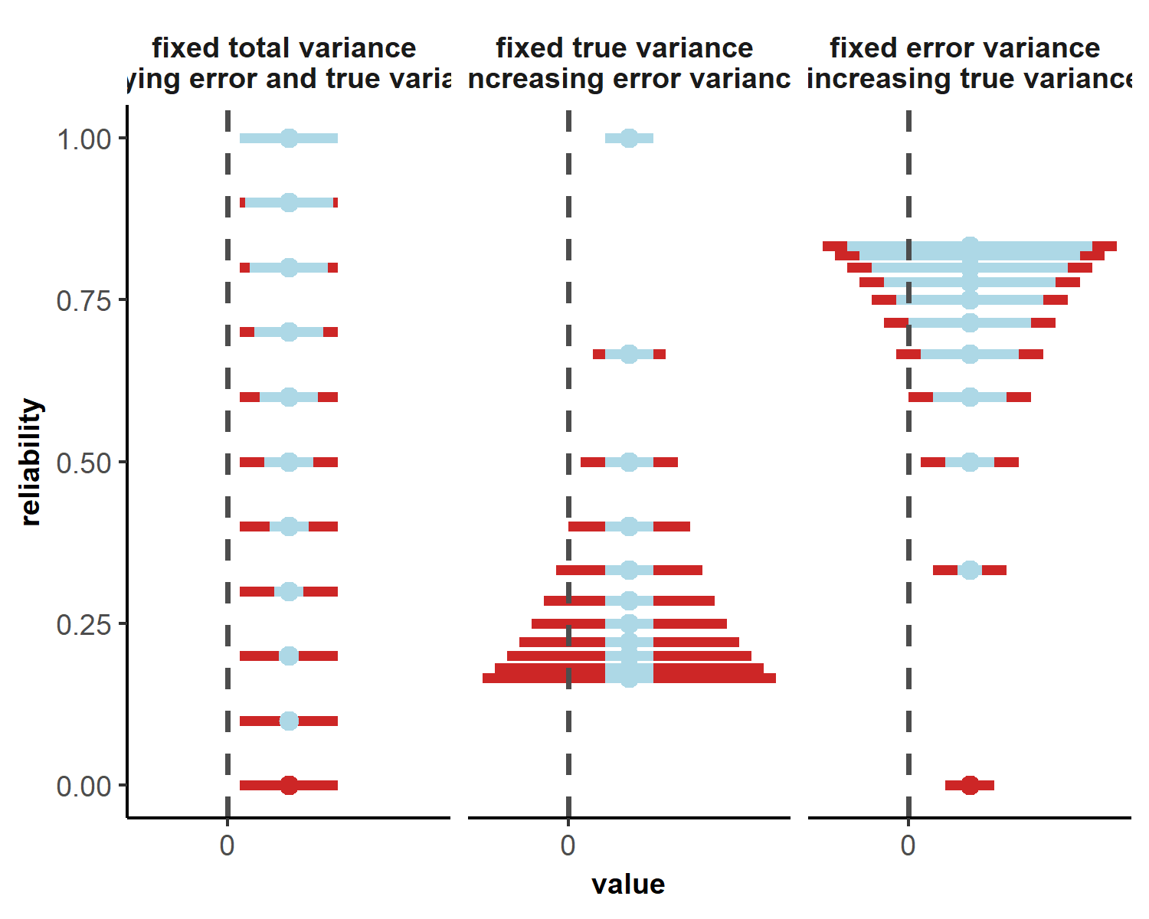

Figure 1 Fixing total variance varying true-score variance and error variance reliability decreases while power remains constant (top to bottom)

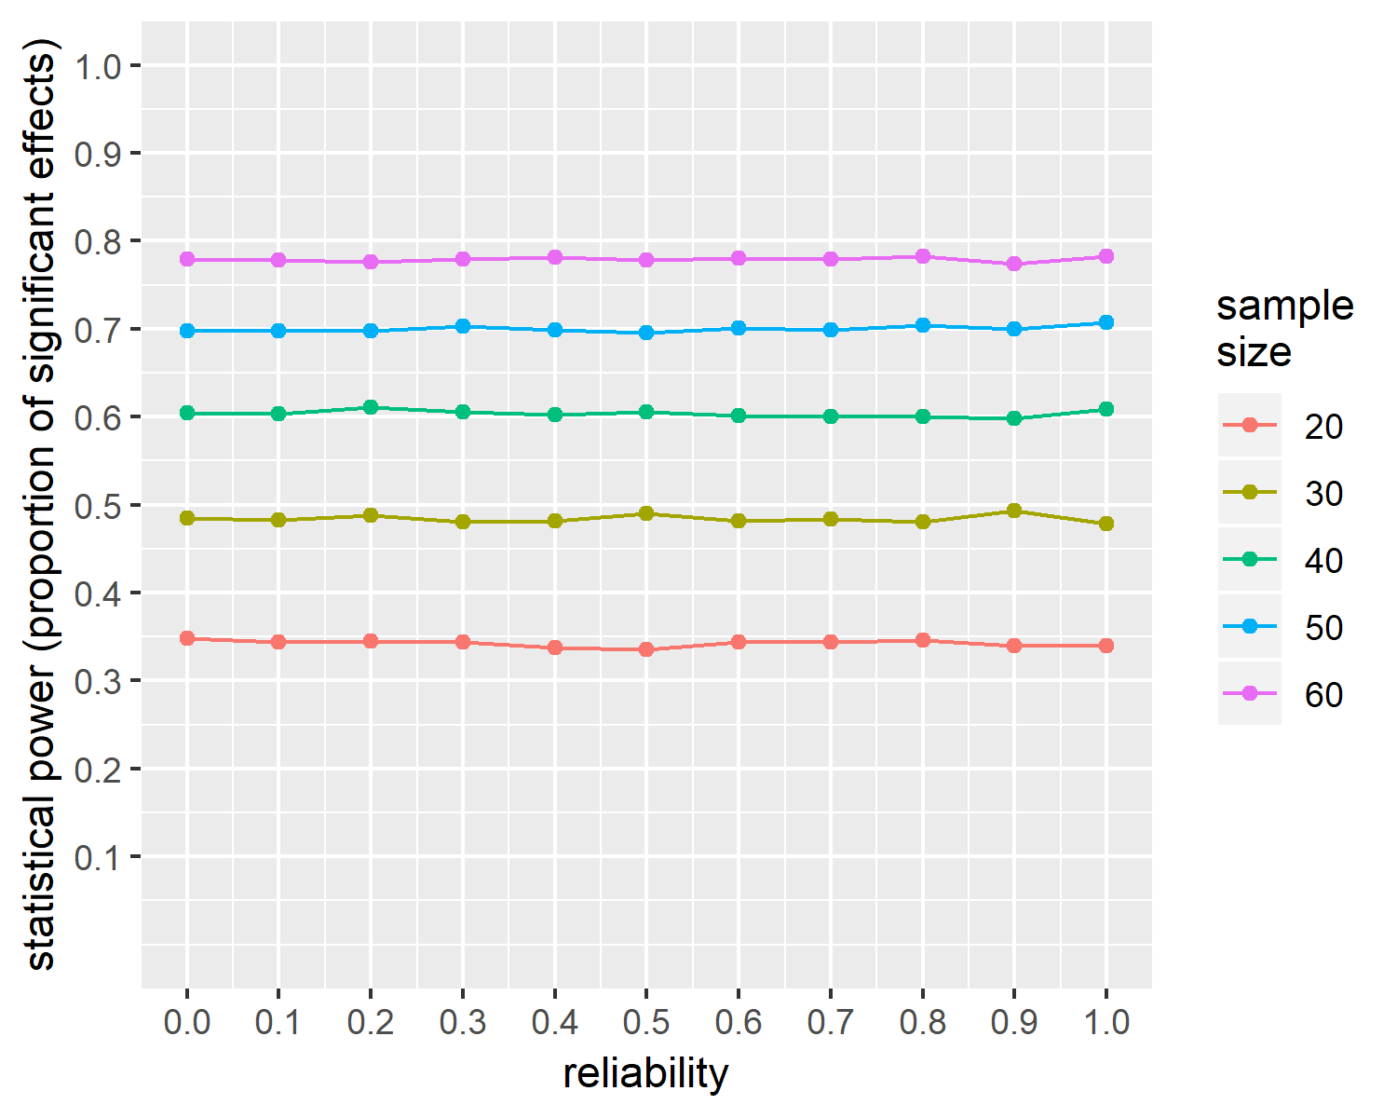

Figure 2 Observed probability of finding a significant result as a function of sample size and reliability where total variance is fixed (true-score and error variance alternate)

## Increasing error variance

An often employed method to examine the relationship between reliability and power is to manipulate reliability by increasing the amount of measurement error. For instance, LeBel and Paunonen (2011) used this procedure and concluded that reductions in reliability reduce the confidence we should place in our analyses and in statistical power (and later extend this to replicability of results). Similarly, Kanyongo and colleagues (Kanyongo, Brooks, Kyei-Blankison, & Gocmen, 2007) used a Monte Carlo simulation approach (MC2G software; <http://www.ohiouniversityfaculty.com/brooksg/>) to demonstrate that increasing measurement error (and therefore, reducing reliability) decreases power for specific analyses, including; paired t-tests, independent t-tests, one-way ANOVA (three groups), Wilcoxon signed-rank tests, and Mann-Whitney-Wilcoxon tests. When applied to correlational analyses, the decline in statistical power (and increase in required sample sizes to achieve 80% power) even at ‘acceptable’ levels of reliability is daunting (Parsons, 2018) in particular given that measurement reliability of cognitive measures often goes unreported (Gawronski, Deutsch, & Banse, 2011, @Parsons2018a).

Figure 1 (middle panel) displays this visually by setting true variance at 1 and increasing error variance such that reliability decreases (from top to bottom) in steps of 0.1. As in Figure 1, the mean difference is set to 2. Here, with decreases in reliability comes a decrease in the observed effect, as the error bars overlap.

To illustrate the relationship between reliability and power, simulated data were generated following Lebel and Paunonen’s (2011) approach. True variance was set at 1, and error variance increased such that reliability increased from .1 to 1 in steps of .1. The ‘control’ group was set to a population mean of 0 and the ‘treatment’ group was set to a mean of .5. Sample sizes of 10, 20, 30, 40, and 50 per group were created. 20000 iterations of this 10*5 design were performed. Statistical power was calculated as the percentage of significant results at an alpha of .05. Figure 3 presents this visually. Note that this plot closely matches the one created by Lebel and Paunonen (2011, p. 576).

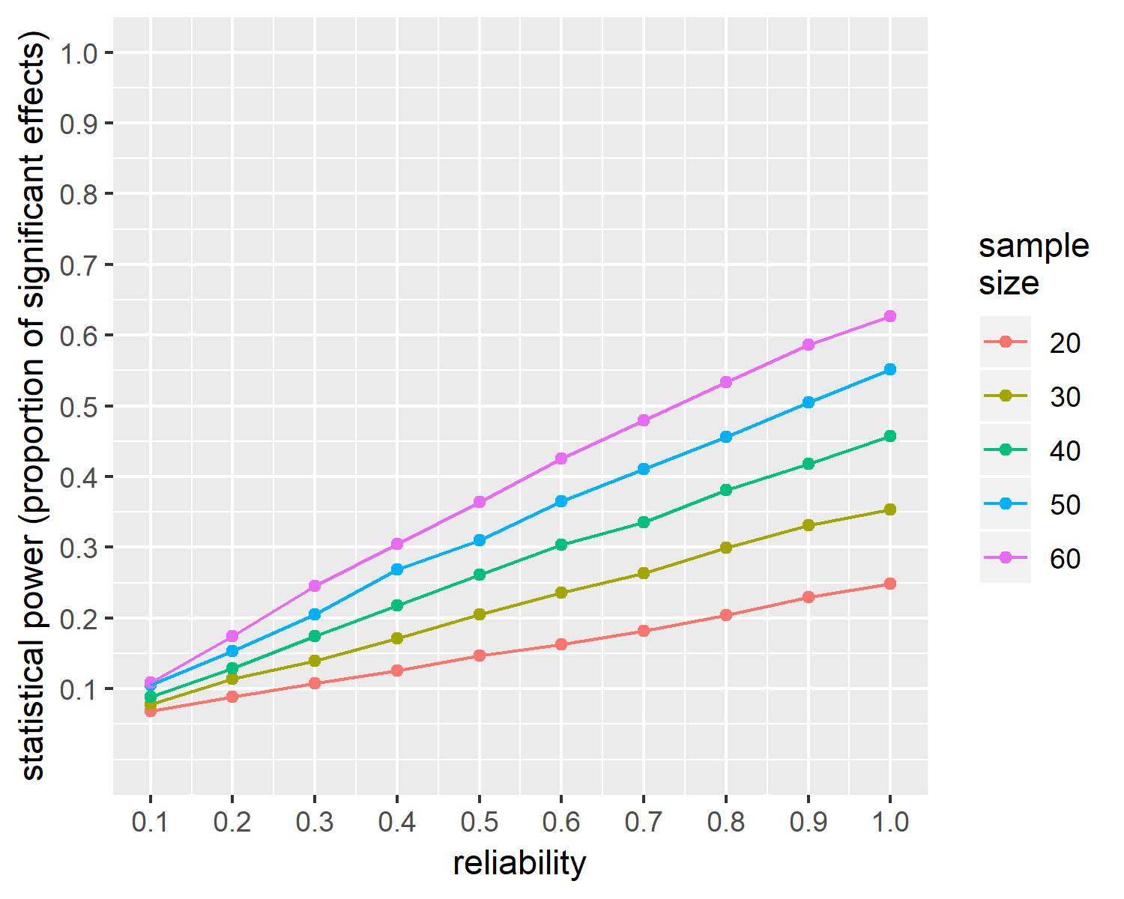

Figure 3 Observed probability of finding a significant result as a function of sample size and reliability where truescore is fixed and error variance is varied.

## Increasing true-score variance

The alternative approach to examine the relationship between reliability and power is to fix error variance and vary true variance (De Schryver, Hughes, Rosseel, & De Houwer, 2016, @Zimmerman2015). In this case the reverse pattern to fixing true-score variance is observed; power decreases with increased reliability when error variance is held constant. Figure 1 (right panel) displays this visually by setting error variance at 1 and increasing true-score variance such that reliability increases (from top to bottom) in steps of 0.1. Here, with increases in reliability comes a decrease in the observed effect, as the true-score variance begins to overlap.

As with the previous approach, data were simulated to illustrate this relationship between reliability and power. In this case, error variance was set to 1 and true variance was increased such that reliability varied from 0 to .9 in steps of .1. As before, the ‘control’ group was set to a population mean of 0 and the ‘treatment’ group was set to a mean of .5. Sample sizes of 10, 20, 30, 40, and 50 per group were created. 20000 iterations of this 10*5 design were performed. Statistical power was calculated as the percentage of significant results at an alpha of .05. Figure 4 presents this visually. Note that this plot closely matches the one created by De Schryver et al. (2016, p. 4).

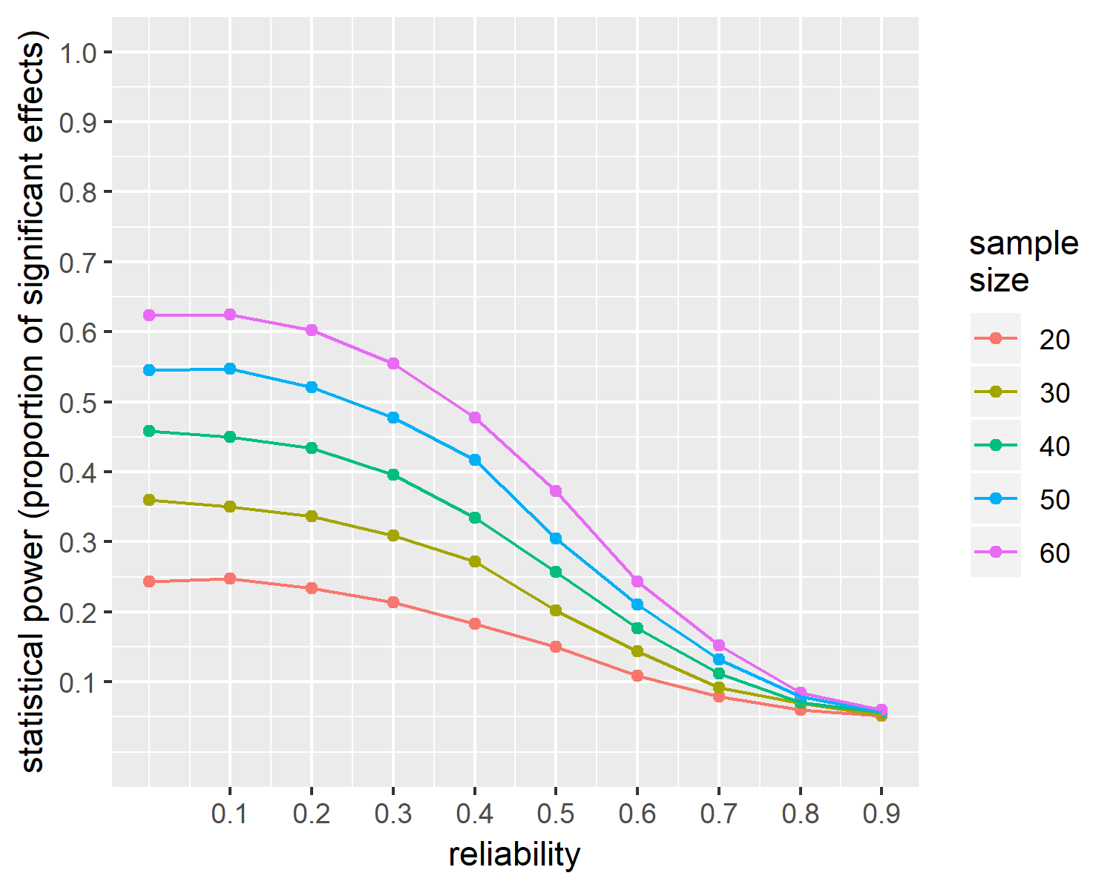

Figure 4 Observed probability of finding a significant result as a function of sample size and reliability where error is fixed and truescore variance is varied.

## Interpreting different reliability-power relationships

The relationship between measurement reliability and statistical power is complex, in so far as it is not a direct relationship. To examine a direct, functional, relationship between reliability and power, either true-score variance or error variance must be fixed, while the other is held constant. Following mathematical definitions is useful in examining the reliability-power relationship (Zimmerman & Zumbo, 2015). Here, I have tried to supplement previous articles with visualisations of the reliability-power relationship under each approach. Under either approach, increases in either true-score variance or error variance lead to an increase in total variance and a direct reduction in statistical power. As demonstrated above, adopting the approach of fixing true-score variance (LeBel & Paunonen, 2011) or of fixing measurement error (e.g. De Schryver et al., 2016) result in opposing relationships between measurement reliability and power.

Fixing true-score variance and increasing measurement error tend to be discussed separately in relation to correlational or individual differences approaches. Whereas, fixing error variance and increasing true-score variance tends to be discussed in relevance to experimental approaches. As noted by Hedge and colleagues (2017, p. 3) “the meanings of a”reliable" task for experimental and correlational research are not only different, but can be opposite in this critical sense" due to the relative advantage or disadvantage of larger variation in the within-subject effect. Fixing true variance has led to recommendations that we must improve the psychometric properties of our measurements, so as not to render our results uninterpretable and to increase the replicability of our research (LeBel and Paunonen (2011); also see, Hedge, Powell, and Sumner (2017), Parsons (2018), Parsons et al. (2018), Rodebaugh et al. (2016)). In contrast, the approach of fixing error variance and increasing true-score variance has been related to the idea that experimentalists seek to maximise an experimental effect (and have greater statistical power) by recruiting more homogeneous samples, fitting with the aim of reducing true-score variance, which results in reductions in reliability (De Schryver et al., 2016).

## Conceptual distinctions between approaches to examine reliability-power relationships

The purpose of this paper is to highlight conceptually distinct rationales for the fact that low power can result from increasing true-score variance or from error variance (while the other stays constant). Specifically, depending on the approach adopted, low power is either; a result of true effects being masked by measurement error, or a result of the effect itself being very small. Of course, I do not aim to argue against these functional relationships between reliability and power. Both rest of mathematical definitions, after all. I do, however, believe that there are conceptual considerations that must be made when interpreting the relationship between reliability and power under either assumption. These conceptualisations have implications for some claims that have been made about the importance of reliability in experimental research. (De Schryver, 2018) provides an illustrating example. Consider two measures, A and B, with error variance of .20. Score A contains true-score variance of .80 (therefore, a reliability of .80), while score B contains true-score variance of .60 (therefore, a reliability of .75). Score A is therefore preferable based on solely on reliability. Yet, calculating Cohen’s d - assuming a mean difference of .50 - reveals that the effect size for A is .50 and for B is .56 due to the greater total variance in score A. Therefore, to maximise the effect size observed, a researcher might seek to use measure B. This example highlights the fact that reliability does not have a 1:1 relationship with statistical power. Selecting a measure based on the size of the effect it produces with the aim of increasing power is a valid approach. However, such an approach might be interpreted as an indication that low reliability is either; not a problem, or may be beneficial under certain conditions. This simplistic conclusion misses the fact that it is total variance that is functionally related to power and not reliability per se. I also worry that demonstrations of this negative relationship has led some to conclude that low reliability is therefore ‘acceptable’ for experimental designs, and by implication that we should not be concerned about the reliability of our measures.

I have several observations based on the visualisations above that I have not seen articulated in discussions surrounding the relationship between reliability and power. I hope that these observations are useful in considering the utility of measurement reliability in experimental research.

First, as highlighted in figure 1; for any specified level of total variance, reliability can take any value. In this case, regardless of reliability; power remains constant despite reductions in the ‘meaning’ of the scores on an individual differences level. That is, it is more difficult to rank individuals within each group. While this reduction in reliability does not influence the power of the between group difference, it will influence correlational analyses with this measure. Likewise, it would be difficult to demonstrate that an individual’s score has changed or to investigate questions of individual differences. This demonstrates that an effect can certainly be found, yet, the reliability and validity of that measurement can still be suspect.

Second and similarly, consider the topmost reliabilities in Figure 1 (right panel) (low reliability). The measurements are little more than measurement error. In these cases, although a highly powered systematic difference between groups has been observed, we cannot have much confidence that this difference is in the process or construct of interest. If reliability is so low that the score is rendered near-meaningless, does it matter how much more power the test has or how much larger the effect size is? The measure is no longer capturing the very thing that researchers are interested in in the first place. Highly reliable measurements have the benefit that the measure is less contaminated by error and more likely to capture the process, or construct, of interest. The only potential benefit of low reliability is of maximising effect sizes under the condition that a certain amount of measurement error is expected. However, this comes with the drawback of a less interpretable measure, and follows the assumption that if there were sufficient true-score variance for a reliable measure then there would be little-to-no actual effect to find in the first instance. In all cases, reducing measurement error is beneficial to the interpretability of scores as well as increasing power (assuming that this reduction in measurement error does not co-occur with an increase in true score variance in excess of this reduction). While experimentalists seek to maximise the effect of interest by recruiting more homogeneous groups, it does not follow that low reliability itself is beneficial, only that reducing total variance (e.g. via reducing measurement error) will maximise the effect observed.

Finally, consider the bottommost bars in figure1 (middle and right panel) containing the maximum total variance - and thus, the lowest power. Each figure suggests an alternative interpretation for the relationship between reliability and (low) power. When error variance is increased (Figure 1 (middle panel)), the true effect is hidden due to measurement error. Whereas, when true variance is increased, the actual true effect is smaller. There is simply less of an effect to find. Therefore, we should expect to observe low power in this case. Although total variance is the same, the composition into true-score and error variance leads to different reasons explaining the resulting low power. Perhaps then, we should not think of the reliability-power relationship under either approach as being a direct result of reliability. The aim of this brief paper is to expand current examinations of the relationship between reliability and statistical power (e.g. Zimmerman and Zumbo (2015)). Visualising these relationships under separate assumptions of fixed true-score variance (Figure 1 (middle panel)) or fixed error variance (Figure 1 (right panel)) suggests each method represents a conceptually distinct process. We might consider each approach separately in terms of obscuring a true effect (fixing true-score variance) or reducing the size of the effect (fixing error variance). The fact that; under the first assumption power increases with improved reliability, whereas under the second assumption the opposite is observed, is less paradoxical when considering these alternative explanations. This in itself might help to avoid potential simplifications that low reliability is acceptable under certain circumstances and promote a more in depth consideration of the plausible influence of measurement reliability on statistical power in a given study.

## References

De Schryver, M. (2018). *A psychometric analysis of choice reaction time measures* (PhD thesis). Ghent University.

De Schryver, M., Hughes, S., Rosseel, Y., & De Houwer, J. (2016). Unreliable yet still replicable: A comment on lebel and paunonen (2011). *Frontiers in Psychology*, *6*(JAN), 1–8. <https://doi.org/10.3389/fpsyg.2015.02039>

Gawronski, B., Deutsch, R., & Banse, R. (2011). Response interference tasks as indirect measures of automatic associations. In K. Klauer, C. Stahl, & A. Voss (Eds.), *Cognitive methods in social psychology* (pp. 78–123). New York, NY: Guilford.

Hedge, C., Powell, G., & Sumner, P. (2017). The reliability paradox: Why robust cognitive tasks do not produce reliable individual differences. *Behavior Research Methods*. <https://doi.org/10.3758/s13428-017-0935-1>

Kanyongo, G. Y., Brooks, G. P., Kyei-Blankison, L., & Gocmen, G. (2007). Reliability and statistical power: How measurement fallibility affects power and required sample sizes for several parametric and nonparametric statistics. *Journal of Modern Applied Statistical Methods*, *6*(1), 81–90. <https://doi.org/10.22237/jmasm/1177992480>

LeBel, E. P., & Paunonen, S. V. (2011). Sexy But Often Unreliable: The Impact of Unreliability on the Replicability of Experimental Findings With Implicit Measures. *Personality and Social Psychology Bulletin*, *37*(4), 570–583. <https://doi.org/10.1177/0146167211400619>

Parsons, S. (2018). Ignoring measurement reliability is a real-life horror story [Blog post]. Retrieved from <https://medium.com/@Sam{_}D{_}Parsons/ignoring-measurement-reliability-is-a-real-life-horror-story-b98a2517db26>

Parsons, S., Kruijt, A.-w., & Fox, E. (2018). Psychological Science needs a standard practice of reporting the reliability of cognitive behavioural measurements, 1–25. <https://doi.org/10.17605/OSF.IO/6KA9Z>

Rodebaugh, T., Scullin, R., Langer, J., Dixon, D., Huppert, J., Bernstein, A., … Lenze, E. (2016). Unreliability as a Threat to Understanding Psychopathology: The Cautionary Tale of Attentional Bias. *Journal of Abnormal Psychology*, *125*(6), 840–851. <https://doi.org/10.1037/abn0000184>

Zimmerman, D., & Zumbo, B. (2015). Resolving the Issue of How Reliability is Related to Statistical Power: Adhering to Mathematical Definitions. *Journal of Modern Applied Statistical Methods*, *14*(2), 9–26. <https://doi.org/10.22237/jmasm/1446350640>