A positive integer is called a *palindrome* if its representation in the decimal system is the same when read from left to right and from right to left. For a given positive integer *K* of not more than 1000000 *digits*, write the value of the smallest palindrome larger than *K* to output. Numbers are always displayed without leading zeros.

Input

The first line contains integer *t*, the number of test cases. Integers *K* are given in the next *t* lines.

Output

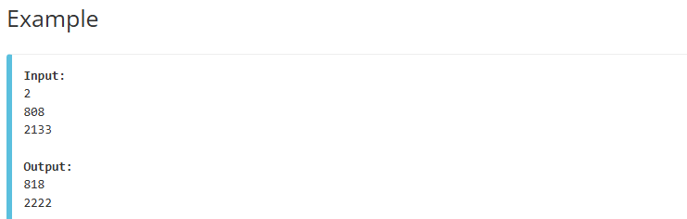For each *K*, output the smallest palindrome larger than *K*.