EX1.

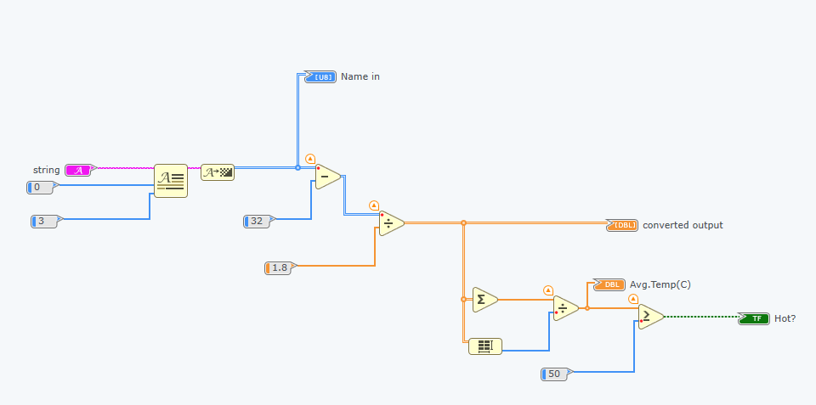

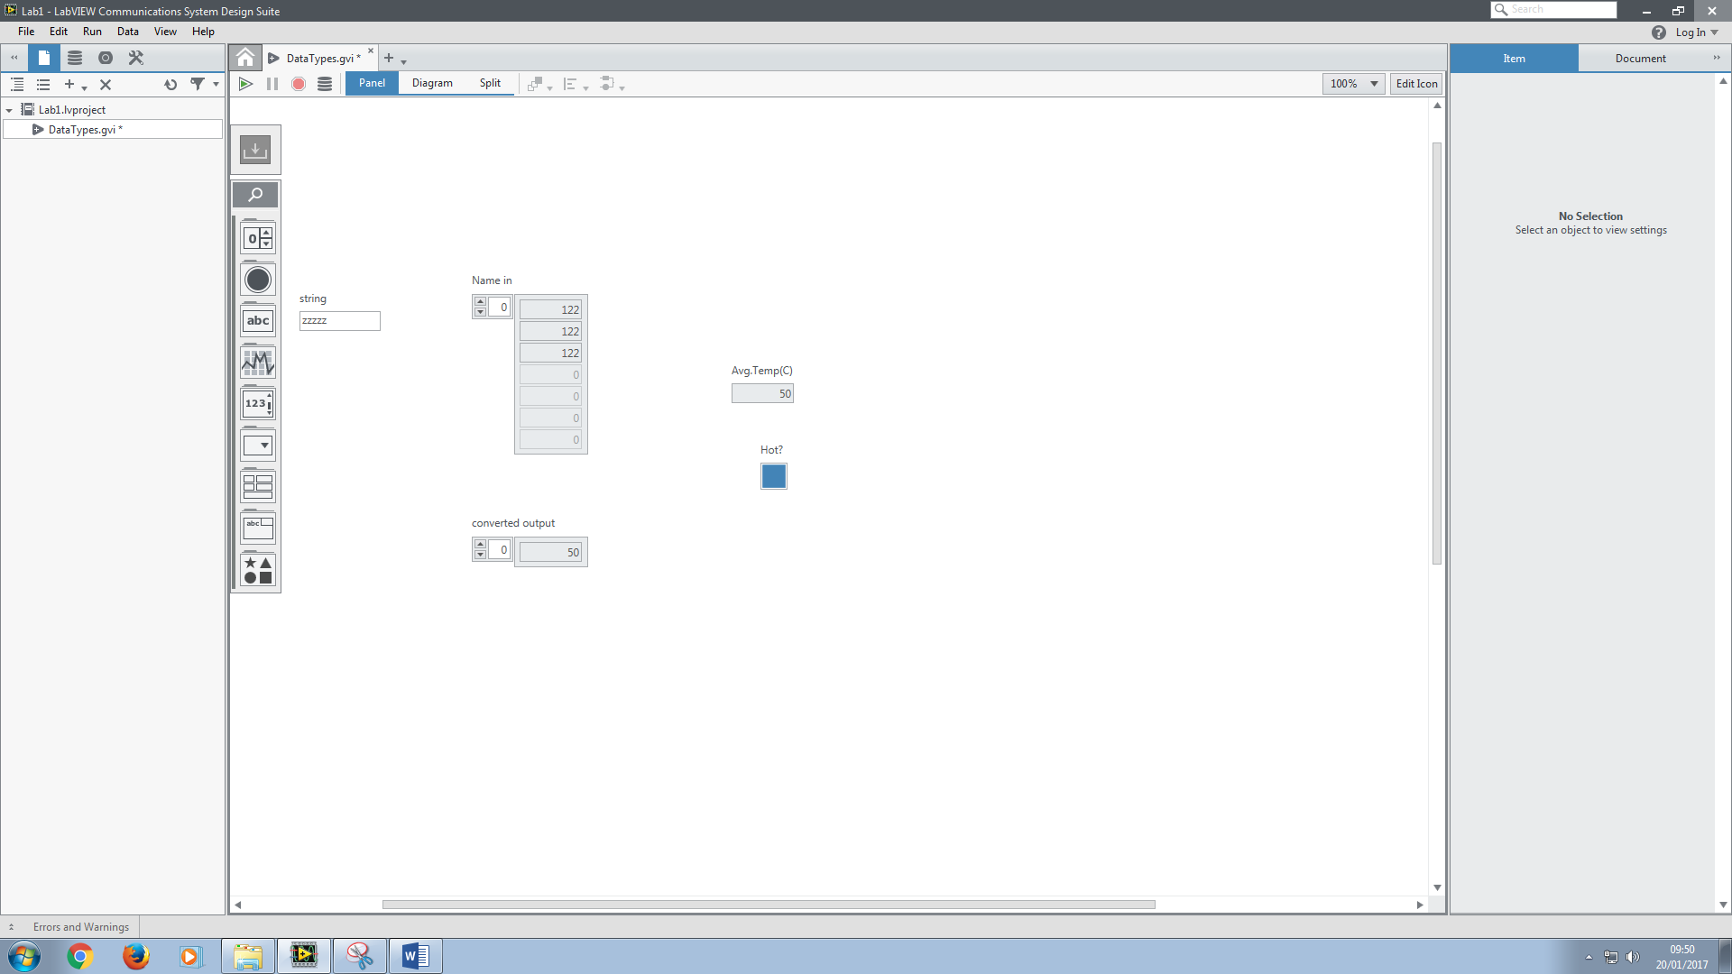

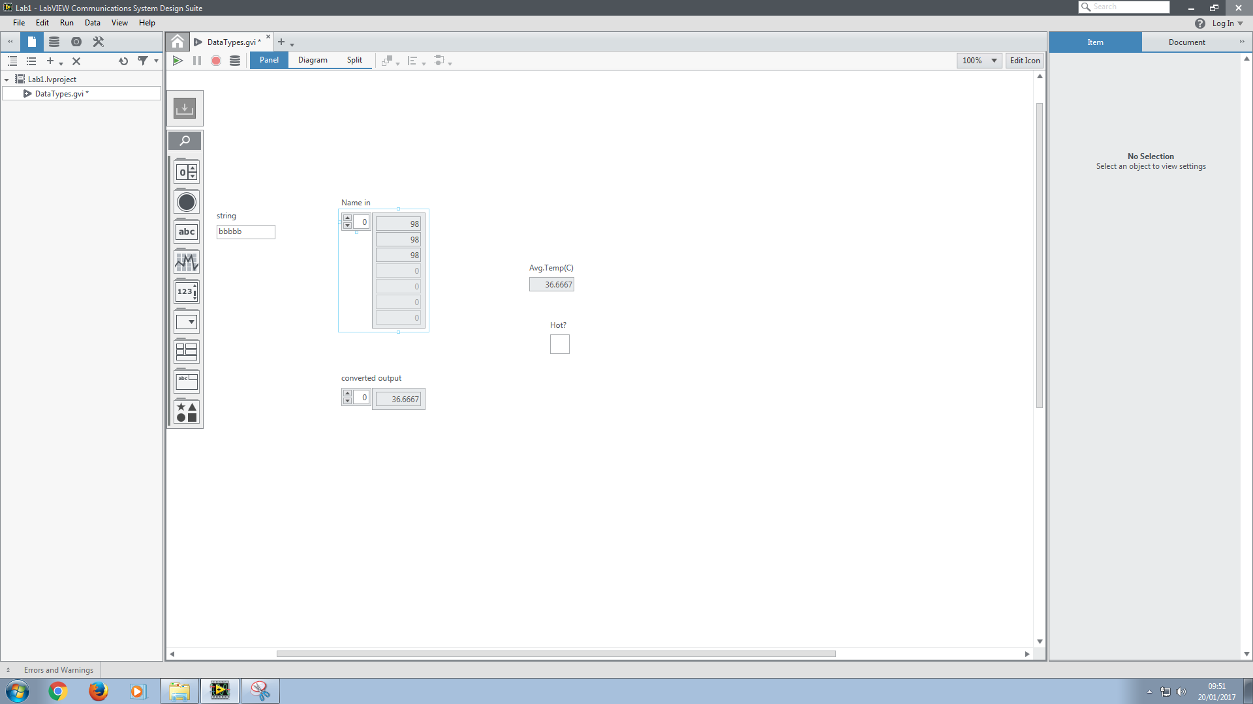

Ex2.

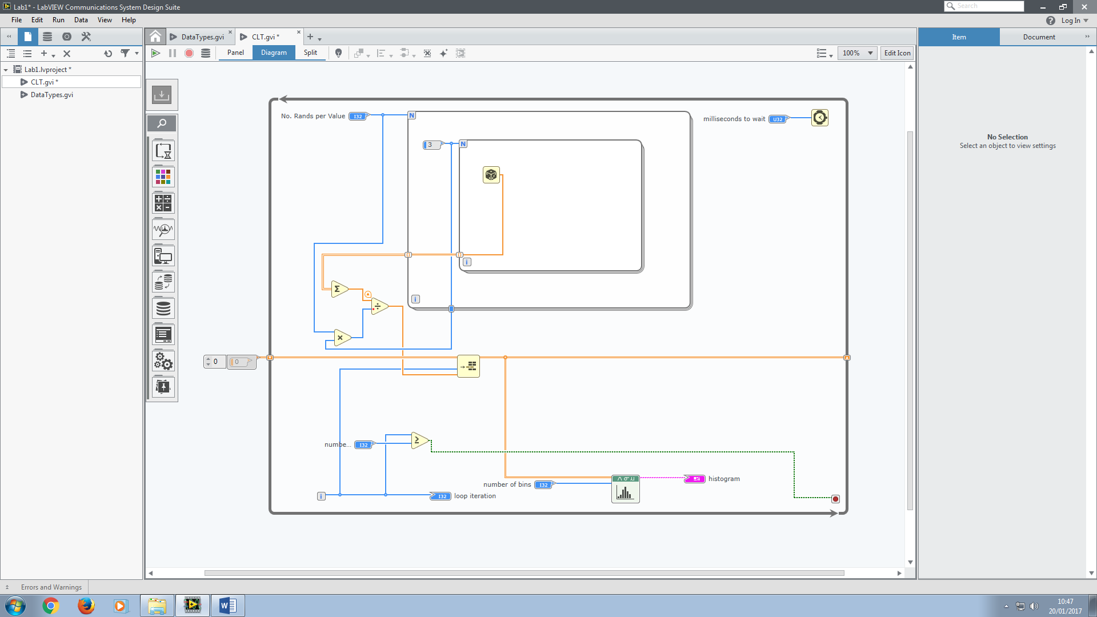

We observed that the normal distribution narrowed as we changed the number of random values averaged per sample (the variance decreased).

We also observed that the histogram approached the shape of a normal distribution as the number of samples increased.

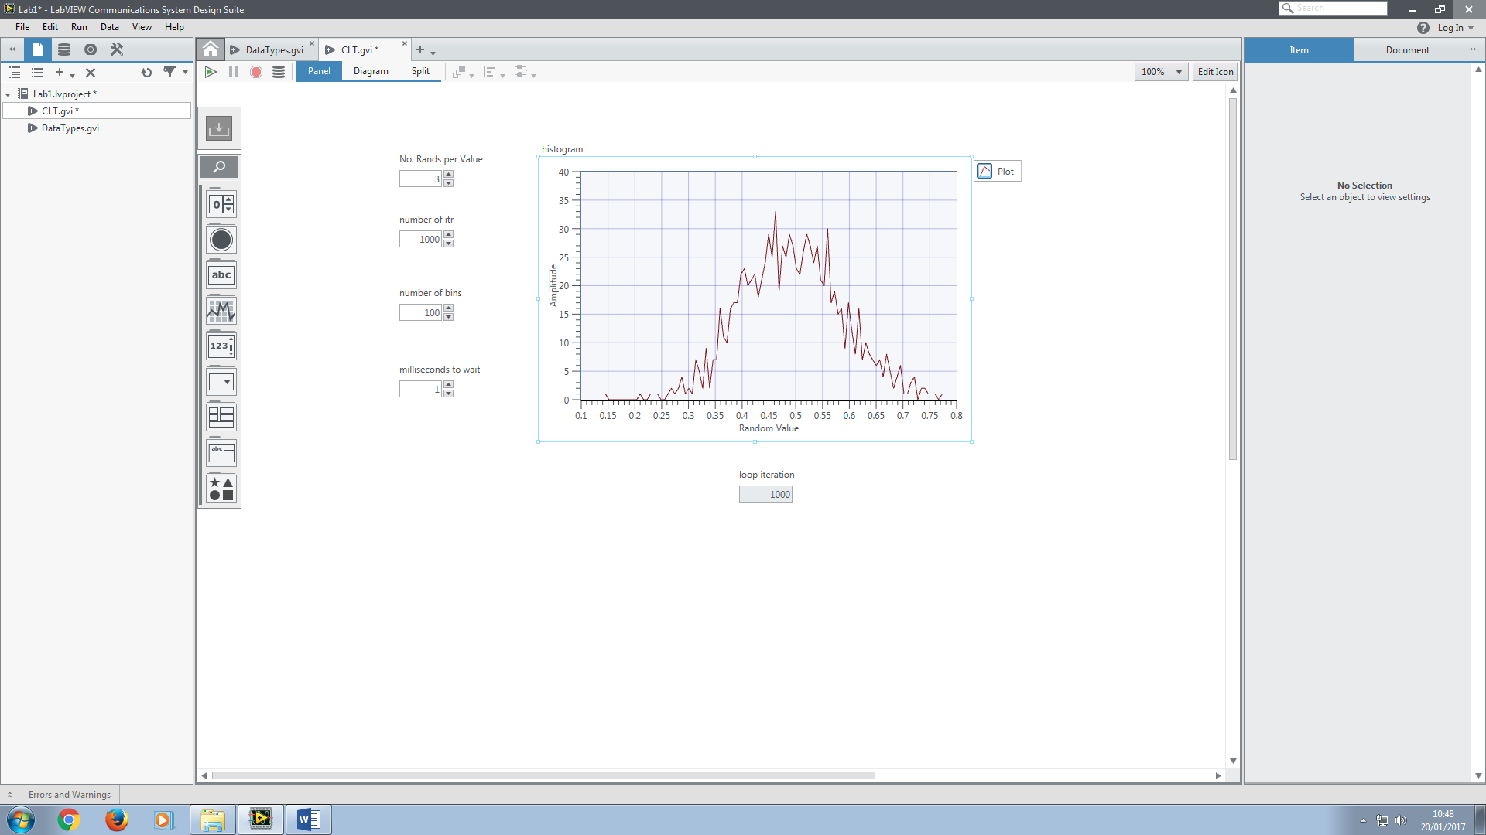

**Our goal is now to alter the distribution such that its mean is 0 and has a variance of 1**

We then altered our control such that the mean of the normal distribution was 0 and the variance was 1 (unit variance). We did this by taking away 0.5 and multiplying by a certain value as determined below:

We defined a new normal distribution Y with a mean of 0, but a variance which is not unity.

Z will be our normal distribution with unity variance as well as a mean of 0.

We need this to be equal to 1.

We already know that the mean is 0.

We know that these two are equivalent:

You can see that they are because the only difference is that in the second formula, the 0.5 is multiplied by N and then divided by N.

The way in which we work out the variance is using the following formula:

We also know that the variance is the same for any distribution, regardless of its mean, so long as its shape is the same. This means that shifting by 0.5 should not affect the variance.

The way in which we calculate the expected value of a continuous variable is to integrate the probability density function over the interval and divide by the interval (multiply by the probability density function since we are calculating the distribution to be that of the random values generated as opposed to that of the overall average samples (of 9 random values).

In the below we calculate which is simply an integration of Y over the interval in which the values lie, since is simply a uniformly distributed random variable over the interval [-0.5,0.5].

Now we can calculate

Now we can deduce the variance:

Now, we have previously been calculating where Y is simply:

We know want:

Therefore we have applied two operations to the random variable. The first was to sum several (N) values of the random variable. The second was to final divide this by the number of values we summed to get a new random variable .

From Wikipedia:

{\displaystyle \operatorname {Var} (aX)=a^{2}\operatorname {Var} (X).}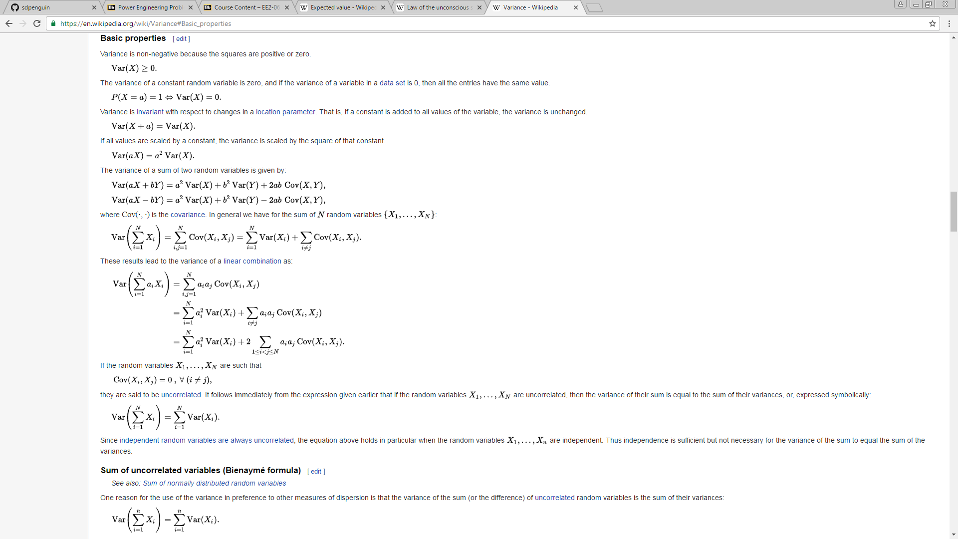

Therefore our random variable’s variance is simply multiplied by 9 and then divided by

Therefore to make the distribution unit variance, we simply need to divide by this number, i.e. we would multiply by .

Essentially we can do this two ways:

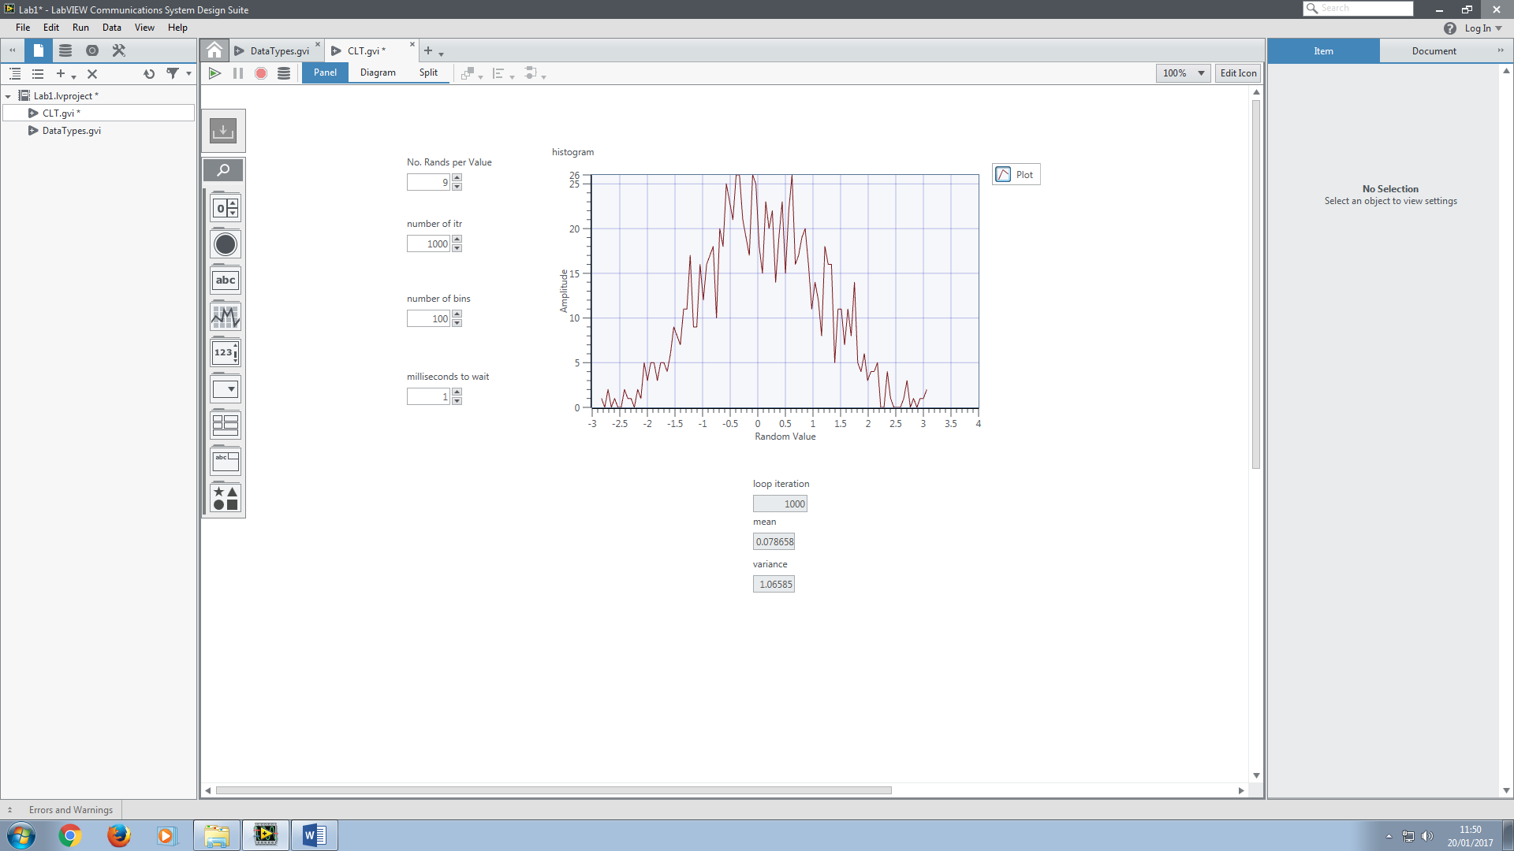

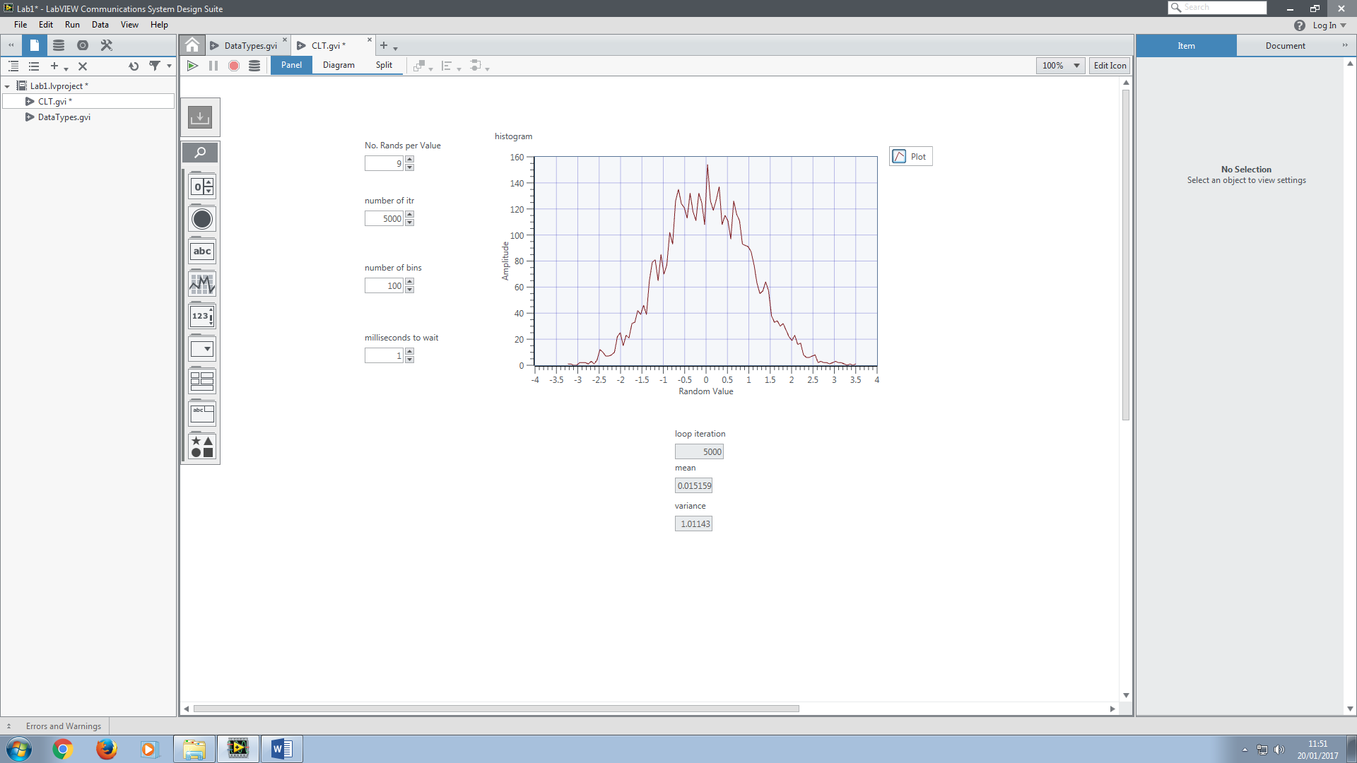

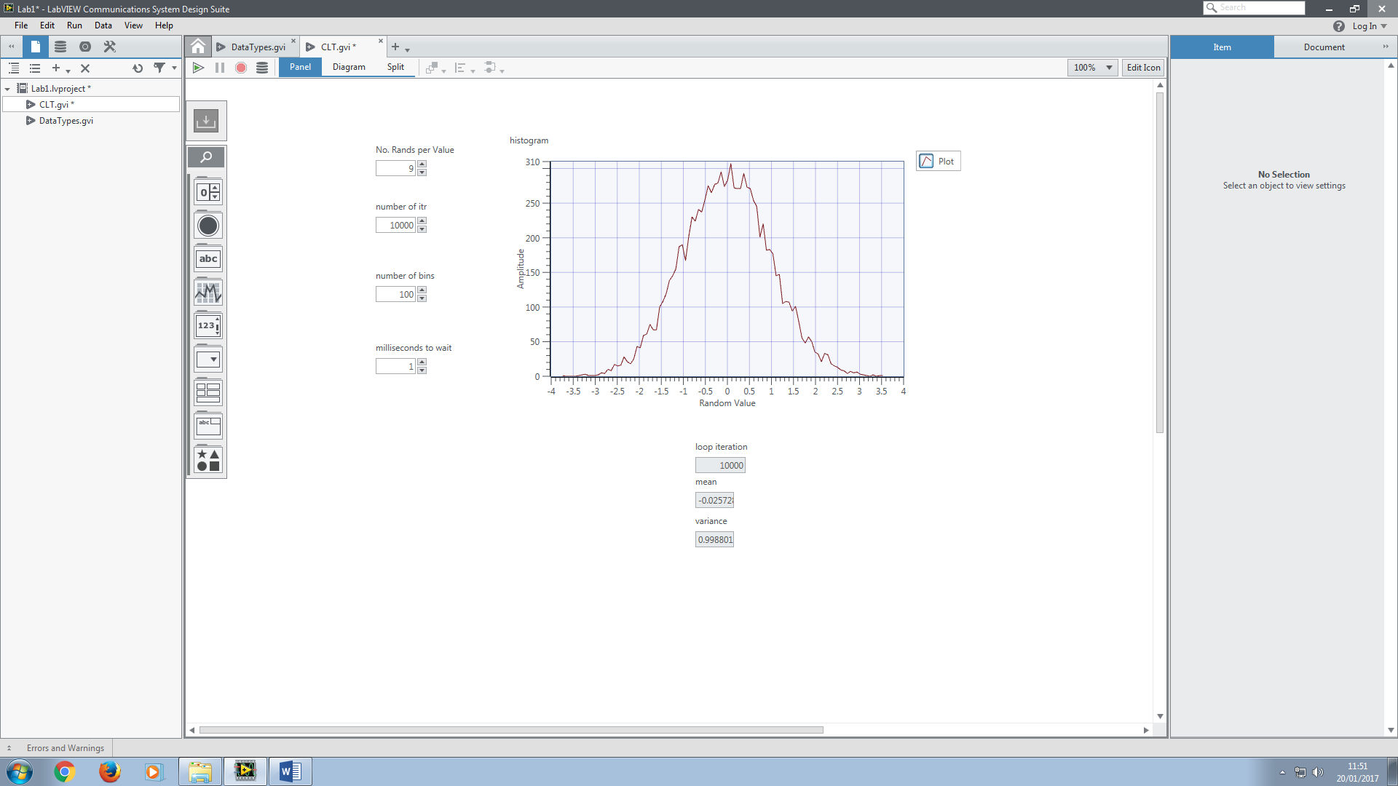

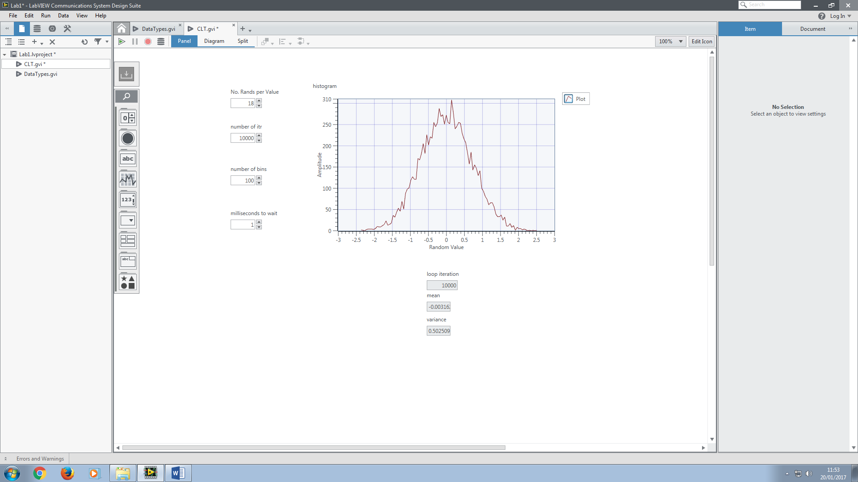

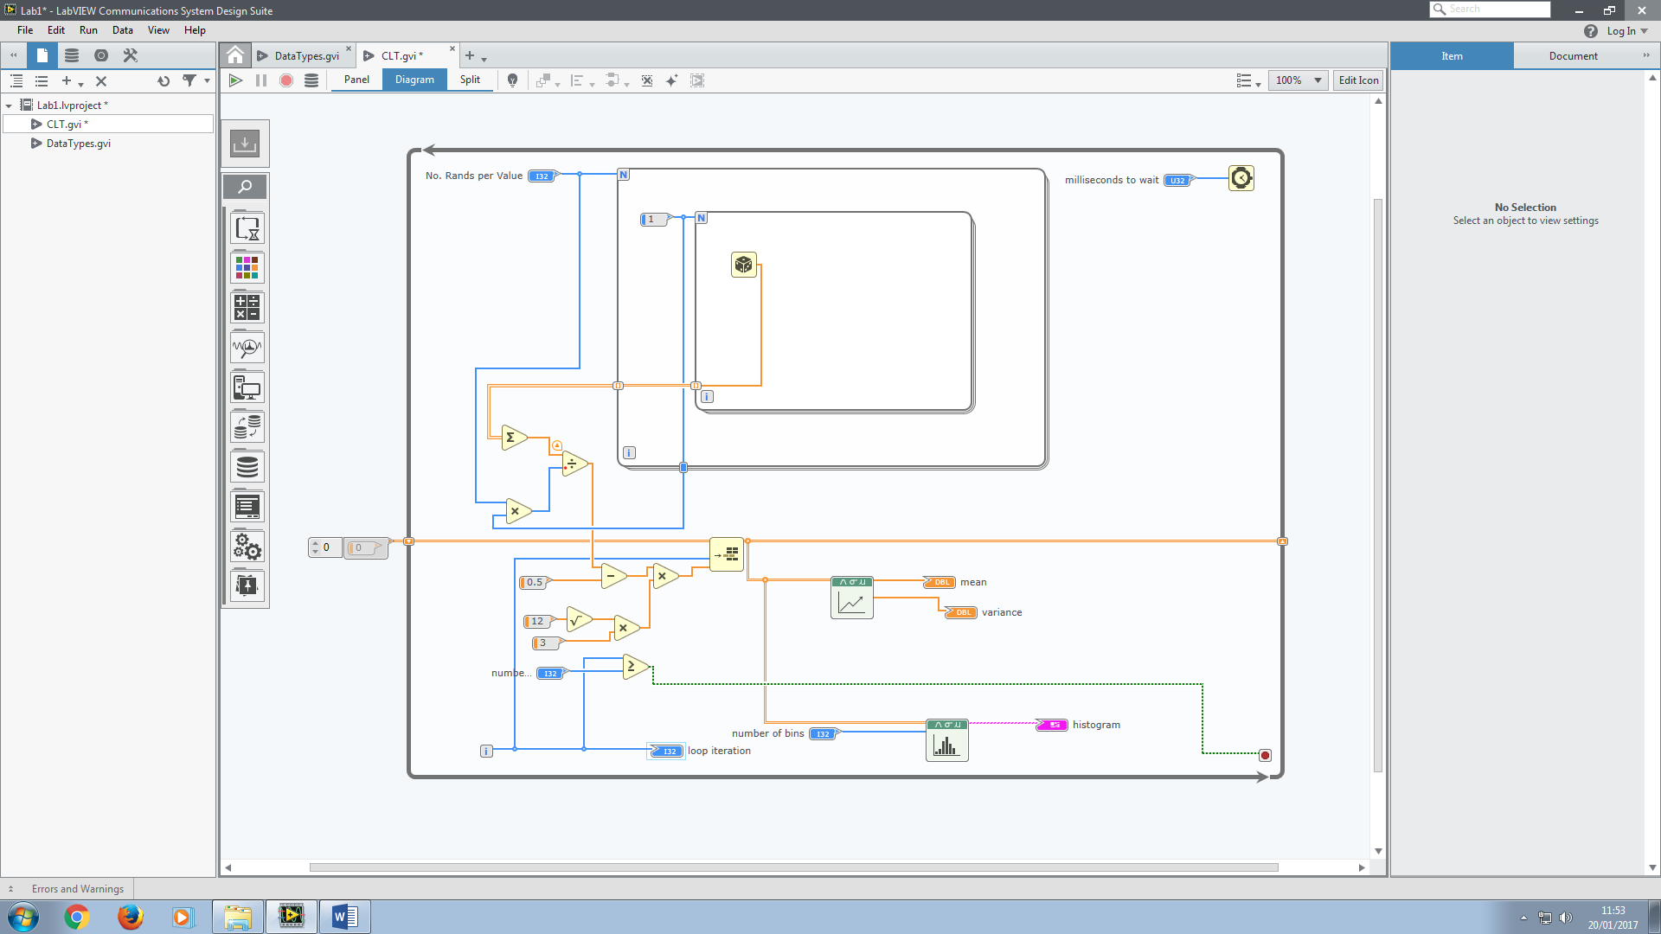

**Exercise 3 – Waveforms**

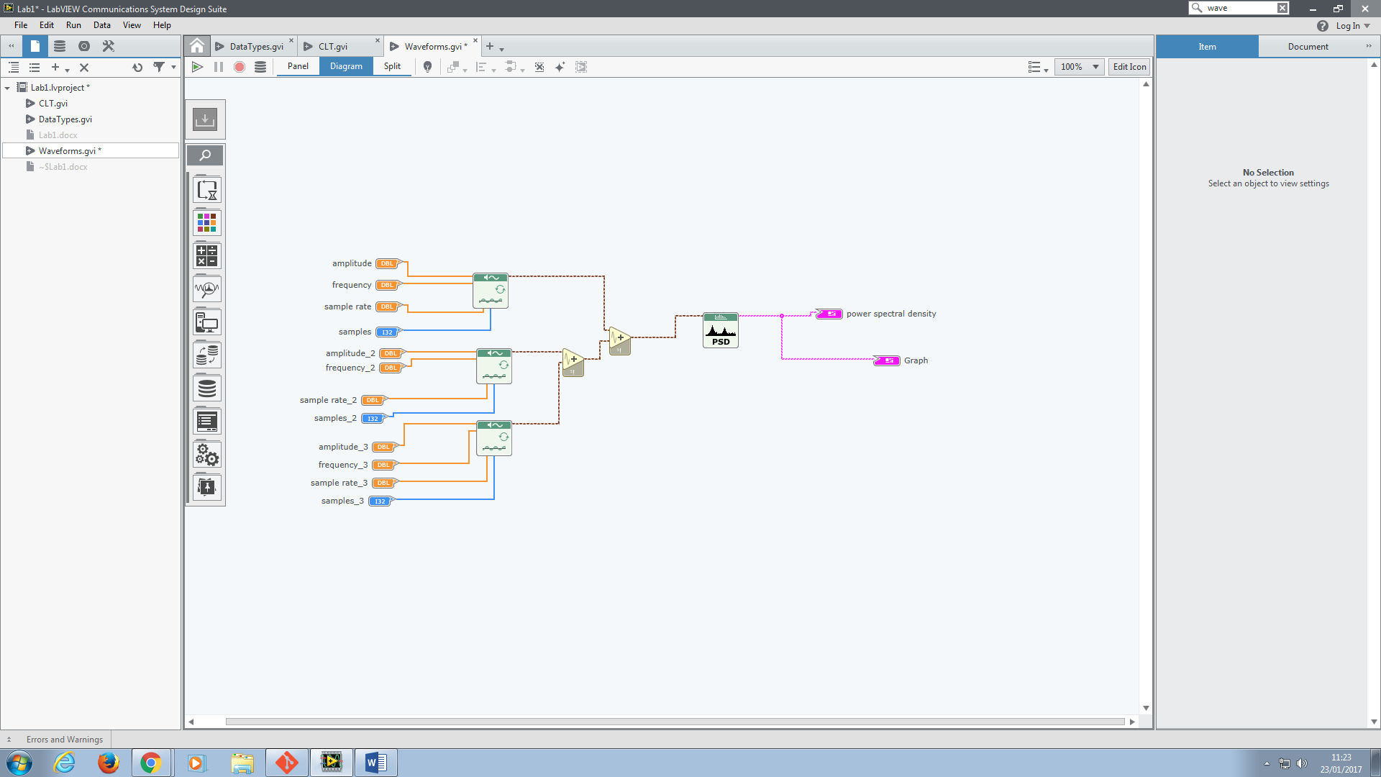

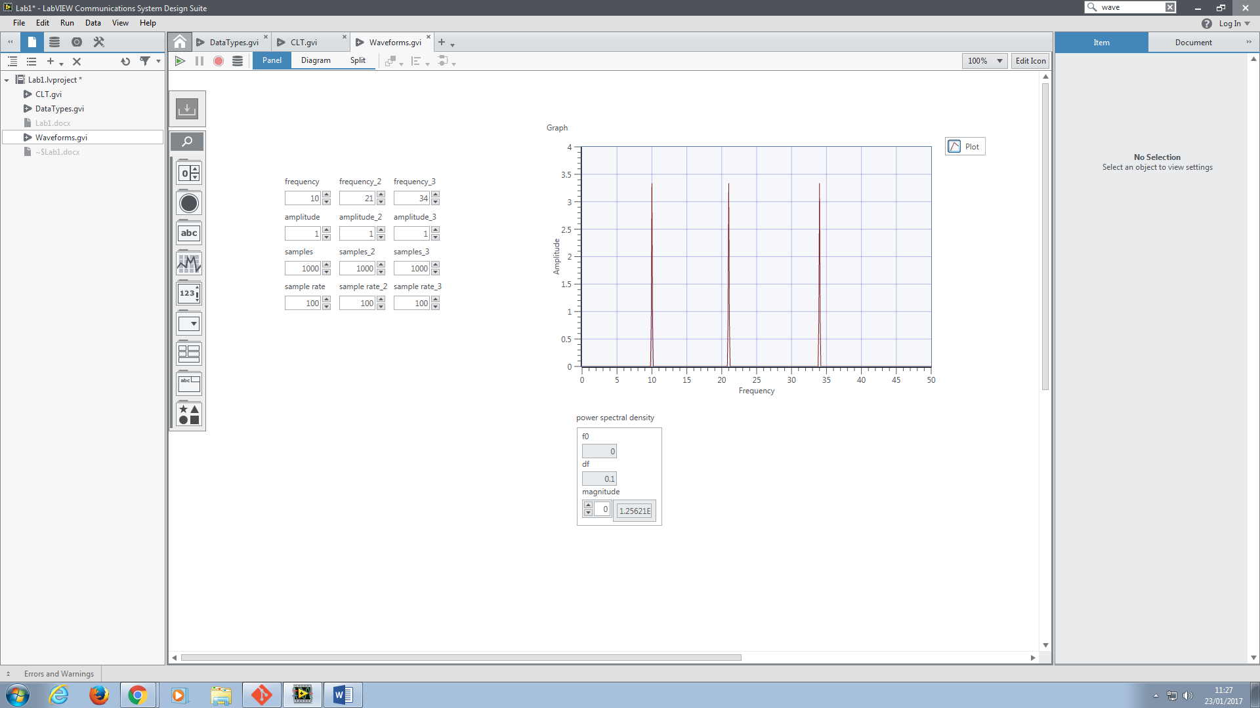

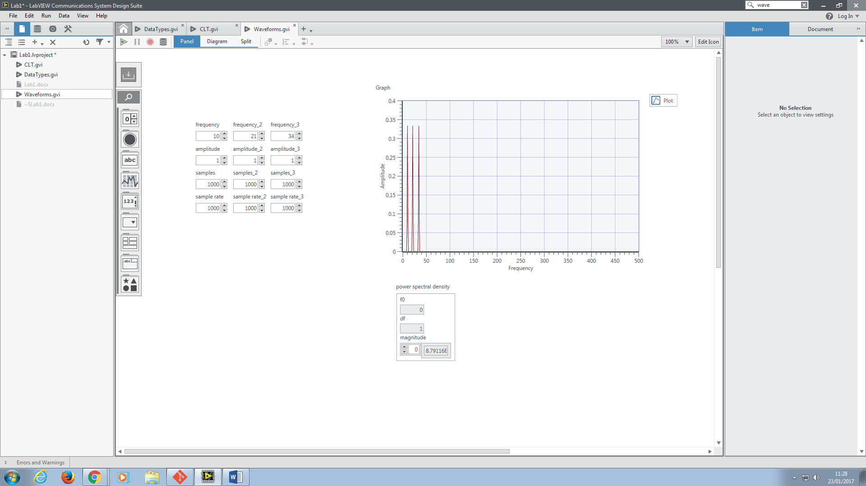

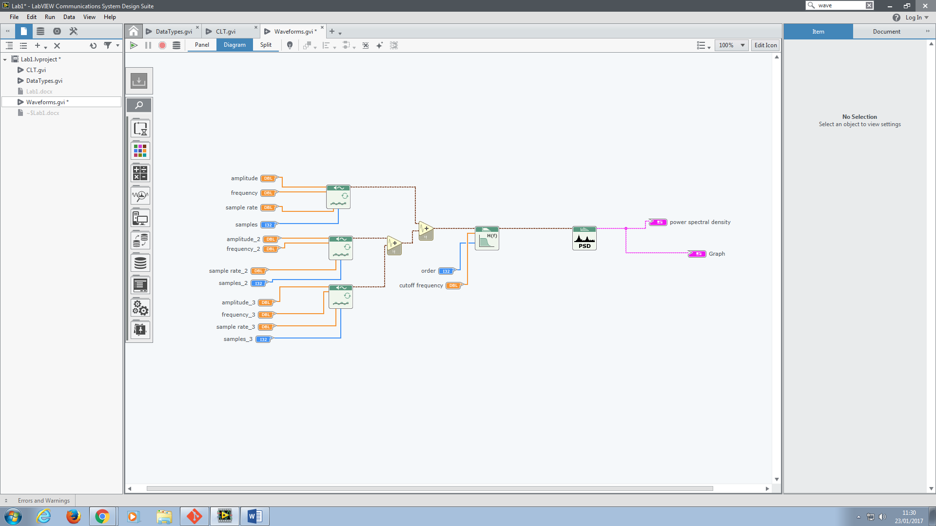

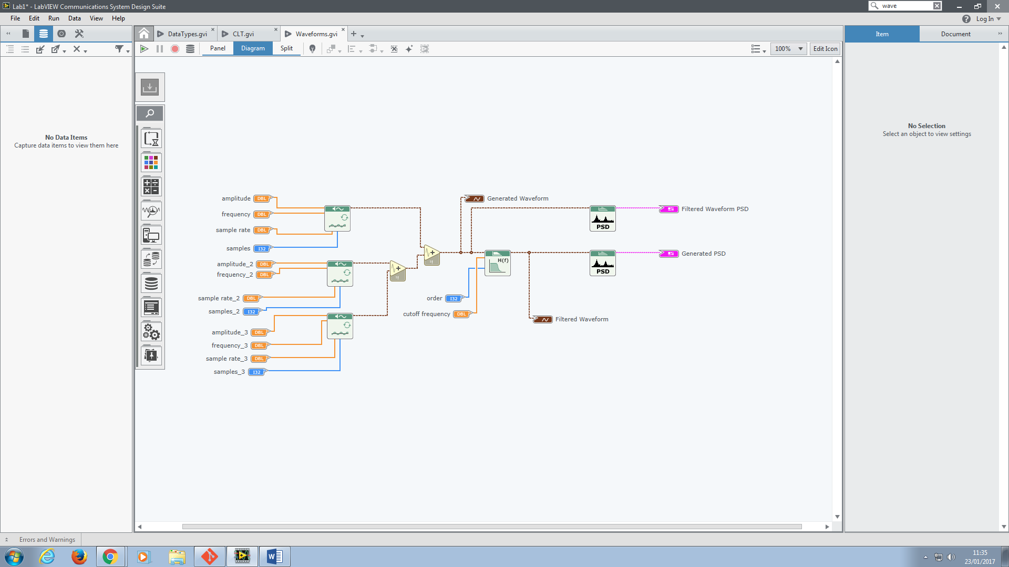

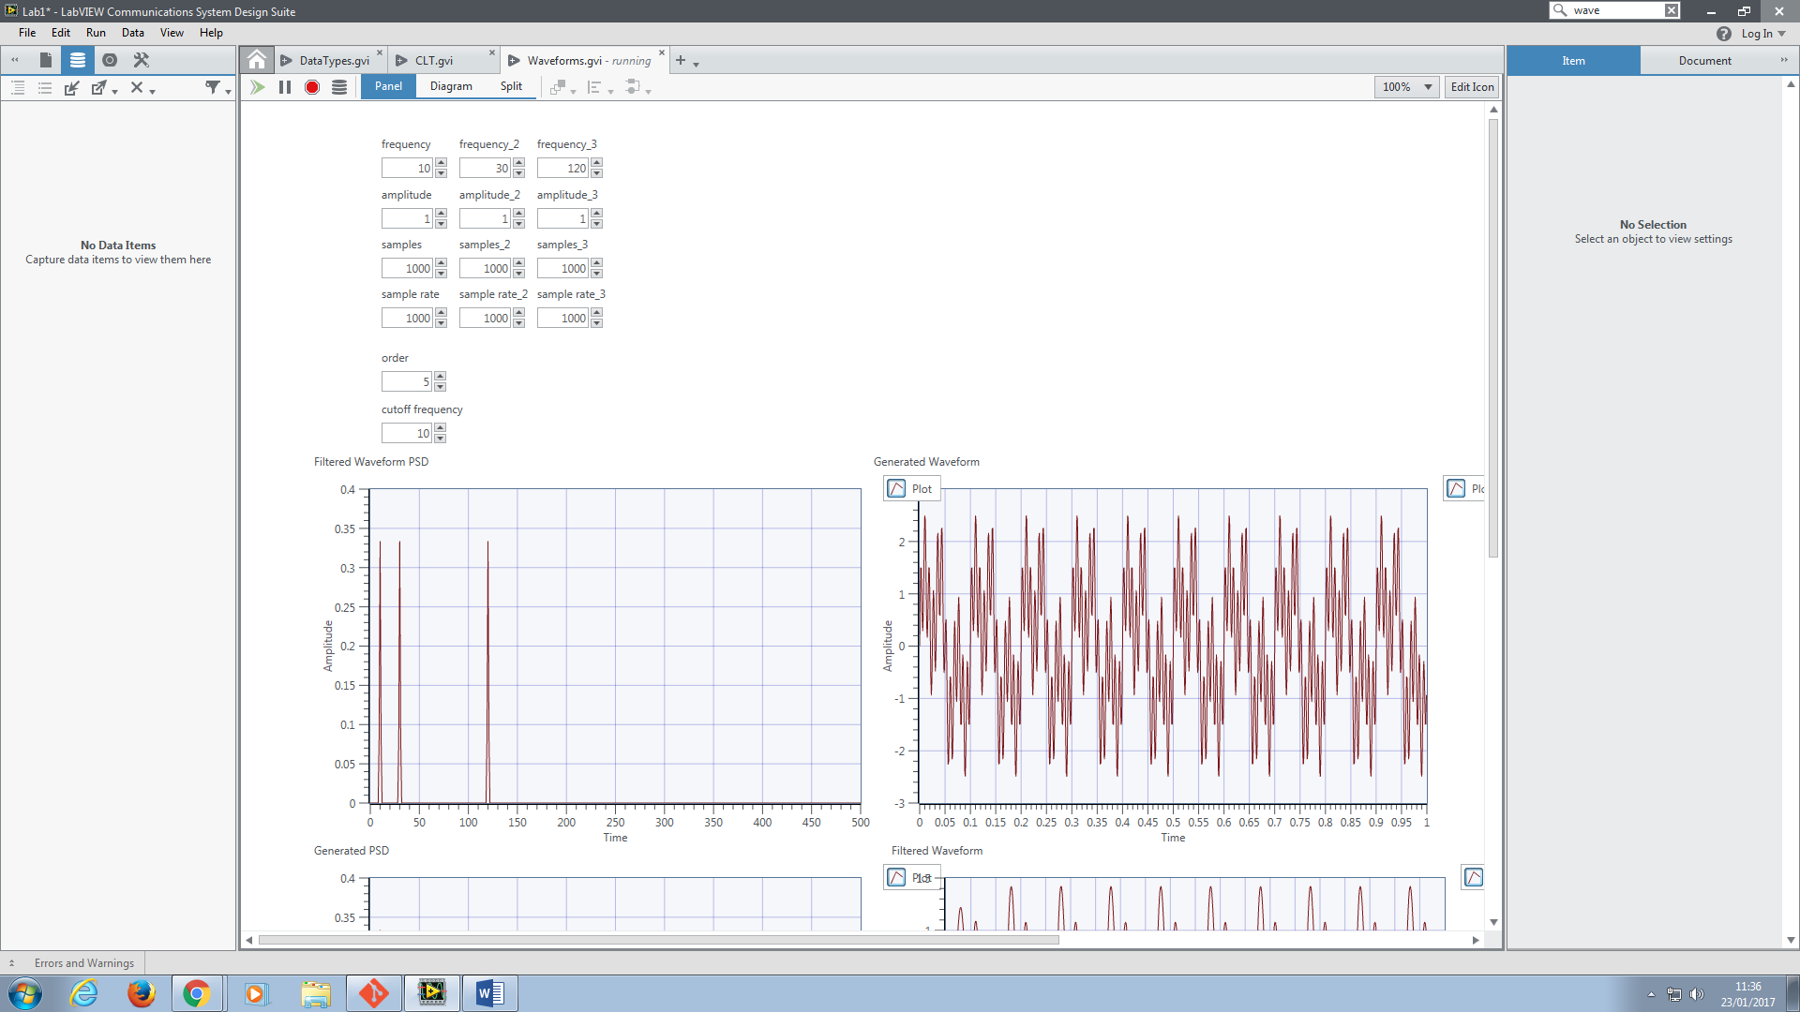

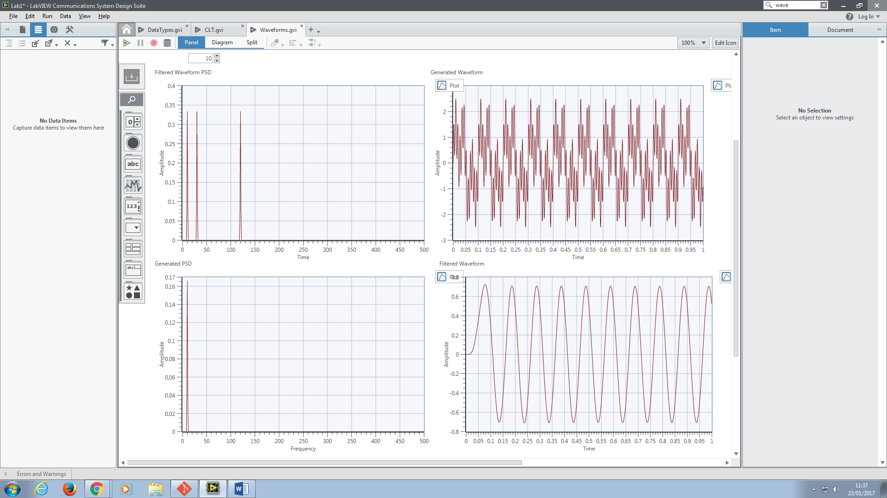

Altered to only include 30Hz component.

