Lab 2

Ex1. AM Modulator

AM(Amplitude modulation) uses the basic relation:

𝒔(𝒕) = [𝑨𝒄 + 𝑨𝒎𝐜𝐨𝐬(𝟐𝝅𝒇𝒎𝒕)]𝐜𝐨𝐬(𝟐𝝅𝒇𝒄𝒕)

Where fm is the frequency of message signal; fc is that of carrier signal.

Ac and Am are amplitude of carrier and message signals.

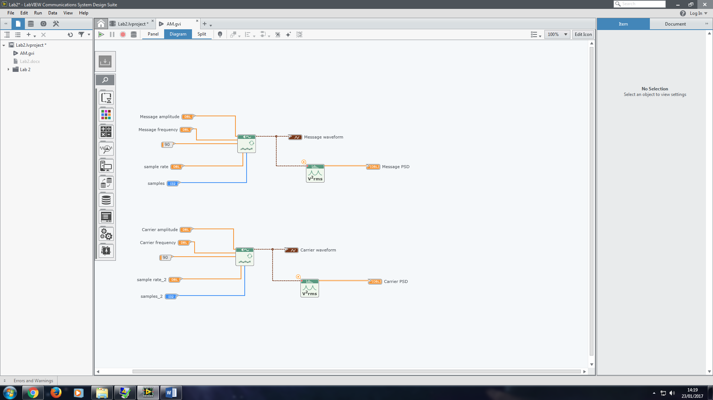

Obtain the waveforms of carrier and message signals and corresponding PSD.

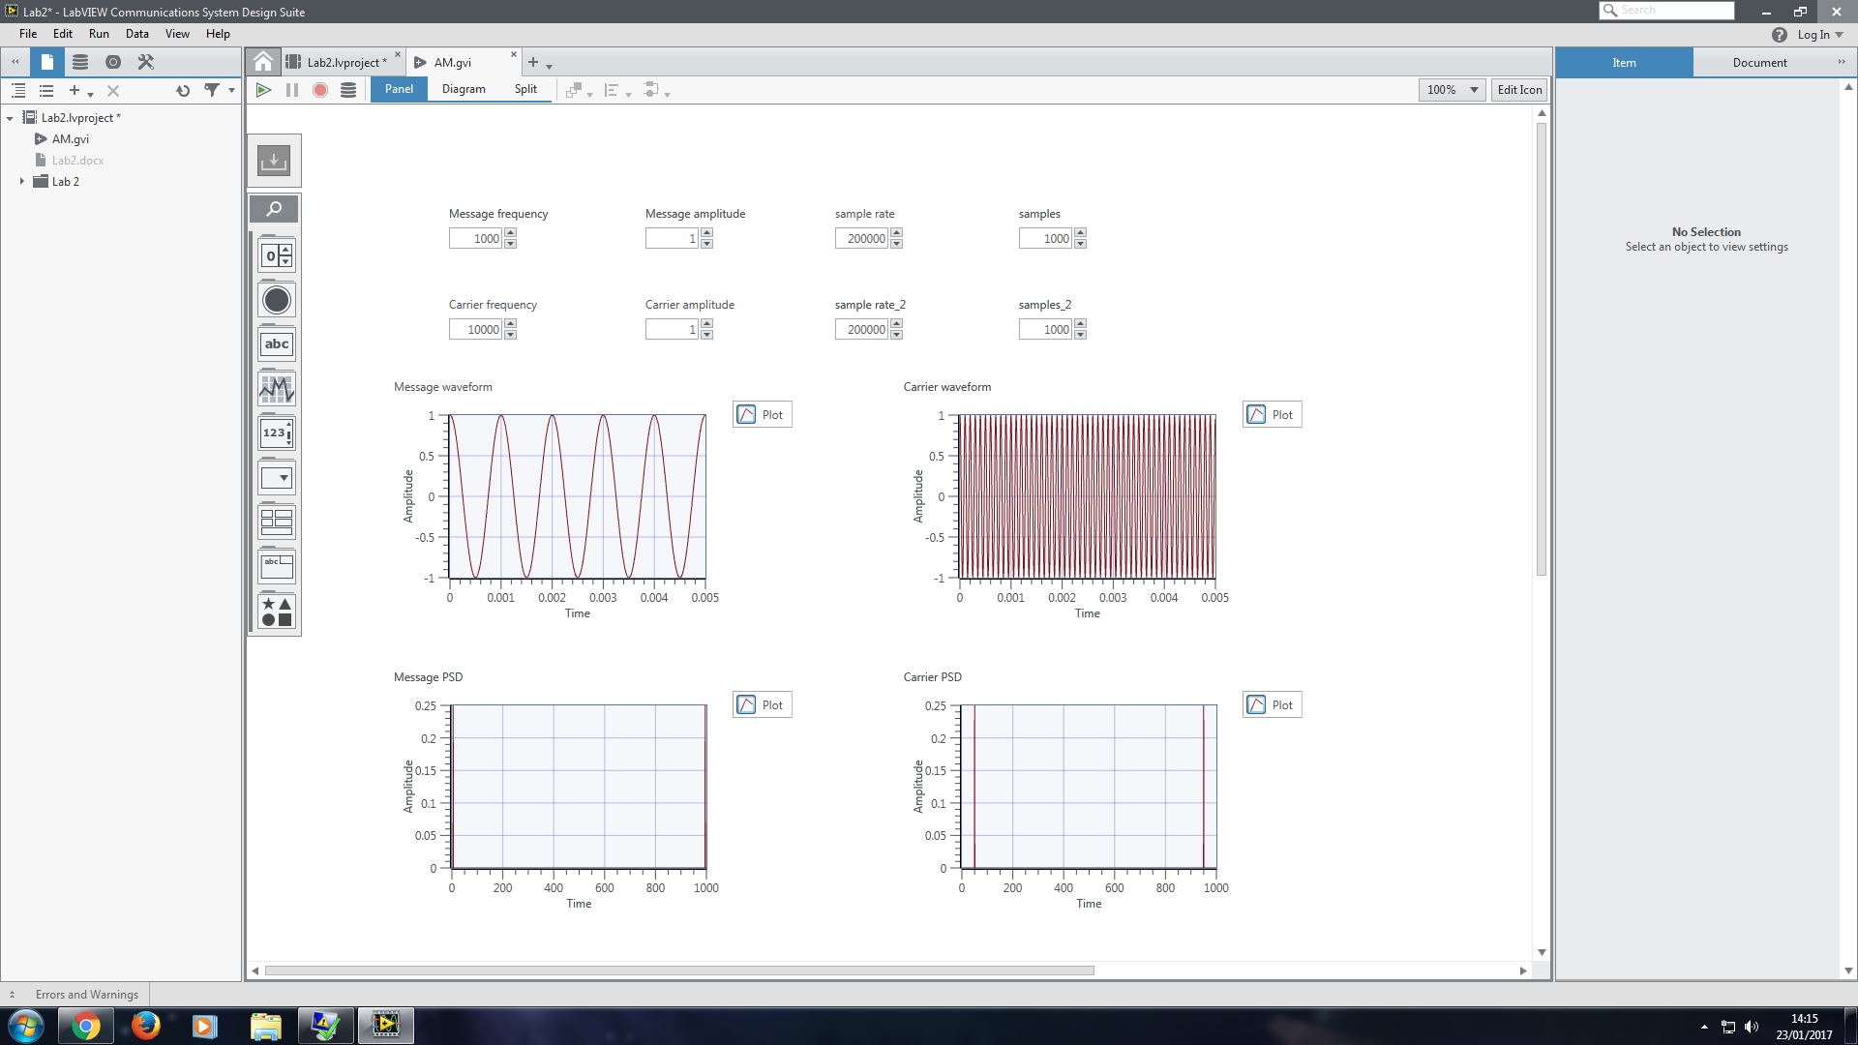

Obtain the AM waveform with modulation index 0.25.

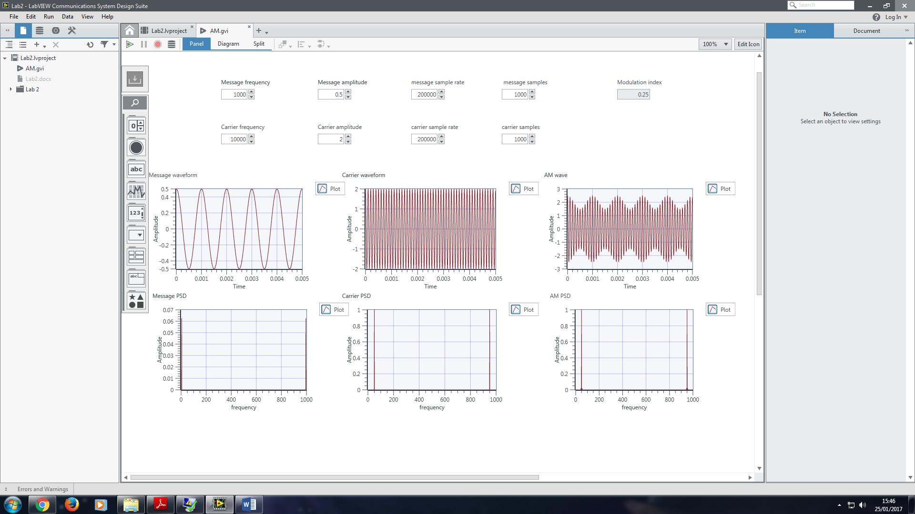

Obtain the AM waveform with modulation index 0.5.

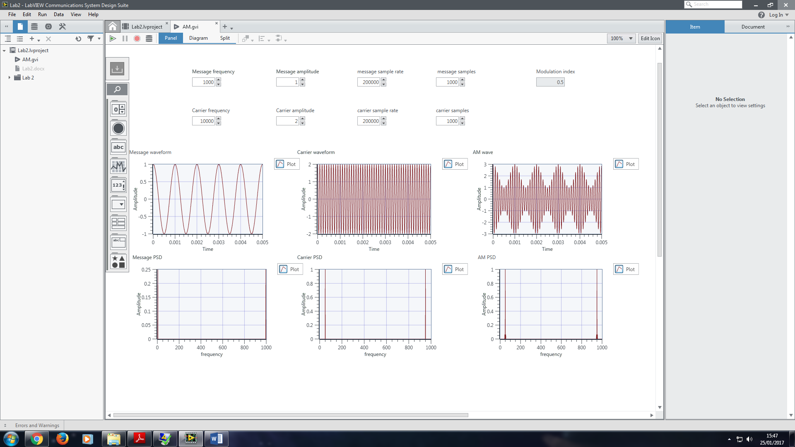

Obtain the AM waveform with modulation index 0.75.

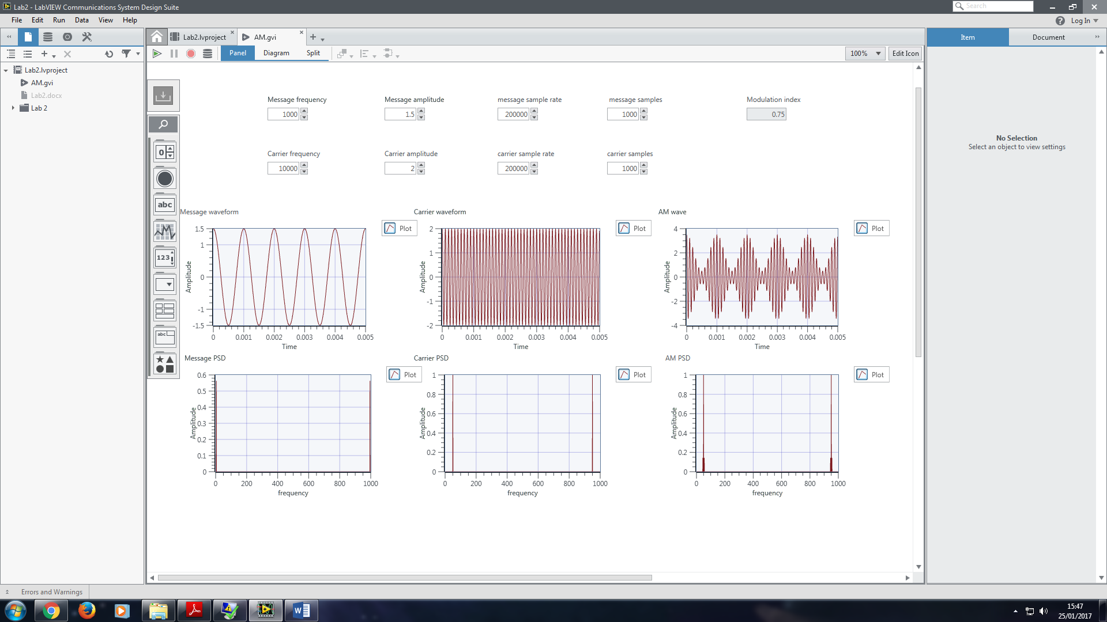

Obtain the AM waveform with modulation index 1.

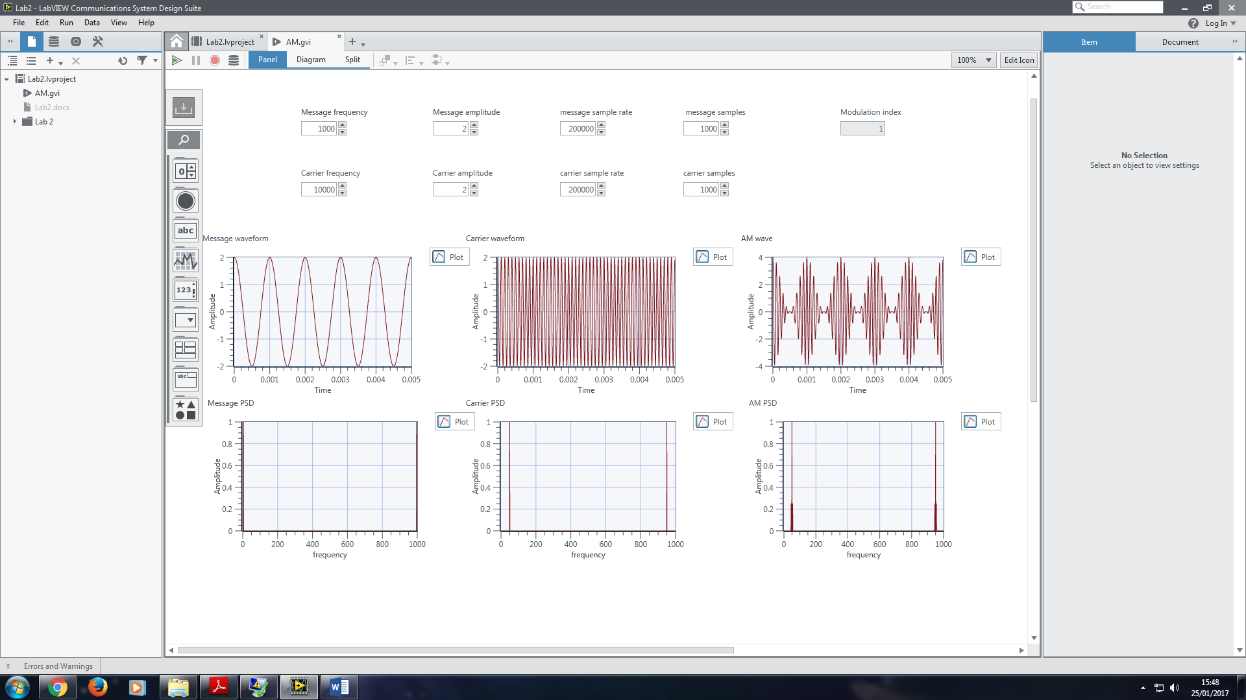

Obtain the AM waveform with modulation index 2.

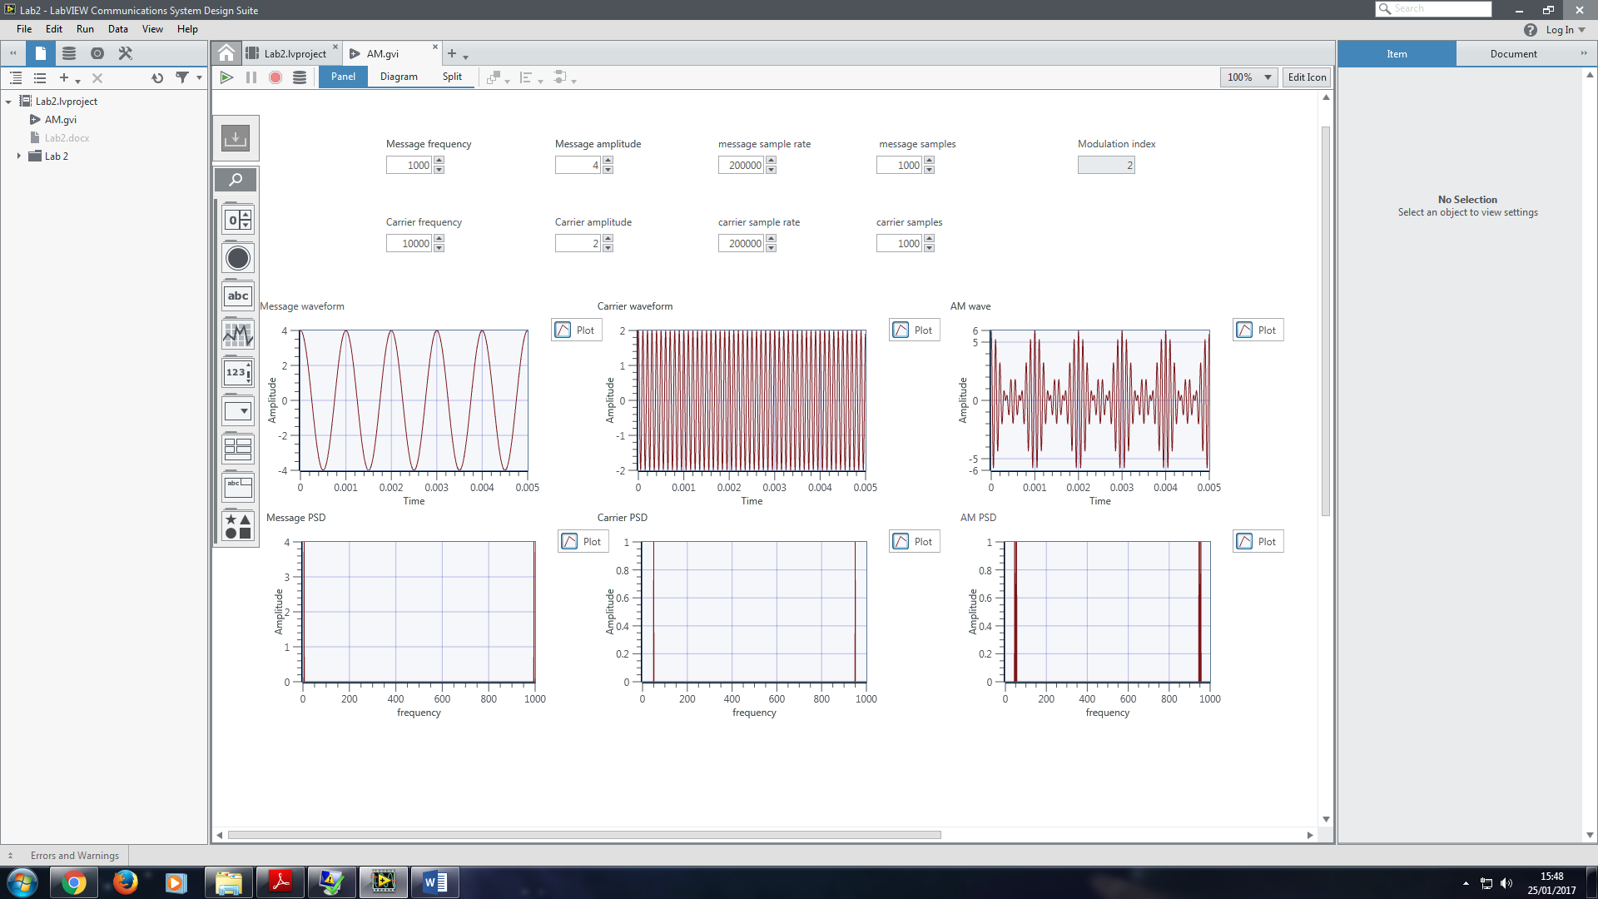

Observe the impact on AM with various frequency:

fm = 1000HZ

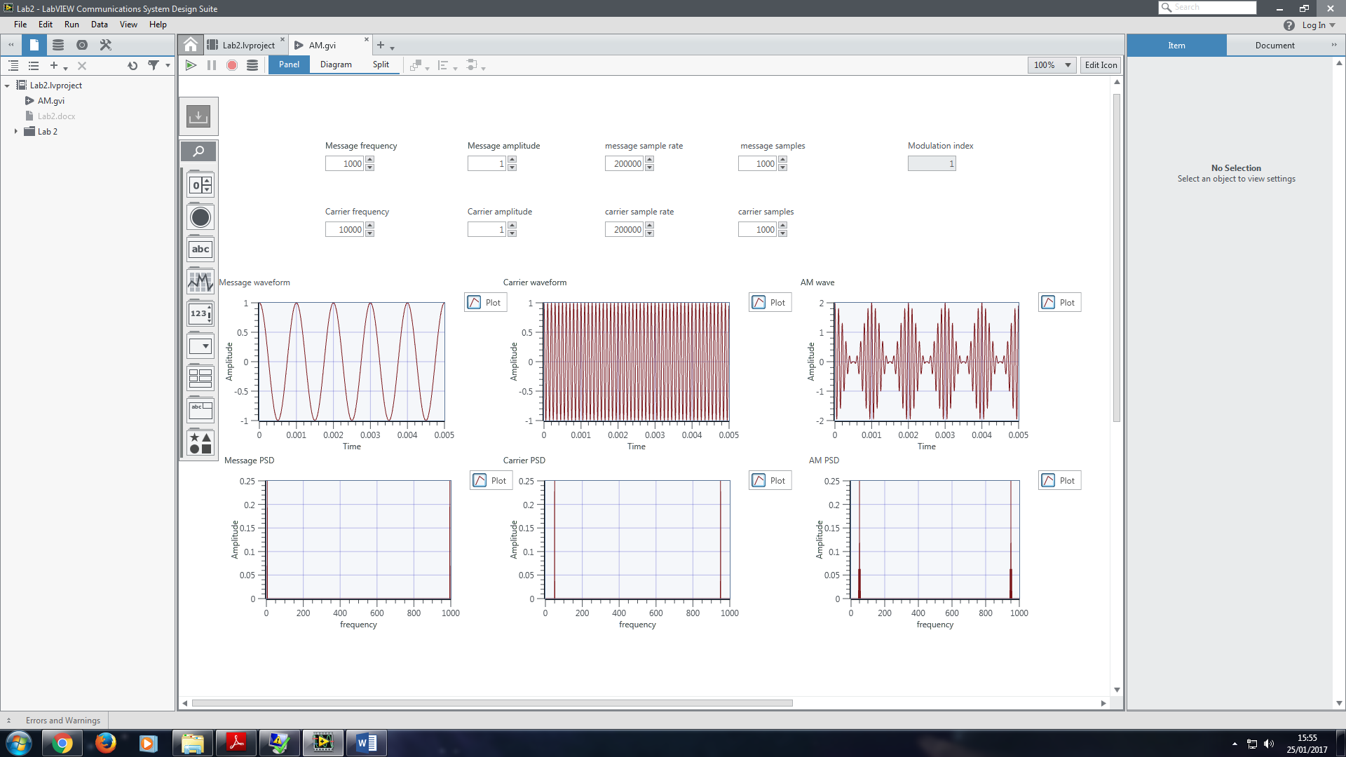

fm = 2000HZ

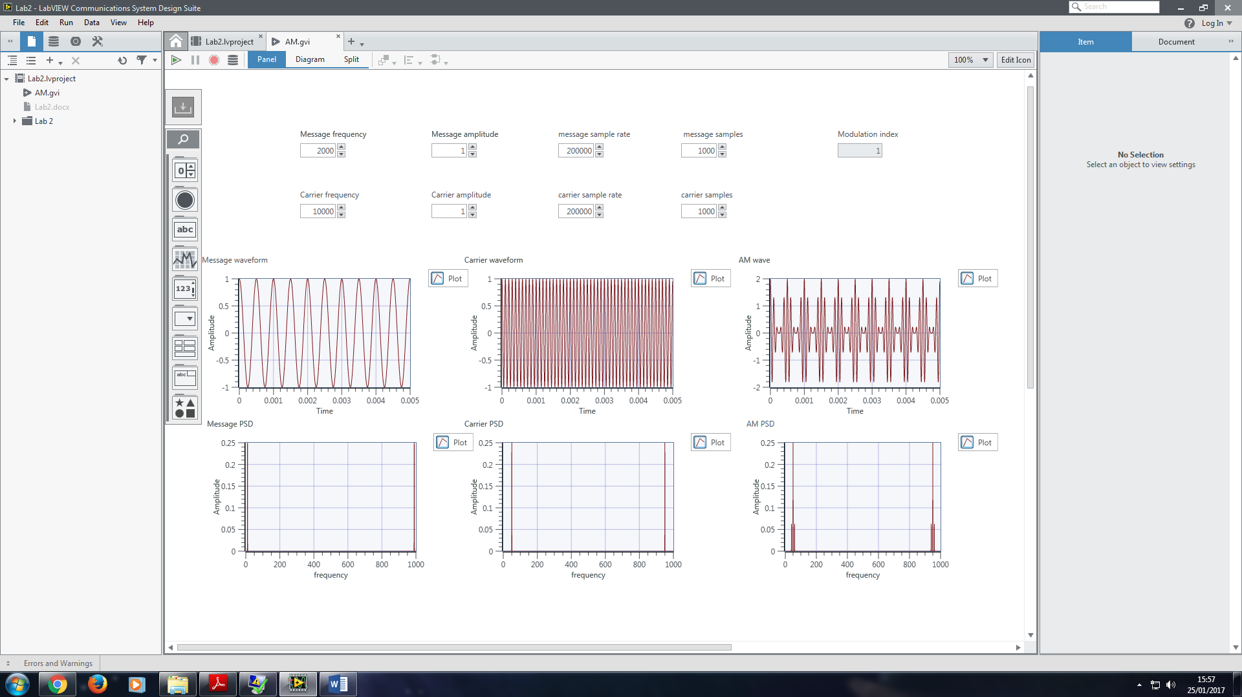

fm = 5000HZ

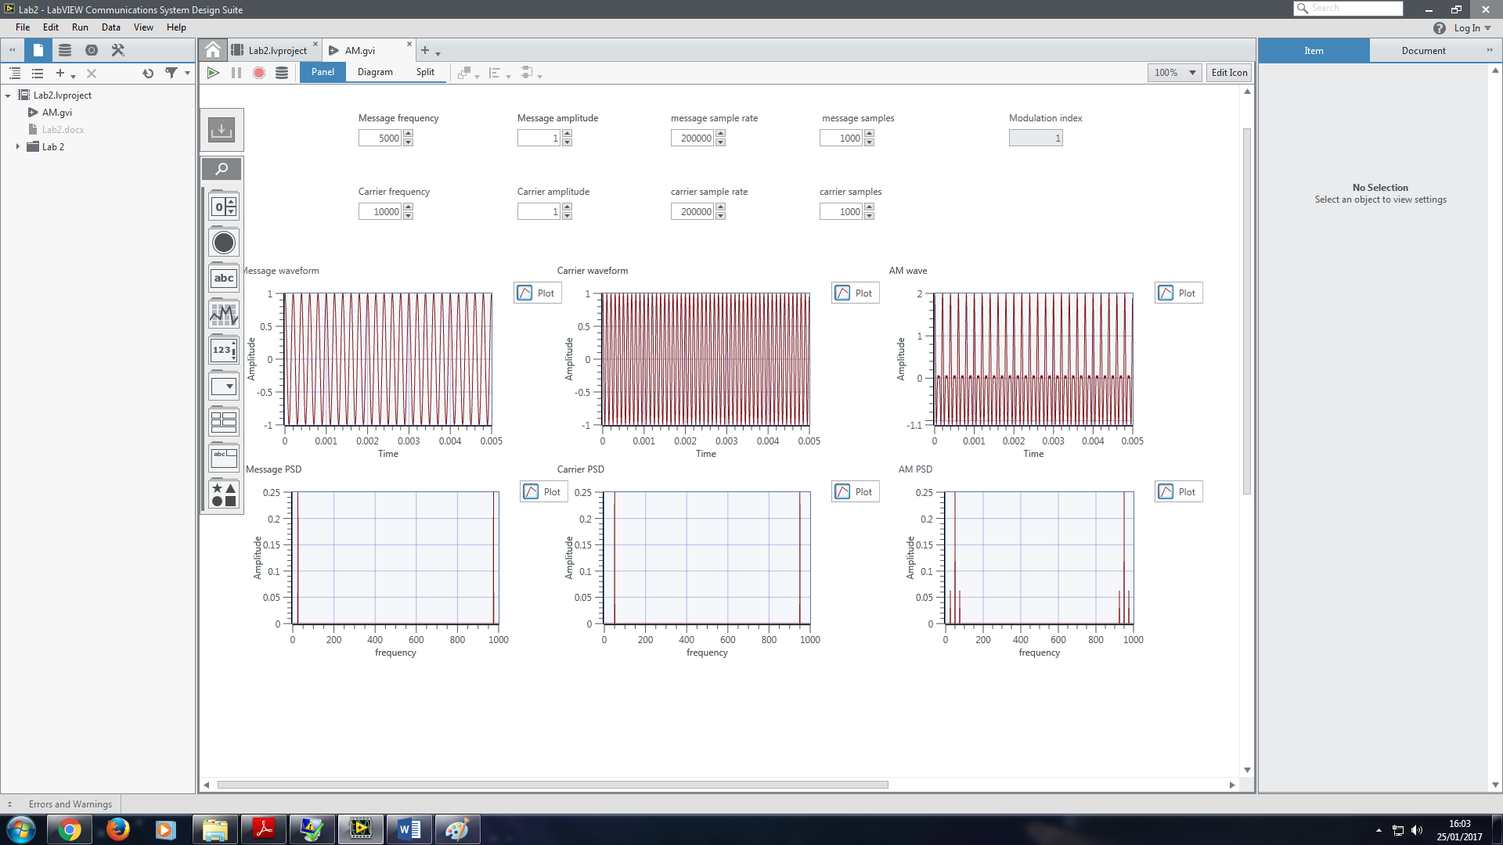

Question: what’s the influence on Am when we change the frequency of message wave?

Diagram of construction of AM:

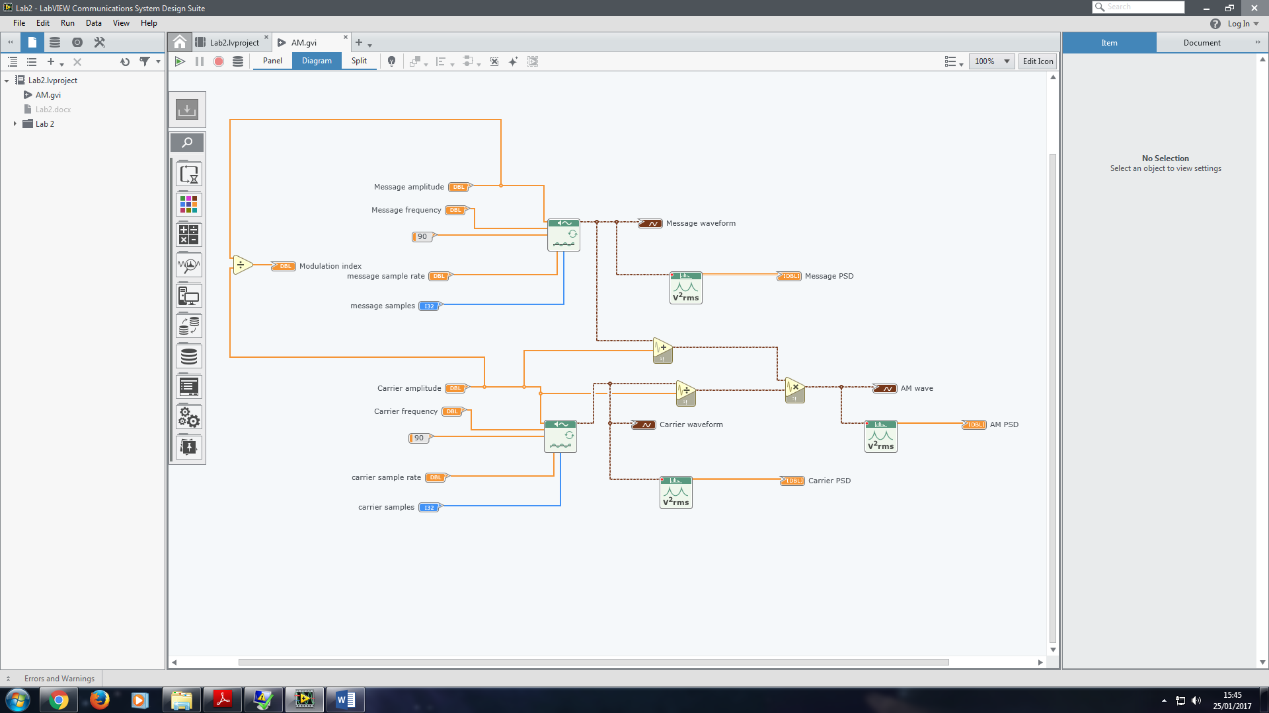

Ex.2 AM Demodulators

Part a: Coherent detection

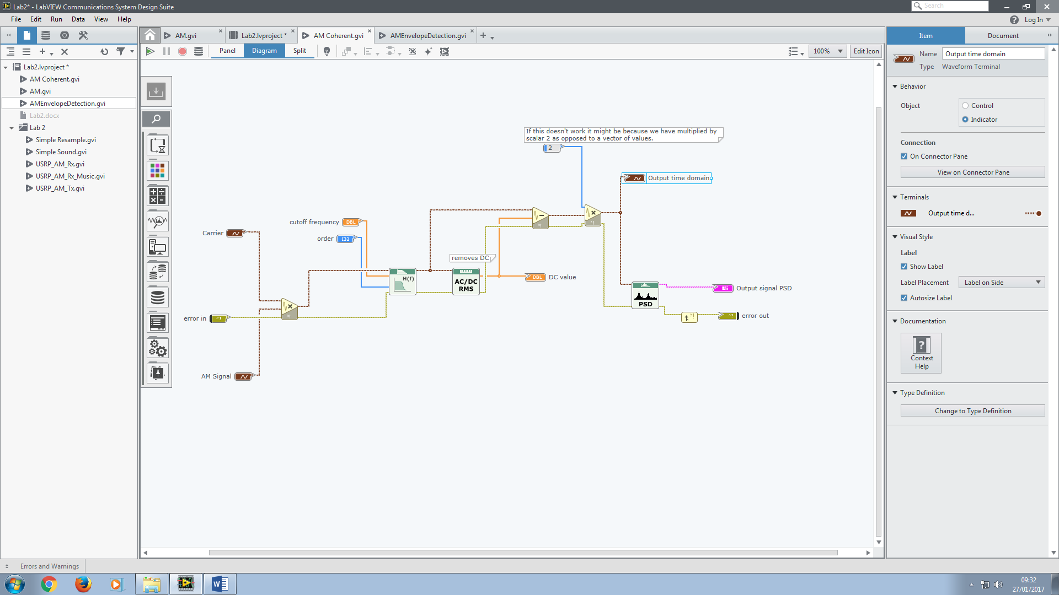

Mathematical theory:

Part b envelop detection:

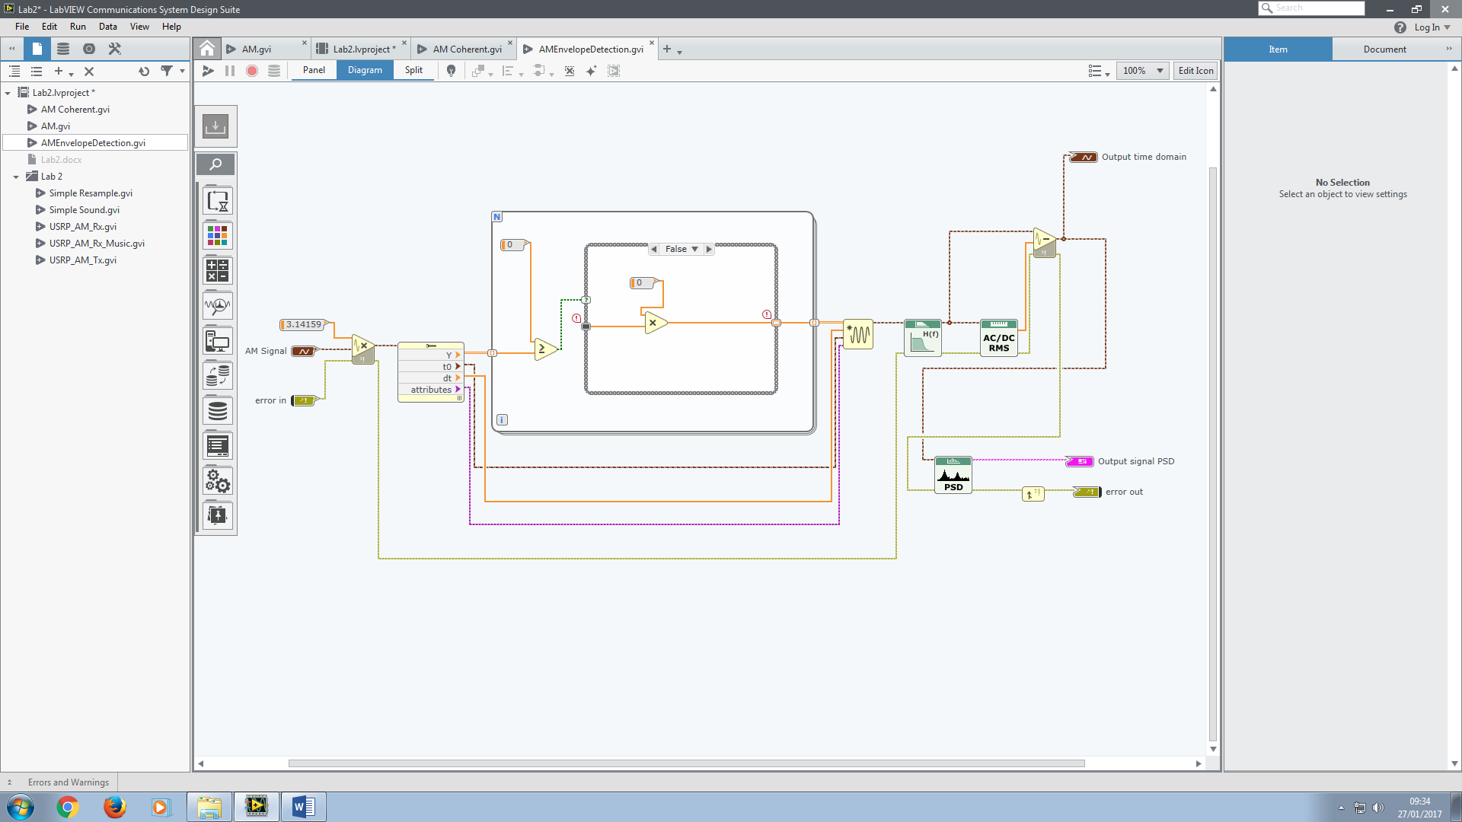

* Remove negative values
* Remove higher frequency components
* Remove DC components (introduced in first step?)

Ex3.

