Level 4 Adult ESL Curriculum · Lesson 3 (Week 3): Have You Finished Yet?
Status: Complete lesson (all 13 Level 4 lessons are published).
Date: October 2026
Audience: Program coordinators and volunteer teachers
Companion files: images/ (12 vocabulary pictures + images/CREDITS.md). Audio: audio/L4_L3_listening.mp3.
Topic: At work: checking what is done and not done, an end-of-shift handoff, and a short, positive check-in with a supervisor. Learners use already, yet, and just and write an update email.

How this lesson is organized
Part | What's inside | Who uses it
Teacher Plan | At a glance, clock-time plan, step-by-step boxes, listening script, answer key, teacher notes | Volunteer teachers
Student Pages | Opening Talk, New Words, My Words, Listening, Grammar, Talk Time, Homework, Read & Write, Exit Ticket, Task Words (optional). Print this part for learners | Learners
Picture Credits | Picture, audio, and license credits | Coordinators

What Lesson 3 builds on and what it adds
Before (review only) | Where | New in Level 4 Lesson 3
Have you ever…? and have / has + a past participle | Level 4 Lessons 1–2 | already / yet / just with the present perfect: Have you cleaned it yet? → Yes, I've already cleaned it.
Object pronouns it / them | Level 3 Lesson 2 | it / them in short answers: I've restocked them. I haven't cleaned it yet.
Simple past with a time: I finished at 3:00. | Level 3 Lessons 2–4 | Present perfect → simple past for the time: I've finished the orders. I finished them at 3:00.

TEACHER PLAN
Lesson 3 (Week 3)

Have You Finished Yet?
At a glance · Clock-time plan · Step by step · Script and answer key

How to Use This Plan
You don't need to speak Spanish or any other language. Teach in English. Show, point, and gesture. Some Grammar pages have one short contrast tip, only where a common mix-up exists. Learners read it on their own. You never need to read, translate, or explain it.

Instructions: use the same short task words every week: Listen. Circle. Check. Write. Work with a partner. Work in a group. Ask a follow-up question. Give a reason. An optional Task Words page is at the back of the workbook for learners who want it.

Instruction rule: Model it (do it with one learner while everyone watches), check it (ask: "Is it done? Did it happen a minute ago? Is it a question or a not sentence?"), then go. Say less, show more.

Grouping toolkit: Pairs: turn to a neighbor; with an odd number, make one group of 3. Groups: 3–4 learners. Inside–outside circles: the inner circle faces out, the outer circle faces in; the outer circle moves one person to the right each round. Mingle: everyone stands and talks to many classmates. The teacher joins a pair only if one learner is left over.

When a learner is stuck or speaks another language to you: (1) show it: the picture, a gesture, or the board; (2) give one more short English example; (3) point to the grammar box on their page; (4) a classmate can help for a few seconds, then back to English. You don't need to understand what classmates say to each other.

Three sentences, not one: in Level 4, every Talk Time answer and every exit ticket has about three connected sentences: the answer, a reason, and a detail or example.

Lesson 3 (Week 3): Have You Finished Yet?
At a glance
Objectives: learners can…
• say what they've already done and what they've just done
• ask Have you… yet? and answer Yes, I've already… / No, not yet.
• put already, just, and yet in the right place
• answer a supervisor's check-in questions in 3 sentences
• write a reply email (5–8 sentences) about what is done and not done yet

Materials
• Student Pages for Lesson 3 (print for the number expected + 3 spares)
• Board and markers; a 5-line checklist drawn on the board
• Talk Time Cards A and B (in the workbook); 3 check-in question cards per group (copy them from the Talk Time page onto index cards, optional)
• A folder for each learner for the writing checks (Writing Check 1 is tonight)
• Listening: phone + small speaker, L4_L3_listening.mp3 (about 1:59). No speaker? Read the script aloud with a volunteer.
• Prep time: 15 minutes (read the plan; draw the checklist; practice reading the listening script).

Key vocabulary (with pictures on the New Words page)
★ to-do list • ★ task • ★ checklist • ★ supervisor • ★ deadline • ★ restock • ★ inventory • ★ clock in • ★ clock out • ★ break room • ★ feedback • check-in (a short meeting)
Also: a shift, a delivery, put away, a cooler, an aisle, a time clock, a training, a reminder, a handoff, a coworker.

Clock-time plan
Times are loose. If the listening or Talk Time runs long, take the time from Read & Write.
Time | Step | Min | Grouping (15 / 7–8) | If running behind
6:00–6:08 | Opening Talk + Homework Check | 8 | Pairs (7 pairs + 1 trio / 3–4 pairs) | One card only
6:08–6:15 | New Words (picture page) + pair game (+ My Words) | 7 | Whole class, then pairs | Teach the ★ words only
6:15–6:30 | Listening: play 1 (Task A), play 2 (Tasks B and C) + "Hear it, say it" | 15 | Individuals, then pairs check | Do Task C together on the board
6:30–6:45 | Grammar Q&A: already / yet / just with the present perfect + pair check | 15 | Whole class, then pairs | Skip the pair check; Talk Time practices it
6:45–7:00 | BREAK | 15
7:00–7:15 | Talk Time: Shift Handoff + Check-in | 15 | Pairs, then groups of 3 | Round 1 only
7:15–7:25 | Read & Write: An email from a supervisor + a reply (Writing Check 1) | 10 | Pairs read, then individual writing | Reading questions only; the writing becomes homework
7:25–7:30 | Exit Ticket + Homework | 5 | Individuals | Never skip

Skip order if you're running behind: (1) the Read & Write writing task (it becomes homework); (2) the pair check at the end of Grammar; (3) the second round of Talk Time. Never skip: the listening tasks, the grammar boxes and the mistakes table, and the exit ticket.

Attendance (15 → 7–8 → 5 or fewer): every step lists the sizes. With 5 or fewer, do Shift Handoff in pairs (or one group of 3, taking turns), and in the Check-in you play the supervisor first. Late arrivals join any pair and take Card B.

Step by step
Step 1 · 6:00–6:08 · Opening Talk · 8 min
• Grouping: pairs, the same partner for both parts. 15 learners: 7 pairs + 1 group of 3. 7–8 learners: 3–4 pairs. 5 or fewer: pairs, or one group with you.
• Before class: write on the board: How long have you…? and for / since
• Opening Talk (5 min): learners open the Opening Talk page. A asks a card question; B answers in 3 sentences (the answer, a reason, a detail); A asks one follow-up. Switch after each card.
• Model with one learner: you ask, "How long have you lived in this city?" The learner answers with for or since. Then you ask, "Where did you live before? How long did you live there?" Help them say 3 sentences.
• Homework Check (3 min): Pairs compare Homework item 1 (for / since sentences) and read one answer from item 3 to each other. Then they fill in the box on the Opening Talk page. Walk around. Write 2 common errors on the board (often I live here since 2020 (→ I've lived here since 2020) and since three years (→ for three years)) and correct them together. Also put up 2 corrections from last week's exit tickets.
• Late arrivals: join any pair as a group of 3.
• If behind: one card only.

Step 2 · 6:08–6:15 · New Words · 7 min
• Grouping: whole class, then pairs. Show the New Words page.
• Do: point to each picture and say the word. Learners repeat once.
• Show the hard words: to-do list (things to do) vs. checklist (a list with boxes to tick ✓); restock (put more on the shelves); inventory (count what you have); clock in / clock out (start and end work; mime a time clock); deadline (the last day); feedback (what a supervisor says about your work); check-in (a short meeting).
• Check meaning (1 min): ask "Is a deadline the first day or the last day?" (the last day) • "Do you clock in at the start or the end of your shift?" (the start) • "Is Great job! feedback?" (yes, positive feedback).
• Pairs (2 min): A says a word; B points to the picture and makes a sentence (Have you clocked in yet? → Yes, I've already clocked in.). Switch. 15 learners: finish with a quick team round (3 teams; you say a clue, the first team with the word gets a point). 7–8: 2 teams. 5 or fewer: one team against the clock.
• My Words: "Write any word you want in your language on the My Words page. It's your personal list. It's optional." Learners do it at home.
• If behind: teach the ★ words only.

Step 3 · 6:15–6:30 · Listening + "Hear it, say it" · 15 min
• Grouping: individuals, then pairs check. With 5 or fewer, check together as a group.
• Before you listen (2 min): say: "It's the end of the evening shift at a grocery store. Ms. Rivera, the supervisor, talks to two workers, Jamal and Kim. Listen: is all the work finished?"
• Play 1 → Task A (the main idea). Pairs compare. Check together.
• Read Tasks B and C together (1 min) so learners know what to listen for.
• Play 2 → Tasks B and C. Pairs compare. Then show the answers (answer key).
• "Hear it, say it" (3 min): Point to the script lines. gonna = going to: "I'm going to clean it before I clock out." wanna = want to: "I want to finish it this week." Then practice hearing 's = has: It's just arrived (= it has just arrived), the weak have in Have you… yet?, and the stress: I've JUST finished it. • I've alREADY restocked them. The class repeats the two lines twice.
• The audio plays the conversation once (about 1:59). Press play again for play 2. A third play is fine if the class needs it. The script says going to and want to. People often say gonna and wanna; learners only need to recognize those words.
• If behind: do Task C together on the board, reading the lines yourself.

Step 4 · 6:30–6:45 · Grammar Q&A · 15 min
• Grouping: whole class, then pairs. Show the Grammar page. The left side is the question. The right side is the answer.
• Show it (2 min): draw a checklist on the board with 5 tasks. Tick two and say, "I've already restocked the shelves. I've already clocked in." Tick one now, in front of the class: "I've just cleaned the board." Point to an empty box: "I haven't checked the inventory yet."
• The boxes (5 min): Box 1: read across: Have you cleaned the break room yet? → Yes, I've already cleaned it. / No, not yet. Box 2: add a time → simple past: I finished them at 3:00. Box 3: word place (already and just before the past participle; yet at the end). Box 4: which one?
• Rule of thumb and Questions and answers (2 min): read the rule of thumb aloud. Read each Q and A; the class reads the right sentence after you.
• Check questions: "I've finished it yesterday. Right or wrong?" (wrong: I finished it yesterday.) • "Where does yet go?" (at the end) • "It's just arrived. It's = it is or it has?" (it has).
• Practice A and B (3 min): learners write, then pairs check. Go over the answers. Read the Common mistakes table together: "Don't say… Say…".
• Pair check (last 3 min): A reads a task from the board checklist and asks Have you… yet? B answers Yes, I've already… / I've just… / No, not yet. Switch. 15 learners: swap partners once. 5 or fewer: you join one pair.
• If behind: skip the pair check. Talk Time practices it.

Break · 6:45–7:00 · 15 min
• Write on the board: Have you… yet? → Yes, I've already… / I've just… / No, not yet. I haven't… yet.

Step 5 · 7:00–7:15 · Talk Time: Shift Handoff + Check-in · 15 min
• Model it first (1 min): hold up Card A and ask a learner to ask you, "Have you restocked aisle 3 yet?" Answer, "Yes, I've already restocked it." Then point to a task with no tick: "No, not yet. I'm going to do it before I clock out." Say: "Answer, then add one more sentence."
• Round 1 (7 min): Shift Handoff (pairs, information gap). A looks at Card A; B covers it. B asks Have you… yet? about each task and ticks done or not yet in the notes. Then switch: A asks about Card B.
• Round 2 (6 min): Check-in (groups of 3). The supervisor reads the 3 question cards. The worker answers with already and yet (invented answers are fine). The observer ticks each already / yet / just they hear. Rotate roles so everyone is the worker once.
• 15 learners: pairs for round 1; then 5 groups of 3 for round 2.
• 7–8 learners: pairs for round 1; then 2 groups for round 2 (the group of 4 has two workers).
• 5 or fewer: pairs (or one group of 3) for round 1. In round 2, you play the supervisor first; then learners take turns.
• Every answer needs a reason; every partner asks a follow-up. Walk around and listen. Note 2 good sentences to praise and 1 common error for next week.
• If behind: round 1 only.

Step 6 · 7:15–7:25 · Read & Write: An email from a supervisor + a reply · 10 min
• Grouping: pairs read and answer; individual writing. With 5 or fewer, read the text aloud together.
• Read (4 min): Learners read the email from Sandra on the Read & Write page and answer the questions. Say: "Read fast first. Then find the answers." Pairs answer questions 1–5 together.
• Check (1 min): go over the answers (answer key).
• Write (5 min): Learners write a reply email (5–8 sentences): what they've already done, what they haven't done yet, when they'll finish it, and one question. Show the example. Invented details are fine. This is Writing Check 1: collect it. Learners start in class and finish at home (Homework item 2).
• If behind: questions 1–5 only; the writing becomes homework.

Step 7 · 7:25–7:30 · Exit Ticket + Homework · 5 min · NEVER SKIP
• Exit ticket (3 min): learners open the Exit Ticket page and answer in 3 sentences with a reason: What have you done this week, and what haven't you done yet? Example on the board: I've already paid my phone bill. I haven't done my laundry yet. I haven't done it because I worked late every night. With 5 or fewer, a learner can say it to you first and then write it.
• Collect the pages. After class, sort them into ✓ / almost / not yet. Start next week with 2 corrections on the board (no names).
• Homework (2 min): open the Homework page. Do item 1 together (item 1: you / finish / the checklist / yet? → Have you finished the checklist yet?). Say: "About 15–20 minutes. Finish your Read & Write writing at home."

Listening script: L4_L3_listening.mp3 (about 1:59; the conversation plays once, so press play again for the second listen)
Audio: play L4_L3_listening.mp3 from a phone + small speaker. No speaker? Read the script with a volunteer, at a natural, friendly speed. The script says going to and want to. People often say gonna and wanna; learners only need to recognize those words.

Narrator: Lesson three. It's the end of the evening shift at a grocery store. Ms. Rivera, the supervisor, talks to Jamal and Kim.
Ms. Rivera: OK, team, it's almost nine. Let's look at the checklist. Jamal, have you restocked the shelves yet?
Jamal: Yes, I've already restocked them. Those shelves are done.
Ms. Rivera: Great. And the delivery? Has the truck arrived yet?
Jamal: Yes, it's just arrived. Kim and I are putting it away.
Kim: We have already put away the milk and the eggs.
Ms. Rivera: Good. Kim, have you cleaned the cooler yet?
Kim: No, not yet. I haven't cleaned it yet. The delivery came late.
Ms. Rivera: That's OK. Are you going to have time tonight?
Kim: I think so. I'm going to start it after the delivery. It takes about twenty minutes.
Ms. Rivera: Perfect. Jamal, have you checked the bakery inventory?
Jamal: I've just finished it. I gave you the list at eight.
Ms. Rivera: Oh, right, I have it here. Thanks. And the break room?
Jamal: Not yet. I'm going to clean it before I clock out.
Ms. Rivera: OK. So the cooler and the break room aren't done yet. Everything else is done.
Kim: Ms. Rivera, have you seen the new training schedule yet?
Ms. Rivera: Yes, I've just seen it. The deadline for the safety training is Friday.
Kim: Thanks. I want to finish it this week.
Ms. Rivera: Good idea. And some quick feedback: you both did great work tonight. The shelves look really good.
Jamal: Thank you. That means a lot.
Kim: Thank you, Ms Rivera. I will see you tomorrow.
Narrator: That's the end of the listening.

Answer key
• Listening Task A: b (No, two things aren't done yet.).
• Listening Task B: 1 done, 2 done, 3 not yet, 4 done, 5 not yet, 6 not yet.
• Listening Task C: 1 already, 2 yet, 3 just, 4 yet, 5 just, 6 already.
• Grammar Practice A: 1 yet, 2 just, 3 yet, 4 yet, 5 already, 6 just.
• Grammar Practice B: 1 haven't, 2 finished, 3 them, 4 Has, 5 has just, 6 did you clock in.
• Talk Time: answers will vary.
• Homework 1: 1 Have you finished the checklist yet? 2 She hasn't clocked out yet. 3 The truck has just arrived. 4 We've already restocked the shelves. Homework 2 and 3: answers will vary. Homework 4: 1 them, 2 it, 3 them, 4 it, 5 them.
• Read & Write B: 1 The evening team. • 2 By Thursday. • 3 Friday, May 16. • 4 On the computer in the break room. • 5 The new schedule. • Writing (C): answers will vary.
• Exit ticket: answers will vary. A good answer: "I've already paid my phone bill. I haven't done my laundry yet. I haven't done it because I worked late every night."
Teacher notes
• Keep work talk positive and invented. Learners never discuss real problems with real bosses or coworkers. Any job works in the role plays; invented answers are fine.
• The board checklist: keep it up all night. A tick = already (or just, if you tick it now); an empty box = not yet.
• Word place: teach already before the past participle. In speaking, I've cleaned it already is also common; accept it. yet always goes at the end.
• 's = has: It's just arrived. She's already left. Ask: "is or has?" If a past participle comes next, it is has.
• Writing Check 1: collect the reply emails. Write one strength and one fix on each (for example, the place of yet). Return them next week; learners keep them in a folder to see progress. No scores.
• Spanish and other languages: the contrast tip on the Grammar page is optional. Learners read it on their own. You never need to read, translate, or explain it.
• Reductions: the listening says going to and want to. People often say gonna and wanna. Learners only need to recognize the short forms; they can always say the full forms.

STUDENT WORKBOOK
Lesson 3 (Week 3)

Have You Finished Yet?
Opening Talk · New Words · Listening · Grammar · Talk Time · Homework · Read & Write · Exit Ticket

Lesson 3 (Week 3) · Opening Talk
Name: ______________________________ Date: ________________
Work with a partner. A asks a question. B answers in 3 sentences: the answer, a reason, and a detail. A asks one follow-up question. Then switch.
A: How long have you lived in this city? | A: How long have you had your phone?
A: How long have you known your best friend? | A: How long have you studied English?

Follow-ups: When did you…? • Where did you… before? • Why?
Write your partner's name and one How long…? answer.
My partner's name | How long? (for / since)

Lesson 3 (Week 3): Have You Finished Yet?
Student Page 1 · Week 3
Name: ______________________________ Date: ________________
New Words
Look. Listen. Repeat. ★ = most important words.
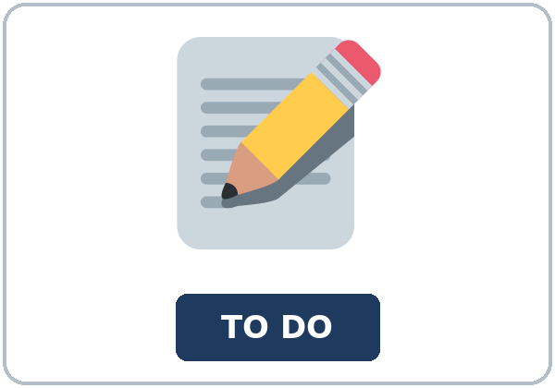  ★ to-do list | 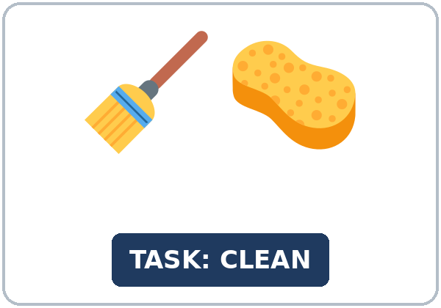  ★ task | 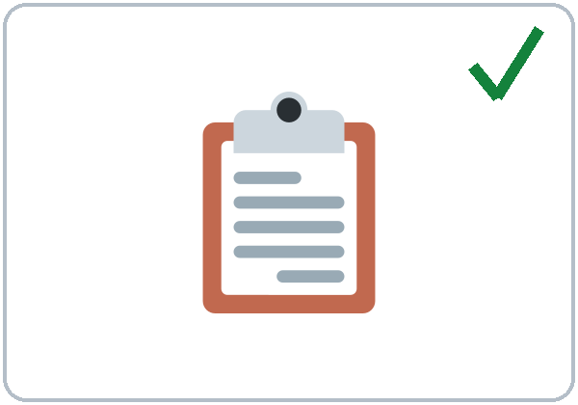  ★ checklist | 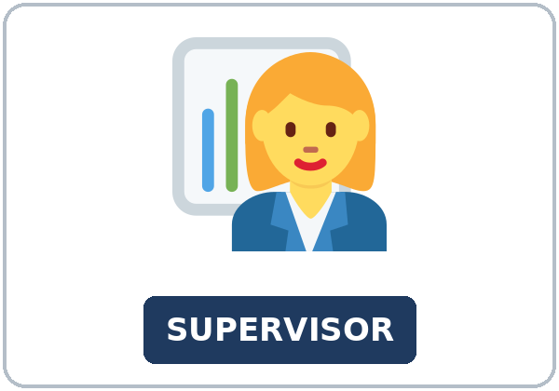  ★ supervisor
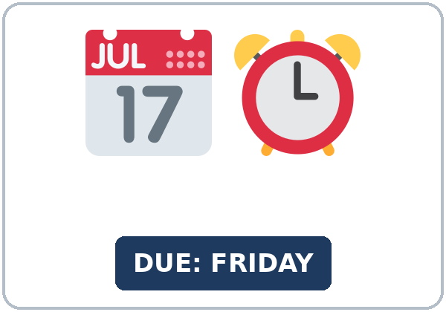  ★ deadline |   ★ restock | 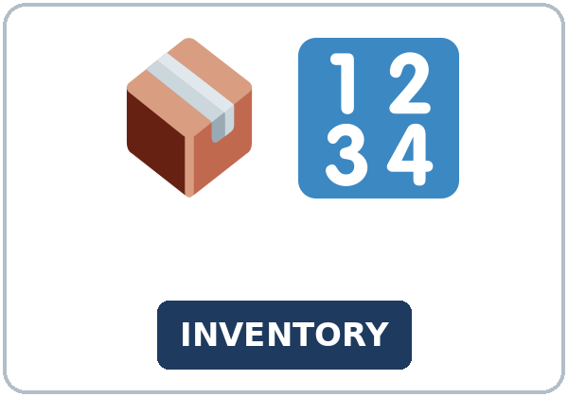  ★ inventory | 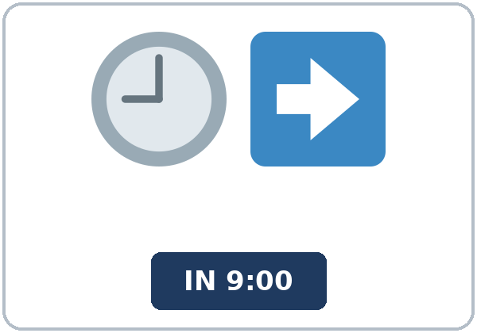  ★ clock in
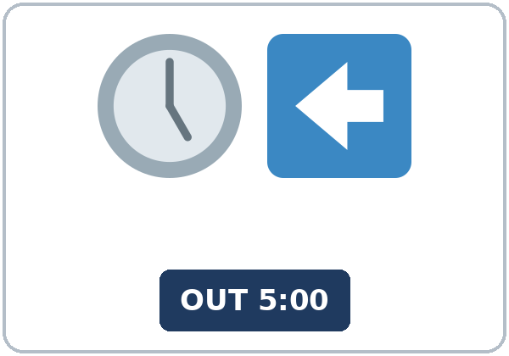  ★ clock out | 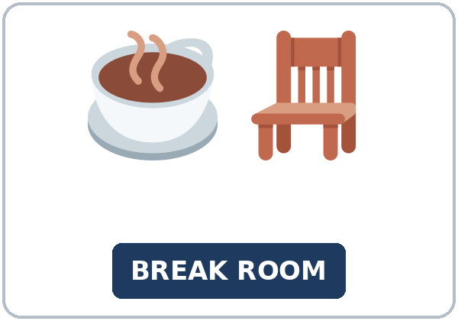  ★ break room | 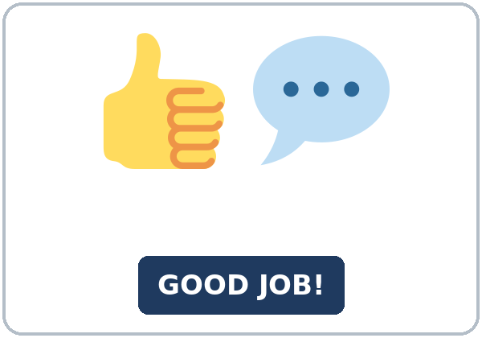  ★ feedback | 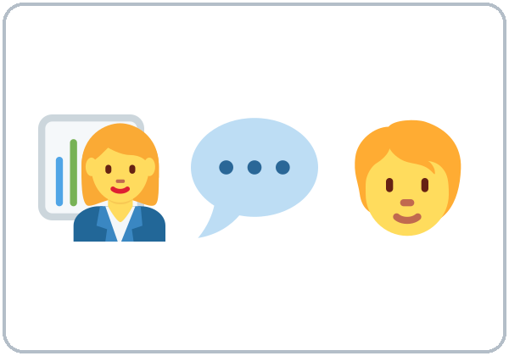  check-in (a short meeting)

Partner game: Done or not yet?
Example: A points to a picture and asks, "Have you clocked in yet?" B answers, "Yes, I've already clocked in." or "No, not yet." Switch.
Lesson 3 (Week 3) · My Words
My personal word list. Write each word in your language, if you want. Then write your own example.
Word | My language | My example
to-do list
task
checklist
supervisor
deadline
restock
inventory
clock in
clock out
break room
feedback
check-in (a short meeting)

Add 2 more words from tonight (from the listening, the reading, or your partner).
Lesson 3 (Week 3) · Listening
It's the end of the evening shift at a grocery store. Ms. Rivera, the night supervisor, checks the work with Jamal and Kim.
A. Listen. Is all the work finished? Circle.
a. Yes, everything is done. b. No, two things aren't done yet. c. No, nothing is done yet.
B. Listen again. Look at the checklist. Circle done or not yet.
1. restock the shelves: (done / not yet)
2. put away the milk and the eggs: (done / not yet)
3. clean the cooler: (done / not yet)
4. check the bakery inventory: (done / not yet)
5. clean the break room: (done / not yet)
6. Kim's safety training: (done / not yet)
C. Listen again. Write already, yet, or just.
1. Yes, I've ____________ restocked them.
2. Has the truck arrived ____________?
3. Yes, it's ____________ arrived.
4. I haven't cleaned it ____________.
5. I've ____________ finished it.
6. We have ____________ put away the milk and the eggs.
Hear it, say it
gonna = going to: "I'm going to clean it before I clock out." • wanna = want to: "I want to finish it this week." You can say going to and want to. Listen for 's = has: It's just arrived. Say it with stress: I've JUST finished it. • I've alREADY restocked them.
Lesson 3 (Week 3) · Grammar
Read across. A reads from the left side. B answers from the right side. Choose one part from each column.
Grammar Box 1: already / yet / just
QUESTION |  |  | ANSWER
Have you | cleaned the break room yet? |  | Yes, I have. | I've already cleaned it.
Have you | cleaned the break room yet? |  | No, not yet. | I haven't cleaned it yet.
Has the truck | arrived yet? |  | Yes, it has. | It's just arrived.
Have they | restocked the shelves yet? |  | Yes, they have. | They've already restocked them.
Has she | finished the training yet? |  | No, she hasn't. | She's going to finish it on Friday.

Grammar Box 2: done → when? (simple past)
QUESTION |  |  | ANSWER
Have you | finished the orders? |  | Yes, I have. | I've finished them.
When did you | finish them? |  | I finished them | at 3:00.  an hour ago.
What have you | done this week? |  | I've checked the inventory, | and I've cleaned the cooler.

Rule of thumb: already = done (maybe sooner than expected). yet = in questions and not sentences, at the end. just = a very short time ago. Add a time (at 3:00, yesterday) → simple past.
Grammar Box 3: word place
WORD | WHERE? | EXAMPLE
already | before the past participle | I've already cleaned it.
just | before the past participle | The truck has just arrived.
yet | at the end (questions and not) | Have you finished yet? I haven't finished yet.
it / them | after the verb | the cooler → I've cleaned it. the shelves → I've restocked them.

Grammar Box 4: Which one?
 | WHEN? | EXAMPLE
have / has + past participle | it is done (or not done); no time | I've finished the orders. I haven't called her yet.
simple past | a finished time (at 3:00, yesterday, an hour ago) | I finished the orders at 3:00.

Questions and answers
Q: Can I say I've finished it yesterday?
A: No. With a finished time, use the simple past: I finished it yesterday.
Q: Where does yet go?
A: At the end: Have you clocked out yet? I haven't clocked out yet.
Q: What does It's just arrived mean?
A: It's = it has. just = a very short time ago. The truck arrived a minute ago.
Practice A: Write already, yet, or just.
1. Have you clocked out ____________?
2. The truck arrived one minute ago. It has ____________ arrived.
3. She hasn't restocked the shelves ____________.
4. Has the supervisor given you feedback ____________?
5. The deadline is Friday, but I've ____________ finished the training. It's only Monday!
6. I can't talk now. I've ____________ clocked in, and I need to start work.
Practice B: Circle the correct words.
1. I (haven't / didn't) cleaned the cooler yet.
2. I (finished / 've finished) the inventory at 8:00.
3. The shelves? Yes, I've restocked (them / it).
4. (Has / Have) the truck arrived yet?
5. The delivery (has just / just has) arrived.
6. When (did you clock in / have you clocked in)?
Common mistakes
✗ Don't say | ✓ Say
I've finished it yesterday. | I finished it yesterday.
I didn't finish yet. | I haven't finished yet.
Have you yet finished? | Have you finished yet?
I have already clean it. | I've already cleaned it.
Has arrived the truck? | Has the truck arrived?

Contrast tip (optional): Spanish ya can mean already (Ya terminé = I've already finished) and yet in questions (¿Ya terminaste? = Have you finished yet?). Todavía no = not yet. In English, yet goes at the end. What does your language do?

Lesson 3 (Week 3) · Talk Time: Shift Handoff
Round 1. A looks at Card A. B covers it. B asks Have you… yet? and ticks the notes. Then switch: A asks about Card B.
Example: B: Have you restocked aisle 3 yet? A: Yes, I've already restocked it. B: Have you cleaned the break room yet? A: No, not yet. I'm going to clean it at 8:00.
CARD A (A's shift) |  | CARD B (B's shift)
restock aisle 3 | ✓ done | count the cash register | ✓ done
clean the break room | not yet | clean the cooler | not yet
check the bakery inventory | ✓ done | fill the ice machine | ✓ done
put away the delivery | ✓ done | mop the floor | ✓ done
empty the trash | not yet | call the morning supervisor | not yet
write the end-of-shift note | not yet | turn off the lights in the back | not yet

My notes about my partner's shift
task 1 | ☐ done ☐ not yet
task 2 | ☐ done ☐ not yet
task 3 | ☐ done ☐ not yet
task 4 | ☐ done ☐ not yet
task 5 | ☐ done ☐ not yet
task 6 | ☐ done ☐ not yet

Lesson 3 (Week 3) · Talk Time: Check-in
Round 2. Work in a group of 3: a supervisor, a worker, and an observer. The supervisor asks the 3 questions. The worker answers in 3 sentences. The observer ticks the words. Then rotate.
SUPERVISOR: question cards
1. What have you done this week?
2. Have you finished the training yet?
3. What's one thing you'd like to learn?

OBSERVER: tick each word you hear | Worker 1 | Worker 2 | Worker 3
already | ☐ | ☐ | ☐
yet | ☐ | ☐ | ☐
just | ☐ | ☐ | ☐
3 sentences? | ☐ | ☐ | ☐

Example (worker): "This week I've already restocked the drinks aisle, and I've trained a new coworker. I haven't finished the safety training yet. I'm going to do it on Thursday because the deadline is Friday."
My answer to question 1 (I've already… / I haven't… yet)

Useful (supervisor): Great job! • Thanks for your hard work. • When are you going to finish it? • Let me know if you need help.
Lesson 3 (Week 3) · Homework
Homework (about 15–20 minutes). Bring it next week!
1. Write the sentence. Use the words.
Example: I / already / clean / the break room → I've already cleaned the break room.
1. you / finish / the checklist / yet? → ______________________________________________
2. she / not / clock out / yet → ______________________________________________
3. the truck / just / arrive → ______________________________________________
4. we / already / restock / the shelves → ______________________________________________
2. Finish your writing from Read & Write C (your reply email). Read it one more time. Check ✓ the list in D.
☐ I finished it. ☐ I checked it with the list.
3. Make a to-do list for this week (at home or at work). Write 3 things you've already done and 2 things you haven't done yet.
I've already… | I haven't… yet.
1. | 1.
2. | 2.
3.

4. Review (object pronouns). Write it or them.
1. The shelves are empty. Can you restock ____________?
2. I've cleaned the cooler. I cleaned ____________ at 8:00.
3. Where are the boxes? I put ____________ in the back room.
4. The checklist? I gave ____________ to Ms. Rivera.
5. My coworkers are great. I like ____________ a lot.
Lesson 3 (Week 3) · Read & Write
A. Read the email. Read fast first. Then read again and answer the questions.
EMAIL · From: Sandra Ortiz (Supervisor) · Subject: This week's checklist
To: Evening team • Hi, team! Thank you for a busy week! The store looks great, and two customers have already written nice comments about the clean aisles.
Here is the checklist for this week. Please reply by Thursday and tell me what you've done and what you haven't done yet.
Weekly checklist: ☐ Restock the drinks aisle every night. ☐ Check the inventory in the back room (by Wednesday). ☐ Clean the break room fridge (Friday). ☐ Finish the online safety training.
Reminder: the deadline for the safety training is Friday, May 16. It takes about 45 minutes. You can do it on the computer in the break room before you clock in. If you have already finished it, thank you! You don't need to do it again.
Also, our new schedule has just arrived. It's on the wall next to the time clock. Please check your days for next week.
See you tonight, Sandra

B. Answer the questions.
1. Who is the email to? ______________________________________________
2. When should the workers reply? ______________________________________________
3. What is the deadline for the safety training? ______________________________________________
4. Where can workers do the training? ______________________________________________
5. What has just arrived? ______________________________________________
C. Write a reply email to Sandra (5–8 sentences). Say what you've already done, what you haven't done yet, when you'll finish it, and ask one question.
Example: Hi, Sandra. Thank you for the checklist. I've already restocked the drinks aisle, and I've checked the inventory in the back room. I haven't cleaned the break room fridge yet because that's on Friday. I'm going to finish the safety training on Thursday before I clock in. Can I do it on my phone? Thanks, Leo
My email

D. Check your writing with a partner.
 | Yes | Not yet
It has 5–8 sentences. | ☐ | ☐
It has something I've already done (already). | ☐ | ☐
It has something I haven't done yet (yet). | ☐ | ☐
It has a question. | ☐ | ☐

Lesson 3 (Week 3) · Exit Ticket
Name: ______________________________ Date: ________________
Answer in 3 sentences. Give a reason. Then give this page to your teacher.
What have you done this week, and what haven't you done yet?
Sentence 1: something you've already done (already) • Sentence 2: something you haven't done yet (yet) • Sentence 3: a reason, with because
My answer
1.
2.
3.

For the teacher | ✓ | almost | not yet
3 sentences, today's grammar, a reason | ☐ | ☐ | ☐

Lesson 3 (Week 3) · Task Words (optional)
This page is for you if you want it. You can skip it. Write each task word in your language, if you want.
Task word | What you do | My language
Listen. | Use your ears. Don't write yet.
Circle. | Draw a circle around the answer.
Check ✓. | Make a ✓ in the box.
Write. | Write words or sentences.
Number. | Write 1, 2, 3… to show the order.
Match. | Find the two parts that go together.
Work with a partner. | Work with one classmate.
Work in a group. | Work with 2 or 3 classmates.
Switch. | Change roles: A is B now.
Ask a follow-up question. | Ask one more question about the answer.
Give a reason. | Say why, with because or so.
Compare. | Look at your partner's answers. Are they the same?

Picture Credits
Pictures use Twemoji graphics by Twitter, Inc. and other contributors (https://github.com/jdecked/twemoji), licensed under CC BY 4.0 (https://creativecommons.org/licenses/by/4.0/). The graphics were resized and combined, and signs and labels were added. The file-by-file list is in images/CREDITS.md.
Listening audio: synthetic voices made with Chatterbox TTS (Resemble AI, MIT License), cloned from synthetic reference clips made with Kokoro-82M (Apache License 2.0). No recordings of real people were used. Each file carries an inaudible Perth watermark marking it as AI-generated. The names and the story are invented.
Course materials: © 2026 the authors, licensed under CC BY-NC-SA 4.0 (https://creativecommons.org/licenses/by-nc-sa/4.0/).

