Level 3 Adult ESL Curriculum · Lesson 13 (Week 14): Where I'm Going
Status: Draft for review; not published.
Date: October 2026
Audience: Program coordinators and volunteer teachers
Companion files: audio/L3_L13_listening.mp3, images/ (12 vocabulary pictures, 1 activity picture + images/CREDITS.md)
Topic: goals for work, school, and family and the next steps to reach them, with going to (plans), hope to / I hope I'll (hopes), and will (decisions and promises); preparing the 1–2 minute graduation talk for Week 16.

How this lesson is organized
Part | What's inside | Who uses it
Teacher Plan | At a glance, clock-time plan, step-by-step boxes, listening script, answer key, teacher notes | Volunteer teachers
Student Pages | Opening Talk, New Words, My Words, Listening, Grammar, Talk Time, Homework, Read & Write, Progress Check. Print this part for learners | Learners
Picture Credits | Picture, audio, and license credits | Coordinators

What Lesson 13 builds on and what it adds
Before (review only) | Where | New in Level 3 Lesson 13
My goal is to… | Level 2 | I hope to…, I hope I'll…, I plan to… / I want to…
be going to for plans | Level 2 | Steps to a goal: First, I'm going to take a computer class.
will vs. going to | Level 3 Lesson 5 | going to = planned; will = decided now or a promise; hope to = not sure
Present continuous for plans | Level 3 Lesson 4 | I'm meeting the counselor on Monday. (a fixed plan)
Mixed tenses, a 1-minute talk | Level 3 Lesson 1 | A 1–2 minute talk: Then → Now → Next
something / anything | Level 3 Lesson 12 | Opening Talk and Homework review

TEACHER PLAN
Lesson 13 (Week 14)

Where I'm Going
At a glance · Clock-time plan · Step by step · Script and answer key

How to Use This Plan
You don't need to speak Spanish or any other language. Teach in English. Show, point, and gesture. Each Grammar page has one short Spanish note and one tip for speakers of other languages. Learners read them on their own. You never need to read, translate, or explain them.

Instructions: use the same short task words every week: Listen. Circle. Check. Write. Work with a partner. Work in a group. Ask a follow-up question. Learners have the Task Words page from Lesson 1.

Instruction rule: Model it (do it with one learner while everyone watches), check it (ask: "Do you write or speak? How many people do you talk to?"), then go. Say less, show more.

Grouping toolkit: Pairs: turn to a neighbor; with an odd number, make one group of 3. Groups: 3–4 learners. Inside–outside circles: the inner circle faces out, the outer circle faces in; the outer circle moves one person to the right each round. Mingle: everyone stands and talks to many classmates. The teacher joins a pair only if one learner is left over.

When a learner is stuck or speaks another language to you: (1) show it: the picture, a gesture, or the board; (2) give one more short English example; (3) point to the grammar box on their page; (4) a classmate can help for a few seconds, then back to English. You don't need to understand what classmates say to each other.

Lesson 13 (Week 14): Where I'm Going
At a glance
Objectives: learners can…
• talk about a plan with going to: I'm going to take a computer class.
• talk about hopes with hope to / I hope I'll: I hope to get my diploma.
• say what they will do first to reach a goal: First, I'll ask about classes.
• choose going to (planned), will (decided now, a promise), or hope to (not sure)
• read a community college flyer and write a graduation talk (6–8 sentences)
• give a 1–2 minute talk about their goals: Then → Now → Next

Materials
• Student Pages for Lesson 13 (print for the number expected + 3 spares)
• Talk Time: the Goal Ladder and the Feedback Cards (on the Talk Time pages)
• phone + small speaker, L3_L13_listening.mp3
• Your own 1-minute talk (prepare it before class; see Step 5)
• Prep time: 10 min.

Key vocabulary (with pictures on the New Words page)
★ plan • ★ hope • ★ decide • ★ diploma • ★ certificate • ★ career • ★ promotion • ★ save money • ★ own business • ★ driver's license • ★ computer class • community college

Clock-time plan
Times are loose. If a step runs long, take time from Read & Write first, then from Talk Time.
Time | Step | Min | Grouping (15 / 7–8) | If running behind
6:00–6:10 | Opening Talk + Homework Check | 10 | Pairs (7 pairs + 1 trio / 3–4 pairs) | One card only
6:10–6:18 | New Words (picture page) + pair game | 8 | Whole class, then pairs | Teach the ★ words only
6:18–6:30 | Listening: play 1 (Task A), play 2 (Tasks B and C) + "Say it" | 12 | Individuals, then pairs check | Do Task C together on the board
6:30–6:45 | Grammar Q&A: going to / will / hope to; plan to / want to + pair drill | 15 | Whole class, then pairs | Skip the pair drill; Talk Time practices it
6:45–7:00 | BREAK | 15
7:00–7:12 | Talk Time: Goal Ladder + Talk Rehearsal | 12 | Pairs, then groups of 3 | Ladder only; the rehearsal becomes homework
7:12–7:17 | Exit Ticket + Homework | 5 | Individuals | Never skip
7:17–7:25 | Read & Write: a college flyer; write the graduation talk | 8 | Individuals, then pairs | Reading questions only; the talk becomes homework
7:25–7:30 | Progress Check | 5 | Individuals | Do it in Week 15 at 6:00, before the final

Skip order if you're running behind: (1) the Read & Write talk (it becomes homework); (2) the pair drill at the end of Grammar; (3) half of Talk Time (the ladder only). Never skip: the listening tasks, the grammar boxes and the mistakes table, and the exit ticket.

Attendance (15 → 7–8): every step lists both sizes. With 5 or fewer, everyone rehearses the talk for the whole group; each listener says one thing they liked.

Step by step
Step 1 · 6:00–6:10 · Opening Talk + Homework Check · 10 min
• Grouping: pairs, the same partner for both parts. 15 learners: 7 pairs + 1 group of 3. 7–8 learners: 3–4 pairs.
• Before class: write on the board: Is anything wrong? Something is wrong with… / No one is home.
• Opening Talk (6 min): learners open the Opening Talk page. A asks a card question; B answers with 2–3 sentences; A asks one follow-up. Switch after each card.
• Model with one learner: "What did you do this year that you're proud of?" → (answer) → "How did you do it?"
• Homework Check (4 min): partners read their Lesson 12 Homework item 2 to each other. Walk around. Write 2 common errors on the board (often I didn't see nothing or Anything is wrong) and correct them together.
• Late arrivals: join any pair as a group of 3.
• If behind: one card only, then the homework check.

Step 2 · 6:10–6:18 · New Words · 8 min
• Grouping: whole class, then pairs. Show the New Words page.
• Do: point to each picture and say the word. Learners repeat once.
• Show diploma and certificate: "A diploma is from a school, like high school. A certificate is for a job skill, like a medical assistant or a forklift driver."
• Check meaning (1 min): "You get a better job at the same company. It's a…?" (promotion) • "You put money in the bank every month. You…?" (save money) • "You need it to drive a car." (a driver's license)
• Pairs (2 min): A says a word; B points to the picture and makes a sentence about a goal (I hope to get my driver's license.). Switch.
• If behind: teach the ★ words only.

Step 3 · 6:18–6:30 · Listening + "Say it" · 12 min
• Grouping: individuals, then pairs check.
• Before you listen (1 min): say: "Sofia was a Level 3 student. Tonight she's visiting the class. She's talking about her goals. What is her main goal? Listen."
• Play 1 → Task A (her main goal). Pairs compare. Check together.
• Read Tasks B and C together (1 min) so learners know what to listen for.
• Play 2 → Tasks B and C. Pairs compare. Then show the answers (answer key).
• "Say it" (2 min): say: "In a talk, pause after each idea, and stress the important word." Read the line in the box with pauses. Then: "People often say going to as gonna. You can understand it; you don't need to say it." The class repeats the line twice.
• The audio plays the talk once (about 1:15). Press play again for play 2. A third play is fine if the class needs it.
• If behind: do Task C together on the board, reading the lines yourself.

Step 4 · 6:30–6:45 · Grammar Q&A · 15 min
• Grouping: whole class, then pairs. Show the Grammar page. The left side is the question. The right side is the answer.
• Show it (2 min): write three sentences on the board: I'm going to take a class in January. (planned) • OK, I'll call the college tomorrow. (decided now) • I hope to get a better job. (I want it, but I'm not sure).
• Boxes 1, 2, and 3 (5 min): read a question from the left; the class answers from the right. Point out: hope to + verb, but I hope I'll + verb.
• Box 4 (2 min): which one? Read the table. Then plan to / want to / hope to + verb.
• Check questions: "I ___ get my diploma." (hope to) • "Next year, I'm ___ take a computer class." (going to) • "The phone is ringing. I ___ get it!" ('ll) • "I hope I ___ have my own business." ('ll)
• Practice A and B (3 min): learners write, then pairs check. Go over the answers.
• Pair drill (last 2 min): A asks "What are you going to do next year?" B answers and adds one I hope to… (I'm going to save money. I hope to buy a car.). Switch.
• If behind: skip the pair drill. Talk Time practices it.

Break · 6:45–7:00 · 15 min
• Write on the board: Then: … years ago, I… / Now: I… / Next: I'm going to… I hope to… and First, I'll…

Step 5 · 7:00–7:12 · Talk Time: Goal Ladder + Talk Rehearsal · 12 min
• Grouping: pairs, then groups of 3. 15 learners: 7 pairs + 1 trio, then 5 groups of 3. 7–8 learners: 3–4 pairs, then 2–3 groups. 5 or fewer: one group.
• Model your own talk first (1 min): give your 1-minute talk (Then → Now → Next, one reason). Example: "Ten years ago, I was a cook. Now I'm a volunteer teacher. Next year, I'm going to take a Spanish class, because I want to understand my neighbors. I hope to visit Mexico." Point to each part on the board as you speak.
• Goal Ladder, pairs (4 min): each learner fills in the ladder on the Talk Time page for one goal (step 1: I'll…; step 2: I'm going to…; top: I hope to…). Then explains it to a partner, who asks two follow-up questions.
• Talk Rehearsal, groups of 3 (6 min): each learner gives the talk (Then → Now → Next, with a reason), reading from the frame is fine. The 2 listeners fill in a Feedback Card: one thing I liked and one tip. About 2 minutes per speaker.
• If behind: the ladder only; the rehearsal becomes homework (practice at home with a family member).

Step 6 · 7:12–7:17 · Exit Ticket + Homework · 5 min · NEVER SKIP
• Exit ticket: each learner writes two sentences on a slip: one with going to or hope to (I hope to get my driver's license.), and one with I'll and because or so (First, I'll study the book, because the test is hard.). Collect at the door.
• Homework: open the Homework page. Do item 1 together (one sentence on the board). Say: "About 15 minutes. Next week is the final exam. In Week 16, you'll give your talk at graduation."

Read & Write · 7:17–7:25 · A College Flyer and the Graduation Talk · 8 min
• Grouping: individuals, then pairs check.
• Read (3 min): learners read the flyer and answer questions 1–5. Say: "Read fast first. Then find the answers."
• Pairs check (1 min): compare answers; check together.
• Write (4 min): learners start their graduation talk (6–8 sentences) with the talk frame. They finish it at home.
• If behind: questions 1–5 only; the talk becomes homework.

Progress Check · 7:25–7:30 · 5 min
• Grouping: individuals. Open the Progress Check page.
• Part A: read the 4 sentences in the answer key, slowly, 2 times each. Learners circle a or b.
• Parts B and C: learners do them alone. Walk around and help with the instructions only.
• Part D: read each "I can…" line aloud and point to the 3 faces: 😀 "I can do it." 🙂 "With a little help." 😐 "Not yet."
• Collect the pages (or check them in Week 15 before the final).
• If behind: do the Progress Check in Week 15 at 6:00, before the final exam.

Listening script: L3_L13_listening.mp3 (about 1:15; the talk plays once, so press play again for the second listen)
Audio: play from a phone + small speaker. No speaker? Read the script with a volunteer, at a normal, friendly speed.

Narrator: Lesson thirteen. Listening. Sofia was a Level 3 student. Tonight, she's talking to the class about her goals. Listen.
Mr. Novak: Welcome back, Sofia! Please tell us about your goals.
Sofia: Thank you. Three years ago, I came to this class. I was nervous, and my English was not very good.
Sofia: Now I work at a hotel, and I can talk with my coworkers in English.
Mr. Novak: That's great. What's your main goal?
Sofia: My main goal is to get a medical assistant certificate. I hope to work at a clinic.
Mr. Novak: How are you going to do that?
Sofia: First, I'm going to take a computer class at the community college. It starts in January.
Sofia: After that, I'll apply for the certificate program. And I hope to help my kids with their homework, too.
Mr. Novak: Any advice for the class?
Sofia: Yes. Come every week, and don't be afraid to make mistakes. You can do it!
Mr. Novak: Thank you, Sofia. Good luck!
Narrator: That's the end of the listening.

Answer key
• Listening Task A: b (a medical assistant certificate).
• Listening Task B: came to this class 1 • works at a hotel 2 • take a computer class 3 • apply for the certificate program 4 • work at a clinic 5 • When does the class start? January • Where does she work now? a hotel.
• Listening Task C: 1 hope to, 2 going to, 3 going to, 4 'll (I'll), 5 hope to.
• Grammar Practice A: 1 going to, 2 'll, 3 hope to, 4 going to, 5 'll.
• Grammar Practice B: 1 to get, 2 I'll, 3 going to, 4 to save, 5 I'll.
• Talk Time: answers will vary.
• Homework 1: 1 I'm going to take a computer class. 2 I hope to get my diploma. 3 I hope I'll have my own business. 4 I'll call the college tomorrow. Homework 2, 3, and 4: answers will vary.
• Read & Write B: 1 free • 2 Computer Basics (Monday and Wednesday, 6:00–8:00 p.m.) • 3 on Saturdays, 9:00 a.m.–12:00 p.m. • 4 at the Welcome Center, Room 101 • 5 Friday, January 15, at 6:30 p.m. • Writing (C): answers will vary.
• Progress Check Part A (the teacher says, 2 times each): 1 "I'm going to take a class in March." → a • 2 "I hope to open my own business." → b • 3 "OK, I'll call them tomorrow." → b • 4 "I'm meeting the counselor on Monday." → a
• Progress Check Part B: 1 to get, 2 going to, 3 I'll, 4 to.
• Progress Check Part C: answers will vary; for example 1 I'm going to save money for a car. 2 I hope to get a promotion.
• Progress Check scoring: A /4 + B /4 + C /2 = /10. This is not a test grade. It shows who needs more help hearing the future forms (A) and with the forms (B, C).
Teacher notes
• Goals are personal (important): every goal is a good goal. "Learn more English" and "help my kids" are great goals. Learners don't have to share personal details; an invented goal is fine. Don't ask about immigration status, money, or family problems.
• Model your talk first: your own 1-minute talk shows the shape (Then → Now → Next) better than any explanation. Keep it simple.
• Three forms, three meanings: going to = already planned (I'm going to take a class in January). will = decided now or a promise (OK, I'll call them). hope to = you want it, but you're not sure (I hope to work at a clinic).
• hope to + verb; I hope I'll + verb. Both are fine. I hope I will to… is wrong.
• gonna: learners will hear it everywhere. They only need to understand it; in their talk, they say going to.
• Graduation (Week 16): learners may read their talk from paper. Next week (Week 15) is the final exam; remind learners to bring their talk draft to graduation.
• Typical mistakes this week: I hope get, I will to study, I'm going to studying, I hope I will to…, I plan study. Say the right form clearly; the learner repeats. Learners can read the Spanish note and the tip on their Grammar page themselves; you don't need to explain them.
• Mixed levels: stronger learners add a reason to every step and a time (in January, next year). Newer learners use the talk frame word for word.

STUDENT WORKBOOK
Lesson 13 (Week 14)

Where I'm Going
Opening Talk · New Words · Listening · Grammar · Talk Time · Homework · Read & Write · Progress Check

Lesson 13 (Week 14) · Opening Talk
Name: ______________________________ Date: ________________
Work with a partner. A asks a question. B answers with 2–3 sentences. A asks one follow-up question. Then switch.
What did you do this year that you're proud of? | Is anything difficult for you in English? What?
Something is wrong with your car. What do you do? | Did you learn anything new this month? What?

Follow-ups: How did you do it? Why? Who helped you?
Homework check: read your Lesson 12 homework (item 2) to your partner. Your partner asks one question about it.
Something wrong (or OK) at my partner's home | My question about it

Lesson 13 (Week 14): Where I'm Going
Student Page 1 · Week 14
Name: ______________________________ Date: ________________
New Words
Look. Listen. Repeat. ★ = most important words.
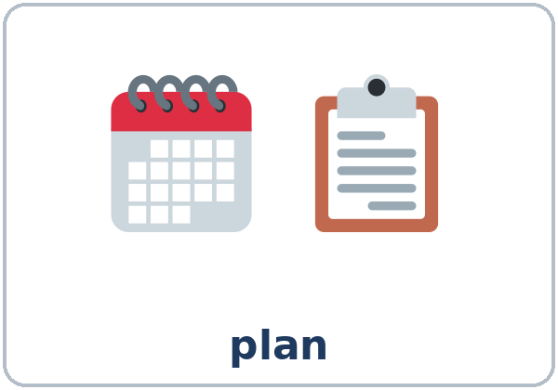  ★ plan | 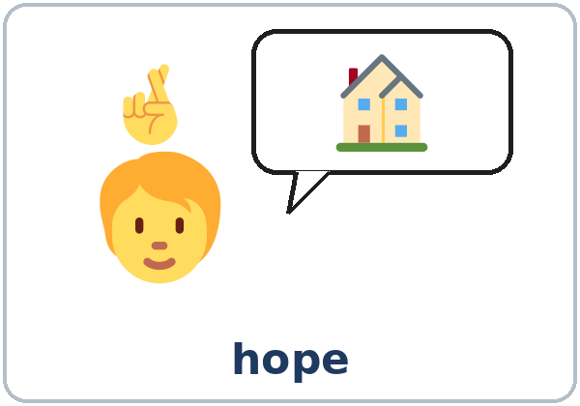  ★ hope | 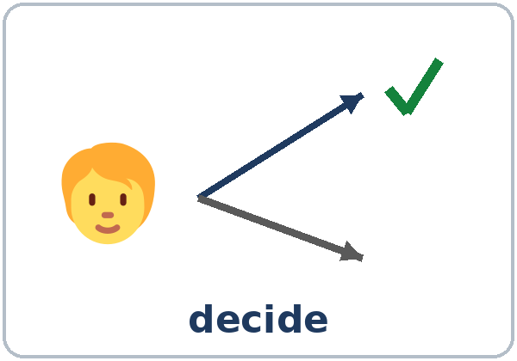  ★ decide | 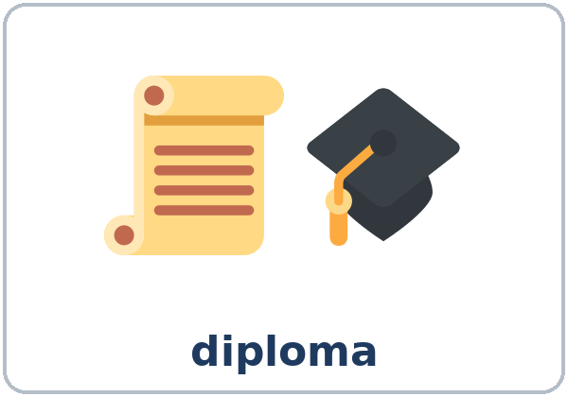  ★ diploma
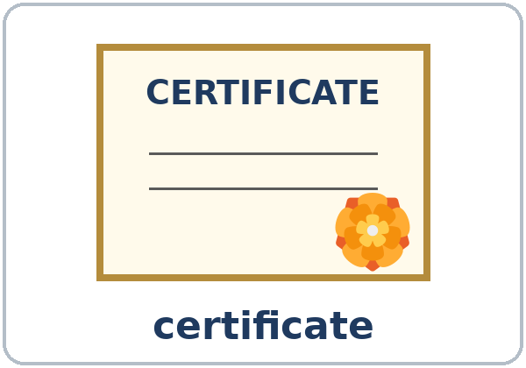  ★ certificate | 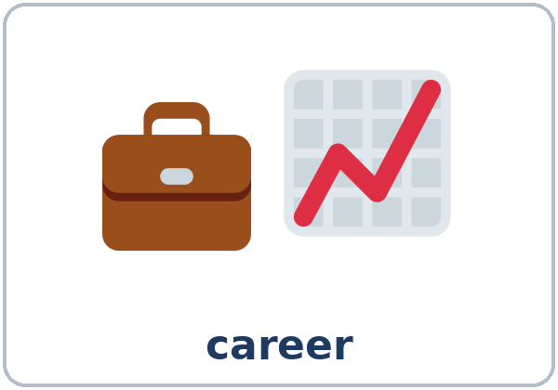  ★ career | 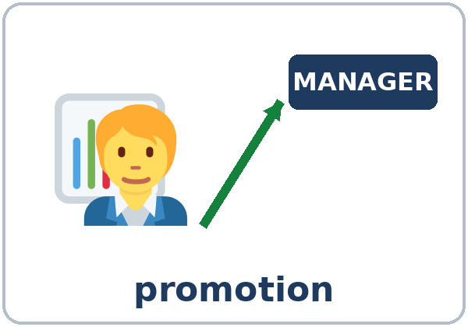  ★ promotion | 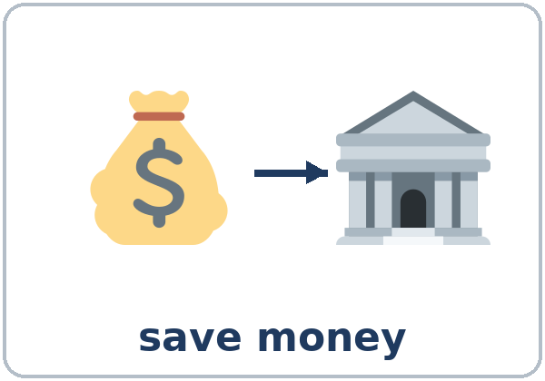  ★ save money
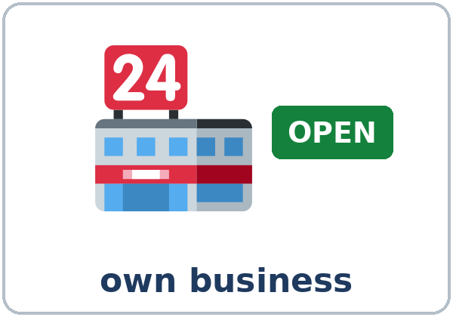  ★ own business | 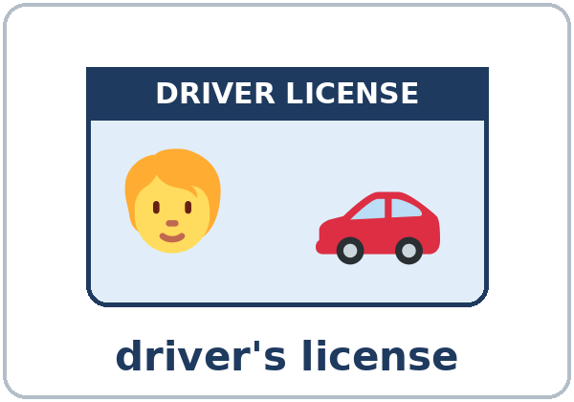  ★ driver's license | 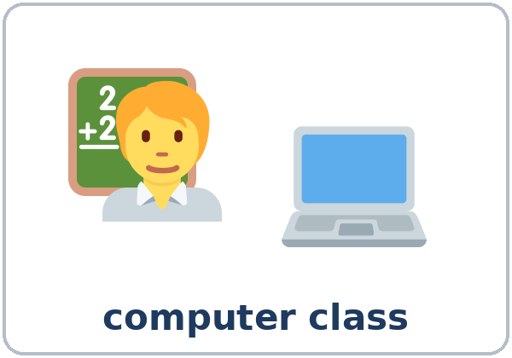  ★ computer class | 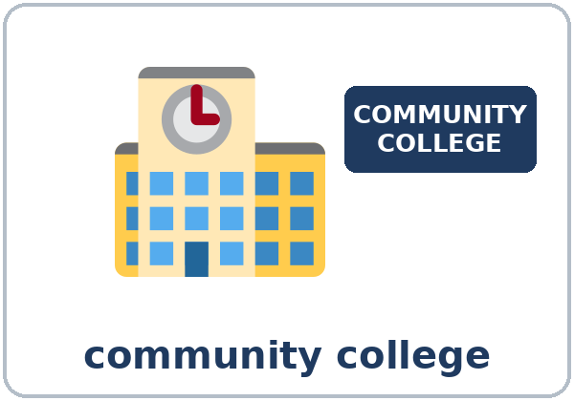  community college

Partner game: A says a word. B points and makes a sentence about a goal.
Example: A: driver's license. B: (points) I hope to get my driver's license next year.
Lesson 13 (Week 14) · My Words
Write each word in your language, if you want. Then write your own example.
Word | My language | My example
plan
hope
decide
diploma
certificate
career
promotion
save money
own business
driver's license
computer class
community college

Lesson 13 (Week 14) · Listening
Listen to Sofia. She was a Level 3 student. Tonight she's talking to the class about her goals. Mr. Novak is the teacher.
A. Listen. What is Sofia's main goal? Circle.
a. a driver's license b. a medical assistant certificate c. her own business
B. Listen again. Number Sofia's steps 1–5 (Then → Now → Next). Then circle.
Step | Number
take a computer class | ____
came to this class | ____
work at a clinic | ____
works at a hotel | ____
apply for the certificate program | ____

The computer class starts in: January / June She works at: a hotel / a clinic
C. Listen again. Write hope to, going to, or 'll.
1. I ____________ work at a clinic.
2. How are you ____________ do that?
3. First, I'm ____________ take a computer class at the community college.
4. After that, I____________ apply for the certificate program.
5. And I ____________ help my kids with their homework, too.
Say it: Three years ago, (pause) I came to this class. (pause) Now (pause) I work at a hotel. • going to → "gonna" (understand it; say going to)
Lesson 13 (Week 14) · Grammar
Read across. A reads from the left side. B answers from the right side. Choose one part from each column.
Grammar Box 1: going to (a plan)
QUESTION |  |  | ANSWER
What are you | going to do next year? |  | I'm going to | take a computer class.
Are you | going to apply? |  | Yes, I'm going to | apply in January.
When are you | meeting the counselor? |  | I'm meeting | the counselor on Monday.

Grammar Box 2: hope to / I hope I'll (a hope)
QUESTION |  |  | ANSWER
What do you | hope to do? |  | I hope to | get my diploma.
What do you | hope to do? |  | I hope I'll | have my own business.
What do you | plan to  want to do? |  | I plan to  I want to | save money for a car.

Grammar Box 3: will (decided now, a promise)
QUESTION |  |  | ANSWER
What will you | do first? |  | First, I'll | ask about classes at the community college.
Can you | call them? |  | OK, I'll | call them tomorrow.

Grammar Box 4: Which one?
 | MEANING | EXAMPLE
going to | already planned | I'm going to take a class in January.
will ('ll) | decided now, or a promise | OK, I'll call the college tomorrow.
hope to / I hope I'll | I want it, but I'm not sure | I hope to get a promotion.
plan to / want to | my idea for the future | I plan to save money.

Questions and answers
Q: I hope get or I hope to get?
A: I hope to get. hope to + verb.
Q: I hope I will to have?
A: No. I hope I'll have my own business. (no to after will)
Q: I'm going to study or I'm going to studying?
A: I'm going to study. going to + verb (no -ing).
Q: What is gonna?
A: Fast speech for going to. Understand it; in your talk, say going to.
Practice A: Write going to, 'll, or hope to.
1. I bought the books. I'm ____________ start the class on Monday. (planned)
2. The phone is ringing. I____________ get it! (decided now)
3. I ____________ get a promotion, but I'm not sure. (a hope)
4. She's ____________ take the driving test in May. (planned)
5. Don't worry. I____________ help you with your talk. (a promise)
Practice B: Circle the right words.
1. I hope (to get / get) my diploma.
2. (I'll / I'll to) call the college tomorrow.
3. We're (going to / going) open a small business.
4. I plan (save / to save) money for a car.
5. I hope (I'll / I will to) have a better job.
Common mistakes
✗ Don't say | ✓ Say
I hope get my diploma. | I hope to get my diploma.
I will to study English. | I will study English.
I'm going to studying. | I'm going to study.
I plan save money. | I plan to save money.

Nota para hispanohablantes: I hope to… = Espero… + infinitivo (Espero conseguir…). I hope I'll… = Espero que…. En inglés no se necesita una forma especial del verbo después de I hope.

Tip for speakers of other languages: going to = already planned. will = decided now or a promise. hope to = you want it, but you're not sure.

Lesson 13 (Week 14) · Talk Time: Goal Ladder
Work with a partner. Choose one goal. Fill in your ladder from the bottom to the top. Explain it to your partner. Your partner asks 2 follow-up questions.
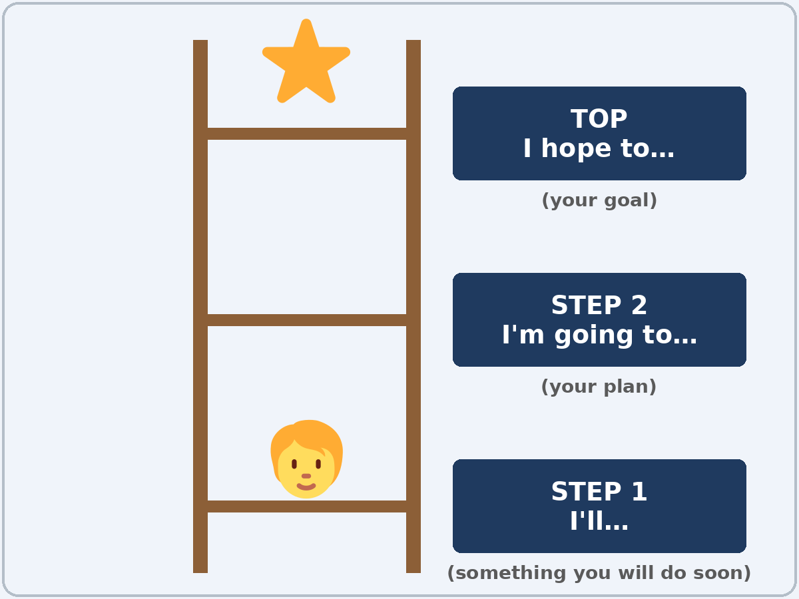

My Goal Ladder
TOP: I hope to…
STEP 2: I'm going to…
STEP 1: I'll…

Follow-ups: When? Why? Who can help you? What will you do first?
Lesson 13 (Week 14) · Talk Time: Talk Rehearsal
In a group of 3, give your talk (1–2 minutes). Use the frame. You can read it. The listeners fill in a Feedback Card.
Talk Frame
Then | … years ago, I… / When I started this class, I…
Now | Now I… / I can… in English.
Next | My main goal is to… / I'm going to… / I hope to…
Why | …because… / …so…
First step | First, I'll…
Thank you | Thank you for listening.

Feedback Card: for (name) __________ | Feedback Card: for (name) __________
One thing I liked: | One thing I liked:
One tip: | One tip:

Lesson 13 (Week 14) · Homework
Homework (about 15 minutes). Bring it to graduation!
1. Write the sentence. Use the words.
Example: I / going to / save money → I'm going to save money.
1. I / going to / take a computer class → ______________________________________________
2. I / hope to / get my diploma → ______________________________________________
3. I / hope I'll / have my own business → ______________________________________________
4. OK, I / will / call the college tomorrow → ______________________________________________
2. Practice your talk at home 2 times, with a family member, a friend, or a mirror. How long was it?
☐ less than 1 minute ☐ 1–2 minutes ☐ more than 2 minutes
3. Ask a family member or a friend: What do you hope to do next year? Write the answer.
______________________________________________________________
______________________________________________________________
4. Review (Lesson 12): Write 2 sentences with something, anything, someone, or no one.
______________________________________________________________
______________________________________________________________
Lesson 13 (Week 14) · Read & Write
A. Read the flyer. (The college and the classes are invented.)
VALLEY COMMUNITY COLLEGE · FREE CLASSES FOR ADULTS · Spring
Computer Basics: email, typing, and the internet. Monday and Wednesday, 6:00–8:00 p.m.
English for Work: interviews and phone calls. Tuesday and Thursday, 6:00–8:00 p.m.
High School Diploma Class: Saturdays, 9:00 a.m.–12:00 p.m.
Medical Assistant Info Night: learn about the certificate program. Friday, January 15, 6:30 p.m.
All classes are free. Sign up at the Welcome Center, Room 101, or call 555-0123. Free parking and childcare.

B. Answer the questions.
1. How much are the classes? ______________________________________________
2. Which class teaches email? When is it? ______________________________________________
3. When is the High School Diploma Class? ______________________________________________
4. Where do you sign up? ______________________________________________
5. When is the Medical Assistant Info Night? ______________________________________________
C. Write your graduation talk (6–8 sentences). Use the Talk Frame: Then → Now → Next, a reason, and your first step.
Example: Two years ago, I started English classes. I was shy, and I didn't understand my children's teachers. Now I can talk to them, and I can make phone calls in English. My main goal is to get my driver's license. I'm going to study the driver's book this winter, because the test is in English. First, I'll take a practice test online. I hope to drive my kids to school next year. Thank you for listening.
My graduation talk

D. Check your talk with a partner.
 | Yes | Not yet
It has Then, Now, and Next. | ☐ | ☐
It uses going to and hope to. | ☐ | ☐
It has a first step with I'll. | ☐ | ☐
It has a reason (because… / so…). | ☐ | ☐

Lesson 13 (Week 14) · Progress Check
Name: ______________________________ Date: ________________
A. Listen to the teacher. Circle a or b.
1. a. It's a plan. b. It's a hope.
2. a. It's a plan. b. It's a hope.
3. a. She planned it last week. b. She decided now.
4. a. It's a fixed plan. b. It's a hope.
B. Circle the right words.
1. I hope (to get / get) a better job.
2. I'm (going to / going) take a class.
3. OK, (I'll / I'll to) help you.
4. I want (to / —) save money.
C. Write.
1. A plan with going to: ______________________________
2. A hope with hope to: ______________________________
Score: A ______ / 4 B ______ / 4 C ______ / 2
D. How do you feel? Check ✓ one face for each line.
I can… | 😀 I can do it. | 🙂 With a little help. | 😐 Not yet.
I can talk about a plan with going to. | ☐ | ☐ | ☐
I can talk about hopes with hope to / I hope I'll. | ☐ | ☐ | ☐
I can say what I will do to reach a goal. | ☐ | ☐ | ☐
I can give a 1–2 minute talk about my goals. | ☐ | ☐ | ☐

Picture Credits
Pictures use Twemoji graphics by Twitter, Inc. and other contributors (https://github.com/jdecked/twemoji), licensed under CC BY 4.0 (https://creativecommons.org/licenses/by/4.0/). The graphics were resized and combined, and drawings (a certificate, a license card, signs, a ladder, bubbles, arrows) and labels were added. The file-by-file list is in images/CREDITS.md.
Listening audio: synthetic voices made with Chatterbox TTS (Resemble AI, MIT License), cloned from synthetic reference clips made with Kokoro-82M (Apache License 2.0). No recordings of real people were used. Each file carries an inaudible Perth watermark marking it as AI-generated. The names and the story are invented.
Course materials: © 2026 the authors, licensed under CC BY-NC-SA 4.0 (https://creativecommons.org/licenses/by-nc-sa/4.0/).

