Level 3 Adult ESL Curriculum · Lesson 2 (Week 2): Who's Who?
Status: Draft for review; not published.
Date: October 2026
Audience: Program coordinators and volunteer teachers
Companion files: audio/L3_L2_listening.mp3, images/ (12 vocabulary pictures, 2 activity pictures + images/CREDITS.md)
Topic: describing people: how someone looks (What does she look like?) and what someone is like (What's he like?), finding a person you've never met, and the object pronouns me, him, her, us, them.

How this lesson is organized
Part | What's inside | Who uses it
Teacher Plan | At a glance, clock-time plan, step-by-step boxes, listening script, answer key, teacher notes | Volunteer teachers
Student Pages | Opening Talk, New Words, My Words, Listening, Grammar, Talk Time (with the crowd picture), Homework, Read & Write, Progress Check. Print this part for learners | Learners
Picture Credits | Picture, audio, and license credits | Coordinators

What Lesson 2 builds on and what it adds
Before (review only) | Where | New in Level 3 Lesson 2
Follow-up questions, because and so | Level 3 Lesson 1 | Follow-ups about people: What's she like? Is she nice?
be + adjective (He's tall), have (She has two kids) | Level 1–2 | He's tall. She has curly hair and glasses.
Describing people (bonus page only) | Level 2 | What does he look like? vs. What's he like?; the woman with long hair
Subject pronouns and my, your, his, her | Level 1 | Object pronouns: me, him, her, us, them
Comparatives (taller than) | Level 2 Lessons 7–8 | Brief review: She's taller than me.

TEACHER PLAN
Lesson 2 (Week 2)

Who's Who?
At a glance · Clock-time plan · Step by step · Script and answer key

How to Use This Plan
You don't need to speak Spanish or any other language. Teach in English. Show, point, and gesture. Each Grammar page has one short Spanish note and one tip for speakers of other languages. Learners read them on their own. You never need to read, translate, or explain them.

Instructions: use the same short task words every week: Listen. Circle. Check. Write. Work with a partner. Work in a group. Ask a follow-up question. Learners have the Task Words page from Lesson 1.

Instruction rule: Model it (do it with one learner while everyone watches), check it (ask: "Do you write or speak? Who talks first?"), then go. Say less, show more.

Grouping toolkit: Pairs: turn to a neighbor; with an odd number, make one group of 3. Groups: 3–4 learners. Inside–outside circles: the inner circle faces out, the outer circle faces in; the outer circle moves one person to the right each round. Mingle: everyone stands and talks to many classmates. The teacher joins a pair only if one learner is left over.

When a learner is stuck or speaks another language to you: (1) show it: the picture, a gesture, or the board; (2) give one more short English example; (3) point to the grammar box on their page; (4) a classmate can help for a few seconds, then back to English. You don't need to understand what classmates say to each other.

Lesson 2 (Week 2): Who's Who?
At a glance
Objectives: learners can…
• describe how someone looks: height, hair, a beard, glasses, clothes (She's tall. She has curly hair.)
• describe someone's personality (He's friendly and funny.)
• ask and answer What does he look like? and What's he like?
• pick someone out: Which one is your sister? → The woman with long hair.
• use the object pronouns me, him, her, us, them (I work with her. She always helps me.)
• read a short welcome email and write 3–4 sentences about a friend or family member

Materials
• Student Pages for Lesson 2 (print for the number expected + 3 spares)
• Talk Time: the crowd picture page (1 per learner) and the person cards (cut up; 1 set of A cards and 1 set of B cards per pair)
• phone + small speaker, L3_L2_listening.mp3
• the Lesson 1 baseline snapshot checklist (continue it this week)
• Prep time: 20 min.

Key vocabulary (with pictures on the New Words page)
★ tall • ★ short • ★ curly hair • ★ straight hair • ★ beard • ★ glasses • ★ friendly • ★ shy • ★ funny • ★ hardworking • patient • quiet

Clock-time plan
Times are loose. If a step runs long, take time from Read & Write first, then from Talk Time.
Time | Step | Min | Grouping (15 / 7–8) | If running behind
6:00–6:10 | Opening Talk + Homework Check | 10 | Pairs (7 pairs + 1 trio / 3–4 pairs) | One card only
6:10–6:18 | New Words (picture page) + pair game | 8 | Whole class, then pairs | Teach the ★ words only
6:18–6:30 | Listening: play 1 (Task A), play 2 (Tasks B and C) + "Say it" | 12 | Individuals, then pairs check | Do Task C together on the board
6:30–6:45 | Grammar Q&A: look like / be like, the… with…, object pronouns + pair drill | 15 | Whole class, then pairs | Skip the pair drill; Talk Time practices it
6:45–7:00 | BREAK | 15
7:00–7:12 | Talk Time: Pick Them Up (information gap) + baseline snapshot | 12 | Pairs, then groups of 3 | Round 1 only
7:12–7:17 | Exit Ticket + Homework | 5 | Individuals | Never skip
7:17–7:25 | Read & Write: a welcome email + 3–4 sentences | 8 | Individuals, then pairs | Reading questions only; writing becomes homework
7:25–7:30 | Progress Check | 5 | Individuals | Do it in Week 3 at 6:00, while people arrive

Skip order if you're running behind: (1) the Read & Write writing task (it becomes homework); (2) the pair drill at the end of Grammar; (3) half of Talk Time. Never skip: the listening tasks, the grammar boxes and the mistakes table, and the exit ticket.

Attendance (15 → 7–8): every step lists both sizes. With 5 or fewer, sit at one table: pair work stays in pairs, and the groups of 3 become one group. Late arrivals join any pair right away.

Step by step
Step 1 · 6:00–6:10 · Opening Talk + Homework Check · 10 min
• Grouping: pairs, the same partner for both parts. 15 learners: 7 pairs + 1 group of 3. 7–8 learners: 3–4 pairs.
• Before class: write on the board: Ask one follow-up question. Give a reason: because… / so…
• Opening Talk (6 min): learners open the Opening Talk page. A asks a card question; B answers with a reason; A asks one follow-up. Switch after each card.
• Model with one learner: "Why are you learning English?" → (answer) → "Really? Where do you use English?"
• Homework Check (4 min): partners compare Lesson 1 Homework item 1 (the because answers). Walk around. Write 2 common errors on the board and correct them together. Correct only those 2.
• Late arrivals: join any pair as a group of 3.
• If behind: one card only, then the homework check.

Step 2 · 6:10–6:18 · New Words · 8 min
• Grouping: whole class, then pairs. Show the New Words page.
• Do: point to each picture and say the word. Learners repeat once. Use the class: "Who has glasses?" (learners with glasses raise a hand) • "Who has curly hair?" Act out shy (look down, speak very quietly: "…hi") and patient (wait calmly, smile, look at your watch).
• Check meaning (1 min): "Is a beard on your head or on your face?" (face) • "A shy person talks a lot: yes or no?" (no) • "A hardworking person works a little or a lot?" (a lot)
• Two groups of words: draw two columns on the board: LOOKS (tall, short, curly hair, straight hair, beard, glasses) and PERSONALITY (friendly, shy, funny, hardworking, patient, quiet). Learners say which column each word goes in.
• Pairs (2 min): A says a word; B points to the picture and makes a sentence (My brother is tall. / My teacher is patient.). Switch.
• If behind: teach the ★ words only.

Step 3 · 6:18–6:30 · Listening + "Say it" · 12 min
• Grouping: individuals, then pairs check.
• Before you listen (1 min): point to the picture on the Listening page. Say: "It's Omar's first day at a hotel. His supervisor is Linda. She tells him about two coworkers, Kevin and Nora. Who is Kevin? Who is Nora? Listen."
• Play 1 → Task A (write the letter of each person). Pairs compare. Check together.
• Read Tasks B and C together (1 min) so learners know what to listen for.
• Play 2 → Tasks B and C. Pairs compare. Then show the answers (answer key).
• "Say it" (2 min): read the words in the "Say it" box. Clap on the strong part: FRIENDly, HARDworking, PAtient, CURly, GLASSes. The class repeats each word twice, then the line Everyone likes him.
• The audio plays the conversation once (about 1:20). Press play again for play 2. A third play is fine if the class needs it.
• If behind: do Task C together on the board, reading the lines yourself.

Step 4 · 6:30–6:45 · Grammar Q&A · 15 min
• Grouping: whole class, then pairs. Show the Grammar page. The left side is the question. The right side is the answer.
• Boxes 1 and 2 (4 min): write on the board: look like = LOOKS and be like = PERSONALITY. Ask about a famous cartoon character or a picture on the New Words page: "What does he look like?" → "He's tall. He has a beard." "What's he like?" → "He's funny."
• Box 3 (2 min): point to the picture on the Listening page. Ask: "Which one is Nora?" → "The short woman with long, straight hair." Learners ask about Kevin and Sam.
• Box 4 (4 min): read the two columns: I → me, he → him, she → her, we → us, they → them. Say: "The second word comes after the verb or after with, to, for." Read each example; the class repeats.
• Check questions: "Do you know Ana? Yes, I know ___." (her) • "Ask Kevin. Ask ___." (him) • "What does she look ___?" (like) • "She has long ___." (hair, not hairs)
• Practice A and B (3 min): learners write, then pairs check. Go over the answers.
• Pair drill (last 2 min): A names a person in the class (only names!); B describes how the person looks, and A asks What's he / she like? B answers only with kind words.
• If behind: skip the pair drill. Talk Time practices it.

Break · 6:45–7:00 · 15 min
• Lay out the crowd picture pages and the person cards (A cards in one pile, B cards in another). Write on the board: What does he / she look like? What's he / she like? Is that him / her?

Step 5 · 7:00–7:12 · Talk Time: Pick Them Up · 12 min
• Grouping: pairs, then groups of 3. 15 learners: 7 pairs + 1 group of 3 (two people share the A cards). 7–8 learners: 3–4 pairs. 5 or fewer: one group; take turns describing.
• Round 1 (7 min): each pair has the crowd picture (people 1–12) and two piles of cards. A takes an A card and doesn't show it. A says, "Can you pick up my cousin at the bus station?" B asks, "What does she look like?" A describes the person on the card (height, hair, glasses or a beard, the shirt color). B points and says the number. A says, "Yes, that's her!" or "No, she has glasses." Then B asks one follow-up: "What's she like?" A invents an answer. Switch: B takes a B card.
• Model with one learner (1 min): use card A1 (person 7) and the model dialogue on the Talk Time page.
• Round 2 (4 min): groups of 3. Each learner describes a person they admire (a family member, a friend, a teacher), personality only, with one reason (My aunt is very patient, because she never gets angry.). The others ask one follow-up question each.
• Writing: after round 1, learners write 2 of the people they found in the table on the Talk Time page.
• Baseline snapshot: while learners talk, call about 5 learners (the ones you didn't talk to in Week 1) for 2 minutes each and use the Lesson 1 baseline checklist.
• If behind: round 1 only.

Step 6 · 7:12–7:17 · Exit Ticket + Homework · 5 min · NEVER SKIP
• Exit ticket: each learner writes two sentences on a slip about a friend or family member: one about how the person looks and one about what the person is like, with because or so (My brother is funny, so everyone likes him.). Collect at the door.
• Homework: open the Homework page. Do item 1 together (describe one person on the board with the class). Say: "About 15 minutes. Bring it next week."

Read & Write · 7:17–7:25 · A Welcome Email · 8 min
• Grouping: individuals, then pairs check.
• Read (3 min): learners read the email on the Read & Write page and answer questions 1–5. Say: "Read fast first. Then find the answers."
• Pairs check (2 min): compare answers; check together.
• Write (3 min): learners write 3–4 sentences about a friend or family member: how the person looks, what the person is like, and one reason (because).
• If behind: questions 1–5 only; the writing becomes homework.

Progress Check · 7:25–7:30 · 5 min
• Grouping: individuals. Open the Progress Check page.
• Part A: read the 4 sentences in the answer key, slowly, 2 times each. Learners circle a or b.
• Parts B and C: learners do them alone. Walk around and help with the instructions only.
• Part D: read each "I can…" line aloud and point to the 3 faces: 😀 "I can do it." 🙂 "With a little help." 😐 "Not yet."
• Collect the pages (or check them at the start of Week 3).
• If behind: do the Progress Check in Week 3 at 6:00, while learners arrive.

Listening script: L3_L2_listening.mp3 (about 1:20; the conversation plays once, so press play again for the second listen)
Audio: play from a phone + small speaker. No speaker? Read the script with a volunteer, at a normal, friendly speed.

Narrator: Lesson two. Listening. It's Omar's first day at a hotel. His supervisor, Linda, tells him about two coworkers. Listen.
Linda: Welcome, Omar! Today you're going to work with Kevin and Nora.
Omar: Great. What's Kevin like?
Linda: He's very friendly, and he's really funny. Everyone likes him.
Omar: What does he look like?
Linda: He's tall, and he has a beard and glasses. You can ask him for help.
Omar: OK. And who is Nora?
Linda: Nora is the short woman with long, straight hair. She's a little shy.
Omar: Is she nice?
Linda: Yes. She's quiet, but she's really hardworking.
Omar: Does she talk a lot?
Linda: Not at first. Talk to her, and ask her questions. She's very patient.
Omar: Where can I find them?
Linda: They're in the laundry room. Come with me. I can introduce you to them.
Omar: Is that Kevin? The man with curly hair?
Linda: No, that's Sam. He works at the front desk. Kevin is the tall man next to him.
Omar: Oh, I see him. He's waving at us.
Linda: Let's go and say hi to him.
Narrator: That's the end of the listening.

Answer key
• Listening Task A: Kevin a (tall, beard, glasses) • Nora b (short, long straight hair) • Sam c (curly hair). Person d is not in the conversation.
• Listening Task B: 1 Kevin, 2 Kevin, 3 Nora, 4 Nora, 5 Nora, 6 Nora.
• Listening Task C: 1 him, 2 her, her, 3 them, 4 them, 5 him.
• Grammar Practice A: 1 her, 2 them, 3 him, 4 us, 5 me, 6 it.
• Grammar Practice B: 1 look like, 2 like, 3 like, 4 look like.
• Talk Time, Round 1 (the number B should point to): A1 Lisa = 7 (tall woman, long straight hair, glasses, blue shirt) • A2 Pedro = 8 (tall man, beard, glasses, green shirt) • A3 Ana = 9 (short woman, curly hair, yellow shirt) • A4 Tom = 6 (short man, curly hair, glasses, orange shirt) • B1 Julia = 1 (tall woman, curly hair, glasses, red shirt) • B2 Mr. Park = 2 (man with a beard, no glasses, blue shirt) • B3 Rosa = 11 (short woman, glasses, gray shirt) • B4 Leo = 10 (tall man, curly hair, red shirt). The personality answers are invented: answers will vary.
• Talk Time table and Round 2: answers will vary.
• Homework 1 and 3: answers will vary. Homework 2: 1 him, 2 them, 3 her, 4 us. Homework 4: 1 because, 2 so, 3 because.
• Read & Write: 1 Ben • 2 She has curly hair and glasses. • 3 He's funny and very friendly. • 4 Monday at 8:00 a.m. • 5 Lucy • Writing (C): answers will vary.
• Progress Check Part A (the teacher says, 2 times each): 1 "My brother is tall, and he has a beard." → a • 2 "My neighbor never gets angry. She's very patient." → b • 3 "Which one is your sister? The woman with curly hair." → a • 4 "What's your coworker like? He's funny and friendly." → b
• Progress Check Part B: 1 look like, 2 him, 3 them, 4 us.
• Progress Check Part C: answers will vary; for example 1 She's short, and she has long hair. 2 She's very friendly.
• Progress Check scoring: A /4 + B /4 + C /2 = /10. This is not a test grade. It shows who needs more help with look like / be like (A, B1, C) and with object pronouns (B2–B4).
Teacher notes
• Kind words only (important): describe only hair, height, glasses, beards, clothes, and personality. Never use words about weight, skin color, or age, and never as a joke. If a learner uses one, say the kind word: "We say tall / short / curly hair." The people in the pictures are invented.
• Real classmates: in the pair drill, learners describe classmates only with the New Words. If a learner seems uncomfortable, describe people in the pictures instead.
• look like vs. be like: the most useful check is the answer: if the answer is about the body or clothes, the question is What does she look like? If it's about personality, it's What's she like?
• Object pronouns: they come after the verb (I know her) and after small words like with, to, for, at (Come with me. Look at him.). Learners often drop them (I know.) or use the subject form (I work with she).
• hair: hair on the head has no -s: She has long hair. Adjectives never take -s: two tall men.
• Mixed levels: stronger learners describe a person in the crowd with 4 details and add a comparison (She's taller than number 3). Newer learners use the model dialogue on the Talk Time page as a script.
• Typical mistakes this week: She has long hairs, What does she like? (for personality), He is a man very tall, I know. (no object), I work with she, He help me. Say the right form clearly; the learner repeats. Learners can read the Spanish note and the tip on their Grammar page themselves; you don't need to explain them.

STUDENT WORKBOOK
Lesson 2 (Week 2)

Who's Who?
Opening Talk · New Words · Listening · Grammar · Talk Time · Homework · Read & Write · Progress Check

Lesson 2 (Week 2) · Opening Talk
Name: ______________________________ Date: ________________
Work with a partner. A asks a question. B answers with a reason. A asks one follow-up question. Then switch.
Why are you learning English? | What did you do last weekend?
Tell me about a neighbor or a coworker. | What are you going to do this weekend? Why?

Follow-ups: Really? Why? What happened? How was it? Where? Who with? What about you?
Homework check: compare your Lesson 1 homework with your partner. Read your answers to item 1.
My partner's answer to "Why are you learning English?"

Lesson 2 (Week 2): Who's Who?
Student Page 1 · Week 2
Name: ______________________________ Date: ________________
New Words
Look. Listen. Repeat. ★ = most important words.
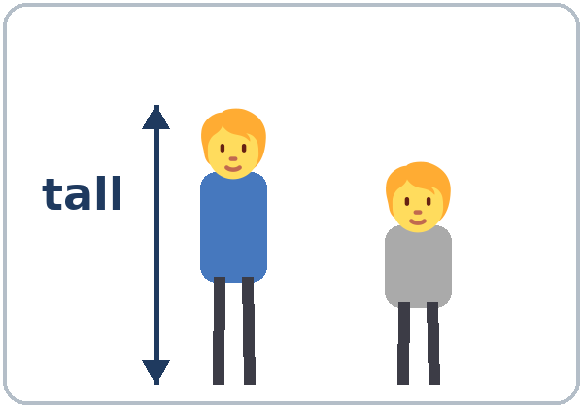  ★ tall | 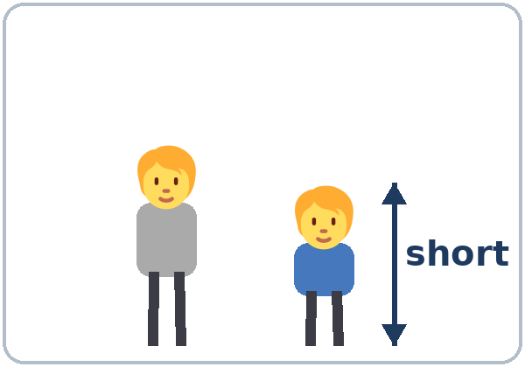  ★ short | 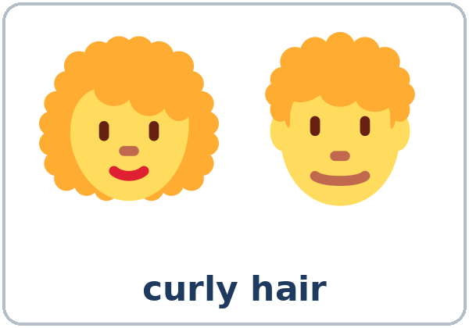  ★ curly hair | 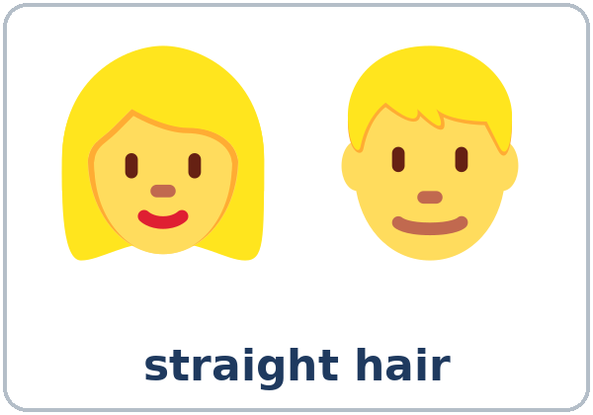  ★ straight hair
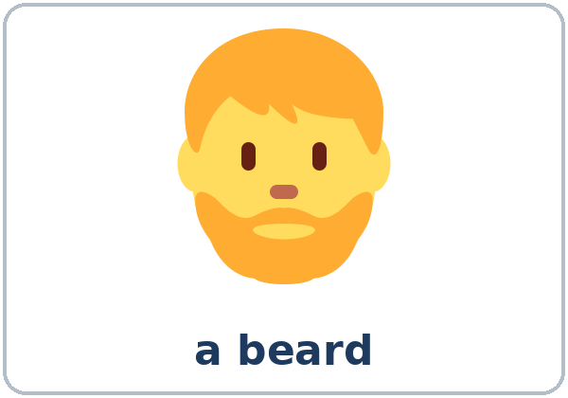  ★ beard | 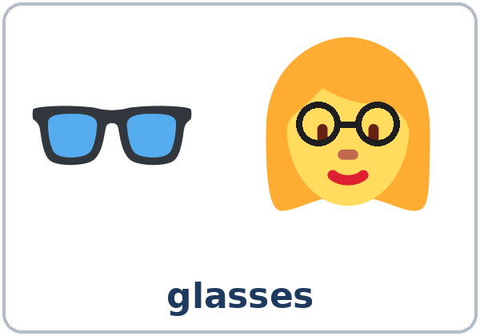  ★ glasses | 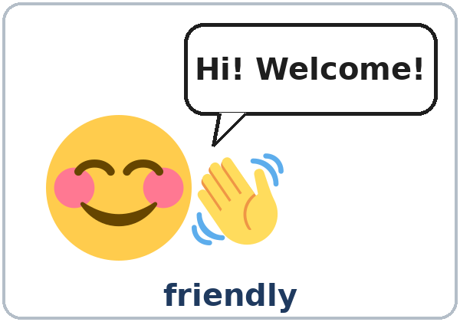  ★ friendly | 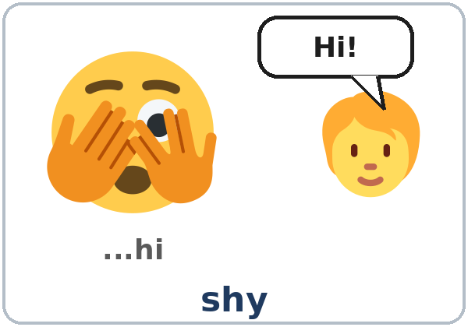  ★ shy
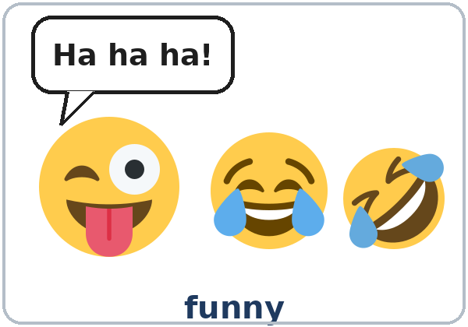  ★ funny | 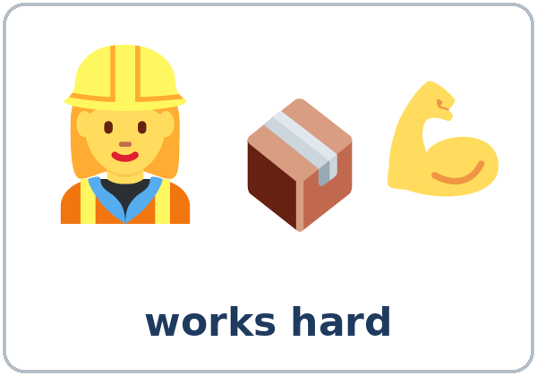  ★ hardworking | 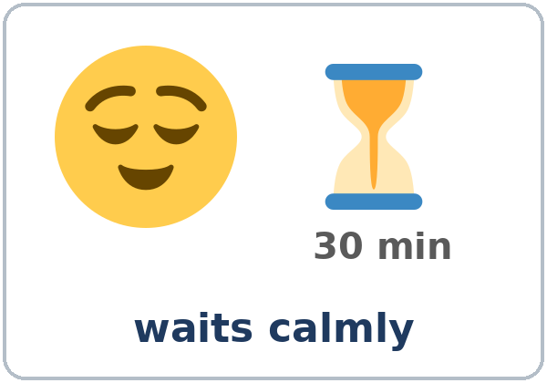  patient | 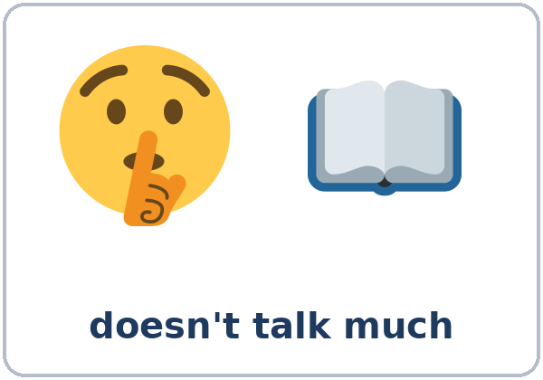  quiet

Partner game: A says a word. B points and makes a sentence.
Example: A: curly hair. B: (points) My sister has curly hair.
Lesson 2 (Week 2) · My Words
Write each word in your language, if you want. Then write your own example.
Word | My language | My example
tall
short
curly hair
straight hair
beard
glasses
friendly
shy
funny
hardworking
patient
quiet

Lesson 2 (Week 2) · Listening
Listen to Linda and Omar. It's Omar's first day at a hotel. Linda is his supervisor.
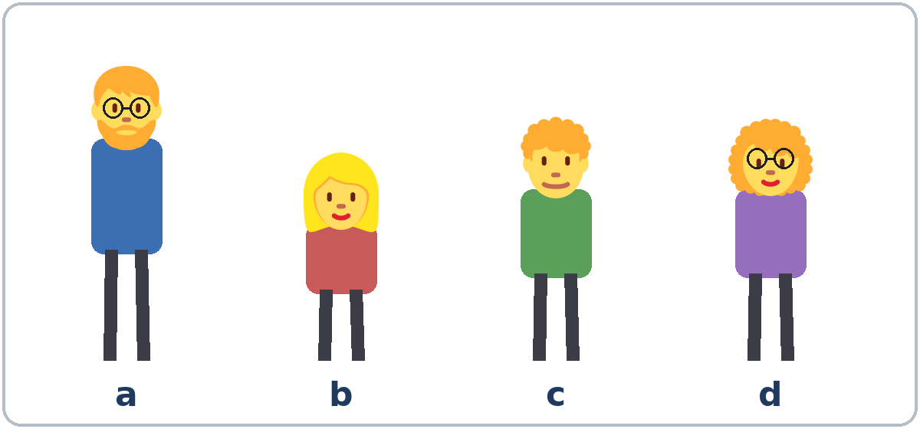

A. Listen. Who is it? Write the letter (a, b, c, or d).
1. Kevin: ______ 2. Nora: ______ 3. Sam: ______
B. Listen again. Who is it? Check ✓ Kevin or Nora.
 | Kevin | Nora |  | Kevin | Nora
1. friendly | ☐ | ☐ | 4. quiet | ☐ | ☐
2. funny | ☐ | ☐ | 5. hardworking | ☐ | ☐
3. shy | ☐ | ☐ | 6. patient | ☐ | ☐

C. Listen again. Write him, her, or them.
1. You can ask ____________ for help.
2. Talk to ____________, and ask ____________ questions.
3. Where can I find ____________?
4. Come with me. I can introduce you to ____________.
5. Let's go and say hi to ____________.
Say it: FRIENDly • HARDworking • PAtient • CURly • GLASSes • Everyone likes him.
Lesson 2 (Week 2) · Grammar
Read across. A reads from the left side. B answers from the right side. Choose one part from each column.
Grammar Box 1: What does he look like? (looks)
QUESTION |  |  |  | ANSWER
What does | he  she | look like? |  | He's  She's | tall.  short.
What does | he  she | look like? |  | He has  She has | a beard.  glasses.  curly hair.  long, straight hair.
What do | they | look like? |  | They're | tall.  short.
What do | they | look like? |  | They have | glasses.  short hair.

Grammar Box 2: What's he like? (personality)
QUESTION |  |  |  | ANSWER
What's | he  she | like? |  | He's  She's | friendly and funny.  quiet but hardworking.  very patient.
What are | they | like? |  | They're | really friendly.  a little shy.
Is | your boss  your teacher | nice? |  | Yes, very nice.  Yes, really nice. | He's very kind.  She's very patient.

Grammar Box 3: Which one is…? → The… with…
QUESTION |  | ANSWER
Which one is your sister? |  | The woman with long hair.  She's the woman with glasses.
Which one is Kevin? |  | The tall man with a beard.  The man next to Sam.
Which one is your boss? |  | The short man with curly hair.  The woman in the red shirt.

Grammar Box 4: Object pronouns: me, him, her, us, them
BEFORE THE VERB |  | AFTER THE VERB (or after with, to, for)
I work here. |  | me | My coworker always helps me.
You are new. |  | you | Can I help you?
He is friendly. |  | him | Ask him for help.
She is patient. |  | her | I work with her.
We are new. |  | us | Linda trains us on Mondays.
They are funny. |  | them | I like them a lot.

Grammar Box 5: Questions and answers with object pronouns
QUESTION |  | ANSWER
Do you know Ana? |  | Yes, I work with her. She always helps me.
Do you know Mr. Lee? |  | Yes, I see him every day. He's our neighbor.
Do you like your coworkers? |  | Yes, I like them a lot. They're very friendly.
Can you call us later? |  | Sure. I can call you at 6:00.

Questions and answers
Q: What's the difference between What does she look like? and What's she like?
A: look like asks about looks: height, hair, glasses, clothes. She's tall. She has glasses. be like asks about personality: She's friendly and patient.
Q: Do I say hair or hairs?
A: hair (no -s) for the hair on your head: She has long, curly hair.
Q: Where does the describing word go?
A: Before the noun, and it never takes -s: a tall man, two tall men, curly hair. Or after be: He's tall.
Q: How do I say which person?
A: the + person + with + thing: the woman with glasses, the man with a beard. For clothes you can also say in: the man in the blue shirt.
Q: When do I use me, him, her, us, them?
A: After a verb (I know her) and after small words like with, to, for, at (Come with me. Talk to him.). Before the verb, use I, he, she, we, they.
Q: Can I compare two people?
A: Yes (Level 2): She's taller than me. He's funnier than his brother. Use me, not I, after than in conversation.
Q: Are there words I shouldn't use?
A: Yes. Talk about hair, height, glasses, beards, clothes, and personality. Words about a person's weight, skin color, or age can be rude.
Practice A: Write me, him, her, it, us, or them.
1. Ana is my neighbor. I see ____________ every day.
2. My brothers are very funny. I love ____________.
3. Mr. Silva is patient. Ask ____________ for help.
4. We're new here. Can you help ____________?
5. I'm a little shy. Please talk to ____________ slowly.
6. That's my phone. Can you give ____________ to me?
Practice B: Write look like or like.
1. What does your brother ____________? He's tall, and he has a beard.
2. What's your teacher ____________? She's very patient.
3. What are your neighbors ____________? They're friendly.
4. What does she ____________? She has curly hair and glasses.
Common mistakes
✗ Don't say | ✓ Say
She has long hairs. | She has long hair.
What does she like? (about personality) | What's she like? / What does she look like?
He is a man very tall. | He's a very tall man. / He's very tall.
two talls men | two tall men
Do you know Ana? Yes, I know. | Yes, I know her.
I work with she. | I work with her.
He help me every day. | He helps me every day.

Nota para hispanohablantes: What's he like? = ¿Cómo es? (su personalidad). What does he look like? = ¿Cómo es físicamente? En inglés se dice hair sin -s: She has long hair (no hairs). Los adjetivos van antes del sustantivo y nunca llevan -s: two tall men. Después del verbo usa me, him, her, us, them: I know her (no I know she).

Tip for speakers of other languages: many verbs in English need an object word after them: I know her (not I know). Can you help me? (not Can you help? when you mean yourself).

Lesson 2 (Week 2) · Talk Time: Pick Them Up
Work with a partner. A has a card. A describes the person. B finds the person in the picture and says the number. Then switch.
A: Can you pick up my cousin at the bus station? B: Sure. What does she look like?
A: She's tall, and she has long, straight hair and glasses. She's wearing a blue shirt.
B: Is that her? Number 7? A: Yes, that's her!
B: What's she like? A: She's really friendly, but she's a little shy at first.
Follow-ups: What's he / she like? Is that him / her? Does he / she have glasses? Is he / she tall?

Person cards (cut out). Don't show your card to your partner!
A cards | B cards
A1. Pick up my cousin Lisa. She's number 7. | B1. Pick up my sister Julia. She's number 1.
A2. Pick up my uncle Pedro. He's number 8. | B2. Pick up my neighbor Mr. Park. He's number 2.
A3. Pick up my coworker Ana. She's number 9. | B3. Pick up my aunt Rosa. She's number 11.
A4. Pick up my friend Tom. He's number 6. | B4. Pick up my friend Leo. He's number 10.

Write about 2 people you found.
Number | What does he / she look like? | What's he / she like?

Lesson 2 (Week 2) · Talk Time: The Bus Station
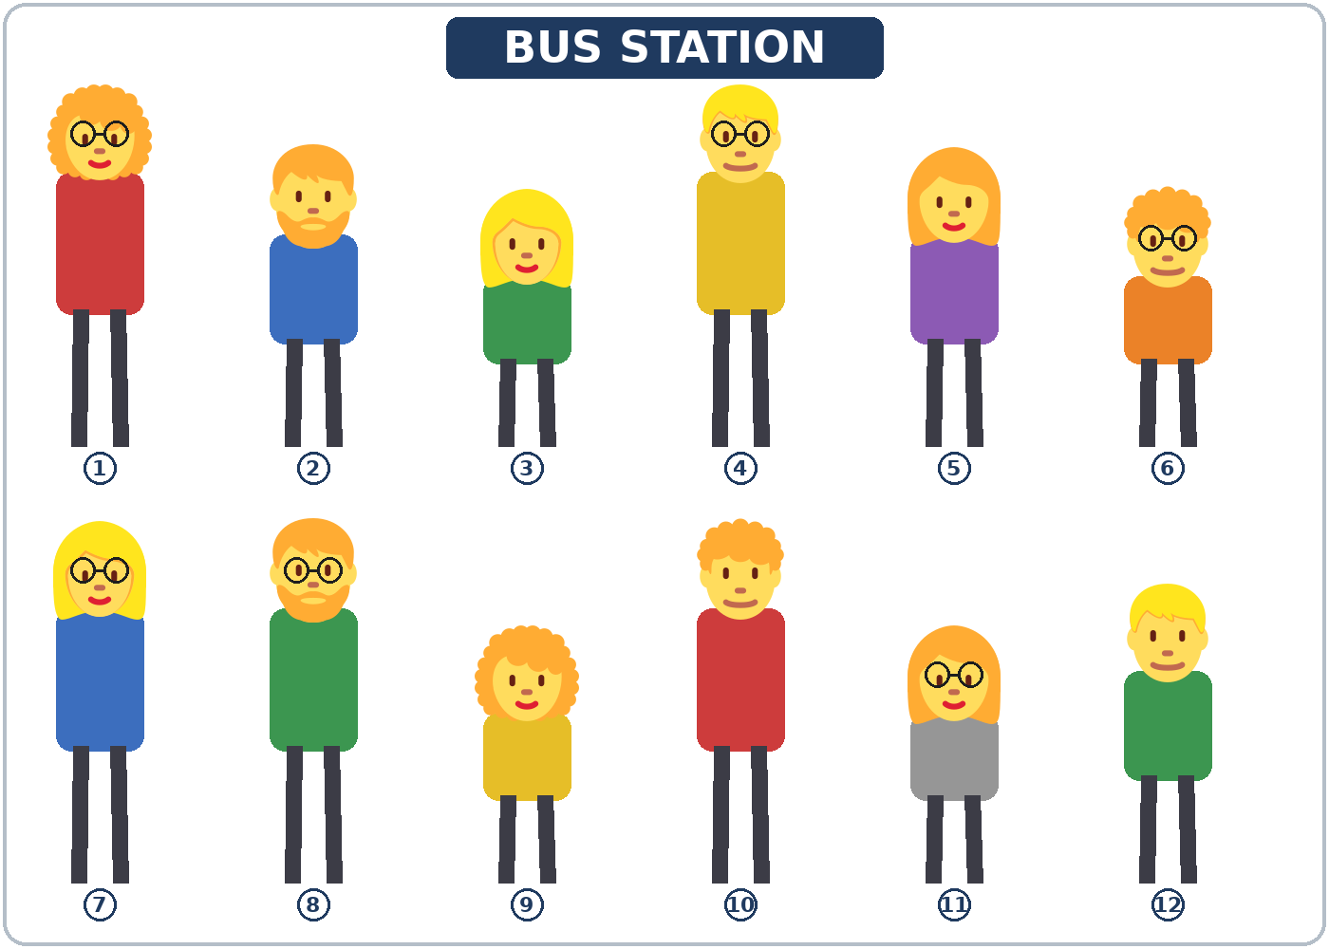

Round 2: Work in a group of 3. Talk about a person you admire. Talk about personality only, and give a reason. The others ask one follow-up question each.
Example: My aunt is very patient, because she never gets angry. She's funny, too.
Lesson 2 (Week 2) · Homework
Homework (about 15 minutes). Bring it next week!
1. Describe a friend or a family member. Write 2 sentences about looks and 2 sentences about personality.
Example: My brother Luis is tall. He has short, curly hair. He's funny and very hardworking.
Name: ______________________________
______________________________________________________________
______________________________________________________________
______________________________________________________________
2. Write him, her, us, or them.
1. My uncle lives near me. I visit ____________ on Sundays.
2. My neighbors are friendly. I talk to ____________ every morning.
3. Rosa is my coworker. I eat lunch with ____________.
4. My brother and I need a ride. Can you drive ____________ to work?
3. Ask a family member or a friend: What was your favorite teacher like? Write the answer. Ask one follow-up question.
My question: What was your favorite teacher like?
Answer: ______________________________________________
My follow-up question: ______________________________________________
Answer: ______________________________________________
4. Review (Lesson 1): Write because or so.
1. I like my coworker ____________ she's very patient.
2. My neighbor is shy, ____________ he doesn't talk a lot.
3. Everyone likes Kevin ____________ he's funny.
Lesson 2 (Week 2) · Read & Write
A. Read the email.
From: Carla Diaz (Manager) · To: Ana Ruiz · Subject: Welcome to Green Leaf Market!
Hi Ana,
Welcome to the team! You start on Monday at 8:00 a.m. Here are three people you are going to work with.
Ben trains all the new cashiers, so you're going to work with him on your first day. He's tall, and he has a beard. He's funny and very friendly.
Lucy has curly hair and glasses. She's quiet, but she's very patient. Ask her about prices. She knows everything!
Mr. Hill is in the office. He's a little shy, but he's really kind. Talk to him about your schedule.
See you on Monday!
Carla

B. Answer the questions.
1. Who trains the new cashiers? ______________________________________________
2. What does Lucy look like? ______________________________________________
3. What's Ben like? ______________________________________________
4. When does Ana start? ______________________________________________
5. Who can Ana ask about prices? ______________________________________________
C. Write 3–4 sentences about a friend or a family member. Say how the person looks and what the person is like. Use because in one sentence.
Example: My friend Sara is short, and she has long, straight hair. She's very friendly. Everyone likes her because she's funny.
______________________________________________________________
______________________________________________________________
______________________________________________________________
______________________________________________________________
D. Check your writing with a partner.
 | Yes | Not yet
There is one sentence about looks. | ☐ | ☐
There is one sentence about personality. | ☐ | ☐
One sentence has because. | ☐ | ☐
hair has no -s. | ☐ | ☐

Lesson 2 (Week 2) · Progress Check
Name: ______________________________ Date: ________________
A. Listen to the teacher. Circle a or b.
1. a. a tall man with a beard b. a short man with glasses
2. a. She's shy. b. She's patient.
3. a. the woman with curly hair b. the woman with straight hair
4. a. He's quiet and shy. b. He's funny and friendly.
B. Circle the right word.
1. What does she (look like / like)? She has glasses.
2. Kevin knows the machines. Ask (he / him) for help.
3. My coworkers are nice. I work with (they / them).
4. Our teacher is patient. She helps (we / us).
C. Write about a classmate. Write 1 sentence about looks and 1 sentence about personality.
1. ______________________________________________
2. ______________________________________________
Score: A ______ / 4 B ______ / 4 C ______ / 2
D. How do you feel? Check ✓ one face for each line.
I can… | 😀 I can do it. | 🙂 With a little help. | 😐 Not yet.
I can describe how someone looks. | ☐ | ☐ | ☐
I can describe someone's personality. | ☐ | ☐ | ☐
I can ask What does he look like? What's he like? | ☐ | ☐ | ☐
I can use me, him, her, us, them. | ☐ | ☐ | ☐

Picture Credits
Pictures use Twemoji graphics by Twitter, Inc. and other contributors (https://github.com/jdecked/twemoji), licensed under CC BY 4.0 (https://creativecommons.org/licenses/by/4.0/). The graphics were resized and combined, and bodies, glasses, speech bubbles, signs, and labels were added. The file-by-file list is in images/CREDITS.md.
Listening audio: synthetic voices made with Chatterbox TTS (Resemble AI, MIT License), cloned from synthetic reference clips made with Kokoro-82M (Apache License 2.0). No recordings of real people were used. Each file carries an inaudible Perth watermark marking it as AI-generated. The names and the story are invented.
Course materials: © 2026 the authors, licensed under CC BY-NC-SA 4.0 (https://creativecommons.org/licenses/by-nc-sa/4.0/).

