Level 3 Adult ESL Curriculum · Lesson 5 (Week 5): Don't Worry, I'll Do It
Status: Draft for review; not published.
Date: October 2026
Audience: Program coordinators and volunteer teachers
Companion files: audio/L3_L5_listening.mp3, images/ (12 vocabulary pictures, 1 activity picture + images/CREDITS.md)
Topic: offering help and making promises at work, with a neighbor, and at a school event, with I'll…, Will you…?, I won't…, and will (decided now) vs. going to (planned before).

How this lesson is organized
Part | What's inside | Who uses it
Teacher Plan | At a glance, clock-time plan, step-by-step boxes, listening script, answer key, teacher notes | Volunteer teachers
Student Pages | Opening Talk, New Words, My Words, Listening, Grammar, Talk Time, Homework, Read & Write, Progress Check. Print this part for learners | Learners
Picture Credits | Picture, audio, and license credits | Coordinators

What Lesson 5 builds on and what it adds
Before (review only) | Where | New in Level 3 Lesson 5
will for offers (to recognize only) | Level 2 Lesson 13 | I'll for offers and quick decisions: I'll get it.
be going to for plans | Level 2 Lesson 11 | will (decided now) vs. going to (planned before)
Can / Could you…? | Level 2 Lesson 12 | Promises: Will you call me? Yes, I will. I won't forget.
Past continuous + when / while | Level 3 Lesson 4 | Opening Talk and Homework review
because / so | Level 3 Lesson 1 | I'll drive, because I have a big car.

TEACHER PLAN
Lesson 5 (Week 5)

Don't Worry, I'll Do It
At a glance · Clock-time plan · Step by step · Script and answer key

How to Use This Plan
You don't need to speak Spanish or any other language. Teach in English. Show, point, and gesture. Each Grammar page has one short Spanish note and one tip for speakers of other languages. Learners read them on their own. You never need to read, translate, or explain them.

Instructions: use the same short task words every week: Listen. Circle. Check. Write. Work with a partner. Work in a group. Ask a follow-up question. Learners have the Task Words page from Lesson 1.

Instruction rule: Model it (do it with one learner while everyone watches), check it (ask: "Do you write or speak? How many people do you talk to?"), then go. Say less, show more.

Grouping toolkit: Pairs: turn to a neighbor; with an odd number, make one group of 3. Groups: 3–4 learners. Inside–outside circles: the inner circle faces out, the outer circle faces in; the outer circle moves one person to the right each round. Mingle: everyone stands and talks to many classmates. The teacher joins a pair only if one learner is left over.

When a learner is stuck or speaks another language to you: (1) show it: the picture, a gesture, or the board; (2) give one more short English example; (3) point to the grammar box on their page; (4) a classmate can help for a few seconds, then back to English. You don't need to understand what classmates say to each other.

Lesson 5 (Week 5): Don't Worry, I'll Do It
At a glance
Objectives: learners can…
• offer help with I'll… (The phone's ringing. I'll get it.)
• make a promise (I'll call you back. Don't worry, I won't forget.)
• ask and answer Will you…? → Yes, I will. / No, I won't.
• understand Do you want me to…? and Shall I…?
• choose will (decided now) or going to (planned before)
• read a school flyer and a sign-up sheet, and write a short text message offering help

Materials
• Student Pages for Lesson 5 (print for the number expected + 3 spares)
• Talk Time: the Problem Cards and the Event Board (on the Talk Time pages)
• phone + small speaker, L3_L5_listening.mp3
• optional: a heavy bag or a box to show carry and offer
• Prep time: 10 min.

Key vocabulary (with pictures on the New Words page)
★ offer • ★ promise • ★ carry • ★ set up • ★ clean up • ★ bring • ★ lend • ★ give a ride • ★ call back • ★ text • school event • flyer

Clock-time plan
Times are loose. If a step runs long, take time from Read & Write first, then from Talk Time.
Time | Step | Min | Grouping (15 / 7–8) | If running behind
6:00–6:10 | Opening Talk + Homework Check | 10 | Pairs (7 pairs + 1 trio / 3–4 pairs) | One card only
6:10–6:18 | New Words (picture page) + pair game | 8 | Whole class, then pairs | Teach the ★ words only
6:18–6:30 | Listening: play 1 (Task A), play 2 (Tasks B and C) + "Say it" | 12 | Individuals, then pairs check | Do Task C together on the board
6:30–6:45 | Grammar Q&A: I'll…; Will you…?; will vs. going to + pair drill | 15 | Whole class, then pairs | Skip the pair drill; Talk Time practices it
6:45–7:00 | BREAK | 15
7:00–7:12 | Talk Time: Problem / Offer Cards + Event Board | 12 | Pairs, then groups of 3–4 | Round 1 only
7:12–7:17 | Exit Ticket + Homework | 5 | Individuals | Never skip
7:17–7:25 | Read & Write: a flyer + a sign-up sheet; a text message | 8 | Individuals, then pairs | Reading questions only; the text becomes homework
7:25–7:30 | Progress Check | 5 | Individuals | Do it in Week 6 at 6:00, while people arrive

Skip order if you're running behind: (1) the Read & Write text message (it becomes homework); (2) the pair drill at the end of Grammar; (3) half of Talk Time (Round 1 only). Never skip: the listening tasks, the grammar boxes and the mistakes table, and the exit ticket.

Attendance (15 → 7–8): every step lists both sizes. With 5 or fewer, sit at one table: Round 1 goes around the table (each person reads a card to the next person), and Round 2 is one group.

Step by step
Step 1 · 6:00–6:10 · Opening Talk + Homework Check · 10 min
• Grouping: pairs, the same partner for both parts. 15 learners: 7 pairs + 1 group of 3. 7–8 learners: 3–4 pairs.
• Before class: write on the board: What were you doing at…? I was…ing when…
• Opening Talk (6 min): learners open the Opening Talk page. A asks a card question; B answers with 2–3 sentences; A asks one follow-up. Switch after each card.
• Model with one learner: "What were you doing at 8:00 last night?" → (answer) → "Really? Who were you with?"
• Homework Check (4 min): partners read their Lesson 4 Homework item 1 (At 7:00 a.m., I was…) to each other. Walk around. Write 2 common errors on the board (often I was cook or They was…) and correct them together.
• Late arrivals: join any pair as a group of 3.
• If behind: one card only, then the homework check.

Step 2 · 6:10–6:18 · New Words · 8 min
• Grouping: whole class, then pairs. Show the New Words page.
• Do: point to each picture and say the word. Learners repeat once. Act out carry (pick up a bag), offer (raise your hand: "I'll help!"), promise (hand on your heart: "I promise"), and clean up (sweep).
• Show offer: pick up a heavy bag and look tired. Wait. When a learner says something, smile: "Thank you! That's an offer." Then say it for them: "I'll carry it."
• Check meaning (1 min): "You give your pen to a classmate for 5 minutes. Is that lend or give?" (lend) • "You drive your neighbor to work. You…?" (give a ride) • "Before a party, you put out the chairs. You…?" (set up) • "After the party?" (clean up)
• Pairs (2 min): A says a word; B points to the picture and makes a sentence (I can give you a ride.). Switch.
• If behind: teach the ★ words only.

Step 3 · 6:18–6:30 · Listening + "Say it" · 12 min
• Grouping: individuals, then pairs check.
• Before you listen (1 min): point to the school event picture on the New Words page. Say: "Carmen and David are parents. Their children go to Hillside School. Carmen is calling David. What is the event? Listen."
• Play 1 → Task A (what is the event?). Pairs compare. Check together.
• Read Tasks B and C together (1 min) so learners know what to listen for. For Task B, show the letters: D = David, R = Rosa, S = David's sister, C = Carmen.
• Play 2 → Tasks B and C. Pairs compare. Then show the answers (answer key).
• "Say it" (2 min): say: "I will is usually I'll: one short sound." Read I'll, you'll, we'll. Then contrast won't (like don't) and want: I won't forget. / I want pizza. The class repeats each line twice.
• The audio plays the conversation once (about 1:15). Press play again for play 2. A third play is fine if the class needs it.
• If behind: do Task C together on the board, reading the lines yourself.

Step 4 · 6:30–6:45 · Grammar Q&A · 15 min
• Grouping: whole class, then pairs. Show the Grammar page. The left side is the problem or the question. The right side is the answer.
• Box 1 (3 min): act it out. Drop a pen: "Oh no!" A learner picks it up: "I'll get it." Read Box 1: you read the problem; the class answers with I'll….
• Box 2 (3 min): promises. Ask a learner: "Will you bring your homework next week?" → "Yes, I will." → "Promise?" → "I promise. I won't forget." Point to won't = will not.
• Box 3 (1 min): Do you want me to…? / Shall I…? are other ways to offer. Learners only need to understand them and answer Yes, please. / No, thanks.
• Box 4 (3 min): draw two pictures on the board: a light bulb (an idea now → I'll) and a calendar (planned before → I'm going to). Read Box 4 across.
• Check questions: "The phone's ringing. I ___ get it." ('ll) • "I bought a ticket. I ___ visit my mom." ('m going to) • "Don't worry, I ___ forget." (won't)
• Practice A and B (3 min): learners write, then pairs check. Go over the answers.
• Pair drill (last 2 min): A says a problem (I'm hungry. / It's cold. / My bag is heavy.); B offers help with I'll…. Switch.
• If behind: skip the pair drill. Talk Time practices it.

Break · 6:45–7:00 · 15 min
• Write on the board: I'll… / Don't worry, I won't… / Thanks! That's very kind. and I'm going to… (I planned it.)

Step 5 · 7:00–7:12 · Talk Time: Problem / Offer Cards + Event Board · 12 min
• Grouping: Round 1 pairs; Round 2 groups of 3–4. 15 learners: 7 pairs + 1 trio, then 4 groups. 7–8 learners: 3–4 pairs, then 2 groups. 5 or fewer: one group for both rounds.
• Round 1, pairs (5 min): A reads a problem card (My car won't start.). B offers help with I'll… and one reason or detail (I'll give you a ride, because I'm going that way.). A says thank you (Thanks! That's very kind.). Switch after each card. Try to use all 8 cards.
• Model with one learner (1 min): read card 1. Help the learner say "I'll give you a ride." Answer: "Really? Thank you so much!"
• Round 2, groups (6 min): each group chooses one event on the Event Board: a park cleanup or a school family night. Each person volunteers for two jobs with I'll… and writes their name. Then each person says one plan with going to (something they planned before): I'm going to work on Saturday morning, so I'll come at 11:00.
• Share (1 min): one person from each group reads their board: "Ana will bring water. Tom will set up the tables."
• If behind: Round 1 only.

Step 6 · 7:12–7:17 · Exit Ticket + Homework · 5 min · NEVER SKIP
• Exit ticket: each learner writes two sentences on a slip: one offer or promise with I'll or I won't, and one plan with going to and because or so (I'm going to visit my sister on Sunday, because it's her birthday.). Collect at the door.
• Homework: open the Homework page. Do item 1 together (one offer on the board). Say: "About 15 minutes. Bring it next week."

Read & Write · 7:17–7:25 · A Flyer, a Sign-Up Sheet, and a Text Message · 8 min
• Grouping: individuals, then pairs check.
• Read (3 min): learners read the flyer and the volunteer sign-up sheet and answer questions 1–5. Say: "Read fast first. Then find the answers."
• Pairs check (1 min): compare answers; check together.
• Write (4 min): learners choose one open job on the sign-up sheet and write a short text message to Carmen offering help, with I'll (and going to if they want). Show the example.
• If behind: questions 1–5 only; the text message becomes homework.

Progress Check · 7:25–7:30 · 5 min
• Grouping: individuals. Open the Progress Check page.
• Part A: read the 4 sentences in the answer key, slowly, 2 times each. Learners circle a (decided now) or b (planned before).
• Parts B and C: learners do them alone. Walk around and help with the instructions only.
• Part D: read each "I can…" line aloud and point to the 3 faces: 😀 "I can do it." 🙂 "With a little help." 😐 "Not yet."
• Collect the pages (or check them at the start of Week 6).
• If behind: do the Progress Check in Week 6 at 6:00, while learners arrive.

Listening script: L3_L5_listening.mp3 (about 1:17; the conversation plays once, so press play again for the second listen)
Audio: play from a phone + small speaker. No speaker? Read the script with a volunteer, at a normal, friendly speed.

Narrator: Lesson five. Listening. Carmen and David are parents at Hillside School. Carmen is calling David. Listen.
Carmen: Hi, David. It's Carmen. It's about the family night at school on Friday.
David: Oh, right. How can I help?
Carmen: We need someone to set up the tables and chairs.
David: No problem. I'll set them up. I'll come early, at five.
Carmen: Thank you! And Rosa is going to bring pizza. She ordered it yesterday.
David: Great. What about drinks?
Carmen: Hmm. No one has the drinks yet.
David: OK, I'll bring the drinks. Juice and water.
Carmen: Perfect. Can you also make a flyer?
David: I'm going to be very busy at work this week. But my sister can make one. I'll ask her and call you back tonight.
Carmen: Will you call me before eight?
David: Yes, I will. I promise. Don't worry, I won't forget.
Carmen: Thanks, David. I'm going to clean up after the event.
David: I'll help you clean up, too. See you on Friday!
Narrator: That's the end of the listening.

Answer key
• Listening Task A: b (a family night at a school).
• Listening Task B: 1 D (set up the tables and chairs) • 2 R (bring pizza) • 3 D (bring drinks) • 4 S (make a flyer) • 5 D (call back tonight) • 6 C and D (clean up after the event: Carmen, and David helps).
• Listening Task C: 1 'll, 2 going to, 3 'll, 4 going to, 5 'll, 6 going to.
• Grammar Practice A: 1 'll, 2 won't, 3 'll, 4 won't, 5 'll, 6 Will.
• Grammar Practice B: 1 I'll get, 2 am going to bake, 3 I'll do, 4 are going to see, 5 I'll share, 6 is going to.
• Talk Time: answers will vary. Sample offers for the problem cards: 1 I'll give you a ride. 2 I'll lend you mine. 3 I'll help you carry them. 4 I'll call him for you. / I'll text him. 5 I'll help you clean up. 6 I'll set up the chairs. 7 I'll lend you an umbrella. 8 I'll show you. / I'll help you.
• Homework 1: answers will vary; for example 1 I'll open the window. 2 I'll lend you a pen. 3 I'll make you a sandwich. 4 I'll help you carry it. Homework 2: 1 'll, 2 'm going to, 3 'll, 4 're going to, 5 won't, 6 Will. Homework 3 and 4: answers will vary.
• Read & Write B: 1 on Friday, October 16, from 6:00 to 8:00 p.m. • 2 in the school gym, 240 Hill Road • 3 Rosa • 4 games for children and rides for families • 5 Carmen, at 555-0186 • Writing (C): answers will vary; for example Hi Carmen, this is Maya. I'll help with the games for the children. I'm going to finish work at 5:00, so I'll be there at 5:45.
• Progress Check Part A (the teacher says, 2 times each): 1 "OK, I'll carry that box for you." → a • 2 "I'm going to visit my sister on Sunday. I bought the bus ticket." → b • 3 "Don't worry. I'll call you back in five minutes." → a • 4 "We're going to have a party next week. We sent the invitations." → b
• Progress Check Part B: 1 will, 2 won't, 3 open, 4 are going to.
• Progress Check Part C: answers will vary; for example 1 I'll carry it for you. 2 I'll give you a ride.
• Progress Check scoring: A /4 + B /4 + C /2 = /10. This is not a test grade. It shows who needs more help hearing will vs. going to (A) and with the forms (B, C).
Teacher notes
• Invented events (important): every event, job, and sign-up sheet in this lesson is invented. Volunteering is an example, not a request: never ask learners to sign up for a real event, give a real phone number, or offer a real ride. "I can't help this time" is always an OK answer.
• will never changes: I will, she will, they will. No -s, no to: She'll call (not She wills call, not She will to call).
• will or going to: I'll = I decide now (an offer, a promise, a quick decision). going to = I planned it before (I bought the ticket; I ordered the pizza). Don't spend a long time on cases where both are possible; in real life, both are often fine.
• Shall I…? / Do you want me to…? are for understanding only this week. Learners answer Yes, please. / No, thanks, I'm OK.
• Mixed levels: stronger learners add a reason to each offer (I'll drive, because I have a big car.). Newer learners use Box 1 as a script in Talk Time.
• Typical mistakes this week: I help you (for an offer), I will to bring, She wills, Don't worry, I don't forget, I'll go to the dentist tomorrow (when it's already planned). Say the right form clearly; the learner repeats. Learners can read the Spanish note and the tip on their Grammar page themselves; you don't need to explain them.

STUDENT WORKBOOK
Lesson 5 (Week 5)

Don't Worry, I'll Do It
Opening Talk · New Words · Listening · Grammar · Talk Time · Homework · Read & Write · Progress Check

Lesson 5 (Week 5) · Opening Talk
Name: ______________________________ Date: ________________
Work with a partner. A asks a question. B answers with 2–3 sentences. A asks one follow-up question. Then switch.
What were you doing at 8:00 last night? | What were you doing when this class started last week?
What was your family doing at 7:00 this morning? | Tell me about a time it started to rain while you were outside.

Follow-ups: Really? Who were you with? What happened then? What did you do?
Homework check: read your Lesson 4 homework (item 1) to your partner. Your partner asks one question about it.
My partner was… (at what time?) | My question about it

Lesson 5 (Week 5): Don't Worry, I'll Do It
Student Page 1 · Week 5
Name: ______________________________ Date: ________________
New Words
Look. Listen. Repeat. ★ = most important words.
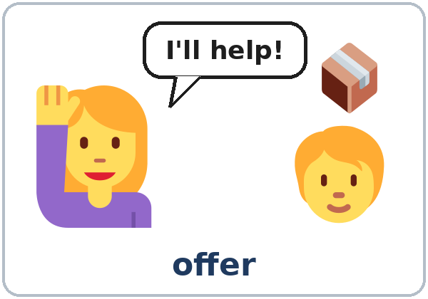  ★ offer | 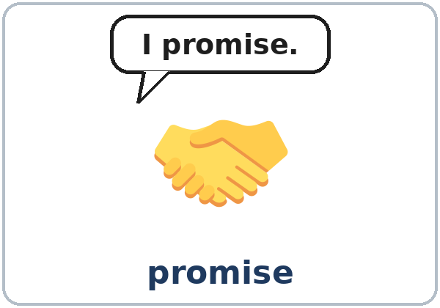  ★ promise | 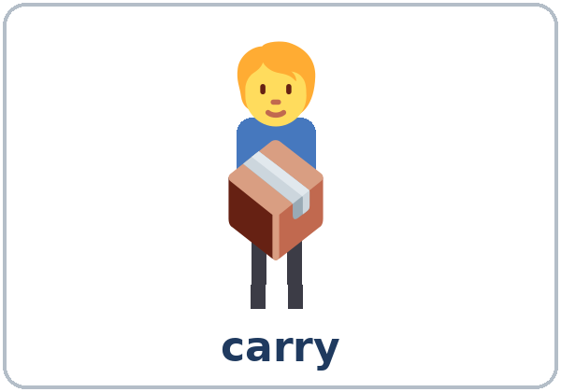  ★ carry | 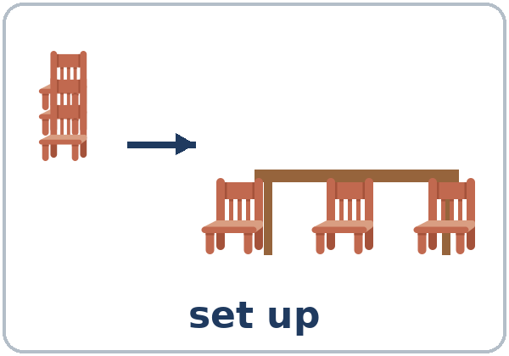  ★ set up
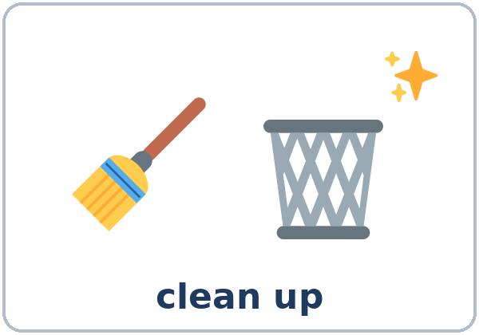  ★ clean up | 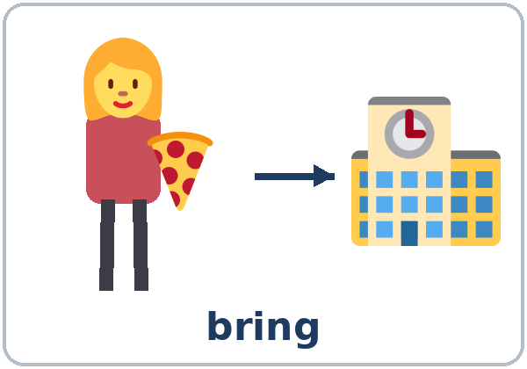  ★ bring | 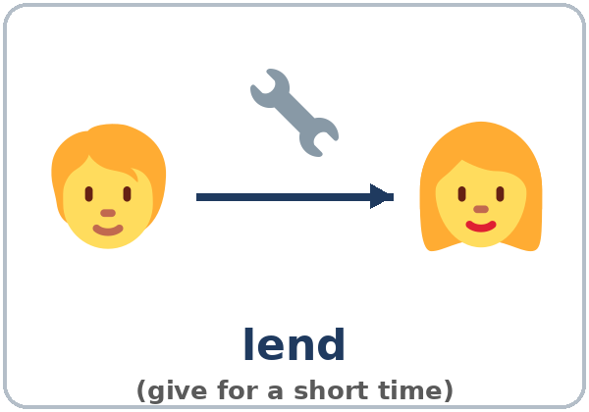  ★ lend | 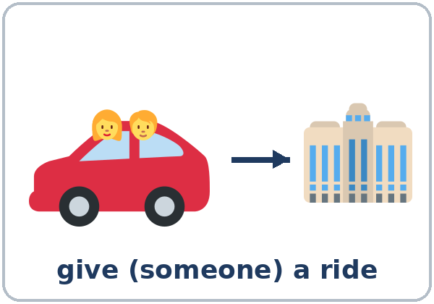  ★ give a ride
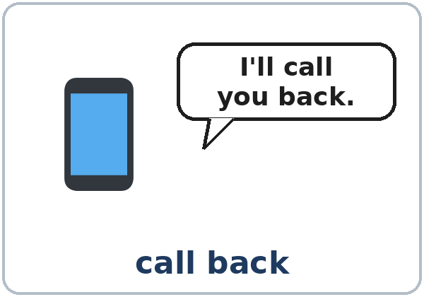  ★ call back | 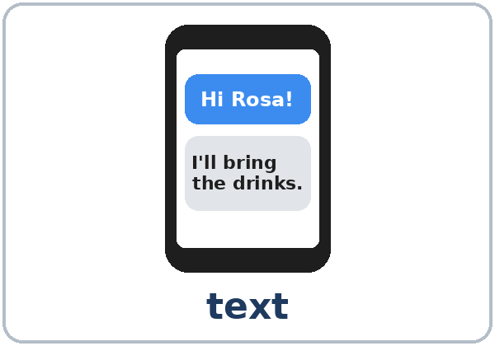  ★ text | 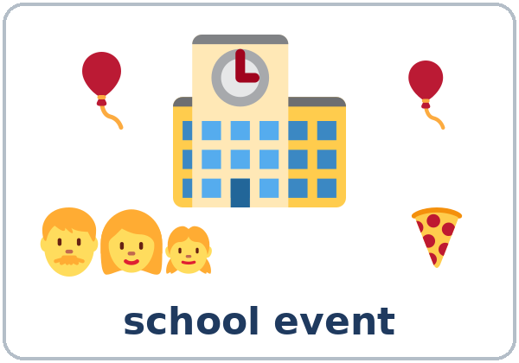  school event | 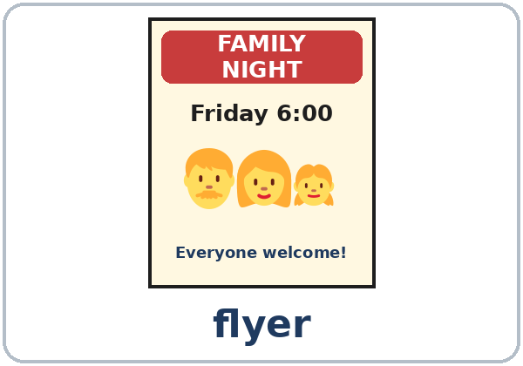  flyer

Partner game: A says a word. B points and makes a sentence.
Example: A: lend. B: (points) I can lend you my pen.
Lesson 5 (Week 5) · My Words
Write each word in your language, if you want. Then write your own example.
Word | My language | My example
offer
promise
carry
set up
clean up
bring
lend
give a ride
call back
text
school event
flyer

Lesson 5 (Week 5) · Listening
Listen to Carmen and David. They're parents at Hillside School. Carmen is calling David.
A. Listen. What is the event? Circle.
a. a birthday party b. a family night at a school c. a park cleanup
B. Listen again. Who will do it? Write D (David), R (Rosa), S (David's sister), or C (Carmen). One job has two letters.
Job | Who? | Job | Who?
1. set up the tables and chairs | ______ | 4. make a flyer | ______
2. bring pizza | ______ | 5. call back tonight | ______
3. bring drinks | ______ | 6. clean up after the event | ______

C. Listen again. Write 'll or going to.
1. No problem. I____ set them up.
2. Rosa is ____________ bring pizza.
3. OK, I____ bring the drinks.
4. I'm ____________ be very busy at work this week.
5. I____ ask her and call you back tonight.
6. I'm ____________ clean up after the event.
Say it: I'll • you'll • we'll • I won't forget. (like don't) • I want pizza.
Lesson 5 (Week 5) · Grammar
Read across. A reads from the left side. B answers from the right side. Choose one part from each column.
Grammar Box 1: Offers with I'll
PROBLEM |  | OFFER (I'll = I will)
The phone's ringing. |  | I'll | get it.  answer it.
These boxes are heavy. |  | I'll | carry them.  help you.
We need chairs for the party. |  | I'll | bring them.  set them up.
I don't have a ride. |  | I'll | give you a ride.  pick you up.
I forgot my pen. |  | I'll | lend you one.  lend you mine.

Grammar Box 2: Promises: Will you…?
QUESTION |  |  |  | ANSWER
Will | you | call me tonight?  be there at five? |  | Yes, I will. | I promise.
Will | you | call me tonight?  be there at five? |  | No, I won't. | Sorry, I'm busy.
Will | you | remember?  be late? |  | Don't worry. | I won't forget.  I won't be late.

Grammar Box 3: Other ways to offer (understand and answer)
OFFER |  |  | ANSWER
Do you want me to | carry that?  open the door? |  | Yes, please. Thanks!  No, thanks. I'm OK.
Shall I | call a taxi?  close the window? |  | Yes, please. That's very kind.  No, thanks.

Grammar Box 4: will (decided now) or going to (planned before)?
will: I decide NOW |  | going to: I PLANNED IT BEFORE
A: We need drinks. B: OK, I'll bring juice. |  | I'm going to bake a cake. (I bought eggs yesterday.)
A: The phone's ringing. B: I'll get it. |  | We're going to visit my mother. (We bought tickets.)
A: It's cold in here. B: I'll close the window. |  | She's going to work on Saturday. (It's on her schedule.)

Questions and answers
Q: Does will change for he or she?
A: No. I will, he will, she will, they will. Then use the base verb: She'll call (not wills, not will to call). I'll = I will; won't = will not.
Q: When do I use will?
A: For something you decide now: an offer (I'll help you), a promise (I'll call you back), or a quick decision (I'll have the soup).
Q: When do I use going to?
A: For a plan you made before: I'm going to visit my sister on Sunday. (I bought the ticket last week.)
Q: How do I say it?
A: I'll is one short sound (like aisle). won't sounds like don't. want is different: I want pizza.
Practice A: Write 'll, won't, or Will.
1. A: It's cold in here. B: I____ close the window.
2. Don't worry, I ____________ forget.
3. A: I don't have a pen. B: I____ lend you one.
4. I promise I ____________ be late.
5. A: Can someone help me? B: I____ help you!
6. ____________ you call me tonight?
Practice B: Circle the right words.
1. A: The phone's ringing! B: OK, (I'll get / I'm going to get) it.
2. I bought eggs and flour yesterday. I (will bake / am going to bake) a cake on Saturday.
3. A: We need someone to clean up. B: (I'll do / I'm going to do) it!
4. We have tickets. We (will see / are going to see) a movie tonight.
5. A: Oh no, I forgot my lunch. B: (I'll share / I'm going to share) mine.
6. She (will / is going to) visit her mother next week. She bought the bus ticket.
Common mistakes
✗ Don't say | ✓ Say
The phone's ringing. I answer it. | The phone's ringing. I'll answer it.
I will to bring the drinks. | I will bring (I'll bring) the drinks.
She wills call you. | She will call you.
Don't worry, I don't forget. | Don't worry, I won't forget.
Will you calling me? | Will you call me?
I'll visit my sister Sunday. (I bought the ticket.) | I'm going to visit my sister on Sunday.

Nota para hispanohablantes: en español muchas veces usamos el presente para ofrecer ayuda: ¿Te ayudo? Yo lo traigo. En inglés se necesita will: I'll help you. I'll bring it. (no I help you, no I bring it). won't = will not: I won't forget = No me voy a olvidar.

Tip for speakers of other languages: will never changes: I will, she will, they will. No -s and no to after it.

Lesson 5 (Week 5) · Talk Time: Problem / Offer Cards
Round 1: Work with a partner. A reads a problem card. B offers help with I'll… and gives a reason or a detail. A says thank you. Then switch.
A: My car won't start, and I have to go to work.
B: Don't worry. I'll give you a ride, because I'm going that way.
A: Really? Thanks! That's very kind.
Useful: Don't worry. No problem. I'll… Thanks! That's very kind. You're the best!

1. My car won't start, and I have to go to work. | 2. I forgot my dictionary at home.
3. I have five heavy boxes in my car. | 4. My boss called, but I was in a meeting.
5. My kitchen is a mess after the party. | 6. Thirty people are coming, and we have no chairs.
7. It's raining, and I don't have an umbrella. | 8. I don't know how to send a photo by text.

Lesson 5 (Week 5) · Talk Time: Event Board
Round 2: Work in a group of 3–4. Choose one event. Each person volunteers for two jobs with I'll… and writes their name. Then each person says one plan with going to.
A Park Cleanup (Saturday, 9:00–12:00) | Name | A School Family Night (Friday, 6:00–8:00) | Name
bring trash bags |  | set up the tables and chairs
bring water for everyone |  | bring food
make a flyer |  | bring drinks
give rides to the park |  | play games with the children
pick up trash near the river |  | play music
take photos |  | clean up after the event
text everyone the time |  | text the families a reminder

Example: I'll bring water and I'll take photos. I'm going to work on Saturday morning, so I'll come at 11:00.
My plan with going to: ______________________________________________________________
Lesson 5 (Week 5) · Homework
Homework (about 15 minutes). Bring it next week!
1. Write an offer with I'll for each problem.
Example: "I'm hungry." → I'll make you a sandwich.
1. "It's hot in here." → ______________________________________________
2. "I don't have a pen." → ______________________________________________
3. "I'm so hungry!" → ______________________________________________
4. "This bag is really heavy." → ______________________________________________
2. Write 'll, 'm going to, 're going to, won't, or Will.
1. A: Someone's at the door. B: I____ open it.
2. I bought paint last week. I____ ____________ paint my bedroom on Saturday.
3. A: I can't find my keys! B: Don't worry. I____ help you look.
4. We have a reservation. We____ ____________ eat at a restaurant tonight.
5. I promise I ____________ tell anyone. It's a secret.
6. ____________ you text me when you get home?
3. Ask a family member or a friend: What are you going to do this weekend? Then offer to help with one thing. Write what you said.
He / She is going to… | My offer (I'll…)

4. Review (Lesson 4): Write 2 sentences. Use was / were + -ing and when.
Example: I was cooking dinner when my friend called.
______________________________________________________________
______________________________________________________________
Lesson 5 (Week 5) · Read & Write
A. Read the flyer and the sign-up sheet.
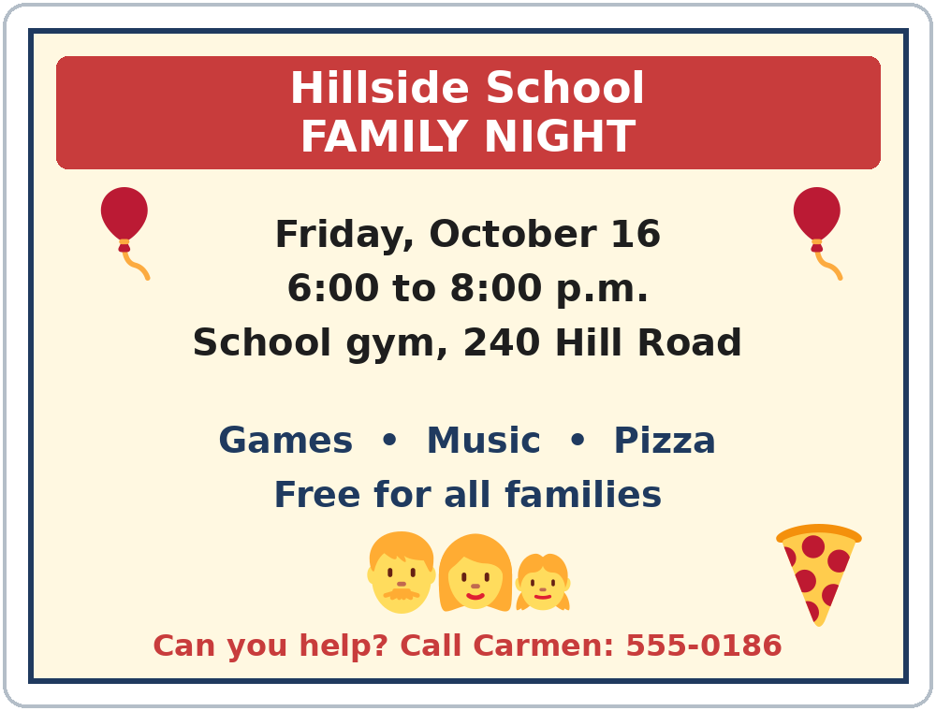

Volunteer Sign-Up Sheet: Family Night | Time | Name
Set up the tables and chairs | 5:00–6:00 | David
Bring pizza | 6:00 | Rosa
Bring drinks | 6:00 | David
Play games with the children | 6:00–7:00
Play music | 6:00–8:00 | Mr. Grant
Give rides to families | 5:30 and 8:15
Clean up | 8:00–8:30 | Carmen

B. Answer the questions.
1. When is family night? ______________________________________________
2. Where is it? ______________________________________________
3. Who is going to bring pizza? ______________________________________________
4. Which two jobs need a volunteer? ______________________________________
5. Who can you call to help? ______________________________________________
C. Choose one job with no name. Write a text message to Carmen. Offer to help with I'll. Say when you'll be there.
Example: Hi Carmen, this is Maya. I'll help with the games for the children. I'm going to finish work at 5:00, so I'll be there at 5:45. See you Friday!
To: Carmen

D. Check your text message with a partner.
 | Yes | Not yet
It says who you are (this is…). | ☐ | ☐
It has an offer with I'll + verb (I'll help…). | ☐ | ☐
It says a time. | ☐ | ☐
Each sentence starts with a capital letter and ends with a period. | ☐ | ☐

Lesson 5 (Week 5) · Progress Check
Name: ______________________________ Date: ________________
A. Listen to the teacher. Circle a or b.
1. a. decided now (will) b. planned before (going to)
2. a. decided now (will) b. planned before (going to)
3. a. decided now (will) b. planned before (going to)
4. a. decided now (will) b. planned before (going to)
B. Circle the right words.
1. I (will / wills) help you.
2. Don't worry, I (won't / don't) forget.
3. A: It's hot in here. B: I'll (open / to open) the window.
4. We bought paint. We (will / are going to) paint the kitchen this weekend.
C. Write an offer with I'll.
1. "My bag is really heavy." → ______________________________________________
2. "I don't have a ride to work." → ______________________________________________
Score: A ______ / 4 B ______ / 4 C ______ / 2
D. How do you feel? Check ✓ one face for each line.
I can… | 😀 I can do it. | 🙂 With a little help. | 😐 Not yet.
I can offer help with I'll…. | ☐ | ☐ | ☐
I can make a promise. | ☐ | ☐ | ☐
I can make a quick decision. | ☐ | ☐ | ☐
I can tell the difference between will and going to. | ☐ | ☐ | ☐

Picture Credits
Pictures use Twemoji graphics by Twitter, Inc. and other contributors (https://github.com/jdecked/twemoji), licensed under CC BY 4.0 (https://creativecommons.org/licenses/by/4.0/). The graphics were resized and combined, and drawings (bubbles, a table, a phone screen, a flyer, bodies) and labels were added. The file-by-file list is in images/CREDITS.md.
Listening audio: synthetic voices made with Chatterbox TTS (Resemble AI, MIT License), cloned from synthetic reference clips made with Kokoro-82M (Apache License 2.0). No recordings of real people were used. Each file carries an inaudible Perth watermark marking it as AI-generated. The names and the story are invented.
Course materials: © 2026 the authors, licensed under CC BY-NC-SA 4.0 (https://creativecommons.org/licenses/by-nc-sa/4.0/).

