Level 3 Adult ESL Curriculum · Lesson 6 (Week 6): Be Ready
Status: Draft for review; not published.
Date: October 2026
Audience: Program coordinators and volunteer teachers
Companion files: audio/L3_L6_listening.mp3, images/ (12 vocabulary pictures, 1 activity picture + images/CREDITS.md)
Topic: weather alerts, storms, heat, and power outages; what to do if…; an emergency kit and a simple plan, with the first conditional (If the power goes out, I'll use a flashlight.) and will + probably / maybe for predictions.

How this lesson is organized
Part | What's inside | Who uses it
Teacher Plan | At a glance, clock-time plan, step-by-step boxes, listening script, answer key, teacher notes | Volunteer teachers
Student Pages | Opening Talk, New Words, My Words, Listening, Grammar, Talk Time, Homework, Read & Write, Progress Check. Print this part for learners | Learners
Picture Credits | Picture, audio, and license credits | Coordinators

What Lesson 6 builds on and what it adds
Before (review only) | Where | New in Level 3 Lesson 6
will for offers and decisions | Level 3 Lesson 5 | will for predictions: It will probably rain.
Simple present + -s | Level 2 Lesson 2 | After if, use the present: If it rains, I'll stay home.
should / shouldn't | Level 2 Lesson 10 | Safety tips: You should keep water at home. (review only)
because / so | Level 3 Lesson 1 | I'll stay home, because the roads will be dangerous.

TEACHER PLAN
Lesson 6 (Week 6)

Be Ready
At a glance · Clock-time plan · Step by step · Script and answer key

How to Use This Plan
You don't need to speak Spanish or any other language. Teach in English. Show, point, and gesture. Each Grammar page has one short Spanish note and one tip for speakers of other languages. Learners read them on their own. You never need to read, translate, or explain them.

Instructions: use the same short task words every week: Listen. Circle. Check. Write. Work with a partner. Work in a group. Ask a follow-up question. Learners have the Task Words page from Lesson 1.

Instruction rule: Model it (do it with one learner while everyone watches), check it (ask: "Do you write or speak? How many people do you talk to?"), then go. Say less, show more.

Grouping toolkit: Pairs: turn to a neighbor; with an odd number, make one group of 3. Groups: 3–4 learners. Inside–outside circles: the inner circle faces out, the outer circle faces in; the outer circle moves one person to the right each round. Mingle: everyone stands and talks to many classmates. The teacher joins a pair only if one learner is left over.

When a learner is stuck or speaks another language to you: (1) show it: the picture, a gesture, or the board; (2) give one more short English example; (3) point to the grammar box on their page; (4) a classmate can help for a few seconds, then back to English. You don't need to understand what classmates say to each other.

Lesson 6 (Week 6): Be Ready
At a glance
Objectives: learners can…
• understand a short weather forecast and a weather alert
• say what will happen if… (If the power goes out, I'll use a flashlight.)
• ask and answer What will you do if…?
• make predictions with probably and maybe (It will probably rain. It probably won't snow.)
• give simple safety tips with should (review)
• read a weather alert text and fill in a simple "My Ready Plan" card

Materials
• Student Pages for Lesson 6 (print for the number expected + 3 spares)
• Talk Time: the Scenario Cards and the group plan (on the Talk Time pages)
• phone + small speaker, L3_L6_listening.mp3
• optional: a real flashlight and a battery to show
• Prep time: 10 min. Choose the weather that fits your area (see the teacher notes).

Key vocabulary (with pictures on the New Words page)
★ forecast • ★ storm • ★ snowstorm • ★ flood • ★ heat wave • ★ weather alert • ★ power outage • ★ flashlight • ★ battery • ★ emergency kit • ★ bottled water • shelter

Clock-time plan
Times are loose. If a step runs long, take time from Read & Write first, then from Talk Time.
Time | Step | Min | Grouping (15 / 7–8) | If running behind
6:00–6:10 | Opening Talk + Homework Check | 10 | Pairs (7 pairs + 1 trio / 3–4 pairs) | One card only
6:10–6:18 | New Words (picture page) + pair game | 8 | Whole class, then pairs | Teach the ★ words only
6:18–6:30 | Listening: play 1 (Task A), play 2 (Tasks B and C) + "Say it" | 12 | Individuals, then pairs check | Do Task C together on the board
6:30–6:45 | Grammar Q&A: If…, …will…; probably / maybe; should review + pair drill | 15 | Whole class, then pairs | Skip the pair drill; Talk Time practices it
6:45–7:00 | BREAK | 15
7:00–7:12 | Talk Time: What If? Chain + Ready Plan | 12 | Groups of 3–4 | Round 1 only
7:12–7:17 | Exit Ticket + Homework | 5 | Individuals | Never skip
7:17–7:25 | Read & Write: a weather alert text + a kit checklist; "My Ready Plan" | 8 | Individuals, then pairs | Reading questions only; the plan becomes homework
7:25–7:30 | Progress Check | 5 | Individuals | Do it in Week 7 at 6:00, while people arrive

Skip order if you're running behind: (1) the Read & Write plan card (it becomes homework); (2) the pair drill at the end of Grammar; (3) half of Talk Time (Round 1 only). Never skip: the listening tasks, the grammar boxes and the mistakes table, and the exit ticket.

Attendance (15 → 7–8): every step lists both sizes. With 5 or fewer, sit at one table: the chain goes around the table, and the whole table makes one Ready Plan.

Step by step
Step 1 · 6:00–6:10 · Opening Talk + Homework Check · 10 min
• Grouping: pairs, the same partner for both parts. 15 learners: 7 pairs + 1 group of 3. 7–8 learners: 3–4 pairs.
• Before class: write on the board: I'll… / I'm going to… / Don't worry, I won't…
• Opening Talk (6 min): learners open the Opening Talk page. A asks a card question or reads a problem; B answers with 2–3 sentences; A asks one follow-up. Switch after each card.
• Model with one learner: "What are you going to do this weekend?" → (answer) → "Really? Who with?"
• Homework Check (4 min): partners read their Lesson 5 Homework item 1 (offers with I'll) to each other. Walk around. Write 2 common errors on the board (often I help you or I will to…) and correct them together.
• Late arrivals: join any pair as a group of 3.
• If behind: one card only, then the homework check.

Step 2 · 6:10–6:18 · New Words · 8 min
• Grouping: whole class, then pairs. Show the New Words page.
• Do: point to each picture and say the word. Learners repeat once. Act out heat wave (fan your face), snowstorm (shiver), and power outage (click a light switch: "Oh no! No lights!").
• Group the words (1 min): draw three columns on the board: WEATHER (forecast, storm, snowstorm, flood, heat wave), PROBLEMS (weather alert, power outage), and BE READY (flashlight, battery, emergency kit, bottled water, shelter). Learners say where each word goes.
• Check meaning (1 min): "No lights, no fridge, no TV. It's a…?" (power outage) • "Where do you put a flashlight, water, and batteries?" (an emergency kit) • "A safe public building for a storm?" (a shelter)
• Pairs (2 min): A says a word; B points to the picture and makes a sentence (I have a flashlight in my kitchen.). Switch.
• If behind: teach the ★ words only.

Step 3 · 6:18–6:30 · Listening + "Say it" · 12 min
• Grouping: individuals, then pairs check.
• Before you listen (1 min): say: "First, you'll hear a weather alert on the radio. Then two roommates, Nadia and Ben, talk about it. What is the weather problem? Listen."
• Play 1 → Task A (what is the weather problem?). Pairs compare. Check together.
• Read Tasks B and C together (1 min) so learners know what to listen for.
• Play 2 → Tasks B and C. Pairs compare. Then show the answers (answer key).
• "Say it" (2 min): say: "It will is usually it'll. It sounds like id-ul." Read it'll, we'll, I'll and the line in the "Say it" box, stressing the key words: If the power goes out, we'll use a flashlight. The class repeats each line twice.
• The audio plays once (about 1:20). Press play again for play 2. A third play is fine if the class needs it.
• If behind: do Task C together on the board, reading the lines yourself.

Step 4 · 6:30–6:45 · Grammar Q&A · 15 min
• Grouping: whole class, then pairs. Show the Grammar page. The left side is the question or the if part. The right side is the answer.
• Draw on the board: IF + present → will. Under it write: If it rains, I'll take the bus. Circle rains and say "present, no will." Circle 'll and say "the result: will."
• Box 1 (3 min): read a question from the left; the class answers from the right. Then ask learners: "What will you do if it snows tomorrow?"
• Box 2 (2 min): the two halves can change places: I'll stay home if it snows. No comma when if is in the middle.
• Boxes 3 and 4 (3 min): draw a line from 0% to 100% on the board. Put won't at 0%, probably won't at 25%, maybe at 50%, probably at 75%, will at 100%. Read Boxes 3 and 4 across. Box 5 is a quick should review.
• Check questions: "If it ___ tomorrow, I'll stay home." (snows) • "If the power goes out, we ___ use flashlights." ('ll) • "It will ___ rain." (probably) • "It ___ won't snow." (probably)
• Practice A and B (3 min): learners write, then pairs check. Go over the answers.
• Pair drill (last 2 min): A says "What will you do if…" + a problem (the bus doesn't come? / it's very hot tomorrow?); B answers with If…, I'll…. Switch.
• If behind: skip the pair drill. Talk Time practices it.

Break · 6:45–7:00 · 15 min
• Write on the board: If it snows, I'll… → If I…, I'll… and probably / maybe / probably not.

Step 5 · 7:00–7:12 · Talk Time: What If? Chain + Ready Plan · 12 min
• Grouping: groups of 3–4. 15 learners: 4 groups. 7–8 learners: 2 groups. 5 or fewer: one group.
• Round 1, the chain (5 min): the first person says a sentence from a start card (If it snows tomorrow, I'll stay home.). The next person starts with the end of that sentence (If I stay home, I'll cook soup.), and so on around the group. Keep going until the chain stops, then start a new card.
• Model with two learners (1 min): "If it snows tomorrow, I'll stay home." → Learner 1: "If I stay home, I'll watch TV." → Learner 2: "If I watch TV, I'll…" Laugh at funny chains; that's fine.
• Round 2, Ready Plan (6 min): each group gets one Scenario Card (a storm, a heat wave, or a power outage). Together they write 4 sentences with If…, we'll… and a list of 5 things for the emergency kit. Then one person presents the plan in 1 minute.
• If behind: Round 1 only.

Step 6 · 7:12–7:17 · Exit Ticket + Homework · 5 min · NEVER SKIP
• Exit ticket: each learner writes two sentences on a slip: one with If…, I'll…, and one prediction with probably and because or so (It will probably rain tomorrow, so I'll take my umbrella.). Collect at the door.
• Homework: open the Homework page. Do item 1 together (one sentence on the board). Say: "About 15 minutes. Bring it next week."

Read & Write · 7:17–7:25 · A Weather Alert and a Ready Plan · 8 min
• Grouping: individuals, then pairs check.
• Read (3 min): learners read the weather alert text and the kit checklist, and answer questions 1–5. Say: "Read fast first. Then find the answers."
• Pairs check (1 min): compare answers; check together.
• Write (4 min): learners fill in the "My Ready Plan" card. Say: "First names only. Don't write phone numbers or addresses." An invented plan is fine.
• If behind: questions 1–5 only; the plan card becomes homework.

Progress Check · 7:25–7:30 · 5 min
• Grouping: individuals. Open the Progress Check page.
• Part A: read the 4 sentences in the answer key, slowly, 2 times each. Learners circle a or b.
• Parts B and C: learners do them alone. Walk around and help with the instructions only.
• Part D: read each "I can…" line aloud and point to the 3 faces: 😀 "I can do it." 🙂 "With a little help." 😐 "Not yet."
• Collect the pages (or check them at the start of Week 7).
• If behind: do the Progress Check in Week 7 at 6:00, while learners arrive.

Listening script: L3_L6_listening.mp3 (about 1:20; it plays once, so press play again for the second listen)
Audio: play from a phone + small speaker. No speaker? Read the script with a volunteer, at a normal, friendly speed. The weather alert is read by the narrator.

Narrator: Lesson six. Listening. First, listen to a weather alert on the radio. Then listen to two roommates, Nadia and Ben.
Narrator: This is a weather alert for Green County. A big storm will arrive tonight at about nine o'clock. There will probably be strong wind and heavy rain. The power will probably go out in some areas.
Nadia: Ben, did you hear that? A storm is coming tonight.
Ben: Yes. If the power goes out, we won't have any lights.
Nadia: Do we have a flashlight?
Ben: We have one, but it doesn't have batteries. I'll buy some after work.
Nadia: Good. And if the power goes out, the fridge won't work.
Ben: Then we'll eat the food in the fridge first! I'll buy bottled water, too.
Nadia: Great. Should we buy candles?
Ben: No, candles aren't safe. We'll use the flashlight. And I'll charge our phones before nine.
Nadia: OK. If the storm is really bad, will we go to work tomorrow?
Ben: Probably not. It'll probably rain all night. I'll check the forecast in the morning.
Narrator: That's the end of the listening.

Answer key
• Listening Task A: b (a storm: strong wind and heavy rain).
• Listening Task B (check ✓): ✓ 1 batteries, ✓ 2 bottled water, ✗ 3 candles, ✓ 4 charged phones, ✗ 5 a snow shovel, ✗ 6 a new fridge. (3 checks.)
• Listening Task C: 1 goes, won't • 2 'll • 3 won't • 4 'll • 5 is • 6 'll.
• Grammar Practice A: 1 rains, 'll take • 2 goes, 'll use • 3 'll stay, snows • 4 don't have, 'll bring • 5 is, 'll go • 6 will, closes.
• Grammar Practice B: 1 rains, 2 probably rain, 3 probably won't, 4 it snows, 5 will use, 6 should.
• Talk Time: answers will vary. Sample Ready Plan (power outage): If the power goes out, we'll use flashlights. If the fridge doesn't work, we'll eat the cold food first. If our phones die, we'll use a radio with batteries. If it's very cold, we'll wear coats. Kit: flashlight, batteries, bottled water, food in cans, a first aid kit.
• Homework 1–4: answers will vary. Homework 2 example: It will probably be sunny tomorrow. It probably won't snow.
• Read & Write B: 1 a heat wave • 2 from Tuesday to Friday • 3 about 100 degrees • 4 from 12:00 to 5:00 p.m. • 5 at Oak Park Library, from 9:00 a.m. to 9:00 p.m. • Writing (C): answers will vary.
• Progress Check Part A (the teacher says, 2 times each): 1 "If it snows tomorrow, I'll stay home." → a • 2 "It will probably rain tonight." → a • 3 "If the power goes out, we'll use flashlights." → b • 4 "It probably won't be hot tomorrow." → b
• Progress Check Part B: 1 rains, 2 'll call, 3 probably won't, 4 it snows.
• Progress Check Part C: answers will vary; for example 1 If the power goes out, I'll use a flashlight. 2 It will probably rain this weekend.
• Progress Check scoring: A /4 + B /4 + C /2 = /10. This is not a test grade. It shows who needs more help hearing if sentences and predictions (A) and with the forms (B, C).
Teacher notes
• Choose your weather: use the weather that fits your area (snow, heat, storms, floods). Skip a word that never happens where you live, or teach it quickly for the news.
• Safety (important): keep candles out of practice plans (fire risk); use flashlights. Never use a grill or a generator inside. Use local alert systems only as examples. Don't do real sign-ups in class. Say once: "In a real emergency, call 911."
• Feelings: some learners have lived through a hurricane, a flood, or an earthquake. Keep the stories in the lesson invented. Never ask about real disasters. "I don't want to say" is always OK.
• After if, use the present: If it rains (not If it will rain). will goes in the other half. In English if needs a subject: If it rains (not If rains).
• probably goes after will and before won't: It will probably rain. It probably won't snow. Maybe goes at the start: Maybe it will snow.
• Mixed levels: stronger learners add because to each Ready Plan sentence. Newer learners use Box 1 as a script.
• Typical mistakes this week: If it will rain, If rains, It will rain probably, It won't probably, You should to buy. Say the right form clearly; the learner repeats. Learners can read the Spanish note and the tip on their Grammar page themselves; you don't need to explain them.

STUDENT WORKBOOK
Lesson 6 (Week 6)

Be Ready
Opening Talk · New Words · Listening · Grammar · Talk Time · Homework · Read & Write · Progress Check

Lesson 6 (Week 6) · Opening Talk
Name: ______________________________ Date: ________________
Work with a partner. A asks a question or reads a problem. B answers with 2–3 sentences. A asks one follow-up question. Then switch.
What are you going to do this weekend? | "I'm moving to a new apartment on Saturday." (B offers help with I'll…)
What are you going to do after class tonight? | "I forgot my lunch today." (B offers help with I'll…)

Follow-ups: Really? Who with? Why? Thanks! That's very kind.
Homework check: read your Lesson 5 homework (item 1) to your partner. Your partner says one more offer.
My partner's offer | My offer

Lesson 6 (Week 6): Be Ready
Student Page 1 · Week 6
Name: ______________________________ Date: ________________
New Words
Look. Listen. Repeat. ★ = most important words.
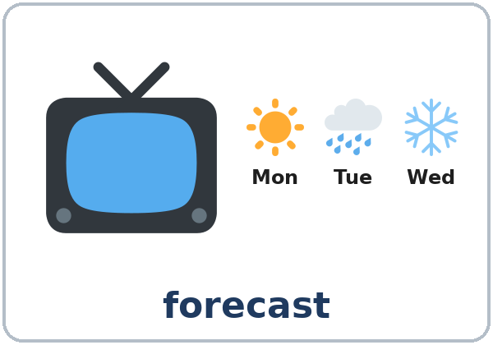  ★ forecast | 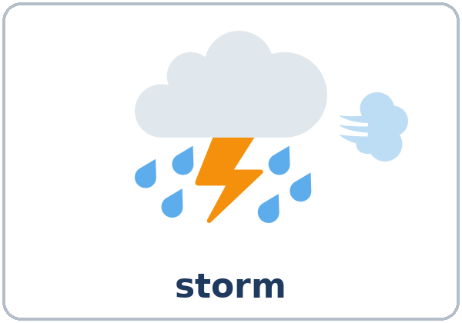  ★ storm | 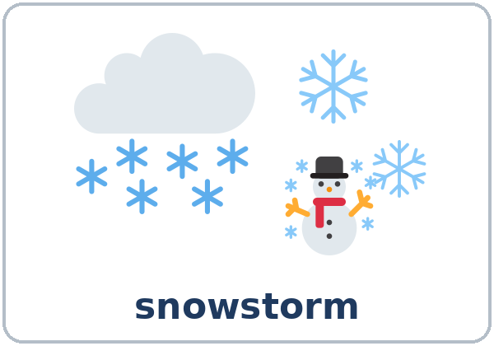  ★ snowstorm | 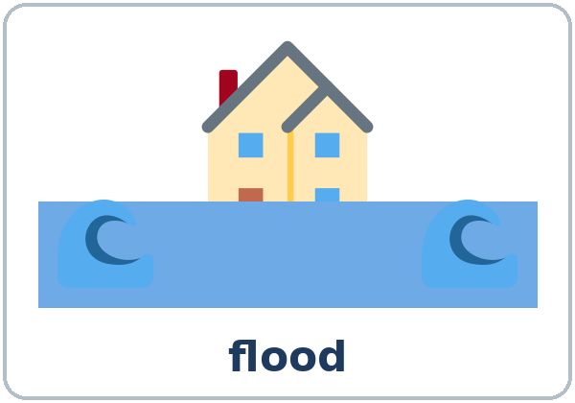  ★ flood
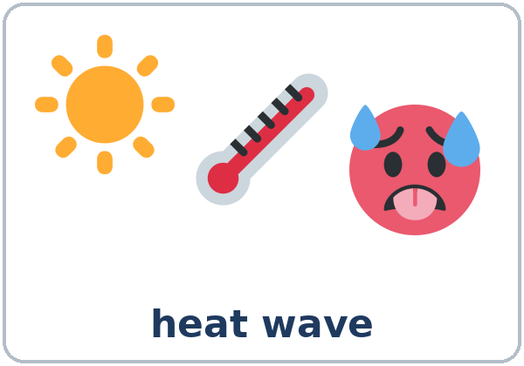  ★ heat wave | 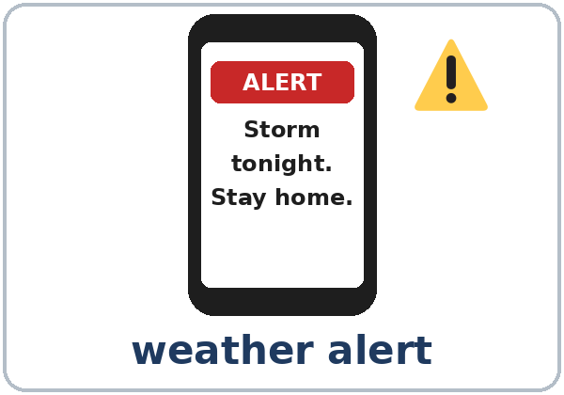  ★ weather alert | 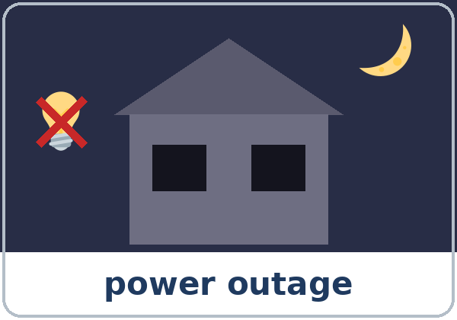  ★ power outage | 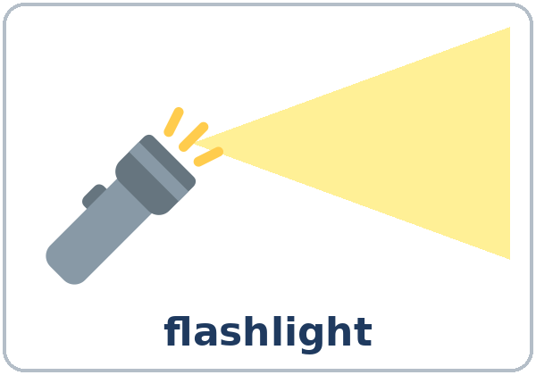  ★ flashlight
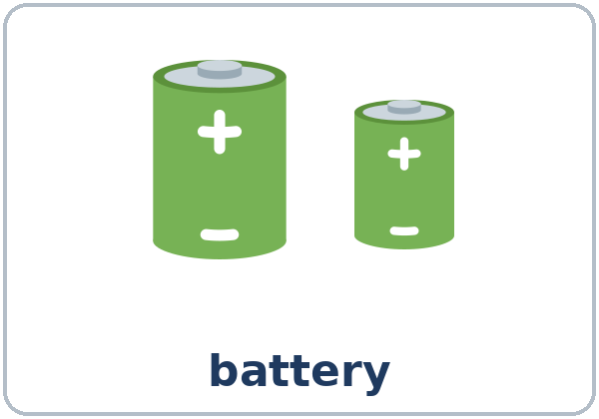  ★ battery | 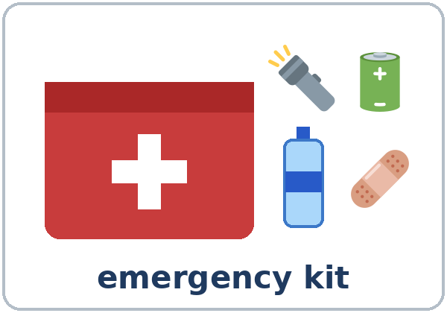  ★ emergency kit | 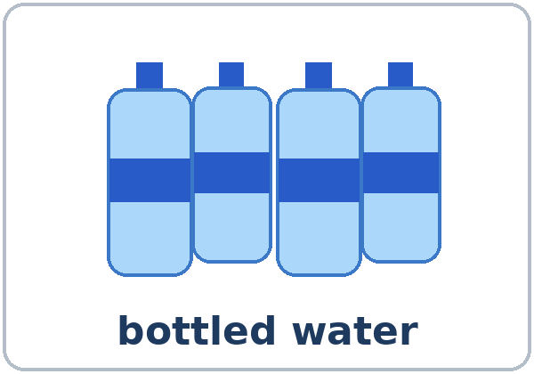  ★ bottled water | 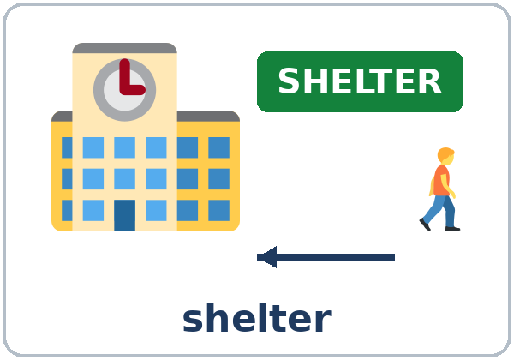  shelter

Partner game: A says a word. B points and makes a sentence.
Example: A: flashlight. B: (points) If the power goes out, I'll use a flashlight.
Lesson 6 (Week 6) · My Words
Write each word in your language, if you want. Then write your own example.
Word | My language | My example
forecast
storm
snowstorm
flood
heat wave
weather alert
power outage
flashlight
battery
emergency kit
bottled water
shelter

Lesson 6 (Week 6) · Listening
First, listen to a weather alert on the radio. Then listen to two roommates, Nadia and Ben.
A. Listen. What is the weather problem? Circle.
a. a heat wave b. a storm with strong wind and heavy rain c. a snowstorm
B. Listen again. What will Ben and Nadia use or buy? Check ✓.
☐ 1. batteries ☐ 2. bottled water ☐ 3. candles
☐ 4. charged phones ☐ 5. a snow shovel ☐ 6. a new fridge
C. Listen again. Write the missing word.
1. If the power ____________ out, we ____________ have any lights.
2. I____ buy some after work.
3. If the power goes out, the fridge ____________ work.
4. Then we____ eat the food in the fridge first!
5. If the storm ____________ really bad, will we go to work tomorrow?
6. It____ probably rain all night.
Say it: it'll (id-ul) • we'll • If the power goes out, we'll use a flashlight.
Lesson 6 (Week 6) · Grammar
Read across. A reads from the left side. B answers from the right side. Choose one part from each column.
Grammar Box 1: What will you do if…?
QUESTION |  |  | ANSWER (If + present, will)
What will you do | if the power goes out? |  | If the power goes out, | I'll use a flashlight.  I'll call my landlord.
What will you do | if it snows tomorrow? |  | If it snows, | I'll stay home.  I'll take the bus.
What will you do | if it's very hot? |  | If it's very hot, | I'll drink a lot of water.  I'll go to the library.

Grammar Box 2: The if part can go first or second
IF FIRST (comma) |  | IF SECOND (no comma)
If it rains, I'll take the bus. |  | I'll take the bus if it rains.
If school closes, my kids will stay home. |  | My kids will stay home if school closes.

Grammar Box 3: Will…? Short answers
QUESTION |  |  | ANSWER
If it snows tomorrow, | will school be closed? |  | Yes, it will.  Probably.  Maybe.  Probably not.  No, it won't.
If the storm is bad, | will the buses run? |  | Probably not.  Maybe.  I don't know.

Grammar Box 4: Predictions with probably and maybe
How sure? | Prediction
100% sure | It will rain.
75% sure | It will probably rain.
50% sure | Maybe it will rain.
25% sure | It probably won't rain.
0% | It won't rain.

Grammar Box 5: Review: safety tips with should
QUESTION |  |  | ANSWER
What should we do | before a storm? |  | You should | buy batteries.  keep bottled water at home.  charge your phone.
What should we do | before a storm? |  | You shouldn't | use candles.  drive in a flood.

Questions and answers
Q: Which verb comes after if?
A: The present: If it rains… (not If it will rain). Put will in the other half: …I'll stay home.
Q: Can I say If rains?
A: No. English needs a subject: If it rains. If it's hot.
Q: Where does probably go?
A: After will: It will probably rain. Before won't: It probably won't snow. Maybe goes first: Maybe it will snow.
Q: How do I say it?
A: it'll sounds like id-ul. Stress the important words: If the power goes out, we'll use a flashlight.
Practice A: Write the verbs.
1. If it ____________ (rain), I ____________ (take) the bus.
2. If the power ____________ (go) out, we ____________ (use) flashlights.
3. She ____________ (stay) home if it ____________ (snow).
4. If you ____________ (not / have) water, I ____________ (bring) some.
5. If it ____________ (be) very hot, we ____________ (go) to the library.
6. What ____________ you do if school ____________ (close)?
Practice B: Circle the right words.
1. If it (rains / will rain), I'll stay home.
2. It will (probably rain / rain probably) tonight.
3. It (probably won't / won't probably) snow.
4. If (it snows / snows), school will be closed.
5. If the power goes out tonight, I (use / will use) a flashlight.
6. You (should / should to) keep water at home.
Common mistakes
✗ Don't say | ✓ Say
If it will rain, I'll stay home. | If it rains, I'll stay home.
If rains, I'll take the bus. | If it rains, I'll take the bus.
If the power goes out, I use a flashlight. (tonight) | If the power goes out, I'll use a flashlight.
It will rain probably. | It will probably rain.
It won't probably snow. | It probably won't snow.
You should to buy batteries. | You should buy batteries.

Nota para hispanohablantes: es como si + presente en español: If it rains, I'll stay = Si llueve, me quedo / me quedaré. No uses will después de if: If it rains (no If it will rain). En inglés se necesita it: If it rains (no If rains).

Tip for speakers of other languages: never put will right after if. Put will in the other half of the sentence.

Lesson 6 (Week 6) · Talk Time: What If? Chain
Round 1: Work in a group of 3–4. Person 1 reads a start card. Person 2 starts with the end of that sentence. Keep going around the group.
1: If it snows tomorrow, I'll stay home.
2: If I stay home, I'll cook soup.
3: If I cook soup, I'll invite my neighbor.
4: If I invite my neighbor, we'll watch a movie!

Start cards
1. If it snows tomorrow, I'll stay home. | 2. If the power goes out tonight, I'll use a flashlight.
3. If it's very hot this weekend, I'll go to the beach. | 4. If the bus doesn't come, I'll walk to work.
5. If it rains on Saturday, I'll clean my house. | 6. If I win some money, I'll buy a new car.

Useful: If I…, I'll… • Then… • That's funny! • Your turn.
Lesson 6 (Week 6) · Talk Time: Ready Plan
Round 2: Your group gets one scenario. Write 4 sentences with If…, we'll… and a list of 5 things for your emergency kit. Then present your plan to the class in 1 minute.
Scenario Cards
A. A big storm Strong wind and rain tonight. The power will probably go out. | B. A heat wave About 100 degrees for 4 days. | C. A power outage No power for 2 days in winter.

Our scenario: ______
Our Ready Plan: If…, we'll…
1. If ______________________________, we'll ______________________________.
2. If ______________________________, we'll ______________________________.
3. If ______________________________, we'll ______________________________.
4. If ______________________________, we'll ______________________________.

Our emergency kit: 5 things
1. | 4.
2. | 5.
3.

Example: If the power goes out, we'll use flashlights. If the fridge doesn't work, we'll eat the cold food first.
Lesson 6 (Week 6) · Homework
Homework (about 15 minutes). Bring it next week!
1. Finish the sentences with I'll….
Example: If it rains this weekend, I'll watch movies at home.
1. If it rains this weekend, ______________________________________________
2. If I have free time tomorrow, ______________________________________________
3. If the power goes out tonight, ______________________________________________
4. If my friend needs help, ______________________________________________
2. What will the weather be like tomorrow? Look at a forecast or guess. Write 3 predictions with will probably, probably won't, or maybe.
1. ______________________________________________________________
2. ______________________________________________________________
3. ______________________________________________________________
3. Ask a family member or a friend: What will you do if the power goes out? Write 2 answers.
Name | What will he / she do?

4. Review (Lesson 5): Write 2 offers with I'll.
Example: "It's cold." → I'll close the window.
______________________________________________________________
______________________________________________________________
Lesson 6 (Week 6) · Read & Write
A. Read the weather alert and the checklist.
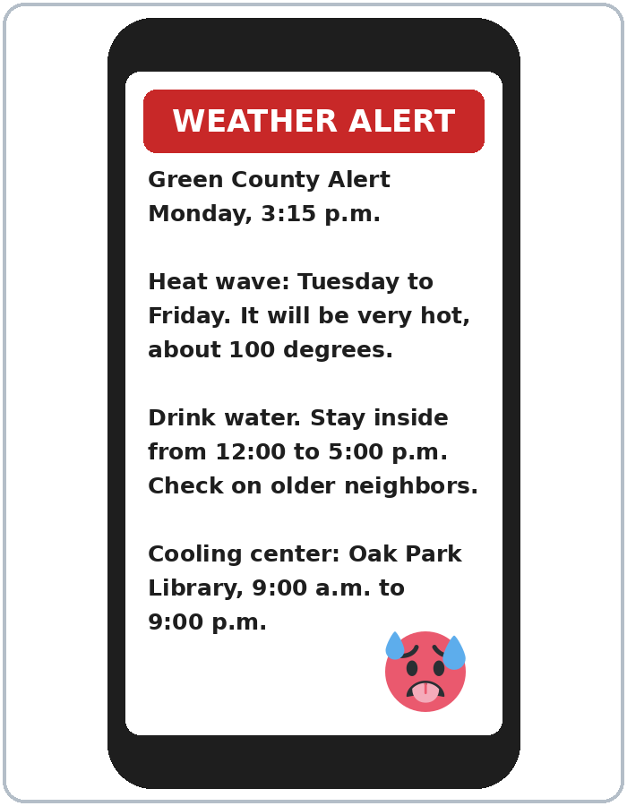 | Emergency Kit Checklist  ☐ a flashlight  ☐ batteries  ☐ bottled water (1 gallon for each person, each day)  ☐ food in cans + a can opener  ☐ a first aid kit  ☐ phone chargers  ☐ a radio with batteries  ☐ medicine for 3 days  ☐ copies of important papers  Keep candles out of your kit. Use flashlights.

B. Answer the questions.
1. What is the weather problem? ______________________________________________
2. When will it be hot? ______________________________________________
3. How hot will it be? ______________________________________________
4. When should people stay inside? ______________________________________________
5. Where is the cooling center? When is it open? ______________________________________________
C. Fill in your Ready Plan card. Use first names only. Don't write phone numbers or addresses.
MY READY PLAN
If there's a weather alert, I'll call… (first name)
If the power goes out, I'll…
If I need to leave home, I'll go to… (a place)
3 things I'll keep in my kit | 1.  2.  3.
If it's very hot, I'll…

D. Check your plan with a partner.
 | Yes | Not yet
The if part has a present verb (goes, is, rains). | ☐ | ☐
The other part has will or 'll. | ☐ | ☐
My kit has no candles. | ☐ | ☐
I wrote first names only. | ☐ | ☐

Lesson 6 (Week 6) · Progress Check
Name: ______________________________ Date: ________________
A. Listen to the teacher. Circle a or b.
1. a. stay home b. go to work
2. a. It will probably rain. b. It won't rain.
3. a. candles b. flashlights
4. a. It will be hot. b. It probably won't be hot.
B. Circle the right words.
1. If it (rains / will rain), I'll take the bus.
2. If you need help, I (call / 'll call) you tonight.
3. It (probably won't / won't probably) snow.
4. If (it snows / snows), school will be closed.
C. Write 2 sentences.
1. If the power goes out, ______________________________________________
2. A prediction with probably: ______________________________________________
Score: A ______ / 4 B ______ / 4 C ______ / 2
D. How do you feel? Check ✓ one face for each line.
I can… | 😀 I can do it. | 🙂 With a little help. | 😐 Not yet.
I can understand a weather forecast. | ☐ | ☐ | ☐
I can say what will happen if…. | ☐ | ☐ | ☐
I can make a simple emergency plan. | ☐ | ☐ | ☐
I can make predictions with probably and maybe. | ☐ | ☐ | ☐

Picture Credits
Pictures use Twemoji graphics by Twitter, Inc. and other contributors (https://github.com/jdecked/twemoji), licensed under CC BY 4.0 (https://creativecommons.org/licenses/by/4.0/). The graphics were resized and combined, and drawings (a house, water, a light beam, bottles, a kit bag, phone screens, signs) and labels were added. The file-by-file list is in images/CREDITS.md.
Listening audio: synthetic voices made with Chatterbox TTS (Resemble AI, MIT License), cloned from synthetic reference clips made with Kokoro-82M (Apache License 2.0). No recordings of real people were used. Each file carries an inaudible Perth watermark marking it as AI-generated. The names, the place, and the story are invented.
Course materials: © 2026 the authors, licensed under CC BY-NC-SA 4.0 (https://creativecommons.org/licenses/by-nc-sa/4.0/).

