Level 1 Adult ESL Curriculum · Lesson 1 (Week 1): Hello! What's Your Name?
Status: Complete sample lesson (Lessons 2–13 are coming soon).
Date: October 2026
Audience: Program coordinators and volunteer teachers
Companion files: audio/L1_listening.mp3, images/ (12 vocabulary pictures + images/CREDITS.md)
Topic: the first night of class: greetings, first and last names, spelling a name, the alphabet, and asking for help (Can you repeat, please?).

How this sample is organized
Part | What's inside | Who uses it
Teacher Plan | At a glance, clock-time plan, step-by-step boxes, Letters & Numbers script, listening script, answer key, teacher notes | Volunteer teachers
Student Pages | Icon key (first page), How Our Class Works, New Words, Classroom Phrases, Listening, Grammar, Talk Time sign-in sheet, Homework, Letters & Numbers, Progress Check. Print this part for learners | Learners
Picture Credits | Picture sources and licenses | Coordinators

What Lesson 1 gives Level 2
Level 2 uses… | Where in Level 2 | Lesson 1 starts it with…
be with I'm and short answers (Are you…? Yes, I am.) | Lesson 1 review, all lessons | I'm Ana. • Are you a student? Yes, I am. / No, I'm not. (Grammar Box 4, a first look; Lesson 2 teaches all persons)
Spelling a name aloud; What's your last name? Can you spell that, please? | Lesson 12 (phone call) | What's your last name? How do you spell it? R-U-I-Z. (Grammar Boxes 2–3, the listening, Talk Time)
Asking for help: Could you repeat that, please? | Lesson 12 | Can you repeat, please? (Classroom Phrases, Grammar Box 3, every week after this)
Nice to meet you and greetings | Lesson 1 | Hello. Nice to meet you. How are you? I'm fine, thanks. And you? (Grammar Box 1)
First name / last name on a form | Lesson 12 forms; Level 1 Lesson 3 | first name, last name (New Words, the ID-card pictures, the sign-in sheet)
The same class routine and page types | Every week | Same steps and the same workbook pages, plus the Letters & Numbers block

TEACHER PLAN
Lesson 1 (Week 1)

Hello! What's Your Name?
At a glance · Clock-time plan · Step by step · Letters & Numbers · Script and answer key

How to Use This Plan
You don't need to speak Spanish or any other language. Teach in English. Show, point, and gesture. The student pages have a picture icon, a Spanish line, and a "My language" line for every task. Learners read those on their own. You never need to read, translate, or explain them.

The icons: every task on the student pages starts with the same icons: 👂 listen · 🗣️ say · 📖 read · ✏️ write · ⭕ circle · ✅ check · ☝️ point · 🔗 match · 👥 partner · 👨‍👩‍👧 group · 🚶 walk and talk · 🏠 homework. Point to the icon when you give an instruction. After a few weeks, learners know what to do from the icon alone.

Instruction rule: Model it (do it with one learner while everyone watches), check it (point to the icon: "Listen or write?"), then go. Say less, show more. Use the same short words every time: Listen. Repeat. Point. Circle. Write. Partner. Group.

Grouping toolkit: Pairs: turn to a neighbor; with an odd number, make one group of 3. Groups: 3–4 learners. Mingle: everyone stands and talks to many classmates. The teacher joins a pair only if one learner is left over.

When a learner is stuck or speaks another language to you: (1) show it: the picture, a gesture, or the board; (2) give one more short English example; (3) point to the icon and the grammar box on their page; (4) a classmate can help for a few seconds, then back to English. You don't need to understand what classmates say to each other.

Lesson 1 (Week 1): Hello! What's Your Name?
At a glance
Objectives: learners can…
• say hello and goodbye (Hello. Hi. Goodbye. See you next week.)
• say their first and last name (My name is Ana. I'm Ana. My last name is Ruiz.)
• ask and answer What's your name? How do you spell it? and spell their name aloud
• ask for help: Can you repeat, please?
• say and write the letters of the alphabet (Letters & Numbers block)

Materials
• name tags and markers
• Student Pages for Lesson 1 (print for the number expected + 3 spares)
• a big alphabet strip (or write A–Z on the board before class)
• a sign-in sheet page for each learner (Talk Time page)
• mini whiteboards or scrap paper for Letters & Numbers
• baseline snapshot checklist (in the answer key)
• phone + small speaker, L1_listening.mp3
• Prep time: 30 min.

Key vocabulary (with pictures on the New Words page)
★ hello • ★ goodbye • ★ name • ★ first name • ★ last name • ★ spell • letter • ★ teacher • ★ student • classmate • book • pen

Classroom phrases (poster page, no pictures needed)
Listen. • Repeat. • Write. • Can you repeat, please? • I don't understand. • How do you say ___ in English?

Clock-time plan
Times are loose. If a step runs long, take the time from Grammar or Talk Time. The last 15 minutes are the Letters & Numbers block.
Time | Step | Min | Grouping (15 / 7–8) | If running behind
6:00–6:10 | Welcome + Hello Circle (Week 1 opening) | 10 | Two circles / one circle | Go around once only
6:10–6:15 | Orientation: How Our Class Works + the icons | 5 | Whole class | Show the icon key; say the 3 rules only
6:15–6:25 | New Words (picture page) + pair picture game | 10 | Pairs | Teach the ★ words only
6:25–6:35 | Listening (audio) + "Say it" | 10 | Individuals, then pairs check | Play the audio 2 times, not 3
6:35–6:45 | Grammar Q&A: What's your name? How do you spell it? + pair drill | 10 | Whole class, then pairs | Skip the pair drill; Talk Time practices it
6:45–7:00 | BREAK | 15
7:00–7:10 | Talk Time: Name Mingle with the sign-in sheet + baseline snapshot | 10 | Mingle: 5–6 people / everyone | Learners talk to 3 people
7:10–7:15 | Exit Ticket + Homework | 5 | Individuals | Never skip
7:15–7:25 | Letters & Numbers: the alphabet (See it → Say it → Write it) | 10 | Whole class, then pairs | Do the tricky letters and "spell your name" only
7:25–7:30 | Progress Check (first can-do self-check) | 5 | Individuals | Do it in Week 2, at 6:00, while people arrive

Skip order if you're running behind: (1) the third play of the audio; (2) the pair drill at the end of Grammar; (3) half of Talk Time. Never skip: the listening tasks, the grammar boxes, and the exit ticket.

Attendance (15 → 7–8): every step lists both sizes. Print for the number you expect, plus 3 spares. Late arrivals join any pair or circle right away.

Step by step
Step 1 · 6:00–6:10 · Welcome + Hello Circle · 10 min
• Grouping: two circles (15 learners) / one circle (7–8 learners). Stand.
• Before class: write on the board: Hello! My name is ___ . Each learner writes a first name on a name tag.
• Model: wave and say, "Hello! My name is (your name)." Point to yourself. Then point to a learner and wait. Help with "My name is…".
• Do: around the circle, each person says "Hello! My name is ___." The group answers "Hello, ___!"
• Round 2: the same with "I'm ___." Point to the board: My name is = I'm.
• Late arrivals: join a circle. Give them a name tag.
• If behind: go around once only.

Step 2 · 6:10–6:15 · Orientation: How Our Class Works · 5 min
• Grouping: whole class. Open the Student Pages to How Our Class Works.
• Show the times: point to the clock and the page: class 6:00, break 6:45, back 7:00, end 7:30.
• Show the icons: point to each icon on the key and do the action: 👂 (hand to ear) "Listen." 🗣️ "Say." ✏️ (mime writing) "Write." 👥 (point to two people) "Partner." Learners copy your gesture.
• Say: "Write your language here," and point to the "My language" column. Learners can fill it in now or at home. No one has to.
• The 3 rules (say and show): (1) "English in class. A classmate can help you for a few seconds. Then back to English." (2) "Homework every week. It's short." (3) "Phones are OK for the audio and a dictionary."
• Also say: "You can use a real name or a practice name." (See Teacher notes.)
• If behind: show the icon key and say the 3 rules only.

Step 3 · 6:15–6:25 · New Words · 10 min
• Grouping: whole class, then pairs.
• Show: the New Words page. Hold up a real book and a real pen first.
• Do: point to each picture and say the word. Learners repeat twice. Say each word slowly and clearly. Act out hello (wave), goodbye (wave and walk to the door), spell (write A-N-A in the air).
• first name / last name: write your own name on the board. Point to the first part: "First name." Point to the second part: "Last name." Do the same with 2 learners' names.
• Pairs (4 min): A points to a picture, B says the word. Then switch. 15 learners: 7 pairs + 1 group of 3. 7–8 learners: 3–4 pairs.
• Classroom phrases (2 min): turn to the Classroom Phrases page. Say each phrase with its gesture; learners repeat. Practice "Can you repeat, please?" right away: say a word too fast, and wait for someone to ask.
• If behind: teach the ★ words only. The other words stay on the page for home study.

Step 4 · 6:25–6:35 · Listening + "Say it" · 10 min
• Grouping: individuals, then pairs check.
• Before you listen (1 min): point to the pictures of Ana and Carlos. Say: "This is Ana. This is Carlos. First night. They say their names. They spell their names."
• Listen 1 → Task A (check Ana or Carlos). Pause after Ana spells her name, and ask the class to point: "Ana or Carlos?"
• Listen 2 → Task B (circle the letters). Listen 3 → Task C (write the two last names).
• Pairs compare after each task: "Show your partner." Then show the answers on the board.
• "Say it" (2 min): play or read 2 lines: "How do you spell it?" and "Can you repeat, please?" The class repeats each line twice. Use a flat, clear voice; then make it friendly.
• The audio plays the conversation once. Press play again for the next listen.
• If behind: play the audio 2 times, and do Task C together on the board.

Step 5 · 6:35–6:45 · Grammar Q&A · 10 min
• Grouping: whole class, then pairs.
• Show: the Grammar page. The left side is the question. The right side is the answer. Point left, then right.
• Q&A: you read a question from the left side. The class reads an answer from the right side. Do Box 1 and Box 2 like this, then Box 3.
• Say and write on the board: "What's = What is. I'm = I am."
• Box 4 (2 min, a first look): "Are you a student?" Class: "Yes, I am." Point to yourself: "Am I a student?" Class: "No, you're not. You're a teacher!" Don't teach more; Lesson 2 does.
• Check questions: "My name ___ Ana." (is) • "How do you ___ it?" (spell) • "Are you a teacher?" (No, I'm not.)
• Pair drill (last 3–4 min): A asks from the left side; B answers from the right side with real information (or a practice name). Then switch.
• If behind: skip the pair drill. Talk Time practices the same questions.

Break · 6:45–7:00 · 15 min
• Put the sign-in sheets on the tables. Write on the board: What's your name? How do you spell it? Can you repeat, please?

Step 6 · 7:00–7:10 · Talk Time: Name Mingle with the Sign-In Sheet · 10 min
• Grouping: mingle. 15 learners: talk to 5–6 people. 7–8 learners: talk to everyone.
• Model with one learner: "Hello! What's your name?" → "Rosa." "How do you spell it?" → "R-O-S-A." Write R-O-S-A on the board as you hear it. Then show your paper to the learner: "Is this right?" → "Yes!"
• Do: learners stand, greet, ask, and write the first and last name on the sign-in sheet as the partner spells it. The partner looks and checks ✓ the spelling. Then they say "Goodbye!" and find a new person.
• Help phrases: point to the board when someone is stuck: "Can you repeat, please?"
• Baseline snapshot: while learners mingle, the teacher (or a second volunteer) calls about 5 learners, one at a time, for 2 minutes and uses the checklist in the answer key. Do the rest in Weeks 2 and 3.
• With 5 or fewer learners: sit at one table and go around; everyone writes everyone's name.
• If behind: learners talk to 3 people.

Step 7 · 7:10–7:15 · Exit Ticket + Homework · 5 min · NEVER SKIP
• Exit ticket: each learner says one sentence to you at the door ("My name is ___. ___-___-___.") or writes one sentence on a slip (My name is ___.). Copying from the grammar box is fine.
• Homework: open the Homework page. Do item 1 together. Point to each icon so learners know what to do at home.

Letters & Numbers · 7:15–7:25 · The Alphabet · 10 min
• Grouping: whole class, then pairs. Use the Letters & Numbers page and the alphabet on the board.
• See it (2 min): point to each letter on the board, A to Z. Say each letter once. Point to a capital and its small letter: "Big A, small a."
• Say it (4 min): learners repeat A to Z after you, in groups of 4–5 letters (A B C D, E F G, H I J K…). Then go to the tricky letters box. Say each letter 3 times, slowly, with its English example word. Spend the most time on A / E / I and G / J.
• Quick check (1 min): say a tricky letter; learners point to it on their page. Say: "E." (They point to E, not I.) "G." (G, not J.)
• Write it (3 min): Task B: say the 5 practice letters (the list is in the answer key). Learners circle them. Then Task C: learners write their name in capital letters and small letters.
• Partners: Task D: A spells their name; B writes it on a whiteboard or paper. A checks. Switch.
• Learners who can't read or write yet: they say the letters with everyone, point instead of circle, and copy their name from their name tag. A helper, if you have one, sits with them.
• If behind: do the tricky letters and Task D only.

Progress Check · 7:25–7:30 · First can-do self-check · 5 min
• Grouping: individuals. Open the Progress Check page.
• Part A: read the 5 letters (answer key), slowly, 2 times each. Learners circle.
• Parts B and C: learners match and write on their own. Walk around and help with the instructions only.
• Part D: read each "I can…" line aloud and point to the 3 faces: 😀 "I can do it." 🙂 "A little." 😐 "Not yet." Learners check one.
• Collect the pages (or check them at the start of Week 2). It shows who needs more help with letters.
• If behind: do the Progress Check in Week 2 at 6:00, while learners arrive.

Listening script: L1_listening.mp3 (about 1:17; the conversation plays once, so play the audio again if needed)
Audio: play from a phone + small speaker. No speaker? Read the script with a volunteer. Read slowly and spell each letter clearly, with a short pause between letters.

Narrator: Lesson one. Listening. It's the first night of English class. Ana and Carlos sign in. Listen.
Receptionist: Hello! Welcome to English class.
Ana: Hello. Thank you.
Receptionist: What's your name?
Ana: My name is Ana.
Receptionist: Hi, Ana. What's your last name?
Ana: It's Ruiz.
Receptionist: How do you spell it?
Ana: R, U, I, Z.
Receptionist: Thank you, Ana. Next, please! Hello! What's your name?
Carlos: Hi. I'm Carlos. My last name is Vega.
Receptionist: How do you spell it?
Carlos: V, E, G, A.
Receptionist: Sorry. Can you repeat, please?
Carlos: Yes, of course. V, E, G, A.
Receptionist: Thank you, Carlos. How are you?
Carlos: I'm fine, thanks. And you?
Receptionist: I'm fine, thank you. Here's your book and a pen.
Carlos: Thank you. Goodbye!
Receptionist: Goodbye!
Narrator: That's the end of the listening.

Answer key
• Listening Task A: 1 Ana, 2 Carlos, 3 Carlos, 4 Carlos.
• Listening Task B: Ana: R U I Z • Carlos: V E G A.
• Listening Task C: RUIZ (Ana) • VEGA (Carlos).
• Grammar practice (Write the missing word): 1 name, 2 What's, 3 spell, 4 repeat, 5 am.
• Homework 3 (write the word): 1 book, 2 pen, 3 teacher, 4 student.
• Letters & Numbers Task B (the teacher says): 1 E, 2 G, 3 I, 4 J, 5 A. Say each letter 2 times.
• Progress Check Part A (the teacher says): 1 I, 2 J, 3 E, 4 H, 5 G. Say each letter 2 times.
• Progress Check Part B: 1 c, 2 d, 3 a, 4 b.
• Progress Check scoring: Part A /5 + Part B /4 + Part C /2 = /11. This is not a test grade. It shows who needs help with letters (Part A) and with reading the questions (Part B).
Baseline snapshot checklist (Weeks 1–3)
Ask the 6 prompts, in this order. Check ✓ if the learner answers without help. Write ~ if they answer with help. Leave it empty if not yet. The final exam uses the same prompts.
Learner | What's your name? | How do you spell it? | Where are you from? | What's your phone number? | Do you have kids? | What do you do?

Learners can give a practice phone number (555-0100 to 555-0199) instead of a real one. Never write down real phone numbers.
Teacher notes
• Names and privacy: every learner may use a practice name in class (for example, a name from the listening). Never ask for immigration status, money, or a real address. Practice phone numbers start with 555-01 (for example, 555-0142).
• Spelling names: write each name on the board exactly as you hear it. If you write the wrong letter, that is useful: the class sees which letter names are not clear yet. Smile, ask "Can you repeat, please?", and fix it together.
• The letters learners mix up most: A / E / I (in English, E sounds like "ee" and I sounds like "eye"), G / J, H ("aych"), Y ("why"), W ("double-u"), and V / B. When you say these, say them slowly, and point to the letter.
• First name and last name: in some cultures the family name comes first, and some learners have two last names. Say: "In the U.S., forms want the first name first." Two last names are fine. Learners write both, or the one they use on forms.
• Mixed levels: learners who already know the alphabet spell longer names (a city, a street) in Talk Time and help a partner. New learners use the grammar box as a script.
• Learners who can't read or write yet: they take part fully in all the speaking. In reading and writing tasks, they point instead of circle, and copy from the board or their name tag. Don't make them read aloud.
• Typical mistakes this week: My name Ana (no is), I Ana (no 'm), and saying the Spanish names of the letters (E said as "eh," I said as "ee"). Correct by saying the right form clearly; the learner repeats. Learners can read the note on their Grammar page themselves; you don't need to explain it.

STUDENT WORKBOOK
Lesson 1 (Week 1)

Hello! What's Your Name?
The Icons · How Our Class Works · New Words · Listening · Grammar · Talk Time · Homework · Letters & Numbers · Progress Check

How to Use This Workbook: The Icons
Name: ______________________________ Date: ________________
Every task has an icon. Look at the icon. It tells you what to do. Write each instruction in your language, if you want.
Icon | English | Español | My language
👂 | Listen. | Escucha.
🗣️ | Say. Repeat. | Di. Repite.
📖 | Read. | Lee.
✏️ | Write. | Escribe.
⭕ | Circle. | Encierra en un círculo.
✅ | Check ✓. | Marca ✓.
☝️ | Point. | Señala.
🔗 | Match. Draw a line. | Une. Dibuja una línea.
👥 | Work with a partner. | Trabaja con un compañero.
👨‍👩‍👧 | Work in a group. | Trabaja en grupo.
🚶 | Walk and talk to classmates. | Camina y habla con tus compañeros.
🏠 | Homework. Do it at home. | Tarea. Hazla en casa.
★ | Important word. | Palabra importante.

How Our Class Works
🕕 Our class
Time | What
6:00–6:45 | 📖 Class
6:45–7:00 | ☕ Break
7:00–7:15 | 👥 Class: talk with classmates
7:15–7:30 | 🔤 Letters & Numbers

• 🗣️ English in class. A classmate can help you for a few seconds.
• 🏠 Homework every week. It is short (10 minutes).
• 📱 Phones are OK for the audio and a dictionary.
Español: Clase de 6:00 a 7:30. Descanso de 6:45 a 7:00. En clase hablamos inglés. Hay tarea corta cada semana. Puedes usar el teléfono para el audio y el diccionario.
My language: ______________________________________________
Nota para hispanohablantes: Cada tarea tiene un ícono, una línea en español y una línea "My language" para escribir en tu idioma. ¡Pero en clase, habla inglés!

For speakers of other languages: write each instruction in your language on the "My language" line. A classmate or a family member can help you at home.

Lesson 1 (Week 1): Hello! What's Your Name?
Student Page 1 · Week 1
Name: ______________________________ Date: ________________
New Words
👂 🗣️ Look. Listen. Repeat. ★ = most important words.
Español: Mira. Escucha. Repite.
My language: ______________________________________________
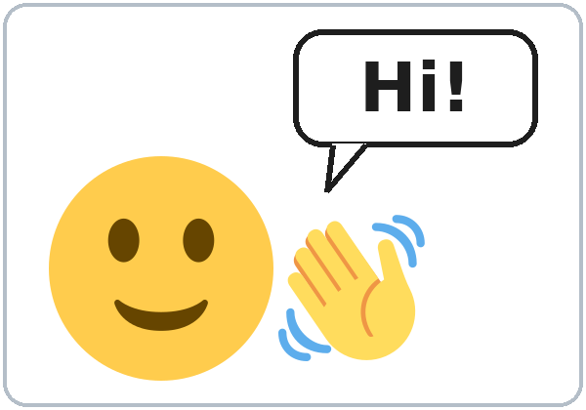  ★ hello | 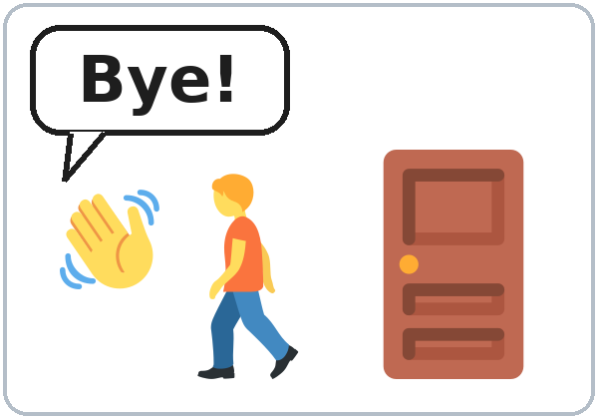  ★ goodbye | 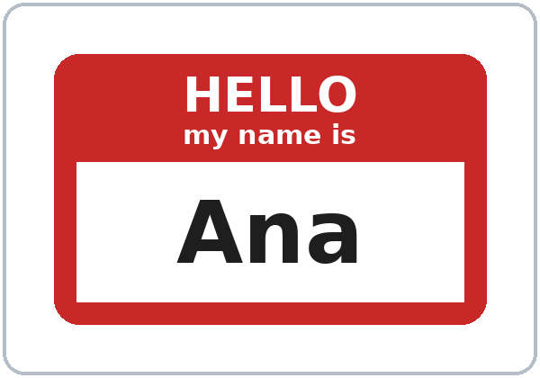  ★ name | 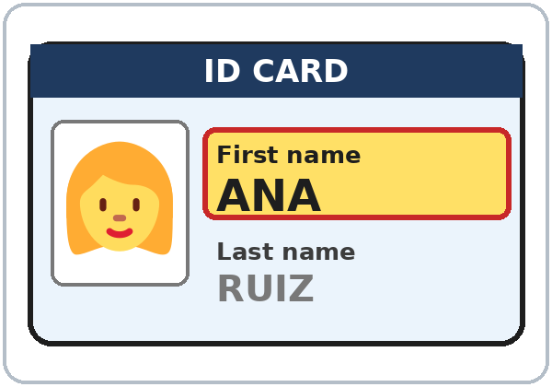  ★ first name
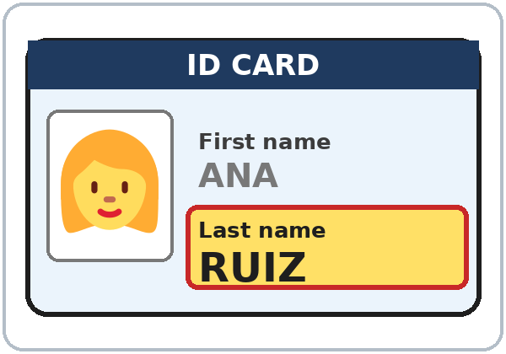  ★ last name | 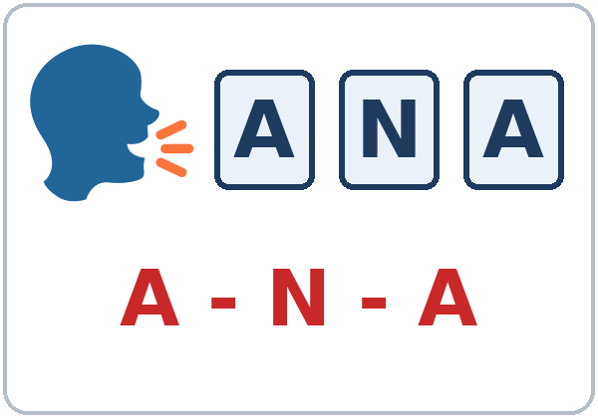  ★ spell | 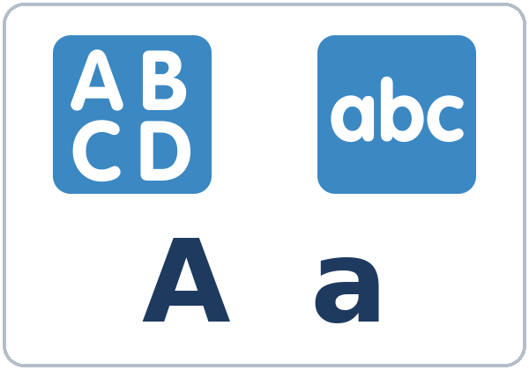  letter | 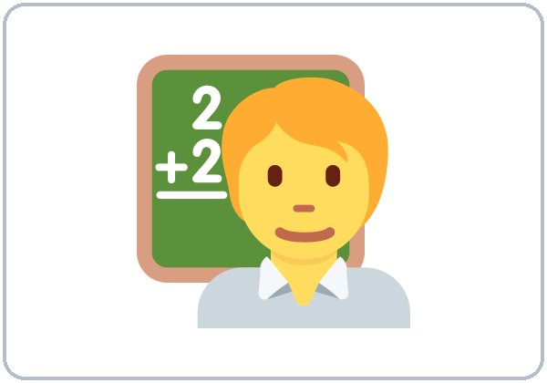  ★ teacher
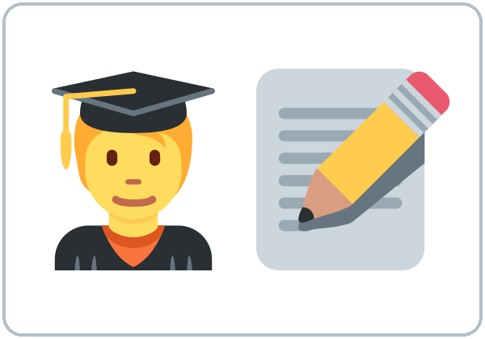  ★ student | 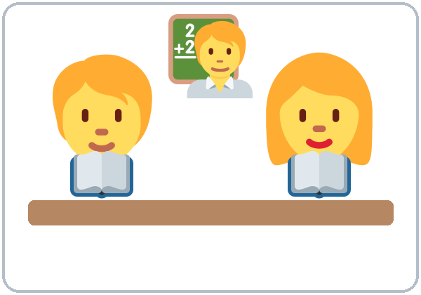  classmate | 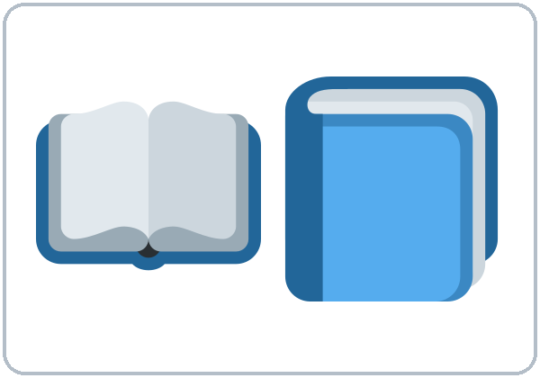  book | 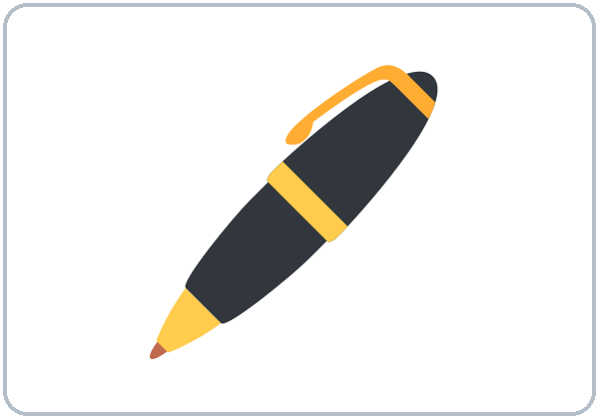  pen

👥 ☝️ 🗣️ Partner game: A points. B says the word.
Español: Con un compañero: A señala una imagen. B dice la palabra. Después cambien.
My language: ______________________________________________
Lesson 1 (Week 1) · Classroom Phrases
👂 🗣️ Listen. Repeat. Use these phrases in class.
Español: Escucha. Repite. Usa estas frases en clase.
My language: ______________________________________________
 | Phrase | Español | My language
👂 | Listen. | Escucha.
🗣️ | Repeat. | Repite.
✏️ | Write. | Escribe.
🔁 | Can you repeat, please? | ¿Puede repetir, por favor?
🤷 | I don't understand. | No entiendo.
❓ | How do you say ___ in English? | ¿Cómo se dice ___ en inglés?

Lesson 1 (Week 1) · Listening
Listen to 👩 Ana and 👨 Carlos. It's the first night of class.
A. 👂 ✅ Listen. Who is it? Check ✓ Ana or Carlos.
Español: Escucha. ¿Quién es? Marca ✓ Ana o Carlos.
My language: ______________________________________________
 | 👩 Ana | 👨 Carlos
1. Last name: Ruiz | ☐ | ☐
2. Last name: Vega | ☐ | ☐
3. "I'm fine, thanks." | ☐ | ☐
4. Gets a book and a pen 📘 🖊️ | ☐ | ☐

B. 👂 ⭕ Listen again. Circle the letters you hear.
Español: Escucha otra vez. Encierra en un círculo las letras que escuchas.
My language: ______________________________________________
1. 👩 Ana: R ( U / O ) ( I / E ) ( Z / S )
2. 👨 Carlos: ( V / B ) ( E / I ) ( G / J ) A
C. 👂 ✏️ Listen again. Write the last names.
Español: Escucha otra vez. Escribe los apellidos.
My language: ______________________________________________
1. 👩 Ana ___ ___ ___ ___
2. 👨 Carlos ___ ___ ___ ___
🗣️ Say it: How do you spell it? • Can you repeat, please?
Español: Escucha y repite. My language: ______________________________
Lesson 1 (Week 1) · Grammar
👥 🗣️ Read across. A reads a question (left). B reads an answer (right). Choose one word from each column.
Español: Lee de izquierda a derecha. A lee una pregunta (izquierda). B lee una respuesta (derecha). Elige una palabra de cada columna.
My language: ______________________________________________
Grammar Box 1: Hello and Goodbye
SAY |  | ANSWER
Hello!  Hi! |  | Hello!  Hi!
Nice to meet you. |  | Nice to meet you, too.
How are you? |  | I'm fine, thanks. And you?  I'm good, thanks. And you?
Goodbye!  Bye! |  | Goodbye!  See you next week!

Grammar Box 2: What's your name?
QUESTION |  |  |  | ANSWER
What's | your | name?  first name? |  | My name is  I'm | Ana.  Carlos.
What's | your | last name? |  | It's  My last name is | Ruiz.  Vega.

Grammar Box 3: How do you spell it?
QUESTION |  |  | ANSWER
How do you spell | it?  your name?  your last name? |  | R-U-I-Z.  V-E-G-A.  A-N-A.
Can you | repeat, please?  spell it, please? |  | Yes. V-E-G-A.  Sure. R-U-I-Z.

Grammar Box 4: Are you a student? (a first look)
QUESTION |  |  |  | ANSWER
Are | you | a student?  a teacher?  Ana? |  | Yes, | I | am.
Are | you | a student?  a teacher?  Ana? |  | No, | I'm | not.

Questions and answers
Q: What is What's?
A: What's = What is. I'm = I am.
Q: How do I say my name?
A: My name is Ana. or I'm Ana. Both are good.
Q: First name or last name?
A: Ana = first name. Ruiz = last name (family name). In English, the first name comes first: Ana Ruiz.
Q: How do I spell my name?
A: Say each letter in English, with a short stop: R… U… I… Z.
Q: I don't understand. What do I say?
A: Can you repeat, please? or I don't understand.
✏️ Practice: Write the missing word.
Español: Escribe la palabra que falta.
My language: ______________________________________________
1. What's your ____________? My name is Ana.
2. ____________ your last name? It's Vega.
3. How do you ____________ it? V-E-G-A.
4. Can you ____________, please? Yes. V-E-G-A.
5. Are you a student? Yes, I ____________.
Common mistakes
✗ Don't say | ✓ Say
My name Ana. | My name is Ana.
I Ana. | I'm Ana.
What your name? | What's your name?
How you spell it? | How do you spell it?
Yes, I'm. | Yes, I am.
Repeat, please! (too strong) | Can you repeat, please?

Nota para hispanohablantes: En inglés, varias letras tienen otro nombre: A se dice «ei», E se dice «i», I se dice «ai», G se dice «yi», J se dice «yei», H se dice «eich», Y se dice «uai» y W se dice «dábel-iu». What's = What is (¿Cuál es…?). Di My name is Ana o I'm Ana (no «I call me Ana»). Siempre usa is o 'm: no «My name Ana».

Tip for speakers of other languages: In English, the first name comes first and the family name comes last: Ana Ruiz. Always use is or 'm in these answers: My name is Ana. I'm Ana.

Lesson 1 (Week 1) · Talk Time: Name Mingle
🚶 🗣️ ✏️ Walk and talk. Ask 5 or 6 classmates. Write their names.
Español: Camina y habla. Pregunta a 5 o 6 compañeros. Escribe sus nombres.
My language: ______________________________________________
A: Hello! What's your name? B: My name is ___.
A: How do you spell it? B: ___-___-___.
A: What's your last name? How do you spell it? B: ___-___-___.
A: Thank you! Goodbye! B: Goodbye!
Help: 🔁 Can you repeat, please? 🤷 I don't understand.

✅ Your partner looks. Is it right? Your partner checks ✓.
Español: Tu compañero mira. ¿Está bien? Tu compañero marca ✓.
My language: ______________________________________________
# | First name | Last name | ✓
1
2
3
4
5
6

Lesson 1 (Week 1) · Homework
🏠 Homework (10 minutes). Bring it next week!
Español: Tarea (10 minutos). ¡Tráela la próxima semana!
My language: ______________________________________________
1. ✏️ Write your name.
Español: Escribe tu nombre.
My language: ______________________________________________
My first name: ______________________________
My last name: ______________________________
My name is ______________________________ .
2. 🗣️ 👨‍👩‍👧 Ask a friend or a family member. Write the name.
Español: Pregunta a un amigo o a un familiar. Escribe el nombre.
My language: ______________________________________________
You: What's your name? How do you spell it?

First name: ______________________
Last name: ______________________
3. 📖 ✏️ Look. Write the word.
Español: Mira. Escribe la palabra.
My language: ______________________________________________
Words: book • pen • teacher • student
1. ____________ | 2. ____________ | 3. ____________ | 4. ____________

4. 🗣️ Say the alphabet A to Z. Say it 2 times.
Español: Di el abecedario de la A a la Z, 2 veces.
My language: ______________________________________________
Lesson 1 (Week 1) · Letters & Numbers
A. 👂 🗣️ Look. Listen. Say the alphabet.
Español: Mira. Escucha. Di el abecedario.
My language: ______________________________________________
A a | B b | C c | D d | E e | F f | G g
H h | I i | J j | K k | L l | M m | N n
O o | P p | Q q | R r | S s | T t | U u
V v | W w | X x | Y y | Z z

⚠️ 🗣️ Tricky letters: say them slowly.
Español: Letras difíciles: dílas despacio.
My language: ______________________________________________
Letter | Say it like… | Example
A a | "ay" (like day) | A-N-A
E e | "ee" (like see) | V-E-G-A
I i | "eye" | R-U-I-Z
G g | "jee" | V-E-G-A
J j | "jay" | J-U-A-N
H h | "aych" | H-E-L-L-O
Y y | "why" | Y-E-S
W w | "double-u" | W-R-I-T-E
V v / B b | "vee" / "bee" | V-E-G-A / B-O-O-K

B. 👂 ⭕ Listen to the teacher. Circle the letter.
Español: Escucha al profesor. Encierra la letra en un círculo.
My language: ______________________________________________
1. | A | E | I
2. | G | J | H
3. | E | I | Y
4. | G | J | Y
5. | A | E | I

C. ✏️ Write your name in CAPITAL letters and small letters.
Español: Escribe tu nombre con letras MAYÚSCULAS y minúsculas.
My language: ______________________________________________
CAPITAL letters (A B C): ______________________________________
small letters (a b c): ______________________________________
D. 👥 🗣️ ✏️ Spell your name. Your partner writes it.
Español: Deletrea tu nombre. Tu compañero lo escribe.
My language: ______________________________________________
My partner's name: ______________________________________
Lesson 1 (Week 1) · Progress Check
Name: ______________________________ Date: ________________
A. 👂 ⭕ Listen to the teacher. Circle the letter.
Español: Escucha al profesor. Encierra la letra en un círculo.
My language: ______________________________________________
1. | A | E | I
2. | G | J | Y
3. | E | I | A
4. | A | H | E
5. | J | G | H

B. 📖 🔗 Match the question and the answer. Draw a line.
Español: Une la pregunta con la respuesta. Dibuja una línea.
My language: ______________________________________________
Question | ✏️ Draw a line. | Answer
1. What's your name? ● |  | ● a. R-U-I-Z.
2. What's your last name? ● |  | ● b. I'm fine, thanks.
3. How do you spell it? ● |  | ● c. My name is Ana.
4. How are you? ● |  | ● d. It's Ruiz.

C. ✏️ Write.
Español: Escribe.
My language: ______________________________________________
My first name: ______________________________
My last name: ______________________________
D. ✅ How do you feel? Check ✓ one face for each line.
Español: ¿Cómo te sientes? Marca ✓ una cara en cada línea. 😀 = I can do it. 🙂 = I can do it with a little help. 😐 = Not yet.
My language: ______________________________________________
I can… | 😀 | 🙂 | 😐
👋 I can say hello and goodbye. | ☐ | ☐ | ☐
🪪 I can say my first and last name. | ☐ | ☐ | ☐
🔤 I can spell my name. | ☐ | ☐ | ☐
🔁 I can ask Can you repeat, please? | ☐ | ☐ | ☐

Score: A ______ / 5 B ______ / 4 C ______ / 2
Picture Credits
Vocabulary pictures use Twemoji graphics by Twitter, Inc. and other contributors (https://github.com/jdecked/twemoji), licensed under CC BY 4.0 (https://creativecommons.org/licenses/by/4.0/). The graphics were resized and combined, and ID cards, a name tag, speech bubbles, letters, and labels were added. The file-by-file list is in images/CREDITS.md.
Task icons on the pages are standard emoji characters shown with the computer's emoji font. Listening audio: synthetic voices made with Chatterbox TTS (Resemble AI, MIT License); each file carries an inaudible Perth watermark marking it as AI-generated. Course materials: licensed under CC BY-NC-SA 4.0 (https://creativecommons.org/licenses/by-nc-sa/4.0/).

