Level 4 Adult ESL Curriculum · Lesson 10 (Week 11): Turn It Off
Status: Draft for review; not published.
Date: October 2026
Audience: Program coordinators and volunteer teachers
Companion files: images/ (12 vocabulary pictures + images/CREDITS.md). Listening audio: not recorded yet (coming soon); until then, read the listening script in this plan aloud.
Topic: Saving energy and keeping a home safe: reading a utility bill, simple ways to use less electricity and water, locking up, and knowing where the fire extinguisher is. Learners give and follow home tips with separable phrasal verbs and it / them. The bill, the company, and the program are invented.

How this lesson is organized
Part | What's inside | Who uses it
Teacher Plan | At a glance, clock-time plan, step-by-step boxes, listening script, answer key, teacher notes | Volunteer teachers
Student Pages | Opening Talk, New Words, My Words, Listening, Grammar, Talk Time, Homework, Read & Write, Exit Ticket, Task Words (optional). Print this part for learners | Learners
Picture Credits | Picture and license credits | Coordinators

What Lesson 10 builds on and what it adds
Before (review only) | Where | New in Level 4 Lesson 10
imperatives; Make sure you… / Don't forget to… | Level 3 Lesson 10 | Make sure you turn the stove off.
object pronouns it / them | Level 2 | turn it off / put them away (the small word goes after it / them)
too much / too many | Level 4 Lesson 7 | We use too much electricity.

TEACHER PLAN
Lesson 10 (Week 11)

Turn It Off
At a glance · Clock-time plan · Step by step · Script and answer key

How to Use This Plan
You don't need to speak Spanish or any other language. Teach in English. Show, point, and gesture. Some Grammar pages have one short contrast tip, only where a common mix-up exists. Learners read it on their own. You never need to read, translate, or explain it.

Instructions: use the same short task words every week: Listen. Circle. Check. Write. Work with a partner. Work in a group. Ask a follow-up question. Give a reason. An optional Task Words page is at the back of the workbook for learners who want it.

Instruction rule: Model it (do it with one learner while everyone watches), check it (ask: "How can you save energy and stay safe at home?"), then go. Say less, show more.

Grouping toolkit: Pairs: turn to a neighbor; with an odd number, make one group of 3. Groups: 3–4 learners. Inside–outside circles: the inner circle faces out, the outer circle faces in; the outer circle moves one person to the right each round. Mingle: everyone stands and talks to many classmates. The teacher joins a pair only if one learner is left over.

When a learner is stuck or speaks another language to you: (1) show it: the picture, a gesture, or the board; (2) give one more short English example; (3) point to the grammar box on their page; (4) a classmate can help for a few seconds, then back to English. You don't need to understand what classmates say to each other.

Three sentences, not one: in Level 4, every Talk Time answer and every exit ticket has about three connected sentences: the answer, a reason, and a detail or example.

Lesson 10 (Week 11): Turn It Off
At a glance
Objectives: learners can…
• use phrasal verbs: turn off, turn down, turn up, put on, put away, take out, throw away, shut off
• put it / them in the right place (turn it off, not turn off it)
• give tips to save energy and stay safe at home (Make sure you… / Don't forget to…)
• read the main parts of a utility bill (amount due, due date, usage)
• write an email (5–8 sentences) to a roommate or family member about changes at home

Materials
• Student Pages for Lesson 10 (print for the number expected + 3 spares)
• Board and markers
• A light switch, a lamp, or a phone charger to point to (optional)
• Poster paper or the back of the Talk Time page for Home Tips
• Listening: no recording yet. Read the listening script aloud (with a volunteer if you can), at a natural speed, two times.
• Prep time: 15 minutes (read the plan; practice reading the listening script; find the light switch and an outlet in the classroom).

Key vocabulary (with pictures on the New Words page)
★ utility bill • ★ electricity • ★ thermostat • ★ save energy • ★ unplug • ★ charger • ★ outlet • ★ fan • ★ deadbolt • ★ peephole • ★ fire extinguisher • usage
Also: an account number, the amount due, a due date, a late fee, the heat, the air conditioner, a light bulb, plugged in, running water, a roommate.

Clock-time plan
Times are loose. If the listening or Talk Time runs long, take the time from Read & Write.
Time | Step | Min | Grouping (15 / 7–8) | If running behind
6:00–6:08 | Opening Talk + Homework Check | 8 | Pairs (7 pairs + 1 trio / 3–4 pairs) | One card only
6:08–6:15 | New Words (picture page) + pair game (+ My Words) | 7 | Whole class, then pairs | Teach the ★ words only
6:15–6:30 | Listening: play 1 (Task A), play 2 (Tasks B and C) + "Hear it, say it" | 15 | Individuals, then pairs check | Do Task C together on the board
6:30–6:45 | Grammar Q&A: phrasal verbs + it / them + pair check | 15 | Whole class, then pairs | Skip the pair check; Talk Time practices it
6:45–7:00 | BREAK | 15
7:00–7:15 | Talk Time: Energy Detective + Home Tips | 15 | Pairs, then groups of 3 | Round 1 only
7:15–7:25 | Read & Write: A utility bill + a flyer; an email | 10 | Pairs read, then individual writing | Reading questions only; the writing becomes homework
7:25–7:30 | Exit Ticket + Homework | 5 | Individuals | Never skip

Skip order if you're running behind: (1) the Read & Write writing task (it becomes homework); (2) the pair check at the end of Grammar; (3) the second round of Talk Time. Never skip: the listening tasks, the grammar boxes and the mistakes table, and the exit ticket.

Attendance (15 → 7–8 → 5 or fewer): every step lists the sizes. With 5 or fewer, do Energy Detective in pairs (you are a partner if needed), then make one Home Tips poster together. Late arrivals join a pair as the "checker" and then take a turn.

Step by step
Step 1 · 6:00–6:08 · Opening Talk · 8 min
• Grouping: pairs, the same partner for both parts. 15 learners: 7 pairs + 1 group of 3. 7–8 learners: 3–4 pairs. 5 or fewer: pairs, or one group with you.
• Before class: write on the board: opinions; agree / disagree politely; as … as
• Opening Talk (5 min): learners open the Opening Talk page. A asks a card question; B answers in 3 sentences (the answer, a reason, a detail); A asks one follow-up. Switch after each card.
• Model with one learner: you say, "What do you think about homework for kids?" The learner gives an opinion and a reason. Then you disagree politely: "I see your point, but…" Help them answer with 3 sentences.
• Homework Check (3 min): Pairs compare Homework item 1 (as … as) and read their opinion and reasons (item 3) to each other. The partner agrees or disagrees politely. Then they fill in the box on the Opening Talk page. Walk around. Write 2 common errors on the board (often I am agree (→ I agree) and not as fast than (→ not as fast as)) and correct them together. Also put up 2 corrections from last week's exit tickets.
• Late arrivals: join any pair as a group of 3.
• If behind: one card only.

Step 2 · 6:08–6:15 · New Words · 7 min
• Grouping: whole class, then pairs. Show the New Words page.
• Do: point to each picture and say the word. Learners repeat once.
• Show the hard words: utility bill (the bill for electricity, gas, or water); electricity; thermostat (it controls the heat); save energy (use less); unplug (take the plug out); charger; outlet (point to one in the room); fan; deadbolt (a strong lock); peephole (a small hole in the door to look out); fire extinguisher; usage (how much you use).
• Check meaning (1 min): ask "Do you plug a charger into an outlet or a peephole?" (an outlet) • "Is a deadbolt a lock or a light?" (a lock) • "Does a thermostat control the heat or the water?" (the heat).
• Pairs (2 min): A says a word; B points to the picture and makes a sentence (Make sure you unplug the charger.). Switch. 15 learners: finish with a quick team round (3 teams; you say a clue, the first team with the word gets a point). 7–8: 2 teams. 5 or fewer: one team against the clock.
• My Words: "Write any word you want in your language on the My Words page. It's your personal list. It's optional." Learners do it at home.
• If behind: teach the ★ words only.

Step 3 · 6:15–6:30 · Listening + "Hear it, say it" · 15 min
• Grouping: individuals, then pairs check. With 5 or fewer, check together as a group.
• Before you listen (2 min): say: "Two roommates, Sofia and Hana, look at a high electric bill and make a plan. Then Sofia calls the electric company. Listen: what is the problem?"
• Play 1 → Task A (the main idea). Pairs compare. Check together.
• Read Tasks B and C together (1 min) so learners know what to listen for.
• Play 2 → Tasks B and C. Pairs compare. Then show the answers (answer key).
• "Hear it, say it" (3 min): Point to the script line. gonna = going to: "I'm gonna unplug my phone charger." Then practice the stress on the small word: turn it OFF, put it aWAY, and the linking: turn_it_off, take_it_out. The class repeats the two lines twice.
• No recording yet: read the script aloud with a volunteer (about 2:07), at a natural speed, two times. Say gonna and wanna where the script has them. When the audio is ready, it plays the conversation once; press play again for play 2. A third play is fine if the class needs it.
• If behind: do Task C together on the board, reading the lines yourself.

Step 4 · 6:30–6:45 · Grammar Q&A · 15 min
• Grouping: whole class, then pairs. Show the Grammar page. The left side is the question. The right side is the answer.
• Show it (2 min): point to the lights and say, "Can you turn off the lights?" A learner turns them off (or mimes it). You say, "Thank you. You turned them off." Turn them on again. Write: turn off the lights / turn the lights off → turn them off. Cross out turn off them.
• The boxes (5 min): Box 1: read across: Can you turn off the lights? → OK, I'll turn them off. Box 2: the past: Did you take out the trash? → Yes, I took it out. Box 3: the 8 phrasal verbs. Box 4: Make sure you… / Don't forget to…
• Rule of thumb and Questions and answers (2 min): read the rule of thumb aloud. Read each Q and A; the class reads the right sentence after you.
• Check questions: "turn off it or turn it off?" (turn it off) • "Is turn the TV off OK?" (yes) • "It's too loud. Turn it up or turn it down?" (turn it down).
• Practice A and B (3 min): learners write, then pairs check. Go over the answers. Read the Common mistakes table together: "Don't say… Say…".
• Pair check (last 3 min): A points to a picture and says, "Can you unplug the charger?" B mimes and answers, "OK, I'll unplug it." A says, "Don't forget to lock the deadbolt." Switch. 15 learners: swap partners once. 5 or fewer: you join one pair.
• If behind: skip the pair check. Talk Time practices it.

Break · 6:45–7:00 · 15 min
• Write on the board: Can you turn off the lights? → OK, I'll turn them off. • Did you take out the trash? → Yes, I took it out. • Make sure you lock the deadbolt.

Step 5 · 7:00–7:15 · Talk Time: Energy Detective + Home Tips · 15 min
• Model it first (1 min): read the first problem on the Apartment A card: "The lights are on in an empty room." Say to a learner, "Turn them off, please." The learner mimes and says, "OK, I'll turn them off." Do one more: "The window is open, and the heat is on." (Close it. Turn the heat down.)
• Round 1 (7 min): Energy Detective (pairs). A reads a problem from the Apartment A card and gives an instruction (Turn them off. Close it. Put it away.). B mimes and answers with it / them. Then switch to the Apartment B card.
• Round 2 (6 min): Home Tips (groups of 3). Groups write 5 tips to save energy or stay safe (Turn down the heat at night. Unplug the charger.) and present them in 1 minute.
• 15 learners: pairs for round 1; then 5 groups of 3.
• 7–8 learners: pairs; then 2 groups.
• 5 or fewer: pairs; then one poster together.
• Every answer needs a reason; every partner asks a follow-up. Walk around and listen. Note 2 good sentences to praise and 1 common error for next week.
• If behind: round 1 only.

Step 6 · 7:15–7:25 · Read & Write: A utility bill + a "Save energy, stay safe" flyer · 10 min
• Grouping: pairs read and answer; individual writing. With 5 or fewer, read the text aloud together.
• Read (4 min): Learners read the invented bill and the flyer on the Read & Write page and answer the questions. Say: "Read fast first. Then find the answers." Pairs answer questions 1–5 together.
• Check (1 min): go over the answers (answer key).
• Write (5 min): Learners write an email (5–8 sentences) to a roommate or family member: what to change at home and why. Show the example. Check for 2 phrasal verbs and one it or them. Learners start in class and finish at home (Homework item 2).
• If behind: questions 1–5 only; the writing becomes homework.

Step 7 · 7:25–7:30 · Exit Ticket + Homework · 5 min · NEVER SKIP
• Exit ticket (3 min): learners open the Exit Ticket page and answer in 3 sentences with a reason: What can people do at home to save energy or stay safe? Example on the board: Turn off the lights when you leave a room. Unplug your charger and put it away. Make sure you lock the deadbolt at night, because it keeps your home safe. With 5 or fewer, a learner can say it to you first and then write it.
• Collect the pages. After class, sort them into ✓ / almost / not yet. Start next week with 2 corrections on the board (no names).
• Homework (2 min): open the Homework page. Do item 1 together (item 1: turn down / the heat (it) → Turn it down.). Say: "About 15–20 minutes. Finish your Read & Write writing at home."

Listening script (not recorded yet; about 2:07 when recorded; the conversation plays once, so press play again for the second listen)
Audio: the recording is coming soon. Until then, read the script aloud two times, with a volunteer if you can, at a natural, friendly speed. Say gonna and wanna where the script has them.

Narrator: Lesson ten. Two roommates, Sofia and Hana, look at their electric bill. Then Sofia calls the electric company.
Sofia: Hana, look at this. Our electric bill is one hundred and forty-two dollars this month!
Hana: What? Last month it was ninety dollars. Why is it so high?
Sofia: Well, we use too much electricity. The heat is on all day, and the lights are on in empty rooms.
Hana: You're right. I always forget to turn them off. Oh, the TV is on now, and nobody is watching. I'll turn it off.
Sofia: OK, let's make a plan. First, we can turn down the heat at night. Sixty-eight degrees is fine.
Hana: Good idea. And I'm gonna unplug my phone charger in the morning. It uses electricity all day.
Sofia: Also, let's put on sweaters and not turn up the heat. Can you call the electric company? I have class.
Hana: Sorry, I have work. Can you call them tonight?
Sofia: Sure. I'll call them now.
Paul: Thank you for calling City Power. This is Paul. How can I help you?
Sofia: Hi. I'm calling about my bill. When is it due?
Paul: Can I have your account number, please?
Sofia: Yes. It's four, seven, two, one, nine.
Paul: Thank you. Your bill is due on March fifteenth.
Sofia: OK. Also, do you have any programs to help us save energy?
Paul: Yes. We have a free home energy check. Someone visits your apartment and gives you tips. And you can get free light bulbs.
Sofia: That sounds great. Can I sign up?
Paul: Sure. Is next Tuesday morning OK?
Sofia: Yes, that's perfect. Thank you.
Paul: You're welcome. And don't forget to turn off the lights when you leave a room!
Narrator: That's the end of the listening.

Answer key
• Listening Task A: a (The electric bill is too high.).
• Listening Task B: 1 $142, 2 down, 3 phone charger, 4 sweaters, 5 March 15, 6 free.
• Listening Task C: 1 them, 2 it, 3 down, 4 on, 5 up, 6 off.
• Grammar Practice A: 1 them, 2 up, 3 it, 4 on, 5 sure, 6 forget.
• Grammar Practice B: 1 it off, 2 throw away, 3 down, 4 put them away, 5 to lock, 6 much.
• Talk Time: answers will vary.
• Homework 1: 1 Turn it down. 2 I took it out. 3 Put them away. 4 Make sure you lock the door. Homework 2 and 3: answers will vary. Homework 4: 1 agree, 2 as, 3 think, 4 point, 5 opinion.
• Read & Write B: 1 $142.00. • 2 March 15. • 3 There is a $10 late fee. • 4 68 degrees. • 5 Look through the peephole. • Writing (C): answers will vary.
• Exit ticket: answers will vary. A good answer: "Turn off the lights when you leave a room. Unplug your charger and put it away. Make sure you lock the deadbolt at night, because it keeps your home safe."
Teacher notes
• Safety stays simple and calm: practical tips only, no fire stories. Point to where the classroom fire extinguisher is.
• Bills are invented: never ask about learners' own bills, rent, or money.
• Bill-help programs vary: list local ones on the "Keep practicing" sheet. Don't promise that a program exists in your area.
• it / them in the middle: this is the main rule. Keep turn it off (not turn off it) on the board all evening.
• Energy Detective: the problem cards replace a picture. Learners can also point to the My Words pictures.
• Spanish and other languages: the contrast tip on the Grammar page is optional. Learners read it on their own. You never need to read, translate, or explain it.
• Reductions: the listening has gonna. Learners need to understand it; they can always say going to.

STUDENT WORKBOOK
Lesson 10 (Week 11)

Turn It Off
Opening Talk · New Words · Listening · Grammar · Talk Time · Homework · Read & Write · Exit Ticket

Lesson 10 (Week 11) · Opening Talk
Name: ______________________________ Date: ________________
Work with a partner. A asks a question. B answers in 3 sentences: the answer, a reason, and a detail. A asks one follow-up question. Then switch.
A: What do you think about homework for kids? | A: How do you feel about a new parking lot downtown?
A: Is a bus as fast as a car? | A: What should change in your neighborhood?

Follow-ups: Do you agree? • Why? • I see your point, but…
Write your partner's name and their opinion from Homework item 3.
My partner's name | Their opinion (In my opinion…)

Lesson 10 (Week 11): Turn It Off
Student Page 1 · Week 11
Name: ______________________________ Date: ________________
New Words
Look. Listen. Repeat. ★ = most important words.
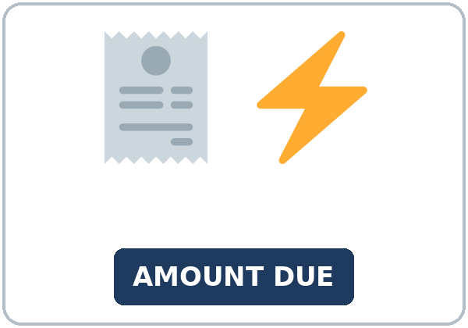  ★ utility bill | 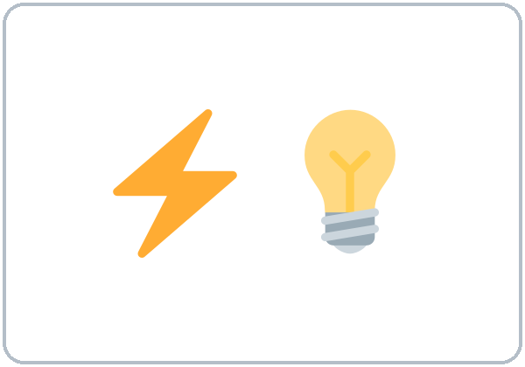  ★ electricity | 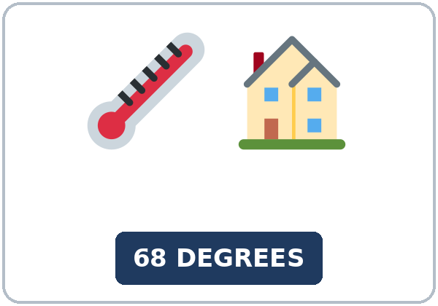  ★ thermostat | 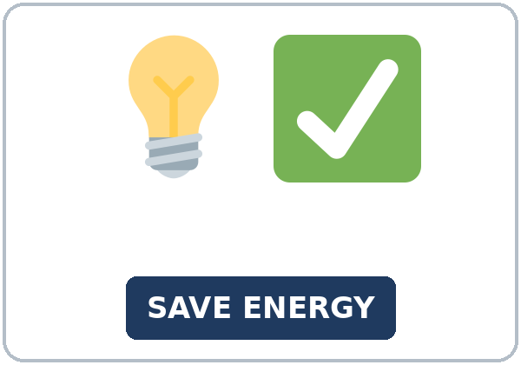  ★ save energy
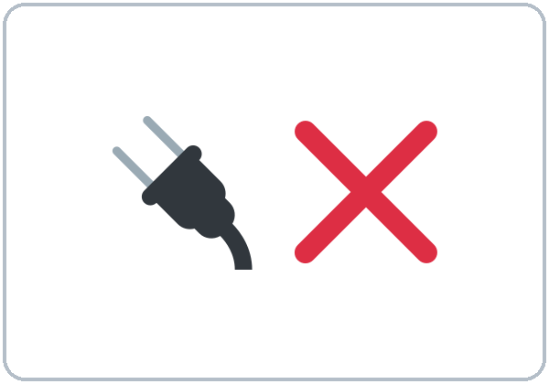  ★ unplug | 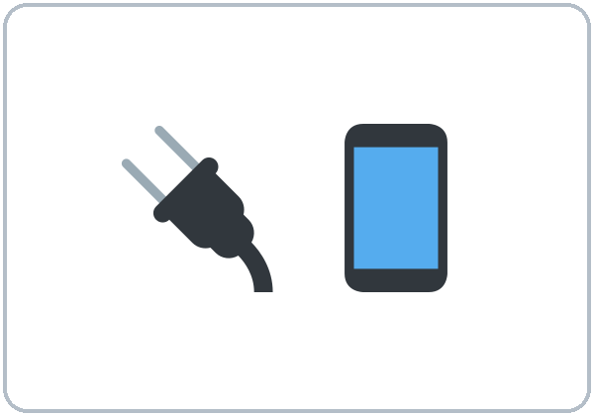  ★ charger | 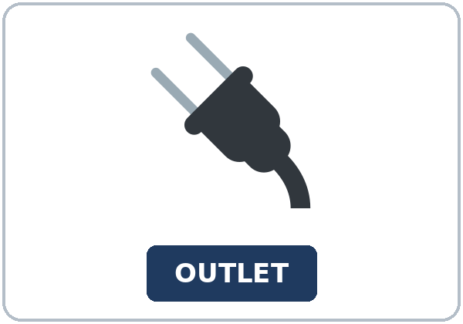  ★ outlet | 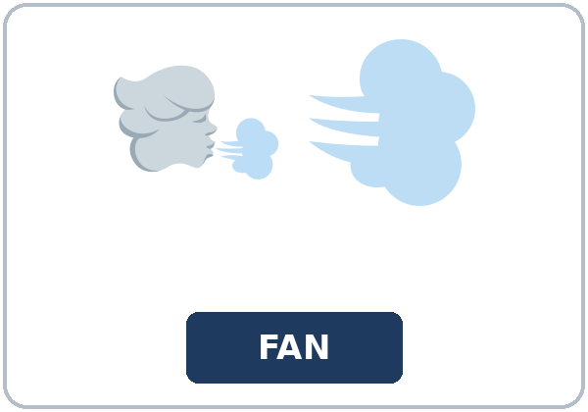  ★ fan
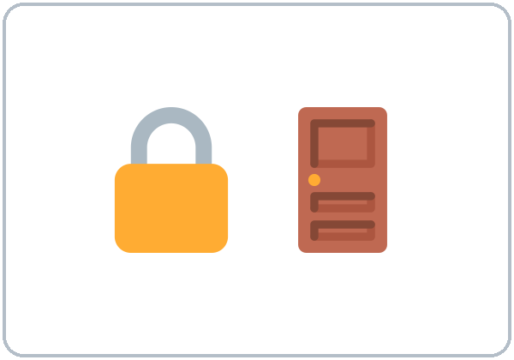  ★ deadbolt | 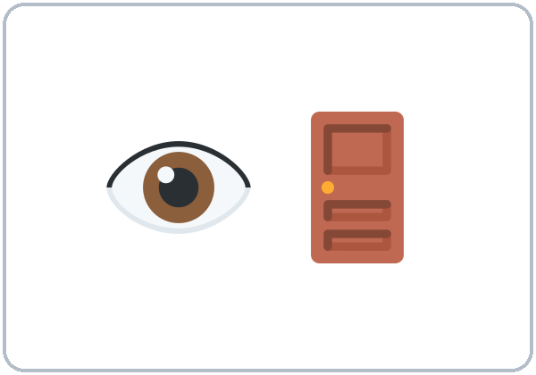  ★ peephole | 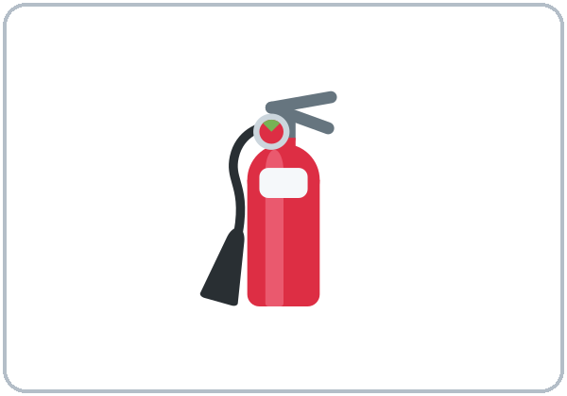  ★ fire extinguisher | 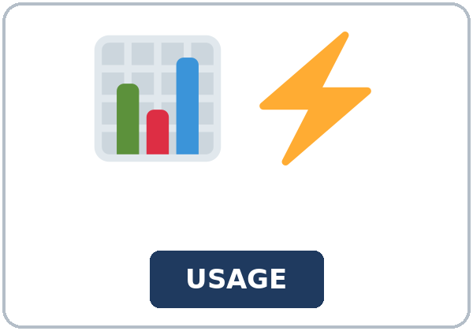  usage

Partner game: Turn it off!
Example: A points to a picture and says, "Can you unplug the charger?" B mimes and answers, "OK, I'll unplug it." Then A gives a tip: "Don't forget to lock the deadbolt." Switch.
Lesson 10 (Week 11) · My Words
My personal word list. Write each word in your language, if you want. Then write your own example.
Word | My language | My example
utility bill
electricity
thermostat
save energy
unplug
charger
outlet
fan
deadbolt
peephole
fire extinguisher
usage

Add 2 more words from tonight (from the listening, the reading, or your partner).
Lesson 10 (Week 11) · Listening
Two roommates look at a high electric bill and decide how to save energy. Then Sofia calls the electric company's customer line.
A. Listen. What is the problem? Circle.
a. The electric bill is too high. b. The heat is broken. c. The bill is late.
B. Listen again. Listen again. Circle the answer.
1. The bill this month is ($142 / $90).
2. They will turn (down / up) the heat at night.
3. Hana is going to unplug her (phone charger / TV).
4. They will put on (sweaters / coats).
5. The bill is due on (March 15 / March 5).
6. The home energy check is (free / $20).
C. Listen again. Write the missing word: the phrasal verb or it / them.
1. I always forget to turn ____________ off.
2. I'll turn ____________ off.
3. we can turn ____________ the heat at night.
4. let's put ____________ sweaters
5. not turn ____________ the heat
6. don't forget to turn ____________ the lights
Hear it, say it
gonna = going to: "I'm gonna unplug my phone charger." You can say going to. Stress the small word: turn it OFF, put it aWAY. Link the words: turn_it_off, take_it_out.
Lesson 10 (Week 11) · Grammar
Read across. A reads from the left side. B answers from the right side. Choose one part from each column.
Grammar Box 1: phrasal verbs + it / them
QUESTION |  |  | ANSWER
Can you turn off | the lights? |  | OK, I'll turn them off. | (not turn off them)
Can you turn | the TV down? |  | Sure, I'll turn it down. | It's loud.
Can you take out | the trash? |  | Yes, I'll take it out | now.

Grammar Box 2: the past
QUESTION |  |  | ANSWER
Did you take out | the trash? |  | Yes, I took it out | this morning.
Did you put away | the dishes? |  | No, I didn't put them away | yet.
Did you shut off | the water? |  | Yes, I shut it off | before I left.

Rule of thumb: With a noun, two places are OK: turn off the TV / turn the TV off. With it / them, only the middle: turn it off (not turn off it).
Grammar Box 3: 8 phrasal verbs for home
VERB | MEANING | EXAMPLE
turn off / turn up / turn down | stop / more / less | Turn off the lights. Turn the heat down at night.
put on / put away | wear / put in its place | Put on a sweater. Put the dishes away.
take out / throw away | take outside / put in the trash | Take out the trash. Throw away old food.
shut off | stop (water, gas) | Shut off the water.

Grammar Box 4: home tips
START | EXAMPLE
Make sure you… | Make sure you lock the deadbolt at night.
Don't forget to… | Don't forget to unplug the charger.
We use too much… | We use too much electricity.

Questions and answers
Q: turn off it or turn it off?
A: turn it off. With it / them, the small word goes after: turn it off, put them away.
Q: Is turn off the TV OK?
A: Yes. With a noun, both are OK: turn off the TV and turn the TV off.
Q: turn down or turn off?
A: turn down = less. turn off = stop. Turn down the heat. Turn off the lights.
Practice A: Write one word.
1. The lights are on. Please turn ____________ off.
2. It's hot. Can you turn ____________ the fan?
3. Did you take out the trash? Yes, I took ____________ out.
4. It's cold. Put ____________ a sweater.
5. Make ____________ you lock the deadbolt.
6. Don't ____________ to unplug the charger.
Practice B: Circle the correct words.
1. Turn (it off / off it), please.
2. Can you (throw away / throw on) the old milk?
3. It's late. Please turn (down / up) the music.
4. I (put them away / put away them) yesterday.
5. Don't forget (to lock / lock) the door.
6. We use too (much / many) water.
Common mistakes
✗ Don't say | ✓ Say
Turn off it. | Turn it off.
I put away them. | I put them away.
Close the light. | Turn off the light.
Open the TV. | Turn on the TV.
Don't forget lock the door. | Don't forget to lock the door.

Contrast tip (optional): Many languages use one verb where English uses two words: Spanish apagar = turn off, bajar = turn down, tirar = throw away. With it / them, the small word goes after the pronoun: turn it off. How do you say these in your language?

Lesson 10 (Week 11) · Talk Time: Energy Detective
Round 1. Work with a partner. A reads a problem and gives an instruction. B mimes and answers with it or them. Then switch: B uses Apartment B.
APARTMENT A (A reads) | APARTMENT B (B reads)
1. The lights are on in an empty room. | 1. The fan is on, and nobody is home.
2. The window is open, and the heat is on. | 2. The dishes are on the table.
3. The charger is plugged in, but there is no phone. | 3. The thermostat says 80 degrees at night.
4. The front door isn't locked. | 4. The water is running in the bathroom.
5. The TV is on, and nobody is watching. | 5. The trash is full.
6. The music is very loud at 11:00 p.m. | 6. There is old food in the fridge.

Example: A: The lights are on in an empty room. Turn them off, please. B: OK, I'll turn them off.
Problem number | Instruction (Turn it off. Put them away.)

Lesson 10 (Week 11) · Talk Time: Home Tips
Round 2. Work in groups of 3. Write 5 tips to save energy or stay safe at home. Then present them in 1 minute.
OUR 5 HOME TIPS | Why?
1.
2.
3.
4.
5.

Example: "Turn down the heat at night, because 68 degrees is fine. Unplug the charger when the phone is full. Make sure you lock the deadbolt."
Useful: Turn it off. • Turn it down. • Unplug it. • Put it away. • Take it out. • Shut it off. • Make sure you… • Don't forget to…
Another group's best tip

Lesson 10 (Week 11) · Homework
Homework (about 15–20 minutes). Bring it next week!
1. Write the sentence. Use it or them.
Example: turn off / the lights (them) → Turn them off.
1. turn down / the heat (it) → ______________________________________________
2. take out / the trash (past: I / it) → ______________________________________________
3. put away / the dishes (them) → ______________________________________________
4. make sure / you / lock / the door → ______________________________________________
2. Finish your writing from Read & Write C (your email). Read it one more time. Check ✓ the list in D.
☐ I finished it. ☐ I checked it with the list.
3. Look around your home. Write 3 things you can do to save energy or stay safe.
My tip (Turn… / Unplug… / Make sure you…) | Why?
1.
2.
3.

4. Review (Lesson 9). Write one word.
1. I ____________ with you. That's true.
2. A bus isn't ____________ fast as a car.
3. What do you ____________ about the plan?
4. I see your ____________, but I'm not sure.
5. In my ____________, we need a playground.
Lesson 10 (Week 11) · Read & Write
A. Read the notice. Read fast first. Then read again and answer the questions.
CITY POWER · A bill + a flyer (invented)
MONTHLY BILL. Account number: 47219 · Name: Sofia Ruiz · Service address: 25 Elm Street, Apt. 3 · Billing period: January 28 to February 27 · Usage: 1,050 kWh (last month: 680 kWh) · Amount due: $142.00 · Due date: March 15. Pay online, by phone, or at any City Power office. If you pay late, there is a $10 late fee.
SAVE ENERGY, STAY SAFE. Small changes can make your bill lower. Turn down the thermostat at night; 68 degrees is a good temperature in winter. Turn off the lights when you leave a room. Unplug chargers when your phone is full. Wash clothes in cold water. In summer, use a fan, not only the air conditioner. Stay safe, too: lock the deadbolt at night, and look through the peephole before you open the door. Know where your fire extinguisher is. Do you need help with your bill? Call us at 555-0142 and ask about our free home energy check.

B. Answer the questions.
1. How much is the bill? ______________________________________________
2. When is it due? ______________________________________________
3. What happens if you pay late? ______________________________________________
4. What is a good temperature at night in winter? ______________________________________________
5. What should you do before you open the door? ______________________________________________
C. Write an email (5–8 sentences) to a roommate or family member: what should you change at home, and why? Use 2 phrasal verbs and it or them.
Example: Hi Hana, Our electric bill was $142 this month. That's too much! Let's turn down the heat at night, because 68 degrees is fine. Please turn off the lights when you leave a room. I'm going to unplug my charger and put it away in the morning. Also, make sure you lock the deadbolt at night. Thanks! Sofia
My email

D. Check your writing with a partner.
 | Yes | Not yet
It has 5–8 sentences. | ☐ | ☐
It has 2 phrasal verbs. | ☐ | ☐
It has it or them in the right place. | ☐ | ☐
It has a reason (because…). | ☐ | ☐

Lesson 10 (Week 11) · Exit Ticket
Name: ______________________________ Date: ________________
Answer in 3 sentences. Give a reason. Then give this page to your teacher.
What can people do at home to save energy or stay safe?
Sentence 1: a tip with a phrasal verb • Sentence 2: a tip with it or them • Sentence 3: a reason, with because
My answer
1.
2.
3.

For the teacher | ✓ | almost | not yet
3 sentences, today's grammar, a reason | ☐ | ☐ | ☐

Lesson 10 (Week 11) · Task Words (optional)
This page is for you if you want it. You can skip it. Write each task word in your language, if you want.
Task word | What you do | My language
Listen. | Use your ears. Don't write yet.
Circle. | Draw a circle around the answer.
Check ✓. | Make a ✓ in the box.
Write. | Write words or sentences.
Number. | Write 1, 2, 3… to show the order.
Match. | Find the two parts that go together.
Work with a partner. | Work with one classmate.
Work in a group. | Work with 2 or 3 classmates.
Switch. | Change roles: A is B now.
Ask a follow-up question. | Ask one more question about the answer.
Give a reason. | Say why, with because or so.
Compare. | Look at your partner's answers. Are they the same?

Picture Credits
Pictures use Twemoji graphics by Twitter, Inc. and other contributors (https://github.com/jdecked/twemoji), licensed under CC BY 4.0 (https://creativecommons.org/licenses/by/4.0/). The graphics were resized and combined, and signs and labels were added. The file-by-file list is in images/CREDITS.md.
Listening audio: not recorded yet. When it is made, it will use synthetic voices made with Chatterbox TTS (Resemble AI, MIT License), cloned from synthetic reference clips made with Kokoro-82M (Apache License 2.0), with no recordings of real people. The names and the story are invented.
Course materials: © 2026 the authors, licensed under CC BY-NC-SA 4.0 (https://creativecommons.org/licenses/by-nc-sa/4.0/).

