Level 4 Adult ESL Curriculum · Lesson 9 (Week 10): I See Your Point
Status: Draft for review; not published.
Date: October 2026
Audience: Program coordinators and volunteer teachers
Companion files: images/ (12 vocabulary pictures + images/CREDITS.md). Listening audio: not recorded yet (coming soon); until then, read the listening script in this plan aloud.
Topic: Giving, asking for, and politely disagreeing with an opinion at a neighborhood meeting about an empty lot (a playground, a parking lot, or a community garden), and writing a short opinion paragraph. Learners use opinion phrases, as … as / not as … as, and paragraph words. All places, people, and plans are invented and local.

How this lesson is organized
Part | What's inside | Who uses it
Teacher Plan | At a glance, clock-time plan, step-by-step boxes, listening script, answer key, teacher notes | Volunteer teachers
Student Pages | Opening Talk, New Words, My Words, Listening, Grammar, Talk Time, Homework, Read & Write, Exit Ticket, Task Words (optional). Print this part for learners | Learners
Picture Credits | Picture and license credits | Coordinators

What Lesson 9 builds on and what it adds
Before (review only) | Where | New in Level 4 Lesson 9
I think…; because | Level 3 | opinion phrases: In my opinion… / I see your point, but…
comparatives (cheaper than, more expensive than) | Level 2 | as … as / not as … as: A garden isn't as expensive as a parking lot.
second conditional | Level 4 Lesson 6 | If we had a playground, kids would play outside more.

TEACHER PLAN
Lesson 9 (Week 10)

I See Your Point
At a glance · Clock-time plan · Step by step · Script and answer key

How to Use This Plan
You don't need to speak Spanish or any other language. Teach in English. Show, point, and gesture. Some Grammar pages have one short contrast tip, only where a common mix-up exists. Learners read it on their own. You never need to read, translate, or explain it.

Instructions: use the same short task words every week: Listen. Circle. Check. Write. Work with a partner. Work in a group. Ask a follow-up question. Give a reason. An optional Task Words page is at the back of the workbook for learners who want it.

Instruction rule: Model it (do it with one learner while everyone watches), check it (ask: "Do you agree? How do you say it politely?"), then go. Say less, show more.

Grouping toolkit: Pairs: turn to a neighbor; with an odd number, make one group of 3. Groups: 3–4 learners. Inside–outside circles: the inner circle faces out, the outer circle faces in; the outer circle moves one person to the right each round. Mingle: everyone stands and talks to many classmates. The teacher joins a pair only if one learner is left over.

When a learner is stuck or speaks another language to you: (1) show it: the picture, a gesture, or the board; (2) give one more short English example; (3) point to the grammar box on their page; (4) a classmate can help for a few seconds, then back to English. You don't need to understand what classmates say to each other.

Three sentences, not one: in Level 4, every Talk Time answer and every exit ticket has about three connected sentences: the answer, a reason, and a detail or example.

Lesson 9 (Week 10): I See Your Point
At a glance
Objectives: learners can…
• give an opinion with a reason
• ask for someone's opinion (What do you think about…? / How do you feel about…?)
• agree and disagree politely (I agree. / I see your point, but…)
• compare two ideas with as … as / not as … as
• write an opinion paragraph (5–8 sentences) with First… Also… That's why…

Materials
• Student Pages for Lesson 9 (print for the number expected + 3 spares)
• Board and markers
• Role cards (in the workbook Talk Time page; copy them onto index cards, optional)
• Three signs for the room: AGREE, NOT SURE, DISAGREE (for Opinion Lines)
• Listening: no recording yet. Read the listening script aloud (with a volunteer if you can), at a natural speed, two times.
• Prep time: 15 minutes (read the plan; practice reading the listening script; put the three signs on the walls).

Key vocabulary (with pictures on the New Words page)
★ opinion • ★ agree • ★ disagree • ★ point (I see your point) • ★ community meeting • ★ empty lot • ★ community garden • ★ parking lot • ★ playground • ★ survey • ★ vote (raise your hand) • advantage / disadvantage
Also: a neighbor, a plan, a flyer, a newsletter, a parking space, a bench, a bus shelter, fair, take care of, a topic sentence.

Clock-time plan
Times are loose. If the listening or Talk Time runs long, take the time from Read & Write.
Time | Step | Min | Grouping (15 / 7–8) | If running behind
6:00–6:08 | Opening Talk + Homework Check | 8 | Pairs (7 pairs + 1 trio / 3–4 pairs) | One card only
6:08–6:15 | New Words (picture page) + pair game (+ My Words) | 7 | Whole class, then pairs | Teach the ★ words only
6:15–6:30 | Listening: play 1 (Task A), play 2 (Tasks B and C) + "Hear it, say it" | 15 | Individuals, then pairs check | Do Task C together on the board
6:30–6:45 | Grammar Q&A: opinions; agree / disagree politely; as … as + pair check | 15 | Whole class, then pairs | Skip the pair check; Talk Time practices it
6:45–7:00 | BREAK | 15
7:00–7:15 | Talk Time: Community Meeting + Opinion Lines | 15 | Groups of 4, then the whole room | Round 1 only
7:15–7:25 | Read & Write: A meeting flyer + two letters; an opinion paragraph | 10 | Pairs read, then individual writing | Reading questions only; the writing becomes homework
7:25–7:30 | Exit Ticket + Homework | 5 | Individuals | Never skip

Skip order if you're running behind: (1) the Read & Write writing task (it becomes homework); (2) the pair check at the end of Grammar; (3) the second round of Talk Time. Never skip: the listening tasks, the grammar boxes and the mistakes table, and the exit ticket.

Attendance (15 → 7–8 → 5 or fewer): every step lists the sizes. With 5 or fewer, do Community Meeting as one group; you take a role card. Do Opinion Lines with everyone. Late arrivals take a role card and join a group.

Step by step
Step 1 · 6:00–6:08 · Opening Talk · 8 min
• Grouping: pairs, the same partner for both parts. 15 learners: 7 pairs + 1 group of 3. 7–8 learners: 3–4 pairs. 5 or fewer: pairs, or one group with you.
• Before class: write on the board: might / may / could; Do you know where…?
• Opening Talk (5 min): learners open the Opening Talk page. A asks a card question; B answers in 3 sentences (the answer, a reason, a detail); A asks one follow-up. Switch after each card.
• Model with one learner: you say, "Do you know when the library opens?" The learner answers with a fact or I'm not sure. It might… Then you ask, "What might change in this city next year?" Help them say 3 sentences.
• Homework Check (3 min): Pairs compare Homework item 1 (might and Do you know…?) and read their 3 changes (item 3) to each other. Then they fill in the box on the Opening Talk page. Walk around. Write 2 common errors on the board (often It might rains (→ It might rain) and Do you know where is the bank? (→ where the bank is)) and correct them together. Also put up 2 corrections from last week's exit tickets.
• Late arrivals: join any pair as a group of 3.
• If behind: one card only.

Step 2 · 6:08–6:15 · New Words · 7 min
• Grouping: whole class, then pairs. Show the New Words page.
• Do: point to each picture and say the word. Learners repeat once.
• Show the hard words: opinion (what you think); agree (thumbs-up) and disagree (thumbs-down, with a smile); I see your point (I understand you); community meeting; empty lot (land with nothing on it); community garden, parking lot, playground; survey (questions for many people); vote (raise your hand); advantage (a plus) and disadvantage (a minus).
• Check meaning (1 min): ask "Is an empty lot full or empty?" (empty) • "If you agree, do you say That's true or That's wrong?" (That's true) • "Is a survey for one person or many people?" (many people).
• Pairs (2 min): A says a word; B points to the picture and makes a sentence (In my opinion, we need a playground.). Switch. 15 learners: finish with a quick team round (3 teams; you say a clue, the first team with the word gets a point). 7–8: 2 teams. 5 or fewer: one team against the clock.
• My Words: "Write any word you want in your language on the My Words page. It's your personal list. It's optional." Learners do it at home.
• If behind: teach the ★ words only.

Step 3 · 6:15–6:30 · Listening + "Hear it, say it" · 15 min
• Grouping: individuals, then pairs check. With 5 or fewer, check together as a group.
• Before you listen (2 min): say: "Neighbors are at a community meeting. Mrs. Okafor is the leader. Ray and Lin give their opinions about the empty lot on Cedar Street. Listen: what are they deciding?"
• Play 1 → Task A (the main idea). Pairs compare. Check together.
• Read Tasks B and C together (1 min) so learners know what to listen for.
• Play 2 → Tasks B and C. Pairs compare. Then show the answers (answer key).
• "Hear it, say it" (3 min): Point to the script lines. wanna = want to: "Tonight we wanna talk about the empty lot." gonna = going to: "Who's gonna take care of it?" Then practice I see your POINT, but… (the voice goes down on point, then a short pause) and the stress in It isn't as EXpensive. The class repeats the two lines twice.
• No recording yet: read the script aloud with a volunteer (about 1:48), at a natural speed, two times. Say gonna and wanna where the script has them. When the audio is ready, it plays the conversation once; press play again for play 2. A third play is fine if the class needs it.
• If behind: do Task C together on the board, reading the lines yourself.

Step 4 · 6:30–6:45 · Grammar Q&A · 15 min
• Grouping: whole class, then pairs. Show the Grammar page. The left side is the question. The right side is the answer.
• Show it (2 min): say, "In my opinion, summer is the best season." Ask a learner, "Do you agree?" Model two answers: a thumbs-up, "I agree. That's true," and a smile, "I see your point, but I like fall." Write: something positive first, then but. Then draw two prices: "A garden is $2,000. A parking lot is $20,000. A garden isn't as expensive as a parking lot."
• The boxes (5 min): Box 1: read across: What do you think about the empty lot? → I think we need a playground. Box 2: agreeing and disagreeing politely. Box 3: as … as / not as … as. Box 4: the words in an opinion paragraph.
• Rule of thumb and Questions and answers (2 min): read the rule of thumb aloud. Read each Q and A; the class reads the right sentence after you.
• Check questions: "I am agree or I agree?" (I agree) • "Which is more polite: That's wrong or I see your point, but…?" (I see your point, but…) • "not as expensive as or not as expensive than?" (as … as).
• Practice A and B (3 min): learners write, then pairs check. Go over the answers. Read the Common mistakes table together: "Don't say… Say…".
• Pair check (last 3 min): A points to a picture and asks, "What do you think about a playground for the lot?" B gives an opinion and a reason. A agrees or disagrees politely. Switch. 15 learners: swap partners once. 5 or fewer: you join one pair.
• If behind: skip the pair check. Talk Time practices it.

Break · 6:45–7:00 · 15 min
• Write on the board: What do you think about…? → In my opinion… • I agree. / I see your point, but… • A garden isn't as expensive as a parking lot.

Step 5 · 7:00–7:15 · Talk Time: Community Meeting + Opinion Lines · 15 min
• Model it first (1 min): take the parent role card. Say, "In my opinion, the lot should be a playground. First, kids need a safe place to play." Ask a learner with the store owner card, "Do you agree?" Help them say, "I see your point, but customers can't find parking." Say: "Polite language is the goal, not winning."
• Round 1 (7 min): Community Meeting (groups of 4). Each person has a role card with a plan and 2 reasons. Each person gives an opinion; the others agree or disagree politely. The group chooses one plan and writes 3 reasons.
• Round 2 (6 min): Opinion Lines (whole room). Read a statement. Learners stand by the AGREE, NOT SURE, or DISAGREE sign and explain. Someone on another side answers with I see your point, but…
• 15 learners: 4 groups (one of 3) for round 1; then whole-room lines.
• 7–8 learners: 2 groups for round 1; then lines.
• 5 or fewer: one group for round 1: you take a role card. Then lines.
• Every answer needs a reason; every partner asks a follow-up. Walk around and listen. Note 2 good sentences to praise and 1 common error for next week.
• If behind: round 1 only.

Step 6 · 7:15–7:25 · Read & Write: A meeting flyer + two letters · 10 min
• Grouping: pairs read and answer; individual writing. With 5 or fewer, read the text aloud together.
• Read (4 min): Learners read the flyer and the two letters on the Read & Write page and answer the questions. Say: "Read fast first. Then find the answers." Pairs answer questions 1–5 together.
• Check (1 min): go over the answers (answer key).
• Write (5 min): Learners write an opinion paragraph (5–8 sentences) about the empty lot: a topic sentence, two reasons (First… Also…), an example, and a closing (That's why…). Show the example. Writing check 3: collect this paragraph and write one strength and one fix. Learners start in class and finish at home (Homework item 2).
• If behind: questions 1–5 only; the writing becomes homework.

Step 7 · 7:25–7:30 · Exit Ticket + Homework · 5 min · NEVER SKIP
• Exit ticket (3 min): learners open the Exit Ticket page and answer in 3 sentences with a reason: Which is better for an empty lot: a playground or a parking lot? Example on the board: In my opinion, a playground is better. Kids need a safe place to play because the park is far. I see the other point, but parking isn't as important as kids. With 5 or fewer, a learner can say it to you first and then write it.
• Collect the pages. After class, sort them into ✓ / almost / not yet. Start next week with 2 corrections on the board (no names).
• Homework (2 min): open the Homework page. Do item 1 together (item 1: playground / important / parking (as … as) → A playground is as important as parking.). Say: "About 15–20 minutes. Finish your Read & Write writing at home."

Listening script (not recorded yet; about 1:48 when recorded; the conversation plays once, so press play again for the second listen)
Audio: the recording is coming soon. Until then, read the script aloud two times, with a volunteer if you can, at a natural, friendly speed. Say gonna and wanna where the script has them.

Narrator: Lesson nine. Neighbors are at a community meeting. They are talking about the empty lot on Cedar Street.
Mrs. Okafor: Good evening, everyone. Thank you for coming. Tonight we wanna talk about the empty lot on Cedar Street. The city says we can choose a plan. Ray, what do you think about it?
Ray: Thanks, Mrs. Okafor. In my opinion, we need a parking lot. There aren't enough parking spaces on our street. I drive around for twenty minutes every night.
Mrs. Okafor: That's true. Parking is a big problem. Lin, how do you feel about it?
Lin: I see your point, Ray, but I'm not sure I agree. I think a community garden is a better idea.
Ray: A garden? Why?
Lin: First, a garden isn't as expensive as a parking lot. Also, if we had a garden, families would grow vegetables, and kids would spend more time outside.
Ray: That's a good idea, but a garden is a lot of work. Who's gonna take care of it?
Lin: I'd help, and I think many neighbors would help too.
Mrs. Okafor: Ray, do you agree with that?
Ray: Well, I agree that a garden is nice. But for me, parking is as important as a garden.
Mrs. Okafor: OK. Those are two good ideas. Let's do a survey. We'll ask every neighbor on Cedar Street.
Lin: I agree. That's fair.
Ray: Yes, that's a good plan. I'll help with the survey.
Mrs. Okafor: Great. We'll vote at the next meeting, on May twelfth. Thank you, everyone.
Narrator: That's the end of the listening.

Answer key
• Listening Task A: a (what to do with the empty lot).
• Listening Task B: 1 a parking lot, 2 aren't enough parking spaces, 3 a community garden, 4 isn't as expensive as, 5 take care of it, 6 do a survey.
• Listening Task C: 1 opinion, 2 feel, 3 point, 4 idea, 5 agree, 6 fair.
• Grammar Practice A: 1 agree, 2 as, 3 think, 4 point, 5 opinion, 6 had.
• Grammar Practice B: 1 I agree, 2 as, 3 That's a good idea, but, 4 feel, 5 expensive, 6 would.
• Talk Time: answers will vary.
• Homework 1: 1 A playground is as important as parking. 2 A bus isn't as fast as a car. 3 What do you think about the new store? 4 I don't agree with you. Homework 2 and 3: answers will vary. Homework 4: 1 rain, 2 is, 3 will, 4 take, 5 leaves.
• Read & Write B: 1 Thursday, May 12, at 7:00 p.m. • 2 A playground. • 3 Kids don't have a safe place to play. • 4 No. He sees her point, but he isn't sure he agrees. • 5 Two benches and a small garden. • Writing (C): answers will vary.
• Exit ticket: answers will vary. A good answer: "In my opinion, a playground is better. Kids need a safe place to play because the park is far. I see the other point, but parking isn't as important as kids."
Teacher notes
• Local and practical: topics stay with parks, parking, store hours, bus stops, and homework. No elections or political parties.
• Praise polite language, not who "wins." Model disagreeing with a smile. Write good phrases you hear on the board.
• I agree, not I am agree: this is very common. Point to the Q&A box and keep it on the board all evening.
• Opinion Lines: learners who can't stand or move can hold up a sign or raise a hand from their seat.
• Writing check 3 (Week 10): collect the opinion paragraph. Write one strength and one fix on each. Learners keep them in their writing folder.
• Spanish and other languages: the contrast tip on the Grammar page is optional. Learners read it on their own. You never need to read, translate, or explain it.
• Reductions: the listening has gonna and wanna. Learners need to understand them; they can always say going to and want to.

STUDENT WORKBOOK
Lesson 9 (Week 10)

I See Your Point
Opening Talk · New Words · Listening · Grammar · Talk Time · Homework · Read & Write · Exit Ticket

Lesson 9 (Week 10) · Opening Talk
Name: ______________________________ Date: ________________
Work with a partner. A asks a question. B answers in 3 sentences: the answer, a reason, and a detail. A asks one follow-up question. Then switch.
A: Do you know when the library opens? | A: What might change in this city next year?
A: Do you know where the nearest bus stop is? | A: Will it rain this weekend?

Follow-ups: Are you sure, or is it maybe? • How do you know? • Why?
Write your partner's name and one change from Homework item 3.
My partner's name | A change (might / may)

Lesson 9 (Week 10): I See Your Point
Student Page 1 · Week 10
Name: ______________________________ Date: ________________
New Words
Look. Listen. Repeat. ★ = most important words.
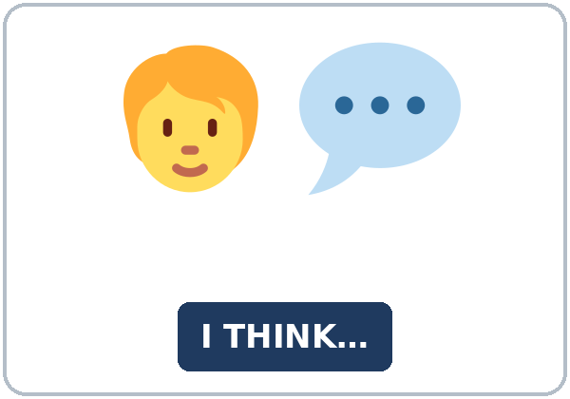  ★ opinion | 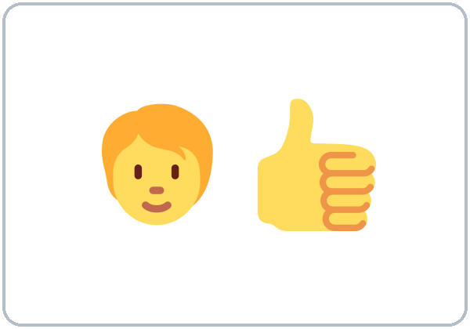  ★ agree | 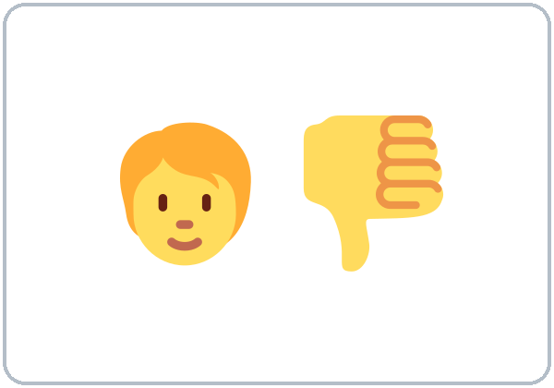  ★ disagree | 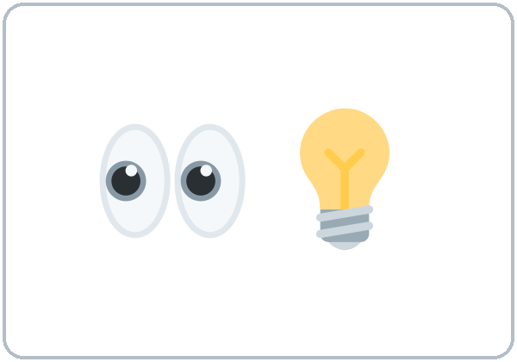  ★ point (I see your point)
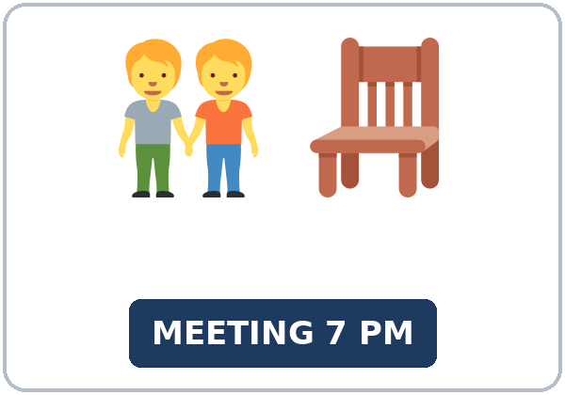  ★ community meeting | 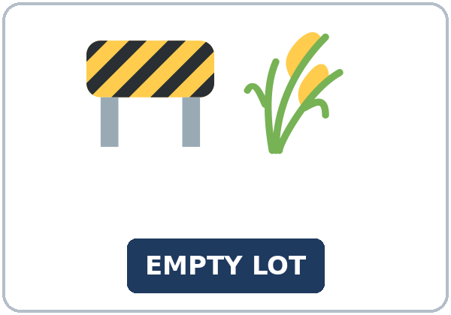  ★ empty lot | 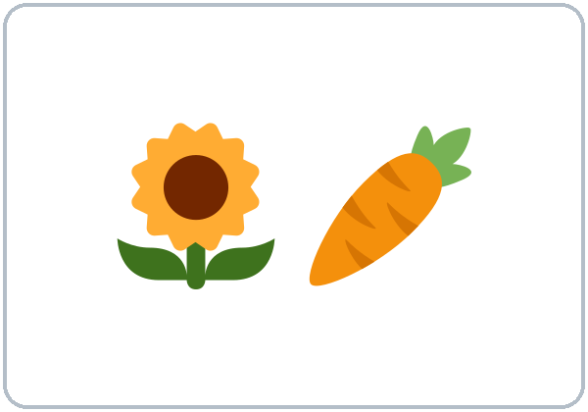  ★ community garden | 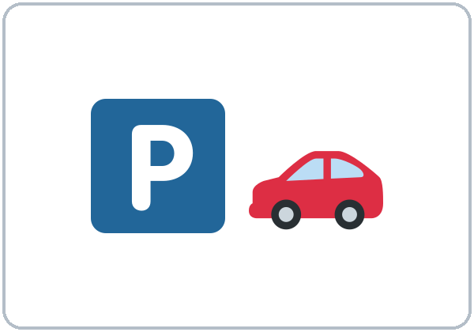  ★ parking lot
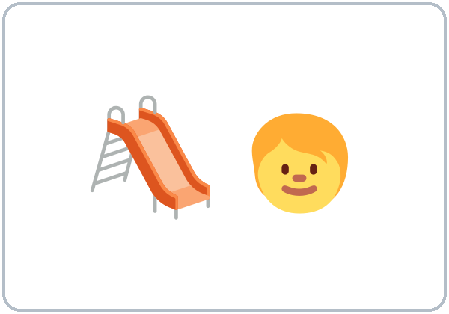  ★ playground |   ★ survey | 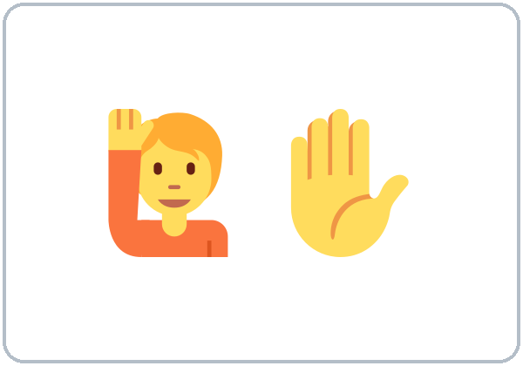  ★ vote (raise your hand) | 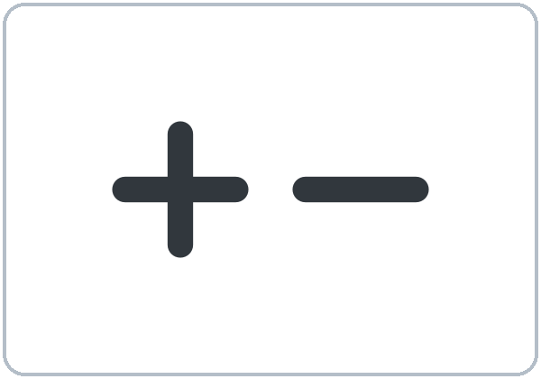  advantage / disadvantage

Partner game: What do you think?
Example: A points to a picture and asks, "What do you think about a community garden?" B gives an opinion and a reason. A says, "I agree," or "I see your point, but…" Switch.
Lesson 9 (Week 10) · My Words
My personal word list. Write each word in your language, if you want. Then write your own example.
Word | My language | My example
opinion
agree
disagree
point (I see your point)
community meeting
empty lot
community garden
parking lot
playground
survey
vote (raise your hand)
advantage / disadvantage

Add 2 more words from tonight (from the listening, the reading, or your partner).
Lesson 9 (Week 10) · Listening
A short neighborhood meeting. The leader, Mrs. Okafor, asks for opinions about the empty lot on Cedar Street. Ray and Lin give their opinions.
A. Listen. What are they deciding? Circle.
a. what to do with the empty lot b. when to have a street party c. where to put a new bus stop
B. Listen again. Match the person, the opinion, and the reason. Circle the answer.
1. Ray wants (a parking lot / a community garden).
2. Ray's reason: there (aren't enough parking spaces / are too many trees) on the street.
3. Lin wants (a parking lot / a community garden).
4. Lin's first reason: a garden (isn't as expensive as / is more expensive than) a parking lot.
5. Ray's question: who's going to (take care of it / pay for it)?
6. The plan: they will (do a survey / build the garden).
C. Listen again. Write the missing word in the polite phrase.
1. In my ____________, we need a parking lot.
2. how do you ____________ about it?
3. I see your ____________, Ray, but I'm not sure I agree.
4. That's a good ____________, but a garden is a lot of work.
5. Well, I ____________ that a garden is nice.
6. I agree. That's ____________.
Hear it, say it
wanna = want to • gonna = going to. You can say want to and going to. In I see your POINT, but…, the voice goes down on point. Stress: It isn't as EXpensive.
Lesson 9 (Week 10) · Grammar
Read across. A reads from the left side. B answers from the right side. Choose one part from each column.
Grammar Box 1: asking for and giving an opinion
QUESTION |  |  | ANSWER
What do you think | about the empty lot? |  | I think | we need a playground.
How do you feel | about a parking lot? |  | In my opinion, | it's a good idea.
What's your opinion | about the bus stop? |  | I'm not sure, but | maybe it's too far.

Grammar Box 2: agreeing and disagreeing politely
QUESTION |  |  | ANSWER
Do you agree | with Ray? |  | Yes, I agree with him. | That's true. Parking is a problem.
Do you agree | with Lin? |  | I see your point, but | a garden is a lot of work.
Do you agree | about the survey? |  | I'm not sure I agree, | because it takes a long time.

Rule of thumb: To disagree politely, say something positive first: I see your point, but… / That's a good idea, but… Say I agree (not I am agree) and I don't agree (not I am not agree).
Grammar Box 3: as … as / not as … as
 | MEANING | EXAMPLE
as important as | the same | A playground is as important as parking.
not as expensive as | less | A garden isn't as expensive as a parking lot.
more … than (review) | more | A parking lot is more expensive than a garden.

Grammar Box 4: an opinion paragraph
PART | WORDS | EXAMPLE
topic sentence | In my opinion, / I think | In my opinion, the lot should be a playground.
reason 1 and reason 2 | First, … Also, … | First, kids need a safe place to play. Also, it isn't as expensive as a parking lot.
example | For example, | For example, the nearest park is two miles away.
closing | That's why | That's why I think a playground is the best plan.

Questions and answers
Q: I am agree or I agree?
A: I agree. agree is a verb, so there is no am. The negative is I don't agree.
Q: How do I disagree politely?
A: Say something positive first: I see your point, but… or That's a good idea, but…
Q: not as expensive as or not as expensive than?
A: Use as … as: A garden isn't as expensive as a parking lot.
Practice A: Write one word.
1. I ____________ with you. That's true.
2. A garden isn't ____________ expensive as a parking lot.
3. What do you ____________ about the new bus stop?
4. I see your ____________, but I'm not sure.
5. In my ____________, we need more trees.
6. If we ____________ a playground, kids would play outside more. (have)
Practice B: Circle the correct words.
1. (I agree / I am agree) with Lin.
2. A playground is as important (as / than) parking.
3. (That's a good idea, but / That's wrong, and) it's a lot of work. (polite)
4. How do you (feel / think) about the plan?
5. A garden isn't as (expensive / more expensive) as a parking lot.
6. If we had a garden, families (would / will) grow vegetables.
Common mistakes
✗ Don't say | ✓ Say
I am agree. | I agree.
I am not agree. | I don't agree.
A garden isn't as expensive than parking. | A garden isn't as expensive as parking.
What do you think the plan? | What do you think about the plan?
No, that's wrong. (in a meeting) | I see your point, but I'm not sure.

Contrast tip (optional): In some languages, a direct "No, that's wrong" is normal in a discussion. In English, people usually soften it: I see your point, but… (Spanish: Entiendo, pero…). What do people say in your language?

Lesson 9 (Week 10) · Talk Time: Community Meeting
Round 1. Work in groups of 4. You are neighbors at a meeting about the empty lot. Take a role card. Give your opinion with 2 reasons. The others agree or disagree politely. Then choose one plan.
ROLE CARDS (invented)
A parent: a playground. Kids need a safe place to play. The nearest park is 2 miles away. | A store owner: a parking lot. Customers can't find parking. More customers means more jobs.
A retired neighbor: a community garden. Older neighbors can meet. Fresh vegetables are healthy. | A bus rider: a bus shelter and benches. It's cold at the bus stop in winter. People wait 20 minutes.

Example: A: In my opinion, the lot should be a playground. First, kids need a safe place to play. B: I see your point, but customers can't find parking. C: That's true, but a garden isn't as expensive as a parking lot.
Name | Plan | Reason | Agree or disagree?

Our group's plan and 3 reasons (First… Also… That's why…)

Lesson 9 (Week 10) · Talk Time: Opinion Lines
Round 2. Listen to the statement. Stand by the sign: AGREE, NOT SURE, or DISAGREE. Say why. Then answer someone on another side with I see your point, but…
STATEMENTS
1. Every job should have a uniform. | 2. Kids should have less homework.
3. Stores should close at 9:00 p.m. | 4. Everyone should learn to cook.
5. Summer is the best season. | 6. It's a good idea to live near your job.

Example: "I agree, because a uniform is easy. You don't have to choose clothes." • "I see your point, but some jobs don't need a uniform."
Statement | Where I stood | My reason

Useful: I agree because… • I'm not sure. • I see your point, but… • That's a good idea, but… • That's true. • It isn't as … as …
Remember: the goal is polite language, not winning.
Lesson 9 (Week 10) · Homework
Homework (about 15–20 minutes). Bring it next week!
1. Write the sentence or question. Use the words.
Example: garden / not / expensive / parking lot → A garden isn't as expensive as a parking lot.
1. playground / important / parking (as … as) → ______________________________________________
2. bus / not / fast / car (not as … as) → ______________________________________________
3. what / you / think / about / the new store? → ______________________________________________
4. I / agree / with you (negative) → ______________________________________________
2. Finish your writing from Read & Write C (your paragraph). Read it one more time. Check ✓ the list in D.
☐ I finished it. ☐ I checked it with the list.
3. What should change in your neighborhood? Write your opinion and 3 reasons.
My opinion (In my opinion, …)

My reasons (First… Also… For example…)
1.
2.
3.

4. Review (Lesson 8). Write one word.
1. It might ____________ tomorrow. (rain)
2. Do you know where the meeting ____________? (be)
3. The sign says the road ____________ close on Monday. (will / might)
4. The repair may ____________ two weeks. (take)
5. Do you know when the bus ____________? (leave)
Lesson 9 (Week 10) · Read & Write
A. Read the notice. Read fast first. Then read again and answer the questions.
CEDAR STREET NEIGHBORS · A flyer + two letters (invented)
COMMUNITY MEETING. What should we do with the empty lot at 400 Cedar Street? Come and share your opinion! Thursday, May 12, 7:00 p.m., Cedar Street Library, Room B. Free childcare. Please bring your survey.
A playground, please! In my opinion, the lot should be a playground. First, our kids don't have a safe place to play. The nearest park is two miles away. Also, a playground isn't as expensive as a parking lot. If we had a playground, families would spend more time outside together. That's why I think a playground is the best plan. Maria G.
What about parking? I see the point about a playground, but I'm not sure I agree. Every night, I drive around for 20 minutes to find a space. Many neighbors work late, and the street is very dark at night. A small parking lot with good lights would help everyone. Maybe we could also put two benches and a small garden next to it. Ray T.

B. Answer the questions.
1. When is the meeting? ______________________________________________
2. What does Maria want? ______________________________________________
3. What is Maria's first reason? ______________________________________________
4. Does Ray agree with Maria? ______________________________________________
5. What could go next to the parking lot? ______________________________________________
C. Write an opinion paragraph (5–8 sentences): what should the empty lot be? Use a topic sentence, two reasons (First… Also…), an example, and a closing sentence (That's why…).
Example: In my opinion, the empty lot should be a community garden. First, a garden isn't as expensive as a parking lot. Also, neighbors could meet and work together. For example, my grandmother loves to grow tomatoes, but she doesn't have a yard. I see the point about parking, but a garden helps more people. That's why I think a garden is the best plan.
My paragraph

D. Check your writing with a partner.
 | Yes | Not yet
It has 5–8 sentences. | ☐ | ☐
It has a topic sentence and a closing sentence. | ☐ | ☐
It has First… and Also…. | ☐ | ☐
It has an example. | ☐ | ☐

Lesson 9 (Week 10) · Exit Ticket
Name: ______________________________ Date: ________________
Answer in 3 sentences. Give a reason. Then give this page to your teacher.
Which is better for an empty lot: a playground or a parking lot?
Sentence 1: your opinion (In my opinion, …) • Sentence 2: a reason, with because • Sentence 3: I see the other point, but…
My answer
1.
2.
3.

For the teacher | ✓ | almost | not yet
3 sentences, today's grammar, a reason | ☐ | ☐ | ☐

Lesson 9 (Week 10) · Task Words (optional)
This page is for you if you want it. You can skip it. Write each task word in your language, if you want.
Task word | What you do | My language
Listen. | Use your ears. Don't write yet.
Circle. | Draw a circle around the answer.
Check ✓. | Make a ✓ in the box.
Write. | Write words or sentences.
Number. | Write 1, 2, 3… to show the order.
Match. | Find the two parts that go together.
Work with a partner. | Work with one classmate.
Work in a group. | Work with 2 or 3 classmates.
Switch. | Change roles: A is B now.
Ask a follow-up question. | Ask one more question about the answer.
Give a reason. | Say why, with because or so.
Compare. | Look at your partner's answers. Are they the same?

Picture Credits
Pictures use Twemoji graphics by Twitter, Inc. and other contributors (https://github.com/jdecked/twemoji), licensed under CC BY 4.0 (https://creativecommons.org/licenses/by/4.0/). The graphics were resized and combined, and signs and labels were added. The file-by-file list is in images/CREDITS.md.
Listening audio: not recorded yet. When it is made, it will use synthetic voices made with Chatterbox TTS (Resemble AI, MIT License), cloned from synthetic reference clips made with Kokoro-82M (Apache License 2.0), with no recordings of real people. The names and the story are invented.
Course materials: © 2026 the authors, licensed under CC BY-NC-SA 4.0 (https://creativecommons.org/licenses/by-nc-sa/4.0/).

