Level 4 Adult ESL Curriculum · Lesson 13 (Week 14): My Story So Far
Status: Complete lesson (all 13 Level 4 lessons are published).
Date: October 2026
Audience: Program coordinators and volunteer teachers
Companion files: images/ (12 vocabulary pictures + images/CREDITS.md). Audio: audio/L4_L13_listening.mp3.
Topic: Personal growth and the graduation talk: learners look back at their own learning (when they started, what was hard, what they can do now) and look forward to the next step. They tell a short story with time clauses (before / after / when), past ability (couldn't / was able to), and the past continuous. Every story is the learner's choice; "my life in this class" is always enough. All names are invented.

How this lesson is organized
Part | What's inside | Who uses it
Teacher Plan | At a glance, clock-time plan, step-by-step boxes, listening script, answer key, teacher notes | Volunteer teachers
Student Pages | Opening Talk, New Words, My Words, Listening, Grammar, Talk Time, Homework, Read & Write, Exit Ticket, Task Words (optional). Print this part for learners | Learners
Picture Credits | Picture, audio, and license credits | Coordinators

What Lesson 13 builds on and what it adds
Before (review only) | Where | New in Level 4 Lesson 13
used to | Level 4 Lesson 2 | I used to stay home on weekends.
present perfect | Level 4 Lessons 1 and 5 | I've made friends in this class.
past continuous | Level 3 | I was working at a restaurant when I met her.

TEACHER PLAN
Lesson 13 (Week 14)

My Story So Far
At a glance · Clock-time plan · Step by step · Script and answer key

How to Use This Plan
You don't need to speak Spanish or any other language. Teach in English. Show, point, and gesture. Some Grammar pages have one short contrast tip, only where a common mix-up exists. Learners read it on their own. You never need to read, translate, or explain it.

Instructions: use the same short task words every week: Listen. Circle. Check. Write. Work with a partner. Work in a group. Ask a follow-up question. Give a reason. An optional Task Words page is at the back of the workbook for learners who want it.

Instruction rule: Model it (do it with one learner while everyone watches), check it (ask: "What can you do now that you couldn't do before? What's next?"), then go. Say less, show more.

Grouping toolkit: Pairs: turn to a neighbor; with an odd number, make one group of 3. Groups: 3–4 learners. Inside–outside circles: the inner circle faces out, the outer circle faces in; the outer circle moves one person to the right each round. Mingle: everyone stands and talks to many classmates. The teacher joins a pair only if one learner is left over.

When a learner is stuck or speaks another language to you: (1) show it: the picture, a gesture, or the board; (2) give one more short English example; (3) point to the grammar box on their page; (4) a classmate can help for a few seconds, then back to English. You don't need to understand what classmates say to each other.

Three sentences, not one: in Level 4, every Talk Time answer and every exit ticket has about three connected sentences: the answer, a reason, and a detail or example.

Lesson 13 (Week 14): My Story So Far
At a glance
Objectives: learners can…
• tell events in order with before / after / when and use a comma when the time clause comes first
• use the present after when / after for the future (After I finish this class, I'll…)
• talk about past ability with couldn't / was able to
• make a 5-event timeline of my learning and tell it to a group
• write an email (5–8 sentences) to my teacher about my story so far, the start of my graduation talk

Materials
• Student Pages for Lesson 13 (print for the number expected + 3 spares)
• Board and markers
• A timeline of your own learning on the board (5 events) for the model
• The feedback cards on the Talk Time page (copy and cut them, optional)
• A timer (phone)
• Listening: phone + small speaker, L4_L13_listening.mp3 (about 1:54). No speaker? Read the script aloud with a volunteer.
• Prep time: 15 minutes (read the plan; practice reading the listening script; write your own 1-minute story to model).

Key vocabulary (with pictures on the New Words page)
★ milestone • ★ challenge • ★ succeed • ★ confident • ★ get used to • ★ make friends • ★ be able to • ★ support • ★ celebrate • ★ timeline • ★ speech • audience
Also: a step, a goal, a success, nervous, proud, advice, a graduation, a certificate, a talk, a shift.

Clock-time plan
Times are loose. If the listening or Talk Time runs long, take the time from Read & Write.
Time | Step | Min | Grouping (15 / 7–8) | If running behind
6:00–6:08 | Opening Talk + Homework Check | 8 | Pairs (7 pairs + 1 trio / 3–4 pairs) | One card only
6:08–6:15 | New Words (picture page) + pair game (+ My Words) | 7 | Whole class, then pairs | Teach the ★ words only
6:15–6:30 | Listening: play 1 (Task A), play 2 (Tasks B and C) + "Hear it, say it" | 15 | Individuals, then pairs check | Do Task C together on the board
6:30–6:45 | Grammar Q&A: before / after / when + pair check | 15 | Whole class, then pairs | Skip the pair check; Talk Time practices it
6:45–7:00 | BREAK | 15
7:00–7:15 | Talk Time: Story Timeline + Talk Rehearsal | 15 | Pairs, then groups of 3 | Round 1 only
7:15–7:25 | Read & Write: A learner story; an email to my teacher | 10 | Pairs read, then individual writing | Reading questions only; the writing becomes homework
7:25–7:30 | Exit Ticket + Homework | 5 | Individuals | Never skip

Skip order if you're running behind: (1) the Read & Write writing task (it becomes homework); (2) the pair check at the end of Grammar; (3) the second round of Talk Time. Never skip: the listening tasks, the grammar boxes and the mistakes table, and the exit ticket.

Attendance (15 → 7–8 → 5 or fewer): every step lists the sizes. With 5 or fewer, each learner makes a timeline and tells it to the whole group; you give the feedback cards. Late arrivals make a 3-event timeline and listen in a group, then tell it.

Step by step
Step 1 · 6:00–6:08 · Opening Talk · 8 min
• Grouping: pairs, the same partner for both parts. 15 learners: 7 pairs + 1 group of 3. 7–8 learners: 3–4 pairs. 5 or fewer: pairs, or one group with you.
• Before class: write on the board: who / that; warning signs
• Opening Talk (5 min): learners open the Opening Talk page. A asks a card question; B answers in 3 sentences (the answer, a reason, a detail); A asks one follow-up. Switch after each card.
• Model with one learner: you say, "Tell me one warning sign of a scam." The learner answers with who / that (A caller who asks for gift cards.). Then you ask, "What should you do?" Help them say 3 sentences.
• Homework Check (3 min): Pairs compare Homework item 1 (who / that) and read their 3 warning signs (item 3) to each other. Then they fill in the box on the Opening Talk page. Walk around. Write 2 common errors on the board (often a man who he called (→ a man who called) and a text who said (→ a text that said)) and correct them together. Also put up 2 corrections from last week's exit tickets.
• Late arrivals: join any pair as a group of 3.
• If behind: one card only.

Step 2 · 6:08–6:15 · New Words · 7 min
• Grouping: whole class, then pairs. Show the New Words page.
• Do: point to each picture and say the word. Learners repeat once.
• Show the hard words: milestone (an important step in your life); challenge (something hard); succeed (do it well, get what you wanted); confident (sure you can do it); get used to (something new becomes normal); make friends; be able to (can); support (help, be there for someone); celebrate (have a party, say "great job!"); timeline (events in order on a line); speech (a talk to many people); audience (the people who listen).
• Check meaning (1 min): ask "Is a challenge easy or hard?" (hard) • "When you are confident, are you sure or not sure?" (sure) • "Do you celebrate a milestone or a problem?" (a milestone).
• Pairs (2 min): A says a word; B points to the picture and makes a sentence (After I finish this class, I'll celebrate.). Switch. 15 learners: finish with a quick team round (3 teams; you say a clue, the first team with the word gets a point). 7–8: 2 teams. 5 or fewer: one team against the clock.
• My Words: "Write any word you want in your language on the My Words page. It's your personal list. It's optional." Learners do it at home.
• If behind: teach the ★ words only.

Step 3 · 6:15–6:30 · Listening + "Hear it, say it" · 15 min
• Grouping: individuals, then pairs check. With 5 or fewer, check together as a group.
• Before you listen (2 min): say: "Mariana was a learner here. Now she is giving a short talk at graduation. Then her old teacher, Mr. Hill, asks her two questions. Listen: what is her main message?"
• Play 1 → Task A (the main idea). Pairs compare. Check together.
• Read Tasks B and C together (1 min) so learners know what to listen for.
• Play 2 → Tasks B and C. Pairs compare. Then show the answers (answer key).
• "Hear it, say it" (3 min): Point to the script line. gonna = going to: "I'm going to take a training class." Then practice the pause at the comma: When I started, (pause) I couldn't understand the bus driver. Stress the key words: NOW I can…, NEXT… The class repeats the two lines twice.
• The audio plays the conversation once (about 1:54). Press play again for play 2. A third play is fine if the class needs it. The script says going to and want to. People often say gonna and wanna; learners only need to recognize those words.
• If behind: do Task C together on the board, reading the lines yourself.

Step 4 · 6:30–6:45 · Grammar Q&A · 15 min
• Grouping: whole class, then pairs. Show the Grammar page. The left side is the question. The right side is the answer.
• Show it (2 min): draw a line on the board with 2 events: I finished school. → I got a job. Say, "After I finished school, I got a job." Point to the comma. Then: "I got a job after I finished school." No comma. Then the future: "After I finish this class, I'll take Level 5." Cross out When I will finish.
• The boxes (5 min): Box 1: read across: What did you do after you finished school? → After I finished school, I worked in a store. Box 2: couldn't / was able to, past continuous. Box 3: the comma. Box 4: the talk frame.
• Rule of thumb and Questions and answers (2 min): read the rule of thumb aloud. Read each Q and A; the class reads the right sentence after you.
• Check questions: "Time clause first: comma or no comma?" (comma) • "When I will finish or When I finish?" (When I finish) • "Last month, I could call the clinic one time, or I was able to call?" (I was able to call).
• Practice A and B (3 min): learners write, then pairs check. Go over the answers. Read the Common mistakes table together: "Don't say… Say…".
• Pair check (last 3 min): A points to a picture and asks, "When did you make friends here?" B answers with a time clause: "When I started this class, I made friends." Switch. 15 learners: swap partners once. 5 or fewer: you join one pair.
• If behind: skip the pair check. Talk Time practices it.

Break · 6:45–7:00 · 15 min
• Write on the board: When I started, I couldn't… • After I finished…, I… • Now I can… • After I finish this class, I'll…

Step 5 · 7:00–7:15 · Talk Time: Story Timeline + Talk Rehearsal · 15 min
• Model it first (1 min): show your own 5-event timeline on the board and tell it in 1 minute: "When I started teaching, I was nervous. After I taught my first class, I felt better…" Then model a feedback card: "One thing I liked: your timeline was clear. One tip: speak a little slower."
• Round 1 (7 min): Story Timeline (pairs). Each learner writes 5 events from their own learning on the timeline (their choice; "my life in this class" is enough). They tell the timeline to a partner with when / before / after. The partner asks one question.
• Round 2 (6 min): Talk Rehearsal (groups of 3). Each learner tells their story (1–2 minutes) with the talk frame. The two listeners fill in a feedback card. Switch.
• 15 learners: pairs; then groups of 3.
• 7–8 learners: pairs; then groups of 3 (or 2 groups of 4).
• 5 or fewer: each learner tells the whole group; you give the feedback cards.
• Every answer needs a reason; every partner asks a follow-up. Walk around and listen. Note 2 good sentences to praise and 1 common error for next week.
• If behind: round 1 only.

Step 6 · 7:15–7:25 · Read & Write: A learner story · 10 min
• Grouping: pairs read and answer; individual writing. With 5 or fewer, read the text aloud together.
• Read (4 min): Learners read the invented story on the Read & Write page, mark the time words, and answer the questions. Say: "Read fast first. Then find the answers." Pairs answer questions 1–5 together.
• Check (1 min): go over the answers (answer key).
• Write (5 min): Learners write an email (5–8 sentences) to their teacher about their story so far, with when / before / after. Show the example. This is the start of their graduation talk (Homework item 3). Learners start in class and finish at home (Homework item 2).
• If behind: questions 1–5 only; the writing becomes homework.

Step 7 · 7:25–7:30 · Exit Ticket + Homework · 5 min · NEVER SKIP
• Exit ticket (3 min): learners open the Exit Ticket page and answer in 3 sentences with a reason: Write about one change in your life. Example on the board: When I started this class, I couldn't talk on the phone in English. I was afraid to call the clinic. Now I can call by myself, because I practiced every week. With 5 or fewer, a learner can say it to you first and then write it.
• Collect the pages. After class, sort them into ✓ / almost / not yet. Start next week with 2 corrections on the board (no names).
• Homework (2 min): open the Homework page. Do item 1 together (item 1: after / I / finish / work, / I / come / to class (past) → After I finished work, I came to class.). Say: "About 15–20 minutes. Finish your Read & Write writing at home."

Listening script: L4_L13_listening.mp3 (about 1:54; the conversation plays once, so press play again for the second listen)
Audio: play L4_L13_listening.mp3 from a phone + small speaker. No speaker? Read the script with a volunteer, at a natural, friendly speed. The script says going to and want to. People often say gonna and wanna; learners only need to recognize those words.

Narrator: Lesson thirteen. Mariana was a learner at this school. Now she is giving a short talk at graduation. Then her old teacher, Mr. Hill, asks her two questions.
Mariana: Good evening, everyone. My name is Mariana. When I started English classes here, I couldn't understand the bus driver. I was afraid to use the phone.
Mariana: The first year was hard. I had a night job at a restaurant, and I was tired. But my classmates helped me, and I made friends.
Mariana: After I finished Level 2, I got a new job at a hotel. Before I started that job, I practiced my interview with my teacher. Last year, I was able to call the clinic by myself for the first time. That was a big milestone for me.
Mariana: Now I can talk to guests at work, and I help my kids with their homework. I'm more confident.
Mariana: What is next for me? Next, I'm going to take a training class. I want a job at the front desk. My advice to you is simple. Come to class, and do not be afraid to make mistakes. Thank you for listening.
Mr. Hill: Thank you, Mariana. That was wonderful. Can I ask you two questions?
Mariana: Of course.
Mr. Hill: What was the biggest challenge for you?
Mariana: Getting used to the phone. When I called someone, I couldn't understand them very well. Now it's easy for me.
Mr. Hill: And what helped you the most?
Mariana: My classmates. When I was tired, they supported me. After class ended, we often studied together. And we celebrated every small success.
Mr. Hill: Thank you. Everyone, let's celebrate Mariana!
Narrator: That's the end of the listening.

Answer key
• Listening Task A: a (Come to class, and don't be afraid to make mistakes.).
• Listening Task B: 1 bus driver, 2 restaurant, 3 hotel, 4 clinic, 5 training class, 6 the phone.
• Listening Task C: 1 When, 2 After, 3 Before, 4 When, 5 When, 6 After.
• Grammar Practice A: 1 When, 2 couldn't, 3 will, 4 able, 5 working, 6 finish.
• Grammar Practice B: 1 finish, 2 After I finished school,, 3 couldn't, 4 was able to, 5 work, 6 made.
• Talk Time: answers will vary.
• Homework 1: 1 After I finished work, I came to class. 2 Before I started this job, I couldn't drive. 3 After I finish this class, I'll take Level 5. 4 Last month, I was able to call the clinic. Homework 2 and 3: answers will vary. Homework 4: 1 that, 2 who, 3 anyone, 4 mustn't, 5 that.
• Read & Write B: 1 He couldn't read the bus schedule. • 2 His neighbor told him. • 3 He came to class. • 4 He filled out a job application online. • 5 He's going to take a forklift training class. • Writing (C): answers will vary.
• Exit ticket: answers will vary. A good answer: "When I started this class, I couldn't talk on the phone in English. I was afraid to call the clinic. Now I can call by myself, because I practiced every week."
Teacher notes
• Stories are the learner's choice. "My life in this class" or "my job" is always enough. Never ask about migration journeys, family separation, or other hard events. If a learner shares something hard, thank them and move on.
• Model first: tell your own 1-minute story with the talk frame before learners start. Reading from paper is OK, today and at graduation.
• Writing check 5 (the graduation talk): the Read & Write email (5–8 sentences) is the first draft. Learners finish the full talk at home (Homework item 3, 12–15 sentences, about 2 minutes). Collect it next week and give one or two tips.
• Next weeks: Week 15 is the final exam; Week 16 is graduation, where learners can give their talk.
• Pronunciation: pause at the comma after a time clause: When I started, (pause) I couldn't…
• Spanish and other languages: the contrast tip on the Grammar page is optional. Learners read it on their own. You never need to read, translate, or explain it.
• Reductions: the listening says going to. People often say gonna. Learners only need to recognize it; they can always say the full form.

STUDENT WORKBOOK
Lesson 13 (Week 14)

My Story So Far
Opening Talk · New Words · Listening · Grammar · Talk Time · Homework · Read & Write · Exit Ticket

Lesson 13 (Week 14) · Opening Talk
Name: ______________________________ Date: ________________
Work with a partner. A asks a question. B answers in 3 sentences: the answer, a reason, and a detail. A asks one follow-up question. Then switch.
A: What is one warning sign of a scam? | A: What should you do with a text that asks for your PIN?
A: Who can you call to check a bill? | A: Is it a scam? "You won a prize! Pay $20 to get it."

Follow-ups: Why? • What should you do?
Write your partner's name and one warning sign from Homework item 3.
My partner's name | Their warning sign and what to do

Lesson 13 (Week 14): My Story So Far
Student Page 1 · Week 14
Name: ______________________________ Date: ________________
New Words
Look. Listen. Repeat. ★ = most important words.
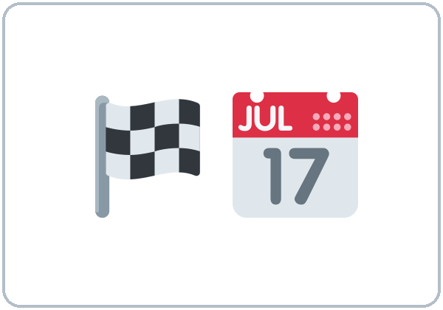  ★ milestone | 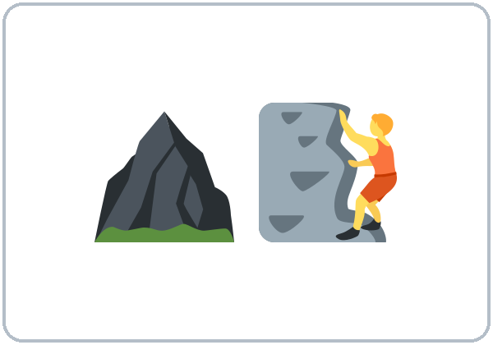  ★ challenge | 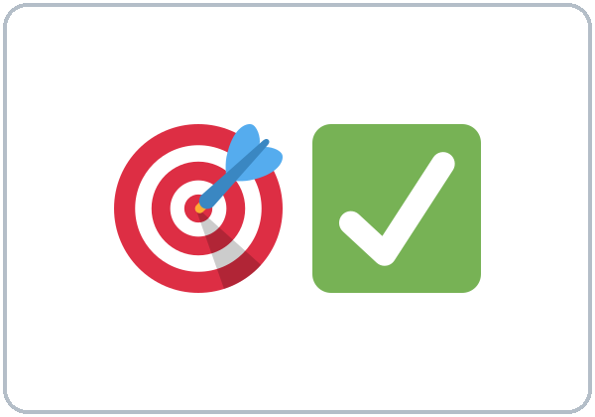  ★ succeed | 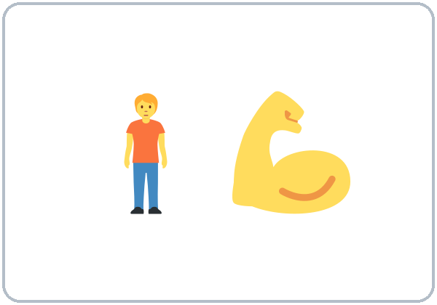  ★ confident
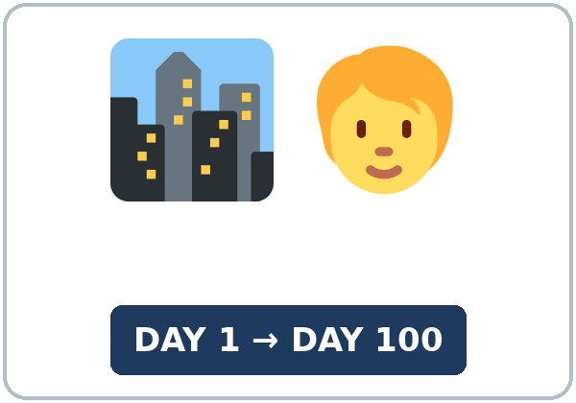  ★ get used to | 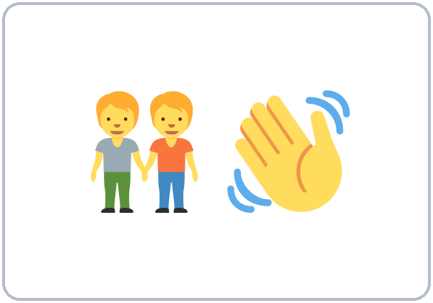  ★ make friends | 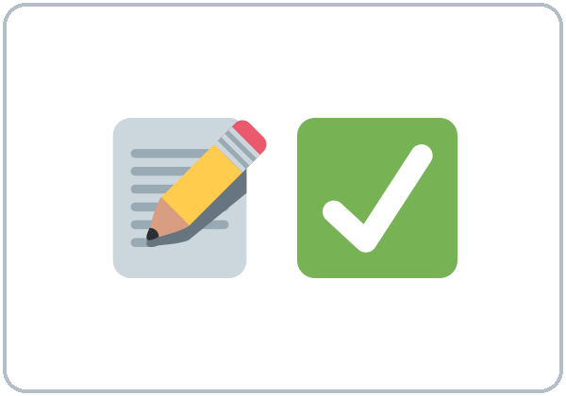  ★ be able to | 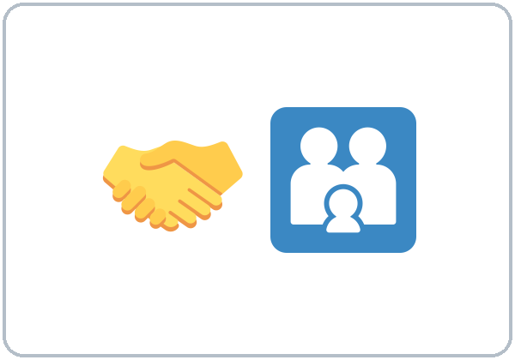  ★ support
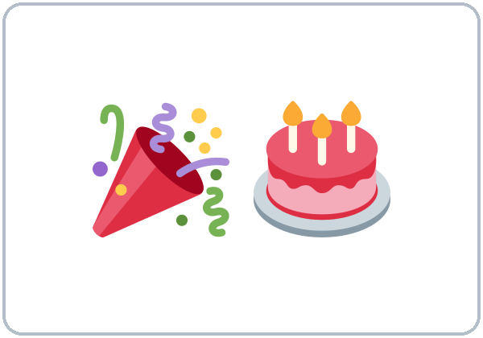  ★ celebrate | 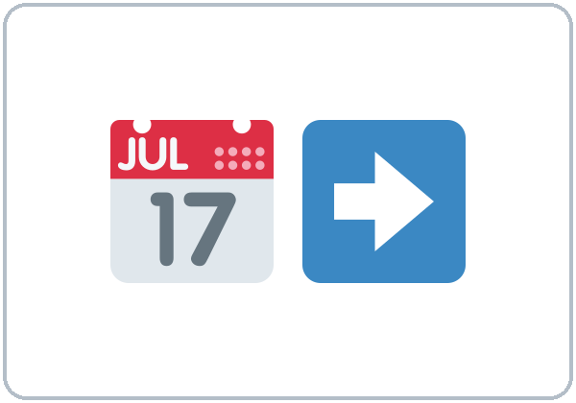  ★ timeline | 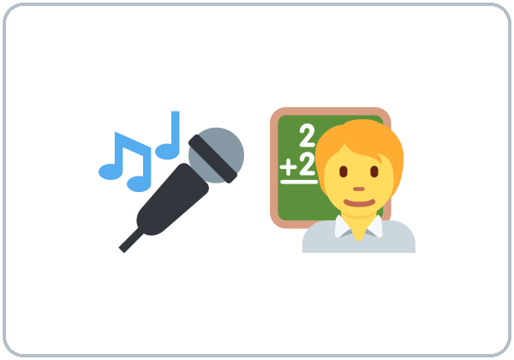  ★ speech | 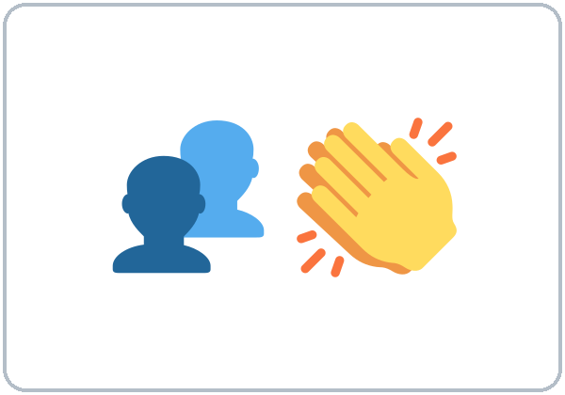  audience

Partner game: When did you…?
Example: A points to a picture and asks, "When did you make friends here?" B answers with a time clause: "When I started this class, I made friends." Switch.
Lesson 13 (Week 14) · My Words
My personal word list. Write each word in your language, if you want. Then write your own example.
Word | My language | My example
milestone
challenge
succeed
confident
get used to
make friends
be able to
support
celebrate
timeline
speech
audience

Add 2 more words from tonight (from the listening, the reading, or your partner).
Lesson 13 (Week 14) · Listening
A former learner, Mariana, gives a short graduation talk about her learning: then, what was hard, now, and next. Her old teacher, Mr. Hill, asks her two questions.
A. Listen. What is Mariana's main message? Circle.
a. Come to class, and don't be afraid to make mistakes. b. Hotel jobs are easy. c. Level 5 is too hard.
B. Listen again. Her story in order: circle the answer.
1. First, when she started, she couldn't understand the (bus driver / teacher).
2. Then, in her first year, she worked at a (restaurant / hotel) at night.
3. After Level 2, she got a job at a (hotel / clinic).
4. Last year, she called the (clinic / school) by herself.
5. Next, after Level 5, she's going to take a (training class / vacation).
6. Her biggest challenge was (the phone / the bus).
C. Listen again. Write before, after, or when.
1. ____________ I started English classes here, I couldn't understand the bus driver
2. ____________ I finished Level 2, I got a new job at a hotel.
3. ____________ I started that job, I practiced my interview with my teacher.
4. ____________ I called someone, I couldn't understand them very well.
5. ____________ I was tired, they supported me.
6. ____________ class ended, we often studied together.
Hear it, say it
gonna = going to: "I'm going to take a training class." You can say going to. Listen for the short pause at the comma: When I started, (pause) I couldn't… Do the same in your talk. Stress the key words: NOW I can…, NEXT…
Lesson 13 (Week 14) · Grammar
Read across. A reads from the left side. B answers from the right side. Choose one part from each column.
Grammar Box 1: before / after / when
QUESTION |  |  | ANSWER
What did you do | after you finished school? |  | After I finished school, | I worked in a store.
How did you feel | when you started this job? |  | When I started this job, | I didn't know anyone.
What couldn't you do | before this class? |  | Before I started this class, | I couldn't fill out a form.
What will you do | after you finish this class? |  | After I finish this class, | I'll take Level 5.

Grammar Box 2: couldn't / was able to; was …ing
QUESTION |  |  | ANSWER
Could you | understand the bus driver? |  | No, I couldn't. | Now I can.
Were you able to | call the clinic? |  | Yes, I was able to | call by myself last month.
What were you doing | when you met your friend? |  | I was working at a restaurant | when I met her.

Rule of thumb: before / after / when + a full sentence (I started, I finished). The time part can come first (with a comma) or second (no comma). For the future, use the present after when / after / before: After I finish this class, I'll take Level 5.
Grammar Box 3: the comma
TIME PART FIRST: comma | TIME PART SECOND: no comma
When I started, I didn't know anyone. | I didn't know anyone when I started.
After I finish this class, I'll take Level 5. | I'll take Level 5 after I finish this class.

Grammar Box 4: the talk frame
PART | SAY
Then | When I started…, I couldn't…
What was hard | It was hard because… But I've…
Now | Now I can… I'm more confident.
Next | After I finish…, I'll… because…

Questions and answers
Q: When I will finish or When I finish?
A: When I finish this class, I'll take Level 5. Use the present after when / after / before, like after if.
Q: Do I need a comma?
A: Time part first: comma. After I finished school, I worked. Time part second: no comma. I worked after I finished school.
Q: couldn't or wasn't able to?
A: Both are OK: I couldn't drive. / I wasn't able to drive. For one success in the past, use was able to: I was able to call the clinic.
Practice A: Write one word.
1. ____________ I started this job, I didn't know anyone.
2. Before I came here, I ____________ speak English. (can't)
3. After I finish this class, I ____________ take Level 5.
4. Last month, I was ____________ to call the clinic by myself.
5. I was ____________ at a store when I met my friend. (work)
6. When I ____________ this class, I'll celebrate. (finish / will finish)
Practice B: Circle the correct words.
1. When I (finish / will finish) the class, I'll look for a new job.
2. (After I finished school, / After I finished school) I worked in a store.
3. Before I started class, I (couldn't / can't) read the bus schedule.
4. I (was able to / could to) fill out the form by myself.
5. I used to (work / working) at night, but now I work days.
6. I've (made / make) many friends in this class.
Common mistakes
✗ Don't say | ✓ Say
When I will finish, I'll call you. | When I finish, I'll call you.
Before I came here I couldn't drive. | Before I came here, I couldn't drive.
I could to fill out the form. | I was able to fill out the form.
After finish class, I go home. | After I finish class, I go home.
I was work when I met her. | I was working when I met her.

Contrast tip (optional): Spanish uses a special verb form after cuando for the future: Cuando termine la clase, voy a celebrar. English uses the simple present: When I finish the class, I'm going to celebrate (not When I will finish). What do you say in your language?

Lesson 13 (Week 14) · Talk Time: Story Timeline
Round 1. Write 5 events from your learning on the timeline. It's your choice: your life in this class is enough. Then tell a partner with when / before / after. Your partner asks one question.
 | When? | What happened?
1. Then | When I started this class,
2.
3.
4. Now | Now
5. Next | After I finish this class,

Example: "When I started this class, I couldn't talk on the phone. After I practiced with my partner, I called the clinic. Last month, I was able to fill out a job form. Now I'm more confident. After I finish this class, I'll take Level 5."
QUESTIONS FOR YOUR PARTNER
What was the hardest part?
How did you feel when…?
What helped you?

Lesson 13 (Week 14) · Talk Time: Talk Rehearsal
Round 2. Work in groups of 3. Tell your story (1–2 minutes) with the talk frame: Then → What was hard → Now → Next. The two listeners fill in a feedback card. Then switch.
TALK FRAME
Then | When I started…, I couldn't…
What was hard | It was hard because… But I've…
Now | Now I can…
Next | After I finish…, I'll… because…

FEEDBACK CARD | Speaker: | Speaker:
One thing I liked
One tip (slower, louder, pause at the comma)

Remember: you can read from your paper. Look up at the audience at the end of each part.
Lesson 13 (Week 14) · Homework
Homework (about 15–20 minutes). Bring it next week!
1. Write the sentence. Use a comma after the time part.
Example: when / I / start / this class, / I / not know / anyone (past) → When I started this class, I didn't know anyone.
1. after / I / finish / work, / I / come / to class (past) → ______________________________________________
2. before / I / start / this job, / I / can't / drive (past) → ______________________________________________
3. after / I / finish / this class, / I / take / Level 5 (future) → ______________________________________________
4. last month, / I / be able to / call the clinic (past) → ______________________________________________
2. Finish your writing from Read & Write C (your email). Read it one more time. Check ✓ the list in D.
☐ I finished it. ☐ I checked it with the list.
3. Finish your graduation talk (12–15 sentences, about 2 minutes). Start with your email from Read & Write. Bring it next week.
PART | My notes
Then (When I started…)
What was hard (It was hard because…)
Now (Now I can…)
Next (After I finish…, I'll…)

4. Review (Lesson 12). Write one word.
1. A scam is a trick ____________ takes your money.
2. Don't trust a caller ____________ asks for gift cards.
3. Never give your PIN to ____________.
4. You ____________ share your password. (must / mustn't)
5. Be careful with texts ____________ ask for your PIN.
Lesson 13 (Week 14) · Read & Write
A. Read the notice. Read fast first. Then read again. Underline the time words (when, before, after, now, last month). Answer the questions.
RIVERSIDE ADULT LEARNING · Class Newsletter (invented)
MY STORY SO FAR, by Tomás R. When I came to this city four years ago, I didn't know anyone. I couldn't read the bus schedule, and I was afraid to go to the doctor alone. I used to stay at home on weekends because everything was difficult.
Two years ago, my neighbor told me about the free English classes at the library. Before I started, I was very nervous. But on the first night, I met my teacher and three classmates who also worked at night. They became my friends.
The first year was a challenge. I was working at a warehouse, and I was always tired. After I finished my shift, I came to class. Sometimes I fell asleep! But I didn't stop.
Now I can do many things by myself. Last month, I was able to fill out a job application online, and I got an interview. I've made friends at work, and I'm more confident on the phone.
When I finish Level 4, I'm going to take a forklift training class. My advice? Come to class, even when you are tired. Small steps make a big change.

B. Answer the questions.
1. When he came to the city, what couldn't he do? ______________________________________________
2. How did he hear about the classes? ______________________________________________
3. What did he do after his shift? ______________________________________________
4. What was he able to do last month? ______________________________________________
5. What will he do when he finishes Level 4? ______________________________________________
C. Write an email (5–8 sentences) to your teacher about your story so far: when you started, what was hard, what you can do now, and your next step, with a reason. Use when / before / after.
Example: Dear Mr. Hill, When I started this class in September, I couldn't understand the news on TV. The hardest part was the phone. After I practiced with my classmates, I felt more confident. Last week, I was able to call my child's school by myself. Now I can help my neighbors with forms. After I finish this class, I'll take Level 5, because I want a better job. Thank you for your help! Rosa
My email

D. Check your writing with a partner.
 | Yes | Not yet
It has 5–8 sentences. | ☐ | ☐
It has when / before / after. | ☐ | ☐
It has a comma after the time part. | ☐ | ☐
It has my next step and a reason. | ☐ | ☐

Lesson 13 (Week 14) · Exit Ticket
Name: ______________________________ Date: ________________
Answer in 3 sentences. Give a reason. Then give this page to your teacher.
Write about one change in your life.
Sentence 1: when it happened, with When… • Sentence 2: what you couldn't do before • Sentence 3: what you can do now, with a reason (because)
My answer
1.
2.
3.

For the teacher | ✓ | almost | not yet
3 sentences, today's grammar, a reason | ☐ | ☐ | ☐

Lesson 13 (Week 14) · Task Words (optional)
This page is for you if you want it. You can skip it. Write each task word in your language, if you want.
Task word | What you do | My language
Listen. | Use your ears. Don't write yet.
Circle. | Draw a circle around the answer.
Check ✓. | Make a ✓ in the box.
Write. | Write words or sentences.
Number. | Write 1, 2, 3… to show the order.
Match. | Find the two parts that go together.
Work with a partner. | Work with one classmate.
Work in a group. | Work with 2 or 3 classmates.
Switch. | Change roles: A is B now.
Ask a follow-up question. | Ask one more question about the answer.
Give a reason. | Say why, with because or so.
Compare. | Look at your partner's answers. Are they the same?

Picture Credits
Pictures use Twemoji graphics by Twitter, Inc. and other contributors (https://github.com/jdecked/twemoji), licensed under CC BY 4.0 (https://creativecommons.org/licenses/by/4.0/). The graphics were resized and combined, and signs and labels were added. The file-by-file list is in images/CREDITS.md.
Listening audio: synthetic voices made with Chatterbox TTS (Resemble AI, MIT License), cloned from synthetic reference clips made with Kokoro-82M (Apache License 2.0). No recordings of real people were used. Each file carries an inaudible Perth watermark marking it as AI-generated. The names and the story are invented.
Course materials: © 2026 the authors, licensed under CC BY-NC-SA 4.0 (https://creativecommons.org/licenses/by-nc-sa/4.0/).

