Level 4 Adult ESL Curriculum · Lesson 7 (Week 7): Too Early or On Time?
Status: Complete lesson (all 13 Level 4 lessons are published).
Date: October 2026
Audience: Program coordinators and volunteer teachers
Companion files: images/ (12 vocabulary pictures + images/CREDITS.md). Audio: audio/L4_L7_listening.mp3.
Topic: Expectations at work and in the community: being on time, dress codes and safety rules, invitations (RSVP, what to bring), and comparing customs respectfully. Learners use too and enough, too much / too many, and must / mustn't / don't have to. The company, the rules, and the people are invented.

How this lesson is organized
Part | What's inside | Who uses it
Teacher Plan | At a glance, clock-time plan, step-by-step boxes, listening script, answer key, teacher notes | Volunteer teachers
Student Pages | Opening Talk, New Words, My Words, Listening, Grammar, Talk Time, Homework, Read & Write, Exit Ticket, Task Words (optional). Print this part for learners | Learners
Picture Credits | Picture, audio, and license credits | Coordinators

What Lesson 7 builds on and what it adds
Before (review only) | Where | New in Level 4 Lesson 7
too small as a fixed phrase; adjectives | Level 3 | too + adjective and adjective + enough: too casual, not formal enough
count and noncount nouns | Level 2 | too much / too many / enough + a noun: too many people, enough time
have to / don't have to | Level 2 | must / mustn't for rules, and don't have to = not necessary

TEACHER PLAN
Lesson 7 (Week 7)

Too Early or On Time?
At a glance · Clock-time plan · Step by step · Script and answer key

How to Use This Plan
You don't need to speak Spanish or any other language. Teach in English. Show, point, and gesture. Some Grammar pages have one short contrast tip, only where a common mix-up exists. Learners read it on their own. You never need to read, translate, or explain it.

Instructions: use the same short task words every week: Listen. Circle. Check. Write. Work with a partner. Work in a group. Ask a follow-up question. Give a reason. An optional Task Words page is at the back of the workbook for learners who want it.

Instruction rule: Model it (do it with one learner while everyone watches), check it (ask: "Is it OK, too much, or not enough?"), then go. Say less, show more.

Grouping toolkit: Pairs: turn to a neighbor; with an odd number, make one group of 3. Groups: 3–4 learners. Inside–outside circles: the inner circle faces out, the outer circle faces in; the outer circle moves one person to the right each round. Mingle: everyone stands and talks to many classmates. The teacher joins a pair only if one learner is left over.

When a learner is stuck or speaks another language to you: (1) show it: the picture, a gesture, or the board; (2) give one more short English example; (3) point to the grammar box on their page; (4) a classmate can help for a few seconds, then back to English. You don't need to understand what classmates say to each other.

Three sentences, not one: in Level 4, every Talk Time answer and every exit ticket has about three connected sentences: the answer, a reason, and a detail or example.

Lesson 7 (Week 7): Too Early or On Time?
At a glance
Objectives: learners can…
• say what is too early, too late, or on time
• use too + adjective and adjective + enough (too casual, safe enough)
• use too much / too many / enough + a noun
• explain a workplace rule with must / mustn't / don't have to
• compare customs politely and write first-week tips for a new coworker (5–8 sentences)

Materials
• Student Pages for Lesson 7 (print for the number expected + 3 spares)
• Board and markers
• Customs question cards and the dress code rule card (in the workbook Talk Time pages; copy them onto index cards, optional)
• A clock or a phone with the time (optional, for the warm-up)
• Listening: phone + small speaker, L4_L7_listening.mp3 (about 1:52). No speaker? Read the script aloud with a volunteer.
• Prep time: 15 minutes (read the plan; practice reading the listening script; practice mustn't (no first t) and eNOUGH).

Key vocabulary (with pictures on the New Words page)
★ on time • ★ early • ★ late • ★ dress code • ★ uniform • ★ casual • ★ formal • ★ closed-toe shoes • ★ name badge • ★ invitation • ★ RSVP • host
Also: an apron, sandals, jewelry, a front counter, a handbook, attendance, a custom, a hometown, a guest, take off (shoes).

Clock-time plan
Times are loose. If the listening or Talk Time runs long, take the time from Read & Write.
Time | Step | Min | Grouping (15 / 7–8) | If running behind
6:00–6:08 | Opening Talk + Homework Check | 8 | Pairs (7 pairs + 1 trio / 3–4 pairs) | One card only
6:08–6:15 | New Words (picture page) + pair game (+ My Words) | 7 | Whole class, then pairs | Teach the ★ words only
6:15–6:30 | Listening: play 1 (Task A), play 2 (Tasks B and C) + "Hear it, say it" | 15 | Individuals, then pairs check | Do Task C together on the board
6:30–6:45 | Grammar Q&A: too / enough; too much / too many; must / mustn't / don't have to + pair check | 15 | Whole class, then pairs | Skip the pair check; Talk Time practices it
6:45–7:00 | BREAK | 15
7:00–7:15 | Talk Time: Customs Compare + Dress Code Check | 15 | Groups, then pairs | Round 1 only
7:15–7:25 | Read & Write: An employee handbook page; first-week tips | 10 | Pairs read, then individual writing | Reading questions only; the writing becomes homework
7:25–7:30 | Exit Ticket + Homework | 5 | Individuals | Never skip

Skip order if you're running behind: (1) the Read & Write writing task (it becomes homework); (2) the pair check at the end of Grammar; (3) the second round of Talk Time. Never skip: the listening tasks, the grammar boxes and the mistakes table, and the exit ticket.

Attendance (15 → 7–8 → 5 or fewer): every step lists the sizes. With 5 or fewer, do Customs Compare as one group, then Dress Code Check in pairs (you join if there is an odd number). Late arrivals join a group and answer the next card.

Step by step
Step 1 · 6:00–6:08 · Opening Talk · 8 min
• Grouping: pairs, the same partner for both parts. 15 learners: 7 pairs + 1 group of 3. 7–8 learners: 3–4 pairs. 5 or fewer: pairs, or one group with you.
• Before class: write on the board: imaginary situations: What would you do if…? / If I had…, I'd…
• Opening Talk (5 min): learners open the Opening Talk page. A asks a card question; B answers in 3 sentences (the answer, a reason, a detail); A asks one follow-up. Switch after each card.
• Model with one learner: you say, "What would you do if you found $50 at work?" The learner answers with If I found…, I'd… Then you ask, "Why?" Help them say 3 sentences.
• Homework Check (3 min): Pairs compare Homework item 1 (If I had…, I'd…) and read their 3 dreams (item 3) to each other. Then they fill in the box on the Opening Talk page. Walk around. Write 2 common errors on the board (often If I would have time… (→ If I had time…) and If I found $50, I will… (→ I'd…)) and correct them together. Also put up 2 corrections from last week's exit tickets.
• Late arrivals: join any pair as a group of 3.
• If behind: one card only.

Step 2 · 6:08–6:15 · New Words · 7 min
• Grouping: whole class, then pairs. Show the New Words page.
• Do: point to each picture and say the word. Learners repeat once.
• Show the hard words: on time, early, late (draw a clock: 6:50, 7:00, 7:20); dress code (the rules about clothes); uniform; casual (T-shirt, jeans) vs. formal (a shirt and tie); closed-toe shoes (point to a sneaker, then mime a sandal: "no"); name badge; invitation (a party card); RSVP (tell the host "yes" or "no"); host (the person who has the party).
• Check meaning (1 min): ask "Is a T-shirt casual or formal?" (casual) • "Are sandals closed-toe shoes?" (no) • "If an invitation says RSVP by Friday, what do you do?" (tell the host by Friday).
• Pairs (2 min): A says a word; B points to the picture and makes a sentence (Jeans are too casual for an interview.). Switch. 15 learners: finish with a quick team round (3 teams; you say a clue, the first team with the word gets a point). 7–8: 2 teams. 5 or fewer: one team against the clock.
• My Words: "Write any word you want in your language on the My Words page. It's your personal list. It's optional." Learners do it at home.
• If behind: teach the ★ words only.

Step 3 · 6:15–6:30 · Listening + "Hear it, say it" · 15 min
• Grouping: individuals, then pairs check. With 5 or fewer, check together as a group.
• Before you listen (2 min): say: "It's Nadia's first week at a bakery. She asks her coworker, Carmen, about the rules. Then the supervisor, Mr. Brooks, comes in. Listen: what are they talking about?"
• Play 1 → Task A (the main idea). Pairs compare. Check together.
• Read Tasks B and C together (1 min) so learners know what to listen for.
• Play 2 → Tasks B and C. Pairs compare. Then show the answers (answer key).
• "Hear it, say it" (3 min): Point to the script lines. wanna = want to: "What do you want to know?" gonna = going to: "I'm going to buy some today." Then practice too / two / to (the same sound) and the stress in TOO late and not eNOUGH. The class repeats the two lines twice.
• The audio plays the conversation once (about 1:52). Press play again for play 2. A third play is fine if the class needs it. The script says going to and want to. People often say gonna and wanna; learners only need to recognize those words.
• If behind: do Task C together on the board, reading the lines yourself.

Step 4 · 6:30–6:45 · Grammar Q&A · 15 min
• Grouping: whole class, then pairs. Show the Grammar page. The left side is the question. The right side is the answer.
• Show it (2 min): draw a clock at 7:10. Say, "My shift starts at 7:00. 7:10 is too late." Draw 6:55: "6:55 is early enough." Write: too = more than OK (a problem); enough = OK. Then show a sandal or mime one: "In a kitchen, you must wear closed-toe shoes. You mustn't wear sandals. You don't have to wear a tie."
• The boxes (5 min): Box 1: read across: Are jeans OK for the interview? → No, they're too casual. / They aren't formal enough. Box 2: too much / too many / enough + a noun. Box 3: must / mustn't / don't have to. Box 4: comparing customs.
• Rule of thumb and Questions and answers (2 min): read the rule of thumb aloud. Read each Q and A; the class reads the right sentence after you.
• Check questions: "enough early or early enough?" (early enough) • "too much people or too many people?" (too many people) • "Is a tie a rule here?" (no) "So: You mustn't wear a tie or You don't have to wear a tie?" (don't have to).
• Practice A and B (3 min): learners write, then pairs check. Go over the answers. Read the Common mistakes table together: "Don't say… Say…".
• Pair check (last 3 min): A points to a picture and asks, "Are sandals OK for the kitchen?" B answers with too or enough and a rule with must / mustn't. Switch. 15 learners: swap partners once. 5 or fewer: you join one pair.
• If behind: skip the pair check. Talk Time practices it.

Break · 6:45–7:00 · 15 min
• Write on the board: too late / early enough • too much work / too many people / enough time • must / mustn't (a rule) / don't have to (not necessary)

Step 5 · 7:00–7:15 · Talk Time: Customs Compare + Dress Code Check · 15 min
• Model it first (1 min): read a card: "A party starts at 7:00. When do people arrive in your hometown?" Help a learner say, "In my hometown, people usually arrive at 8:00, but here many people arrive at 7:15." Say: "Describe; don't judge. No place is better."
• Round 1 (7 min): Customs Compare (groups). One person reads a question card. Each person answers. The group writes 2 sentences with In my hometown…, but here… No place is "better."
• Round 2 (6 min): Dress Code Check (pairs). Pairs read the rule card and the 6 workers. For each worker, they say too casual, not safe enough, or OK, and the rule with must / mustn't / don't have to.
• 15 learners: 5 groups of 3 for round 1; then pairs.
• 7–8 learners: 2 groups for round 1; then pairs.
• 5 or fewer: one group for round 1; then pairs (you join if there is an odd number).
• Every answer needs a reason; every partner asks a follow-up. Walk around and listen. Note 2 good sentences to praise and 1 common error for next week.
• If behind: round 1 only.

Step 6 · 7:15–7:25 · Read & Write: An employee handbook page · 10 min
• Grouping: pairs read and answer; individual writing. With 5 or fewer, read the text aloud together.
• Read (4 min): Learners read the handbook page on the Read & Write page and answer the questions. Say: "Read fast first. Then find the answers." Pairs answer questions 1–5 together.
• Check (1 min): go over the answers (answer key).
• Write (5 min): Learners write "Tips for your first week" for a new coworker (5–8 sentences) with must, don't have to, too, and enough. Show the example. Writing check 2: collect this writing and write one strength and one fix. Learners start in class and finish at home (Homework item 2).
• If behind: questions 1–5 only; the writing becomes homework.

Step 7 · 7:25–7:30 · Exit Ticket + Homework · 5 min · NEVER SKIP
• Exit ticket (3 min): learners open the Exit Ticket page and answer in 3 sentences with a reason: What is one custom here that is different from your hometown (or another place you know)? Example on the board: Here, people usually arrive on time for a doctor's appointment. In my hometown, people often arrive a little late. I like the custom here because I don't wait a long time. With 5 or fewer, a learner can say it to you first and then write it.
• Collect the pages. After class, sort them into ✓ / almost / not yet. Start next week with 2 corrections on the board (no names).
• Homework (2 min): open the Homework page. Do item 1 together (item 1: 6:55 / early / for a 7:00 shift? (enough) → Is 6:55 early enough for a 7:00 shift?). Say: "About 15–20 minutes. Finish your Read & Write writing at home."

Listening script: L4_L7_listening.mp3 (about 1:52; the conversation plays once, so press play again for the second listen)
Audio: play L4_L7_listening.mp3 from a phone + small speaker. No speaker? Read the script with a volunteer, at a natural, friendly speed. The script says going to and want to. People often say gonna and wanna; learners only need to recognize those words.

Narrator: Lesson seven. It's Nadia's first week at a bakery. She asks her coworker, Carmen, some questions.
Nadia: Carmen, can I ask you a few questions? I'm still learning the rules.
Carmen: Sure, Nadia. What do you want to know?
Nadia: My shift starts at seven. Is six fifty-five early enough?
Carmen: Yes, that's perfect. Here, on time means five minutes early. Seven ten is too late.
Nadia: OK. And what about the uniform? Do I have to wear the hat?
Carmen: Yes, you must wear the hat and the apron in the kitchen. But you don't have to wear them in the break room.
Nadia: Got it. What about my phone?
Carmen: You mustn't use your phone in the kitchen. You can use it on your break.
Nadia: And are these shoes OK? They're new.
Carmen: Hmm, those are sandals. They aren't safe enough for the kitchen.
Mr. Brooks: Carmen's right. Good morning, Nadia. I'm Mr. Brooks, the supervisor. You must wear closed-toe shoes. The trays are too hot, and the floor is sometimes wet.
Nadia: I'm sorry. I didn't know. I'm going to buy some today.
Mr. Brooks: That's OK. For today, there are extra shoes in the office. Maybe they're too big, but they're safe.
Nadia: Thank you. Is there anything else?
Mr. Brooks: Just one more thing. If you're going to be late, you must call me before your shift.
Carmen: Don't worry, Nadia. Everyone makes mistakes in the first week. There's too much to remember!
Nadia: That's true. Thanks, both of you.
Narrator: That's the end of the listening.

Answer key
• Listening Task A: a (the rules at work).
• Listening Task B: 1 five minutes early, 2 must, 3 don't have to, 4 mustn't, 5 must, 6 call Mr. Brooks.
• Listening Task C: 1 enough, 2 too, 3 enough, 4 too, 5 too, 6 much.
• Grammar Practice A: 1 too, 2 enough, 3 many, 4 much, 5 enough, 6 too.
• Grammar Practice B: 1 mustn't, 2 don't have to, 3 early enough, 4 many, 5 enough time, 6 aren't safe enough.
• Talk Time: answers will vary.
• Homework 1: 1 Is 6:55 early enough for a 7:00 shift? 2 There are too many people in the store. 3 I don't have enough time for lunch. 4 You mustn't use your phone in the kitchen. Homework 2 and 3: answers will vary. Homework 4: 1 had, 2 were, 3 would, 4 I'll, 5 give.
• Read & Write B: 1 5 to 10 minutes before your shift. • 2 Call your supervisor at least one hour before your shift. • 3 No. A text is not enough. • 4 No, but they must wear a name badge. • 5 In the break room. • Writing (C): answers will vary.
• Exit ticket: answers will vary. A good answer: "Here, people usually arrive on time for a doctor's appointment. In my hometown, people often arrive a little late. I like the custom here because I don't wait a long time."
Teacher notes
• Describe, don't judge: customs vary inside every country, including the U.S., and inside every family. No place is "better." Model It's different and I like both.
• Rules come from each employer: the bakery, the kitchen, and their rules are invented. Learners can say "At my job…" if they want; they never have to.
• mustn't vs. don't have to: this is the biggest mix-up. Use a thumbs-down for mustn't (don't do it) and a shrug for don't have to (you choose).
• Writing check 2 (Week 7): collect the first-week tips. Write one strength and one fix on each. Learners keep them in their writing folder.
• Week 8 is the midterm. It covers Lessons 1–7. Remind learners to bring their workbook.
• Spanish and other languages: the contrast tip on the Grammar page is optional. Learners read it on their own. You never need to read, translate, or explain it.
• Reductions: the listening says going to and want to. People often say gonna and wanna. Learners only need to recognize the short forms; they can always say the full forms.

STUDENT WORKBOOK
Lesson 7 (Week 7)

Too Early or On Time?
Opening Talk · New Words · Listening · Grammar · Talk Time · Homework · Read & Write · Exit Ticket

Lesson 7 (Week 7) · Opening Talk
Name: ______________________________ Date: ________________
Work with a partner. A asks a question. B answers in 3 sentences: the answer, a reason, and a detail. A asks one follow-up question. Then switch.
A: What would you do if you found $50 at work? | A: What would you do if you had a free week?
A: If you had a magic wand, what would you do? | A: What would you do if a cashier gave you too much change?

Follow-ups: Why? • Would you tell anyone? • What would your family do?
Write your partner's name and one dream from Homework item 3.
My partner's name | A dream (If I had…, I'd…)

Lesson 7 (Week 7): Too Early or On Time?
Student Page 1 · Week 7
Name: ______________________________ Date: ________________
New Words
Look. Listen. Repeat. ★ = most important words.
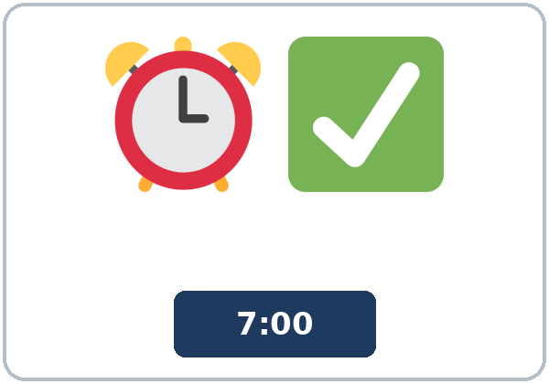  ★ on time | 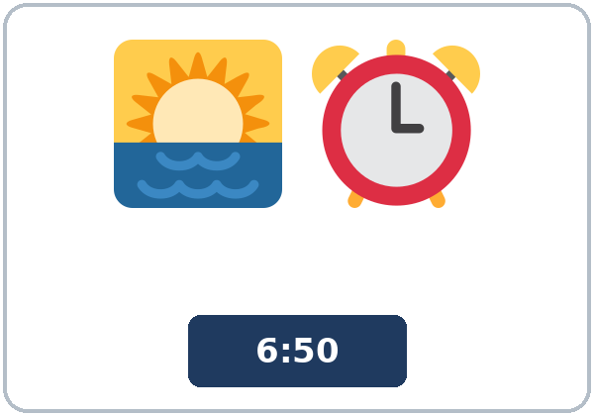  ★ early | 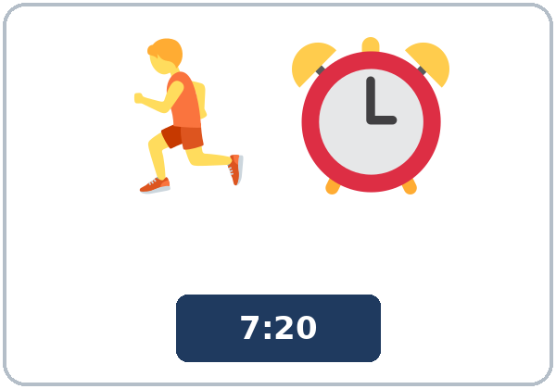  ★ late | 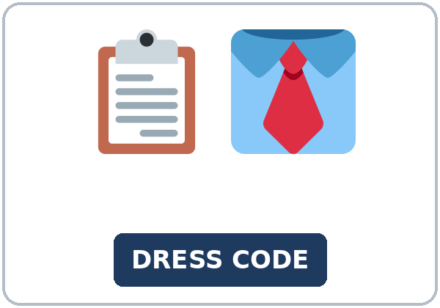  ★ dress code
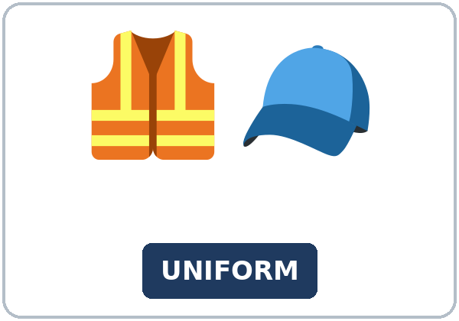  ★ uniform | 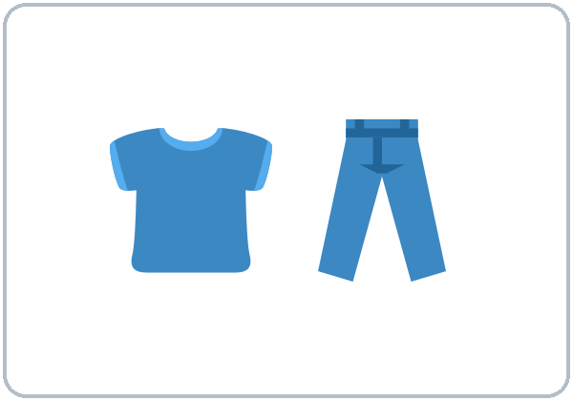  ★ casual | 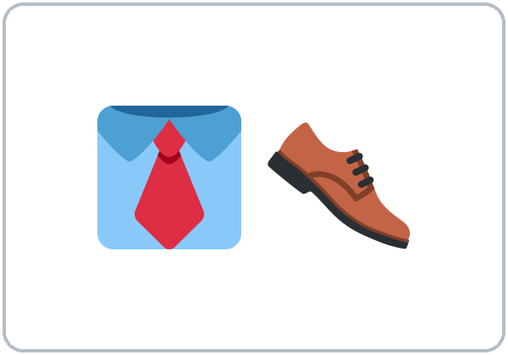  ★ formal | 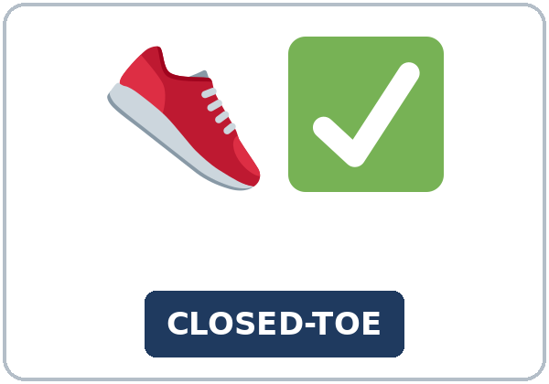  ★ closed-toe shoes
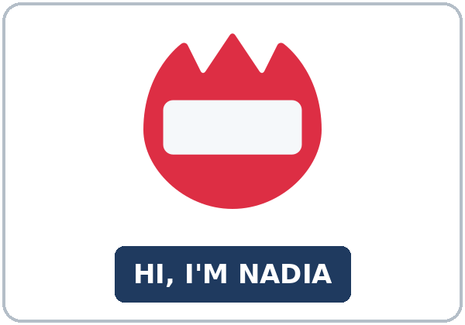  ★ name badge | 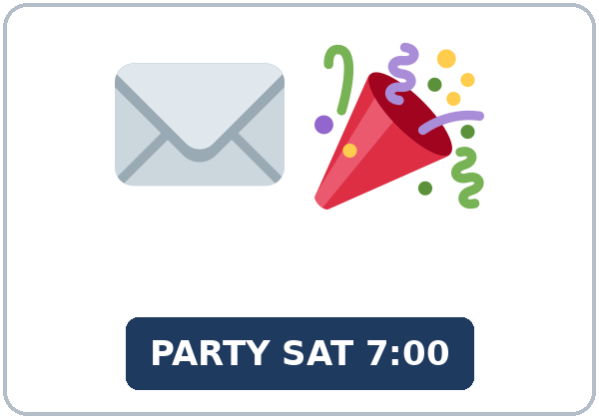  ★ invitation | 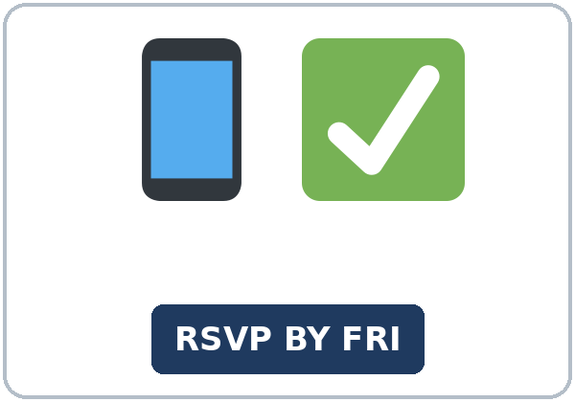  ★ RSVP | 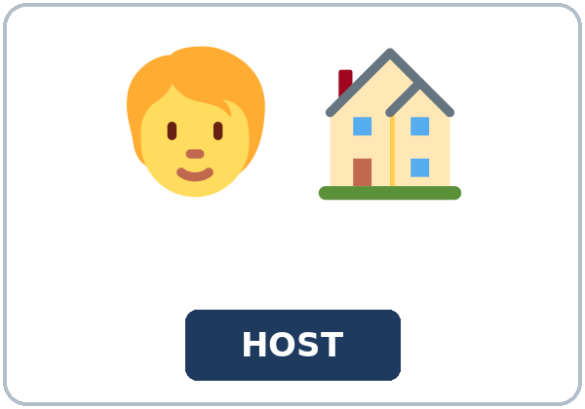  host

Partner game: Too, enough, or OK?
Example: A points to a picture and asks, "Are sandals OK for the kitchen?" B answers with too or enough and a rule: "No, they aren't safe enough. You must wear closed-toe shoes." Switch.
Lesson 7 (Week 7) · My Words
My personal word list. Write each word in your language, if you want. Then write your own example.
Word | My language | My example
on time
early
late
dress code
uniform
casual
formal
closed-toe shoes
name badge
invitation
RSVP
host

Add 2 more words from tonight (from the listening, the reading, or your partner).
Lesson 7 (Week 7) · Listening
It's Nadia's first week at a bakery. She asks her coworker, Carmen, about the rules. Then the supervisor, Mr. Brooks, joins them.
A. Listen. What are they talking about? Circle.
a. the rules at work b. a party invitation c. a job interview
B. Listen again. Check the rules. Circle the answer.
1. On time means (five minutes early / exactly seven o'clock).
2. In the kitchen, you (must / don't have to) wear the hat and the apron.
3. In the break room, you (must / don't have to) wear them.
4. You (must / mustn't) use your phone in the kitchen.
5. You (must / don't have to) wear closed-toe shoes.
6. If you're going to be late, you must (call Mr. Brooks / text Carmen).
C. Listen again. Write the missing word: too, enough, or much.
1. Is six fifty-five early ____________?
2. Seven ten is ____________ late.
3. They aren't safe ____________ for the kitchen.
4. The trays are ____________ hot, and the floor is sometimes wet.
5. Maybe they're ____________ big, but they're safe.
6. There's too ____________ to remember!
Hear it, say it
wanna = want to: "What do you want to know?" • gonna = going to: "I'm going to buy some today." You can say want to and going to. too, two, and to sound the same: listen to the meaning. Stress: TOO late • not eNOUGH. In mustn't, you don't hear the first t.
Lesson 7 (Week 7) · Grammar
Read across. A reads from the left side. B answers from the right side. Choose one part from each column.
Grammar Box 1: too + adjective, adjective + enough
QUESTION |  |  | ANSWER
Are jeans OK | for the interview? |  | No, they're too casual. | They aren't formal enough.
Is 6:55 | early enough? |  | Yes, it's early enough. | That's perfect.
Is 7:10 OK | for a 7:00 shift? |  | No, it's too late. | Come at 6:55.
Are sandals | safe enough? |  | No, they aren't safe enough. | Wear closed-toe shoes.

Grammar Box 2: too much / too many / enough + a noun
QUESTION |  |  | ANSWER
Do you have | enough time? |  | No, I have too much work. | I don't have enough time.
Are there | enough chairs? |  | No, there are too many people. | We need more chairs.
Do we have | enough food? |  | Yes, we have enough food. | Don't buy more.

Rule of thumb: too = more than OK (a problem). enough = OK. enough goes after an adjective (early enough) and before a noun (enough time). too many + things you can count; too much + things you can't count.
Grammar Box 3: must / mustn't / don't have to
 | MEANING | EXAMPLE
must | it's a rule; do it | You must wear closed-toe shoes.
mustn't | it's against the rules; don't do it | You mustn't use your phone in the kitchen.
don't have to | it's not necessary; you choose | You don't have to wear a tie.

Grammar Box 4: comparing customs
TO SAY | EXAMPLE
In my hometown…, but here… | In my hometown, guests usually bring food, but here people often ask the host first.
usually / often / sometimes | People usually arrive on time for work.
describe; don't judge | It's different. I like both.

Questions and answers
Q: enough early or early enough?
A: After an adjective: early enough. Before a noun: enough time.
Q: Are mustn't and don't have to the same?
A: No! mustn't = don't do it (it's a rule). don't have to = not necessary (you can if you want).
Q: too much or too many?
A: too many + things you can count (people, chairs). too much + things you can't count (work, time, noise).
Practice A: Write too, much, many, or enough.
1. 7:10 is ____________ late for a 7:00 shift.
2. The room isn't big ____________ for 30 people.
3. There are too ____________ cars in the parking lot.
4. I have too ____________ work today.
5. We don't have ____________ chairs.
6. Jeans are ____________ casual for an interview.
Practice B: Circle the correct words.
1. You (mustn't / don't have to) smoke in the building. (It's a rule.)
2. It's Friday. You (mustn't / don't have to) wear a tie. (It's not necessary.)
3. Is 6:55 (early enough / enough early)?
4. There are too (many / much) people here.
5. I don't have (enough time / time enough).
6. Sandals (aren't safe enough / are too safe) for the kitchen.
Common mistakes
✗ Don't say | ✓ Say
It's enough big. | It's big enough.
There are too much people. | There are too many people.
You don't have to use your phone on the floor. (It's a rule.) | You mustn't use your phone on the floor.
You must to wear a badge. | You must wear a badge.
I have too many work. | I have too much work.

Contrast tip (optional): Spanish demasiado covers too and too much / too many: demasiado caro = too expensive; demasiada gente = too many people. Suficiente = enough. English puts enough after an adjective: big enough (not enough big). What does your language do?

Lesson 7 (Week 7) · Talk Time: Customs Compare
Round 1. Work in groups. One person reads a question card. Each person answers. Then write 2 sentences with In my hometown…, but here… No place is "better."
QUESTION CARDS
1. A party starts at 7:00. When do people arrive in your hometown? | 2. What do guests bring to a dinner?
3. What do people wear to a job interview? | 4. How early do people arrive for work?
5. Do people take off their shoes in a home? | 6. How do people answer an invitation?

Example: A: A party starts at 7:00. When do people arrive in your hometown? B: In my hometown, people usually arrive at 8:00, but here many people arrive at 7:15. C: In my family, we're always on time!
Card | In my hometown… | Here…

Our 2 sentences (In my hometown…, but here…)
1.
2.

Remember: customs are different in every country, every city, and every family. Describe; don't judge.
Lesson 7 (Week 7) · Talk Time: Dress Code Check
Round 2. Work with a partner. Read the rule card. For each worker, say too casual, not safe enough, or OK. Then say the rule with must / mustn't / don't have to.
RIVERSIDE KITCHEN · DRESS CODE (invented)
Kitchen: You must wear closed-toe shoes and a hat. You mustn't wear rings or bracelets. | Front desk: You must wear a name badge and a collared shirt. You don't have to wear a tie.

Worker | too casual / not safe enough / OK | The rule
1. A cook wears sandals.
2. A cook wears a ring.
3. A cook wears sneakers and a hat.
4. A front-desk worker wears a T-shirt.
5. A front-desk worker wears a collared shirt and no tie.
6. A front-desk worker forgets her name badge.

Example: "Number 1: sandals aren't safe enough. You must wear closed-toe shoes."
Useful: too casual • not formal enough • not safe enough • That's OK. • You must… • You mustn't… • You don't have to…
Lesson 7 (Week 7) · Homework
Homework (about 15–20 minutes). Bring it next week!
1. Write the sentence. Use the words.
Example: jeans / casual / for an interview (too) → Jeans are too casual for an interview.
1. 6:55 / early / for a 7:00 shift? (enough) → ______________________________________________
2. there / be / many people / in the store (too) → ______________________________________________
3. I / not have / time / for lunch (enough) → ______________________________________________
4. you / use / your phone / in the kitchen (mustn't) → ______________________________________________
2. Finish your writing from Read & Write C (your tips). Read it one more time. Check ✓ the list in D.
☐ I finished it. ☐ I checked it with the list.
3. Write 3 rules from a job, a school, or a place you know. Use must, mustn't, or don't have to. Then write why.
The rule | Why? (because…)
1.
2.
3.

4. Review (Lesson 6). Write one word.
1. If I ____________ a car, I'd drive to work. (have)
2. If I ____________ you, I'd tell the truth. (be)
3. What ____________ you do if you found $50?
4. If it rains tomorrow, ____________ take the bus. (I'll / I'd)
5. If I found a wallet, I'd ____________ it back. (give)
Lesson 7 (Week 7) · Read & Write
A. Read the notice. Read fast first. Then read again and answer the questions.
SUNRISE BAKERY · Employee Handbook, page 4 (invented company)
Attendance. Please arrive 5 to 10 minutes before your shift. Your shift starts when you are in uniform and ready to work. If you are going to be late, you must call your supervisor at least one hour before your shift. A text is not enough. If you are sick, call before 6:00 a.m.
Dress code. In the kitchen, you must wear the bakery hat, an apron, and closed-toe shoes. Sandals are not safe enough. You mustn't wear rings or bracelets in the kitchen, but a watch is OK. At the front counter, you don't have to wear a hat, but you must wear your name badge. Clean black pants are fine. Jeans with holes are too casual.
Breaks. You get a 15-minute break for every 4 hours of work. You mustn't use your phone in the kitchen. You can use it in the break room. Please wash your hands after every break.
Questions? Ask your supervisor. We are happy to help in your first weeks.

B. Answer the questions.
1. When should you arrive? ______________________________________________
2. What must you do if you're going to be late? ______________________________________________
3. Is a text OK? Why or why not? ______________________________________________
4. Do front counter workers have to wear a hat? ______________________________________________
5. Where can you use your phone? ______________________________________________
C. Write "Tips for your first week" for a new coworker at a job you know (5–8 sentences). Use must, don't have to, too, and enough.
Example: Welcome to Green Market! Here are some tips for your first week. You must arrive 5 minutes early, so 8:00 is not early enough for an 8:00 shift. You must wear your name badge every day. You don't have to wear a uniform, but jeans with holes are too casual. Don't worry if you make a mistake. Ask questions, and you'll learn fast!
My tips

D. Check your writing with a partner.
 | Yes | Not yet
It has 5–8 sentences. | ☐ | ☐
It has must and don't have to. | ☐ | ☐
It has too or enough. | ☐ | ☐
It is friendly and helpful. | ☐ | ☐

Lesson 7 (Week 7) · Exit Ticket
Name: ______________________________ Date: ________________
Answer in 3 sentences. Give a reason. Then give this page to your teacher.
What is one custom here that is different from your hometown (or another place you know)?
Sentence 1: here (Here, people…) • Sentence 2: there (In my hometown, people…) • Sentence 3: what you think, with because
My answer
1.
2.
3.

For the teacher | ✓ | almost | not yet
3 sentences, today's grammar, a reason | ☐ | ☐ | ☐

Lesson 7 (Week 7) · Task Words (optional)
This page is for you if you want it. You can skip it. Write each task word in your language, if you want.
Task word | What you do | My language
Listen. | Use your ears. Don't write yet.
Circle. | Draw a circle around the answer.
Check ✓. | Make a ✓ in the box.
Write. | Write words or sentences.
Number. | Write 1, 2, 3… to show the order.
Match. | Find the two parts that go together.
Work with a partner. | Work with one classmate.
Work in a group. | Work with 2 or 3 classmates.
Switch. | Change roles: A is B now.
Ask a follow-up question. | Ask one more question about the answer.
Give a reason. | Say why, with because or so.
Compare. | Look at your partner's answers. Are they the same?

Picture Credits
Pictures use Twemoji graphics by Twitter, Inc. and other contributors (https://github.com/jdecked/twemoji), licensed under CC BY 4.0 (https://creativecommons.org/licenses/by/4.0/). The graphics were resized and combined, and signs and labels were added. The file-by-file list is in images/CREDITS.md.
Listening audio: synthetic voices made with Chatterbox TTS (Resemble AI, MIT License), cloned from synthetic reference clips made with Kokoro-82M (Apache License 2.0). No recordings of real people were used. Each file carries an inaudible Perth watermark marking it as AI-generated. The names and the story are invented.
Course materials: © 2026 the authors, licensed under CC BY-NC-SA 4.0 (https://creativecommons.org/licenses/by-nc-sa/4.0/).

