Level 4 Adult ESL Curriculum · Lesson 4 (Week 4): How Long Have You Had It?
Status: Complete lesson (all 13 Level 4 lessons are published).
Date: October 2026
Audience: Program coordinators and volunteer teachers
Companion files: images/ (12 vocabulary pictures + images/CREDITS.md). Audio: audio/L4_L4_listening.mp3.
Topic: Health: a new-patient health history form, a mild symptom at a clinic, dental and preventive care, and reading an insurance card. Learners say how long they've had a symptom and make suggestions with Why don't you…? / You could… / It's a good idea to… Everything is invented, practical, and calm.

How this lesson is organized
Part | What's inside | Who uses it
Teacher Plan | At a glance, clock-time plan, step-by-step boxes, listening script, answer key, teacher notes | Volunteer teachers
Student Pages | Opening Talk, New Words, My Words, Listening, Grammar, Talk Time, Homework, Read & Write, Exit Ticket, Task Words (optional). Print this part for learners | Learners
Picture Credits | Picture, audio, and license credits | Coordinators

What Lesson 4 builds on and what it adds
Before (review only) | Where | New in Level 4 Lesson 4
How long have you…? for / since | Level 4 Lesson 2 | present perfect for health: How long have you had this rash? → I've had it for three days. / since Monday.
Have you ever…? + simple past for the time | Level 4 Lesson 1 | health history: Have you ever had surgery? → Yes, I had knee surgery in 2018.
should for advice | Level 2 | suggestions: Why don't you…? / You could… / It's a good idea to… (softer than should)

TEACHER PLAN
Lesson 4 (Week 4)

How Long Have You Had It?
At a glance · Clock-time plan · Step by step · Script and answer key

How to Use This Plan
You don't need to speak Spanish or any other language. Teach in English. Show, point, and gesture. Some Grammar pages have one short contrast tip, only where a common mix-up exists. Learners read it on their own. You never need to read, translate, or explain it.

Instructions: use the same short task words every week: Listen. Circle. Check. Write. Work with a partner. Work in a group. Ask a follow-up question. Give a reason. An optional Task Words page is at the back of the workbook for learners who want it.

Instruction rule: Model it (do it with one learner while everyone watches), check it (ask: "Is it still true now? Is it a strong idea or a soft idea?"), then go. Say less, show more.

Grouping toolkit: Pairs: turn to a neighbor; with an odd number, make one group of 3. Groups: 3–4 learners. Inside–outside circles: the inner circle faces out, the outer circle faces in; the outer circle moves one person to the right each round. Mingle: everyone stands and talks to many classmates. The teacher joins a pair only if one learner is left over.

When a learner is stuck or speaks another language to you: (1) show it: the picture, a gesture, or the board; (2) give one more short English example; (3) point to the grammar box on their page; (4) a classmate can help for a few seconds, then back to English. You don't need to understand what classmates say to each other.

Three sentences, not one: in Level 4, every Talk Time answer and every exit ticket has about three connected sentences: the answer, a reason, and a detail or example.

Lesson 4 (Week 4): How Long Have You Had It?
At a glance
Objectives: learners can…
• describe a symptom and say how long they've had it (for / since)
• answer health history questions (Have you ever had…?)
• make a suggestion with Why don't you…? / You could… / It's a good idea to…
• find key information on an insurance card and a clinic letter (copay, deductible)
• write an email to a friend (5–8 sentences) with suggestions and reasons

Materials
• Student Pages for Lesson 4 (print for the number expected + 3 spares)
• Board and markers
• Symptom cards and problem cards (in the workbook Talk Time pages; copy them onto index cards, optional)
• Optional: an old, blank clinic form or a sample insurance card (invented, no real names or numbers)
• Listening: phone + small speaker, L4_L4_listening.mp3 (about 1:58). No speaker? Read the script aloud with a volunteer.
• Prep time: 15 minutes (read the plan; practice reading the listening script; draw a simple form on the board).

Key vocabulary (with pictures on the New Words page)
★ checkup • ★ health history • ★ symptom • ★ allergy • ★ blood pressure • ★ rash • ★ dizzy • ★ teeth cleaning • ★ cavity • ★ flu shot • ★ prescription • copay
Also: a medical assistant, a receptionist, a backache, a cough, a sore throat, a heating pad, a stretch, surgery, allergic to, an insurance card, a member ID, a deductible.

Clock-time plan
Times are loose. If the listening or Talk Time runs long, take the time from Read & Write.
Time | Step | Min | Grouping (15 / 7–8) | If running behind
6:00–6:08 | Opening Talk + Homework Check | 8 | Pairs (7 pairs + 1 trio / 3–4 pairs) | One card only
6:08–6:15 | New Words (picture page) + pair game (+ My Words) | 7 | Whole class, then pairs | Teach the ★ words only
6:15–6:30 | Listening: play 1 (Task A), play 2 (Tasks B and C) + "Hear it, say it" | 15 | Individuals, then pairs check | Do Task C together on the board
6:30–6:45 | Grammar Q&A: Present perfect for health + suggestions + pair check | 15 | Whole class, then pairs | Skip the pair check; Talk Time practices it
6:45–7:00 | BREAK | 15
7:00–7:15 | Talk Time: Clinic Intake + Good Idea Circle | 15 | Pairs back to back, then circles of 5 | Round 1 only
7:15–7:25 | Read & Write: A clinic letter + an insurance card; an email to a friend | 10 | Pairs read, then individual writing | Reading questions only; the writing becomes homework
7:25–7:30 | Exit Ticket + Homework | 5 | Individuals | Never skip

Skip order if you're running behind: (1) the Read & Write writing task (it becomes homework); (2) the pair check at the end of Grammar; (3) the second round of Talk Time. Never skip: the listening tasks, the grammar boxes and the mistakes table, and the exit ticket.

Attendance (15 → 7–8 → 5 or fewer): every step lists the sizes. With 5 or fewer, do Clinic Intake in pairs (you are a patient if there is an odd number), then one Good Idea Circle; you add problem cards. Late arrivals join a circle and suggest first.

Step by step
Step 1 · 6:00–6:08 · Opening Talk · 8 min
• Grouping: pairs, the same partner for both parts. 15 learners: 7 pairs + 1 group of 3. 7–8 learners: 3–4 pairs. 5 or fewer: pairs, or one group with you.
• Before class: write on the board: Have you… yet? and already / just
• Opening Talk (5 min): learners open the Opening Talk page. A asks a card question; B answers in 3 sentences (the answer, a reason, a detail); A asks one follow-up. Switch after each card.
• Model with one learner: you ask, "Have you done your laundry yet this week?" The learner answers with already or not yet. Then you ask, "When did you do it?" Help them say 3 sentences.
• Homework Check (3 min): Pairs compare Homework item 1 (already / yet / just sentences) and read their to-do list (item 3) to each other. Then they fill in the box on the Opening Talk page. Walk around. Write 2 common errors on the board (often I've finished it yesterday (→ I finished it yesterday) and Have you yet…? (→ yet at the end)) and correct them together. Also put up 2 corrections from last week's exit tickets.
• Late arrivals: join any pair as a group of 3.
• If behind: one card only.

Step 2 · 6:08–6:15 · New Words · 7 min
• Grouping: whole class, then pairs. Show the New Words page.
• Do: point to each picture and say the word. Learners repeat once.
• Show the hard words: checkup (a visit when you are well); health history (a form: your past illnesses, surgery, allergies); symptom (what you feel: a cough, a rash); allergy (I'm allergic to peanuts); blood pressure (mime the arm cuff: 120 over 80); dizzy (mime the room turning); teeth cleaning and cavity (a hole in a tooth); flu shot; prescription (paper from the doctor for medicine); copay (the money you pay at each visit).
• Check meaning (1 min): ask "Do you get a checkup when you are sick or when you are well?" (when you are well; it's every year) • "Is a cough a symptom?" (yes) • "Do you pay a copay at the clinic or at home?" (at the clinic).
• Pairs (2 min): A says a word; B points to the picture and makes a sentence (How long have you had the cough? → I've had it since Sunday.). Switch. 15 learners: finish with a quick team round (3 teams; you say a clue, the first team with the word gets a point). 7–8: 2 teams. 5 or fewer: one team against the clock.
• My Words: "Write any word you want in your language on the My Words page. It's your personal list. It's optional." Learners do it at home.
• If behind: teach the ★ words only.

Step 3 · 6:15–6:30 · Listening + "Hear it, say it" · 15 min
• Grouping: individuals, then pairs check. With 5 or fewer, check together as a group.
• Before you listen (2 min): say: "Amina is at a clinic. First, Daniel, the medical assistant, asks her some questions. Then she talks to Ms. Park, the receptionist. Listen: why is Amina at the clinic?"
• Play 1 → Task A (the main idea). Pairs compare. Check together.
• Read Tasks B and C together (1 min) so learners know what to listen for.
• Play 2 → Tasks B and C. Pairs compare. Then show the answers (answer key).
• "Hear it, say it" (3 min): Point to the script lines. gonna = going to: "The doctor's going to see you in a few minutes." wanna = want to: "I want to make an appointment." Then practice Why don't you…? as one smooth group with falling intonation (a suggestion, not a real question), and the stress: I've had a RASH since MONday. The class repeats the two lines twice.
• The audio plays the conversation once (about 1:58). Press play again for play 2. A third play is fine if the class needs it. The script says going to and want to. People often say gonna and wanna; learners only need to recognize those words.
• If behind: do Task C together on the board, reading the lines yourself.

Step 4 · 6:30–6:45 · Grammar Q&A · 15 min
• Grouping: whole class, then pairs. Show the Grammar page. The left side is the question. The right side is the answer.
• Show it (2 min): say, "I have a cough. It started on Sunday. Today is Thursday." Write: I've had a cough since Sunday. I've had it for four days. Then hold your back: "My back hurts." Point to a learner and help them say, "Why don't you call the clinic?" Write three suggestions on the board.
• The boxes (5 min): Box 1: read across: How long have you had this rash? → I've had it for three days. and Have you ever had surgery? → Yes, I had knee surgery in 2018. Box 2: a problem → a suggestion. Box 3: how to say a symptom. Box 4: strong or soft?
• Rule of thumb and Questions and answers (2 min): read the rule of thumb aloud. Read each Q and A; the class reads the right sentence after you.
• Check questions: "I have a rash since Monday. Right or wrong?" (wrong: I've had a rash since Monday.) • "You could to try or You could try?" (You could try) • "Is Why don't you call? a real question?" (no, it's a suggestion).
• Practice A and B (3 min): learners write, then pairs check. Go over the answers. Read the Common mistakes table together: "Don't say… Say…".
• Pair check (last 3 min): A says a problem from Box 2. B gives a suggestion with Why don't you… / You could… A says, "Good idea." Switch. 15 learners: swap partners once. 5 or fewer: you join one pair.
• If behind: skip the pair check. Talk Time practices it.

Break · 6:45–7:00 · 15 min
• Write on the board: How long have you had it? → I've had it for… / since… • Why don't you…? / You could… / It's a good idea to…

Step 5 · 7:00–7:15 · Talk Time: Clinic Intake + Good Idea Circle · 15 min
• Model it first (1 min): sit back to back with a learner. You are the medical assistant: "What brings you in today?" The learner reads a symptom card: "I have a rash on my arm." You ask, "How long have you had it?" Then switch: the learner asks you. Say: "Answer, then add one more detail."
• Round 1 (7 min): Clinic Intake (pairs, back to back). A is the medical assistant and asks the 8 form questions; B chooses a symptom card and answers (invented answers). A writes short notes. Then switch, with a new card.
• Round 2 (6 min): Good Idea Circle (circles of 5). One learner reads a problem card. The next two learners each give a suggestion. The first learner chooses one and says why: "Good idea. I'm going to… because…" Then the next learner reads a card.
• 15 learners: pairs for round 1; then 3 circles of 5 for round 2.
• 7–8 learners: pairs for round 1; then one circle for round 2.
• 5 or fewer: pairs (you join if there is an odd number) for round 1. In round 2, make one circle; you add problem cards and suggest first.
• Every answer needs a reason; every partner asks a follow-up. Walk around and listen. Note 2 good sentences to praise and 1 common error for next week.
• If behind: round 1 only.

Step 6 · 7:15–7:25 · Read & Write: A clinic letter + an insurance card · 10 min
• Grouping: pairs read and answer; individual writing. With 5 or fewer, read the text aloud together.
• Read (4 min): Learners read the letter from the clinic and the insurance card on the Read & Write page and answer the questions. Point to copay and deductible on the card. Say: "Read fast first. Then find the answers." Pairs answer questions 1–5 together.
• Check (1 min): go over the answers (answer key).
• Write (5 min): Learners write an email to a friend (5–8 sentences). The friend has had a backache for a week. Ask how long, give two suggestions with reasons, and say what to bring to the clinic. Show the example. Invented details are fine. Learners start in class and finish at home (Homework item 2).
• If behind: questions 1–5 only; the writing becomes homework.

Step 7 · 7:25–7:30 · Exit Ticket + Homework · 5 min · NEVER SKIP
• Exit ticket (3 min): learners open the Exit Ticket page and answer in 3 sentences with a reason: A friend has had a backache for a week. What do you say? Example on the board: How long have you had it? Why don't you call the clinic? It's a good idea because a week is a long time. With 5 or fewer, a learner can say it to you first and then write it.
• Collect the pages. After class, sort them into ✓ / almost / not yet. Start next week with 2 corrections on the board (no names).
• Homework (2 min): open the Homework page. Do item 1 together (item 1: she / have / a rash / ___ / three days → She's had a rash for three days.). Say: "About 15–20 minutes. Finish your Read & Write writing at home."

Listening script: L4_L4_listening.mp3 (about 1:58; the conversation plays once, so press play again for the second listen)
Audio: play L4_L4_listening.mp3 from a phone + small speaker. No speaker? Read the script with a volunteer, at a natural, friendly speed. The script says going to and want to. People often say gonna and wanna; learners only need to recognize those words.

Narrator: Lesson four. Amina is at a clinic. First, she talks to Daniel, the medical assistant.
Daniel: Hi, Amina. I'm Daniel. I'm going to ask you a few questions for your health history. What brings you in today?
Amina: My lower back hurts. It isn't very bad, but it hasn't stopped.
Daniel: I'm sorry to hear that. How long have you had the back pain?
Amina: I've had it for about two weeks. It started when I moved some heavy boxes.
Daniel: OK. Have you ever had back problems before?
Amina: No, never. This is the first time.
Daniel: Have you ever had surgery?
Amina: Yes, I had knee surgery in 2018.
Daniel: Thank you. Do you have any allergies?
Amina: Yes, I'm allergic to penicillin. I get a rash.
Daniel: I'll write that down. Have you tried anything for the pain?
Amina: I've used a heating pad a few times. It helps a little.
Daniel: Have you felt dizzy?
Amina: No, I haven't.
Daniel: Good. Now let me check your blood pressure. It looks normal. The doctor's going to see you in a few minutes.
Narrator: Later, at checkout, Amina talks to Ms. Park, the receptionist.
Ms. Park: Hi, Amina. Your copay today is twenty dollars.
Amina: OK. Here's my new insurance card. I've had it since January.
Ms. Park: Thank you. Also, you haven't had a teeth cleaning for a year, and you haven't had a checkup since last spring. It's a good idea to get one every six months.
Amina: You're right. I want to make an appointment with the dentist.
Ms. Park: Why don't you call the dental office tomorrow? Here's the number. And you could get a flu shot here next week.
Amina: Good idea. Thank you!
Narrator: That's the end of the listening.

Answer key
• Listening Task A: b (for back pain).
• Listening Task B: 1 back pain, 2 about two weeks, 3 no, 4 penicillin, 5 no, 6 $20.
• Listening Task C: 1 for, 2 ever, 3 ever, 4 since, 5 for, 6 since.
• Grammar Practice A: 1 had, 2 call, 3 felt, 4 try, 5 get, 6 had.
• Grammar Practice B: 1 've had, 2 try, 3 Why don't you, 4 for, 5 had, 6 to get.
• Talk Time: answers will vary.
• Homework 1: 1 She's had a rash for three days. 2 Why don't you call the dentist? 3 You could try a heating pad. 4 Has he ever had surgery? Homework 2 and 3: answers will vary. Homework 4: 1 already, 2 yet, 3 just, 4 yet, 5 already.
• Read & Write B: 1 In March 2025. • 2 Every six months. • 3 Her insurance card, a photo ID, and a list of her medicines. • 4 $20. • 5 $1,000. • Writing (C): answers will vary.
• Exit ticket: answers will vary. A good answer: "How long have you had it? Why don't you call the clinic? It's a good idea because a week is a long time."
Teacher notes
• Keep health invented and mild. All patients and symptoms are invented. Never ask learners about their own health, medicines, or insurance. If a learner shares something, thank them and move on.
• Real health questions: say, "For a real health question, ask your doctor or pharmacist. In an emergency, call 911." It is printed on the Good Idea Circle page.
• Insurance: stay at "read the card; know copay and deductible." A copay is what you pay at each visit; a deductible is what you pay first in a year before the plan pays more. Don't explain plans or prices.
• for / since: for + a length of time (three days); since + a start (Monday, January). With a finished time (in 2018), use the simple past.
• Why don't you…? is a suggestion, not a real question. Model falling intonation. Learners answer Good idea or Thanks, I will, not Because….
• Spanish and other languages: the contrast tip on the Grammar page is optional. Learners read it on their own. You never need to read, translate, or explain it.
• Reductions: the listening says going to and want to. People often say gonna and wanna. Learners only need to recognize the short forms; they can always say the full forms.

STUDENT WORKBOOK
Lesson 4 (Week 4)

How Long Have You Had It?
Opening Talk · New Words · Listening · Grammar · Talk Time · Homework · Read & Write · Exit Ticket

Lesson 4 (Week 4) · Opening Talk
Name: ______________________________ Date: ________________
Work with a partner. A asks a question. B answers in 3 sentences: the answer, a reason, and a detail. A asks one follow-up question. Then switch.
A: Have you done your laundry yet this week? | A: What have you already done today?
A: Have you paid your bills yet this month? | A: Have you cooked dinner yet today?

Follow-ups: When did you…? • What haven't you done yet? • Why?
Write your partner's name and one thing they've already done.
My partner's name | Already done (already / just)

Lesson 4 (Week 4): How Long Have You Had It?
Student Page 1 · Week 4
Name: ______________________________ Date: ________________
New Words
Look. Listen. Repeat. ★ = most important words.
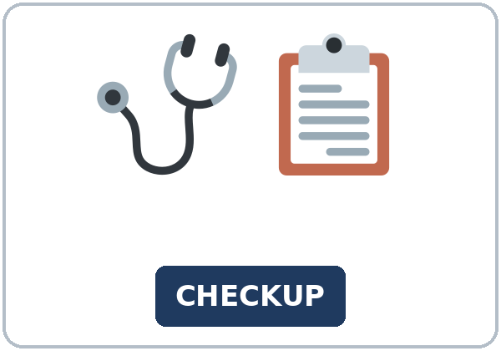  ★ checkup | 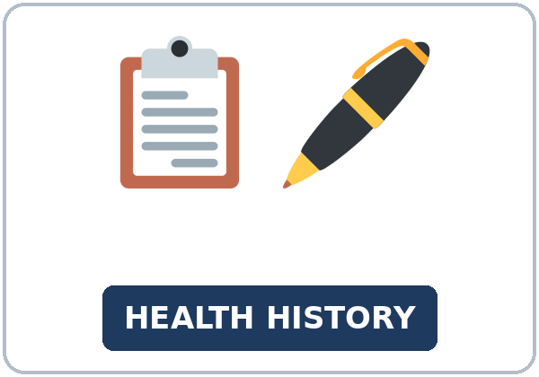  ★ health history | 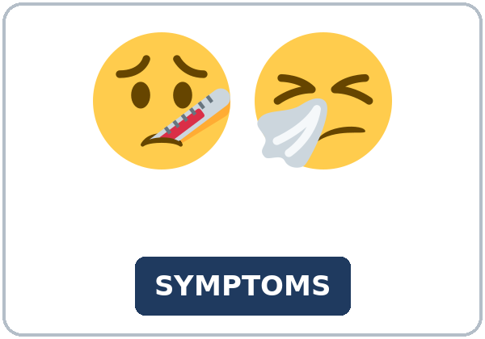  ★ symptom | 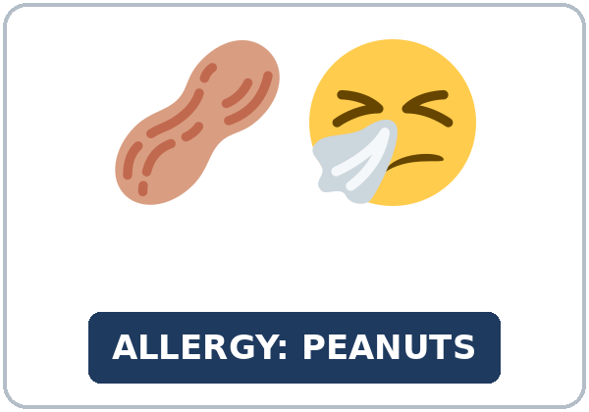  ★ allergy
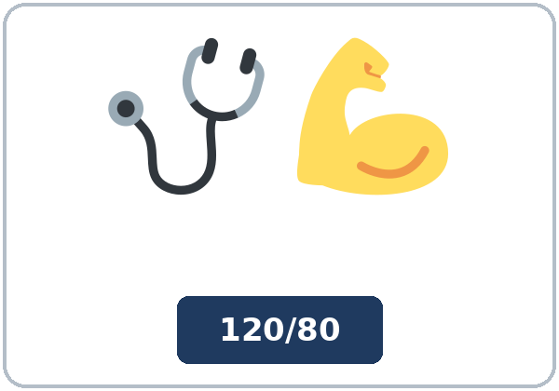  ★ blood pressure | 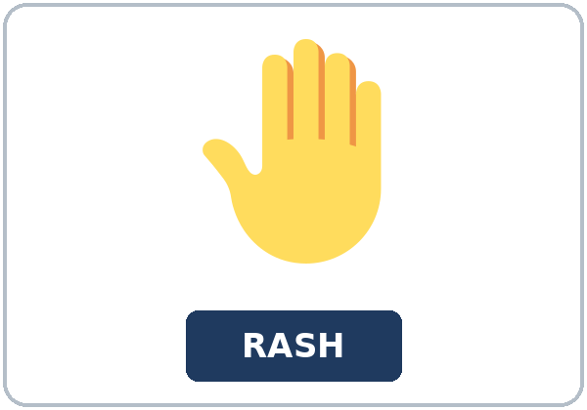  ★ rash | 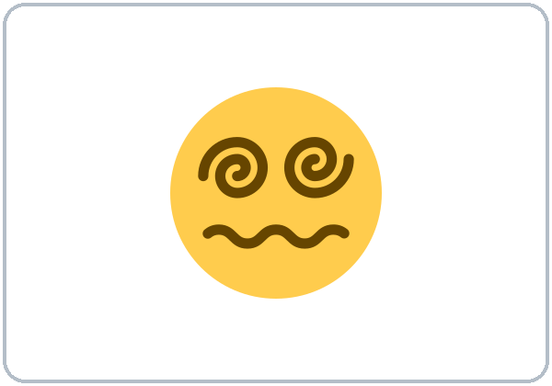  ★ dizzy | 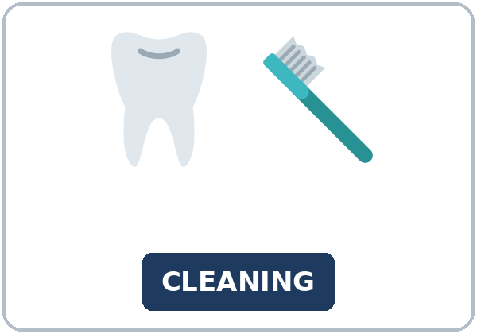  ★ teeth cleaning
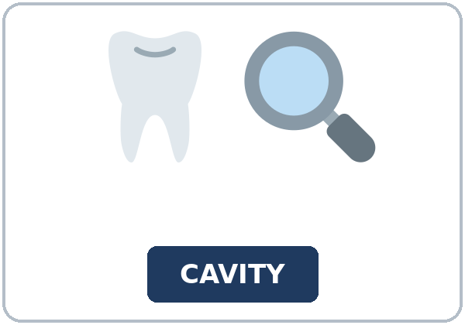  ★ cavity |   ★ flu shot | 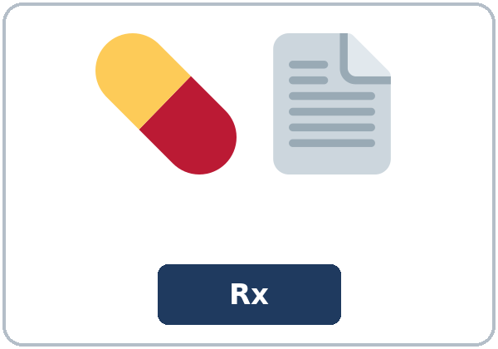  ★ prescription |   copay

Partner game: Symptom or suggestion?
Example: A points to a picture and says a problem, for example, "I've had a rash since Monday." B gives a suggestion: "Why don't you call the clinic?" Switch.
Lesson 4 (Week 4) · My Words
My personal word list. Write each word in your language, if you want. Then write your own example.
Word | My language | My example
checkup
health history
symptom
allergy
blood pressure
rash
dizzy
teeth cleaning
cavity
flu shot
prescription
copay

Add 2 more words from tonight (from the listening, the reading, or your partner).
Lesson 4 (Week 4) · Listening
Amina is at a clinic for back pain. First, Daniel, the medical assistant, asks her health history questions. Then, at checkout, she talks to Ms. Park, the receptionist.
A. Listen. Why is Amina at the clinic? Circle.
a. for a flu shot b. for back pain c. for a teeth cleaning
B. Listen again. Complete Amina's form. Circle the answer.
1. Symptom: (a rash / back pain / a cough)
2. How long? (two days / about two weeks / since January)
3. Back problems before? (yes / no)
4. Allergy: (peanuts / penicillin / none)
5. Dizzy? (yes / no)
6. Copay today: ($10 / $20 / $40)
C. Listen again. Write for, since, or ever.
1. I've had it ____________ about two weeks.
2. Have you ____________ had back problems before?
3. Have you ____________ had surgery?
4. I've had it ____________ January.
5. Also, you haven't had a teeth cleaning ____________ a year
6. and you haven't had a checkup ____________ last spring.
Hear it, say it
gonna = going to: "The doctor's going to see you in a few minutes." • wanna = want to: "I want to make an appointment." You can say going to and want to. Say Why don't you…? as one smooth group, with your voice going down at the end: it's a suggestion, not a real question. Stress: I've had a RASH since MONday.
Lesson 4 (Week 4) · Grammar
Read across. A reads from the left side. B answers from the right side. Choose one part from each column.
Grammar Box 1: How long…? / Have you ever…?
QUESTION |  |  | ANSWER
How long have you | had this rash? |  | I've had it | for three days.
How long have you | had this rash? |  | I've had it | since Monday.
How long has your back | hurt? |  | It's hurt | for about two weeks.
Have you ever | had surgery? |  | No, never.  Yes, I have. | I had knee surgery in 2018.
Have you | tried anything for it? |  | Yes, I have. | I've used a heating pad.

Grammar Box 2: a problem → a suggestion
PROBLEM |  |  | SUGGESTION
My back hurts. | What can I do? |  | Why don't you | call the clinic?
I sit all day at work. | Any ideas? |  | You could | take a short walk at lunch.
I haven't had a checkup | for two years. |  | It's a good idea to | get one every year.
My tooth has hurt | since Friday. |  | You should | see a dentist soon.

Rule of thumb: Use have / has + past participle + for / since for a problem that started in the past and is still true. After Why don't you, You could, It's a good idea to, and should, use the base verb (call, try, get).
Grammar Box 3: how to say a symptom
SAY | EXAMPLES
I have / I've had + a noun | a rash, a cough, a backache, a sore throat → I've had a cough since Sunday.
My ___ hurts / has hurt | My back hurts. My tooth has hurt for a week.
I feel / I've felt + a word | dizzy, tired → I've felt tired for three days.

Grammar Box 4: strong or soft?
 | HOW STRONG? | EXAMPLE
You should… | strong advice | You should see a doctor.
It's a good idea to… | a general idea (good for everyone) | It's a good idea to get a flu shot every year.
Why don't you…? / You could… | a soft idea; the person chooses | Why don't you try a heating pad? You could stretch.

Questions and answers
Q: Can I say I have a rash since Monday?
A: No. It started in the past and is still true: I've had a rash since Monday.
Q: Is Why don't you call the clinic? a real question?
A: No. It's a suggestion. Answer: Good idea. / Thanks, I will. Your voice goes down at the end.
Q: You could to try or You could try?
A: After could, use the base verb: You could try a heating pad.
Practice A: Write the correct form of the verb.
1. How long have you ____________ the cough? (have)
2. Why don't you ____________ the clinic? (call)
3. I've ____________ dizzy since this morning. (feel)
4. You could ____________ some easy stretches. (try)
5. It's a good idea to ____________ a flu shot every year. (get)
6. Have you ever ____________ surgery? (have)
Practice B: Circle the correct words.
1. I ('ve had / have) a rash since Saturday.
2. You could (try / to try) a heating pad.
3. (Why don't you / Why you don't) call the dentist?
4. My tooth has hurt (for / since) a week.
5. I (had / 've had) knee surgery in 2018.
6. It's a good idea (to get / get) a checkup.
Common mistakes
✗ Don't say | ✓ Say
I have a rash since Monday. | I've had a rash since Monday.
You could to call the clinic. | You could call the clinic.
Why you don't try a heating pad? | Why don't you try a heating pad?
It's a good idea get a checkup. | It's a good idea to get a checkup.
I've had surgery in 2018. | I had surgery in 2018.

Contrast tip (optional): Spanish ¿Por qué no llamas a la clínica? = Why don't you call the clinic? It's a suggestion, not a real question, in Spanish and in English. But Spanish Tengo un sarpullido desde el lunes is I've had a rash since Monday in English, not I have. What does your language do?

Lesson 4 (Week 4) · Talk Time: Clinic Intake
Round 1. Sit back to back. A is the medical assistant and asks the questions. B is the patient: choose a symptom card and answer. A writes short notes. Then switch, with a new card.
SYMPTOM CARDS (invented)
1. a rash on your arm, for 3 days | 2. a backache, since Saturday
3. a sensitive tooth, for a week | 4. a cough, since Sunday

HEALTH HISTORY FORM | Notes
1. What brings you in today?
2. How long have you had it?
3. Have you ever had this before?
4. Have you tried anything for it?
5. Do you have any allergies?
6. Have you ever had surgery?
7. Have you had a flu shot this year?
8. When was your last checkup?

Example: A: What brings you in today? B: I have a rash on my arm. A: How long have you had it? B: I've had it for three days. A: Have you ever had this before? B: No, never.
Useful (medical assistant): I'm sorry to hear that. • I'll write that down. • The doctor's going to see you soon.
Lesson 4 (Week 4) · Talk Time: Good Idea Circle
Round 2. Work in a circle. One person reads a problem card. The next two people each give a suggestion. The first person chooses one and says why. Then the next person reads a card.
PROBLEM CARDS
1. I sit all day at work. | 2. I haven't had a checkup for two years.
3. My tooth has hurt since Friday. | 4. I feel tired every afternoon.
5. I've had a cough for a week. | 6. I want to get a flu shot. Where?
7. My back hurts after work. | 8. I don't understand my insurance card.

Suggest: Why don't you…? • You could… • It's a good idea to…
Choose: Good idea. I'm going to… because… • Thanks. I like that idea because…
Example: A: I sit all day at work. B: Why don't you take a short walk at lunch? C: You could stand up every hour. A: Good idea. I'm going to walk at lunch because I like being outside.
My problem card and the idea I chose (and why)

Remember: for a real health question, ask your doctor or pharmacist. In an emergency, call 911.
Lesson 4 (Week 4) · Homework
Homework (about 15–20 minutes). Bring it next week!
1. Write the sentence. Use the words.
Example: I / have / a cough / ___ / Sunday → I've had a cough since Sunday.
1. she / have / a rash / ___ / three days → ______________________________________________
2. why / not / you / call / the dentist? → ______________________________________________
3. you / could / try / a heating pad → ______________________________________________
4. he / ever / have / surgery? → ______________________________________________
2. Finish your writing from Read & Write C (your email). Read it one more time. Check ✓ the list in D.
☐ I finished it. ☐ I checked it with the list.
3. Write 3 good ideas to stay healthy. Use It's a good idea to… / You could… / Why don't you…? and give a reason.
Good idea | Why?
1.
2.
3.

4. Review (Lesson 3). Write already, yet, or just.
1. I've ____________ made a dentist appointment. It's on Monday.
2. Have you had your flu shot ____________?
3. The clinic has ____________ called. They called a minute ago.
4. I haven't picked up my prescription ____________.
5. We've ____________ paid the copay. We paid it this morning.
Lesson 4 (Week 4) · Read & Write
A. Read the letter. Read fast first. Then read again and answer the questions.
LETTER · Riverside Family Clinic + an insurance card
Riverside Family Clinic • 410 Main Street • (555) 330-2100 • Dear Carmen Lopez,
Our records show that you have not had a yearly checkup since March 2025. It's a good idea to see your doctor once a year, even when you feel well. At a checkup, we check your blood pressure, update your health history, and answer your questions.
Stay healthy this year: ✓ Get a checkup every year. ✓ Get a teeth cleaning every six months. ✓ Get a flu shot every fall.
Please bring: your insurance card, a photo ID, and a list of any medicines you take.
Your copay: look at your insurance card. Your copay is the amount you pay at each visit. Some tests cost more if you have not paid your full deductible yet.
To make an appointment, call us. We are open Monday to Saturday, 8:00 a.m. to 6:00 p.m. Sincerely, Riverside Family Clinic
INSURANCE CARD (invented): BlueRiver Health Plan • Member: CARMEN LOPEZ • Member ID: BRH 448 2190 • Copay: Doctor $20 • Specialist $40 • Urgent care $50 • Deductible: $1,000

B. Answer the questions.
1. When did Carmen have her last checkup? ______________________________________________
2. How often is it a good idea to get a teeth cleaning? ______________________________________________
3. What three things should she bring? ______________________________________________
4. What is her copay for a doctor visit? ______________________________________________
5. How much is her deductible? ______________________________________________
C. Write an email to a friend (5–8 sentences). Your friend has had a backache for a week. Ask how long, give two suggestions with reasons, and say what to bring to the clinic.
Example: Hi, Rosa. I'm sorry your back hurts. How long have you had the pain? Why don't you call the clinic tomorrow? It's a good idea because a week is a long time. You could also try a heating pad, because it helps my back. Don't forget to bring your insurance card and a photo ID. Feel better soon! Marta
My email

D. Check your writing with a partner.
 | Yes | Not yet
It has 5–8 sentences. | ☐ | ☐
It has a question with How long…? | ☐ | ☐
It has two suggestions. | ☐ | ☐
It has a reason with because. | ☐ | ☐

Lesson 4 (Week 4) · Exit Ticket
Name: ______________________________ Date: ________________
Answer in 3 sentences. Give a reason. Then give this page to your teacher.
A friend has had a backache for a week. What do you say?
Sentence 1: ask how long (How long have you…?) • Sentence 2: a suggestion (Why don't you… / You could…) • Sentence 3: a reason, with because
My answer
1.
2.
3.

For the teacher | ✓ | almost | not yet
3 sentences, today's grammar, a reason | ☐ | ☐ | ☐

Lesson 4 (Week 4) · Task Words (optional)
This page is for you if you want it. You can skip it. Write each task word in your language, if you want.
Task word | What you do | My language
Listen. | Use your ears. Don't write yet.
Circle. | Draw a circle around the answer.
Check ✓. | Make a ✓ in the box.
Write. | Write words or sentences.
Number. | Write 1, 2, 3… to show the order.
Match. | Find the two parts that go together.
Work with a partner. | Work with one classmate.
Work in a group. | Work with 2 or 3 classmates.
Switch. | Change roles: A is B now.
Ask a follow-up question. | Ask one more question about the answer.
Give a reason. | Say why, with because or so.
Compare. | Look at your partner's answers. Are they the same?

Picture Credits
Pictures use Twemoji graphics by Twitter, Inc. and other contributors (https://github.com/jdecked/twemoji), licensed under CC BY 4.0 (https://creativecommons.org/licenses/by/4.0/). The graphics were resized and combined, and signs and labels were added. The file-by-file list is in images/CREDITS.md.
Listening audio: synthetic voices made with Chatterbox TTS (Resemble AI, MIT License), cloned from synthetic reference clips made with Kokoro-82M (Apache License 2.0). No recordings of real people were used. Each file carries an inaudible Perth watermark marking it as AI-generated. The names and the story are invented.
Course materials: © 2026 the authors, licensed under CC BY-NC-SA 4.0 (https://creativecommons.org/licenses/by-nc-sa/4.0/).

