Level 3 Adult ESL Curriculum · Lesson 1 (Week 1): Tell Me More
Status: Complete sample lesson (all 13 Level 3 lessons are published).
Date: October 2026
Audience: Program coordinators and volunteer teachers
Companion files: audio/L3_L1_listening.mp3, images/ (12 vocabulary pictures + images/CREDITS.md)
Topic: the first night of Level 3: getting to know classmates beyond the basics, and keeping a conversation going with follow-up questions, reasons (because), and results (so).

How this sample is organized
Part | What's inside | Who uses it
Teacher Plan | At a glance, clock-time plan, step-by-step boxes, listening script, answer key, baseline checklist, teacher notes | Volunteer teachers
Student Pages | Task Words, How Our Class Works, New Words, Listening, Grammar, Talk Time, Homework, Read & Write, Progress Check. Print this part for learners | Learners
Picture Credits | Picture, audio, and license credits | Coordinators

What Lesson 1 builds on (from Level 2) and what it adds
From Level 2 (review only) | Where in Level 2 | New in Level 3 Lesson 1
Do you…? Does he…? and Wh- question order | Lessons 1–2 | Follow-up questions: Really? Why? What happened? How was it? What about you?
Did you…? and the simple past | Lessons 5–6 | Why did you…? → Because…
be going to | Lesson 11 | Mixed-tense conversation: present, past, and future in one chat
because (modeled, not taught) | Lesson 3 Four Corners | because (reason) and so (result), taught and practiced
A 1-minute talk | Lesson 13 | Three-sentence answers with a reason

TEACHER PLAN
Lesson 1 (Week 1)

Tell Me More
At a glance · Clock-time plan · Step by step · Script and answer key

How to Use This Plan
You don't need to speak Spanish or any other language. Teach in English. Show, point, and gesture. Each Grammar page has one short Spanish note and one tip for speakers of other languages. Learners read them on their own. You never need to read, translate, or explain them.

Instructions: use the same short task words every week: Listen. Circle. Check. Write. Work with a partner. Work in a group. Ask a follow-up question. The first student page lists them with a Spanish column and a "My language" column, so learners can look them up.

Instruction rule: Model it (do it with one learner while everyone watches), check it (ask: "Do you write or speak? How many questions?"), then go. Say less, show more.

Grouping toolkit: Pairs: turn to a neighbor; with an odd number, make one group of 3. Groups: 3–4 learners. Inside–outside circles: the inner circle faces out, the outer circle faces in; the outer circle moves one person to the right each round. Mingle: everyone stands and talks to many classmates. The teacher joins a pair only if one learner is left over.

When a learner is stuck or speaks another language to you: (1) show it: the picture, a gesture, or the board; (2) give one more short English example; (3) point to the grammar box on their page; (4) a classmate can help for a few seconds, then back to English. You don't need to understand what classmates say to each other.

Lesson 1 (Week 1): Tell Me More
At a glance
Objectives: learners can…
• ask and answer questions about the present, the past, and the future in one conversation (review)
• ask follow-up questions: Really? Why? What happened? How was it? What about you?
• give a reason with because (I take the bus because it's cheap)
• say a result with so (My car broke down, so I took the bus)
• read a community center flyer and write 3 sentences about a classmate

Materials
• name tags and markers
• Student Pages for Lesson 1 (print for the number expected + 3 spares)
• Talk Time question cards: cut up the cards on the Talk Time page (1 set per pair, or one set for each circle)
• baseline snapshot checklist (after the answer key)
• phone + small speaker, L3_L1_listening.mp3
• Prep time: 25 min.

Key vocabulary (with pictures on the New Words page)
★ neighbor • ★ coworker • ★ small talk • ★ follow-up question • ★ reason • ★ good news • ★ bad news • ★ chat • ★ introduce • community center • volunteer • get along

Clock-time plan
Times are loose. If a step runs long, take time from Read & Write first, then from Talk Time.
Time | Step | Min | Grouping (15 / 7–8) | If running behind
6:00–6:10 | Welcome + "One Question, One Follow-Up" (Week 1 opening) | 10 | Pairs (7 pairs + 1 trio / 3–4 pairs) | One round only
6:10–6:15 | Orientation: How Our Class Works + Task Words | 5 | Whole class | Show the times and say the 3 rules only
6:15–6:22 | New Words (picture page) + pair game | 7 | Pairs | Teach the ★ words only
6:22–6:34 | Listening: play 1 (Task A), play 2 (Tasks B and C) + "Say it" | 12 | Individuals, then pairs check | Do Task C together on the board
6:34–6:45 | Grammar Q&A: follow-ups, because, so + pair drill | 11 | Whole class, then pairs | Skip the pair drill; Talk Time practices it
6:45–7:00 | BREAK | 15
7:00–7:12 | Talk Time: The Three-Question Rule + baseline snapshot | 12 | Two circles / one circle | Two rounds only
7:12–7:17 | Exit Ticket + Homework | 5 | Individuals | Never skip
7:17–7:25 | Read & Write: community center flyer + 3 sentences | 8 | Individuals, then pairs | Reading questions only; writing becomes homework
7:25–7:30 | Progress Check (first can-do self-check) | 5 | Individuals | Do it in Week 2 at 6:00, while people arrive

Skip order if you're running behind: (1) the Read & Write writing task (it becomes homework); (2) the pair drill at the end of Grammar; (3) half of Talk Time. Never skip: the listening tasks, the grammar boxes and the mistakes table, and the exit ticket.

Attendance (15 → 7–8): every step lists both sizes. With 5 or fewer, sit at one table: pair work stays in pairs, and circles become "rotate seats." Late arrivals join any pair or circle right away.

Step by step
Step 1 · 6:00–6:10 · Welcome + "One Question, One Follow-Up" · 10 min
• Grouping: pairs. 15 learners: 7 pairs + 1 group of 3. 7–8 learners: 3–4 pairs. Learners write a first name on a name tag.
• Before class: write on the board: What did you do last weekend? → Really? How was it?
• Model with one learner: ask, "What did you do last weekend?" The learner answers. Then say, "Really? How was it?" Point to the second question on the board and say, "This is a follow-up question. It asks for more."
• Do (round 1, 4 min): A asks one question from the board, B answers, A asks one follow-up. Switch.
• Round 2 (4 min): new partner. Add a second question to the board: What are you going to do this weekend? → Why?
• Late arrivals: join any pair as a group of 3.
• If behind: one round only.

Step 2 · 6:10–6:15 · Orientation: How Our Class Works · 5 min
• Grouping: whole class. Open the Student Pages to How Our Class Works.
• Show the times: class 6:00, break 6:45, back 7:00, end 7:30.
• The 3 rules (say and show): (1) "English in class. A classmate can help you for a few seconds. Then back to English." (2) "Homework every week. About 15 minutes." (3) "Phones are OK for the audio and a dictionary."
• Task Words page: point to it. Say: "These are the words for our tasks. You can write them in your language here," and point to the My language column. No one has to.
• Also say: "In this class, we don't give one-word answers. We give a reason, and we ask a question back."
• If behind: show the times and say the 3 rules only.

Step 3 · 6:15–6:22 · New Words · 7 min
• Grouping: whole class, then pairs. Show the New Words page.
• Do: point to each picture and say the word. Learners repeat once. Act out small talk (say "Nice day, isn't it?" to a learner), introduce (introduce one learner to another: "Rosa, this is Ana"), and get along (smile and shake hands with a learner).
• Check meaning (1 min): ask, "Is your coworker at home or at work?" (at work) • "Is a new job good news or bad news?" (good news) • "Does a volunteer get money?" (no)
• Pairs (2 min): A says a word; B points to the picture and makes a short sentence (My neighbor is friendly.). Switch.
• My language column: learners may write each word in their language at home. Don't spend class time on it.
• If behind: teach the ★ words only.

Step 4 · 6:22–6:34 · Listening + "Say it" · 12 min
• Grouping: individuals, then pairs check.
• Before you listen (1 min): say: "This is Elena. This is David. They're neighbors. They're at the laundromat. One person has good news. One person has bad news."
• Play 1 → Task A (who has good news, who has bad news). Pairs compare. Check together.
• Read Tasks B and C together (1 min) so learners know what to listen for.
• Play 2 → Tasks B and C. Pairs compare. Then show the answers (answer key).
• "Say it" (2 min): read 2 lines: "Really? Why?" and "What about you? How was your week?" The class repeats each line twice. Make Really? go up and sound interested.
• The audio plays the conversation once (about 1:31). Press play again for play 2. A third play is fine if the class needs it.
• If behind: do Task C together on the board, reading the lines yourself.

Step 5 · 6:34–6:45 · Grammar Q&A · 11 min
• Grouping: whole class, then pairs. Show the Grammar page. The left side is the question (or what someone says). The right side is the answer (or the follow-up).
• Box 1 (review, 2 min): you read a question; the class answers from the right side. Point to the time words: on weekends (present), last weekend (past), this weekend (future). Don't re-teach; Level 2 taught these.
• Box 2 (3 min): read a sentence from the left; the class reads a follow-up from the right. Then say your own news ("I have a new cat!") and wait for follow-ups.
• Boxes 3 and 4 (3 min): write on the board: because + reason and so + result. Read one row from each box. Ask: "My car broke down. Is that the reason or the result?" (reason) "I took the bus." (result).
• Check questions: "I stayed home ___ I was sick." (because) • "I was sick, ___ I stayed home." (so) • "Why ___ you take the bus?" (do)
• Pair drill (last 3 min): A asks a Why…? question; B answers with because; A asks one follow-up. Switch.
• If behind: skip the pair drill. Talk Time practices it.

Break · 6:45–7:00 · 15 min
• Cut up or lay out the Talk Time question cards. Write on the board: Really? Why? What happened? How was it? What about you?

Step 6 · 7:00–7:12 · Talk Time: The Three-Question Rule · 12 min
• Grouping: inside–outside circles. 15 learners: two circles of 7–8 (the teacher or one trio fills a gap). 7–8 learners: one circle. 5 or fewer: sit at one table and rotate seats.
• The rule: the inner circle has a question card. A asks the card question. B answers. A must ask two follow-up questions. B must use because or so at least once. Then switch roles, and the outer circle moves one person to the right.
• Model with one learner (1 min): "What do you do on weekends?" → "I play soccer." → "Really? Where?" → "In the park, because it's free." → "Who do you play with?"
• Do: 3–4 rounds of about 2 minutes each. Learners write one answer on their Talk Time page after each round.
• Baseline snapshot: while learners talk, the teacher (or a second volunteer) calls about 5 learners, one at a time, for 2 minutes and uses the checklist after the answer key. Do the rest in Weeks 2 and 3.
• If behind: two rounds only.

Step 7 · 7:12–7:17 · Exit Ticket + Homework · 5 min · NEVER SKIP
• Exit ticket: each learner writes two sentences on a slip: one about a classmate (Rosa takes the bus because she doesn't have a car.) and one with so. Collect at the door.
• Homework: open the Homework page. Do item 1 together. Say: "About 15 minutes. Bring it next week."

Read & Write · 7:17–7:25 · A Community Center Flyer · 8 min
• Grouping: individuals, then pairs check.
• Read (3 min): learners read the flyer on the Read & Write page on their own and answer questions 1–5. Say: "Read fast first. Then find the answers."
• Pairs check (2 min): compare answers; check together.
• Write (3 min): learners write 3 sentences about a classmate from Talk Time, using the frame. One sentence needs because.
• If behind: questions 1–5 only; the writing becomes homework.

Progress Check · 7:25–7:30 · First can-do self-check · 5 min
• Grouping: individuals. Open the Progress Check page.
• Part A: read the 4 sentences in the answer key, slowly, 2 times each. Learners circle the best follow-up.
• Parts B and C: learners do them alone. Walk around and help with the instructions only.
• Part D: read each "I can…" line aloud and point to the 3 faces: 😀 "I can do it." 🙂 "With a little help." 😐 "Not yet."
• Collect the pages (or check them at the start of Week 2).
• If behind: do the Progress Check in Week 2 at 6:00, while learners arrive.

Listening script: L3_L1_listening.mp3 (about 1:31; the conversation plays once, so press play again for the second listen)
Audio: play from a phone + small speaker. No speaker? Read the script with a volunteer, at a normal, friendly speed.

Narrator: Lesson one. Listening. Elena and David are neighbors. It's Saturday morning, and they're at the laundromat. Listen.
Elena: Hi, David! How are you?
David: Hi, Elena. I'm OK, thanks. I'm just really tired.
Elena: Really? Why?
David: Because my car broke down on Tuesday.
Elena: Oh no! What happened?
David: It just stopped on the highway. Now it's at the mechanic, so I took the bus to work every day this week.
Elena: That's bad news. When is it going to be ready?
David: Maybe next Friday. What about you? How was your week?
Elena: It was great! I have good news. I got a new job.
David: That's wonderful! Where is it?
Elena: At the hospital on Pine Street. I'm going to work in the kitchen.
David: Do you like it?
Elena: Yes, I love it, because the people are really friendly.
David: How do you get there?
Elena: I walk. It's only ten minutes from my apartment, so I don't need a car.
David: Lucky you! I really need my car, because my job is far away.
Elena: Do you want a ride on Monday? I start at seven.
David: Thanks, but I start at six. I'm going to take the bus again.
Elena: OK. Good luck with your car!
David: Thanks. And congratulations on your new job!
Narrator: That's the end of the listening.

Answer key
• Listening Task A: 1 Elena, 2 David, 3 David, 4 Elena.
• Listening Task B: 1 T, 2 F (he took the bus), 3 T, 4 F (at a hospital), 5 T, 6 F (he starts at six).
• Listening Task C: 1 Because, 2 so, 3 because, 4 so, 5 because.
• Grammar practice (because or so): 1 because, 2 so, 3 because, 4 so, 5 because, 6 so.
• Read & Write: 1 Saturdays, 10:00–11:30 a.m. (Room 4) • 2 No. It's on Tuesdays and Thursdays. • 3 children (ages 6–12) • 4 set up chairs and welcome new families • 5 Sunday.
• Progress Check Part A (the teacher says, 2 times each): 1 "I'm really tired today." → a (Why?) • 2 "I went to a wedding on Saturday." → b (How was it?) • 3 "I have good news!" → a (Really? What is it?) • 4 "My phone is broken." → b (Oh no! What happened?)
• Progress Check Part B: 1 because, 2 so, 3 so, 4 because.
• Progress Check Part C: any good follow-up question, for example 1 Really? Where? / When do you start? 2 How was it? / Who did you go with?
• Progress Check scoring: A /4 + B /4 + C /2 = /10. This is not a test grade. It shows who needs more help with follow-ups (A, C) and with because / so (B).
Baseline snapshot checklist (Weeks 1–3)
Ask the 6 prompts, in this order. Check ✓ if the learner answers in a full sentence without help. Write ~ if they answer with help. Write + if they also add a reason or a detail. Leave it empty if not yet. The final exam uses the same prompts.
Learner | Tell me about your week. | What did you do last weekend? | What are you going to do next month? | Describe a friend. | What was your life like as a child? | What will you do if it rains on Saturday?

Prompts 4–6 use Lessons 2, 3, and 6 grammar. In Week 1, most learners can't answer them well yet. That is expected: they show growth at the final.
Teacher notes
• Privacy: learners choose what to share. Any answer can be invented. Never ask about immigration status, money, or a real address. "I don't want to say" is always OK, and so is changing the topic.
• Why follow-ups matter: at Level 2, learners answered questions. At Level 3, they keep the conversation going. Praise every follow-up you hear in Talk Time, even a simple Really?
• because vs. so: because comes before the reason; so comes before the result. A quick test: "Why?" is answered by the because part.
• Mixed levels: stronger learners ask three follow-ups instead of two and answer with two reasons. Learners who are new to the class use Box 2 on their page as a script.
• New learners who skipped Level 2: pair them with a returning learner in Step 1 and Talk Time. Check the placement questions in the scope and sequence (Section 2.1) after class.
• Typical mistakes this week: Because I was tired, so I stayed home (both words), Why you take the bus? (no do), What you did last weekend? (no did before the person), and one-word answers. Say the right form clearly; the learner repeats. Learners can read the Spanish note and the tip on their Grammar page themselves; you don't need to explain them.

STUDENT WORKBOOK
Lesson 1 (Week 1)

Tell Me More
Task Words · How Our Class Works · New Words · Listening · Grammar · Talk Time · Homework · Read & Write · Progress Check

Task Words
Name: ______________________________ Date: ________________
These words are in the instructions every week. Write them in your language, if you want.
English | Español | My language
Listen. | Escucha.
Listen again. | Escucha otra vez.
Read. | Lee.
Write. | Escribe.
Circle the answer. | Encierra la respuesta en un círculo.
Check ✓. | Marca ✓.
True or False | Verdadero o falso
Match. | Une.
Work with a partner. | Trabaja con un compañero.
Work in a group. | Trabaja en grupo.
Ask a follow-up question. | Haz una pregunta de seguimiento.
Give a reason. | Da una razón.
Homework | Tarea
★ = important word | ★ = palabra importante

How Our Class Works
Time | What
6:00–6:45 | Class
6:45–7:00 | Break
7:00–7:17 | Class: talk with classmates
7:17–7:30 | Read & Write

• English in class. A classmate can help you for a few seconds.
• Homework every week. It takes about 15 minutes.
• Phones are OK for the audio and a dictionary.
• In Level 3, don't stop at one word. Give a reason. Ask a question back.
Nota para hispanohablantes: Cada lección de gramática tiene una nota corta en español. En la página de palabras nuevas puedes escribir cada palabra en tu idioma. ¡Pero en clase, habla inglés!

For speakers of other languages: write the task words and the new words in your language in the My language columns. A classmate or a family member can help you at home.

Lesson 1 (Week 1): Tell Me More
Student Page 1 · Week 1
Name: ______________________________ Date: ________________
New Words
Look. Listen. Repeat. ★ = most important words.
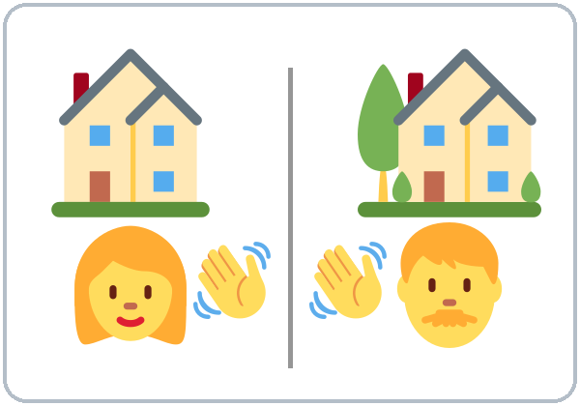  ★ neighbor | 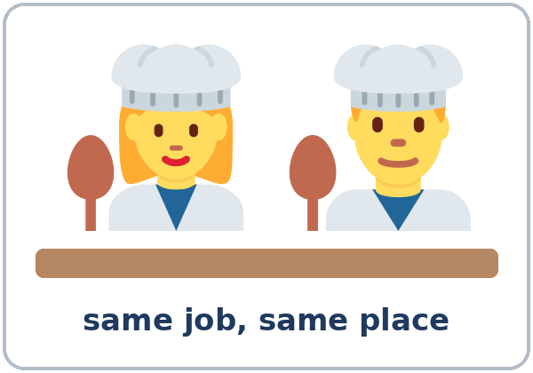  ★ coworker | 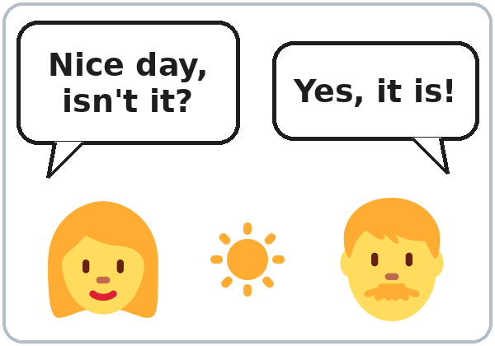  ★ small talk | 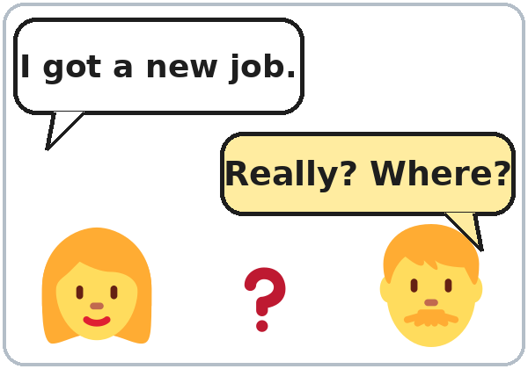  ★ follow-up question
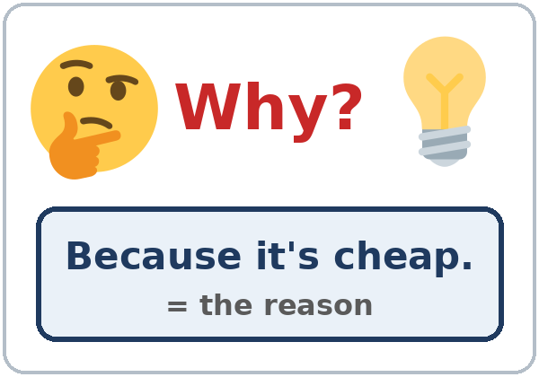  ★ reason |   ★ good news | 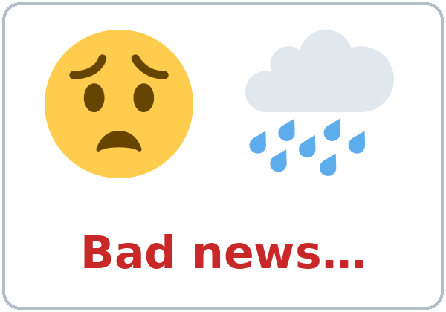  ★ bad news | 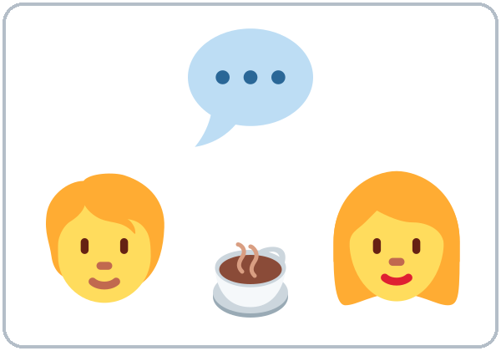  ★ chat
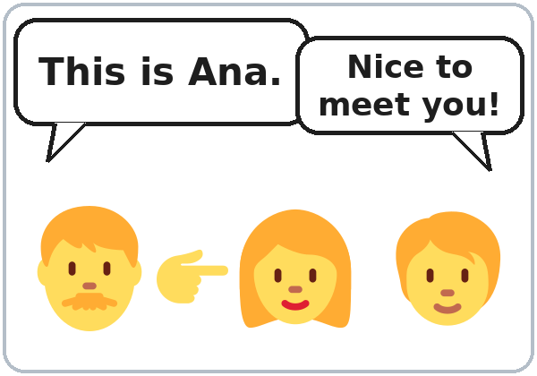  ★ introduce | 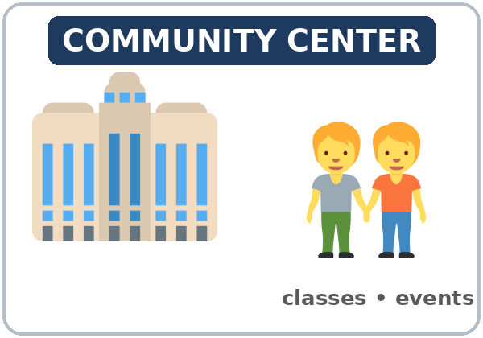  community center | 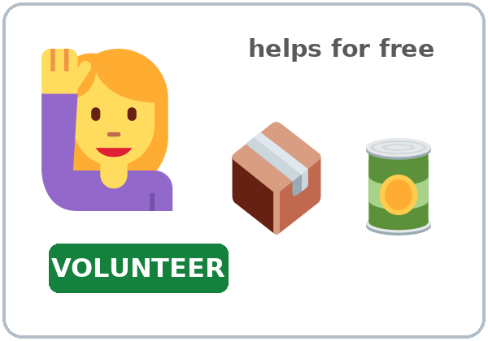  volunteer | 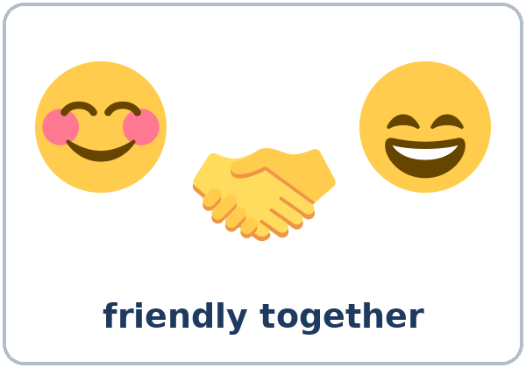  get along

Partner game: A says a word. B points and makes a sentence.
Example: A: coworker. B: (points) My coworker is very friendly.
Lesson 1 (Week 1) · My Words
Write each word in your language, if you want. Then write your own example.
Word | My language | My example
neighbor
coworker
small talk
follow-up question
reason
good news
bad news
chat
introduce
community center
volunteer
get along

Lesson 1 (Week 1) · Listening
Listen to Elena and David. They're neighbors. They're at the laundromat on Saturday morning.
A. Listen. Who is it? Check ✓ Elena or David.
 | Elena | David
1. has good news | ☐ | ☐
2. has bad news | ☐ | ☐
3. is very tired | ☐ | ☐
4. has a new job | ☐ | ☐

B. Listen again. Check ✓ True or False.
 | True | False
1. David's car broke down on Tuesday. | ☐ | ☐
2. David took a taxi to work this week. | ☐ | ☐
3. The car is maybe going to be ready next Friday. | ☐ | ☐
4. Elena's new job is at a school. | ☐ | ☐
5. Elena walks to work. | ☐ | ☐
6. David starts work at seven. | ☐ | ☐

C. Listen again. Write because or so.
1. Elena: Really? Why? David: ____________ my car broke down on Tuesday.
2. Now it's at the mechanic, ____________ I took the bus to work every day this week.
3. Yes, I love it, ____________ the people are really friendly.
4. It's only ten minutes from my apartment, ____________ I don't need a car.
5. I really need my car, ____________ my job is far away.
Say it: Really? Why? • What about you? How was your week?
Lesson 1 (Week 1) · Grammar
Read across. A reads from the left side. B answers from the right side. Choose one part from each column.
Grammar Box 1: Questions about now, the past, and the future (review)
QUESTION |  |  |  | ANSWER
What do | you | do on weekends? |  | I | usually | play soccer.  visit my family.
What did | you | do last weekend? |  | I | watched  cleaned | a movie.  the house.
What are | you | going to do this weekend? |  | I'm | going to | rest.  cook for my family.

Grammar Box 2: Follow-up questions
SOMEONE SAYS |  | YOU ASK A FOLLOW-UP QUESTION
I got a new job. |  | Really? Where?  That's great! When do you start?
My car broke down. |  | Oh no! What happened?  Where is it now?
I went to a party. |  | How was it?  Who did you go with?
I'm really tired today. |  | Why?  Are you OK?
I like my neighborhood. |  | Why?  What do you like about it?
My week was busy. How was your week? |  | It was good, thanks.  What about you?

Grammar Box 3: Why…? → Because… (the reason)
QUESTION |  |  |  | ANSWER
Why do | you | take the bus? |  | Because | it's cheap.  I don't have a car.
Why does | she | like her job? |  | Because | the people are friendly.  it's near her home.
Why did | you | stay home? |  | Because | I was tired.  it was cold.

Grammar Box 4: …, so… (the result)
THE REASON |  | THE RESULT
My car broke down, |  | so I took the bus.
It's only ten minutes away, |  | so I walk.
I was tired, |  | so I stayed home.
My job is far away, |  | so I need a car.

Questions and answers
Q: What is a follow-up question?
A: A second question about the same topic. It shows you are listening and keeps the conversation going. I got a new job. → Really? Where?
Q: When do I use because?
A: Before the reason. I take the bus because it's cheap. The because part answers Why?
Q: When do I use so?
A: Before the result. It's cheap, so I take the bus. Put a comma before so.
Q: Can I use because and so in the same sentence?
A: No. Use one. ✓ I was tired, so I stayed home. ✓ I stayed home because I was tired.
Q: Can I start an answer with Because?
A: Yes, in a conversation, after Why?: Why? → Because I was tired. In writing, join it to the other sentence: I stayed home because I was tired.
Q: How do I ask the question back?
A: What about you? or And you? My week was busy. What about you?
Practice: Write because or so.
1. I'm learning English ____________ I want a better job.
2. It was raining, ____________ I took an umbrella.
3. She likes her neighbors ____________ they are very friendly.
4. The store was closed, ____________ we went home.
5. He drinks coffee every morning ____________ he starts work at 6:00.
6. My coworker was sick, ____________ I worked late.
Common mistakes
✗ Don't say | ✓ Say
Because I was tired, so I stayed home. | I was tired, so I stayed home. / I stayed home because I was tired.
Why you take the bus? | Why do you take the bus?
What you did last weekend? | What did you do last weekend?
Because of it's cheap. | Because it's cheap.
I going to rest. | I'm going to rest.
(one word) "Good." | "Good, thanks. I played soccer. What about you?"

Nota para hispanohablantes: En inglés, Why? (¿Por qué?) y because (porque) son dos palabras diferentes. So aquí significa «así que» o «por eso». No uses because y so en la misma oración: «Because I was tired, so I stayed home» está mal. Di: I was tired, so I stayed home. Y no olvides do / did en las preguntas: Why do you…? What did you…?

Tip for speakers of other languages: In English, a one-word answer can sound unfriendly or bored. Add a reason (because…) or ask a question back (What about you?).

Lesson 1 (Week 1) · Talk Time: The Three-Question Rule
Work with a partner. A asks the card question. B answers. A asks two follow-up questions. Then switch.
A: What do you do on weekends? B: I play soccer.
A: Really? Where? B: In the park, because it's free.
A: Who do you play with? B: My brother and his friends. What about you?
Follow-ups: Really? Why? What happened? How was it? Where? When? Who with? What about you?

Question cards (cut out)
What do you do on weekends? | What did you do last weekend?
What are you going to do this weekend? | Where do you buy food? Why?
What's your favorite day of the week? Why? | How do you get to class?
What did you eat for dinner yesterday? | What are you going to do after class?

Write one answer from each partner.
Partner's name | Question | Answer + reason (because… / so…)

Lesson 1 (Week 1) · Homework
Homework (about 15 minutes). Bring it next week!
1. Answer the questions. Give a reason with because.
1. Why are you learning English? ______________________________________________
2. Why do you like (or not like) your neighborhood? ______________________________________________
3. Why did you choose this class? ______________________________________________
2. Ask a friend, a family member, or a coworker 2 questions. Ask one follow-up question each time. Write the answers.
My question | Follow-up question | Answer

3. Write one sentence with so.
1. My car broke down. I took the bus. → ______________________________________________
2. It was hot. We went to the park. → ______________________________________________
3. I was hungry. I made a sandwich. → ______________________________________________
4. Review (Level 2): What did you do last weekend? Write 2 sentences.
______________________________________________________________
______________________________________________________________
Lesson 1 (Week 1) · Read & Write
A. Read the flyer.
MAPLE STREET COMMUNITY CENTER
English Conversation Club. Saturdays, 10:00–11:30 a.m., Room 4. Practice speaking with your neighbors. All levels are welcome. It's free!
Computer Basics. Tuesdays and Thursdays, 5:30–6:30 p.m. Learn to use email and fill out online forms. Bring your phone, or use our computers.
Homework Help for Kids. Monday to Thursday, 3:30–5:00 p.m., for children ages 6 to 12.
Volunteers needed! Can you help on Saturday mornings? We need people to set up chairs and welcome new families. Call 555-0137 or come to the front desk.
The center is closed on Sundays.

B. Answer the questions.
1. When is the English Conversation Club? ______________________________________________
2. Is Computer Basics on Monday? ______________________________________________
3. Who is Homework Help for? ______________________________________________
4. What do the volunteers do? ______________________________________________
5. What day is the center closed? ______________________________________________
C. Write 3 sentences about a classmate from Talk Time. Use because in one sentence.
Also use so in one sentence, if you can.
Example: My classmate's name is Rosa. On weekends, she visits her sister. She takes the bus because she doesn't have a car.
My classmate's name is ______________________________ .
______________________________________________________________
______________________________________________________________
______________________________________________________________
D. Check your writing with a partner.
 | Yes | Not yet
There are 3 sentences. | ☐ | ☐
One sentence has because. | ☐ | ☐
Each sentence starts with a capital letter and ends with a period. | ☐ | ☐

Lesson 1 (Week 1) · Progress Check
Name: ______________________________ Date: ________________
A. Listen to the teacher. Circle the best follow-up question.
1. a. Why? b. Where?
2. a. How old are you? b. How was it?
3. a. Really? What is it? b. Oh no! I'm sorry.
4. a. That's great! b. Oh no! What happened?
B. Write because or so.
1. I take the bus ____________ it's cheap.
2. It was cold, ____________ I wore a jacket.
3. My coworker was sick, ____________ I helped her.
4. We like this park ____________ it's quiet.
C. Write a follow-up question.
1. "I got a new job." → ______________________________________________
2. "I went to a party last night." → ______________________________________________
Score: A ______ / 4 B ______ / 4 C ______ / 2
D. How do you feel? Check ✓ one face for each line.
I can… | 😀 I can do it. | 🙂 With a little help. | 😐 Not yet.
I can ask a follow-up question. | ☐ | ☐ | ☐
I can give a reason with because. | ☐ | ☐ | ☐
I can say a result with so. | ☐ | ☐ | ☐
I can talk about my week, my past, and my plans. | ☐ | ☐ | ☐

Picture Credits
Vocabulary pictures use Twemoji graphics by Twitter, Inc. and other contributors (https://github.com/jdecked/twemoji), licensed under CC BY 4.0 (https://creativecommons.org/licenses/by/4.0/). The graphics were resized and combined, and speech bubbles, signs, and labels were added. The file-by-file list is in images/CREDITS.md.
Listening audio: synthetic voices made with Chatterbox TTS (Resemble AI, MIT License), cloned from synthetic reference clips made with Kokoro-82M (Apache License 2.0). No recordings of real people were used. Each file carries an inaudible Perth watermark marking it as AI-generated. The names and the story are invented.
Course materials: © 2026 the authors, licensed under CC BY-NC-SA 4.0 (https://creativecommons.org/licenses/by-nc-sa/4.0/).

