Level 3 Adult ESL Curriculum · Lesson 10 (Week 11): Step by Step
Status: Complete lesson (all 13 Level 3 lessons are published).
Date: October 2026
Audience: Program coordinators and volunteer teachers
Companion files: audio/L3_L10_listening.mp3, images/ (12 vocabulary pictures, 1 activity picture + images/CREDITS.md)
Topic: giving and following instructions at work, at home, and on a label: sequence words (first, next, then, after that, finally) with imperatives, Don't…, and How do I…? What do I do next?

How this lesson is organized
Part | What's inside | Who uses it
Teacher Plan | At a glance, clock-time plan, step-by-step boxes, listening script, answer key, teacher notes | Volunteer teachers
Student Pages | Opening Talk, New Words, My Words, Listening, Grammar, Talk Time, Homework, Read & Write, Progress Check. Print this part for learners | Learners
Picture Credits | Picture, audio, and license credits | Coordinators

What Lesson 10 builds on and what it adds
Before (review only) | Where | New in Level 3 Lesson 10
Imperatives: Open your book. Listen. | Level 1 | Instructions in order: First, put on your goggles. Then, fill the tank.
You have to / You need to | Level 2 | Brief review: You need to plug it in.
should / shouldn't | Level 2 Lesson 10 | Safety steps: Don't open the door. Don't forget to…
Times and numbers | Levels 1–2 | Reading a medicine label: every 8 hours, with food
good at / interested in + -ing | Level 3 Lesson 9 | Opening Talk and Homework review

TEACHER PLAN
Lesson 10 (Week 11)

Step by Step
At a glance · Clock-time plan · Step by step · Script and answer key

How to Use This Plan
You don't need to speak Spanish or any other language. Teach in English. Show, point, and gesture. Each Grammar page has one short Spanish note and one tip for speakers of other languages. Learners read them on their own. You never need to read, translate, or explain them.

Instructions: use the same short task words every week: Listen. Circle. Check. Write. Work with a partner. Work in a group. Ask a follow-up question. Learners have the Task Words page from Lesson 1.

Instruction rule: Model it (do it with one learner while everyone watches), check it (ask: "Do you write or speak? How many people do you talk to?"), then go. Say less, show more.

Grouping toolkit: Pairs: turn to a neighbor; with an odd number, make one group of 3. Groups: 3–4 learners. Inside–outside circles: the inner circle faces out, the outer circle faces in; the outer circle moves one person to the right each round. Mingle: everyone stands and talks to many classmates. The teacher joins a pair only if one learner is left over.

When a learner is stuck or speaks another language to you: (1) show it: the picture, a gesture, or the board; (2) give one more short English example; (3) point to the grammar box on their page; (4) a classmate can help for a few seconds, then back to English. You don't need to understand what classmates say to each other.

Lesson 10 (Week 11): Step by Step
At a glance
Objectives: learners can…
• give instructions in order with first, next, then, after that, finally
• follow spoken instructions and number the steps
• ask How do I…? What do I do next? What do I do after that?
• give a warning with Don't… and Don't forget to…
• read a medicine label (invented) and answer questions about it
• write 4 steps for a task they know

Materials
• Student Pages for Lesson 10 (print for the number expected + 3 spares)
• Talk Time: the four step strips (on the Talk Time page)
• phone + small speaker, L3_L10_listening.mp3
• optional: a phone charger and a cup, to show plug in and the steps of a task
• Prep time: 5 min.

Key vocabulary (with pictures on the New Words page)
★ instructions • ★ step • ★ press • ★ plug in • ★ turn on / turn off • ★ laundry • ★ detergent • ★ safety goggles • ★ label • ★ tablet (medicine) • ★ password • log in

Clock-time plan
Times are loose. If a step runs long, take time from Read & Write first, then from Talk Time.
Time | Step | Min | Grouping (15 / 7–8) | If running behind
6:00–6:10 | Opening Talk + Homework Check | 10 | Pairs (7 pairs + 1 trio / 3–4 pairs) | One card only
6:10–6:18 | New Words (picture page) + pair game | 8 | Whole class, then pairs | Teach the ★ words only
6:18–6:30 | Listening: play 1 (Task A), play 2 (Tasks B and C) + "Say it" | 12 | Individuals, then pairs check | Do Task C together on the board
6:30–6:45 | Grammar Q&A: sequence words + imperatives; Don't…; How do I…? + pair drill | 15 | Whole class, then pairs | Skip the pair drill; Talk Time practices it
6:45–7:00 | BREAK | 15
7:00–7:12 | Talk Time: Teach Me in Four Steps | 12 | Pairs (one learner teaches the group with 5 or fewer) | 2 strips only
7:12–7:17 | Exit Ticket + Homework | 5 | Individuals | Never skip
7:17–7:25 | Read & Write: a medicine label; write 4 steps | 8 | Individuals, then pairs | Reading questions only; the steps become homework
7:25–7:30 | Progress Check | 5 | Individuals | Do it in Week 12 at 6:00, while people arrive

Skip order if you're running behind: (1) the Read & Write writing task (it becomes homework); (2) the pair drill at the end of Grammar; (3) half of Talk Time (2 strips only). Never skip: the listening tasks, the grammar boxes and the mistakes table, and the exit ticket.

Attendance (15 → 7–8): every step lists both sizes. With 5 or fewer, sit at one table: one learner teaches a strip to the group, and the group mimes each step.

Step by step
Step 1 · 6:00–6:10 · Opening Talk + Homework Check · 10 min
• Grouping: pairs, the same partner for both parts. 15 learners: 7 pairs + 1 group of 3. 7–8 learners: 3–4 pairs.
• Before class: write on the board: I'm good at… / I'm interested in… / I don't mind… + -ing
• Opening Talk (6 min): learners open the Opening Talk page. A asks a card question; B answers with 2–3 sentences; A asks one follow-up. Switch after each card.
• Model with one learner: "What are you good at?" → (answer) → "Can you give me an example?"
• Homework Check (4 min): partners read their Lesson 9 Homework item 2 (Tell me about yourself) to each other. Walk around. Write 2 common errors on the board (often good at cook or interested on) and correct them together.
• Late arrivals: join any pair as a group of 3.
• If behind: one card only, then the homework check.

Step 2 · 6:10–6:18 · New Words · 8 min
• Grouping: whole class, then pairs. Show the New Words page.
• Do: point to each picture and say the word. Learners repeat once. Mime each action: press a button, plug in a cord, turn on a light, turn it off, put on safety goggles.
• Show step: count on your fingers: "Step 1, step 2, step 3."
• Check meaning (1 min): "You wash clothes with…?" (detergent) • "On a medicine bottle, you read the…?" (label) • "Before you log in, you type your…?" (password)
• Pairs (2 min): A says a word; B points to the picture and mimes it or makes a sentence (Press START.). Switch.
• If behind: teach the ★ words only.

Step 3 · 6:18–6:30 · Listening + "Say it" · 12 min
• Grouping: individuals, then pairs check.
• Before you listen (1 min): say: "Maria is a new worker at a supermarket. Her coworker Tom is teaching her to use a machine. What machine is it? Listen."
• Play 1 → Task A (what machine?). Pairs compare. Check together.
• Read Tasks B and C together (1 min) so learners know what to listen for.
• Play 2 → Tasks B and C. Pairs compare. Then show the answers (answer key).
• "Say it" (2 min): say: "For th in then and the, put your tongue between your teeth, and use your voice." Then third: the same tongue, no voice. Pause a little after each step. The class repeats each line in the box twice.
• The audio plays the conversation once (about 1:11). Press play again for play 2. A third play is fine if the class needs it.
• If behind: do Task C together on the board, reading the lines yourself.

Step 4 · 6:30–6:45 · Grammar Q&A · 15 min
• Grouping: whole class, then pairs. Show the Grammar page. The left side is the question. The right side is the answer.
• Show it (2 min): make a cup of tea in mime and say each step: "First, boil the water. Next, put the tea bag in the cup. Then, add the water. After that, wait 3 minutes. Finally, drink it!" Hold up one finger for each step.
• Boxes 1 and 2 (4 min): read a question from the left; the class answers from the right. Point out: no you and no -s in an instruction (Press START).
• Box 3 (2 min): warnings: Don't + verb, Don't forget to + verb.
• Box 4 (1 min): the five sequence words, in order. Say them; the class repeats.
• Check questions: "___, put on your goggles. (step 1)" (First) • "___, turn it off. (the last step)" (Finally) • "Don't ___ (open) the door." (open) • "How ___ I log in?" (do)
• Practice A and B (3 min): learners write, then pairs check. Go over the answers.
• Pair drill (last 2 min): A asks "How do I make rice?" (or tea, a sandwich). B answers with 3 steps and sequence words. Switch.
• If behind: skip the pair drill. Talk Time practices it.

Break · 6:45–7:00 · 15 min
• Write on the board: First, … Next, … Then, … After that, … Finally, … and How do I…? / What do I do next? / Don't forget to…

Step 5 · 7:00–7:12 · Talk Time: Teach Me in Four Steps · 12 min
• Grouping: pairs. 15 learners: 7 pairs + 1 trio. 7–8 learners: 3–4 pairs. 5 or fewer: one learner teaches a strip to the group, and the group mimes.
• How it works: the Talk Time page has 4 strips. In each strip, the 4 pictures (A–D) are not in order. A chooses a strip, finds the right order (writes it under the strip), and teaches B with sequence words: First, turn on the water. Next, use soap… B mimes each step and asks What do I do next? Then switch with a new strip.
• Model with one learner (1 min): strip 1: "First, turn on the water." (point to B) "Next, use soap." (D) … The learner mimes.
• Rounds (8 min): about 2 minutes per strip; each pair does all 4 strips if there is time. Walk around and listen for the sequence words.
• Finish (2 min): ask 2 pairs to teach one strip to the class.
• If behind: 2 strips only.

Step 6 · 7:12–7:17 · Exit Ticket + Homework · 5 min · NEVER SKIP
• Exit ticket: each learner writes two sentences on a slip: two steps for a task with sequence words (First, open the app. Then, type your password.), and one warning with Don't and a reason with because or so (Don't open the door, because the water is hot.). Collect at the door.
• Homework: open the Homework page. Do item 1 together (one sentence on the board). Say: "About 15 minutes. Bring it next week."

Read & Write · 7:17–7:25 · A Medicine Label and 4 Steps · 8 min
• Grouping: individuals, then pairs check.
• Say first: "This label is invented. It's for reading practice only. For real medicine, always ask a pharmacist or a doctor."
• Read (3 min): learners read the label and answer questions 1–5. Say: "Read fast first. Then find the answers."
• Pairs check (1 min): compare answers; check together.
• Write (4 min): learners write 4 steps for a task they know (making coffee, washing a car, sending a text) with sequence words and one Don't.
• If behind: questions 1–5 only; the steps become homework.

Progress Check · 7:25–7:30 · 5 min
• Grouping: individuals. Open the Progress Check page.
• Part A: read the 4 sentences in the answer key, slowly, 2 times each. Learners circle a or b.
• Parts B and C: learners do them alone. Walk around and help with the instructions only.
• Part D: read each "I can…" line aloud and point to the 3 faces: 😀 "I can do it." 🙂 "With a little help." 😐 "Not yet."
• Collect the pages (or check them at the start of Week 12).
• If behind: do the Progress Check in Week 12 at 6:00, while learners arrive.

Listening script: L3_L10_listening.mp3 (about 1:11; the conversation plays once, so press play again for the second listen)
Audio: play from a phone + small speaker. No speaker? Read the script with a volunteer, at a normal, friendly speed.

Narrator: Lesson ten. Listening. Maria is a new worker at a supermarket. Her coworker Tom is teaching her to use a machine. Listen.
Tom: Hi, Maria. Welcome to the team! Today I'm going to show you the floor cleaning machine. It's easy.
Maria: Great. How do I start?
Tom: First, put on your safety goggles. Then, fill the tank with water.
Maria: Why do I need goggles?
Tom: Because the detergent can hurt your eyes. Next, add one cup of detergent. Not more!
Maria: One cup. Got it. What do I do after that?
Tom: After that, plug it in and turn it on. A green light comes on.
Maria: And then I just push it?
Tom: Right. Push it slowly. Don't leave it alone when it's on.
Maria: What do I do when I finish?
Tom: Finally, turn it off, unplug it, and empty the tank.
Maria: Thanks, Tom. Can I try it now?
Tom: Sure. Press the start button, and let's go. I'll walk with you.
Narrator: That's the end of the listening.

Answer key
• Listening Task A: c (a floor cleaning machine).
• Listening Task B: put on safety goggles 1 • fill the tank with water 2 • add detergent 3 • plug it in and turn it on 4 • turn it off and empty the tank 5 • How much detergent? one cup • The light is green.
• Listening Task C: 1 First, 2 Then, 3 Next, 4 After that, 5 Finally.
• Grammar Practice A: 1 First, 2 Next, 3 Then, 4 After that, 5 Finally.
• Grammar Practice B: 1 Press, 2 Don't open, 3 do, 4 to take, 5 Turn off.
• Talk Time (the right order): strip 1 (washing hands) B, D, A, C • strip 2 (coffee) C, A, D, B • strip 3 (a photo) D, B, C, A • strip 4 (parking) A, D, B, C. The sentences learners say will vary.
• Homework 1: 1 Press START. 2 Don't open the door. 3 Plug in the machine. / Plug the machine in. 4 Don't forget to take your card. Homework 2, 3, and 4: answers will vary.
• Read & Write B: 1 1 tablet • 2 every 8 hours • 3 with food • 4 3 tablets • 5 ask a pharmacist or a doctor • Writing (C): answers will vary.
• Progress Check Part A (the teacher says, 2 times each): 1 "First, plug it in. Then, turn it on." → a • 2 "Don't open the door." → b • 3 "After that, press START." → a • 4 "Finally, take your card." → b
• Progress Check Part B: 1 First, 2 Press, 3 Don't, 4 Finally.
• Progress Check Part C: answers will vary; for example 1 First, open the app. Next, type your password. Then, press LOG IN. 2 Don't forget to take your receipt.
• Progress Check scoring: A /4 + B /4 + C /2 = /10. This is not a test grade. It shows who needs more help hearing the steps (A) and with the forms (B, C).
Teacher notes
• The medicine label is invented (important): it is for reading practice only. Tell learners to ask a pharmacist or a doctor about real medicine. Don't give medical advice, and don't ask learners about their own medicines.
• Instructions have no you and no -s: Press START (not You press START or Presses START). Negative: Don't + verb (Don't open).
• Sequence words: first (step 1), next / then / after that (the middle steps, in any order), finally (the last step). A comma after each one is fine but not important.
• Don't forget to… is a friendly reminder: Don't forget to take your card.
• Review: You have to / You need to also give instructions: You need to plug it in first. Accept it; don't teach it again.
• Typical mistakes this week: You press START, Presses START, No open the door, Don't forget take, Final, turn it off. Say the right form clearly; the learner repeats. Learners can read the Spanish note and the tip on their Grammar page themselves; you don't need to explain them.
• Mixed levels: stronger learners add a Don't… warning to each strip. Newer learners use Boxes 1 and 4 as a script.

STUDENT WORKBOOK
Lesson 10 (Week 11)

Step by Step
Opening Talk · New Words · Listening · Grammar · Talk Time · Homework · Read & Write · Progress Check

Lesson 10 (Week 11) · Opening Talk
Name: ______________________________ Date: ________________
Work with a partner. A asks a question. B answers with 2–3 sentences. A asks one follow-up question. Then switch.
What are you good at? Give an example. | What are you interested in learning?
What job do you enjoy (or would you enjoy)? Why? | What work don't you mind doing? What work do you hate?

Follow-ups: Can you give me an example? Why? Where did you learn that?
Homework check: read your Lesson 9 homework (item 2) to your partner. Your partner asks one question about it.
One strength of my partner | My question about it

Lesson 10 (Week 11): Step by Step
Student Page 1 · Week 11
Name: ______________________________ Date: ________________
New Words
Look. Listen. Repeat. ★ = most important words.
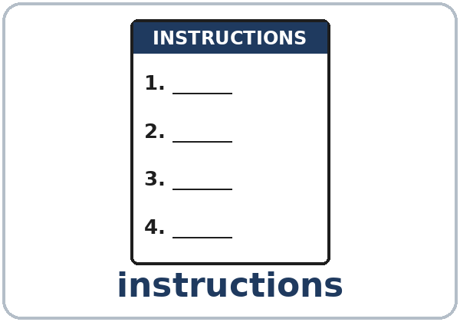  ★ instructions | 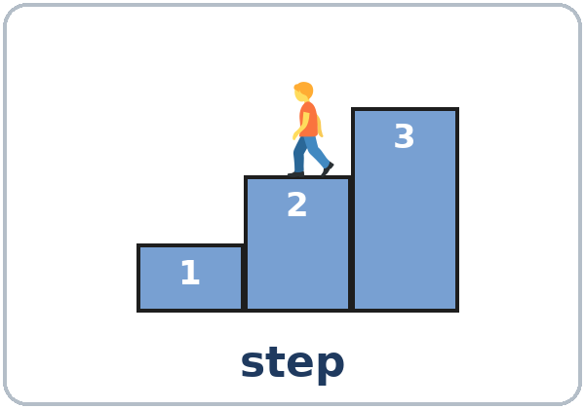  ★ step | 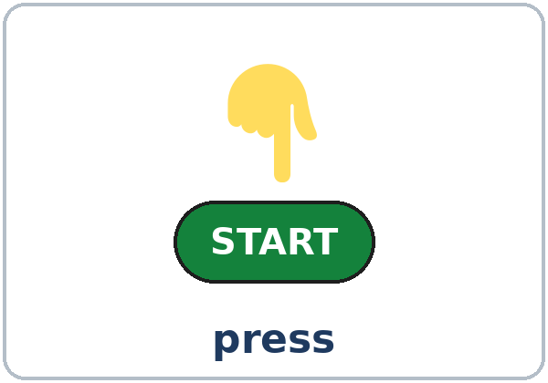  ★ press | 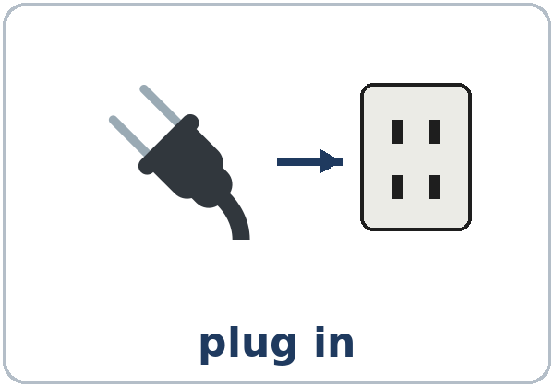  ★ plug in
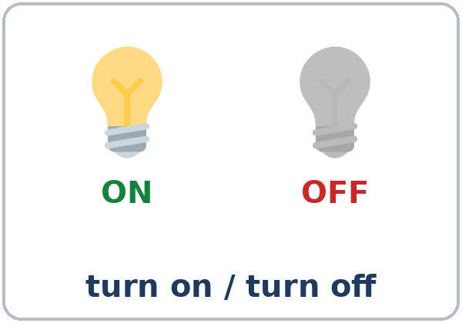  ★ turn on / turn off | 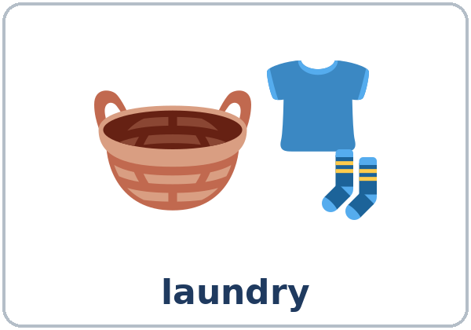  ★ laundry | 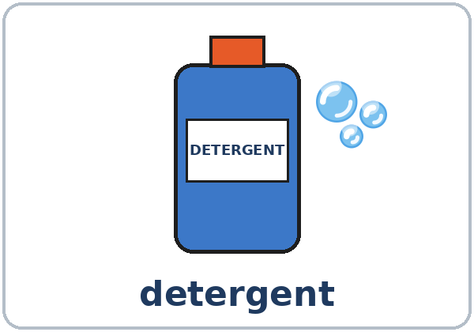  ★ detergent | 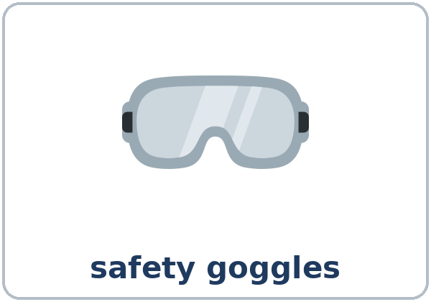  ★ safety goggles
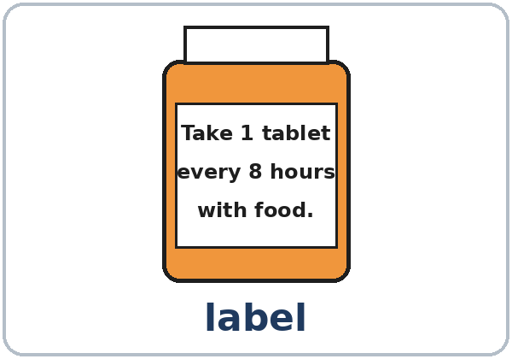  ★ label | 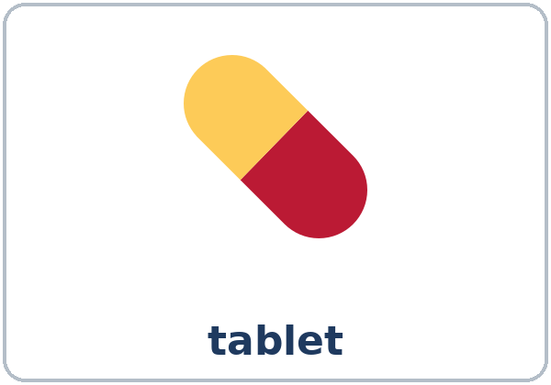  ★ tablet (medicine) | 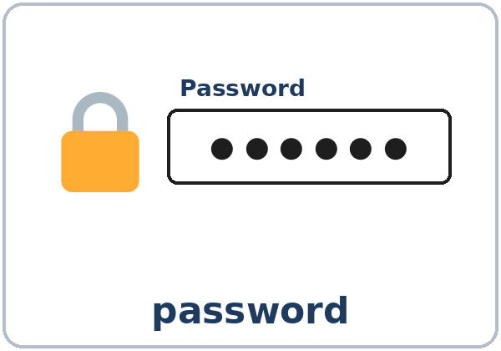  ★ password | 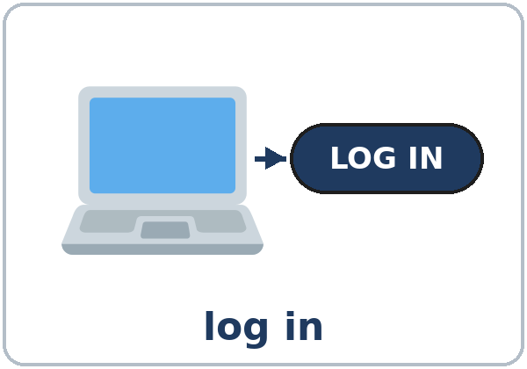  log in

Partner game: A says a word. B points and mimes it or makes a sentence.
Example: A: press. B: (points, mimes) Press START.
Lesson 10 (Week 11) · My Words
Write each word in your language, if you want. Then write your own example.
Word | My language | My example
instructions
step
press
plug in
turn on / turn off
laundry
detergent
safety goggles
label
tablet (medicine)
password
log in

Lesson 10 (Week 11) · Listening
Listen to Maria. She's a new worker at a supermarket. Her coworker Tom is teaching her to use a machine.
A. Listen. What machine is it? Circle.
a. a washing machine b. a coffee machine c. a floor cleaning machine
B. Listen again. Number the steps 1–5. Then circle.
Step | Number
add detergent | ____
put on safety goggles | ____
turn it off and empty the tank | ____
fill the tank with water | ____
plug it in and turn it on | ____

How much detergent? one cup / two cups The light is: red / green
C. Listen again. Write the sequence word.
1. ____________, put on your safety goggles.
2. ____________, fill the tank with water.
3. ____________, add one cup of detergent.
4. ____________, plug it in and turn it on.
5. ____________, turn it off, unplug it, and empty the tank.
Say it: Then, push it slowly. • The third step • First… (pause) Next… (pause) Then…
Lesson 10 (Week 11) · Grammar
Read across. A reads from the left side. B answers from the right side. Choose one part from each column.
Grammar Box 1: How do I…?
QUESTION |  |  | ANSWER
How do I | use this machine? |  | First, | put in the clothes.
How do I | use this machine? |  | Next, | add the detergent.
How do I | use this machine? |  | Then, | press START.
How do I | log in? |  | First, | type your password.

Grammar Box 2: What do I do next?
QUESTION |  |  | ANSWER
What do I do | next?  after that? |  | After that, | wait 30 minutes.
What do I do | at the end? |  | Finally, | take out the clothes.

Grammar Box 3: Don't…
QUESTION |  |  | ANSWER
Can I | open the door now? |  | No. Don't | open the door. It's hot.
Anything | else? |  | Don't forget to | take your card.

Grammar Box 4: Sequence words
STEP 1 | STEP 2 | STEP 3 | LAST STEP
First, … | Next, … | Then, … / After that, … | Finally, …
First, put on your goggles. | Next, fill the tank. | Then, plug it in. | Finally, turn it off.

Questions and answers
Q: Do I say you in an instruction?
A: No. Start with the verb: Press START. (not You press START)
Q: Press or Presses?
A: Press. Instructions have no -s: Turn it on. Add the soap.
Q: How do I say no in an instruction?
A: Don't + verb: Don't open the door. (not No open)
Q: Don't forget take or Don't forget to take?
A: Don't forget to take your card.
Q: Finally or Final?
A: Finally, for the last step: Finally, turn it off.
Practice A: Write First, Next, Then, After that, or Finally.
Making tea:
1. ____________, boil the water.
2. ____________, put a tea bag in the cup.
3. ____________, add the hot water.
4. ____________, wait 3 minutes.
5. ____________, take out the tea bag and drink it.
Practice B: Circle the right words.
1. (Press / You presses) the green button.
2. (No open / Don't open) the door.
3. How (do / does) I log in?
4. Don't forget (take / to take) your receipt.
5. (Turn off / Turns off) the light, please.
Common mistakes
✗ Don't say | ✓ Say
You press START. | Press START.
No open the door. | Don't open the door.
Don't forget take your card. | Don't forget to take your card.
Final, turn it off. | Finally, turn it off.

Nota para hispanohablantes: las instrucciones en inglés no tienen you ni terminación: Press START (no You press ni Presses). Negativo: Don't + verbo: Don't open.

Tip for speakers of other languages: listen for the sequence words. They tell you when a new step starts.

Lesson 10 (Week 11) · Talk Time: Teach Me in Four Steps
Work with a partner. A chooses a strip. The pictures are not in order. A finds the right order and teaches B: First, … Next, … B mimes each step and asks What do I do next? Then switch.
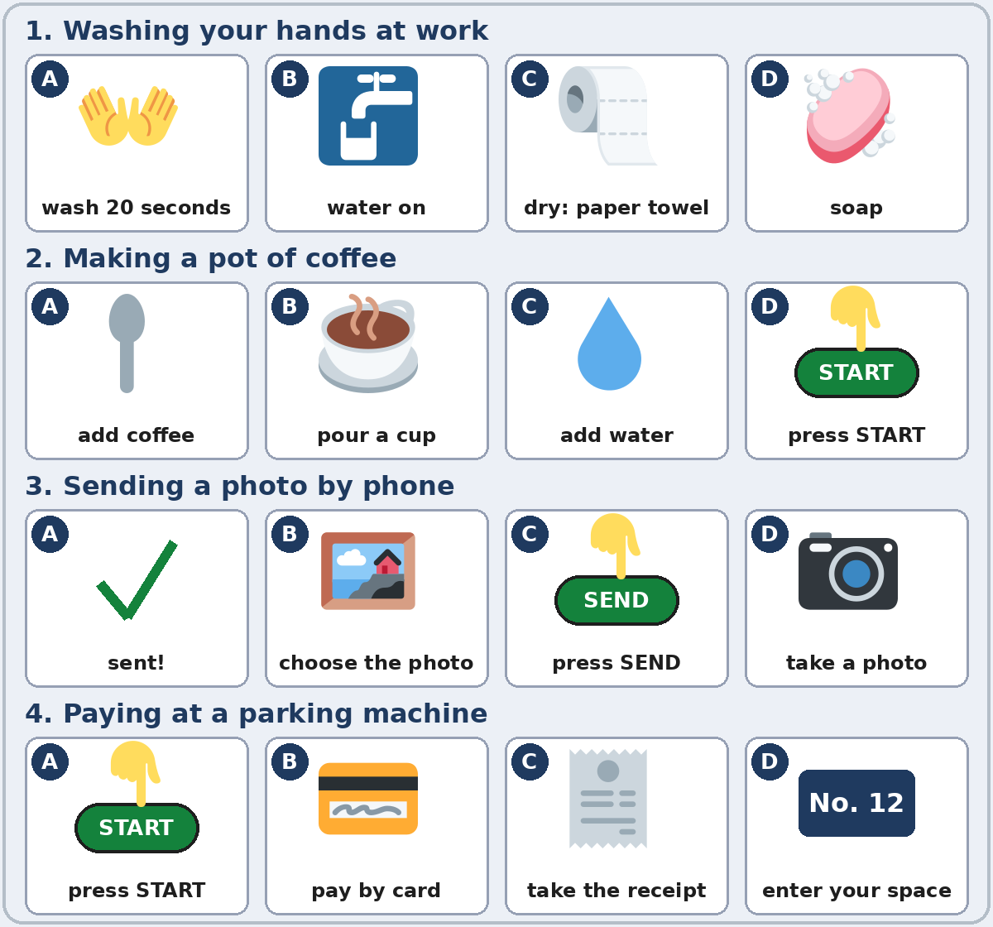

Strip | The right order | Strip | The right order
1. Washing hands | ___ ___ ___ ___ | 3. Sending a photo | ___ ___ ___ ___
2. Making coffee | ___ ___ ___ ___ | 4. Paying for parking | ___ ___ ___ ___

A: First, turn on the water. Next, … B: (mimes) What do I do next? Add a Don't: Don't forget to…

Lesson 10 (Week 11) · Homework
Homework (about 15 minutes). Bring it next week!
1. Write the instruction. No you, no -s.
Example: You turn on the light. → Turn on the light.
1. You press START. → ______________________________________________
2. You no open the door. → ______________________________________________
3. You plugs in the machine. → ______________________________________________
4. Don't forget take your card. → ______________________________________________
2. Write 4 steps for something you do at home (making rice, washing the dishes, doing laundry). Use First, Next, Then, Finally.
Example: First, put the clothes in the machine. Next, add the detergent. Then, press START. Finally, put the clothes in the dryer.
______________________________________________________________
______________________________________________________________
______________________________________________________________
3. Ask a family member or a coworker: How do you make your favorite food? Write 3 steps.
______________________________________________________________
______________________________________________________________
______________________________________________________________
4. Review (Lesson 9): Write 2 sentences about you with good at, interested in, or enjoy + -ing.
______________________________________________________________
______________________________________________________________
Lesson 10 (Week 11) · Read & Write
A. Read the medicine label. (This label is invented. It's for reading practice only. For real medicine, ask a pharmacist or a doctor.)
OAK STREET PHARMACY · DAY COLD TABLETS · 24 tablets
Directions: Adults: take 1 tablet every 8 hours with food. Drink a full glass of water with each tablet. Do not take more than 3 tablets in 24 hours. Do not give to children under 12.
Warnings: This medicine can make you sleepy. Do not drive after you take it. If you feel worse after 3 days, stop and ask a pharmacist or a doctor.
Store at room temperature. Keep away from children.

B. Answer the questions.
1. How many tablets do you take each time? ______________________________________________
2. How often do you take a tablet? ______________________________________________
3. Do you take it with food or without food? ______________________________________________
4. What is the most you can take in 24 hours? ______________________________________________
5. You feel worse after 3 days. What do you do? ______________________________________________
C. Write 4 steps for a task you know (making coffee, washing a car, sending a text, logging in to a website). Use sequence words and one Don't.
Example: First, open the website. Next, type your email and your password. Then, press LOG IN. Finally, check your messages. Don't share your password!
My instructions: How to __________________________

D. Check your instructions with a partner.
 | Yes | Not yet
It has 4 steps in order. | ☐ | ☐
It uses First, Next, Then, Finally (or After that). | ☐ | ☐
The steps start with a verb (no you). | ☐ | ☐
It has one Don't…. | ☐ | ☐

Lesson 10 (Week 11) · Progress Check
Name: ______________________________ Date: ________________
A. Listen to the teacher. Circle a or b.
1. a. plug it in → turn it on b. turn it on → plug it in
2. a. Open the door. b. Don't open the door.
3. a. press START b. press STOP
4. a. This is the first step. b. This is the last step.
B. Circle the right words.
1. (First / Finally), put on your goggles. (step 1)
2. (Press / You press) the button.
3. (Don't / No) touch the machine.
4. (Final / Finally), turn it off. (the last step)
C. Write.
1. How do I log in? Write 3 steps. ______________________________________________
2. Write one Don't forget to…. ______________________________________________
Score: A ______ / 4 B ______ / 4 C ______ / 2
D. How do you feel? Check ✓ one face for each line.
I can… | 😀 I can do it. | 🙂 With a little help. | 😐 Not yet.
I can give instructions in order. | ☐ | ☐ | ☐
I can follow instructions. | ☐ | ☐ | ☐
I can ask How do I…? What do I do next? | ☐ | ☐ | ☐
I can read a medicine label. | ☐ | ☐ | ☐

Picture Credits
Pictures use Twemoji graphics by Twitter, Inc. and other contributors (https://github.com/jdecked/twemoji), licensed under CC BY 4.0 (https://creativecommons.org/licenses/by/4.0/). The graphics were resized and combined, one was recolored (a light bulb), and drawings (a bottle, a label, buttons, an outlet, stairs, forms, panels, arrows) and labels were added. The file-by-file list is in images/CREDITS.md.
Listening audio: synthetic voices made with Chatterbox TTS (Resemble AI, MIT License), cloned from synthetic reference clips made with Kokoro-82M (Apache License 2.0). No recordings of real people were used. Each file carries an inaudible Perth watermark marking it as AI-generated. The names and the story are invented.
Course materials: © 2026 the authors, licensed under CC BY-NC-SA 4.0 (https://creativecommons.org/licenses/by-nc-sa/4.0/).

