Level 3 Adult ESL Curriculum · Lesson 7 (Week 7): Can I Exchange This?
Status: Complete lesson (all 13 Level 3 lessons are published).
Date: October 2026
Audience: Program coordinators and volunteer teachers
Companion files: audio/L3_L7_listening.mp3, images/ (12 vocabulary pictures + images/CREDITS.md)
Topic: customer service: returning or exchanging an item, asking for a refund, and changing or canceling an appointment, with I'd like to + verb, reasons with because, and polite requests with Could I / Can I / May I…?

How this lesson is organized
Part | What's inside | Who uses it
Teacher Plan | At a glance, clock-time plan, step-by-step boxes, listening script, answer key, teacher notes | Volunteer teachers
Student Pages | Opening Talk, New Words, My Words, Listening, Grammar, Talk Time, Homework, Read & Write, Progress Check. Print this part for learners | Learners
Picture Credits | Picture, audio, and license credits | Coordinators

What Lesson 7 builds on and what it adds
Before (review only) | Where | New in Level 3 Lesson 7
I'd like + noun: I'd like a coffee. | Level 2 Lesson 9 | I'd like to + verb: I'd like to return this.
Can / Could you…?; phone calls | Level 2 Lesson 12 | Could I / May I…? (asking for permission)
appointment, receipt | Level 2 Lessons 10, 12 | Changing and canceling an appointment; You need the receipt.
because | Level 3 Lesson 1 | Reasons: because it's too small
First conditional | Level 3 Lesson 6 | If it doesn't fit, can I return it?

TEACHER PLAN
Lesson 7 (Week 7)

Can I Exchange This?
At a glance · Clock-time plan · Step by step · Script and answer key

How to Use This Plan
You don't need to speak Spanish or any other language. Teach in English. Show, point, and gesture. Each Grammar page has one short Spanish note and one tip for speakers of other languages. Learners read them on their own. You never need to read, translate, or explain them.

Instructions: use the same short task words every week: Listen. Circle. Check. Write. Work with a partner. Work in a group. Ask a follow-up question. Learners have the Task Words page from Lesson 1.

Instruction rule: Model it (do it with one learner while everyone watches), check it (ask: "Do you write or speak? How many people do you talk to?"), then go. Say less, show more.

Grouping toolkit: Pairs: turn to a neighbor; with an odd number, make one group of 3. Groups: 3–4 learners. Inside–outside circles: the inner circle faces out, the outer circle faces in; the outer circle moves one person to the right each round. Mingle: everyone stands and talks to many classmates. The teacher joins a pair only if one learner is left over.

When a learner is stuck or speaks another language to you: (1) show it: the picture, a gesture, or the board; (2) give one more short English example; (3) point to the grammar box on their page; (4) a classmate can help for a few seconds, then back to English. You don't need to understand what classmates say to each other.

Lesson 7 (Week 7): Can I Exchange This?
At a glance
Objectives: learners can…
• say I'd like to return / exchange this and give a reason (because it's too small)
• ask for permission with Could I / Can I / May I…? and answer
• ask for a refund or store credit, and ask for the manager politely
• change or cancel an appointment by phone
• tell the difference between I'd like + a thing and I'd like to + a verb
• read a store return policy and fill out a return form

Materials
• Student Pages for Lesson 7 (print for the number expected + 3 spares)
• Talk Time: the Store Policy Card, the Customer Cards, and the calendar slips (on the Talk Time pages)
• phone + small speaker, L3_L7_listening.mp3
• optional: a T-shirt or a bag to "return" when you model (no play money needed)
• Prep time: 10 min.

Key vocabulary (with pictures on the New Words page)
★ return • ★ exchange • ★ refund • ★ store credit • ★ size • ★ broken • ★ customer • ★ manager • ★ cancel • ★ reschedule • ★ available • stain

Clock-time plan
Times are loose. If a step runs long, take time from Read & Write first, then from Talk Time.
Time | Step | Min | Grouping (15 / 7–8) | If running behind
6:00–6:10 | Opening Talk + Homework Check | 10 | Pairs (7 pairs + 1 trio / 3–4 pairs) | One card only
6:10–6:18 | New Words (picture page) + pair game | 8 | Whole class, then pairs | Teach the ★ words only
6:18–6:30 | Listening: play 1 (Task A), play 2 (Tasks B and C) + "Say it" | 12 | Individuals, then pairs check | Do Task C together on the board
6:30–6:45 | Grammar Q&A: I'd like to…; reasons; Could I / May I…?; appointments + pair drill | 15 | Whole class, then pairs | Skip the pair drill; Talk Time practices it
6:45–7:00 | BREAK | 15
7:00–7:12 | Talk Time: Service Desk + phone call (back to back) | 12 | Pairs (clerk / customer) | Round 1 only
7:12–7:17 | Exit Ticket + Homework | 5 | Individuals | Never skip
7:17–7:25 | Read & Write: a return policy + a return form | 8 | Individuals, then pairs | Reading questions only; the form becomes homework
7:25–7:30 | Progress Check | 5 | Individuals | Do it at the start of the midterm review, while people arrive

Skip order if you're running behind: (1) the Read & Write form (it becomes homework); (2) the pair drill at the end of Grammar; (3) half of Talk Time (Round 1 only). Never skip: the listening tasks, the grammar boxes and the mistakes table, and the exit ticket.

Attendance (15 → 7–8): every step lists both sizes. With 5 or fewer, sit at one table: one "service desk" (one clerk), and customers take turns.

Next week is the midterm (Week 8). Remind learners at the end of class. The midterm reviews Lessons 1–7.

Step by step
Step 1 · 6:00–6:10 · Opening Talk + Homework Check · 10 min
• Grouping: pairs, the same partner for both parts. 15 learners: 7 pairs + 1 group of 3. 7–8 learners: 3–4 pairs.
• Before class: write on the board: What will you do if…? If…, I'll…
• Opening Talk (6 min): learners open the Opening Talk page. A asks a card question; B answers with 2–3 sentences; A asks one follow-up. Switch after each card.
• Model with one learner: "What will you do if it rains this weekend?" → (answer) → "Really? With who?"
• Homework Check (4 min): partners read their Lesson 6 Homework item 1 (If it rains this weekend, I'll…) to each other. Walk around. Write 2 common errors on the board (often If it will rain or If rains) and correct them together.
• Late arrivals: join any pair as a group of 3.
• If behind: one card only, then the homework check.

Step 2 · 6:10–6:18 · New Words · 8 min
• Grouping: whole class, then pairs. Show the New Words page.
• Do: point to each picture and say the word. Learners repeat once. Hold up a T-shirt: "It's too small. I'd like to return it… or exchange it for a large."
• Two pairs of words (1 min): refund (money back) vs. store credit (money for this store only). cancel (no appointment) vs. reschedule (a new day or time).
• Check meaning (1 min): "The shirt has a brown spot. It has a…?" (stain) • "The phone doesn't work. It's…?" (broken) • "Who is the boss in the store?" (the manager) • "Thursday at 4:30 is free. It's…?" (available)
• Pairs (2 min): A says a word; B points to the picture and makes a sentence (I'd like a refund.). Switch.
• If behind: teach the ★ words only.

Step 3 · 6:18–6:30 · Listening + "Say it" · 12 min
• Grouping: individuals, then pairs check.
• Before you listen (1 min): point to the customer picture. Say: "This is Lina. She's at the service desk at Valley Mart, a big store. She has a phone case. What does she want to do? Listen."
• Play 1 → Task A (return or exchange? refund or store credit?). Pairs compare. Check together.
• Read Tasks B and C together (1 min) so learners know what to listen for.
• Play 2 → Tasks B and C. Pairs compare. Then show the answers (answer key).
• "Say it" (2 min): say: "Polite questions go up at the end: Could I exchange it? ↗" Then: "I'd like to is fast: I'd-like-tuh." Read the lines in the "Say it" box. The class repeats each line twice.
• The audio plays the conversation once (about 1:17). Press play again for play 2. A third play is fine if the class needs it.
• If behind: do Task C together on the board, reading the lines yourself.

Step 4 · 6:30–6:45 · Grammar Q&A · 15 min
• Grouping: whole class, then pairs. Show the Grammar page. The left side is the question. The right side is the answer.
• Write on the board: I'd like + a thing (I'd like a bag) and I'd like to + a verb (I'd like to return it).
• Boxes 1 and 2 (4 min): you are the clerk: "Can I help you?" The class answers from Box 1. Then "What's wrong with it?" The class answers from Box 2 (It's too small. It has a stain.).
• Box 3 (3 min): Could I / Can I / May I…? May I is the most polite. Read the answers: Sure. / Of course. / Sorry, you need the receipt.
• Box 4 (2 min): appointments. Read the phone lines across with one learner.
• Check questions: "I'd like ___ return this." (to) • "I'd like ___ refund." (a) • "It's ___ small. It doesn't fit." (too) • "___ I speak to the manager?" (May / Could)
• Practice A and B (3 min): learners write, then pairs check. Go over the answers.
• Pair drill (last 2 min): A is the clerk: "Can I help you?" B returns something from the New Words page with a reason. Switch.
• If behind: skip the pair drill. Talk Time practices it.

Break · 6:45–7:00 · 15 min
• Write on the board: I'd like to return / exchange this, because… / Could I…? / May I speak to the manager?

Step 5 · 7:00–7:12 · Talk Time: Service Desk · 12 min
• Grouping: pairs: A = clerk, B = customer. 15 learners: 7 pairs + 1 trio (two customers wait in line). 7–8 learners: 3–4 pairs. 5 or fewer: one clerk; customers take turns.
• Round 1 (6 min): the clerk reads the Store Policy Card (30 days, receipt needed for a refund, store credit with no receipt, sale items store credit only). The customer chooses a Customer Card and returns or exchanges the item. The clerk follows the policy. After each card, switch roles.
• Model with one learner (1 min): you are the customer with card 1: "Hi. I'd like to return these shoes." → "What's wrong with them?" → "They're too big." → "Do you have the receipt?" → "Yes, here it is."
• Round 2, phone call (5 min): pairs sit back to back (no looking). A is the receptionist with the available times. B is the patient and wants to change or cancel an appointment. B uses the calendar slip. Then switch with the second slip.
• If behind: Round 1 only.

Step 6 · 7:12–7:17 · Exit Ticket + Homework · 5 min · NEVER SKIP
• Exit ticket: each learner writes two sentences on a slip: one with I'd like to… and a reason with because (I'd like to exchange this shirt, because it has a stain.), and one polite question with Could I or May I. Collect at the door.
• Homework: open the Homework page. Do item 1 together (one sentence on the board). Say: "About 15 minutes. Bring it next week. Next week is the midterm review."

Read & Write · 7:17–7:25 · A Return Policy and a Return Form · 8 min
• Grouping: individuals, then pairs check.
• Read (3 min): learners read the Valley Mart return policy and answer questions 1–5. Say: "Read fast first. Then find the answers."
• Pairs check (1 min): compare answers; check together.
• Write (4 min): learners read the situation and fill out the return form. They choose refund, exchange, or store credit (any choice that fits the policy is correct).
• If behind: questions 1–5 only; the form becomes homework.

Progress Check · 7:25–7:30 · 5 min
• Grouping: individuals. Open the Progress Check page.
• Part A: read the 4 sentences in the answer key, slowly, 2 times each. Learners circle a or b.
• Parts B and C: learners do them alone. Walk around and help with the instructions only.
• Part D: read each "I can…" line aloud and point to the 3 faces: 😀 "I can do it." 🙂 "With a little help." 😐 "Not yet."
• Collect the pages (or check them at the start of Week 8).
• If behind: do the Progress Check at the start of the midterm review, while learners arrive.

Listening script: L3_L7_listening.mp3 (about 1:17; the conversation plays once, so press play again for the second listen)
Audio: play from a phone + small speaker. No speaker? Read the script with a volunteer, at a normal, friendly speed.

Narrator: Lesson seven. Listening. Lina is at the service desk at Valley Mart. Listen.
Clerk: Hi. Can I help you?
Lina: Yes, I'd like to return this phone case.
Clerk: OK. What's wrong with it?
Lina: It's too small. It doesn't fit my phone.
Clerk: I see. Do you have the receipt?
Lina: No, sorry. I lost it. Could I get a refund?
Clerk: Sorry, you need the receipt for a refund. But I can give you store credit.
Lina: OK, that's fine. I'd like a bigger case.
Clerk: Sure. The bigger cases are in aisle five.
Lina: Thanks. Also, I have an appointment at your eye center on Monday. I'd like to change it.
Clerk: No problem. I can do that here. What day is good for you?
Lina: Is Thursday available?
Clerk: Let me check. Yes, Thursday at four thirty is available.
Lina: Perfect. I'd like to take that time.
Clerk: OK. Your new appointment is Thursday at four thirty.
Lina: Thank you so much.
Narrator: That's the end of the listening.

Answer key
• Listening Task A: 1 a (return it) • 2 b (store credit; she has no receipt).
• Listening Task B: 1 too small • 2 Monday • 3 Thursday • 4 4:30.
• Listening Task C: 1 like to, 2 Could, 3 like, 4 like to, 5 like to.
• Grammar Practice A: 1 like to, 2 like, 3 like to, 4 like, 5 like to.
• Grammar Practice B: 1 Could, 2 speak, 3 too small, 4 cancel, 5 available.
• Talk Time Round 1 (following the Store Policy Card): 1 shoes, too big, receipt, 10 days → refund or exchange • 2 lamp, broken, no receipt → store credit • 3 jacket on sale, stain → store credit only • 4 shirt, 45 days → sorry, more than 30 days (the customer can ask for the manager) • 5 coffee maker, wrong color, receipt, 5 days → refund or exchange • 6 pants, too long, no receipt → store credit or exchange. Wording will vary.
• Talk Time Round 2: Slip 1: Tuesday 10:00 → a new time on Wednesday or Friday (Wednesday 3:00, Friday 9:30, or Friday 4:30) • Slip 2: cancel the Thursday 2:00 appointment. Answers will vary.
• Homework 1: answers will vary; for example 1 I'd like to return these shoes, because they're too small. Homework 2: 1 like to, 2 like, 3 like to, 4 like, 5 like to, 6 like to. Homework 3 and 4: answers will vary.
• Read & Write B: 1 30 days • 2 store credit • 3 No (phones and electronics: 15 days only) • 4 No (no returns on food and medicine) • 5 store credit only
• Read & Write C (sample form): Item: a blue sweater, size M • Date bought: 10 days ago • Price: $24 • Reason: It has a stain. • Receipt: Yes • I'd like: a refund or an exchange (both fit the policy; store credit is also OK). Wording will vary.
• Progress Check Part A (the teacher says, 2 times each): 1 "I'd like to return these shoes. They're too big." → a • 2 "Could I exchange this shirt for a large?" → b • 3 "I'd like to cancel my appointment on Friday." → a • 4 "Is Tuesday at ten available? I'd like to change my appointment." → b
• Progress Check Part B: 1 to return, 2 exchange, 3 too small, 4 a refund.
• Progress Check Part C: answers will vary; for example 1 I'd like to return this lamp, because it's broken. 2 May I speak to the manager, please?
• Progress Check scoring: A /4 + B /4 + C /2 = /10. This is not a test grade. It shows who needs more help hearing requests (A) and with I'd like / I'd like to and polite questions (B, C).
Teacher notes
• Invented stores only (important): Valley Mart, its policy, and the eye center are invented. No play money is needed. Learners never talk about their own purchases, debts, or money problems.
• I'd like vs. I'd like to: after I'd like, use a thing (I'd like a bag). After I'd like to, use a verb (I'd like to return it). I'd like = I would like: more polite than I want.
• too + adjective: It's too small means it's a problem (it doesn't fit). very small is not a problem. Teach too small / too big / too long as fixed phrases.
• Could I / Can I / May I: all are OK. May I is the most polite and formal. The answer is usually Sure. / Of course. / Sorry, ….
• Midterm next week: remind learners. The midterm reviews Lessons 1–7.
• Mixed levels: stronger learners argue politely in Round 1 (Could I speak to the manager, please?). Newer learners use Boxes 1–3 as a script.
• Typical mistakes this week: I'd like return, I like to return this (for now), Could I to exchange, It's very small (for a problem), I want change my appointment. Say the right form clearly; the learner repeats. Learners can read the Spanish note and the tip on their Grammar page themselves; you don't need to explain them.

STUDENT WORKBOOK
Lesson 7 (Week 7)

Can I Exchange This?
Opening Talk · New Words · Listening · Grammar · Talk Time · Homework · Read & Write · Progress Check

Lesson 7 (Week 7) · Opening Talk
Name: ______________________________ Date: ________________
Work with a partner. A asks a question. B answers with 2–3 sentences. A asks one follow-up question. Then switch.
What will you do if it rains this weekend? | What will you do if the power goes out tonight?
What will the weather probably be like tomorrow? | What will you do if you have a free day next week?

Follow-ups: Really? Why? With who? What else will you do?
Homework check: read your Lesson 6 homework (item 1) to your partner. Your partner asks one question about it.
My partner will… if… | My question about it

Lesson 7 (Week 7): Can I Exchange This?
Student Page 1 · Week 7
Name: ______________________________ Date: ________________
New Words
Look. Listen. Repeat. ★ = most important words.
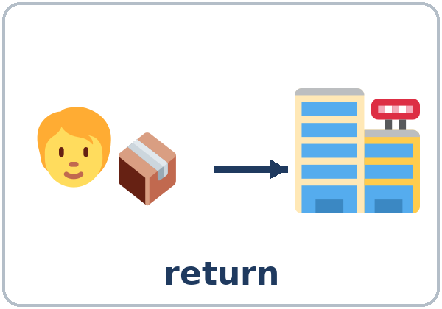  ★ return | 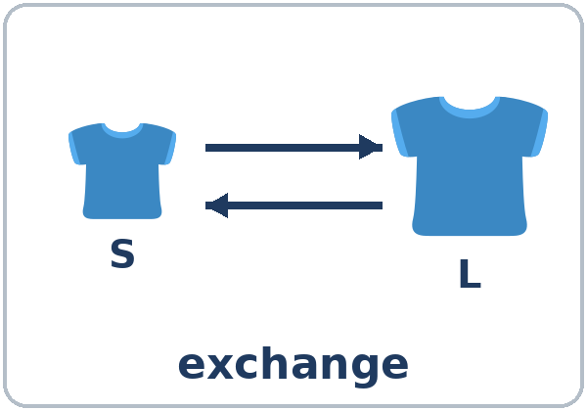  ★ exchange | 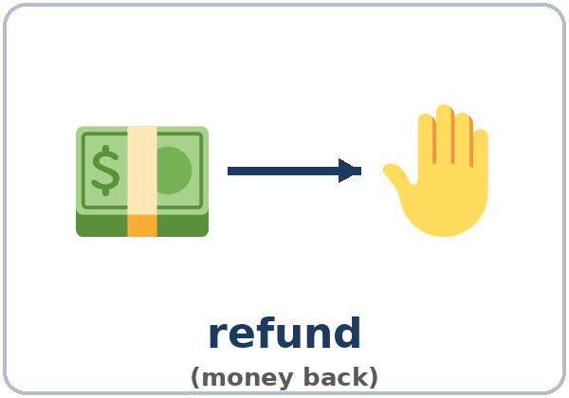  ★ refund | 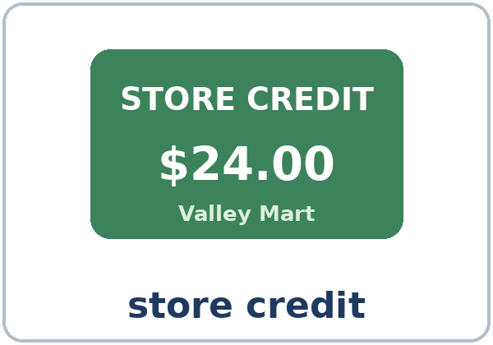  ★ store credit
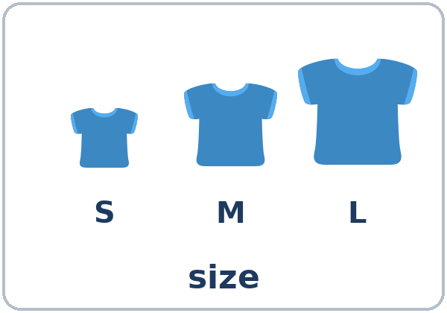  ★ size | 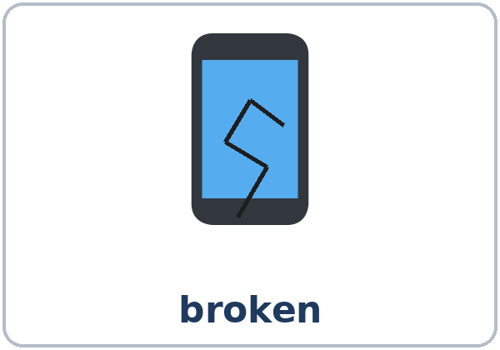  ★ broken | 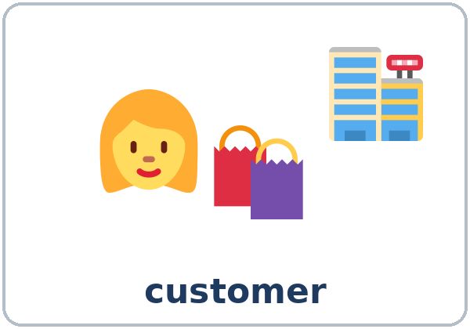  ★ customer | 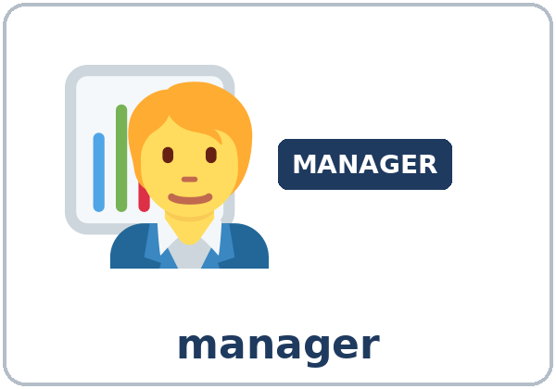  ★ manager
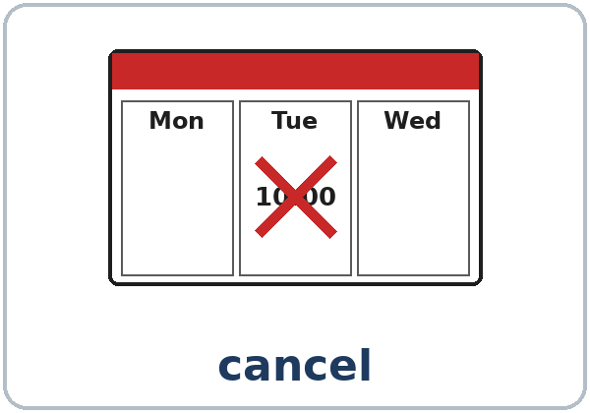  ★ cancel | 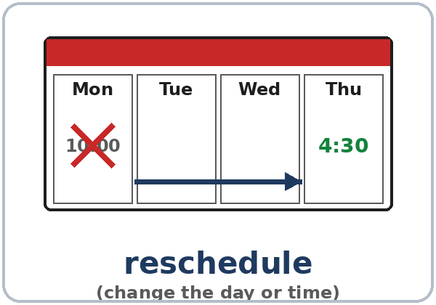  ★ reschedule | 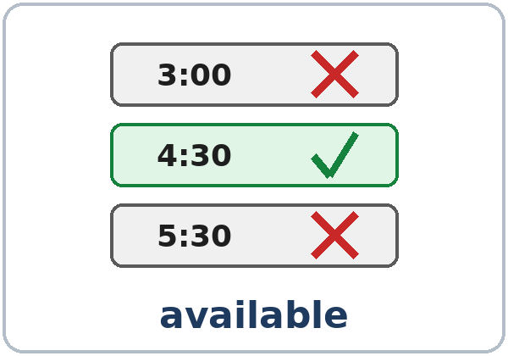  ★ available | 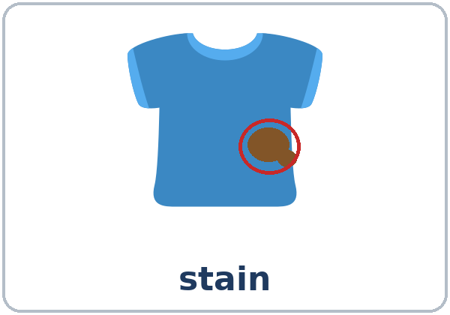  stain

Partner game: A says a word. B points and makes a sentence.
Example: A: exchange. B: (points) I'd like to exchange this shirt for a large.
Lesson 7 (Week 7) · My Words
Write each word in your language, if you want. Then write your own example.
Word | My language | My example
return
exchange
refund
store credit
size
broken
customer
manager
cancel
reschedule
available
stain

Lesson 7 (Week 7) · Listening
Listen to Lina. She's at the service desk at Valley Mart, a big store.
A. Listen. Circle a or b.
1. What does Lina want to do first? a. return a phone case b. buy a phone
2. What does she get? a. a refund (money back) b. store credit
B. Listen again. Circle the right answer.
1. What's wrong with the phone case? too big / too small / broken
2. When is her eye appointment now? Monday / Tuesday / Friday
3. What is the new day? Wednesday / Thursday / Saturday
4. What is the new time? 4:00 / 4:30 / 5:30
C. Listen again. Write like, like to, or Could.
1. Yes, I'd ____________ return this phone case.
2. ____________ I get a refund?
3. OK, that's fine. I'd ____________ a bigger case.
4. I'd ____________ change it.
5. Perfect. I'd ____________ take that time.
Say it: Could I exchange it? ↗ • I'd like to (I'd-like-tuh) return this. • May I speak to the manager? ↗
Lesson 7 (Week 7) · Grammar
Read across. A reads from the left side. B answers from the right side. Choose one part from each column.
Grammar Box 1: Can I help you?
QUESTION |  | ANSWER
Can I help you? |  | Yes, I'd like to | return  exchange | this shirt.  these shoes.
Can I help you? |  | Yes, I'd like | a refund,  store credit, | please.

Grammar Box 2: Reasons
QUESTION |  |  | ANSWER (because + a reason)
Why? / | What's wrong with it? |  | Because it's | too small.  too big.  broken.
Why? / | What's wrong with them? |  | Because they | have a stain.  don't fit.

Grammar Box 3: Asking for permission
QUESTION |  |  | ANSWER
Could I  Can I | exchange it for a large?  get a refund? |  | Sure.  Of course.
May I (very polite) | speak to the manager?  pay with a card? |  | Sorry, you need the receipt.  Sorry, cash only.

Grammar Box 4: Changing an appointment
CALLER |  |  | RECEPTIONIST
I'd like to | change my appointment.  reschedule my appointment. |  | What day is good for you?
Is Thursday | available? |  | Yes, at 4:30.  Sorry, we're full. Is Friday OK?
I'd like to | cancel my appointment. |  | OK. Your appointment is canceled.

Grammar Box 5: I'd like + a thing, I'd like to + a verb
I'd like + A THING |  | I'd like to + A VERB
I'd like a refund. |  | I'd like to return this.
I'd like a bigger size. |  | I'd like to exchange it.
I'd like an appointment on Friday. |  | I'd like to cancel my appointment.

Questions and answers
Q: I'd like or I want?
A: I'd like (= I would like) is more polite. Use it in stores, at the clinic, and on the phone.
Q: I'd like or I'd like to?
A: A thing after I'd like (I'd like a bag). A verb after I'd like to (I'd like to return it).
Q: too small or very small?
A: too small = a problem: it doesn't fit. very small = not a problem. It's too small, so I'd like to exchange it.
Q: Could I, Can I, or May I?
A: All three are OK. May I is the most polite. After them, use the base verb: Could I exchange it? (not to exchange)
Practice A: Write like or like to.
1. I'd ____________ return these shoes.
2. I'd ____________ a bag, please.
3. I'd ____________ exchange this shirt for a medium.
4. I'd ____________ a refund, please.
5. I'd ____________ cancel my appointment.
Practice B: Circle the right words.
1. (Could / Would) I exchange this?
2. May I (speak / to speak) to the manager?
3. It's (too small / small too). It doesn't fit.
4. I'd like to (cancel / canceling) my appointment.
5. Is Thursday (available / free time)?
Common mistakes
✗ Don't say | ✓ Say
I'd like return this. | I'd like to return this.
I want change my appointment. | I'd like to change my appointment.
Could I to exchange it? | Could I exchange it?
It's very small. It doesn't fit. | It's too small. It doesn't fit.
I'd like to a refund. | I'd like a refund.

Nota para hispanohablantes: I'd like to return this = Quisiera devolver esto. return = devolver; exchange = cambiar. May I…? es muy cortés, como ¿Me permite…?

Tip for speakers of other languages: after I'd like use a thing (I'd like a bag). After I'd like to use a verb (I'd like to return it).

Lesson 7 (Week 7) · Talk Time: Service Desk
Round 1: Work with a partner. A is the clerk. B is the customer. The clerk follows the Store Policy Card. The customer chooses a card. Then switch.
Clerk: Hi. Can I help you? Customer: Yes, I'd like to return these shoes.
Clerk: What's wrong with them? Customer: They're too big.
Clerk: Do you have the receipt? Customer: Yes, here it is. Could I get a refund?
Clerk: Sure. / Sorry, but I can give you store credit.

Store Policy Card (for the clerk)
• Returns: within 30 days.
• With a receipt: a refund or an exchange.
• No receipt: store credit or an exchange.
• Sale items: store credit only.
• More than 30 days: "Sorry, we can't take it." (The customer can ask for the manager.)

Customer Cards
1. shoes • too big • receipt: yes • bought 10 days ago | 2. a lamp • broken • receipt: no • bought 1 week ago
3. a jacket (on sale) • has a stain • receipt: yes • 2 weeks ago | 4. a shirt • the wrong color • receipt: yes • 45 days ago
5. a coffee maker • the wrong color • receipt: yes • 5 days ago | 6. pants • too long • receipt: no • 3 days ago

Lesson 7 (Week 7) · Talk Time: On the Phone
Round 2: Sit back to back. A is the receptionist at Valley Eye Center. B is the patient. B uses a calendar slip and doesn't look at A's table. A offers the available times. Then switch with the second slip.
A: Valley Eye Center. How can I help you? B: Hi. I'd like to change my appointment.
A: When is it? B: It's on Tuesday at 10:00. Is Wednesday available?
A: Let me check. Yes, Wednesday at 3:00 is available. B: Great. I'd like to take that time.

A only: open times | Mon | Tue | Wed | Thu | Fri
Morning | full | full | full | 11:00 | 9:30
Afternoon | 2:00 | full | 3:00 | full | 4:30

Patient: Slip 1 | Patient: Slip 2
Your appointment: Tuesday at 10:00. You can't come. You'd like to reschedule. You can come on Wednesday or Friday. | Your appointment: Thursday at 2:00. You'd like to cancel it. (Say why: because I have to work.)

My new appointment (Slip 1): Day: ____________ Time: ____________
Lesson 7 (Week 7) · Homework
Homework (about 15 minutes). Bring it next week!
1. What do you say at the service desk? Write I'd like to… and a reason with because.
Example: shoes, too small → I'd like to return these shoes, because they're too small.
1. shoes, too small → ______________________________________________
2. a lamp, broken → ______________________________________________
3. a shirt, has a stain → ______________________________________________
4. a jacket, too big, exchange → ______________________________________________
2. Write like or like to.
1. I'd ____________ speak to the manager, please.
2. I'd ____________ a receipt, please.
3. I'd ____________ reschedule my appointment.
4. I'd ____________ store credit, please.
5. I'd ____________ pay with a card.
6. I'd ____________ exchange this for a medium.
3. Finish the phone call. Write the patient's words.
Receptionist: Valley Eye Center. How can I help you?
You: ______________________________________________________________
Receptionist: What day is good for you?
You: ______________________________________________________________
Receptionist: Yes, Friday at 9:30 is available.
You: ______________________________________________________________
4. Review (Lesson 6): Write 2 sentences with If…, I'll….
______________________________________________________________
______________________________________________________________
Lesson 7 (Week 7) · Read & Write
A. Read the store's return policy.
Valley Mart Return Policy
You can return most items within 30 days. Please bring the receipt.
• With a receipt: you get a full refund (cash or card), or you can exchange the item.
• No receipt: you get store credit.
• Clothes: you can exchange them for a different size or color within 30 days. The tags must be on.
• Phones and electronics: 15 days only. They must be in the box.
• Food and medicine: no returns.
• Items on sale: store credit only.
Questions? Please ask at the Service Desk, or ask for a manager.

B. Answer the questions.
1. How many days do you have to return most items? ______________________________
2. You have no receipt. What do you get? ______________________________
3. You bought headphones 20 days ago. Can you return them? ______________________________
4. Can you return food? ______________________________
5. You bought a dress on sale. What do you get? ______________________________
C. Read the situation. Fill out the return form.
You bought a blue sweater (size M) at Valley Mart 10 days ago. It was $24. It has a stain. You have the receipt.
VALLEY MART RETURN FORM
Item
Size
Date bought
Price
What's wrong with it?
Receipt? | ☐ Yes ☐ No
I'd like… | ☐ a refund ☐ an exchange ☐ store credit
Customer signature

D. Check your form with a partner.
 | Yes | Not yet
The reason says what's wrong (It has a stain.). | ☐ | ☐
The choice follows the Valley Mart policy. | ☐ | ☐
The item, size, and price are the same as the situation. | ☐ | ☐
Tell your partner: I'd like to…, because… | ☐ | ☐

Lesson 7 (Week 7) · Progress Check
Name: ______________________________ Date: ________________
A. Listen to the teacher. Circle a or b.
1. a. return b. exchange
2. a. return b. exchange
3. a. cancel b. reschedule
4. a. cancel b. reschedule
B. Circle the right words.
1. I'd like (return / to return) this lamp.
2. Could I (exchange / to exchange) it for a large?
3. It's (too small / very small), and it doesn't fit.
4. I'd like (a refund / to refund), please.
C. Write.
1. Return a broken lamp. Give a reason. ______________________________________
2. Ask for the manager politely. ______________________________________
Score: A ______ / 4 B ______ / 4 C ______ / 2
D. How do you feel? Check ✓ one face for each line.
I can… | 😀 I can do it. | 🙂 With a little help. | 😐 Not yet.
I can say I'd like to return / exchange this. | ☐ | ☐ | ☐
I can give a reason. | ☐ | ☐ | ☐
I can ask for permission with Could I / May I…? | ☐ | ☐ | ☐
I can change or cancel an appointment. | ☐ | ☐ | ☐

Picture Credits
Pictures use Twemoji graphics by Twitter, Inc. and other contributors (https://github.com/jdecked/twemoji), licensed under CC BY 4.0 (https://creativecommons.org/licenses/by/4.0/). The graphics were resized and combined, and drawings (calendars, time slots, a store credit card, a name tag, cracks, a stain, arrows) and labels were added. The file-by-file list is in images/CREDITS.md.
Listening audio: synthetic voices made with Chatterbox TTS (Resemble AI, MIT License), cloned from synthetic reference clips made with Kokoro-82M (Apache License 2.0). No recordings of real people were used. Each file carries an inaudible Perth watermark marking it as AI-generated. The names, the store, and the story are invented.
Course materials: © 2026 the authors, licensed under CC BY-NC-SA 4.0 (https://creativecommons.org/licenses/by-nc-sa/4.0/).

