Level 5 Adult ESL Curriculum · Lesson 12 (Week 13): The Room Where We Meet
Status: Published. Listening audio, lesson pages, and teacher slides are ready.
Date: October 2026
Audience: Volunteer teachers and adult learners
Companion files: images/ (12 vocabulary pictures + images/CREDITS_L5_L12.md). Listening audio: L5_L12_listening.mp3 (2:17).
Topic: A library meeting about evening hours. Learners follow an agenda, refer to a proposal, and one learner chairs a four-minute round. A second card set uses the same English for a school conference.

How this lesson is organized
Part | What's inside | Who uses it
Teacher Plan | At a glance, clock, steps, listening script, answer key, notes | Volunteer teachers
Student Pages | Opening Talk, New Words, Listening, Grammar, Talk Time, Homework, Read & Write, Exit Ticket | Learners

TEACHER PLAN
Lesson 12 (Week 13)

The Room Where We Meet
At a glance · Clock · Steps · Script and answer key

Lesson 12 (Week 13): The Room Where We Meet
At a glance
Objectives: learners can…
• point to a thing with which and a place with where
• still use who for a person
• ask a question from the agenda
• give an opinion with a reason and listen to one other opinion

Today you will: Use which and where. • Ask from the agenda. • Give an opinion and a reason.
By the end of class, you can do these four things. Every goal is a good goal.
• I can point to a thing with which and a place with where.
• I can still use who for a person.
• I can ask a question from the agenda.
• I can give my opinion with a reason and listen to one other opinion.
Materials
• Student pages for Lesson 12
• A one-page agenda: welcome, the proposal, questions, a decision
• A second card set: a school conference (same English)
• A timer, name tents, and one question card per person
• Listening: L5_L12_listening.mp3 (2:17). No speaker? Read the script aloud with a volunteer.
• Prep time: 15 minutes

Key vocabulary
★ agenda • ★ chairperson • ★ minutes • ★ microphone • ★ handout • ★ proposal • ★ sign-in sheet • ★ name tent • ★ timer • ★ question card • library • auditorium

Clock-time plan
Time | Step | Min | Grouping (15 / 7–8) | If running behind
6:00–6:06 | Opening Talk + Homework Check | 6 | Pairs | One card only
6:06–6:12 | New Words + pair game | 6 | Whole class, then pairs | ★ words only
6:12–6:32 | Listening + Hear it, say it | 20 | Individuals, then pairs | Task C on the board
6:32–6:45 | Grammar Q&A + pair check | 13 | Whole class, then pairs | Skip the pair check
6:45–7:00 | BREAK | 15
7:00–7:18 | Talk Time: Read the Agenda + A Learner Chairs | 18 | Groups of 4 | Round 1 only
7:18–7:25 | Read & Write | 7 | Pairs read, then writing | Questions only
7:25–7:30 | Exit Ticket + Homework | 5 | Individuals | Never skip

15: 4 groups (one of 3). 7–8: 2 groups. 5 or fewer: one meeting; rotate the chair if you have time.

Step by step
Step 1 · 6:00–6:06 · Opening Talk + Homework Check · 6 min
• A asks a card question. B answers in about four sentences. A asks one follow-up. Then switch.
• Homework check: one line from the Lesson 11 letter, or Waiting on hold is tiring. Write 2 corrections. No names.

Step 2 · 6:06–6:12 · New Words · 6 min
• Point, say, repeat.
• Show: the chairperson keeps the order. The minutes are the notes. A name tent shows who is speaking. A question card is one question, not a speech. The library is the small room. The auditorium is the big room. We are not meeting there.
• Check the meaning: "Is which for a thing or a place?" (A thing.) • "Is where for a thing or a place?" (A place.) • "Is who for a person?" (Yes.)
• Partner game, then teams: 15 learners, 3 teams; 7–8, 2 teams; 5 or fewer, one team against the clock.

Step 3 · 6:12–6:32 · Listening + Hear it, say it · 20 min
• Before you listen: A short library meeting. Ms. Adeyemi chairs. Tom wants later hours. Grace wants the current hours, because the bus she takes stops early. They agree to a one-month try.
• Voices: Ms. Adeyemi, Tom, and Grace. A narrator opens and closes the listening.
• Play 1 → Task A. Play 2 → Tasks B and C.
• Hear it, say it: gonna and wanna are short forms. This listening uses the full forms. Which is not witch. A short pause before which or where when the clause adds important information.

Step 4 · 6:32–6:45 · Grammar Q&A + pair check · 13 min
• Box 1: which for things. The proposal which the chair read is on page 2.
• Box 2: where for places. This is the room where we meet.
• Box 3: who for a person. The person who takes notes is the secretary.
• Box 4: opinion phrases. I think… / I see your point, but…
• Rule of thumb: Which and who tell you which thing or person. Do not add it or he after them (the proposal which the chair read, not which the chair read it). Where replaces there.
• Pair check: A says room, proposal, or person. B makes a sentence with where, which, or who.

Step 5 · 7:00–7:18 · Talk Time · 18 min
• Round 1, Read the Agenda: groups of 4 get a one-page agenda (welcome, the proposal, questions, a decision). Each person prepares one question with which or where.
• Round 2, A Learner Chairs: the chair keeps the order, invites one speaker, and stops at four minutes. The group writes one sentence: the decision and one reason. A second set of cards is a school conference for groups that prefer it.
• The question is library hours or a school conference time. No elections and no party names. The chair's job is to keep the order, not to win.
• If behind: round 1 only.

Step 6 · 7:18–7:25 · Read & Write · 7 min
• Read the agenda and the proposal. Pairs answer the five questions.
• Write a 6–8 sentence comment for the chair: what you support, one reason, and a question with which or where.

Step 7 · 7:25–7:30 · Exit Ticket + Homework · 5 min · NEVER SKIP
• Exit ticket: Which idea do you support, and where would you say it? Four sentences with which or where, a reason, and one polite phrase.
• Homework item 1 together: The room ____ we meet. → where. About 20–25 minutes.

Listening script
2:17. Spoken lines use going to and want to.
Narrator: Lesson twelve. This is a short meeting at the library. Ms. Adeyemi is the chairperson. Tom and Grace are going to talk about evening hours.
Ms. Adeyemi: Welcome. Please look at the agenda, which is on your handout. This is the room where we meet.
Tom: I want to speak about the proposal. I want later hours.
Grace: I see your point, but I want to keep the current hours. The bus I take stops early.
Ms. Adeyemi: The proposal which I read is on page 2. It says a one-month try.
Tom: The library which we use closes at six. I want it open until eight.
Grace: The stop where I catch the bus is dark after seven. That is my reason.
Ms. Adeyemi: The person who takes notes is writing the minutes. Please use the microphone when you speak.
Tom: I think a one-month try is fair. I'm going to come after work on Thursday.
Grace: I see your point, but I need a safe ride. I can try it where the evening bus still runs.
Ms. Adeyemi: Please take a question card. Tom, which hours do you want?
Tom: I want eight o'clock on Thursday only. I want to keep the change small.
Grace: I can agree to Thursday if the sign-in sheet shows how many people come.
Ms. Adeyemi: Our decision is a one-month try on Thursday, until eight. The timer says we should stop.
Tom: My name tent is on the table, so the minutes can show who spoke.
Grace: The auditorium is too big. This library room is the place where we should meet.
Ms. Adeyemi: I am going to put the decision in the minutes. Thank you. I am glad the meeting was calm.
Tom: I want to ask one question. Which bus still runs at eight?
Grace: The bus where I get off stops at seven. Thursday is the only day I can try.
Ms. Adeyemi: Then Thursday is the try. We are not going to move the meeting to the auditorium.
Narrator: That's the end of the listening.

Answer key
• Listening Task A: b (Evening hours.)
• Listening Task B: 1 later hours, 2 the current hours, 3 the bus stops early, 4 a one-month try, 5 Thursday, 6 eight.
• Listening Task C: 1 where, 2 which, 3 which, 4 which, 5 where, 6 where.
• Grammar Practice A: 1 where, 2 which, 3 who, 4 where, 5 which, 6 who.
• Grammar Practice B: 1 where, 2 which, 3 who, 4 it, 5 there, 6 but.
• Homework 1: where.
• Read & Write: 1 Evening hours. 2 Ms. Adeyemi. 3 Later hours, until eight on Thursday. 4 The bus stops early. 5 In the room where we meet.
• Exit ticket: four sentences with which or where, a reason, and one polite phrase.
Teacher notes
• The question is library hours or a school conference time. No elections and no party names.
• The chair's job is to keep the order, not to win. Thank the learner who invites a quiet person to speak.
• Do not add it or he after which or who. Where replaces there.
• Some cards are a parent. Some are a volunteer. Pick either one. Do not ask who has children. No grades and no discipline stories.
• gonna and wanna are short forms. This listening uses the full forms.

STUDENT WORKBOOK
Lesson 12 (Week 13)

The Room Where We Meet
Opening Talk · New Words · Listening · Grammar · Talk Time · Homework · Read & Write · Exit Ticket

Lesson 12 (Week 13) · Opening Talk
Name: ______________________________ Date: ________________
Work with a partner. A asks a card question. B answers in about four sentences. A asks one follow-up. Then switch.
1. Start a sentence with Waiting. | 2. Soften a request with I was wondering if.
3. Say one passive: The form was received. | 4. What is a reference number for?
5. Homework check: one line from your letter.

Follow-ups: Why? • Can you say that another way? • Which word was hard?
Lesson 12 (Week 13) · Words
New Words
Look. Listen. Repeat. ★ = most important words.
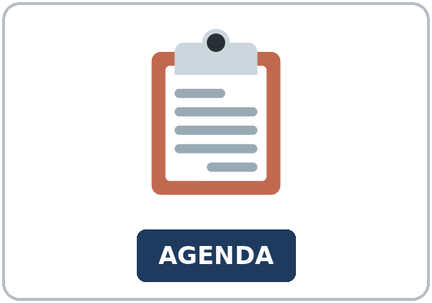  ★ agenda | 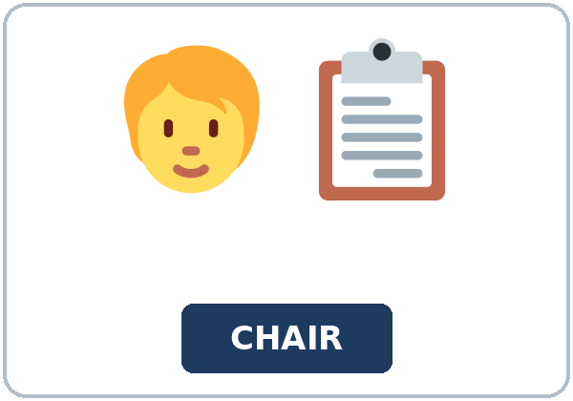  ★ chairperson |   ★ minutes |   ★ microphone
  ★ handout |   ★ proposal | 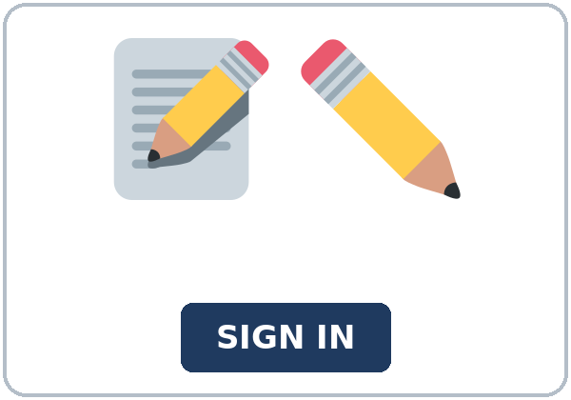  ★ sign-in sheet | 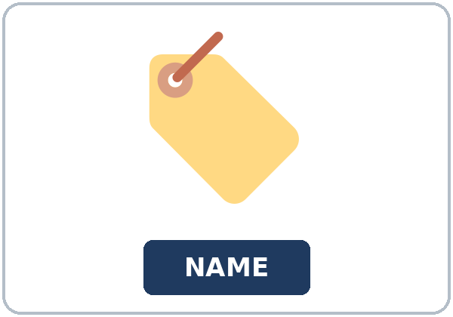  ★ name tent
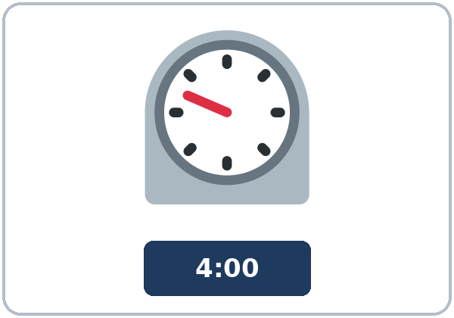  ★ timer | 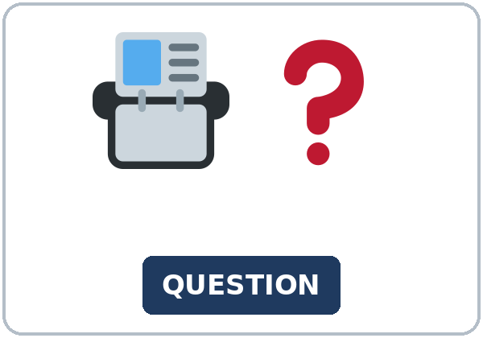  ★ question card | 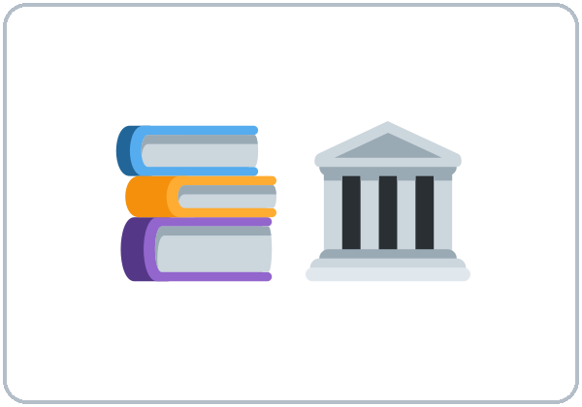  library | 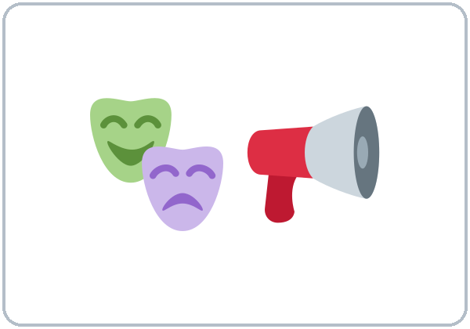  auditorium

Partner game: Say it in a sentence
Example: A points to library. B says: "This is the room where we meet." Switch.
Lesson 12 (Week 13) · Listening
A short library meeting. Ms. Adeyemi chairs. Tom wants later hours. Grace wants the current hours, because the bus she takes stops early. They agree to a one-month try.
Voices: Ms. Adeyemi, Tom, and Grace. A narrator opens and closes the listening.
A. Listen. What are they deciding? Circle.
a. A new library building. b. Evening hours. c. The price of a bus pass.
B. Listen again. Circle the answers.
1. Tom wants: (later hours / the current hours / a new bus)
2. Grace wants: (later hours / the current hours / no meeting)
3. Grace's reason: (the bus stops early / the room is cold / she wants a microphone)
4. The decision: (close the library / a one-month try / move to the auditorium)
5. The try is on: (Monday / Thursday / Sunday)
6. Open until: (six / seven / eight)
C. Listen again. Write which or where.
1. This is the room ____________ we meet.
2. The agenda, ____________ is on your handout, lists the hours.
3. The proposal ____________ I read is on page 2.
4. The library ____________ we use closes at six.
5. The stop ____________ I catch the bus is dark after seven.
6. This is the place ____________ we should meet.
Hear it, say it
gonna and wanna are short forms. This listening uses the full forms. gonna = going to. wanna = want to. You can say going to and want to. Which is not witch.
Say each line two times. Pause a little before which or where.
• This is the room where we meet.
• The proposal which I read is on page 2.
• I'm going to come after work on Thursday.
• I want to keep the current hours.
Lesson 12 (Week 13) · Grammar
Grammar Box 1: which for a thing
WHICH + THING | NO EXTRA IT
The proposal which the chair read | is on page 2.
The library which we use | closes at six.
The agenda which is on the handout | lists the hours.

Grammar Box 2: where for a place
WHERE REPLACES THERE | EXAMPLE
This is the room where we meet. | Not: the room which we meet.
The stop where I catch the bus | is dark after seven.
The place where we should meet | is this library room.

Grammar Box 3: who for a person
WHO, NOT WHICH | EXAMPLE
The person who takes notes | is the secretary.
The chairperson who keeps the order | is Ms. Adeyemi.
The person who rides the bus | is Grace.

Grammar Box 4: an opinion and a reason
YOU CAN SAY | EXAMPLE
I think… | I think a one-month try is fair.
I see your point, but… | I see your point, but I need a safe ride.
Which or where | Which idea? Where would you say it?

Rule of thumb: Which and who tell you which thing or person. Do not add it or he after them (the proposal which the chair read, not which the chair read it). Where replaces there.
Questions and answers
Q: The room which we meet. Right or wrong?
A: Wrong. The room where we meet.
Q: Can I say the proposal which the chair read it?
A: No. Drop it.
Q: The person which takes notes. Right or wrong?
A: Wrong. The person who takes notes.
Practice A: Write which, where, or who.
1. This is the room ____________ we meet.
2. The proposal ____________ the chair read is on page 2.
3. The person ____________ takes notes is the secretary.
4. The stop ____________ I catch the bus is dark after seven.
5. The library ____________ we use closes at six.
6. The chairperson ____________ keeps the order is Ms. Adeyemi.
Practice B: Circle the correct words.
1. This is the room (which / where) we meet.
2. The proposal (which / where) the chair read is on page 2.
3. The person (which / who) takes notes is the secretary.
4. Don't add (it / which) after which the chair read.
5. Where replaces (there / it).
6. I see your point, (but / because) I need a safe ride.
Common mistakes
Don't say | Say
The room which we meet. | The room where we meet.
The proposal which the chair read it. | The proposal which the chair read.
The person which takes notes. | The person who takes notes.
The room where we meet there. | The room where we meet.

Pair check
A says "room," "proposal," or "person." B makes one sentence with where, which, or who. Then switch.
Lesson 12 (Week 13) · Talk Time: Read the Agenda
Round 1. Groups of 4. Read the agenda. Each person prepares one question with which or where.
Agenda: welcome, the proposal, questions, a decision.
My question (which or where)

A school conference is the alternate. Same English. Which time works, and where will we meet?
Lesson 12 (Week 13) · Talk Time: A Learner Chairs
Round 2. The chair keeps the order. 7:00–7:18 for both rounds.
The chair invites one speaker and stops at four minutes. The group writes one sentence: the decision and one reason. A second set of cards is a school conference for groups that prefer it.
Our one sentence: the decision and one reason

15: 4 groups (one of 3). 7–8: 2 groups. 5 or fewer: one meeting; rotate the chair if you have time.
Lesson 12 (Week 13) · Homework
Homework (about 20–25 minutes). Bring it next week.
1. Write where.
The room ____________ we meet.
2. Finish your comment for the chair (Read & Write).
3. Ask one which or where question at home. Write it.
4. Review: write one sentence with who for a person.
Lesson 12 (Week 13) · Read & Write
A. Read the agenda and the proposal.
River Bend Library · Evening hours meeting
Agenda
1. Welcome and the sign-in sheet
2. The proposal, which is on page 2 of this handout
3. Questions, one question card each
4. A decision
Please sign in before you sit down. Write your name the same way it appears on your name tent. If you arrive late, add your name at the bottom. The minutes will list the people who signed in. Please wear a name tent. The chairperson is Ms. Adeyemi. The person who takes notes will write the minutes. Use the microphone when you speak. The timer is four minutes for each speaker. We are in the room where we meet. We are not in the auditorium. The auditorium is too big for this group.
Proposal: a one-month try of later hours
The library which we use now closes at six. Some workers cannot come before six. Tom's proposal says the library stays open until eight on Thursday for one month. The handout shows the same idea. He thinks a short try is fair. He is going to come after work if the hours change. He does not want the library open late every night. Thursday is the only day in the proposal.
Grace does not want the change every night. The bus she takes stops early. The stop where she catches the bus is dark after seven. She can agree to Thursday only, if the sign-in sheet shows how many people come. She wants a safe ride home. That is her reason. She sees Tom's point, but she will not give up the bus.
The chair asks each person for one reason. A useful sentence is: I think a one-month try is fair. Another is: I see your point, but I need a safe ride. The decision is about hours. It is not an election, and it is not about a party. At the end, the chair reads one sentence: the decision and one reason. Example: We will try Thursday hours until eight for one month, because workers need a later time and riders need a safe bus.
If your group prefers a school conference, use the same English. The question can be: Which time works, and where will we meet? A parent or a volunteer can both use the card. Do not talk about grades. Do not talk about discipline. The chair still keeps the order and still stops at four minutes.
B. Answer the questions.
1. What are they deciding? ______________________________________________
2. Who is the chairperson? ______________________________________________
3. What does Tom want? ______________________________________________
4. Why does Grace want the current hours? ______________________________________________
5. Where is the meeting? ______________________________________________
C. Write a 6–8 sentence comment for the chair. What you support, one reason, and a question with which or where.
My comment

Lesson 12 (Week 13) · Exit Ticket
Name: ______________________________ Date: ________________
Which idea do you support, and where would you say it?
Four sentences with which or where, a reason, and one polite phrase.
Give it to me at the door.
My answer
1.
2.
3.
4.

Picture Credits
Pictures use Twemoji graphics by Twitter, Inc. and other contributors (https://github.com/jdecked/twemoji), licensed under CC BY 4.0 (https://creativecommons.org/licenses/by/4.0/). The graphics were resized and combined, and signs and labels were added. The file-by-file list is in images/CREDITS_L5_L12.md.
Listening audio: L5_L12_listening.mp3 (2:17). The voices are computer-generated. No recordings of real people. The names and the story are invented.
Course materials: © 2026 the authors, licensed under CC BY-NC-SA 4.0 (https://creativecommons.org/licenses/by-nc-sa/4.0/).

