Level 5 Adult ESL Curriculum · Lesson 4 (Week 4): Unless You Call First
Status: Published. Listening audio, lesson pages, and teacher slides are ready.
Date: October 2026
Audience: Program coordinators and volunteer teachers
Companion files: images/ (12 vocabulary pictures + images/CREDITS_L5_L4.md). Listening audio: L5_L4_listening.mp3 (1:48).
Topic: A workplace visitor notice and a short building notice. Learners explain a condition with unless, as long as, and even though, and they ask one polite question about a rule.

How this lesson is organized
Part | What's inside | Who uses it
Teacher Plan | At a glance, clock-time plan, step-by-step boxes, listening script, answer key, teacher notes | Volunteer teachers
Student Pages | Opening Talk, New Words, Listening, Grammar, Talk Time, Homework, Read & Write, Exit Ticket. Print this part for learners | Learners
Picture Credits | Picture, audio, and license credits | Coordinators

What Lesson 4 builds on and what it adds
Before (review only) | Where | New in Level 5 Lesson 4
If + present, then will | Earlier levels | unless = if… not: You can't go in unless you call first.
have to and must | Earlier levels | as long as = only if this stays true
A result that happens anyway | New this week | even though: Even though you are on time, you still need to confirm.

TEACHER PLAN
Lesson 4 (Week 4)

Unless You Call First
At a glance · Clock-time plan · Step by step · Script and answer key

How to Use This Plan
Teach in English. You do not need to speak the learner's language. Show, point, and gesture. There is no contrast box on the student page. The common mix-up is in the mistakes table, in English.

Instructions: use the same short task words every week: Listen. Circle. Check. Write. Work with a partner. Work in a group. Ask a follow-up question. Give a reason.

Instruction rule: Model it (do it with one learner while everyone watches), check it (ask: "Does unless mean if or if not?"), then go. Say less, show more.

Grouping toolkit: Pairs: turn to a neighbor; with an odd number, make one group of 3. Groups: 3–4 learners. The teacher joins a pair only if one learner is left over.

When a learner is stuck: (1) show the picture, a gesture, or the board; (2) give one more short English example; (3) point to the grammar box; (4) a classmate can help for a few seconds, then back to English.

About four sentences: in Level 5, the Talk Time product and the exit ticket are about four connected sentences. Opening Talk is shorter: two or three sentences, then one follow-up.

Lesson 4 (Week 4): Unless You Call First
At a glance
Objectives: learners can…
• explain unless in their own words
• say what is allowed as long as something else is true
• contrast with even though
• ask one polite question about a rule they do not understand

Materials
• Student Pages for Lesson 4 (print for the number expected + 3 spares)
• Board and markers
• Six rule strips (copy the strips from the Talk Time page, one set per pair)
• Listening: phone + small speaker, L5_L4_listening.mp3 (1:48). No speaker? Read the script aloud with a volunteer.
• Prep time: 15 minutes (read the plan; cut the strips; practice reading the listening script).

Key vocabulary (with pictures on the New Words page)
★ policy • ★ notice • ★ appointment • ★ cancel • ★ confirm • ★ visitor • ★ front desk • ★ office hours • ★ requirement • ★ permission • exception • visitor badge
Also: sign the book, hold the room, a guest, a lobby, office hours from nine to five.

Clock-time plan
Times are loose. If the listening or Talk Time runs long, take the time from Read & Write.
Time | Step | Min | Grouping (15 / 7–8) | If running behind
6:00–6:06 | Opening Talk | 6 | Pairs (7 pairs + 1 trio / 3–4 pairs) | One card only
6:06–6:12 | New Words + check the meaning | 6 | Whole class, then pairs | Teach the ★ words only
6:12–6:32 | Listening: play 1 (Task A), play 2 (Tasks B and C) + "Hear it, say it" | 20 | Individuals, then pairs check | Do Task C together on the board
6:32–6:45 | Grammar Q&A: unless, as long as, even though + pair check | 13 | Whole class, then pairs | Skip the pair check; Talk Time practices it
6:45–7:00 | BREAK | 15
7:00–7:18 | Talk Time: Notice Sort + Ask the Desk | 18 | Pairs, then a new partner / pairs | Round 1 only
7:18–7:25 | Read & Write: a visitor policy and a note to a coworker | 7 | Pairs read, then individual writing | Reading questions only; the writing becomes homework
7:25–7:30 | Exit Ticket + Homework | 5 | Individuals | Never skip

Skip order if you're running behind: (1) the Read & Write writing task (it becomes homework); (2) the pair check at the end of Grammar; (3) the second round of Talk Time. Never skip: the listening tasks, the grammar boxes and the mistakes table, and the exit ticket.

Attendance (15 → 7–8 → 5 or fewer): with 5 or fewer, the whole group sorts the strips, then pairs ask. Late arrivals join any pair right away.

Step by step
Step 1 · 6:00–6:06 · Opening Talk · 6 min
• Grouping: pairs. 15 learners: 7 pairs + 1 group of 3. 7–8 learners: 3–4 pairs. 5 or fewer: pairs, or one group with you.
• Say this once: "This lesson is not legal advice. For a real question about your job or your building, ask that office, or use the local help line on the Keep practicing sheet."
• Before class: write on the board: unless = if not and You can't go in unless you call first.
• Opening Talk (5 min): learners open the Opening Talk page. A asks a card question; B answers in two or three sentences; A asks one follow-up. Switch after each card.
• Model with one learner: you ask, "What do you wish you had asked last week?" The learner answers. Then you ask, "Why?" Help them stop after two or three sentences.
• Card 4 is the homework check: one I wish I had sentence from last week. Do not ask about family loss, money trouble, or leaving a country.
• If behind: one card only.

Step 2 · 6:06–6:12 · New Words · 6 min
• Grouping: whole class, then pairs. Show the New Words page.
• Do: point to each picture and say the word. Learners repeat once. ★ = the most important words.
• Show the hard words: appointment (a set time) vs. permission (someone says you may); confirm (the time is yes) vs. cancel (the time is off); requirement (you have to) vs. exception (one time, not the usual rule). Office hours on the card are nine to five.
• Check the meaning (1 min): "Does unless mean if or if not?" (if not) • "What must a visitor wear?" (a visitor badge) • "Where do you ask about a rule?" (the front desk).
• Partner game (2 min): A points to a picture and asks a question. B answers. Switch. Example: "visitor: What does a visitor wear?" "A visitor badge."
• If behind: teach the ★ words only.

Step 3 · 6:12–6:32 · Listening + "Hear it, say it" · 20 min
• Grouping: individuals, then pairs check. With 5 or fewer, check together as a group.
• Before you listen (2 min): say: "Andre did not call first. Helen explains the rule, and Mei says he can wait. Listen: can he go in now?"
• Voices: Andre, Helen, and Mei. A narrator opens and closes the audio.
• Play 1 → Task A (the main idea). Pairs compare. Check together. Then read Tasks B and C together so learners know what to listen for.
• Play 2 → Tasks B and C. Pairs compare. Then show the answers (answer key).
• "Hear it, say it" (3 min): gonna and wanna are short forms. This listening uses the full forms. You can say want to and going to. Then say unless with stress on the second syllable, and say as long as as one chunk. The class repeats each line two times.
• The audio plays the conversation once (1:48). Press play again for play 2. A third play is fine if the class needs it. The script says going to and want to. People often say gonna and wanna; learners only need to recognize those words.
• If behind: do Task C together on the board, reading the lines yourself.

Step 4 · 6:32–6:45 · Grammar Q&A · 13 min
• Grouping: whole class, then pairs. Show the Grammar page. The left side is the sentence. The right side is the meaning.
• Show it (2 min): on the board, write if you do not call and draw an arrow to unless you call. Say both. Then say as long as as "only if this stays true," and even though as "the result happens anyway."
• The boxes: Box 1 unless. Box 2 as long as. Box 3 even though. Box 4 have to, must, and if + will.
• Rule of thumb (read it aloud): unless means if… not. As long as means "only if this stays true." Even though means the result happens anyway.
• Questions and answers: Q: Can I say Unless you will call? A: No. Use the present: Unless you call. Q: What does as long as mean? A: Only if this stays true. Q: What does even though mean? A: The result happens anyway.
• Practice A and B: learners write, then pairs check. Go over the answers. Read the Common mistakes table together: "Don't say… Say…".
• Pair check (last 2 min): A reads a rule strip. B says unless, as long as, or even though. Switch.
• If behind: skip the pair check. Talk Time practices it.

Break · 6:45–7:00 · 15 min
• Write on the board: unless = if not · as long as = only if this stays true · even though = the result happens anyway.

Step 5 · 7:00–7:18 · Talk Time: Notice Sort + Ask the Desk · 18 min
• Model it first (1 min): hold up "You can't go in unless you call first." Ask: "Which word?" (unless). Then ask one learner, "What happens unless I call?" Answer with the rule.
• Round 1 (8 min): Notice Sort (pairs). Pairs get six rule strips and match each one to unless, as long as, or even though. They say the rule in their own words.
• Round 2 (8 min): Ask the Desk (pairs). A is the front desk. B asks one question about a rule (What happens unless I call?). A answers with unless, as long as, or even though. Switch.
• 15 learners: pairs, then a new partner. 7–8: pairs. 5 or fewer: the whole group sorts the strips, then pairs ask.
• Do not role-play evictions, firings, or punishments. The notices are invented.
• If behind: round 1 only.

Step 6 · 7:18–7:25 · Read & Write: A visitor policy + a note · 7 min
• Grouping: pairs read and answer; individual writing. With 5 or fewer, read the notice aloud together.
• Read (4 min): learners read the visitor policy and the six-line building notice. Say: "Read fast first. Then find the answers." Pairs answer questions 1–5 together.
• Check (1 min): go over the answers (answer key).
• Write (2 min, finish at home): a 6-sentence note to a coworker explaining two rules, with unless and as long as. Invented details are fine.
• If behind: questions 1–5 only; the writing becomes homework.

Step 7 · 7:25–7:30 · Exit Ticket + Homework · 5 min · NEVER SKIP
• Exit ticket (3 min): Explain one rule from tonight. Four sentences: the rule, unless or as long as, an example, and who to ask if you are not sure. With 5 or fewer, a learner can say it to you first and then write it.
• Collect the pages. After class, sort them into ✓ / almost / not yet. Start next week with 2 corrections on the board (no names).
• Homework (2 min): about 15–20 minutes. Item 1 is three sentences, one with each new word. Item 2 finishes the note. Item 3 is one polite question about a class rule, not a real job problem. Item 4 reviews have to and must.

Listening script: L5_L4_listening.mp3 (1:48; the conversation plays once, so press play again for the second listen)
Audio: play L5_L4_listening.mp3 from a phone + small speaker. No speaker? Read the script with a volunteer, at a natural, friendly speed. The script says going to and want to. People often say gonna and wanna; learners only need to recognize those words.

Narrator: Lesson four. Andre is at the front desk. He wants to go to a meeting, but he did not call first.
Helen: Good afternoon. Do you have an appointment?
Andre: I want to go to the four o'clock meeting. I did not call this morning.
Helen: I'm sorry. You can't go in unless you call first. That rule is on the notice.
Andre: Even though I am on time?
Helen: Even though you are on time, you still need to confirm.
Andre: What do I have to do?
Helen: You have to sign the book, and you must wear a visitor badge.
Andre: Is there an exception if I already have permission?
Helen: Permission is not the same as an appointment. Unless you confirm, the desk cannot make an exception.
Helen: The requirement is on the door. Please read the policy before you sit down.
Mei: Hi, Andre. You can wait as long as the four o'clock group finishes on time.
Andre: What happens unless they finish?
Mei: Then the room is closed. If you call first next time, they will hold the room.
Helen: You can bring a guest as long as you tell the front desk.
Andre: I am going to call tomorrow. Can I cancel today's meeting?
Helen: Yes. I can cancel it, or you can wait. Office hours end at five.
Andre: What happens unless I call tomorrow too?
Mei: Call during office hours, from nine to five. Then they can confirm the room.
Andre: I'll wait. Thank you for explaining the policy.
Narrator: That's the end of the listening.

Answer key
• Listening Task A: b (No, not unless he calls).
• Listening Task B: 1 false, 2 true, 3 true, 4 true, 5 false, 6 true.
• Listening Task C: 1 unless, 2 Even though, 3 as long as, 4 as long as, 5 Unless, 6 unless.
• Grammar Practice A: 1 unless, 2 as long as, 3 Even though, 4 Unless, 5 even though, 6 as long as.
• Grammar Practice B: 1 call, 2 tell, 3 still must, 4 must, 5 will hold, 6 even though.
• Talk Time, Notice Sort: 1 unless, 2 as long as, 3 even though, 4 unless, 5 as long as, 6 even though. Ask the Desk: answers will vary.
• Homework 1: answers will vary. A good set: "You can't go in unless you call first. You can bring a guest as long as you tell the front desk. Even though you are on time, you still need to confirm." Homework 2 and 3: answers will vary. Homework 4: 1 have to, 2 must.
• Read & Write B: 1 No. Call first. • 2 A visitor badge. • 3 Tell the front desk first. • 4 Nine to five. • 5 The front desk. • Writing (C): answers will vary.
• Exit ticket: answers will vary. A good answer: "You can't go in unless you call first. As long as you tell the front desk, you can bring a guest. For example, call in the morning and give your name. If you are not sure, ask the front desk."
Teacher notes
• This lesson is not legal advice. For a real question about a job or a building, the learner asks that office, or uses the local help line on the Keep practicing sheet. Say that once. Do not role-play evictions, firings, or punishments.
• Invented only. The policy, the hours, and the meeting are invented. Learners may invent the office in Talk Time.
• The three words: unless = if not. As long as = only if this stays true. Even though = the result happens anyway. After unless, as long as, and if, the verb for a future meaning stays present: unless you call, not unless you will call.
• Reductions: the listening says going to and want to. People often say gonna and wanna. Learners only need to recognize the short forms; they can always say the full forms.
• Pronunciation: unless is stressed on the second syllable. As long as is one chunk.

STUDENT WORKBOOK
Lesson 4 (Week 4)

Unless You Call First
Opening Talk · New Words · Listening · Grammar · Talk Time · Homework · Read & Write · Exit Ticket

Lesson 4 (Week 4) · Opening Talk
Name: ______________________________ Date: ________________
Work with a partner. A asks a question. B answers in two or three sentences. A asks one follow-up question. Then switch.
A: What do you wish you had asked last week? | A: Have you ever read a notice on a door?
A: What do you do before you visit an office? | A: Homework check: say one I wish I had sentence.

Follow-ups: Why? • What will you do next time?
Write your partner's name and one rule your partner follows.
My partner's name | One rule

Lesson 4 (Week 4): Unless You Call First
Student Page · Week 4
Name: ______________________________ Date: ________________
New Words
Look. Listen. Repeat. ★ = most important words.
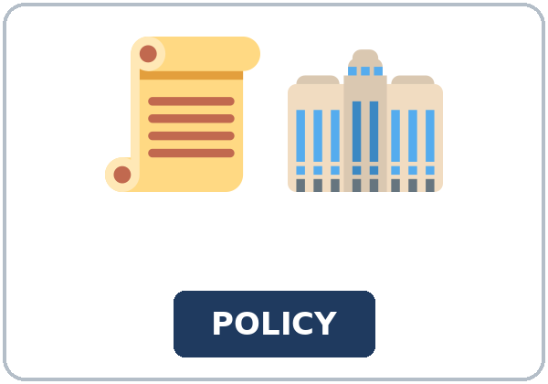  ★ policy | 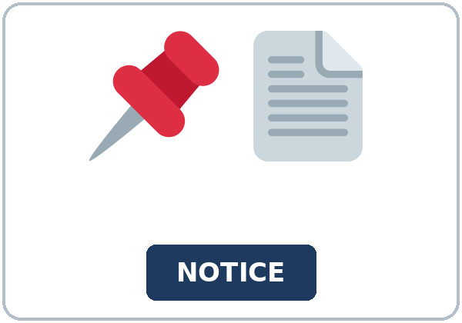  ★ notice | 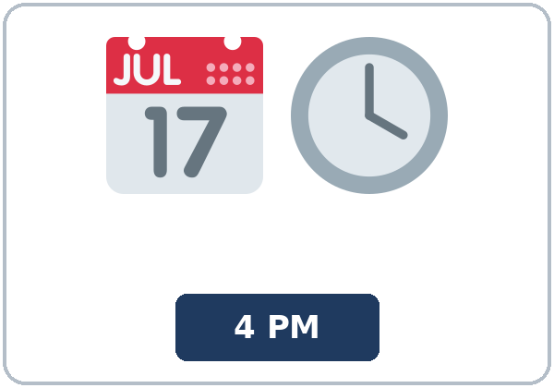  ★ appointment | 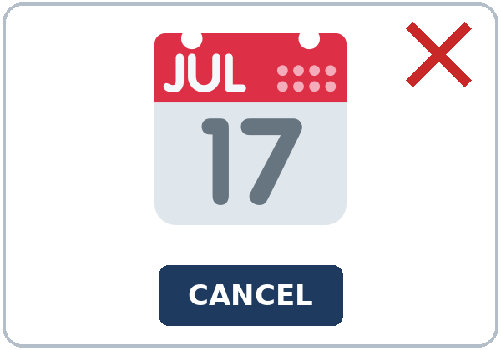  ★ cancel
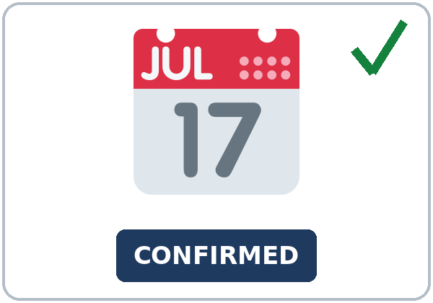  ★ confirm | 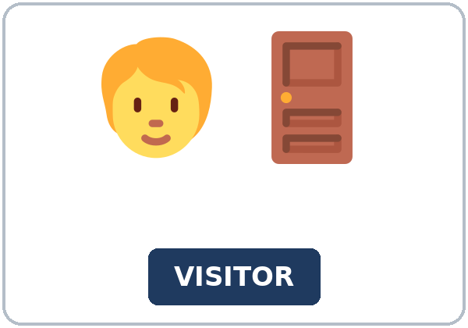  ★ visitor | 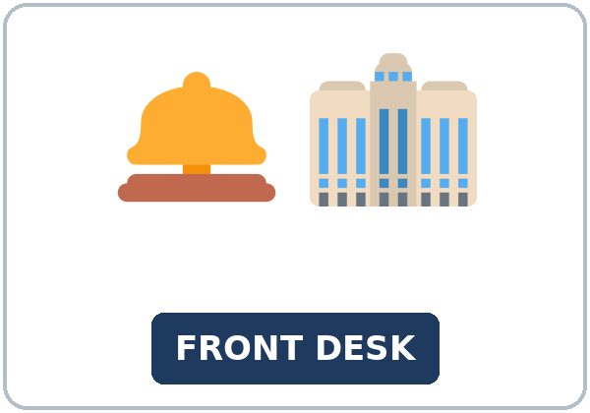  ★ front desk | 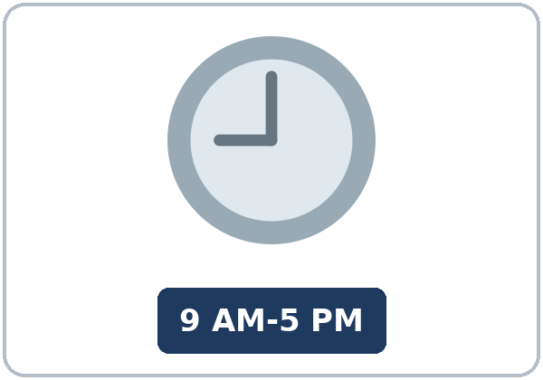  ★ office hours
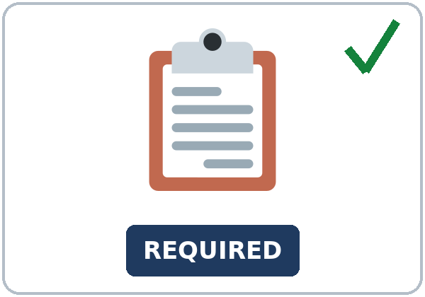  ★ requirement | 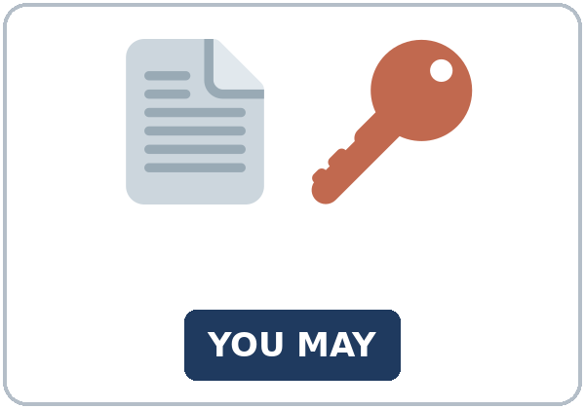  ★ permission |   exception |   visitor badge

Partner game: Point and ask.
Example: A points to a picture and asks: "visitor: What does a visitor wear?" B answers: "A visitor badge." Switch.
Lesson 4 (Week 4) · Listening
Andre did not call first. Helen explains the rule, and Mei says he can wait.
A. Listen. Can Andre go in now? Circle.
a. Yes, he can go in b. No, not unless he calls c. The office is closed
B. Listen again. True or false? Circle.
1. He called this morning. (true / false)
2. He must wear a visitor badge. (true / false)
3. He can wait as long as the group finishes. (true / false)
4. A guest is OK if he tells the desk. (true / false)
5. Office hours end at four. (true / false)
6. Even though he is on time, he must confirm. (true / false)
C. Listen again. Write unless, as long as, or even though.
1. You can't go in ____________ you call first.
2. ____________ you are on time, you still need to confirm.
3. You can wait ____________ the group finishes on time.
4. You can bring a guest ____________ you tell the front desk.
5. ____________ you confirm, the desk cannot make an exception.
6. The room is closed ____________ they finish on time.
Hear it, say it
gonna and wanna are short forms. This listening uses the full forms. You can say want to and going to. Say each line two times.
I want to go to the four o'clock meeting. • I am going to call tomorrow. • You can't go in unless you call first. • You can wait as long as the group finishes.
unless — stress the second syllable. as long as — say it as one chunk.
Lesson 4 (Week 4) · Grammar
Read across. The left side is the sentence. The right side is the meaning.
Grammar Box 1: unless means if not
SENTENCE | MEANING
You can't go in unless you sign the book. | if you do not sign
You can't go in unless you call first. | if you do not call
Unless you confirm, they will not hold the room. | present verb after unless

Grammar Box 2: as long as
SENTENCE | MEANING
You can bring a guest as long as you tell the desk. | only if you tell them
You can wait as long as the group finishes on time. | only if that stays true
As long as you call first, they will hold the room. | present verb, same as if

Grammar Box 3: even though
SENTENCE | MEANING
Even though the office is busy, you still need an appointment. | the result happens anyway
Even though you are on time, you still need to confirm. | on time does not change the rule
Even though you have permission, you still sign the book. | permission is not enough

Grammar Box 4: have to, must, and if
SENTENCE | MEANING
You have to sign the book. | a requirement
You must wear the visitor badge. | a requirement
If you call first, they will hold the room. | if + present, then will

Rule of thumb: unless means if… not. As long as means "only if this stays true." Even though means the result happens anyway.
Questions and answers
Q: Can I say Unless you will call?
A: No. Use the present: Unless you call.
Q: What does as long as mean?
A: Only if this stays true.
Q: What does even though mean?
A: The result happens anyway.
Practice A: Write unless, as long as, or even though.
1. You can't go in ____________ you sign the book.
2. You can bring a guest ____________ you tell the front desk.
3. ____________ the office is busy, you still need an appointment.
4. ____________ you call first, they will not hold the room.
5. You still sign the book ____________ you have permission.
6. They will hold the room ____________ you confirm.
Practice B: Circle the correct words.
1. Unless you (call / will call) first, you can't go in.
2. As long as you (tell / will tell) the desk, you can bring a guest.
3. Even though he is on time, he (still must / doesn't) confirm.
4. You (must / must to) wear the visitor badge.
5. If you call first, they (hold / will hold) the room.
6. You have to sign (unless / even though) you already have permission.
Common mistakes
✗ Don't say | ✓ Say
Unless you will call, they will not hold the room. | Unless you call, they will not hold the room.
As long as you will tell them, you can bring a guest. | As long as you tell them, you can bring a guest.
Even though the office is busy, but you need an appointment. | Even though the office is busy, you still need an appointment.
You must to wear the badge. | You must wear the visitor badge.
If you will call first, they will hold the room. | If you call first, they will hold the room.

Lesson 4 (Week 4) · Talk Time: Notice Sort
Round 1. Match each strip to unless, as long as, or even though. Say the rule in your own words.
Strip | Word
1. You can't go in unless you call first.
2. You can wait as long as the group finishes on time.
3. Even though you are on time, you still need to confirm.
4. Unless you sign the book, you can't go in.
5. You can bring a guest as long as you tell the front desk.
6. Even though the office is busy, you still need an appointment.

Lesson 4 (Week 4) · Talk Time: Ask the Desk
Round 2. A is the front desk. B asks one question. A answers with the rule. Then switch.
B can ask: What happens unless I call? • Can I bring a guest? • Do I still need an appointment if I am on time?
A answers with unless, as long as, or even though.
My question | My partner's answer

Useful: Can you say that again, please? • Where is that on the notice?
Lesson 4 (Week 4) · Homework
Homework (about 15–20 minutes). Bring it next week!
1. Write three sentences: one with unless, one with as long as, and one with even though.
1. ______________________________________________
2. ______________________________________________
3. ______________________________________________
2. Finish your 6-sentence note from Read & Write C. Use unless once and as long as once.
☐ I finished it. ☐ I used unless. ☐ I used as long as.
3. Write one polite question about a class rule. Do not write about a real job problem.
______________________________________________
4. Review. Write have to or must.
1. You ____________ sign the book.
2. You ____________ wear a visitor badge.
Lesson 4 (Week 4) · Read & Write
A. Read the policy and the notice. Read fast first. Then read again and answer the questions.
VISITOR POLICY · a class example
Please read this policy before you go to the front desk. The office and the rules on this page are invented for class.
A visitor needs an appointment. You can't go in unless you call first. Call the front desk during office hours. Office hours are nine to five, Monday to Friday. If you call first, the front desk will hold the room until your time. Unless you confirm, they will not hold the room.
When you arrive, you have to sign the book. Write your name and the time. You must wear a visitor badge. Wear the badge where people can see it. Give it back at the front desk when you leave. A badge is not a key. It only shows that you signed in.
You can bring one guest as long as you tell the front desk before you come. Tell them the guest's name. The guest has to sign the book. The guest must wear a badge too. You cannot bring a guest unless the desk says yes. Two guests are too many for one visit.
Even though the office is busy, you still need an appointment. Even though you are on time, you still need to confirm. A busy lobby does not change the rule. A call the day before is best. A call the same morning is OK as long as someone answers the phone.
There is one exception. A worker who already has permission from the front desk may walk a visitor to the desk. The visitor still has to sign the book and wear a badge. Permission is not the same as an appointment. Unless you confirm, the desk cannot make an exception for a meeting room. The exception is for the walk to the desk, not for the room.
If you need to cancel, call the front desk. Say your name and the time. Do not ask a friend to cancel for you unless you cannot call. If you do not understand a requirement, ask one polite question. You can say, "What happens unless I call?" The person at the desk will point to the notice and explain the rule.
Keep the policy near the door. Read the notice again if you are not sure. The front desk can repeat a rule. They cannot change the policy during your visit. Write the two rules you need in a note to a coworker, and ask the desk if a word is not clear.

BUILDING NOTICE · six lines
1. Office hours are nine to five.
2. You can't go in unless you sign the book.
3. You must wear a visitor badge.
4. You can wait in the lobby as long as a meeting is still in the room.
5. Even though the lobby is open, the offices close at five.
6. Ask the front desk if you do not understand a rule.

B. Answer the questions.
1. Go in without calling first? ______________________________________________
2. What must a visitor wear? ______________________________________________
3. When can you bring a guest? ______________________________________________
4. What are the office hours? ______________________________________________
5. Who explains a rule? ______________________________________________
C. Write a 6-sentence note to a coworker. Explain two rules. Use unless once and as long as once. Invented details are fine.
Example: You can't go in unless you call first. You have to sign the book. You must wear a visitor badge. You can bring a guest as long as you tell the front desk. Even though the office is busy, you still need an appointment. If you are not sure, ask the front desk.
My note

Lesson 4 (Week 4) · Exit Ticket
Name: ______________________________ Date: ________________
Explain one rule from tonight. Four sentences. Then give this page to your teacher.
Sentence 1: the rule • Sentence 2: unless or as long as • Sentence 3: an example • Sentence 4: who to ask if you are not sure
My answer
1.
2.
3.
4.

For the teacher | ✓ | almost | not yet
Four sentences, today's grammar, a person to ask | ☐ | ☐ | ☐

Picture Credits
Pictures use Twemoji graphics by Twitter, Inc. and other contributors (https://github.com/jdecked/twemoji), licensed under CC BY 4.0 (https://creativecommons.org/licenses/by/4.0/). The graphics were resized and combined, and signs and labels were added. The file-by-file list is in images/CREDITS_L5_L4.md.
Listening audio (L5_L4_listening.mp3, 1:48): synthetic voices made with Chatterbox TTS (MIT License), cloned from short synthetic reference clips made with Kokoro-82M (Apache License 2.0). No recordings of real people. Andre, Helen, and Mei are invented names. The story is invented.
Course materials: © 2026 the authors, licensed under CC BY-NC-SA 4.0 (https://creativecommons.org/licenses/by-nc-sa/4.0/).

