Level 5 Adult ESL Curriculum · Lesson 7 (Week 7): You Sent It, Didn't You?
Status: Published. Listening audio, lesson pages, and teacher slides are ready.
Date: October 2026
Audience: Program coordinators and volunteer teachers
Companion files: images/ (12 vocabulary pictures + images/CREDITS_L5_L7.md). Listening audio is recorded (about 1:30).
Topic: Confirm the details on a class registration: spelling, email, day, and phone number. The tag means "I think this is right. Please confirm." The forms use a class ID only.

How this lesson is organized
Part | What's inside | Who uses it
Teacher Plan | At a glance, clock-time plan, step-by-step boxes, listening script, answer key, teacher notes | Volunteer teachers
Student Pages | Opening Talk, New Words, Listening, Grammar, Talk Time, Homework, Read & Write, Exit Ticket. Print this part for learners | Learners
Picture Credits | Picture, audio, and license credits | Coordinators

What Lesson 7 builds on and what it adds
Before (review only) | Where | New in Level 5 Lesson 7
said, told, and asked | Lesson 6 | A tag that checks a detail you think is true
Short answers: Yes, I did. / No, it isn't. | Earlier levels | The short answer stays positive when the real answer is yes
Polite corrections | Everyday talk | Actually, plus the right detail

TEACHER PLAN
Lesson 7 (Week 7)

You Sent It, Didn't You?
At a glance · Clock-time plan · Step by step · Script and answer key

How to Use This Plan
Teach in English. Show, point, and gesture. The common mix-up is a row in the mistakes table. There is no separate tip to translate.

Instructions: use the same short task words every week: Listen. Circle. Check. Write. Work with a partner. Work in a group. Ask a follow-up question. Give a reason.

Instruction rule: Model it (do it with one learner while everyone watches), check it (ask: "Positive statement or negative? What tag?"), then go. Say less, show more.

Grouping toolkit: Pairs: turn to a neighbor; with an odd number, make one group of 3. Groups: 3–4 learners. The teacher joins a pair only if one learner is left over.

When a learner is stuck: (1) show it: the picture, a gesture, or the board; (2) give one more short English example; (3) point to the grammar box; (4) a classmate can help for a few seconds, then back to English.

Four sentences on the exit ticket: two of them are tags, and one is a correction or one Yes, it is.

Lesson 7 (Week 7): You Sent It, Didn't You?
At a glance
By the end of class, you can do these four things.
Today you will: Add a tag to a statement I think is true. Answer a tag with a short yes or no. Write a confirmation email.
Now you can: Add a tag to a statement I think is true. Answer a tag with a short yes or no. Write a confirmation email.
Objectives: learners can…
• I can add a tag to a statement I think is true.
• I can answer a tag with a short yes or no.
• I can correct a wrong detail politely.
• I can write a confirmation email.

Materials
• Student Pages for Lesson 7 (print for the number expected + 3 spares)
• Board and markers
• Two copies of the Detail Check form on the Talk Time page (one says Tuesday; one says Wednesday)
• Listening: phone + small speaker. The audio is recorded (about 1:30). No speaker? Read the script aloud with a volunteer.
• Prep time: 15 minutes (read the plan; mark one wrong detail on a desk copy; practice the falling tag).

Key vocabulary (with pictures on the New Words page)
★ spelling • ★ email address • ★ phone number • ★ schedule • ★ signature • ★ form • ★ checkbox • ★ correction • ★ double-check • ★ copy • initial • capital letter
Also: class ID, confirm, mismatch, evening class, community center desk.

Clock-time plan
Times are loose. If the listening or Talk Time runs long, take the time from Read & Write.
Time | Step | Min | Grouping (15 / 7–8) | If running behind
6:00–6:06 | Opening Talk + Homework Check | 6 | Pairs (7 pairs + 1 trio / 3–4 pairs) | One card only
6:06–6:12 | New Words (picture page) + pair game | 6 | Whole class, then pairs | Teach the ★ words only
6:12–6:32 | Listening: play 1 (Task A), play 2 (Tasks B and C) + "Hear it, say it" | 20 | Individuals, then pairs check | Do Task C together on the board
6:32–6:45 | Grammar Q&A: tag questions + pair check | 13 | Whole class, then pairs | Skip the pair check; Talk Time practices it
6:45–7:00 | BREAK | 15
7:00–7:18 | Talk Time: Detail Check + Read-Back | 18 | Pairs, swap forms once / pairs | Round 1 only
7:18–7:25 | Read & Write: a form, an email, and a correction | 7 | Pairs read, then individual writing | Reading questions only; the writing becomes homework
7:25–7:30 | Exit Ticket + Homework | 5 | Individuals | Never skip

Skip order if you're running behind: (1) the Read & Write writing task (it becomes homework); (2) the pair check at the end of Grammar; (3) the second round of Talk Time. Never skip: the listening tasks, the grammar box and the mistakes table, and the exit ticket.

Attendance (15 → 7–8 → 5 or fewer): with 5 or fewer, sit at one table. For Talk Time, use one form, and you read a wrong detail.

Step by step
Step 1 · 6:00–6:06 · Opening Talk + Homework Check · 6 min
• Grouping: pairs, the same partner for both parts. 15 learners: 7 pairs + 1 group of 3. 7–8 learners: 3–4 pairs. 5 or fewer: pairs, or one group with you.
• Before class: write on the board: She said… / She told me… / She asked me to… / She asked if…
• Opening Talk: A asks last week's question. B answers with a short summary. The quote can be from Lesson 6, not from a classmate's private life.
• Model with one learner: "The nurse said the checkup was on Thursday. She told me the time had changed. She asked me to call before 3:00. She asked if Thursday was OK."
• Homework Check: pairs read one sentence from the Lesson 6 message. Write 2 corrections on the board (often said me and told that). No names.
• If behind: one card only.

Step 2 · 6:06–6:12 · New Words · 6 min
• Grouping: whole class, then pairs. Show the New Words page.
• Do: point to each picture and say the word. Learners repeat once. ★ = the most important words.
• Show the hard words: email address (not the message, the address) • signature (your name in writing) vs. initial (the first letters only) • checkbox (a small box you mark) • double-check (look a second time) • capital letter (L, not l).
• Check the Meaning: 1. Is this a phone number or an email address? (an email address) • 2. What small box do you mark on a form? (a checkbox) • 3. Is the L in Leah small or capital? (capital).
• Partner game: Check the form! A points to a picture. B names it and uses it in one sentence. Switch. 15 learners: then 3 teams. 7–8: 2 teams. 5 or fewer: one team against the clock.
• If behind: teach the ★ words only.

Step 3 · 6:12–6:32 · Listening + "Hear it, say it" · 20 min
• Grouping: individuals, then pairs check. With 5 or fewer, check together as a group.
• Before you listen: "Leah is at a community center desk. She wants to check her evening-class form with Mr. Ortiz. Listen: is every detail correct at the start?"
• Voices: Narrator, Leah, Mr. Ortiz.
• Play 1 → Task A (the main idea). Pairs compare. Check together.
• Read Tasks B and C together so learners know what to listen for.
• Play 2 → Tasks B and C. Pairs compare. Then show the answers.
• "Hear it, say it": gonna and wanna are short forms. This listening uses the full forms. You can say going to and want to. Say each line two times. The tag falls when you are only checking. A rising tag can mean a real question. This lesson practices the falling check.
• The audio is recorded (about 1:30). When it is ready, it plays the conversation once. Press play again for play 2. A third play is fine if the class needs it. Until then, read the script with a volunteer at a normal, friendly speed, two times.
• If behind: do Task C together on the board.

Step 4 · 6:32–6:45 · Grammar Q&A + pair check · 13 min
• Grouping: whole class, then pairs. The left side is the question. The right side is the answer.
• Show it: say a sure detail with a falling tag: "You sent the form, didn't you?" Nod on didn't you. Then shake your head and say, "Actually, the room is C."
• The boxes: Box 1 positive statement, negative tag. Box 2 negative statement, positive tag. Box 3 no helping verb, so do / does / did. Box 4 Actually plus the right detail.
• Rule of thumb: The tag uses the same helping verb as the statement, and it flips the yes/no. If there is no helping verb, use do / does / did.
• Questions and answers: read each Q. The class reads the A.
• Practice A and B: learners write, then pairs check. Read the Common mistakes table: "Don't say… Say…"
• Pair check: A says, "The room is A." B adds the tag: "The room is A, isn't it?" A answers, "Actually, it's room C." Then switch. 15 learners: swap partners once if time. 5 or fewer: you join one pair.
• If behind: skip the pair check. Talk Time practices it.

Break · 6:45–7:00 · 15 min
• Write on the board: Positive statement → negative tag. Negative statement → positive tag. Yes stays yes: Yes, I did.

Step 5 · 7:00–7:18 · Talk Time: Detail Check + Read-Back · 18 min
• Model it first: hold up the Tuesday copy and the Wednesday copy. Ask, "It's Tuesday, isn't it?" Answer, "Actually, it's Wednesday."
• Round 1, Detail Check (pairs): A has a form with four details. B has a slightly different copy. They confirm with tags and correct one item. 15: pairs, swap forms once. 7–8: pairs. 5 or fewer: one form, and you read a wrong detail.
• Round 2, Read-Back: B says a two-sentence confirmation. A listens and answers the tag. Then switch.
• The forms use a class ID only. Do not collect real Social Security numbers, immigration papers, bank numbers, or medical record numbers. Praise the correction, not the speed.
• If behind: round 1 only.

Step 6 · 7:18–7:25 · Read & Write · 7 min
• Grouping: pairs read and answer; individual writing. With 5 or fewer, read the email aloud together.
• Read: the registration form and Mr. Ortiz's email. One detail does not match. Say: "Read fast first. Then find the mismatch."
• Check: go over questions 1–5.
• Write: a confirmation email of 6–8 sentences that names the mismatch and the correction. This is writing check 3. Learners start in class and finish at home. After class, write one strength and one fix. No grade on the person, only on the email.
• If behind: questions 1–5 only; the writing becomes homework.

Step 7 · 7:25–7:30 · Exit Ticket + Homework · 5 min · NEVER SKIP
• Exit ticket: Confirm two details about this class. Four sentences, two of them tags, and one correction or one Yes, it is. Example: The class is on Tuesday, isn't it? Yes, it is. The room is A, isn't it? Actually, it's room C.
• Collect the pages. Sort them into yes / almost / not yet. Start next week with 2 corrections. No names.
• Homework: about 20–25 minutes. Do item 1 together: You sent the form, ______? → You sent the form, didn't you?

Listening script
1:30. The conversation plays once, so press play again for the second listen.
Audio: Play L5_L7_listening.mp3 (1:30) from a phone and a small speaker. No speaker? Read the script with a volunteer, at a normal, friendly speed. The script says going to and want to. People often say gonna and wanna; learners only need to recognize those words.

Narrator: Lesson seven. Leah is at the community center desk. She wants to check her evening-class form. Mr. Ortiz has the copy.
Mr. Ortiz: Good evening. You sent the form, didn't you?
Leah: Yes, I did. I want to double-check every line.
Mr. Ortiz: Your class ID is C42, isn't it?
Leah: Yes, it is.
Mr. Ortiz: And the email address is right, isn't it?
Leah: Yes, it is. The name starts with a capital letter. Please check the spelling.
Mr. Ortiz: I will. You wrote a phone number on line three, didn't you?
Leah: Yes, I did. I double-checked it at home.
Mr. Ortiz: The class is on Tuesday at six, isn't it?
Leah: Yes, it is. I'm going to come straight from work.
Mr. Ortiz: And the room is A, isn't it?
Leah: Actually, it isn't. The schedule says room C. Can you make that correction?
Mr. Ortiz: You're right. I'll change the room to C and initial the correction.
Leah: Thank you. My signature is on the form, isn't it?
Mr. Ortiz: Yes, it is. I'll check the box and give you this copy.
Leah: Great. I'm going to keep the copy.
Mr. Ortiz: Your friend isn't in this class, is she?
Leah: No, she isn't. This copy is only for me.
Narrator: That's the end of the listening.

Answer key
• Listening Task A: b (No. The room is wrong.)
• Listening Task B: 1 Correct, 2 Correct, 3 Correct, 4 Correct, 5 Wrong. C42 is the class ID. Tuesday at six is 6:00. The room on his copy is A; the schedule says room C.
• Listening Task C: 1 didn't you, 2 isn't it, 3 isn't it, 4 didn't you, 5 isn't it, 6 is she.
• Grammar Practice A: 1 didn't you, 2 isn't it, 3 is she, 4 don't you, 5 doesn't it, 6 didn't she.
• Grammar Practice B: 1 Yes, I did. 2 isn't it, 3 is she, 4 didn't you, 5 isn't it, 6 No, I didn't.
• Talk Time: answers will vary. One good correction: It's Tuesday, isn't it? Actually, it's Wednesday.
• Homework 1: 1 You sent the form, didn't you? 2 The class is on Tuesday, isn't it? 3 She isn't on the list, is she? 4 You need a copy, don't you? Homework 2–4: answers will vary. A good item 4: She told me to check the room.
• Read & Write B: 1 C-42. 2 Tuesday at 6:00. 3 Room C. 4 Room A. 5 The room. Writing (C): answers will vary. A good email names room A and room C and asks for the correction.
• Exit ticket: answers will vary. A good answer: "The class is on Tuesday, isn't it? Yes, it is. The room is A, isn't it? Actually, it's room C."
Teacher notes
• The forms use a class ID, an email, and an invented phone number. Do not collect real Social Security numbers, immigration papers, bank numbers, or medical record numbers.
• Praise the correction, not the speed. Actually plus the right detail is the goal.
• Falling tag: you are checking, not starting an argument. Mention that a rising tag can mean a real question. Practice only the falling check tonight.
• Reductions: the listening says going to and want to. People often say gonna and wanna. Learners only need to recognize the short forms.
• Writing check 3: on the confirmation email, write one strength and one fix. Learners keep the email in a folder.
• All names, the class, the phone number, and the email are invented.

STUDENT WORKBOOK
Lesson 7 (Week 7)

You Sent It, Didn't You?
Opening Talk · New Words · Listening · Grammar · Talk Time · Homework · Read & Write · Exit Ticket

Lesson 7 (Week 7) · Opening Talk
Student Page · Week 7
Name: ______________________________ Date: ________________
Work with a partner. A asks last week's question. B answers with a short summary. Then compare one homework sentence.
The quote can be from Lesson 6, not from a classmate's private life.
1. What did the person say? Use said or told.
2. What did the person ask you to do? Use asked me to.
3. What yes/no question did the person ask? Use asked if.
4. Homework check: read one sentence from your Lesson 6 message.
Model: The nurse said the checkup was on Thursday. She told me the time had changed. She asked me to call before 3:00. She asked if Thursday was OK.
Lesson 7 (Week 7): You Sent It, Didn't You?
Student Page · Week 7
New Words
Look. Listen. Repeat. ★ = most important words.
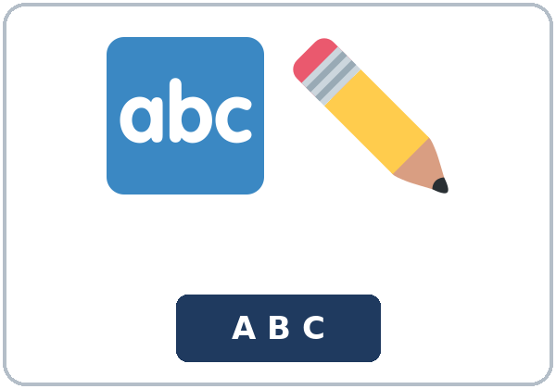  ★ spelling |   ★ email address | 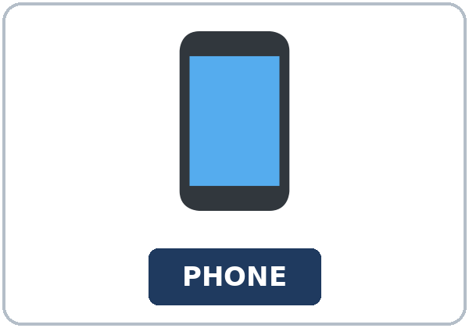  ★ phone number | 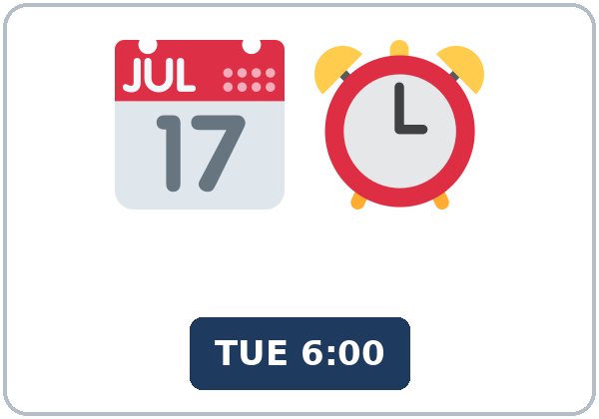  ★ schedule
  ★ signature | 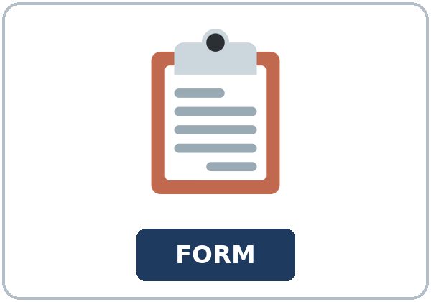  ★ form | 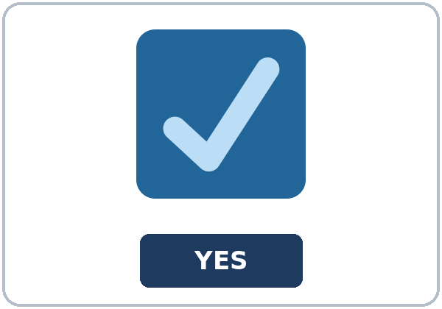  ★ checkbox | 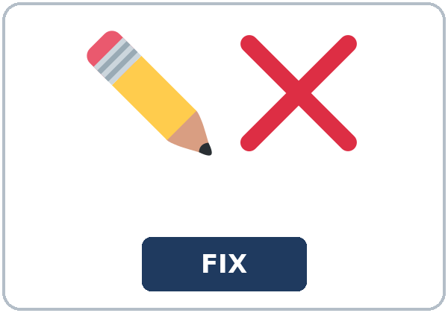  ★ correction
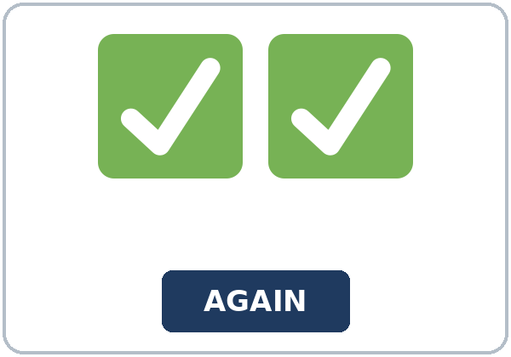  ★ double-check | 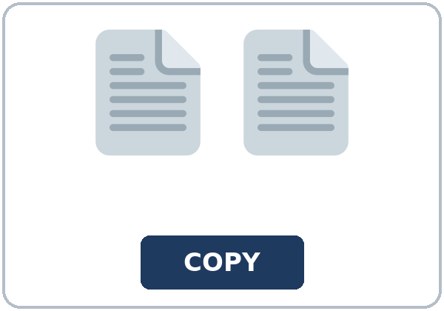  ★ copy | 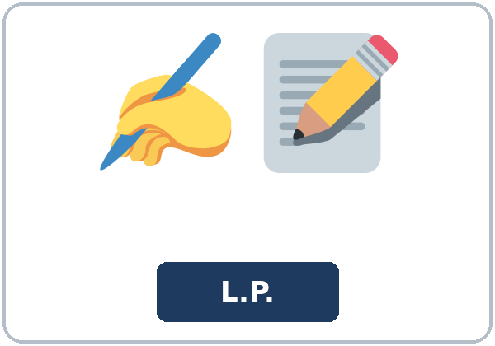  initial | 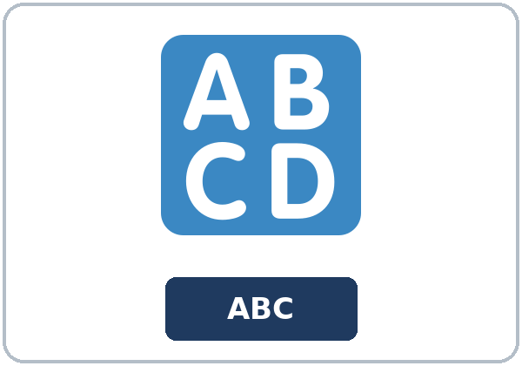  capital letter

Partner game: Check the form!
Example: A points to a picture. B names it and uses it in one sentence. "This is a checkbox. I mark the checkbox." Switch.
Check the Meaning
Look at the picture. Answer the question.
1. Is this a phone number or an email address? ______________
2. What small box do you mark on a form? ______________
3. Is the L in Leah small or capital? ______________
Lesson 7 (Week 7) · Listening
Leah is at a community center desk. She wants to check her evening-class form with Mr. Ortiz.
A. Listen. Is every detail correct at the start? Circle.
a. Yes. Every detail is correct. b. No. The room is wrong. c. She did not send the form.
B. Listen again. Mark each detail correct or wrong.
1. Class ID C-42: (Correct / Wrong)
2. Email leah@mail.example: (Correct / Wrong)
3. Day: Tuesday: (Correct / Wrong)
4. Time: 6:00: (Correct / Wrong)
5. Room on his copy: A: (Correct / Wrong)
C. Listen again. Write the tag.
1. You sent the form, ______?
2. Your class ID is C forty-two, ______?
3. The email address is leah at mail dot example, ______?
4. You wrote a phone number on line three, ______?
5. The class is on Tuesday at six, ______?
6. Your friend isn't in this class, ______?
Hear it, say it
gonna and wanna are short forms. This listening uses the full forms. You can say going to and want to. Say each line two times.
1. I want to double-check every line.
2. I'm going to come straight from work.
3. You sent the form, didn't you?
4. Actually, it isn't.
The tag falls when you are only checking. A rising tag can mean a real question. This lesson practices the falling check.
Lesson 7 (Week 7) · Grammar
Read across. The left side is the question. The right side is the answer.
Grammar Box 1: a negative tag
QUESTION | ANSWER
You sent the form, didn't you? | Yes, I did.
The class is on Tuesday, isn't it? | Yes, it is.
She signed the copy, didn't she? | Yes, she did.

A positive statement takes a negative tag. The falling tone means you are checking, not starting an argument.
Grammar Box 2: a positive tag
QUESTION | ANSWER
She isn't on the list, is she? | No, she isn't.
The room isn't A, is it? | No, it isn't.
You didn't initial it, did you? | Actually, I did.

A negative statement takes a positive tag.
Grammar Box 3: do, does, or did
QUESTION | ANSWER
You need a copy, don't you? | Yes, I do.
The schedule starts at six, doesn't it? | Yes, it does.
Leah checked the spelling, didn't she? | Yes, she did.

Rule of thumb: The tag uses the same helping verb as the statement, and it flips the yes/no. If there is no helping verb, use do / does / did.
Grammar Box 4: correct a detail
QUESTION | ANSWER
The room is A, isn't it? | Actually, it's room C.
The class is on Wednesday, isn't it? | Actually, it's on Tuesday.
Your email ends in mail.example, doesn't it? | Yes, it does.

Questions and answers
Q: The person says yes. Can I answer Yes, I didn't?
A: No. If the answer is yes, the short answer stays positive: Yes, I did.
Q: I am sure, and I only want to check. Do I say You sent it, did you?
A: No. The check on a positive sentence takes didn't: You sent it, didn't you?
Q: The statement is negative. What tag do I use?
A: A positive tag. She isn't on the list, is she?
Practice A: Write the tag.
1. You sent the form, ______?
2. The class is on Tuesday, ______?
3. She isn't on the list, ______?
4. You need a copy, ______?
5. The schedule starts at six, ______?
6. Leah checked the spelling, ______?
Practice B: Circle the correct words.
1. You sent it, didn't you? (Yes, I did. / Yes, I didn't.)
2. The room is A, ______? (isn't it / is it)
3. She isn't on the list, ______? (isn't she / is she)
4. You checked the spelling, ______? (didn't you / did you)
5. The class ID is C forty-two, ______? (isn't it / is it)
6. You didn't sign it, did you? (No, I didn't. / Yes, I didn't.)
Common mistakes
✗ Don't say | ✓ Say
Yes, I didn't. | Yes, I did.
You sent it, did you? | You sent it, didn't you?
The class is on Tuesday, doesn't it? | The class is on Tuesday, isn't it?
She isn't on the list, isn't she? | She isn't on the list, is she?
You need a copy, doesn't you? | You need a copy, don't you?

Lesson 7 (Week 7) · Talk Time: Detail Check
Round 1. A has four details. B has a different copy. Confirm with tags. Correct one item. Then swap forms once.
Model: It's Tuesday, isn't it? Actually, it's Wednesday.
Detail | Copy A | Copy B
Day | Tuesday | Wednesday
Time | 6:00 | 6:00
Room | C | C
Email | leah@mail.example | leah@mail.example

The forms use a class ID only. Invented answers are fine.
Useful: It's Tuesday, isn't it? • Actually, it's Wednesday. • Can you spell that? • Let me double-check.
Lesson 7 (Week 7) · Talk Time: Read-Back
Round 2. B says two sentences. A listens and answers the tag. Then switch.
B: The class is on Tuesday, isn't it? The room is C.
A: Yes, it is.
One sentence is a correction, or Yes, it is.
My two sentences
1.
2.

15: pairs, swap forms once. 7–8: pairs. 5 or fewer: one form, and the teacher reads a wrong detail.
Lesson 7 (Week 7) · Homework
Homework (about 20–25 minutes). Bring it next week!
1. Add the tag.
Example: You sent the form, ______? → You sent the form, didn't you?
1. You sent the form, ______? → ______________________________________________
2. The class is on Tuesday, ______? → ______________________________________________
3. She isn't on the list, ______? → ______________________________________________
4. You need a copy, ______? → ______________________________________________
2. Finish your confirmation email (Read & Write C). Read it one more time.
☐ I named the mismatch. ☐ I named the correction. ☐ I used 6–8 sentences.
3. Confirm two details with a friend or a family member. Use a tag. Write what they answered.
Tag question | Short answer
1.
2.

4. Review (said / told). Report one sentence from Lesson 6. Use said or told. Not a classmate's private life.
______________________________________________________________________________
Lesson 7 (Week 7) · Read & Write
A. Read the form and the email. One detail does not match. Read fast first. Then read again and answer the questions.
EVENING CLASS · Registration form
Please read: This form uses a class ID only. Write your class ID on the first line. Do not write any other ID number. Check the spelling of the email address. Use a capital letter when the name needs one. Write the day, the time, and the room from your schedule. If a line is wrong, ask for a correction before you sign. Sign on the signature line. Mark the checkbox after you double-check. Keep your copy. The desk keeps the other copy.
Class ID: C-42
Name: Leah
Email address: leah@mail.example
Phone number: (555) 014-2208
Class: Evening English
Day: Tuesday
Time: 6:00
Room: C
Signature: Leah
Checkbox: I double-checked the spelling. Yes.
Copy: one copy for the learner, one copy for the desk.

Email from Mr. Ortiz
Dear Leah,
Thank you for sending your form. I have your copy at the community center desk. I want to confirm the details before Tuesday. I am going to keep this email with your form.
Your class ID is C-42. Your email address is leah@mail.example. The L in Leah is a capital letter, and the spelling matches your signature. Your phone number on the form is (555) 014-2208. I double-checked it. I am not going to read it aloud.
The class is Evening English. It meets on Tuesday at 6:00. You are going to come straight from work. Please initial the schedule if you need a correction later. There is a checkbox next to the spelling line. I checked it after I looked at your capital letter.
One detail does not match. This email says the room is A. Your form says the room is C, and your schedule says the room is C. Please write back with the correction. I want to double-check with you before I change my copy.
If room C is correct, I will change the room, check the box, and initial the correction. Please bring your copy on Tuesday.
See you then.
Mr. Ortiz

B. Answer the questions.
1. What is Leah's class ID? ______________________________________________
2. What day and time is the class? ______________________________________________
3. What room is on the form? ______________________________________________
4. What room is in the email? ______________________________________________
5. What is the mismatch? ______________________________________________
C. Write a confirmation email (6–8 sentences). Name the mismatch and the correction.
Start: Dear Mr. Ortiz, Thank you for your email. The room on my form is C. Your email says room A.
My email

D. Check your writing with a partner.
 | Yes | Not yet
It has 6–8 sentences. | ☐ | ☐
It names the mismatch (room A and room C). | ☐ | ☐
It asks for the correction, or it gives the correction. | ☐ | ☐
It uses a polite close. | ☐ | ☐

Lesson 7 (Week 7) · Exit Ticket
Name: ______________________________ Date: ________________
Confirm two details about this class. Four sentences. Give this page to your teacher.
Two of them are tags. One is a correction, or Yes, it is.
Example: The class is on Tuesday, isn't it? Yes, it is. The room is A, isn't it? Actually, it's room C.
My answer
1.
2.
3.
4.

For the teacher | yes | almost | not yet
Four sentences, two tags, one correction or Yes, it is. | ☐ | ☐ | ☐

Picture Credits
Pictures use Twemoji graphics by Twitter, Inc. and other contributors (https://github.com/jdecked/twemoji), licensed under CC BY 4.0 (https://creativecommons.org/licenses/by/4.0/). The graphics were resized and combined, and signs and labels were added. The file-by-file list is in images/CREDITS_L5_L7.md.
Listening audio (L5_L7_listening.mp3, 1:30): synthetic voices made with Chatterbox TTS (MIT License), cloned from synthetic reference clips made with Kokoro-82M (Apache License 2.0). No recordings of real people. The names and the story are invented.
Course materials: © 2026 the authors, licensed under CC BY-NC-SA 4.0 (https://creativecommons.org/licenses/by-nc-sa/4.0/).

