Level 5 Adult ESL Curriculum · Lesson 3 (Week 3): I Wish I Had Asked
Status: Published. Listening audio, lesson pages, and teacher slides are ready.
Date: October 2026
Audience: Program coordinators and volunteer teachers
Companion files: images/ (12 vocabulary pictures + images/CREDITS_L5_L3.md). Listening audio: L5_L3_listening.mp3 (1:23).
Topic: Mild regrets about class, a work schedule, or a sign-up deadline. Learners say what they wish were true now, what they wish they had done, and one sentence about a different past.

How this lesson is organized
Part | What's inside | Who uses it
Teacher Plan | At a glance, the clock, steps, the listening script, the answer key | Volunteer teachers
Student Pages | Opening Talk, New Words, Listening, Grammar, Talk Time, Homework, Read & Write, Exit Ticket | Learners
Picture Credits | Picture and license lines | Coordinators

TEACHER PLAN
Lesson 3 (Week 3)

I Wish I Had Asked
At a glance · Clock · Steps · Script and answer key

How to Use This Plan
Teach in English. You do not need to speak the learners' languages. Show the picture and point to the grammar box. There is no contrast-tip box.

One main point tonight. Model it, check it, then go.

Cards stay on class, work schedules, and sign-ups. Do not grade the feeling. No cards about family loss, money trouble, or leaving a country.

Lesson 3 (Week 3): I Wish I Had Asked
At a glance
By the end of class, you can do these things.
Objectives: learners can…
• I can say I wish I had… for a past regret.
• I can say I wish I knew… for something I want now.
• I can say one If I had…, I would have… sentence.
• I can say what I will do next time.

Materials
• Student pages for Lesson 3 (print the number you expect + 3 spares)
• Board and markers
• Listening: L5_L3_listening.mp3 (1:23). Play it two times. No speaker? Read the script aloud with a volunteer.
• Prep time: 15 minutes

Key vocabulary (with pictures on the New Words page)
★ wish • ★ regret • ★ calendar • ★ reminder • ★ alarm • ★ sign-up sheet • ★ tutor • ★ practice • ★ question • ★ choice • help desk • next time

Clock-time plan
Time | Step | Min
6:00–6:06 | Opening Talk | 6
6:06–6:12 | New Words | 6
6:12–6:32 | Listening. Task A on play 1. Tasks B and C on play 2. | 20
6:32–6:45 | Grammar | 13
6:45–7:00 | Break | 15
7:00–7:18 | Talk Time | 18
7:18–7:25 | Read & Write | 7
7:25–7:30 | Exit ticket and homework | 5

Step by step
• 6:00 Opening. Work with a partner. Ask about last week. Then switch.
• 6:06 New words. Look, listen, repeat. Then the partner game.
• Check the meaning: "Is a calendar a list of dates?" (yes) • "What can wake you up?" (an alarm) • "Where can you ask for help?" (the help desk).
• 6:12 Listening. After class, Alicia and Chris talk about a workshop they signed up for late. They wish they had asked sooner. Play 1: Task A. Play 2: Tasks B and C.
• Hear it. gonna and wanna are short forms. This listening uses the full forms. Say going to and want to.
• 6:32 Grammar. Read across. A reads the question. B says the answer.
• Pair check. A says a mild regret from class. B says I wish I had… and Next time I will…. Then switch.
• 7:00 Talk Time. Round 1, then round 2. Stop at 7:18.
• Class size. 15 learners: 7 pairs + 1 group of 3. 7–8 learners: 3–4 pairs. 5 or fewer: pairs, or one group with you.
• 7:18 Read & Write. Read once. Then answer. Start the writing in class.
• 7:25 Exit. Write about one mild regret. Four sentences. Collect the page.
• Cards stay on class, work schedules, and sign-ups. Do not grade the feeling. No cards about family loss, money trouble, or leaving a country.
Listening script
Audio is recorded (about 1:23). Read it with volunteers at a natural, friendly speed. The spoken lines use going to and want to. gonna and wanna are short forms. This listening uses the full forms.
Narrator: Lesson three. After class, Alicia and Chris talk about a workshop. They signed up late.
Alicia: I want to take the workshop, but the sign-up sheet was already full.
Chris: I am going to be honest. I wish I had set an alarm.
Alicia: I wish I knew the deadline sooner. I wish I had asked the tutor on Monday.
Chris: If you had asked, you would have known.
Alicia: Yes. If I had asked, I would have known. I should have asked earlier.
Chris: I wish I had put a reminder on my calendar. The alarm on my phone was off.
Alicia: Next time I will ask on the first day.
Chris: I am going to put the reminder on the calendar tonight.
Alicia: If I had another chance, I would ask on the first day. I would not wait.
Chris: If I had set the alarm, I would have arrived on time to sign up.
Alicia: We can still practice. I want to bring one question next week.
Chris: Good. Let us ask at the help desk if we are not sure which choice to make.
Alicia: I am going to write the next step before I leave.
Narrator: They choose a next step. The regret stays small. It is only about the sign-up.
Narrator: That's the end of the listening.

Answer key
• Check the meaning: 1 yes, 2 an alarm, 3 the help desk.
• Listening Task A: b (They signed up for the workshop late.)
• Listening Task B: 1 asked the tutor, 2 set an alarm, 3 ask on the first day, 4 would have known.
• Listening Task C: 1 wish I had, 2 would have, 3 wish I had, 4 would have, 5 would have, 6 wish I had.
• Grammar Practice A: 1 knew, 2 had, 3 would, 4 should, 5 will, 6 had.
• Grammar Practice B: 1 knew, 2 had asked, 3 had asked, 4 should have asked, 5 will ask, 6 would ask.
• Read & Write B: 1 The workshop sign-up., 2 I wish I knew the deadline., 3 I wish I had asked the tutor., 4 If I had asked, I would have known., 5 Ask on the first day..
• Exit ticket: answers will vary. A good answer uses tonight's grammar.
Teacher notes
• Cards stay on class, work schedules, and sign-ups. Do not grade the feeling. No cards about family loss, money trouble, or leaving a country.
• Any next step with a reason is a good answer.
• Reductions: the listening says going to and want to. People often say gonna and wanna. Learners only need to recognize the short forms.
• All names, places, and numbers are invented.

STUDENT WORKBOOK
Lesson 3 (Week 3)

I Wish I Had Asked
Opening Talk · New Words · Listening · Grammar · Talk Time · Homework · Read & Write · Exit Ticket

Lesson 3 (Week 3) · Opening Talk
Name: ______________________________ Date: ________________
Work with a partner. Ask about last week. Then switch.
1. What had you already finished before class?
2. Say one earlier event with had.
3. Say the later event with by the time.
4. Homework check: read one sentence from your Lesson 2 note.
Lesson 3 (Week 3): I Wish I Had Asked
Name: ______________________________ Date: ________________
New Words
Look. Listen. Repeat. ★ = most important words.
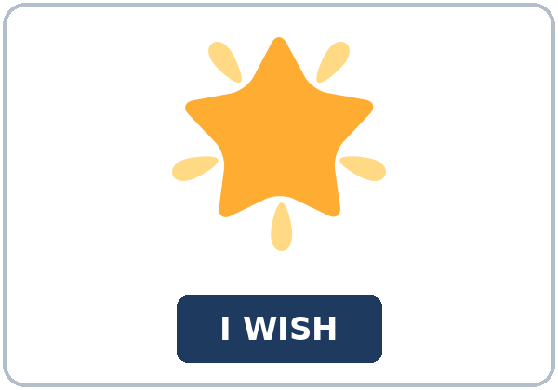  ★ wish | 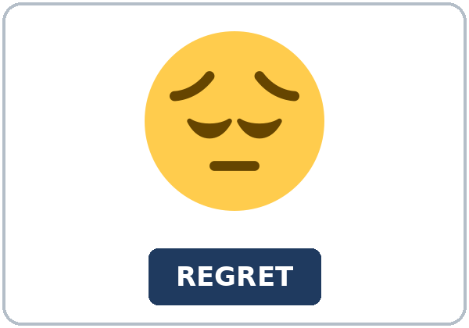  ★ regret | 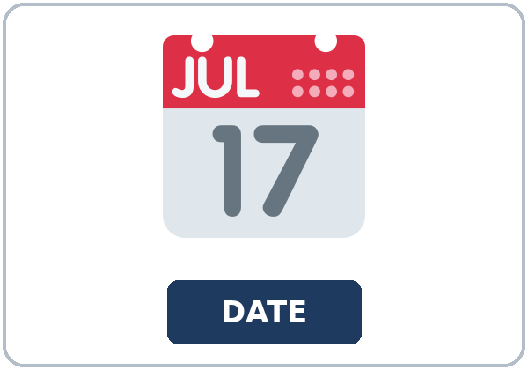  ★ calendar | 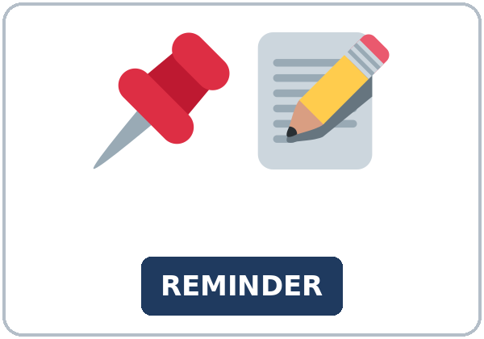  ★ reminder
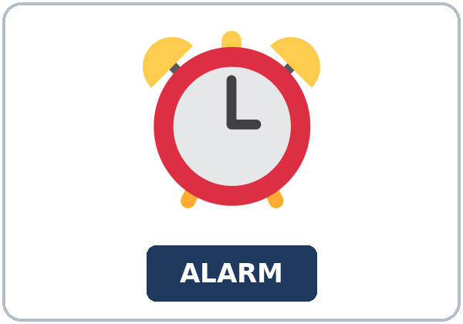  ★ alarm | 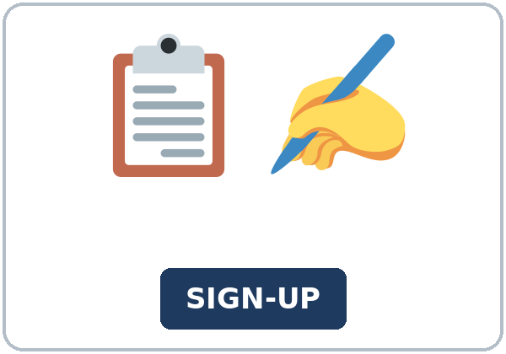  ★ sign-up sheet | 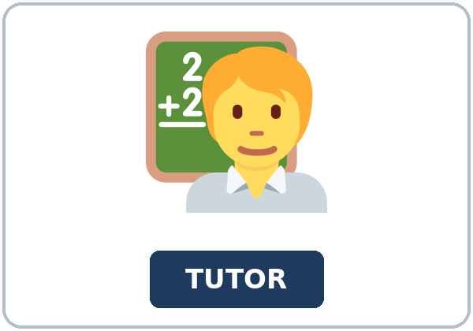  ★ tutor | 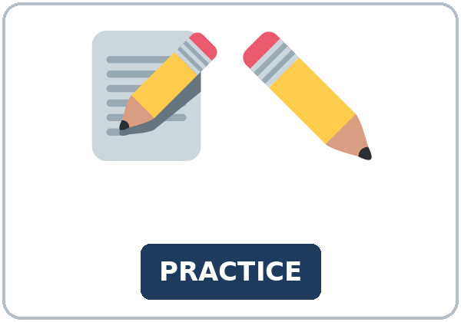  ★ practice
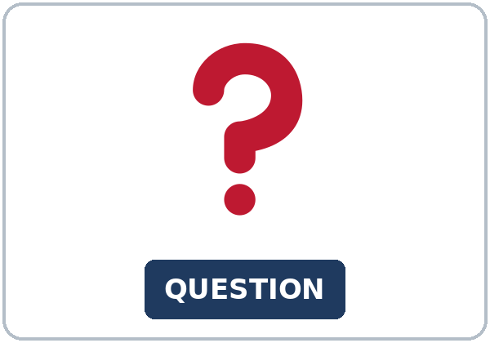  ★ question | 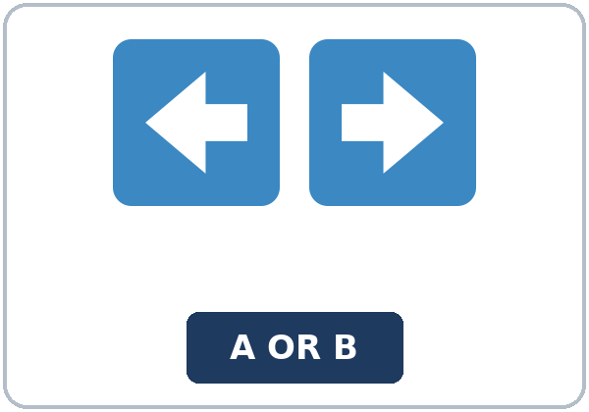  ★ choice | 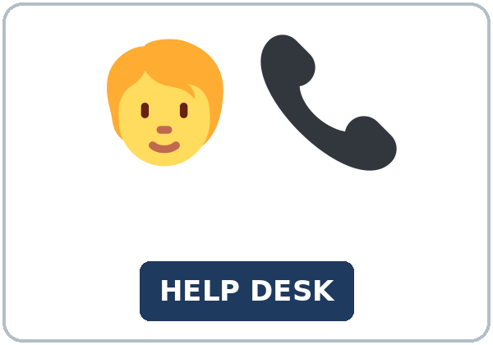  help desk | 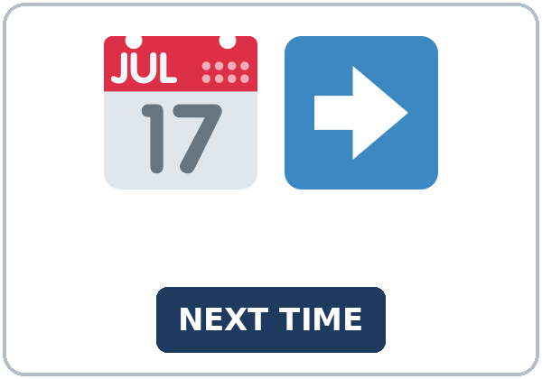  next time

Partner game: Point and wish
Example: A points to a picture. B names it and uses it in one sentence. Then switch.
Lesson 3 (Week 3) · Listening
After class, Alicia and Chris talk about a workshop they signed up for late. They wish they had asked sooner.
A. Listen. What do they regret? Circle.
a. They lost a book. b. They signed up for the workshop late. c. They want to leave the class.
B. Listen again. Circle the answers.
1. Alicia's wish (asked the tutor / left the class / skipped practice)
2. Chris's wish (set an alarm / changed jobs / missed the class)
3. Next time Alicia will (ask on the first day / wait a year / stay quiet)
4. The if sentence uses (would have known / will know / knew)
C. Listen again. Write wish I had or would have.
1. Alicia: "I ____________ asked the tutor."
2. "If I had asked, I ____________ known the date."
3. Chris: "I ____________ set an alarm."
4. "If I had set one, I ____________ arrived on time."
5. Alicia: "Then I ____________ known."
6. Chris: "I ____________ put a reminder on the calendar."
Hear it, say it
gonna and wanna are short forms. This listening uses the full forms. You can say going to and want to.
In I wish I had asked, say the full had. In I would ask next time, say the full would. Say each line two times.
1. I want to ask the tutor.
2. I am going to sign up on the first day.
3. I wish I had asked.
4. If I had asked, I would have known.
Lesson 3 (Week 3) · Grammar
Read across. A reads the question. B says the answer.
Grammar Box 1: a wish about now
WISH | MEANING
I wish I knew the deadline. | a wish about now
I wish I had a reminder. | had means owned
I wish I were on the list. | were, for now

Grammar Box 2: a wish about the past
WISH | MEANING
I wish I had asked the tutor. | a past regret
I wish I had set an alarm. | had + participle
I wish we had signed up on Monday. | the sign-up is finished

Grammar Box 3: one different past
IF | RESULT
If I had asked, I would have known. | one pattern
If he had set an alarm, he would have arrived on time. | same pattern
If we had read the reminder, we would have signed up. | same pattern

Grammar Box 4: should have, and next time
NOW | NEXT
I should have asked earlier. | same idea as the wish
Next time I will ask on the first day. | a plan
If I had another chance, I would ask. | next time

Rule of thumb: A wish about now uses a past verb (knew, had, were). A wish about the past uses had + participle. After If I had + participle, the other half is would have + participle.
Practice A: Write the missing word.
1. I wish I ____________ the deadline.
2. I wish I ____________ asked the tutor.
3. If I had asked, I ____________ have known.
4. I ____________ have asked earlier.
5. Next time I ____________ ask on the first day.
6. I wish I ____________ a reminder.
Practice B: Circle the correct words.
1. I wish I (knew / know)
2. I wish I (had asked / would have asked)
3. If I (had asked / would have asked)
4. I (should have asked / should asked)
5. Next time I (will ask / would have ask)
6. If I had another chance, I (would ask / would have asked)
Common mistakes
Don't say | Say
I wish I would have asked. | I wish I had asked.
If I would have asked, I would have known. | If I had asked, I would have known.
I wish I know the deadline. | I wish I knew the deadline.
I should asked earlier. | I should have asked earlier.

Pair check
A says a mild regret from class. B says I wish I had… and Next time I will…. Then switch.
Lesson 3 (Week 3) · Talk Time: Wish Cards
Round 1. Pairs. Use a mild card from class or a sign-up.
1. I missed the sign-up.
2. I did not ask for the example.
3. I arrived after the explanation.
Lesson 3 (Week 3) · Talk Time: One Different Past
Round 2. Pairs. Add one if sentence. Then switch.
1. Say If I had…, I would have….
2. The group repeats the clearest sentence.
3. Name the next step.
Lesson 3 (Week 3) · Homework
Homework (about 20–25 minutes). Bring it next week!
1. Write I wish I knew and one past wish.
2. Finish the six-sentence note from Read & Write.
3. Tell a friend one next step. Write the sentence.
4. Review: had already. Write one sentence from Lesson 2.
Lesson 3 (Week 3) · Read & Write
A. Read. Read once. Then find the answers.
A note from the tutor
You missed the workshop sign-up. This note is from the class tutor. It is practice for class. It is not a grade. It is not about your family, your money, or a job. The problem is small. The sign-up date passed before you wrote your name on the sheet.
Start with a wish about now. You can say, "I wish I knew the deadline." Knew is a past form, and it talks about right now. You do not know the deadline today. You can also say, "I wish I had a reminder on my calendar." In that sentence, had means owned. It is not the regret form. A third line is, "I wish I were on the list." Were is the form we use after wish when we mean now.
Then say a wish about the past. "I wish I had asked the tutor." The asking is finished, and you are sorry you did not do it. Do not say, "I wish I would have asked." After wish, a past regret uses had plus the past participle. Had asked, had set, and had signed are the forms for tonight.
One different past is enough. "If I had asked, I would have known." The if half uses had plus a participle. The other half uses would have plus a participle. You do not need every person, and you do not need both clause orders. One clear sentence is the goal. Chris can say, "If I had set an alarm, I would have arrived on time."
You can put the same idea in a shorter line. "I should have asked earlier." That line is one row in the grammar box. It is not a new lesson. It means the same thing as the wish about the past. Use it once, then move to the next step.
Next time, make a plan you can do. "Next time I will ask on the first day." You can also say, "If I had another chance, I would ask on the first day." Put a reminder on the calendar. Set an alarm the day before. Bring one question to practice. If you are not sure which choice to make, ask at the help desk.

B. Answer the questions.
1. What did the learner miss? ______________________________________________
2. Which wish is about now? ______________________________________________
3. Which wish is about the past? ______________________________________________
4. What is the if sentence? ______________________________________________
5. What will the learner do next time? ______________________________________________
C. Write a 6-sentence note to yourself. One wish about now, one wish about the past, one If I had sentence, and what you will do next time.
Lesson 3 (Week 3) · Exit Ticket
Name: ______________________________ Date: ________________
Write about one mild regret. Four sentences.
The wish, the if sentence, what you should have done, and the next step. Then give this page to your teacher.
My answer

Picture Credits
Pictures use Twemoji graphics by Twitter, Inc. and other contributors (https://github.com/jdecked/twemoji), licensed under CC BY 4.0 (https://creativecommons.org/licenses/by/4.0/). The graphics were resized and combined, and signs and labels were added. The file-by-file list is in images/CREDITS_L5_L3.md.
Listening audio: L5_L3_listening.mp3 (1:23). The voices are computer-generated. No recordings of real people. The names and the story are invented.
Course materials: © 2026 the authors, licensed under CC BY-NC-SA 4.0 (https://creativecommons.org/licenses/by-nc-sa/4.0/).

