Level 5 Adult ESL Curriculum · Lesson 6 (Week 6): She Told Me to Call
Status: Published. Listening audio, lesson pages, and teacher slides are ready.
Date: October 2026
Audience: Program coordinators and volunteer teachers
Companion files: images/ (12 vocabulary pictures + images/CREDITS_L5_L6.md). Listening audio: L5_L6_listening.mp3 (1:41).
Topic: Pass on a short clinic message. The checkup moved to Thursday. Learners report what the nurse said, what she asked, and what to do. The message is invented and mild.

How this lesson is organized
Part | What's inside | Who uses it
Teacher Plan | At a glance, the clock, steps, the listening script, the answer key | Volunteer teachers
Student Pages | Opening Talk, New Words, Listening, Grammar, Talk Time, Homework, Read & Write, Exit Ticket | Learners
Picture Credits | Picture and license lines | Coordinators

TEACHER PLAN
Lesson 6 (Week 6)

She Told Me to Call
At a glance · Clock · Steps · Script and answer key

How to Use This Plan
Teach in English. You do not need to speak the learners' languages. Show the picture and point to the grammar box. There is no contrast-tip box.

One main point tonight. Model it, check it, then go.

This lesson is not medical advice. For a real health question, ask your clinic. In an emergency, call 911.

Lesson 6 (Week 6): She Told Me to Call
At a glance
By the end of class, you can do these things.
Objectives: learners can…
• I can report a statement with said and told.
• I can report a request with asked me to.
• I can report a yes or no question with asked if.
• I can write the message so another person can act on it.

Materials
• Student pages for Lesson 6 (print the number you expect + 3 spares)
• Board and markers
• Listening: L5_L6_listening.mp3 (1:41). Play it two times. No speaker? Read the script aloud with a volunteer.
• Prep time: 15 minutes

Key vocabulary (with pictures on the New Words page)
★ message • ★ note • ★ callback • ★ nurse • ★ clinic • ★ folder • ★ detail • ★ time change • ★ family member • ★ relay • phone log • waiting room

Clock-time plan
Time | Step | Min
6:00–6:06 | Opening Talk | 6
6:06–6:12 | New Words | 6
6:12–6:32 | Listening. Task A on play 1. Tasks B and C on play 2. | 20
6:32–6:45 | Grammar | 13
6:45–7:00 | Break | 15
7:00–7:18 | Talk Time | 18
7:18–7:25 | Read & Write | 7
7:25–7:30 | Exit ticket and homework | 5

Step by step
• 6:00 Opening. Work with a partner. Say one passive line from last week. Then switch.
• 6:06 New words. Look, listen, repeat. Then the partner game.
• Check the meaning: "What do you write a message on?" (a note) • "Where do you sit before the call?" (the waiting room) • "Who can you pass the message to?" (a family member).
• 6:12 Listening. Jana calls the clinic. Nurse Patel moves a checkup to Thursday. The call ends. At home, Jana tells her brother Ken what was said. Play 1: Task A. Play 2: Tasks B and C.
• Hear it. gonna and wanna are short forms. This listening uses the full forms. Say going to and want to.
• 6:32 Grammar. Read across. A reads the question. B says the answer.
• Pair check. A reads one direct sentence. B reports it with said, told, or asked. Then switch.
• 7:00 Talk Time. Round 1, then round 2. Stop at 7:18.
• Class size. 15 learners: 7 pairs + 1 group of 3. 7–8 learners: 3–4 pairs. 5 or fewer: pairs, or one group with you.
• 7:18 Read & Write. Read once. Then answer. Start the writing in class.
• 7:25 Exit. Report one thing someone said in class tonight. Four sentences. Collect the page.
• This lesson is not medical advice. For a real health question, ask your clinic. In an emergency, call 911.
Listening script
Audio is recorded (about 1:41). Read it with volunteers at a natural, friendly speed. The spoken lines use going to and want to. gonna and wanna are short forms. This listening uses the full forms.
Narrator: Lesson six. Jana is in the waiting room. She calls the clinic. This checkup has no symptoms. It is only a time change.
Jana: Hello. I want to check my appointment. I am going to write down every detail.
Nurse Patel: The checkup is on Thursday. The time has changed.
Jana: Thursday. I want to be sure I have it.
Nurse Patel: Please call before three o'clock. And please bring the appointment card.
Jana: I am going to call before three o'clock.
Nurse Patel: We will call you if the room changes. Is Thursday OK?
Jana: Yes. Thursday is OK.
Narrator: The call ends. Jana is home now. She tells her brother Ken. Ken was not on the clinic call.
Jana: The nurse said the checkup was on Thursday. She told me the time had changed.
Ken: What did she ask you to do?
Jana: She asked me to call before three o'clock. She asked me to bring the appointment card.
Ken: Did she ask a yes or no question?
Jana: She asked if Thursday was OK. I said yes.
Ken: Anything else?
Jana: She said they would call me if the room changes. I am going to put the note in the folder.
Ken: I can read it back. Thursday, call before three o'clock, bring the card.
Narrator: The message has who, the day, and what to do. That is enough.
Narrator: That's the end of the listening.

Answer key
• Check the meaning: 1 a note, 2 the waiting room, 3 a family member.
• Listening Task A: b (No. It moved to Thursday.)
• Listening Task B: 1 Thursday, 2 3:00, 3 the appointment card, 4 Ken, 5 the room changes.
• Listening Task C: 1 said, 2 told, 3 asked, 4 asked, 5 said, 6 asked.
• Grammar Practice A: 1 said, 2 told, 3 asked, 4 asked, 5 would, 6 me.
• Grammar Practice B: 1 said the day had changed, 2 told me the new time, 3 asked me to call, 4 if Thursday was OK, 5 would call, 6 could come.
• Read & Write B: 1 Thursday., 2 Call before 3:00., 3 The appointment card., 4 They would call if the room changes., 5 Ken, a family member..
• Exit ticket: answers will vary. A good answer uses tonight's grammar.
Teacher notes
• This lesson is not medical advice. For a real health question, ask your clinic. In an emergency, call 911.
• Do not ask about real symptoms, medicines, or family health. The nurse scene ends before the home scene starts.
• Reductions: the listening says going to and want to. People often say gonna and wanna. Learners only need to recognize the short forms.
• All names, places, and numbers are invented.

STUDENT WORKBOOK
Lesson 6 (Week 6)

She Told Me to Call
Opening Talk · New Words · Listening · Grammar · Talk Time · Homework · Read & Write · Exit Ticket

Lesson 6 (Week 6) · Opening Talk
Name: ______________________________ Date: ________________
Work with a partner. Say one passive line from last week. Then switch.
1. Say one line from the practice statement with was.
2. What was added on Tuesday?
3. What does credit mean on that page?
4. Homework check: read one budget line. Use invented numbers only.
Lesson 6 (Week 6): She Told Me to Call
Name: ______________________________ Date: ________________
New Words
Look. Listen. Repeat. ★ = most important words.
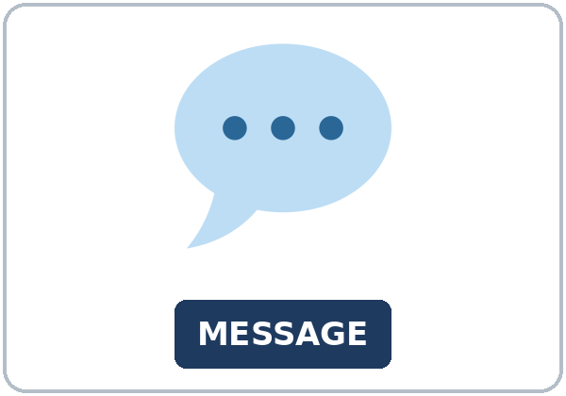  ★ message | 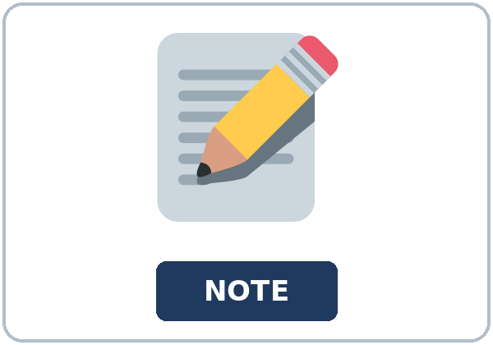  ★ note |   ★ callback | 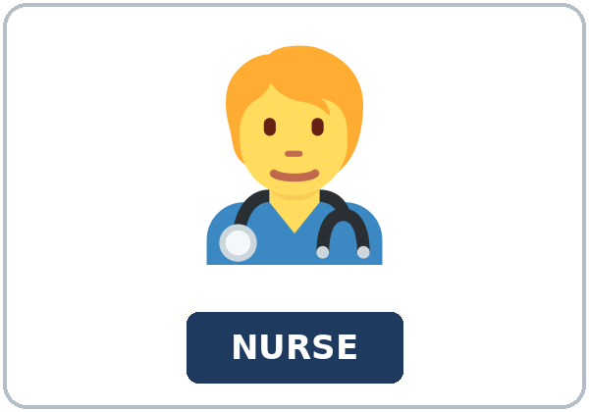  ★ nurse
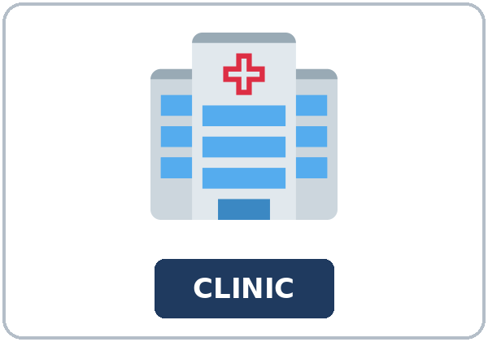  ★ clinic | 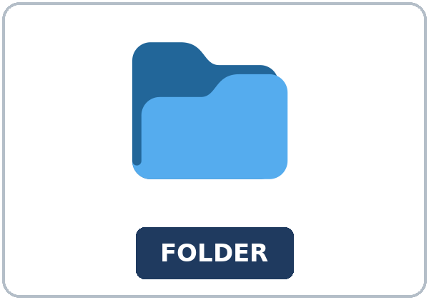  ★ folder | 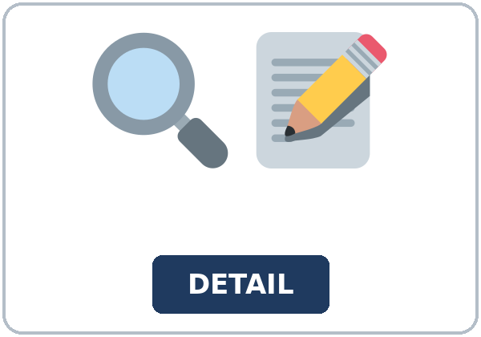  ★ detail | 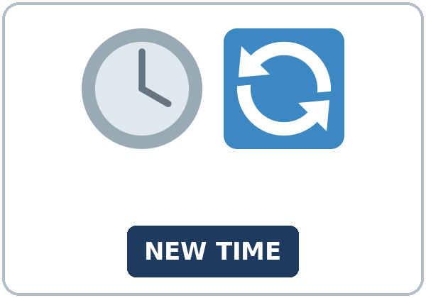  ★ time change
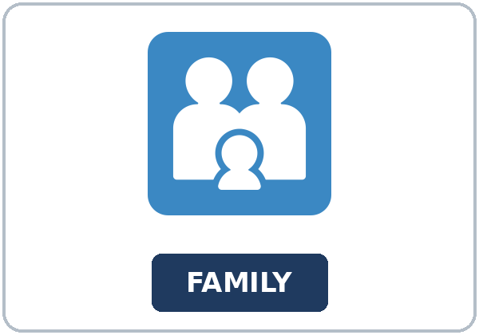  ★ family member | 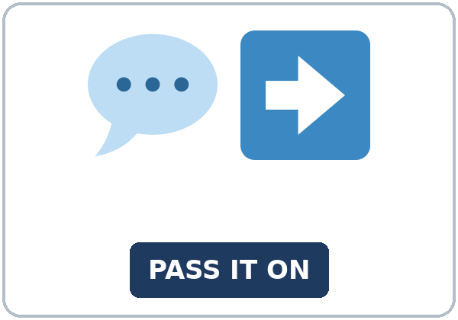  ★ relay | 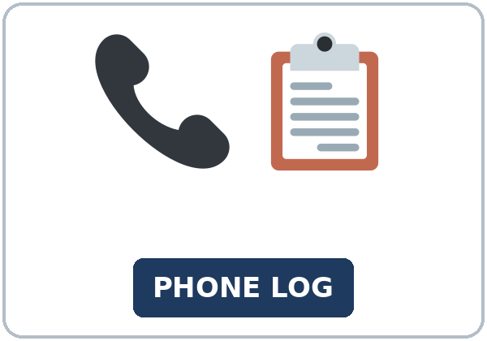  phone log | 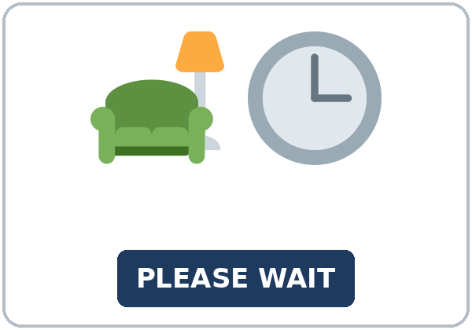  waiting room

Partner game: Pass the word
Example: A points to a picture. B names it and uses it in one sentence. Then switch.
Lesson 6 (Week 6) · Listening
Jana calls the clinic. Nurse Patel moves a checkup to Thursday. The call ends. At home, Jana tells her brother Ken what was said.
A. Listen. Did the checkup stay on the same day? Circle.
a. Yes. It stayed on the same day. b. No. It moved to Thursday. c. It was canceled.
B. Listen again. Complete the message.
1. New day (Thursday / Monday / Friday)
2. Call before (3:00 / 5:00 / 9:00)
3. Bring (the appointment card / a lunch / a photo)
4. She tells the message to (Ken / the nurse / a teacher)
5. They will call if (the room changes / the clinic closes / the class is off)
C. Listen again. Write said, told, or asked.
1. She ____________ the checkup was on Thursday.
2. She ____________ me the time had changed.
3. She ____________ me to call before 3:00.
4. She ____________ if Thursday was OK.
5. She ____________ they would call me.
6. She ____________ me to bring the card.
Hear it, say it
gonna and wanna are short forms. This listening uses the full forms. You can say going to and want to.
Said is one syllable. Link told me. If you say that, keep it weak. Say each line two times.
1. I want to write the message down.
2. I am going to call before 3:00.
3. She told me to bring the card.
4. She said they would call.
Lesson 6 (Week 6) · Grammar
Read across. A reads the question. B says the answer.
Grammar Box 1: said
DIRECT | REPORTED
The nurse said, "The checkup is on Thursday." | She said the checkup was on Thursday.
"We will call you." | She said they would call me.
She said the time had changed. | said does not need a person

Grammar Box 2: told
SAY THIS | NOTE
She told me the time had changed. | tell needs a person
She told me the checkup was on Thursday. | told me, not told to me
She told Ken the new day. | a person after told

Grammar Box 3: asked me to
REQUEST | FORM
She asked me to call before 3:00. | a request
She asked me to bring the card. | asked me to + verb
She asked me to write it in the folder. | a request

Grammar Box 4: asked if
QUESTION | REPORTED
She asked if Thursday was OK. | statement order
She asked if I could come before 3:00. | can becomes could
She asked if Ken was at home. | yes or no, then statement order

Rule of thumb: Told me, not told to me, and not said me. For a request, asked me to plus a verb. For a yes or no question, asked if plus statement order.
Practice A: Write said, told, asked, would, or me.
1. She ____________ the checkup was on Thursday.
2. She ____________ me the time had changed.
3. She ____________ me to call before 3:00.
4. She ____________ if Thursday was OK.
5. She said they ____________ call me.
6. She told ____________ the new day.
Practice B: Circle the correct words.
1. She (said the day had changed / said me the day had changed)
2. She (told me the new time / told to me the new time)
3. She (asked me to call / asked that I call)
4. She asked (if Thursday was OK / if was Thursday OK)
5. She said they (would call / will call)
6. She asked if I (could come / can come)
Common mistakes
Don't say | Say
She said me the day. | She told me the day.
She told that the time had changed. | She said that the time had changed.
She asked me if I can come. | She asked if I could come.
She told to me. | She told me.

Pair check
A reads one direct sentence. B reports it with said, told, or asked. Then switch.
Lesson 6 (Week 6) · Talk Time: Message Relay
Round 1. Groups of 3. A reads a card. B tells C. C reads it back.
1. She said the checkup was on Thursday.
2. She asked me to call before 3:00.
3. She asked if Thursday was OK.
Lesson 6 (Week 6) · Talk Time: Is It Enough?
Round 2. Groups of 3. Check the written message for who, what day, and what to do.
1. Who called?
2. What day is the checkup?
3. What should Jana do?
Lesson 6 (Week 6) · Homework
Homework (about 20–25 minutes). Bring it next week!
1. Report one sentence with said or told.
2. Finish the message for a family member. Six to eight sentences.
3. Read the message to a friend. They name the day and the task.
4. Review: one passive line from Lesson 5.
Lesson 6 (Week 6) · Read & Write
A. Read. Read once. Then find the answers.
Phone log · Monday 2:10
This page is a practice phone log. It is not medical advice. It does not name a symptom, a medicine, or a test result. The only news is a new day and time for a checkup. For a real health question, ask your clinic. In an emergency, call 911.
Phone log. Monday, 2:10. Nurse Patel called Jana, and Jana called back. The nurse said, "The checkup is on Thursday." She told Jana that the time had changed. She asked Jana to call before 3:00. She asked Jana to bring the appointment card. She asked if Thursday was OK. Jana said yes.
The nurse also said, "We will call you if the room changes." When Jana reports that sentence later, will becomes would. She said they would call her if the room changes. Say does not need a person. Tell does. Jana can say, "She told me the time had changed." She should not say, "She said me," and she should not say, "She told to me."
The call ends before Jana goes home. At home, she tells her brother Ken. Ken was not on the clinic call. Jana is the person who passes the message on. A message needs three details so another person can act: who called, what day, and what to do.
Here is the message Jana would leave. "The nurse said the checkup was on Thursday. She told me the time had changed. She asked me to call before 3:00. She asked me to bring the appointment card. She asked if Thursday was OK. She said they would call me if the room changes."
Ken reads it back. He can say who, what day, and what to do. Who: Nurse Patel. Day: Thursday. What to do: call before 3:00 and bring the appointment card. If one of those is missing, the message is not enough. Add the missing line. Do not add a symptom. There is no symptom in this log.
Write the message in six to eight sentences. Use said or told, asked me to, and asked if. The quote can be the practice message. It should not be a classmate's private life. Keep the note in the folder. Write the callback number only if it is the invented number on this page.

B. Answer the questions.
1. What day is the checkup? ______________________________________________
2. What did the nurse ask Jana to do first? ______________________________________________
3. What should she bring? ______________________________________________
4. What did the nurse say about a later call? ______________________________________________
5. Who is the message for? ______________________________________________
C. Write the message Jana would leave for a family member who missed the call. Six to eight sentences. Use said or told, asked me to, and asked if.
Lesson 6 (Week 6) · Exit Ticket
Name: ______________________________ Date: ________________
Report one thing someone said in class tonight. Four sentences.
Use said or told, and asked me to or asked if. The quote can be from the lesson. Then give this page to your teacher.
My answer

Picture Credits
Pictures use Twemoji graphics by Twitter, Inc. and other contributors (https://github.com/jdecked/twemoji), licensed under CC BY 4.0 (https://creativecommons.org/licenses/by/4.0/). The graphics were resized and combined, and signs and labels were added. The file-by-file list is in images/CREDITS_L5_L6.md.
Listening audio: L5_L6_listening.mp3 (1:41). The voices are computer-generated. No recordings of real people. The names and the story are invented.
Course materials: © 2026 the authors, licensed under CC BY-NC-SA 4.0 (https://creativecommons.org/licenses/by-nc-sa/4.0/).

