Level 3 Adult ESL Curriculum · Lesson 11 (Week 12): Bored or Boring?
Status: Complete lesson (all 13 Level 3 lessons are published).
Date: October 2026
Audience: Program coordinators and volunteer teachers
Companion files: audio/L3_L11_listening.mp3, images/ (12 vocabulary pictures, 1 activity picture + images/CREDITS.md)
Topic: community events (a festival, a concert, a fair, a museum, a workshop): how they were and how people felt, with -ing / -ed adjectives (It was boring. I was bored.), an opinion with a reason (I thought it was…, so…), and short reviews.

How this lesson is organized
Part | What's inside | Who uses it
Teacher Plan | At a glance, clock-time plan, step-by-step boxes, listening script, answer key, teacher notes | Volunteer teachers
Student Pages | Opening Talk, New Words, My Words, Listening, Grammar, Talk Time, Homework, Read & Write, Progress Check. Print this part for learners | Learners
Picture Credits | Picture, audio, and license credits | Coordinators

What Lesson 11 builds on and what it adds
Before (review only) | Where | New in Level 3 Lesson 11
How was your weekend? It was good. | Level 2 | It was exciting. / I was excited. (-ing = the thing, -ed = the feeling)
Simple past: went, saw, ate | Level 2 | Telling about an event: I went to the festival. It was fun.
because / so | Level 3 Lesson 1 | Opinions with a reason: I thought it was confusing, so I left early.
interested in | Level 3 Lesson 9 | interested (the person) vs. interesting (the thing)
Sequence words + imperatives | Level 3 Lesson 10 | Opening Talk and Homework review

TEACHER PLAN
Lesson 11 (Week 12)

Bored or Boring?
At a glance · Clock-time plan · Step by step · Script and answer key

How to Use This Plan
You don't need to speak Spanish or any other language. Teach in English. Show, point, and gesture. Each Grammar page has one short Spanish note and one tip for speakers of other languages. Learners read them on their own. You never need to read, translate, or explain them.

Instructions: use the same short task words every week: Listen. Circle. Check. Write. Work with a partner. Work in a group. Ask a follow-up question. Learners have the Task Words page from Lesson 1.

Instruction rule: Model it (do it with one learner while everyone watches), check it (ask: "Do you write or speak? How many people do you talk to?"), then go. Say less, show more.

Grouping toolkit: Pairs: turn to a neighbor; with an odd number, make one group of 3. Groups: 3–4 learners. Inside–outside circles: the inner circle faces out, the outer circle faces in; the outer circle moves one person to the right each round. Mingle: everyone stands and talks to many classmates. The teacher joins a pair only if one learner is left over.

When a learner is stuck or speaks another language to you: (1) show it: the picture, a gesture, or the board; (2) give one more short English example; (3) point to the grammar box on their page; (4) a classmate can help for a few seconds, then back to English. You don't need to understand what classmates say to each other.

Lesson 11 (Week 12): Bored or Boring?
At a glance
Objectives: learners can…
• say how something was: It was exciting. / It was boring.
• say how they felt: I was excited. / I was bored.
• choose -ing (the thing, the experience) or -ed (the person's feeling)
• give an opinion with a reason: I thought it was confusing, so I left early.
• read three short reviews and write a 3–4 sentence review with stars

Materials
• Student Pages for Lesson 11 (print for the number expected + 3 spares)
• Talk Time: the six event cards (on the Talk Time page)
• phone + small speaker, L3_L11_listening.mp3
• optional: a sheet of paper for the class "best weekend event" board
• Prep time: 5 min.

Key vocabulary (with pictures on the New Words page)
★ exciting / excited • ★ boring / bored • ★ interesting / interested • ★ confusing / confused • ★ relaxing / relaxed • ★ tiring / tired • ★ surprising / surprised • ★ festival • ★ concert • ★ museum • fair • review (stars)

Clock-time plan
Times are loose. If a step runs long, take time from Read & Write first, then from Talk Time.
Time | Step | Min | Grouping (15 / 7–8) | If running behind
6:00–6:10 | Opening Talk + Homework Check | 10 | Pairs (7 pairs + 1 trio / 3–4 pairs) | One card only
6:10–6:18 | New Words (picture page) + pair game | 8 | Whole class, then pairs | Teach the ★ words only
6:18–6:30 | Listening: play 1 (Task A), play 2 (Tasks B and C) + "Say it" | 12 | Individuals, then pairs check | Do Task C together on the board
6:30–6:45 | Grammar Q&A: -ing / -ed; How was it? How did you feel?; I thought it was… + pair drill | 15 | Whole class, then pairs | Skip the pair drill; Talk Time practices it
6:45–7:00 | BREAK | 15
7:00–7:12 | Talk Time: Star Ratings + the best weekend event | 12 | Pairs, then groups of 3–4 | Round 1 only
7:12–7:17 | Exit Ticket + Homework | 5 | Individuals | Never skip
7:17–7:25 | Read & Write: three short reviews; write a review | 8 | Individuals, then pairs | Reading questions only; the review becomes homework
7:25–7:30 | Progress Check | 5 | Individuals | Do it in Week 13 at 6:00, while people arrive

Skip order if you're running behind: (1) the Read & Write review (it becomes homework); (2) the pair drill at the end of Grammar; (3) half of Talk Time (Round 1 only). Never skip: the listening tasks, the grammar boxes and the mistakes table, and the exit ticket.

Attendance (15 → 7–8): every step lists both sizes. With 5 or fewer, do Round 1 as a circle (each person tells, the person on the left gives the stars), then Round 2 as one group.

Step by step
Step 1 · 6:00–6:10 · Opening Talk + Homework Check · 10 min
• Grouping: pairs, the same partner for both parts. 15 learners: 7 pairs + 1 group of 3. 7–8 learners: 3–4 pairs.
• Before class: write on the board: First, … Next, … Then, … Finally, …
• Opening Talk (6 min): learners open the Opening Talk page. A asks a card question; B answers with 2–3 sentences; A asks one follow-up. Switch after each card.
• Model with one learner: "How do you make your favorite food?" → (answer) → "What do you do after that?"
• Homework Check (4 min): partners read their Lesson 10 Homework item 2 (4 steps) to each other. The partner mimes the steps. Walk around. Write 2 common errors on the board (often You press or No open) and correct them together.
• Late arrivals: join any pair as a group of 3.
• If behind: one card only, then the homework check.

Step 2 · 6:10–6:18 · New Words · 8 min
• Grouping: whole class, then pairs. Show the New Words page.
• Do: point to each picture and say both words. Learners repeat once. For each pair, point to the left picture: "It was exciting." Point to the face: "I was excited."
• Show it with your face: yawn: "The movie was boring. I was bored." Look confused: "The map was confusing. I was confused."
• Check meaning (1 min): "A big event in a park with food and music is a…?" (festival) • "You see old pictures and things at a…?" (museum) • "You go to hear music at a…?" (concert)
• Pairs (2 min): A points to a picture; B says two sentences (It was relaxing. I was relaxed.). Switch.
• If behind: teach the ★ words only.

Step 3 · 6:18–6:30 · Listening + "Say it" · 12 min
• Grouping: individuals, then pairs check.
• Before you listen (1 min): say: "It's Monday. Elena and Luis are coworkers. They're talking about the weekend. Did they like their weekend events? Listen."
• Play 1 → Task A (did they like it?). Pairs compare. Check together.
• Read Tasks B and C together (1 min) so learners know what to listen for.
• Play 2 → Tasks B and C. Pairs compare. Then show the answers (answer key).
• "Say it" (2 min): say: "-ed has 3 sounds." Read: relaxed (t), bored (d), interested (id, one more syllable). The class repeats each word twice. Then the lines in the box.
• The audio plays the conversation once (about 1:17). Press play again for play 2. A third play is fine if the class needs it.
• If behind: do Task C together on the board, reading the lines yourself.

Step 4 · 6:30–6:45 · Grammar Q&A · 15 min
• Grouping: whole class, then pairs. Show the Grammar page. The left side is the question. The right side is the answer.
• Show it (2 min): draw on the board: a TV (the thing) → a face (the person). Under the TV write boring, under the face bored. Say: "-ing is the thing. -ed is the person's feeling."
• Boxes 1 and 2 (4 min): read a question from the left; the class answers from the right. Point out: It was… + -ing; I was… + -ed.
• Box 3 (2 min): an opinion + a reason: I thought it was confusing, so I left early.
• Box 4 (1 min): the -ing / -ed table; read across.
• Check questions: "The movie was ___ (bore)." (boring) • "I was very ___ (excite)." (excited) • "Were you ___ (interest)?" (interested) • "I thought it was ___ (confuse)." (confusing)
• Practice A and B (3 min): learners write, then pairs check. Go over the answers.
• Pair drill (last 2 min): A asks "How was your weekend?" B answers with one -ing and one -ed word (It was relaxing. I was relaxed.). Switch.
• If behind: skip the pair drill. Talk Time practices it.

Break · 6:45–7:00 · 15 min
• Write on the board: How was it? It was… -ing / How did you feel? I was… -ed / I thought it was…, so…

Step 5 · 7:00–7:12 · Talk Time: Star Ratings · 12 min
• Grouping: Round 1 pairs; Round 2 groups of 3–4. 15 learners: 7 pairs + 1 trio. 7–8 learners: 3–4 pairs, then 2 groups. 5 or fewer: one circle, then one group.
• Round 1 (7 min): each learner chooses an event card (1–6) or a real event (a TV show or a sports game is fine). A tells B about it: how it was, how they felt, and one reason. B asks two follow-up questions and gives it 1–5 stars in the table. Switch.
• Model with one learner (1 min): "Last Saturday, I went to the Fall Fair. It was exciting, but the lines were long, so I was tired." The learner asks: "Who did you go with? Was the food good?" → "4 stars!"
• Round 2, groups (4 min): each group chooses "the best weekend event" for the class bulletin board and agrees on two reasons (It was exciting, and it was free.). One person reports to the class.
• If behind: Round 1 only.

Step 6 · 7:12–7:17 · Exit Ticket + Homework · 5 min · NEVER SKIP
• Exit ticket: each learner writes two sentences on a slip: one with -ing and one with -ed about the same event, and a reason with because or so (The concert was exciting, so I was excited all night.). Collect at the door.
• Homework: open the Homework page. Do item 1 together (one sentence on the board). Say: "About 15 minutes. Bring it next week."

Read & Write · 7:17–7:25 · Three Short Reviews · 8 min
• Grouping: individuals, then pairs check.
• Read (3 min): learners read the three reviews and answer questions 1–5. Say: "Read fast first. Then find the answers."
• Pairs check (1 min): compare answers; check together.
• Write (4 min): learners write a 3–4 sentence review of an event (or a TV show, a movie, a game) with 1–5 stars and one reason.
• If behind: questions 1–5 only; the review becomes homework.

Progress Check · 7:25–7:30 · 5 min
• Grouping: individuals. Open the Progress Check page.
• Part A: read the 4 sentences in the answer key, slowly, 2 times each. Learners circle a or b.
• Parts B and C: learners do them alone. Walk around and help with the instructions only.
• Part D: read each "I can…" line aloud and point to the 3 faces: 😀 "I can do it." 🙂 "With a little help." 😐 "Not yet."
• Collect the pages (or check them at the start of Week 13).
• If behind: do the Progress Check in Week 13 at 6:00, while learners arrive.

Listening script: L3_L11_listening.mp3 (about 1:17; the conversation plays once, so press play again for the second listen)
Audio: play from a phone + small speaker. No speaker? Read the script with a volunteer, at a normal, friendly speed.

Narrator: Lesson eleven. Listening. It's Monday morning. Elena and Luis are coworkers. They're talking about the weekend. Listen.
Luis: Hi, Elena. How was your weekend? Did you do anything fun?
Elena: It was great! I went to the food festival at Riverside Park with my sister.
Luis: Really? How was it?
Elena: It was so exciting. There was live music, and we tried food from ten countries.
Luis: Was it crowded?
Elena: Yes, very. The lines were long, so I was a little tired at the end. How about you?
Luis: I went to a photo workshop at the city museum on Sunday. I was really interested in it.
Elena: Oh, nice! Was it interesting?
Luis: Not really. I thought it was confusing. The teacher talked very fast.
Elena: Oh no. Were you bored?
Luis: Yes, I was bored, so I left early. But the museum coffee shop was really relaxing.
Elena: Next time, come to the festival with me. You'll love it!
Luis: OK. That sounds fun. Maybe next month.
Narrator: That's the end of the listening.

Answer key
• Listening Task A: Elena (the food festival) 😀 • Luis (the photo workshop) 😐.
• Listening Task B: 1 c (exciting) • 2 a (tired) • 3 e (confusing) • 4 d (bored) • 5 b (relaxing).
• Listening Task C: 1 exciting, 2 tired, 3 interesting, 4 confusing, 5 bored, 6 relaxing.
• Grammar Practice A: 1 boring, 2 bored, 3 interesting, 4 surprised, 5 tiring, 6 confused.
• Grammar Practice B: 1 exciting, 2 excited, 3 interested, 4 confusing, 5 relaxed.
• Talk Time: answers will vary.
• Homework 1: 1 The movie was boring. 2 I was tired after work. 3 The museum was interesting. 4 She was surprised. Homework 2, 3, and 4: answers will vary.
• Read & Write B: 1 the Fall Fair (5 stars) • 2 Music in the Park (2 stars) • 3 it was confusing; the teacher talked fast, but the library helper was patient • 4 the music started late, and it was too loud, so they were tired and left early • 5 the food (the apple pie) and the rides for kids • Writing (C): answers will vary.
• Progress Check Part A (the teacher says, 2 times each): 1 "The concert was boring." → a • 2 "I was surprised." → b • 3 "The museum was interesting." → a • 4 "We were tired, so we left." → b
• Progress Check Part B: 1 exciting, 2 bored, 3 confusing, 4 relaxed.
• Progress Check Part C: answers will vary; for example 1 The festival was exciting. I was excited. 2 I thought it was boring, so I left early.
• Progress Check scoring: A /4 + B /4 + C /2 = /10. This is not a test grade. It shows who needs more help hearing the endings (A) and choosing -ing / -ed (B, C).
Teacher notes
• General events only (important): use community events, TV, movies, or sports. Learners never have to share where they spend their money or free time; the event cards are always an option.
• The one rule: -ing = the thing or the experience (The movie was boring). -ed = how the person feels (I was bored).
• Careful: I'm boring means people don't enjoy talking to me. Learners laugh when they hear it; use that.
• I thought it was… gives an opinion in the past: I thought it was confusing, so I left early. Accept I think it was… too.
• -ed sounds: /t/ after x, k, s, sh, ch, p (relaxed); /id/ after t, d (interested, one more syllable); /d/ for the rest (bored, tired, surprised). Don't teach the rule; just model and repeat.
• Typical mistakes this week: I'm boring (for bored), It was excited, I was interesting in the museum, The movie was bored, I thought was confusing. Say the right form clearly; the learner repeats. Learners can read the Spanish note and the tip on their Grammar page themselves; you don't need to explain them.
• Mixed levels: stronger learners add a second reason and a recommendation (You should go!). Newer learners use Boxes 1 and 2 as a script.

STUDENT WORKBOOK
Lesson 11 (Week 12)

Bored or Boring?
Opening Talk · New Words · Listening · Grammar · Talk Time · Homework · Read & Write · Progress Check

Lesson 11 (Week 12) · Opening Talk
Name: ______________________________ Date: ________________
Work with a partner. A asks a question. B answers with 2–3 sentences. A asks one follow-up question. Then switch.
How do you make your favorite food? | How do you send a photo on your phone?
What do you do first when you get home? | What instructions do you follow at work or at home?

Follow-ups: What do you do next? And after that? Is it easy?
Homework check: read your Lesson 10 homework (item 2) to your partner. Your partner mimes the steps.
My partner's task | The steps were in order.
 | ☐ Yes ☐ Not yet

Lesson 11 (Week 12): Bored or Boring?
Student Page 1 · Week 12
Name: ______________________________ Date: ________________
New Words
Look. Listen. Repeat. ★ = most important words. Left: the thing (-ing). Right: the person (-ed).
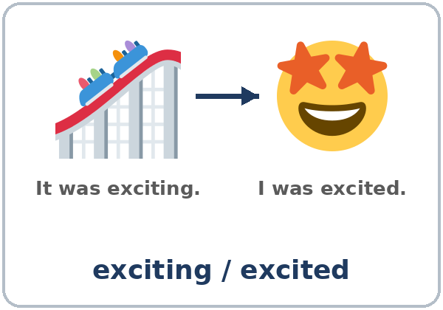  ★ exciting / excited | 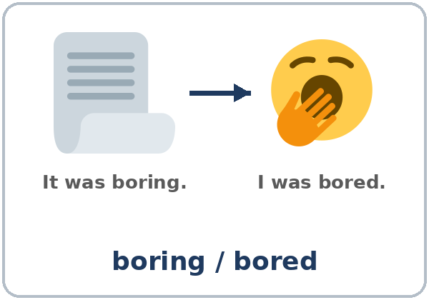  ★ boring / bored | 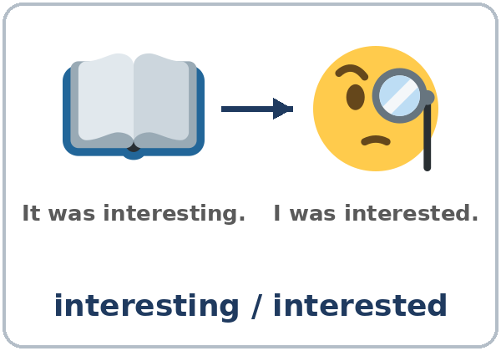  ★ interesting / interested | 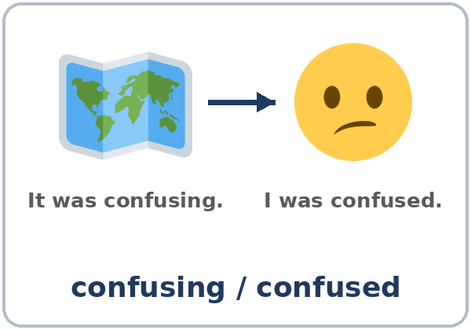  ★ confusing / confused
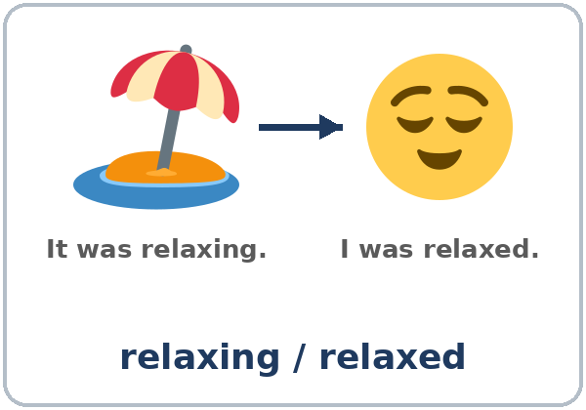  ★ relaxing / relaxed | 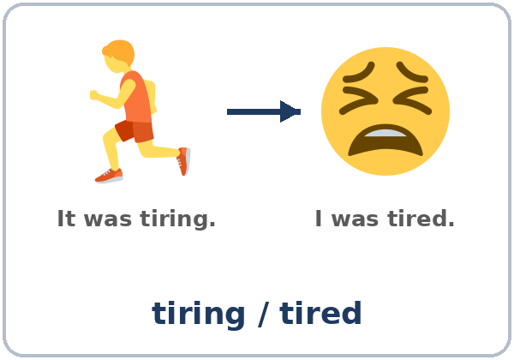  ★ tiring / tired | 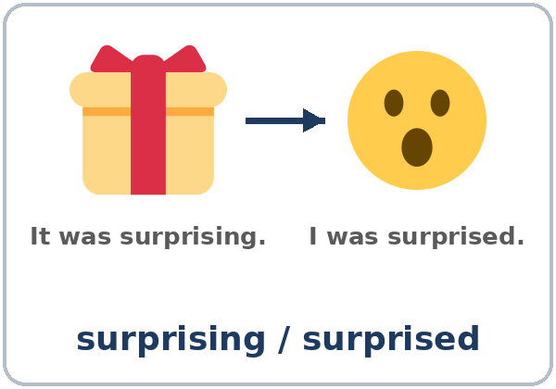  ★ surprising / surprised | 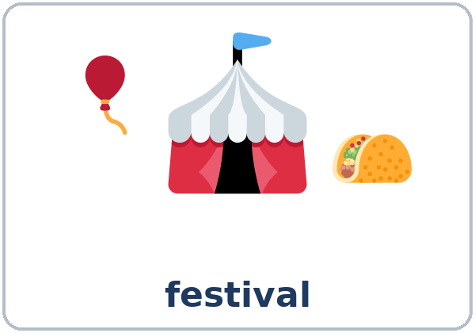  ★ festival
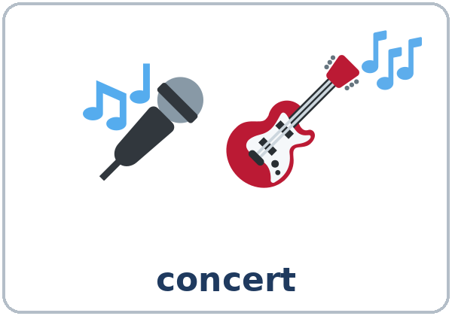  ★ concert | 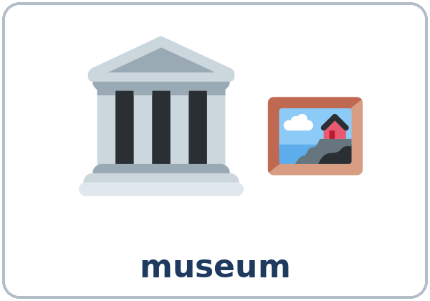  ★ museum | 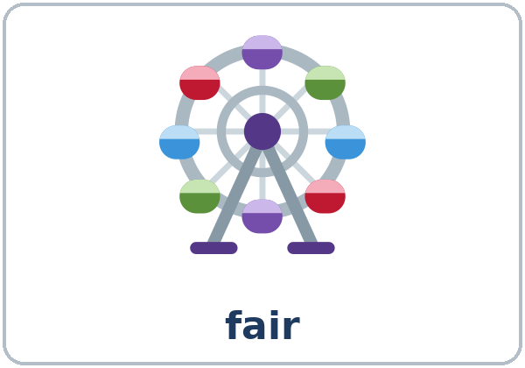  fair | 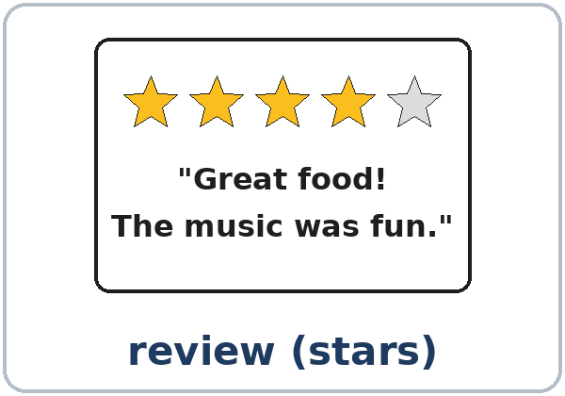  review (stars)

Partner game: A points to a picture. B says two sentences.
Example: A: (points to the beach) B: It was relaxing. I was relaxed.
Lesson 11 (Week 12) · My Words
Write each word in your language, if you want. Then write your own example.
Word | My language | My example
exciting / excited
boring / bored
interesting / interested
confusing / confused
relaxing / relaxed
tiring / tired
surprising / surprised
festival
concert
museum
fair
review (stars)

Lesson 11 (Week 12) · Listening
Listen to Elena and Luis. They're coworkers. It's Monday, and they're talking about the weekend.
A. Listen. Did they like it? Check ✓ a face.
 | 😀 | 😐
Elena: the food festival | ☐ | ☐
Luis: the photo workshop | ☐ | ☐

B. Listen again. Match. Write the letter.
Who or what? | The word
1. the food festival ____ | a. tired
2. Elena at the end ____ | b. relaxing
3. the photo workshop ____ | c. exciting
4. Luis at the workshop ____ | d. bored
5. the museum coffee shop ____ | e. confusing

C. Listen again. Write -ing or -ed.
1. It was so excit____.
2. I was a little tir____ at the end.
3. Oh, nice! Was it interest____?
4. I thought it was confus____.
5. Yes, I was bor____, so I left early.
6. But the museum coffee shop was really relax____.
Say it: relaxed (t) • bored (d) • interested (id) • I was bored, so I left early.
Lesson 11 (Week 12) · Grammar
Read across. A reads from the left side. B answers from the right side. Choose one part from each column.
Grammar Box 1: How was it? (the thing: -ing)
QUESTION |  |  | ANSWER
How was | the concert?  the festival? |  | It was | exciting!  boring.
Was the workshop | interesting? |  | Yes, it was.  No, | it was confusing.

Grammar Box 2: How did you feel? (the person: -ed)
QUESTION |  |  | ANSWER
How did you | feel? |  | I was | excited.  bored.
Were you | interested? |  | Yes, I was very | interested.
Was she | tired? |  | Yes, she was | tired at the end.

Grammar Box 3: An opinion + a reason
QUESTION |  |  | ANSWER
What did you | think? |  | I thought it was confusing, | so I left early.
Did you like | it? |  | Yes. I thought it was relaxing, | because the music was soft.

Grammar Box 4: -ing or -ed?
THE THING: It was… | THE PERSON: I was… | THE THING: It was… | THE PERSON: I was…
exciting | excited | relaxing | relaxed
boring | bored | tiring | tired
interesting | interested | surprising | surprised
confusing | confused

Questions and answers
Q: I'm boring or I'm bored?
A: I'm bored = I feel bored. I'm boring = people don't have fun with me!
Q: When do I use -ing?
A: For the thing or the experience: The movie was boring.
Q: When do I use -ed?
A: For the person's feeling: I was bored.
Q: How do I give an opinion?
A: I thought it was + -ing, + a reason: I thought it was exciting, because the music was great.
Practice A: Write -ing or -ed.
1. The class was very bor____. Everyone was sleepy.
2. I was bor____, so I went home.
3. The museum was interest____.
4. She was surpris____. It was her birthday party!
5. Work was tir____ today. I worked 10 hours.
6. The map was hard. I was confus____.
Practice B: Circle the right word.
1. The soccer game was (exciting / excited).
2. The kids were (exciting / excited).
3. Are you (interesting / interested) in art?
4. The instructions were (confusing / confused).
5. After the beach, I felt (relaxing / relaxed).
Common mistakes
✗ Don't say | ✓ Say
I'm boring. (for a feeling) | I'm bored.
The movie was bored. | The movie was boring.
I was interesting in the museum. | I was interested in the museum.
I thought was confusing. | I thought it was confusing.

Nota para hispanohablantes: en español es una palabra (aburrido); en inglés son dos: I'm bored (estoy aburrido), It's boring (es aburrido). Cuidado: I'm boring quiere decir soy aburrido.

Tip for speakers of other languages: people usually feel the -ed word. Things and experiences are the -ing word.

Lesson 11 (Week 12) · Talk Time: Star Ratings
Round 1: Work with a partner. Choose an event card (or a real event). Tell your partner how it was, how you felt, and why. Your partner asks 2 follow-up questions and gives 1–5 stars. Switch.
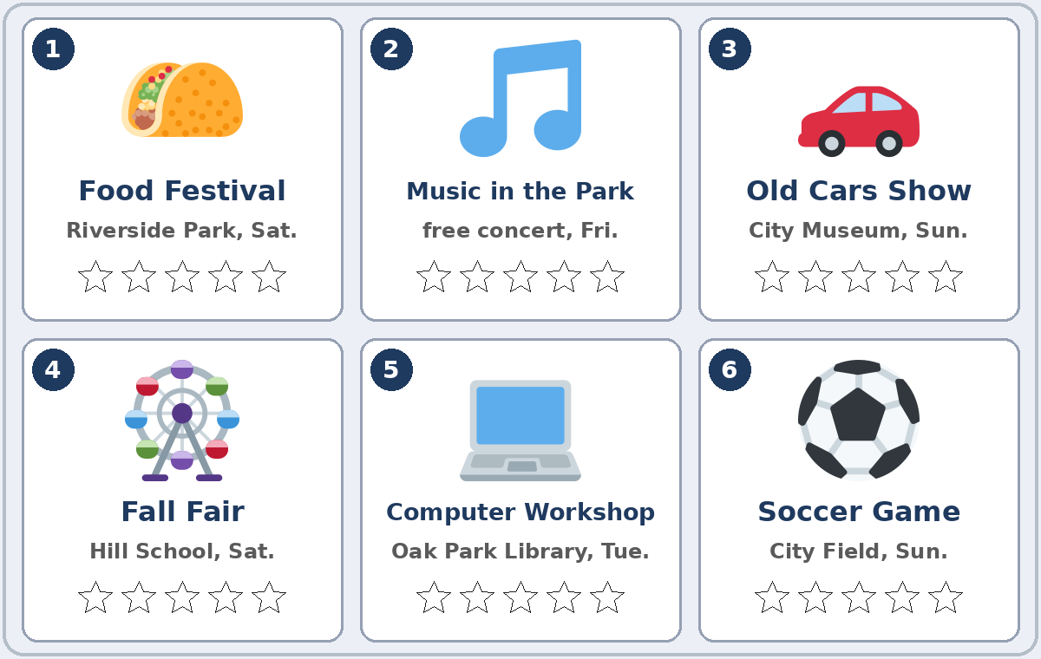

A: Last Saturday, I went to the Fall Fair. It was exciting, but the lines were long, so I was tired.
B: Who did you go with? Was the food good? … I give it 4 stars!

My partner's event | How was it? How did they feel? | Stars (1–5)
 |  | ____ / 5
 |  | ____ / 5

Round 2: In a group of 3–4, choose the best weekend event for the class board. Agree on two reasons. Our best event is… because… and…
Lesson 11 (Week 12) · Homework
Homework (about 15 minutes). Bring it next week!
1. Write the sentence. Use -ing or -ed.
Example: the game / exciting → The game was exciting.
1. the movie / bore → ______________________________________________
2. I / tire / after work → ______________________________________________
3. the museum / interest → ______________________________________________
4. she / surprise → ______________________________________________
2. Think of an event, a movie, or a game from this month. Write 3 sentences: how it was, how you felt, and why.
Example: I watched a soccer game on TV. It was exciting. I was excited, because my team won.
______________________________________________________________
______________________________________________________________
______________________________________________________________
3. Ask a family member or a coworker: What was the best event or movie this year? Why? Write the answer.
______________________________________________________________
______________________________________________________________
4. Review (Lesson 10): Write 3 steps for making a cup of coffee or tea. Use First, Then, Finally.
______________________________________________________________
______________________________________________________________
______________________________________________________________
Lesson 11 (Week 12) · Read & Write
A. Read the three reviews on the community website.
Fall Fair at Hill School · 5 stars · by Ana R.
We went on Saturday with the kids. The rides were exciting, and the apple pie was amazing. The kids were tired at the end, but very happy. It was only $5 for a family. Go next year!

Music in the Park · 2 stars · by Tom B.
I was excited about this free concert, but it was disappointing. The music started an hour late, and it was too loud. We were tired, so we left early. Maybe next time.

Computer Workshop at Oak Park Library · 3 stars · by Lin K.
I was interested in learning about email. The teacher talked very fast, so it was a little confusing. But the library helper was patient, and I sent my first email!

B. Answer the questions.
1. Which event got 5 stars? ______________________________________________
2. Which event got 2 stars? ______________________________________________
3. How was the computer workshop? Why? ______________________________________________
4. Why did Tom leave early? ______________________________________________
5. What did Ana like at the fair? ______________________________________________
C. Write a 3–4 sentence review of an event, a movie, or a game. Give it 1–5 stars. Say how it was, how you felt, and one reason.
Example: City Soccer Game, 4 stars. The game was exciting, and our team won. I was a little cold, but I was happy. The tickets were cheap, so it's great for families.
My review: __________________________ Stars: ____ / 5

D. Check your review with a partner.
 | Yes | Not yet
It has stars and the name of the event. | ☐ | ☐
It uses an -ing word for the event. | ☐ | ☐
It uses an -ed word for a feeling. | ☐ | ☐
It has one reason (because… / so…). | ☐ | ☐

Lesson 11 (Week 12) · Progress Check
Name: ______________________________ Date: ________________
A. Listen to the teacher. Circle a or b.
1. a. The concert was not fun. b. The concert was fun.
2. a. It was surprising. b. I felt surprised.
3. a. I liked the museum. b. I didn't like the museum.
4. a. They stayed until the end. b. They left because they were tired.
B. Circle the right word.
1. The game was (exciting / excited).
2. I was (boring / bored) at the meeting.
3. The instructions were (confusing / confused).
4. After the vacation, I felt (relaxing / relaxed).
C. Write.
1. An event: one -ing + one -ed sentence. ______________________________
2. An opinion: I thought it was…, so… ______________________________
Score: A ______ / 4 B ______ / 4 C ______ / 2
D. How do you feel? Check ✓ one face for each line.
I can… | 😀 I can do it. | 🙂 With a little help. | 😐 Not yet.
I can say how something was (It was interesting). | ☐ | ☐ | ☐
I can say how I felt (I was interested). | ☐ | ☐ | ☐
I can give an opinion with a reason. | ☐ | ☐ | ☐
I can write a short review. | ☐ | ☐ | ☐

Picture Credits
Pictures use Twemoji graphics by Twitter, Inc. and other contributors (https://github.com/jdecked/twemoji), licensed under CC BY 4.0 (https://creativecommons.org/licenses/by/4.0/). The graphics were resized and combined, and drawings (a review card, stars, event cards, arrows) and labels were added. The file-by-file list is in images/CREDITS.md.
Listening audio: synthetic voices made with Chatterbox TTS (Resemble AI, MIT License), cloned from synthetic reference clips made with Kokoro-82M (Apache License 2.0). No recordings of real people were used. Each file carries an inaudible Perth watermark marking it as AI-generated. The names and the story are invented.
Course materials: © 2026 the authors, licensed under CC BY-NC-SA 4.0 (https://creativecommons.org/licenses/by-nc-sa/4.0/).

