Level 3 Adult ESL Curriculum · Lesson 12 (Week 13): Something's Wrong
Status: Complete lesson (all 13 Level 3 lessons are published).
Date: October 2026
Audience: Program coordinators and volunteer teachers
Companion files: audio/L3_L12_listening.mp3, images/ (12 vocabulary pictures, 1 activity picture + images/CREDITS.md)
Topic: problems at home (a leak, the heat, a lock, pests, a smoke alarm): calling a building manager, scheduling a repair, and writing a short maintenance request, with something / anything / nothing and someone / anyone / no one.

How this lesson is organized
Part | What's inside | Who uses it
Teacher Plan | At a glance, clock-time plan, step-by-step boxes, listening script, answer key, teacher notes | Volunteer teachers
Student Pages | Opening Talk, New Words, My Words, Listening, Grammar, Talk Time, Homework, Read & Write, Progress Check. Print this part for learners | Learners
Picture Credits | Picture, audio, and license credits | Coordinators

What Lesson 12 builds on and what it adds
Before (review only) | Where | New in Level 3 Lesson 12
some / any + a noun | Level 2 | something / anything / nothing, someone / anyone / no one
fix, phone calls, Can / Could you…? | Level 2 | Asking for a repair and setting a time: Can you send someone today?
will for offers | Level 3 Lesson 5 | I'll send someone tomorrow morning.
First conditional | Level 3 Lesson 6 | If it gets worse, I'll call you.
-ing / -ed adjectives | Level 3 Lesson 11 | Opening Talk and Homework review

TEACHER PLAN
Lesson 12 (Week 13)

Something's Wrong
At a glance · Clock-time plan · Step by step · Script and answer key

How to Use This Plan
You don't need to speak Spanish or any other language. Teach in English. Show, point, and gesture. Each Grammar page has one short Spanish note and one tip for speakers of other languages. Learners read them on their own. You never need to read, translate, or explain them.

Instructions: use the same short task words every week: Listen. Circle. Check. Write. Work with a partner. Work in a group. Ask a follow-up question. Learners have the Task Words page from Lesson 1.

Instruction rule: Model it (do it with one learner while everyone watches), check it (ask: "Do you write or speak? How many people do you talk to?"), then go. Say less, show more.

Grouping toolkit: Pairs: turn to a neighbor; with an odd number, make one group of 3. Groups: 3–4 learners. Inside–outside circles: the inner circle faces out, the outer circle faces in; the outer circle moves one person to the right each round. Mingle: everyone stands and talks to many classmates. The teacher joins a pair only if one learner is left over.

When a learner is stuck or speaks another language to you: (1) show it: the picture, a gesture, or the board; (2) give one more short English example; (3) point to the grammar box on their page; (4) a classmate can help for a few seconds, then back to English. You don't need to understand what classmates say to each other.

Lesson 12 (Week 13): Something's Wrong
At a glance
Objectives: learners can…
• say what's wrong in a home: Something is wrong with the heater. The sink is leaking.
• use something / anything / nothing and someone / anyone / no one
• ask for a repair and agree on a day and time: Can you send someone? Is anyone home on Tuesday?
• use one negative only: I didn't see anything. (not I didn't see nothing)
• read a maintenance request and write a short one (3–5 sentences)

Materials
• Student Pages for Lesson 12 (print for the number expected + 3 spares)
• Talk Time: the Tenant Cards, the Repair Schedule, and the apartment picture (on the Talk Time pages)
• phone + small speaker, L3_L12_listening.mp3
• Prep time: 5 min (Round 1 is back to back: put chairs in pairs, back to back, if you can).

Key vocabulary (with pictures on the New Words page)
★ landlord • ★ repair person • ★ maintenance request • ★ leak • ★ sink • ★ toilet • ★ heater • ★ light bulb • ★ lock • ★ smoke alarm • mouse • cockroach

Clock-time plan
Times are loose. If a step runs long, take time from Read & Write first, then from Talk Time.
Time | Step | Min | Grouping (15 / 7–8) | If running behind
6:00–6:10 | Opening Talk + Homework Check | 10 | Pairs (7 pairs + 1 trio / 3–4 pairs) | One card only
6:10–6:18 | New Words (picture page) + pair game | 8 | Whole class, then pairs | Teach the ★ words only
6:18–6:30 | Listening: play 1 (Task A), play 2 (Tasks B and C) + "Say it" | 12 | Individuals, then pairs check | Do Task C together on the board
6:30–6:45 | Grammar Q&A: something / anything / nothing; someone / anyone / no one + pair drill | 15 | Whole class, then pairs | Skip the pair drill; Talk Time practices it
6:45–7:00 | BREAK | 15
7:00–7:12 | Talk Time: The Repair Call + Find Something | 12 | Pairs, back to back | Round 1 only
7:12–7:17 | Exit Ticket + Homework | 5 | Individuals | Never skip
7:17–7:25 | Read & Write: a maintenance request; write one | 8 | Individuals, then pairs | Reading questions only; the request becomes homework
7:25–7:30 | Progress Check | 5 | Individuals | Do it in Week 14 at 6:00, while people arrive

Skip order if you're running behind: (1) the Read & Write request (it becomes homework); (2) the pair drill at the end of Grammar; (3) half of Talk Time (Round 1 only). Never skip: the listening tasks, the grammar boxes and the mistakes table, and the exit ticket.

Attendance (15 → 7–8): every step lists both sizes. With 5 or fewer, one learner is the building manager with the schedule, and the others call one by one; then change managers.

Step by step
Step 1 · 6:00–6:10 · Opening Talk + Homework Check · 10 min
• Grouping: pairs, the same partner for both parts. 15 learners: 7 pairs + 1 group of 3. 7–8 learners: 3–4 pairs.
• Before class: write on the board: How was it? It was… -ing / I was… -ed
• Opening Talk (6 min): learners open the Opening Talk page. A asks a card question; B answers with 2–3 sentences; A asks one follow-up. Switch after each card.
• Model with one learner: "What was the last movie you saw? How was it?" → (answer) → "How did you feel at the end?"
• Homework Check (4 min): partners read their Lesson 11 Homework item 2 to each other. Walk around. Write 2 common errors on the board (often I was boring or It was excited) and correct them together.
• Late arrivals: join any pair as a group of 3.
• If behind: one card only, then the homework check.

Step 2 · 6:10–6:18 · New Words · 8 min
• Grouping: whole class, then pairs. Show the New Words page.
• Do: point to each picture and say the word. Learners repeat once. Mime: water drops from a leak, try a door with a broken lock, cover your ears for a smoke alarm: "Beep! Beep!"
• Show landlord and repair person: "The landlord owns the building. The repair person fixes things."
• Check meaning (1 min): "Water is coming from the pipe. It's a…?" (leak) • "The room is cold. What's wrong?" (the heater) • "You write about a problem on a…?" (maintenance request)
• Pairs (2 min): A says a word; B points to the picture and makes a sentence (The sink is leaking.). Switch.
• If behind: teach the ★ words only.

Step 3 · 6:18–6:30 · Listening + "Say it" · 12 min
• Grouping: individuals, then pairs check.
• Before you listen (1 min): say: "Sara lives in an apartment. She's calling the building office. What problems does she have? Listen."
• Play 1 → Task A (which problems?). Pairs compare. Check together.
• Read Tasks B and C together (1 min) so learners know what to listen for.
• Play 2 → Tasks B and C. Pairs compare. Then show the answers (answer key).
• "Say it" (2 min): say: "Stress the first part: SOMEthing, ANyone, NO one." Then thing: tongue between the teeth, th (not ting). The class repeats each word twice, then the line in the box.
• The audio plays the conversation once (about 1:16). Press play again for play 2. A third play is fine if the class needs it.
• If behind: do Task C together on the board, reading the lines yourself.

Step 4 · 6:30–6:45 · Grammar Q&A · 15 min
• Grouping: whole class, then pairs. Show the Grammar page. The left side is the question. The right side is the answer.
• Show it (2 min): look into an empty cup: "Is there anything in it? No, there isn't anything. There's nothing in it." Look at the door: "Is anyone at the door? No, no one is there."
• Boxes 1, 2, and 3 (5 min): read a question from the left; the class answers from the right.
• Box 4 (2 min): the table: some- in + sentences, any- in questions and with not, no- alone. Point to the one-negative rule: I didn't see anything = I saw nothing.
• Check questions: "Is ___ wrong?" (anything) • "Yes, ___ is wrong with the sink." (something) • "No, ___ is home." (no one) • "I didn't hear ___." (anything)
• Practice A and B (3 min): learners write, then pairs check. Go over the answers.
• Pair drill (last 2 min): A points to a picture on the New Words page: "Is anything wrong with the ___?" B answers: Yes, something is wrong with it. It's… or No, nothing is wrong. Switch.
• If behind: skip the pair drill. Talk Time practices it.

Break · 6:45–7:00 · 15 min
• Write on the board: Is anything wrong? / Something is wrong with… / Is anyone home? / No one is home. / Can you send someone? Turn pairs of chairs back to back for Round 1.

Step 5 · 7:00–7:12 · Talk Time: The Repair Call · 12 min
• Grouping: pairs, back to back (like a phone call: no looking!). 15 learners: 7 pairs + 1 trio (two tenants). 7–8 learners: 3–4 pairs. 5 or fewer: one manager, the others call one by one.
• Round 1 (7 min): A is a tenant with a Tenant Card; B is the building manager with the Repair Schedule. A calls: says what's wrong and since when. B asks one question (Is there any water on the floor?) and finds an open time when someone is home. They agree on a day and time; B writes it in the schedule. Switch roles with a new card.
• Model with one learner (1 min): you are the tenant with card 1: "Hi, this is apartment 3A. Something is wrong with my toilet. It's leaking." The manager: "Is anyone home on Monday at 4:00?" → "Yes, someone is home after 3."
• Round 2, Find Something (4 min): pairs look at the apartment picture and find 7 problems. They say There's something wrong with the… / There's a… on the… / There isn't anything wrong with the chair. The first pair to find all 7 wins.
• If behind: Round 1 only.

Step 6 · 7:12–7:17 · Exit Ticket + Homework · 5 min · NEVER SKIP
• Exit ticket: each learner writes two sentences on a slip: one with something / anything / nothing or someone / anyone / no one (Something is wrong with my heater.), and one with if or so (No one is home in the morning, so please come at 3.). Collect at the door.
• Homework: open the Homework page. Do item 1 together (one sentence on the board). Say: "About 15 minutes. Bring it next week."

Read & Write · 7:17–7:25 · A Maintenance Request · 8 min
• Grouping: individuals, then pairs check.
• Read (3 min): learners read the request form and Ken's note and answer questions 1–5. Say: "Read fast first. Then find the answers."
• Pairs check (1 min): compare answers; check together.
• Write (4 min): learners write a 3–5 sentence maintenance request: the problem, since when, the best time, and a phone number. Say: "Invent the apartment, the problem, and a 555 number."
• If behind: questions 1–5 only; the request becomes homework.

Progress Check · 7:25–7:30 · 5 min
• Grouping: individuals. Open the Progress Check page.
• Part A: read the 4 sentences in the answer key, slowly, 2 times each. Learners circle a or b.
• Parts B and C: learners do them alone. Walk around and help with the instructions only.
• Part D: read each "I can…" line aloud and point to the 3 faces: 😀 "I can do it." 🙂 "With a little help." 😐 "Not yet."
• Collect the pages (or check them at the start of Week 14).
• If behind: do the Progress Check in Week 14 at 6:00, while learners arrive.

Listening script: L3_L12_listening.mp3 (about 1:16; the conversation plays once, so press play again for the second listen)
Audio: play from a phone + small speaker. No speaker? Read the script with a volunteer, at a normal, friendly speed.

Narrator: Lesson twelve. Listening. Sara lives in an apartment. She's calling the building office about some problems. Listen.
Mr. Grant: Maple Court Apartments, this is Mr. Grant. How can I help you?
Sara: Hi, this is Sara in apartment 4B. Something is wrong with my kitchen sink. It's leaking.
Mr. Grant: Oh no. Is there any water on the floor?
Sara: Yes, a little. I put a towel under it. And there's something else. The heater doesn't work.
Mr. Grant: Do you see anything on the screen?
Sara: No, I don't see anything. The screen is black, and the apartment is really cold.
Mr. Grant: OK. I'll send someone tomorrow morning. Is anyone home at nine?
Sara: No, no one is home in the morning. I work until two.
Mr. Grant: How about Tuesday at three?
Sara: Tuesday at three is fine. If it gets worse tonight, I'll call you.
Mr. Grant: Great. The repair person will fix both things. Until then, don't use the sink.
Sara: OK, I won't. Thank you so much.
Narrator: That's the end of the listening.

Answer key
• Listening Task A: ✓ the kitchen sink (it's leaking) and ✓ the heater (it doesn't work). ✗ the toilet, ✗ the lock, ✗ a mouse.
• Listening Task B: 1 4B • 2 a little water • 3 black • 4 Tuesday • 5 3:00.
• Listening Task C: 1 Something, 2 any, 3 something, 4 anything, 5 someone, 6 anyone, 7 no one.
• Grammar Practice A: 1 something, 2 anything, 3 nothing, 4 someone, 5 anyone, 6 No one.
• Grammar Practice B: 1 anything, 2 someone, 3 anything, 4 nothing, 5 anyone.
• Talk Time Round 1 (possible open times): card 1 → Mon 4:00 or Tue 4:00 • card 2 → Tue 9:00 or Fri 1:00 • card 3 → Thu 9:00 or Thu 1:00 • card 4 → Mon 1:00, Mon 4:00, or Fri 1:00. The conversations will vary.
• Talk Time Round 2 (7 problems): the smoke alarm is beeping • the light bulb is out (off) • the sink is leaking • the heater doesn't work (it's cold) • the door lock is open / broken • a cockroach on the wall • a mouse on the floor. (Nothing is wrong with the plant, the chair, or the picture.)
• Homework 1: 1 Something is wrong with the heater. 2 Is anyone home? 3 I didn't see anything. / I saw nothing. 4 No one called. Homework 2, 3, and 4: answers will vary.
• Read & Write B: 1 apartment 2C • 2 the bathroom light (it doesn't turn on) and the lock on the front door (it's hard to close) • 3 since last Friday • 4 after 5:00 p.m. on weekdays, or Saturday • 5 call or text Ken at 555-0191 • Writing (C): answers will vary.
• Progress Check Part A (the teacher says, 2 times each): 1 "Something is wrong with the sink." → a • 2 "No one is home on Monday." → b • 3 "I didn't see anything." → b • 4 "I'll send someone on Friday." → a
• Progress Check Part B: 1 anything, 2 Someone, 3 anything, 4 no one.
• Progress Check Part C: answers will vary; for example 1 Something is wrong with my heater. It doesn't work. 2 Can you send someone on Tuesday after 3:00?
• Progress Check scoring: A /4 + B /4 + C /2 = /10. This is not a test grade. It shows who needs more help hearing some- / any- / no- (A) and with the forms (B, C).
Teacher notes
• Keep it practical and invented (important): never ask about learners' real rent, landlord, or living situation. Use the cards and invented apartments. Tenant rights are a Level 5 topic; if a learner asks, point to the local resources on the "Keep practicing" sheet.
• The rule in one line: some- in + sentences (Something is wrong), any- in questions and with not (Is anything wrong? I didn't see anything), no- alone (Nothing is wrong. No one is home).
• One negative only: I didn't see anything or I saw nothing (not I didn't see nothing).
• Something is wrong with… is the most useful sentence today. Practice it with many nouns.
• Review: If it gets worse, I'll call you (Lesson 6) and I'll send someone (Lesson 5). Accept both; don't teach them again.
• Typical mistakes this week: I didn't see nothing, Is something wrong? (OK in real life, but teach anything first), Nobody is not home, Anything is wrong (in a + sentence), some one as two words. Say the right form clearly; the learner repeats. Learners can read the Spanish note and the tip on their Grammar page themselves; you don't need to explain them.
• Mixed levels: stronger learners add since… and an If…, I'll… sentence to each call. Newer learners use Boxes 1 and 2 as a script.

STUDENT WORKBOOK
Lesson 12 (Week 13)

Something's Wrong
Opening Talk · New Words · Listening · Grammar · Talk Time · Homework · Read & Write · Progress Check

Lesson 12 (Week 13) · Opening Talk
Name: ______________________________ Date: ________________
Work with a partner. A asks a question. B answers with 2–3 sentences. A asks one follow-up question. Then switch.
What was the last movie you saw? How was it? | What's a relaxing place in your town?
What was the most exciting day this year? | What's boring for you? Why?

Follow-ups: How did you feel? Why? Who were you with?
Homework check: read your Lesson 11 homework (item 2) to your partner. Your partner asks one question about it.
My partner's event, and how it was | My question about it

Lesson 12 (Week 13): Something's Wrong
Student Page 1 · Week 13
Name: ______________________________ Date: ________________
New Words
Look. Listen. Repeat. ★ = most important words.
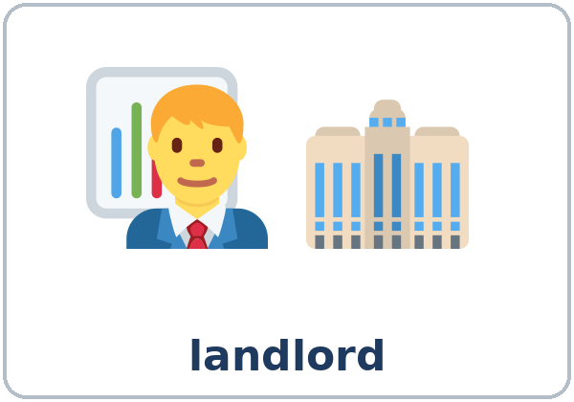  ★ landlord |   ★ repair person | 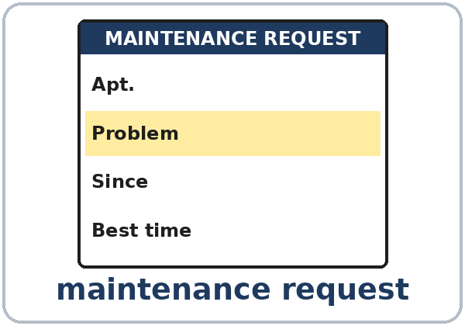  ★ maintenance request | 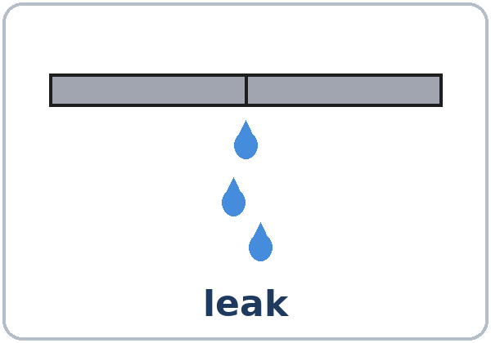  ★ leak
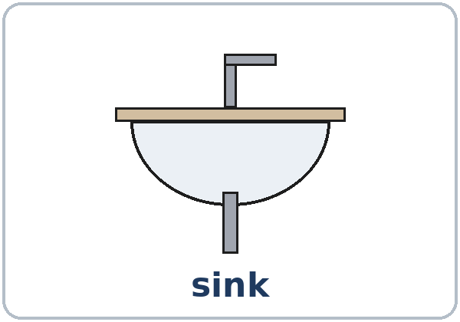  ★ sink | 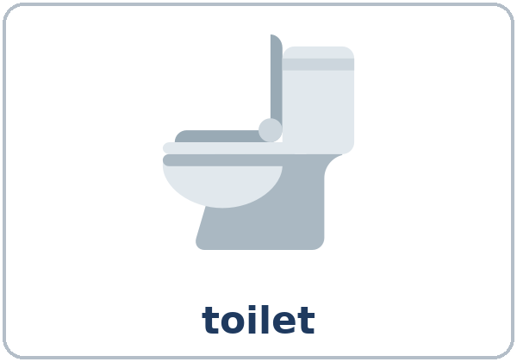  ★ toilet | 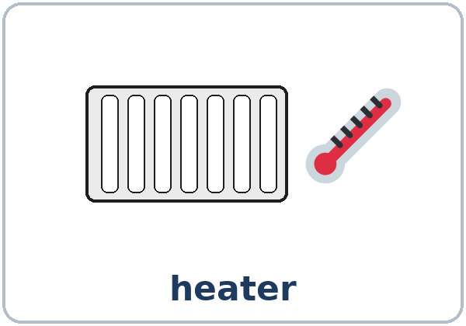  ★ heater |   ★ light bulb
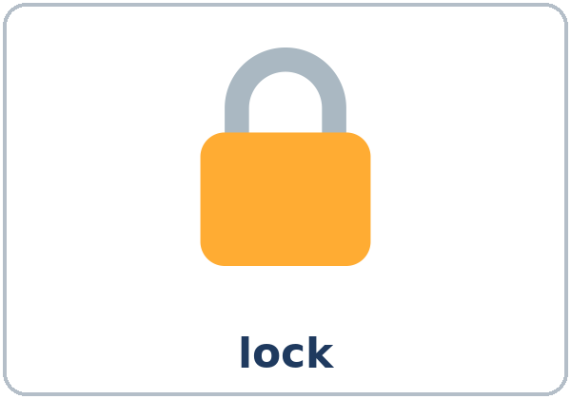  ★ lock | 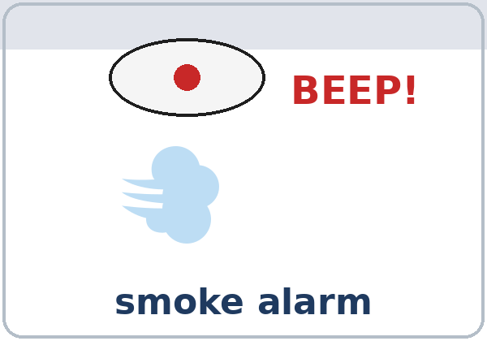  ★ smoke alarm |   mouse |   cockroach

Partner game: A says a word. B points and makes a sentence.
Example: A: sink. B: (points) The sink is leaking. Something is wrong with it.
Lesson 12 (Week 13) · My Words
Write each word in your language, if you want. Then write your own example.
Word | My language | My example
landlord
repair person
maintenance request
leak
sink
toilet
heater
light bulb
lock
smoke alarm
mouse
cockroach

Lesson 12 (Week 13) · Listening
Listen to Sara. She's calling the building office. Mr. Grant is the building manager.
A. Listen. What problems does Sara have? Check ✓.
☐ the kitchen sink ☐ the toilet ☐ the heater ☐ the lock ☐ a mouse
B. Listen again. Circle.
1. Apartment: 4B / 4D
2. Water on the floor: a little / a lot
3. The heater screen is: black / blue
4. Day: Monday / Tuesday
5. Time: 9:00 / 3:00
C. Listen again. Write something, anything, any, someone, anyone, or no one.
1. ____________ is wrong with my kitchen sink.
2. Is there ____________ water on the floor?
3. And there's ____________ else. The heater doesn't work.
4. No, I don't see ____________.
5. I'll send ____________ tomorrow morning.
6. Is ____________ home at nine?
7. No, ____________ is home in the morning.
Say it: SOMEthing • ANyone • NO one • thing (not ting) • Something is wrong with my sink.
Lesson 12 (Week 13) · Grammar
Read across. A reads from the left side. B answers from the right side. Choose one part from each column.
Grammar Box 1: Is anything wrong?
QUESTION |  |  | ANSWER
Is anything | wrong? |  | Yes, something is wrong | with the heater.  with the sink.
Is anything | wrong? |  | No, nothing is wrong. | It's fine.
Is anything wrong | with the lock? |  | Yes. It doesn't close. | The door is open.

Grammar Box 2: Is anyone home?
QUESTION |  |  | ANSWER
Is anyone | home on Tuesday? |  | Yes, someone is home | after 3:00.
Is anyone | home on Tuesday? |  | No, no one is home. | We work all day.
Can you | send someone today? |  | I'll send someone | tomorrow morning.

Grammar Box 3: Did you see anything?
QUESTION |  |  | ANSWER
Did you | see anything? |  | No, I didn't see anything. | (= I saw nothing.)
Did | anyone call? |  | No, no one | called.
Did | anyone call? |  | Yes, someone | called at 2:00.

Grammar Box 4: some- / any- / no-
 | THINGS | PEOPLE | EXAMPLE
+ sentence | something | someone | Something is wrong.
question | anything | anyone | Is anyone home?
with not | not… anything | not… anyone | I didn't see anything.
alone | nothing | no one | No one is home.

Questions and answers
Q: I didn't see nothing?
A: No. One negative only: I didn't see anything. or I saw nothing.
Q: something or anything?
A: something in + sentences: Something is wrong. anything in questions and with not: Is anything wrong?
Q: no one or nobody?
A: The same meaning: No one is home. / Nobody is home.
Q: How do I start a repair call?
A: Hi, this is… in apartment… Something is wrong with my…
Practice A: Write something, anything, nothing, someone, anyone, or no one.
1. ____________ is wrong with my toilet.
2. Is ____________ wrong with the light?
3. The box is empty. There's ____________ in it.
4. I can hear ____________ at the door.
5. Is ____________ home on Friday?
6. ____________ is home. We're at work.
Practice B: Circle the right word.
1. I didn't hear (anything / nothing).
2. Can you send (someone / anyone) today?
3. Is (something / anything) wrong with the heater?
4. There's (nothing / anything) in the fridge.
5. Did (anyone / no one) call?
Common mistakes
✗ Don't say | ✓ Say
I didn't see nothing. | I didn't see anything.
Anything is wrong with the sink. | Something is wrong with the sink.
No one is not home. | No one is home.
Is some one home? | Is anyone home?

Nota para hispanohablantes: en español se usan dos negativos (No veo nada). En inglés, solo uno: I don't see anything o I see nothing (no I don't see nothing).

Tip for speakers of other languages: in questions, anything and anyone are the safe choice: Is anything wrong?

Lesson 12 (Week 13) · Talk Time: The Repair Call
Round 1: Sit back to back with a partner. A is the tenant (Tenant Card). B is the building manager (Repair Schedule). A says what's wrong. B asks one question and finds an open time. Agree on a day and time. Then switch.
Tenant Cards
1. Apartment 3A. The toilet is leaking. You're home Monday to Wednesday after 3:00. | 2. Apartment 1D. The heater doesn't work. You're home Tuesday morning and Friday afternoon.
3. Apartment 5B. The smoke alarm beeps all night. You're home all day Thursday. | 4. Apartment 2F. There's a mouse in the kitchen. You're home Monday and Friday after 12:00.

Repair Schedule (manager only) | 9:00 | 1:00 | 4:00
Monday | booked | open | open
Tuesday | open | booked | open
Wednesday | booked | booked | booked
Thursday | open | open | booked
Friday | booked | open | booked

A: Hi, this is apartment 3A. Something is wrong with my toilet. It's leaking.
B: Is there any water on the floor? … Is anyone home on Monday at 4:00?
A: Yes, someone is home after 3:00. B: OK. I'll send someone on Monday at 4:00.

Lesson 12 (Week 13) · Talk Time: Find Something
Round 2: Work with a partner. Find 7 problems in the apartment. Say: There's something wrong with the… / There's a… on the… / There isn't anything wrong with the…
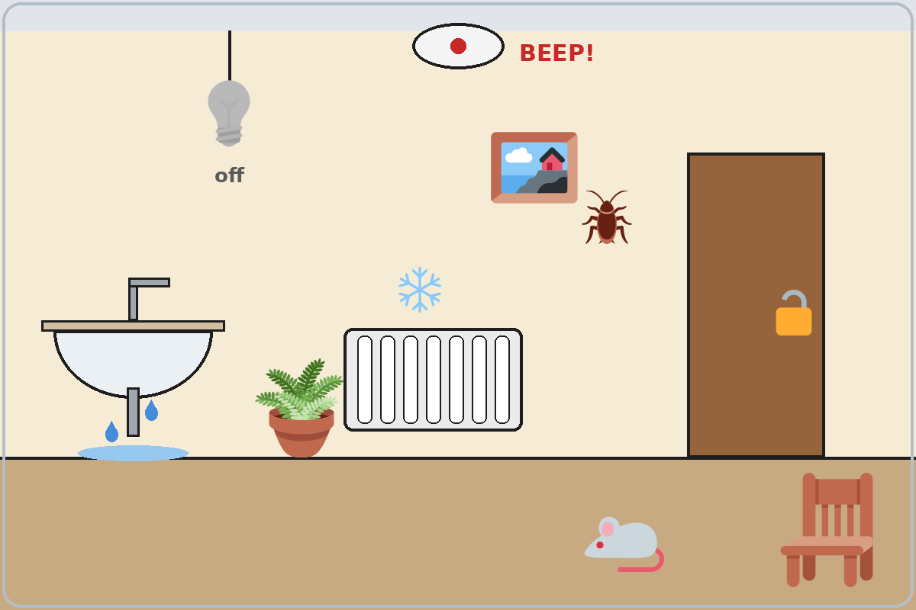

Problems we found
1. | 5.
2. | 6.
3. | 7.
4. | Nothing is wrong with:

Lesson 12 (Week 13) · Homework
Homework (about 15 minutes). Bring it next week!
1. Write the sentence again. Use something, anything, nothing, someone, anyone, or no one.
Example: A thing is wrong with my phone. → Something is wrong with my phone.
1. A thing is wrong with the heater. → ______________________________________________
2. Is a person home? → ______________________________________________
3. I didn't see nothing. → ______________________________________________
4. Not one person called. → ______________________________________________
2. Look around your home (or imagine an apartment). Write 3 sentences: what's OK and what's wrong.
Example: Nothing is wrong with the fridge. Something is wrong with the bathroom light. It doesn't turn on.
______________________________________________________________
______________________________________________________________
______________________________________________________________
3. With a family member, practice a repair call. Write the day and time you agreed on.
Example: The repair person will come on Thursday at 10:00.
______________________________________________________________
4. Review (Lesson 11): Write 2 sentences about a TV show or an event: one -ing word and one -ed word.
______________________________________________________________
______________________________________________________________
Lesson 12 (Week 13) · Read & Write
A. Read the maintenance request and Ken's note.
MAPLE COURT APARTMENTS · MAINTENANCE REQUEST
Name | Ken Lee
Apartment | 2C
Phone | 555-0191
Problem | 1. The bathroom light doesn't turn on. 2. The front door lock is hard to close.
Since | last Friday
Best time | weekdays after 5:00 p.m., or Saturday
OK to enter if no one is home? | No

Ken's note to the manager
Hello Mr. Grant, something is wrong with the light in my bathroom. I changed the light bulb, but nothing happened. Also, the lock on the front door is hard to close. No one is home before 5:00 on weekdays. If you can't come this week, please call or text me at 555-0191. Thank you! Ken

B. Answer the questions.
1. What apartment does Ken live in? ______________________________________________
2. What two things are wrong? ______________________________________________
3. Since when? ______________________________________________
4. What is the best time for a repair? ______________________________________________
5. How can the manager contact Ken? ______________________________________________
C. Write a maintenance request (3–5 sentences): the problem, since when, the best time, and a phone number. Invent the apartment and use a 555 number.
Example: Hello, this is Rosa in apartment 6A. Something is wrong with my heater. It doesn't work, and the apartment is cold. It started on Sunday. No one is home in the morning, so please come after 2:00. My number is 555-0158.
My maintenance request

D. Check your request with a partner.
 | Yes | Not yet
It says what's wrong (Something is wrong with…). | ☐ | ☐
It says since when. | ☐ | ☐
It gives the best time (No one is home… / Someone is home…). | ☐ | ☐
It has an invented 555 number (no real numbers). | ☐ | ☐

Lesson 12 (Week 13) · Progress Check
Name: ______________________________ Date: ________________
A. Listen to the teacher. Circle a or b.
1. a. The sink has a problem. b. The sink is fine.
2. a. People are home on Monday. b. The apartment is empty on Monday.
3. a. I saw something. b. I saw nothing.
4. a. A repair person will come. b. No repair person will come.
B. Circle the right word.
1. Is (anything / something) wrong?
2. (Anyone / Someone) is at the door.
3. I didn't hear (nothing / anything).
4. Sorry, (no one / anyone) is home.
C. Write.
1. A problem at home: ______________________________
2. Ask for a repair and a time: ______________________________
Score: A ______ / 4 B ______ / 4 C ______ / 2
D. How do you feel? Check ✓ one face for each line.
I can… | 😀 I can do it. | 🙂 With a little help. | 😐 Not yet.
I can say what's wrong in my home. | ☐ | ☐ | ☐
I can use something / anything / nothing. | ☐ | ☐ | ☐
I can ask for a repair and set a time. | ☐ | ☐ | ☐
I can write a short maintenance request. | ☐ | ☐ | ☐

Picture Credits
Pictures use Twemoji graphics by Twitter, Inc. and other contributors (https://github.com/jdecked/twemoji), licensed under CC BY 4.0 (https://creativecommons.org/licenses/by/4.0/). The graphics were resized and combined, one was recolored (a light bulb), and drawings (a sink, a heater, a pipe, water drops, a smoke alarm, a form, a room, a door) and labels were added. The file-by-file list is in images/CREDITS.md.
Listening audio: synthetic voices made with Chatterbox TTS (Resemble AI, MIT License), cloned from synthetic reference clips made with Kokoro-82M (Apache License 2.0). No recordings of real people were used. Each file carries an inaudible Perth watermark marking it as AI-generated. The names and the story are invented.
Course materials: © 2026 the authors, licensed under CC BY-NC-SA 4.0 (https://creativecommons.org/licenses/by-nc-sa/4.0/).

