Level 3 Adult ESL Curriculum · Lesson 3 (Week 3): When I Was Young
Status: Complete lesson (all 13 Level 3 lessons are published).
Date: October 2026
Audience: Program coordinators and volunteer teachers
Companion files: audio/L3_L3_listening.mp3, images/ (12 vocabulary pictures, 1 activity picture + images/CREDITS.md)
Topic: life in the past and how things have changed: childhood, chores, school, and communication then and now, with used to, didn't use to, and Did you use to…?

How this lesson is organized
Part | What's inside | Who uses it
Teacher Plan | At a glance, clock-time plan, step-by-step boxes, listening script, answer key, teacher notes | Volunteer teachers
Student Pages | Opening Talk, New Words, My Words, Listening, Grammar, Talk Time, Homework, Read & Write, Progress Check. Print this part for learners | Learners
Picture Credits | Picture, audio, and license credits | Coordinators

What Lesson 3 builds on and what it adds
Before (review only) | Where | New in Level 3 Lesson 3
Simple past: I walked. I had. Did you…? | Level 2 Lessons 5–6 | used to for past habits: I used to walk to school.
didn't + verb | Level 2 Lesson 5 | I didn't use to drink coffee.
Simple present + frequency words (usually) | Level 2 Lesson 2 | Then vs. now: I used to…, but now I usually…
Describing people | Level 3 Lesson 2 | What were you like as a child? I used to be very shy.
because / so | Level 3 Lesson 1 | We used to walk, because the school was near.

TEACHER PLAN
Lesson 3 (Week 3)

When I Was Young
At a glance · Clock-time plan · Step by step · Script and answer key

How to Use This Plan
You don't need to speak Spanish or any other language. Teach in English. Show, point, and gesture. Each Grammar page has one short Spanish note and one tip for speakers of other languages. Learners read them on their own. You never need to read, translate, or explain them.

Instructions: use the same short task words every week: Listen. Circle. Check. Write. Work with a partner. Work in a group. Ask a follow-up question. Learners have the Task Words page from Lesson 1.

Instruction rule: Model it (do it with one learner while everyone watches), check it (ask: "Do you write or speak? How many people do you talk to?"), then go. Say less, show more.

Grouping toolkit: Pairs: turn to a neighbor; with an odd number, make one group of 3. Groups: 3–4 learners. Inside–outside circles: the inner circle faces out, the outer circle faces in; the outer circle moves one person to the right each round. Mingle: everyone stands and talks to many classmates. The teacher joins a pair only if one learner is left over.

When a learner is stuck or speaks another language to you: (1) show it: the picture, a gesture, or the board; (2) give one more short English example; (3) point to the grammar box on their page; (4) a classmate can help for a few seconds, then back to English. You don't need to understand what classmates say to each other.

Lesson 3 (Week 3): When I Was Young
At a glance
Objectives: learners can…
• say what they used to do (I used to help on the farm.)
• say what they didn't use to do (I didn't use to drink coffee.)
• ask and answer Did you use to…? → Yes, I did. / No, I didn't.
• compare then and now (I used to write letters. Now I send text messages.)
• tell the difference between a past habit (used to), one time in the past (simple past), and now (simple present)
• read a short memory story and write 4 sentences about then and now

Materials
• Student Pages for Lesson 3 (print for the number expected + 3 spares)
• Talk Time: the "Then and Now" mingle sheet (on the Talk Time page; 1 per learner)
• phone + small speaker, L3_L3_listening.mp3
• the Lesson 1 baseline snapshot checklist (finish it this week)
• optional: an old object or a photo of an old radio or phone to show (not a family photo)
• Prep time: 15 min.

Key vocabulary (with pictures on the New Words page)
★ childhood • ★ village • ★ farm • ★ river • ★ climb trees • ★ chores • ★ feed the animals • ★ radio • ★ letter (mail) • ★ landline phone • jump rope • then / now

Clock-time plan
Times are loose. If a step runs long, take time from Read & Write first, then from Talk Time.
Time | Step | Min | Grouping (15 / 7–8) | If running behind
6:00–6:10 | Opening Talk + Homework Check | 10 | Pairs (7 pairs + 1 trio / 3–4 pairs) | One card only
6:10–6:18 | New Words (picture page) + pair game | 8 | Whole class, then pairs | Teach the ★ words only
6:18–6:30 | Listening: play 1 (Task A), play 2 (Tasks B and C) + "Say it" | 12 | Individuals, then pairs check | Do Task C together on the board
6:30–6:45 | Grammar Q&A: used to / didn't use to / Did you use to…? + pair drill | 15 | Whole class, then pairs | Skip the pair drill; Talk Time practices it
6:45–7:00 | BREAK | 15
7:00–7:12 | Talk Time: Then and Now Mingle + groups of 3 + baseline snapshot | 12 | Mingle, then groups of 3 | Mingle only
7:12–7:17 | Exit Ticket + Homework | 5 | Individuals | Never skip
7:17–7:25 | Read & Write: a memory story + 4 sentences | 8 | Individuals, then pairs | Reading questions only; writing becomes homework
7:25–7:30 | Progress Check | 5 | Individuals | Do it in Week 4 at 6:00, while people arrive

Skip order if you're running behind: (1) the Read & Write writing task (it becomes homework); (2) the pair drill at the end of Grammar; (3) half of Talk Time. Never skip: the listening tasks, the grammar boxes and the mistakes table, and the exit ticket.

Attendance (15 → 7–8): every step lists both sizes. With 5 or fewer, sit at one table: the mingle becomes "ask everyone at the table," and the groups of 3 become one group. Late arrivals join the mingle right away.

Step by step
Step 1 · 6:00–6:10 · Opening Talk + Homework Check · 10 min
• Grouping: pairs, the same partner for both parts. 15 learners: 7 pairs + 1 group of 3. 7–8 learners: 3–4 pairs.
• Before class: write on the board: What does he / she look like? What's he / she like?
• Opening Talk (6 min): learners open the Opening Talk page. A asks a card question; B answers with 2–3 sentences; A asks one follow-up. Switch after each card.
• Model with one learner: "Tell me about your best friend. What's she like?" → (answer) → "Really? What does she look like?"
• Homework Check (4 min): partners read their Lesson 2 Homework item 1 (the person they described) to each other. Walk around. Write 2 common errors on the board (often long hairs or What does she like?) and correct them together.
• Late arrivals: join any pair as a group of 3.
• If behind: one card only, then the homework check.

Step 2 · 6:10–6:18 · New Words · 8 min
• Grouping: whole class, then pairs. Show the New Words page.
• Do: point to each picture and say the word. Learners repeat once. Act out climb trees (climb with your arms), jump rope (turn a rope and jump), and feed the animals (throw corn to chickens).
• Then / now: point to the last picture. Say: "Then, people listened to the radio. Now, we use a phone." Make two columns on the board: THEN and NOW. Learners say where radio, letter, landline phone, text message go.
• Check meaning (1 min): "Is a village big or small?" (small) • "Are chores fun or work?" (work: cleaning, cooking, washing) • "Is your childhood now or in the past?" (in the past)
• Pairs (2 min): A says a word; B points to the picture and makes a sentence (My grandmother had a farm.). Switch.
• If behind: teach the ★ words only.

Step 3 · 6:18–6:30 · Listening + "Say it" · 12 min
• Grouping: individuals, then pairs check.
• Before you listen (1 min): point to the old photo on the Listening page. Say: "This is Daniel. This is his mother, Teresa. They're looking at an old photo of Teresa's childhood. Where did she live? Listen."
• Play 1 → Task A (then or now). Pairs compare. Check together.
• Read Tasks B and C together (1 min) so learners know what to listen for.
• Play 2 → Tasks B and C. Pairs compare. Then show the answers (answer key).
• "Say it" (2 min): say: "used to sounds like yoos-tuh." Read the line in the "Say it" box, then Did you use to walk? and I didn't use to have a TV. The class repeats each line twice. Point out that used to and use to sound the same.
• The audio plays the conversation once (about 1:15). Press play again for play 2. A third play is fine if the class needs it.
• If behind: do Task C together on the board, reading the lines yourself.

Step 4 · 6:30–6:45 · Grammar Q&A · 15 min
• Grouping: whole class, then pairs. Show the Grammar page. The left side is the question. The right side is the answer.
• Draw a timeline on the board: a long line with THEN on the left and NOW on the right. Draw many small marks on the THEN side and write: I used to walk to school (many times). On the NOW side write: Now I drive.
• Box 1 (3 min): read a question from the left; the class answers from the right. Then ask learners: "What did you use to do after school?"
• Box 2 (3 min): questions and short answers: Did you use to…? → Yes, I did. / No, I didn't. Point to use (no -d) after did and didn't.
• Boxes 3 and 4 (3 min): read the THEN / NOW rows. Then read Box 4: a habit (used to), one time (went), now (usually).
• Check questions: "I ___ live in a village." (used to) • "Did you ___ walk to school?" (use to) • "Last Saturday I ___ to the park." (went, one time) • "Now I ___ drive to work." (usually)
• Practice A and B (3 min): learners write, then pairs check. Go over the answers.
• Pair drill (last 2 min): A asks Did you use to…? with a word from the New Words page; B answers with a short answer and one more sentence. Switch.
• If behind: skip the pair drill. Talk Time practices it.

Break · 6:45–7:00 · 15 min
• Write on the board: Did you use to…? Yes, I did. / No, I didn't. and Where? Why? When? What about now?

Step 5 · 7:00–7:12 · Talk Time: Then and Now Mingle · 12 min
• Grouping: mingle, then groups of 3. 15 learners: everyone stands. 7–8 learners: everyone stands. 5 or fewer: sit together and ask everyone.
• Round 1, mingle (7 min): learners take the "Then and Now" sheet. They walk and ask one classmate one question (Did you use to have a radio?). If the answer is Yes, they write the name and ask one follow-up (Where? Why?), and write a short answer. If No, they say thank you and ask another person. Try to get a different name for each line.
• Model with one learner (1 min): "Did you use to walk far to school?" → "Yes, I did." → "Really? How far?" → "About one hour." Write the name and "1 hour."
• Round 2, groups of 3 (4 min): learners fill in 3 rows of the "My Then and Now Chart" (1 minute). Then each learner says 3 sentences comparing then and now (I used to live in a village. Now I live in a city. I didn't use to cook, but now I cook every day.). Listeners ask one follow-up each.
• Baseline snapshot: while learners talk, finish the Lesson 1 baseline checklist with the last learners.
• If behind: the mingle only.

Step 6 · 7:12–7:17 · Exit Ticket + Homework · 5 min · NEVER SKIP
• Exit ticket: each learner writes two sentences on a slip: one with used to or didn't use to, and one about now with because or so (I used to walk to work. Now I take the bus because I live far away.). Collect at the door.
• Homework: open the Homework page. Do item 1 together (one used to sentence on the board). Say: "About 15 minutes. Bring it next week."

Read & Write · 7:17–7:25 · A Memory Story · 8 min
• Grouping: individuals, then pairs check.
• Read (3 min): learners read the story on the Read & Write page and answer questions 1–5. Say: "Read fast first. Then find the answers."
• Pairs check (2 min): compare answers; check together.
• Write (3 min): learners write 4 sentences: 2 with used to (then) and 2 about now. Any place they used to live, or any job they used to have, is OK.
• If behind: questions 1–5 only; the writing becomes homework.

Progress Check · 7:25–7:30 · 5 min
• Grouping: individuals. Open the Progress Check page.
• Part A: read the 4 sentences in the answer key, slowly, 2 times each. Learners check Then or Now.
• Parts B and C: learners do them alone. Walk around and help with the instructions only.
• Part D: read each "I can…" line aloud and point to the 3 faces: 😀 "I can do it." 🙂 "With a little help." 😐 "Not yet."
• Collect the pages (or check them at the start of Week 4).
• If behind: do the Progress Check in Week 4 at 6:00, while learners arrive.

Listening script: L3_L3_listening.mp3 (about 1:15; the conversation plays once, so press play again for the second listen)
Audio: play from a phone + small speaker. No speaker? Read the script with a volunteer, at a normal, friendly speed.

Narrator: Lesson three. Listening. Daniel and his mother, Teresa, are looking at an old photo. Listen.
Daniel: Mom, is this you in the photo?
Teresa: Yes! That's me with my sister. We used to live in a small village.
Daniel: Is that your house?
Teresa: Yes. We used to live on a farm near a river.
Daniel: Did you use to help on the farm?
Teresa: Yes, I did. Every morning, I used to feed the animals before school.
Daniel: Wow. Did you use to walk to school?
Teresa: Yes. It was far, so we used to walk for an hour.
Daniel: What did you do after school?
Teresa: We used to do our chores. Then we used to climb trees and swim in the river.
Daniel: Did you have a TV?
Teresa: No, we didn't use to have a TV. We used to listen to the radio at night.
Daniel: And did you have a phone?
Teresa: No. We used to write letters to my aunt in the city. Now I send you text messages every day!
Daniel: That's true. Life is really different now.
Narrator: That's the end of the listening.

Answer key
• Listening Task A: 1 Then, 2 Then, 3 Now, 4 Then.
• Listening Task B (check ✓): 1 ✓ feed the animals, 2 ✓ walk to school, 3 ✓ climb trees, 4 ✓ swim in the river, 5 ✗ watch TV, 6 ✓ listen to the radio, 7 ✓ write letters, 8 ✗ talk on a landline phone. (6 checks.)
• Listening Task C: 1 used to, 2 use to, 3 used to, 4 use to, 5 use to, 6 used to.
• Grammar Practice A: 1 used to, 2 didn't use to, 3 use to, 4 used to, 5 didn't use to, 6 use to.
• Grammar Practice B: 1 a habit, 2 one time, 3 a habit, 4 now.
• Talk Time: answers will vary.
• Homework 1 and 3: answers will vary. Homework 2: 1 I used to play soccer. 2 She used to work at a hotel. 3 We didn't use to have a car. 4 Did you use to live in a village? Homework 4: answers will vary (one sentence about looks, one about personality).
• Read & Write: 1 in a small village (near the mountains) • 2 She carried water / she used to carry water from the river. • 3 No. She didn't use to have shoes for school. (She walked to school without shoes.) • 4 In a city, in an apartment. • 5 a garden / her garden • Writing (C): answers will vary.
• Progress Check Part A (the teacher says, 2 times each): 1 "I used to live with my grandparents." → Then • 2 "I usually take the bus to work." → Now • 3 "We didn't use to have a car." → Then • 4 "My children send me text messages." → Now
• Progress Check Part B: 1 used to, 2 use to, 3 use to, 4 used to.
• Progress Check Part C: answers will vary; for example 1 I used to live in a village. 2 Now I live in a big city.
• Progress Check scoring: A /4 + B /4 + C /2 = /10. This is not a test grade. It shows who needs more help hearing then vs. now (A) and with used to / use to (B, C).
Teacher notes
• Choice and comfort (important): learners choose what to share. Childhood can be hard for some people. "A place I used to live," "a job I used to have," or an invented story are always OK. Never ask why someone moved or left a country. "I don't want to say" is always OK.
• What used to means: something that happened many times in the past and is not true now. If it happened one time, use the simple past (Last year I went to Texas).
• used to vs. use to: after did and didn't, write use (no -d): Did you use to…? I didn't use to… They sound the same, so this is a spelling point. Don't spend a lot of time on it.
• Now: for now, use the simple present with usually / every day: Now I usually drive. Learners sometimes say I use to drive for now; say "Now you usually drive."
• Mixed levels: stronger learners add a reason to each then/now sentence (I used to walk, because we didn't have a car). Newer learners use Box 1 and Box 3 as a script in Talk Time.
• Typical mistakes this week: I use to live… (for the past), Did you used to…?, I didn't used to…, I used to go to Texas last year (one time), I am used to play soccer. Say the right form clearly; the learner repeats. Learners can read the Spanish note and the tip on their Grammar page themselves; you don't need to explain them.

STUDENT WORKBOOK
Lesson 3 (Week 3)

When I Was Young
Opening Talk · New Words · Listening · Grammar · Talk Time · Homework · Read & Write · Progress Check

Lesson 3 (Week 3) · Opening Talk
Name: ______________________________ Date: ________________
Work with a partner. A asks a question. B answers with 2–3 sentences. A asks one follow-up question. Then switch.
Tell me about your best friend. What's he / she like? | What does your neighbor look like?
Who is the funniest person in your family? Why? | Describe a coworker or a classmate. Is he / she friendly?

Follow-ups: Really? Why? What does he / she look like? What's he / she like? What about you?
Homework check: read your Lesson 2 homework (item 1) to your partner. Your partner asks one question about the person.
My partner described… | My question about the person

Lesson 3 (Week 3): When I Was Young
Student Page 1 · Week 3
Name: ______________________________ Date: ________________
New Words
Look. Listen. Repeat. ★ = most important words.
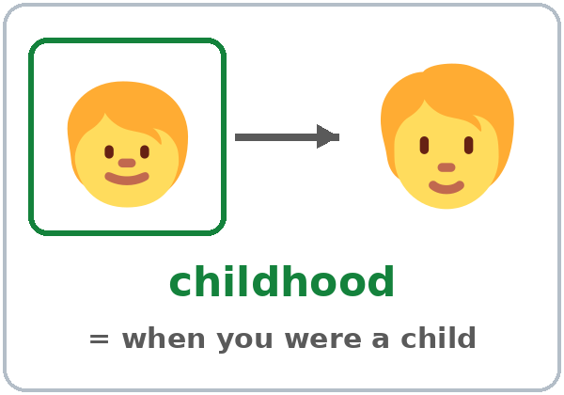  ★ childhood | 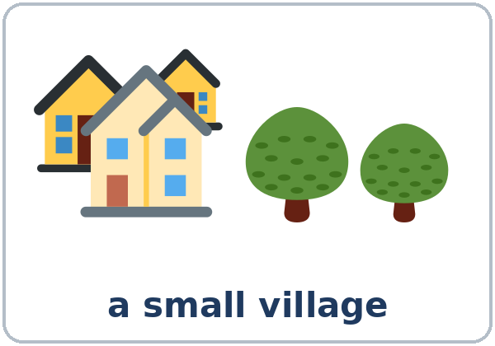  ★ village | 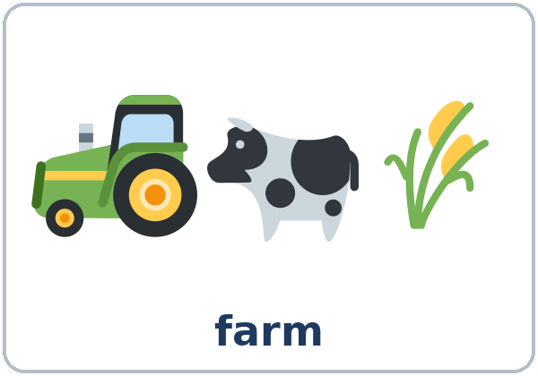  ★ farm | 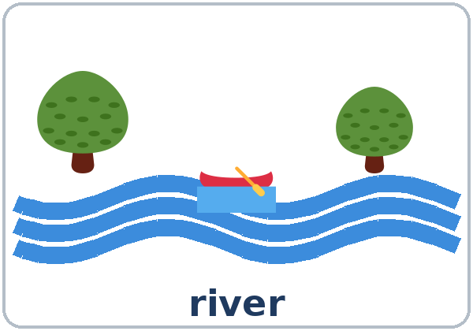  ★ river
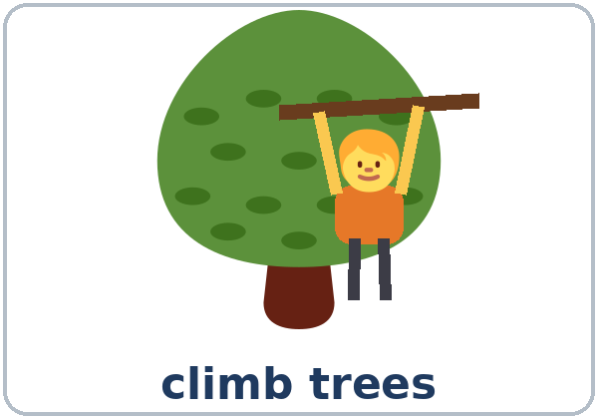  ★ climb trees | 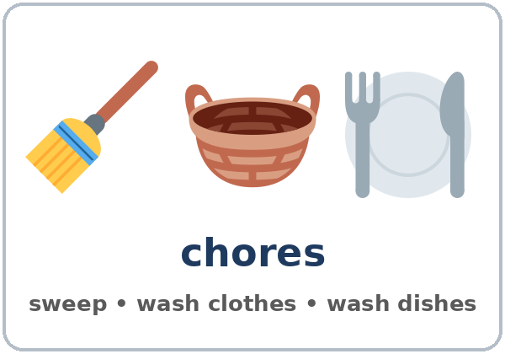  ★ chores | 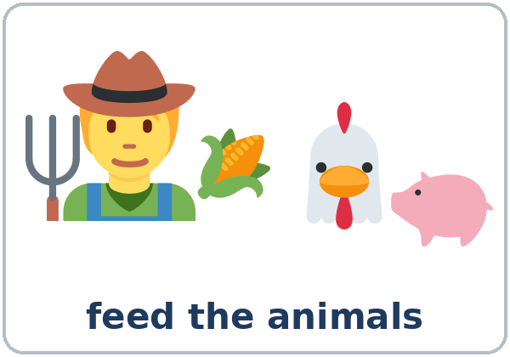  ★ feed the animals | 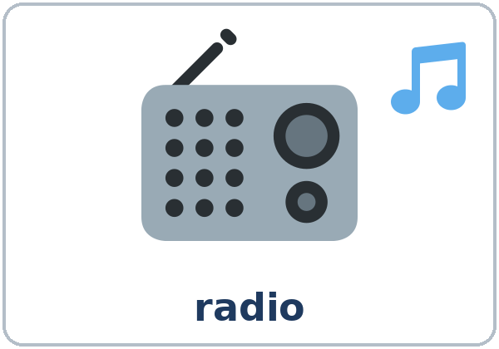  ★ radio
  ★ letter (mail) | 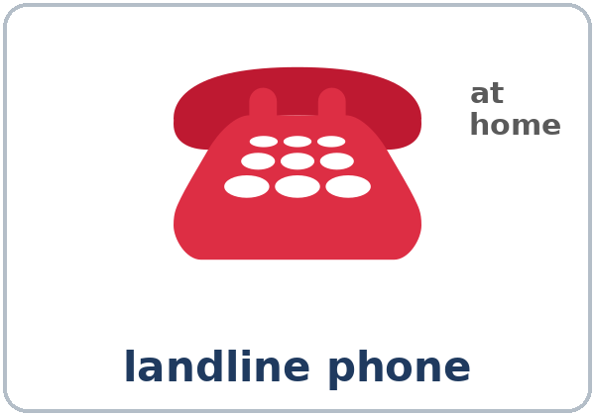  ★ landline phone | 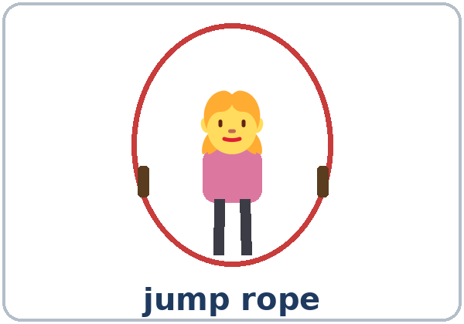  jump rope | 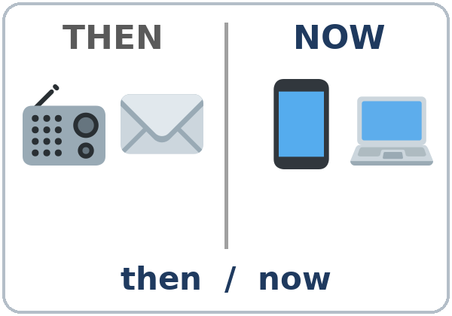  then / now

Partner game: A says a word. B points and makes a sentence.
Example: A: radio. B: (points) My grandfather used to listen to the radio.
Lesson 3 (Week 3) · My Words
Write each word in your language, if you want. Then write your own example.
Word | My language | My example
childhood
village
farm
river
climb trees
chores
feed the animals
radio
letter (mail)
landline phone
jump rope
then / now

Lesson 3 (Week 3) · Listening
Listen to Daniel and his mother, Teresa. They're looking at an old photo.
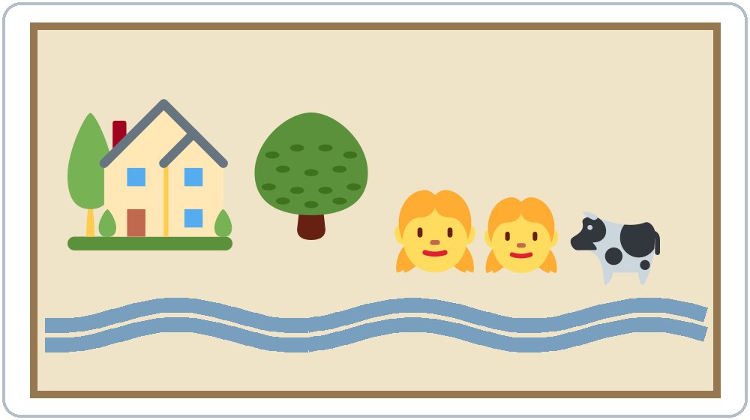

A. Listen. Teresa: then (her childhood) or now? Check ✓.
 | Then | Now |  | Then | Now
1. lives on a farm | ☐ | ☐ | 3. sends text messages | ☐ | ☐
2. walks to school for an hour | ☐ | ☐ | 4. writes letters to her aunt | ☐ | ☐

B. Listen again. What did Teresa use to do? Check ✓ the things she used to do.
☐ 1. feed the animals ☐ 2. walk to school ☐ 3. climb trees ☐ 4. swim in the river
☐ 5. watch TV ☐ 6. listen to the radio ☐ 7. write letters ☐ 8. talk on a landline phone
C. Listen again. Write used to or use to.
1. We ____________ live in a small village.
2. Did you ____________ help on the farm?
3. Every morning, I ____________ feed the animals before school.
4. Did you ____________ walk to school?
5. No, we didn't ____________ have a TV.
6. We ____________ write letters to my aunt in the city.
Say it: used to = "yoos-tuh" • We used to live on a farm.
Lesson 3 (Week 3) · Grammar
Read across. A reads from the left side. B answers from the right side. Choose one part from each column.
Grammar Box 1: What did you use to do?
QUESTION |  |  |  |  | ANSWER
What did | you | use to do | after school?  on weekends? |  | I used to | help on the farm.  play soccer.  do chores.
What did | she  he | use to do | in the evening?  in the summer? |  | She used to  He used to | listen to the radio.  swim in the river.
Where did | you | use to | live?  work? |  | I used to | live in a village.  work on a farm.

Grammar Box 2: Did you use to…? Short answers
QUESTION |  |  |  |  | ANSWER
Did | you | use to | walk to school?  climb trees? |  | Yes, | I | did.
 |  |  |  |  | No, | I | didn't.
Did | your family | use to | have a radio?  have a TV? |  | Yes, | we | did.
 |  |  |  |  | No, | we | didn't.

Grammar Box 3: Then and now
THEN (used to / didn't use to) |  | NOW (simple present)
I used to write letters. |  | Now I send text messages.
I didn't use to drink coffee. |  | Now I drink it every day.
We used to live in a village. |  | Now we live in a city.
She used to be very shy. |  | Now she's very friendly.

Grammar Box 4: A habit, one time, or now?
A HABIT IN THE PAST (many times) |  | ONE TIME IN THE PAST | ‖ | NOW
I used to walk to school. |  | One day I took the bus. | ‖ | Now I usually drive.
We used to eat dinner at 8:00. |  | Last night we ate at 6:00. | ‖ | Now we usually eat at 7:00.

Questions and answers
Q: What does used to mean?
A: Something happened many times in the past, and it's not true now. I used to live on a farm (but now I live in a city).
Q: Does used to change for he or she?
A: No. I used to, she used to, they used to. Then use the base verb: She used to walk (not walked).
Q: When do I write use to (no -d)?
A: After did and didn't: Did you use to walk? I didn't use to drink coffee.
Q: Can I use used to for one time?
A: No. For one time, use the simple past: Last summer I went to the beach. (not I used to go)
Q: Can I use used to for now?
A: No. used to is only for the past. For now, say usually or every day: Now I usually take the bus.
Q: How do I say it?
A: used to and use to both sound like "yoos-tuh."
Practice A: Write used to, use to, or didn't use to.
1. When I was a child, I ____________ climb trees every day.
2. We had no TV. We ____________ watch TV at night.
3. Did your grandparents ____________ have a farm?
4. My mother ____________ make bread every morning.
5. I ____________ like coffee, but now I love it!
6. Did you ____________ write letters?
Practice B: A habit, one time, or now? Circle.
1. I used to swim in the river. (a habit / one time / now)
2. Last Sunday I went to the river. (a habit / one time / now)
3. My father used to work on weekends. (a habit / one time / now)
4. I usually send text messages. (a habit / one time / now)
Common mistakes
✗ Don't say | ✓ Say
I use to live on a farm. (the past) | I used to live on a farm.
Did you used to walk to school? | Did you use to walk to school?
I didn't used to drink coffee. | I didn't use to drink coffee.
She used to walked to school. | She used to walk to school.
I used to go to Texas last year. | I went to Texas last year.
I use to take the bus now. | Now I usually take the bus.

Nota para hispanohablantes: used to es como el imperfecto (-aba / -ía) o solía: I used to play = Jugaba / Solía jugar. Úsalo solo para el pasado. En preguntas y negativos se escribe use (sin -d): Did you use to…? I didn't use to… Para una sola vez usa el pasado simple: Ayer fui = Yesterday I went (no used to go).

Tip for speakers of other languages: used to is only for the past. For now, say I usually…. For one time in the past, use the simple past (I went, I saw).

Lesson 3 (Week 3) · Talk Time: Then and Now Mingle
Stand up. Ask classmates Did you use to…? If the answer is Yes, write the name and ask one follow-up question. Find a different person for each line.
A: Did you use to walk far to school? B: Yes, I did.
A: Really? How far? B: About one hour, because there was no bus.
A: And now? B: Now I drive my kids to school!
Follow-ups: Where? When? Why? How far? Who with? And now?

Find someone who… | Name | Follow-up answer
1. used to have a radio
2. used to walk far to school
3. didn't use to cook
4. used to live in a village or on a farm
5. used to play a sport
6. used to write letters
7. used to have a different job
8. didn't use to drink coffee

Lesson 3 (Week 3) · Talk Time: My Then and Now Chart
Round 2: Fill in 3 rows of the chart. Then work in a group of 3. Say 3 sentences about then and now. The others ask one follow-up question each.
 | Then (I used to… / I didn't use to…) | Now (I… / I usually…)
Home (a house, an apartment, a village, a city)
School or work
Free time (sports, games, TV, music)
Food (breakfast, dinner, cooking)
Talking to family (letters, phone, text messages)

Example: I used to live in a small village. Now I live in a big city. I didn't use to cook, but now I cook every day, because my kids are hungry!
Follow-ups: Really? Why? Do you miss it? What was it like? Which is better, then or now?
Lesson 3 (Week 3) · Homework
Homework (about 15 minutes). Bring it next week!
1. Write 3 sentences about your childhood or a place you used to live. Use used to or didn't use to.
Example: When I was young, I used to help my mother in the kitchen.
1. ______________________________________________________________
2. ______________________________________________________________
3. ______________________________________________________________
2. Write the sentence with used to, didn't use to, or Did… use to.
1. I played soccer. (many times, not now) → ______________________________________________
2. She worked at a hotel. (many times, not now) → ______________________________________________
3. We didn't have a car. (not then) → ______________________________________________
4. you / live in a village? (question) → ______________________________________________
3. Ask an older family member, a neighbor, or a friend: What did you use to do when you were young? Write 2 answers. Ask one follow-up question.
Answer | My follow-up question | Answer

4. Review (Lesson 2): Describe a friend. Write 1 sentence about looks and 1 sentence about personality.
______________________________________________________________
______________________________________________________________
Lesson 3 (Week 3) · Read & Write
A. Read the story.
My Childhood, by Marta
When I was a child, I used to live in a small village near the mountains. My family didn't have a lot of money, but we were happy. Every morning, I used to carry water from the river with my brother. Then we used to walk to school. I didn't use to have shoes for school, so I walked without shoes! After school, I used to play with my friends and jump rope.
Now I live in a city. I have an apartment, and I take the bus to work. I don't carry water, but I have a small garden. I grow tomatoes, because they remind me of my village.

B. Answer the questions.
1. Where did Marta use to live? ______________________________________________
2. What did she use to do every morning? ______________________________________________
3. Did she use to have shoes for school? ______________________________________________
4. Where does she live now? ______________________________________________
5. What does she have now that reminds her of her village? ______________________________________________
C. Write 4 sentences: 2 sentences about then (used to) and 2 sentences about now. You can write about your childhood, a place you used to live, or a job you used to have.
Example: I used to work on a farm. I used to start work at 5:00 in the morning. Now I work in a restaurant. I start at 10:00, so I can sleep more!
Then: ______________________________________________________________
Then: ______________________________________________________________
Now: ______________________________________________________________
Now: ______________________________________________________________
D. Check your writing with a partner.
 | Yes | Not yet
2 sentences have used to or didn't use to. | ☐ | ☐
The verb after used to has no -ed (used to walk). | ☐ | ☐
2 sentences are about now (simple present). | ☐ | ☐
Each sentence starts with a capital letter and ends with a period. | ☐ | ☐

Lesson 3 (Week 3) · Progress Check
Name: ______________________________ Date: ________________
A. Listen to the teacher. Then or now? Check ✓.
 | Then | Now
1. | ☐ | ☐
2. | ☐ | ☐
3. | ☐ | ☐
4. | ☐ | ☐

B. Circle the right words.
1. I (used to / use to) live with my grandparents.
2. Did you (used to / use to) have a radio?
3. We didn't (used to / use to) have a TV.
4. My father (used to / use to) work on a farm.
C. Write 2 sentences: 1 with used to and 1 about now.
1. ______________________________________________
2. ______________________________________________
Score: A ______ / 4 B ______ / 4 C ______ / 2
D. How do you feel? Check ✓ one face for each line.
I can… | 😀 I can do it. | 🙂 With a little help. | 😐 Not yet.
I can say what I used to do. | ☐ | ☐ | ☐
I can say what I didn't use to do. | ☐ | ☐ | ☐
I can ask Did you use to…? | ☐ | ☐ | ☐
I can compare then and now. | ☐ | ☐ | ☐

Picture Credits
Pictures use Twemoji graphics by Twitter, Inc. and other contributors (https://github.com/jdecked/twemoji), licensed under CC BY 4.0 (https://creativecommons.org/licenses/by/4.0/). The graphics were resized and combined, and drawings (a river, a rope, a photo frame, bodies) and labels were added. The file-by-file list is in images/CREDITS.md.
Listening audio: synthetic voices made with Chatterbox TTS (Resemble AI, MIT License), cloned from synthetic reference clips made with Kokoro-82M (Apache License 2.0). No recordings of real people were used. Each file carries an inaudible Perth watermark marking it as AI-generated. The names and the story are invented.
Course materials: © 2026 the authors, licensed under CC BY-NC-SA 4.0 (https://creativecommons.org/licenses/by-nc-sa/4.0/).

