Level 3 Adult ESL Curriculum · Lesson 8 (Week 9): Lost and Found
Status: Complete lesson (all 13 Level 3 lessons are published).
Date: October 2026
Audience: Program coordinators and volunteer teachers
Companion files: audio/L3_L8_listening.mp3, images/ (12 vocabulary pictures, 1 activity picture + images/CREDITS.md)
Topic: losing and finding things: describing a lost item and saying who owns what at a lost-and-found office, with Whose…? and the possessive pronouns mine, yours, his, hers, ours, theirs.

How this lesson is organized
Part | What's inside | Who uses it
Teacher Plan | At a glance, clock-time plan, step-by-step boxes, listening script, answer key, teacher notes | Volunteer teachers
Student Pages | Opening Talk, New Words, My Words, Listening, Grammar, Talk Time, Homework, Read & Write, Progress Check. Print this part for learners | Learners
Picture Credits | Picture, audio, and license credits | Coordinators

What Lesson 8 builds on and what it adds
Before (review only) | Where | New in Level 3 Lesson 8
my, your, his, her, our, their + a noun | Level 1 | mine, yours, his, hers, ours, theirs (no noun): It's mine.
's for owners: Ana's bag | Level 1 | Whose bag is this? It's Ana's.
Colors, sizes, with | Levels 1–2 | Describing an item: a small black wallet with a zipper
Past continuous + when | Level 3 Lesson 4 | I was waiting for the bus when I lost it.
I'd like to… | Level 3 Lesson 7 | Opening Talk and Homework review

TEACHER PLAN
Lesson 8 (Week 9)

Lost and Found
At a glance · Clock-time plan · Step by step · Script and answer key

How to Use This Plan
You don't need to speak Spanish or any other language. Teach in English. Show, point, and gesture. Each Grammar page has one short Spanish note and one tip for speakers of other languages. Learners read them on their own. You never need to read, translate, or explain them.

Instructions: use the same short task words every week: Listen. Circle. Check. Write. Work with a partner. Work in a group. Ask a follow-up question. Learners have the Task Words page from Lesson 1.

Instruction rule: Model it (do it with one learner while everyone watches), check it (ask: "Do you write or speak? How many people do you talk to?"), then go. Say less, show more.

Grouping toolkit: Pairs: turn to a neighbor; with an odd number, make one group of 3. Groups: 3–4 learners. Inside–outside circles: the inner circle faces out, the outer circle faces in; the outer circle moves one person to the right each round. Mingle: everyone stands and talks to many classmates. The teacher joins a pair only if one learner is left over.

When a learner is stuck or speaks another language to you: (1) show it: the picture, a gesture, or the board; (2) give one more short English example; (3) point to the grammar box on their page; (4) a classmate can help for a few seconds, then back to English. You don't need to understand what classmates say to each other.

Lesson 8 (Week 9): Lost and Found
At a glance
Objectives: learners can…
• ask Whose… is this? / Whose… are these?
• answer with mine, yours, his, hers, ours, theirs or a name + 's (It's Ana's.)
• ask and answer Is this yours? → Yes, it's mine. / No, it isn't mine.
• describe a lost item: size, color, and details (a small black wallet with a zipper)
• say what they were doing when they lost something (I was waiting for the bus when I lost it.)
• read a FOUND notice, fill out a lost-item report, and write a short FOUND notice

Materials
• Student Pages for Lesson 8 (print for the number expected + 3 spares)
• Talk Time: the Lost and Found picture and the Owner Cards (on the Talk Time pages)
• phone + small speaker, L3_L8_listening.mp3
• optional: 3 classroom things (a pen, a cup, a book) to show mine / yours / hers
• Prep time: 10 min.

Key vocabulary (with pictures on the New Words page)
★ wallet • ★ purse • ★ keys • ★ umbrella • ★ backpack • ★ sunglasses • ★ headphones • ★ gloves • ★ scarf • ★ lost and found • ★ belong to • describe

Clock-time plan
Times are loose. If a step runs long, take time from Read & Write first, then from Talk Time.
Time | Step | Min | Grouping (15 / 7–8) | If running behind
6:00–6:10 | Opening Talk + Midterm check-in | 10 | Pairs (7 pairs + 1 trio / 3–4 pairs) | One card only
6:10–6:18 | New Words (picture page) + pair game | 8 | Whole class, then pairs | Teach the ★ words only
6:18–6:30 | Listening: play 1 (Task A), play 2 (Tasks B and C) + "Say it" | 12 | Individuals, then pairs check | Do Task C together on the board
6:30–6:45 | Grammar Q&A: Whose…?; mine / yours / his / hers / ours / theirs; describing + pair drill | 15 | Whole class, then pairs | Skip the pair drill; Talk Time practices it
6:45–7:00 | BREAK | 15
7:00–7:12 | Talk Time: The Lost and Found Box + whose is it? | 12 | Pairs, then groups of 3–4 | Round 1 only
7:12–7:17 | Exit Ticket + Homework | 5 | Individuals | Never skip
7:17–7:25 | Read & Write: a FOUND notice + a lost-item report; write a FOUND notice | 8 | Individuals, then pairs | Reading questions only; the notice becomes homework
7:25–7:30 | Progress Check | 5 | Individuals | Do it in Week 10 at 6:00, while people arrive

Skip order if you're running behind: (1) the Read & Write FOUND notice (it becomes homework); (2) the pair drill at the end of Grammar; (3) half of Talk Time (Round 1 only). Never skip: the listening tasks, the grammar boxes and the mistakes table, and the exit ticket.

Attendance (15 → 7–8): every step lists both sizes. With 5 or fewer, sit at one table: one clerk, and the others are owners; take turns being the clerk.

Step by step
Step 1 · 6:00–6:10 · Opening Talk + Midterm check-in · 10 min
• Grouping: pairs, the same partner for both parts. 15 learners: 7 pairs + 1 group of 3. 7–8 learners: 3–4 pairs.
• Before class: write on the board: I'd like to… / Could I…? / May I…?
• Opening Talk (6 min): learners open the Opening Talk page. A asks a card question; B answers with 2–3 sentences; A asks one follow-up. Switch after each card.
• Model with one learner: "What did you do last weekend?" → (answer) → "Really? How was it?"
• Midterm check-in (4 min): give back the midterms (if they are marked). Partners say one thing that was easy and one thing that was hard (The listening was easy. Part C was hard, because…). Write 2 common errors from the midterm on the board and correct them together.
• Late arrivals: join any pair as a group of 3.
• If behind: one card only, then the check-in.

Step 2 · 6:10–6:18 · New Words · 8 min
• Grouping: whole class, then pairs. Show the New Words page.
• Do: point to each picture and say the word. Learners repeat once. Put on imaginary gloves and a scarf; look for your keys in your pockets: "Where are my keys? I lost them!"
• Show belong to: hold up your own pen. "This pen belongs to me. It's mine." Point to a learner's book (don't take it): "That book belongs to you. It's yours."
• Check meaning (1 min): "Where do you keep money?" (a wallet / a purse) • "You listen to music with…?" (headphones) • "At the bus station, where do they keep lost things?" (the lost and found)
• Pairs (2 min): A says a word; B points to the picture and makes a sentence (My umbrella is black.). Switch.
• If behind: teach the ★ words only.

Step 3 · 6:18–6:30 · Listening + "Say it" · 12 min
• Grouping: individuals, then pairs check.
• Before you listen (1 min): say: "David lost something on the bus. He's calling the lost and found. What did he lose? Listen."
• Play 1 → Task A (what did he lose?). Pairs compare. Check together.
• Read Tasks B and C together (1 min) so learners know what to listen for.
• Play 2 → Tasks B and C. Pairs compare. Then show the answers (answer key).
• "Say it" (2 min): say: "yours, hers, ours, theirs end with a z sound." Read them; the class repeats. Then: "Whose and who's sound the same: hooz." Read the line in the "Say it" box. The class repeats each line twice.
• The audio plays the conversation once (about 1:17). Press play again for play 2. A third play is fine if the class needs it.
• If behind: do Task C together on the board, reading the lines yourself.

Step 4 · 6:30–6:45 · Grammar Q&A · 15 min
• Grouping: whole class, then pairs. Show the Grammar page. The left side is the question. The right side is the answer.
• Show it (2 min): put three things on your desk: your pen, a cup, a book. Point to the pen: "Whose pen is this? It's my pen. It's mine." Give the cup to a woman: "It's her cup. It's hers." Give the book to a man: "It's his."
• Boxes 1 and 2 (4 min): read a question from the left; the class answers from the right. Point out is this / are these (one / more than one).
• Box 3 (2 min): read across: my bag → mine. In each pair, the first column needs a noun; the second stands alone.
• Box 4 (2 min): describing: size → color → item → with… Hold up something: "It's a small blue pen with a cap."
• Check questions: "This is my book. It's ___." (mine) • "___ keys are these?" (Whose) • "It's her umbrella. It's ___." (hers) • "a ___ wallet: black / small" (small black)
• Practice A and B (3 min): learners write, then pairs check. Go over the answers.
• Pair drill (last 2 min): A points to something in a picture on the New Words page: "Whose ___ is this?" B answers with a pronoun or a classmate's name + 's. Switch.
• If behind: skip the pair drill. Talk Time practices it.

Break · 6:45–7:00 · 15 min
• Write on the board: Whose… is this? / Is this yours? / It's mine. / It isn't mine. Maybe it's hers. and size → color → item → with…

Step 5 · 7:00–7:12 · Talk Time: The Lost and Found Box · 12 min
• Grouping: Round 1 pairs (A = clerk, B = owner); Round 2 groups of 3–4. 15 learners: 7 pairs + 1 trio. 7–8 learners: 3–4 pairs. 5 or fewer: one clerk, the others are owners.
• Round 1 (7 min): each owner takes an Owner Card (the teacher gives one number, 1–8; use the cards in order). The owner fills in the short lost-item form on the card (small, red, backpack…). Then the owner describes the item to the clerk. The clerk looks at the Lost and Found picture and asks Is this yours? (pointing to a number). The owner answers: Yes, it's mine! / No, it isn't mine. Mine is… Then switch with a new card.
• Model with one learner (1 min): you are the owner with card 1: "I lost my backpack. It's big and blue." The learner points: "Is number 1 yours?" → "Yes, it's mine! Thank you!"
• Round 2, groups (4 min): each person keeps their last Owner Card. The group looks at the picture together and says whose each item is: Number 3 is Maria's. It's hers. Number 9 is mine. If no one has the card, say It isn't ours. Maybe it's theirs (another group's).
• If behind: Round 1 only.

Step 6 · 7:12–7:17 · Exit Ticket + Homework · 5 min · NEVER SKIP
• Exit ticket: each learner writes two sentences on a slip: one with a possessive pronoun (This umbrella isn't mine. It's hers.), and one about losing something with when and because or so (I was waiting for the bus when I lost my keys, so I called the lost and found.). Collect at the door.
• Homework: open the Homework page. Do item 1 together (one sentence on the board). Say: "About 15 minutes. Bring it next week."

Read & Write · 7:17–7:25 · A FOUND Notice and a Lost-Item Report · 8 min
• Grouping: individuals, then pairs check.
• Read (3 min): learners read the FOUND notice and the lost-item report and answer questions 1–5. Say: "Read fast first. Then find the answers."
• Pairs check (1 min): compare answers; check together.
• Write (4 min): learners choose one item from the Lost and Found picture and write a short FOUND notice (what, where, when, how to contact). Say: "Invent a first name and use a 555 phone number."
• If behind: questions 1–5 only; the notice becomes homework.

Progress Check · 7:25–7:30 · 5 min
• Grouping: individuals. Open the Progress Check page.
• Part A: read the 4 sentences in the answer key, slowly, 2 times each. Learners circle a or b.
• Parts B and C: learners do them alone. Walk around and help with the instructions only.
• Part D: read each "I can…" line aloud and point to the 3 faces: 😀 "I can do it." 🙂 "With a little help." 😐 "Not yet."
• Collect the pages (or check them at the start of Week 10).
• If behind: do the Progress Check in Week 10 at 6:00, while learners arrive.

Listening script: L3_L8_listening.mp3 (about 1:17; the conversation plays once, so press play again for the second listen)
Audio: play from a phone + small speaker. No speaker? Read the script with a volunteer, at a normal, friendly speed.

Narrator: Lesson eight. Listening. David lost something on the bus. He's calling the lost and found. Listen.
Joan: City Bus, Lost and Found. How can I help you?
David: Hi. I lost my backpack on the bus this morning.
Joan: OK. Can you describe it?
David: It's a big blue backpack with a black zipper. My brother has the same one, but his is green.
Joan: What was inside?
David: My headphones, a red scarf, and some gloves.
Joan: And what were you doing when you lost it?
David: I was talking on the phone. I got off at Park Street, and I left it on the seat.
Joan: Let me check. We have two blue backpacks. One is small, and one is big.
David: The big one is mine.
Joan: There are white headphones inside. Are they yours?
David: No, mine are black. Those aren't mine.
Joan: Wait. Here's another big one, with black headphones and a red scarf.
David: Yes! That's mine. Thank you!
Joan: You're welcome. You can pick it up today before five.
Narrator: That's the end of the listening.

Answer key
• Listening Task A: b (a backpack).
• Listening Task B: 1 blue • 2 big • 3 ✓ headphones, ✓ a scarf, ✓ gloves, ✗ a wallet, ✗ keys • 4 Park Street • 5 5:00.
• Listening Task C: 1 his, 2 mine, 3 yours, 4 mine, 5 mine.
• Grammar Practice A: 1 mine, 2 hers, 3 ours, 4 yours, 5 theirs, 6 his.
• Grammar Practice B: 1 Whose, 2 mine, 3 your, 4 hers, 5 small black.
• Talk Time Round 1 (Owner Card → picture number): 1 → 1 (big blue backpack) • 2 → 4 (red umbrella) • 3 → 6 (keys with a heart) • 4 → 10 (brown wallet) • 5 → 12 (green scarf) • 6 → 8 (glasses with blue lenses) • 7 → 2 (small red backpack) • 8 → 9 (black wallet). Items 3, 5, 7, and 11 have no owner. Round 2: answers will vary.
• Homework 1: 1 It's mine. 2 They're hers. 3 It's ours. 4 Are they yours? Homework 2: answers will vary (size → color → item → with…). Homework 3 and 4: answers will vary.
• Read & Write B: 1 keys (a set of keys with a blue star key chain) • 2 at Lincoln Park, near the basketball courts • 3 on Saturday, May 9 • 4 describe the key chain and say where you lost them • 5 a black umbrella with a wooden handle • Writing (C): answers will vary.
• Progress Check Part A (the teacher says, 2 times each): 1 "Whose keys are these? They're mine." → a • 2 "Is this your umbrella? No, it's hers." → b • 3 "I lost a small black wallet." → a • 4 "These gloves aren't ours. They're theirs." → b
• Progress Check Part B: 1 Whose, 2 mine, 3 Their, 4 yours.
• Progress Check Part C: answers will vary; for example 1 I lost a big red backpack with a zipper. 2 It's mine. / It's Ana's.
• Progress Check scoring: A /4 + B /4 + C /2 = /10. This is not a test grade. It shows who needs more help hearing possessives (A) and with the forms (B, C).
Teacher notes
• Picture cards, not real things (important): use the pictures and Owner Cards, not learners' real wallets, purses, or phones. Remind learners never to write real ID numbers, bank card numbers, or addresses on any form, in class or in real life on a public notice.
• Two kinds of words: my, your, his, her, our, their need a noun (my bag). mine, yours, his, hers, ours, theirs stand alone (It's mine). his is the same in both.
• No the: It's mine (not It's the mine). No apostrophe: yours, hers, ours, theirs (not your's).
• Whose and who's: they sound the same. Whose = which person owns it (Whose bag is this?). Who's = who is (Who's that?).
• Describing order: size → color → item → with… (a small black wallet with a zipper). Don't teach a long rule; this one order is enough.
• Typical mistakes this week: It's the mine, Is this your?, Who's bag is this?, It's mine bag, a wallet black, his for a woman (It's Maria's. It's his.). Say the right form clearly; the learner repeats. Learners can read the Spanish note and the tip on their Grammar page themselves; you don't need to explain them.
• Mixed levels: stronger learners add when and where they lost the item with the past continuous. Newer learners use Boxes 1 and 2 as a script.

STUDENT WORKBOOK
Lesson 8 (Week 9)

Lost and Found
Opening Talk · New Words · Listening · Grammar · Talk Time · Homework · Read & Write · Progress Check

Lesson 8 (Week 9) · Opening Talk
Name: ______________________________ Date: ________________
Work with a partner. A asks a question. B answers with 2–3 sentences. A asks one follow-up question. Then switch.
What did you do last weekend? | What will you do if it's sunny next Saturday?
You bought shoes, and they're too small. What do you say at the store? | You'd like to change an appointment. What do you say on the phone?

Follow-ups: Really? How was it? Why? What did they say?
Midterm check-in: tell your partner one easy part and one hard part of the midterm. Say why.
Easy for me | Hard for me (because…)

Lesson 8 (Week 9): Lost and Found
Student Page 1 · Week 9
Name: ______________________________ Date: ________________
New Words
Look. Listen. Repeat. ★ = most important words.
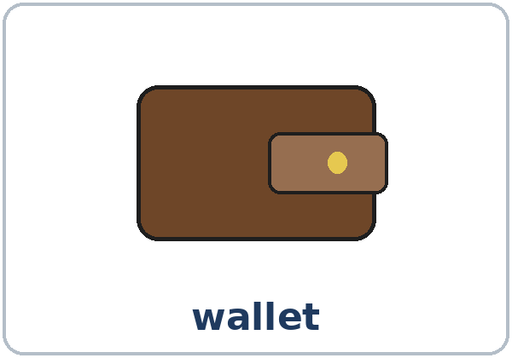  ★ wallet | 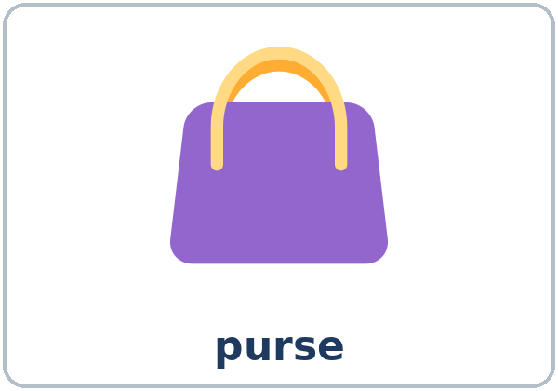  ★ purse | 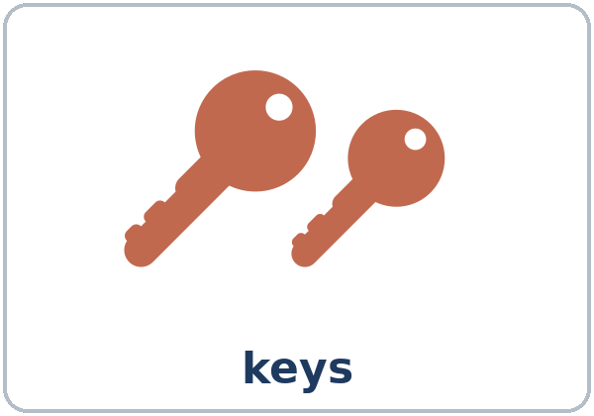  ★ keys | 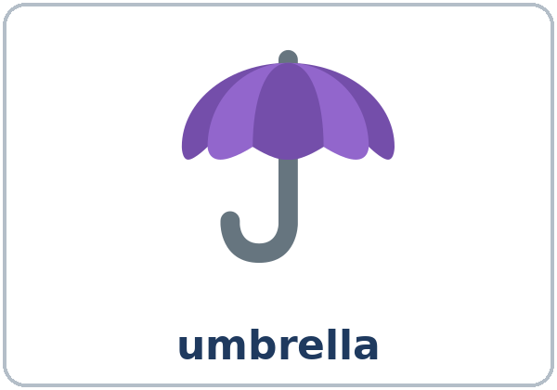  ★ umbrella
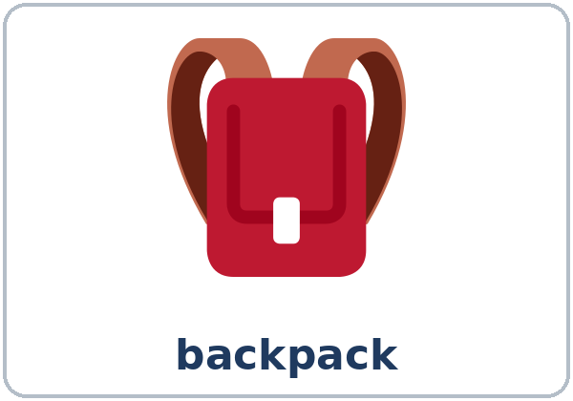  ★ backpack | 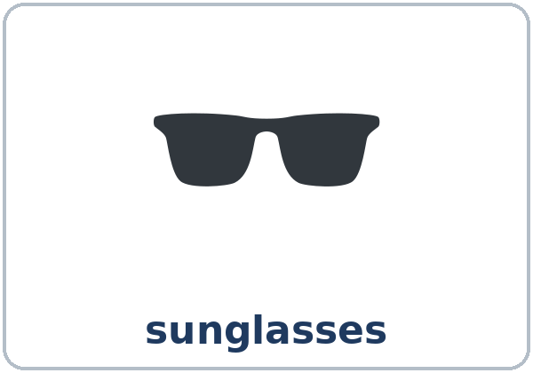  ★ sunglasses | 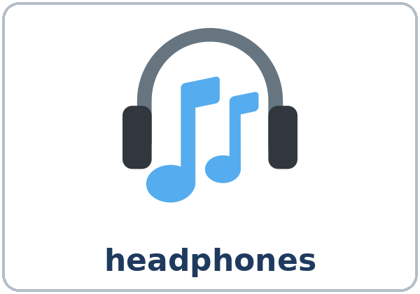  ★ headphones | 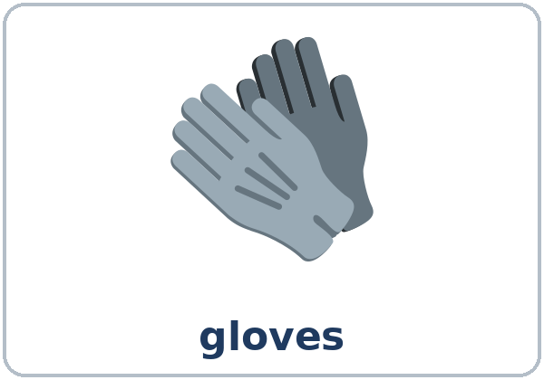  ★ gloves
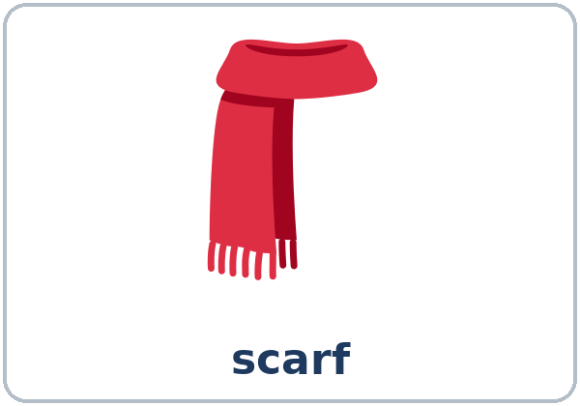  ★ scarf | 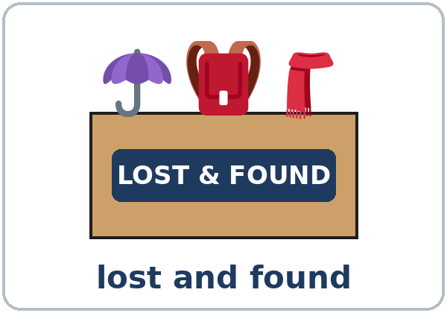  ★ lost and found | 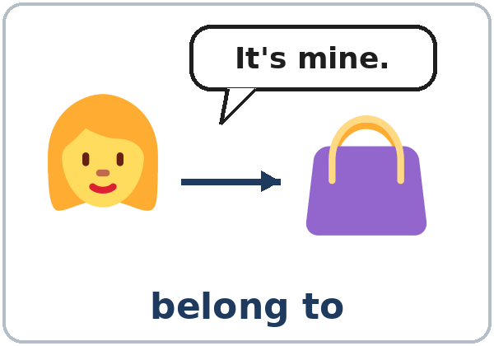  ★ belong to | 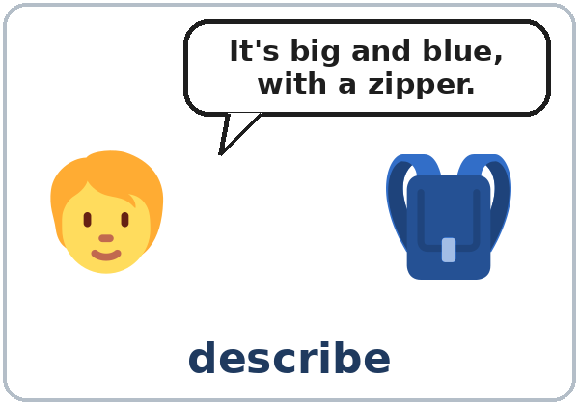  describe

Partner game: A says a word. B points and makes a sentence.
Example: A: umbrella. B: (points) My umbrella is black. It's small.
Lesson 8 (Week 9) · My Words
Write each word in your language, if you want. Then write your own example.
Word | My language | My example
wallet
purse
keys
umbrella
backpack
sunglasses
headphones
gloves
scarf
lost and found
belong to
describe

Lesson 8 (Week 9) · Listening
Listen to David. He's calling the lost and found at City Bus. Joan answers the phone.
A. Listen. What did David lose? Circle.
a. a wallet b. a backpack c. an umbrella
B. Listen again. Circle or check ✓ the details.
1. Color: blue / green / black
2. Size: big / small
3. What was inside? ☐ headphones ☐ a scarf ☐ gloves ☐ a wallet ☐ keys
4. Where did he get off the bus? Park Street / Main Street
5. Pick it up today before: 5:00 / 9:00
C. Listen again. Write his, mine, or yours.
1. My brother has the same one, but ____________ is green.
2. The big one is ____________.
3. There are white headphones inside. Are they ____________?
4. No, ____________ are black.
5. Yes! That's ____________. Thank you!
Say it: yours • hers • ours • theirs (z sound) • Whose = who's (hooz) • Whose bag is this?
Lesson 8 (Week 9) · Grammar
Read across. A reads from the left side. B answers from the right side. Choose one part from each column.
Grammar Box 1: Whose…?
QUESTION |  |  |  | ANSWER
Whose | umbrella  wallet | is this? |  | It's | mine.  hers.  Ana's.
Whose | keys  gloves | are these? |  | They're | ours.  his.  Tom's.
Whose | backpack | is that? |  | I think it's | theirs.  yours.

Grammar Box 2: Is this yours?
QUESTION |  |  | ANSWER
Is this | yours?  his? |  | Yes, it's mine.  Yes, it's his. | Thank you!
Is this | yours?  his? |  | No, it isn't mine. | Maybe it's hers.
Are these | yours?  theirs? |  | No, they aren't ours. | Ours are black.

Grammar Box 3: my bag → mine
+ A NOUN | NO NOUN | + A NOUN | NO NOUN
It's my bag. | It's mine. | It's her bag. | It's hers.
It's your bag. | It's yours. | It's our bag. | It's ours.
It's his bag. | It's his. | It's their bag. | It's theirs.

Grammar Box 4: Describing an item
 | SIZE | COLOR | ITEM | DETAIL
It's a | small / big | black / blue | wallet. / backpack. | with a zipper. / with two pockets.
They're | — | brown / red | gloves. / sunglasses. | with a star. / in a black case.

Questions and answers
Q: my or mine?
A: my + a noun: It's my bag. mine alone: It's mine. (not It's mine bag)
Q: Can I say It's the mine?
A: No. No the: It's mine. It's hers. And no apostrophe: yours, hers, ours, theirs.
Q: his or hers?
A: his = a man's. hers = a woman's. It's Maria's. It's hers.
Q: Whose or who's?
A: They sound the same. Whose = which person owns it: Whose bag is this? Who's = who is: Who's that?
Q: How do I describe it?
A: Size → color → item → with…: a small black wallet with a zipper (not a wallet black small).
Practice A: Write mine, yours, his, hers, ours, or theirs.
1. This is my bag. It's ____________.
2. That's her umbrella. It's ____________.
3. These are our keys. They're ____________.
4. Is this your scarf? Is it ____________?
5. Those are their gloves. They're ____________.
6. That's his wallet. It's ____________.
Practice B: Circle the right words.
1. (Whose / Who's) bag is this?
2. It's (my / mine).
3. Is this (your / yours) umbrella?
4. Those sunglasses are (her / hers).
5. It's a (black small / small black) wallet.
Common mistakes
✗ Don't say | ✓ Say
It's the mine. | It's mine.
Is this your? | Is this yours?
Who's bag is this? | Whose bag is this?
It's a wallet black. | It's a black wallet.

Nota para hispanohablantes: mine = (el / la) mío / mía, pero en inglés no se usa the: It's mine (no It's the mine). His (de él) y hers (de ella) son palabras diferentes; en español suyo sirve para los dos.

Tip for speakers of other languages: mine, yours, hers stand alone. my, your, her need a noun (my bag).

Lesson 8 (Week 9) · Talk Time: The Lost and Found Box
Round 1: Work with a partner. A is the clerk. B is the owner. B fills in the form on an Owner Card and describes the item. A looks at the picture and asks Is this yours? Then switch.
B: Hi. I lost my backpack. It's big and blue. A: Is number 1 yours?
B: Yes, it's mine! Thank you! / No, it isn't mine. Mine is…
Useful: Whose… is this? Is this yours? What color is it? Is it big or small? Does it have…?

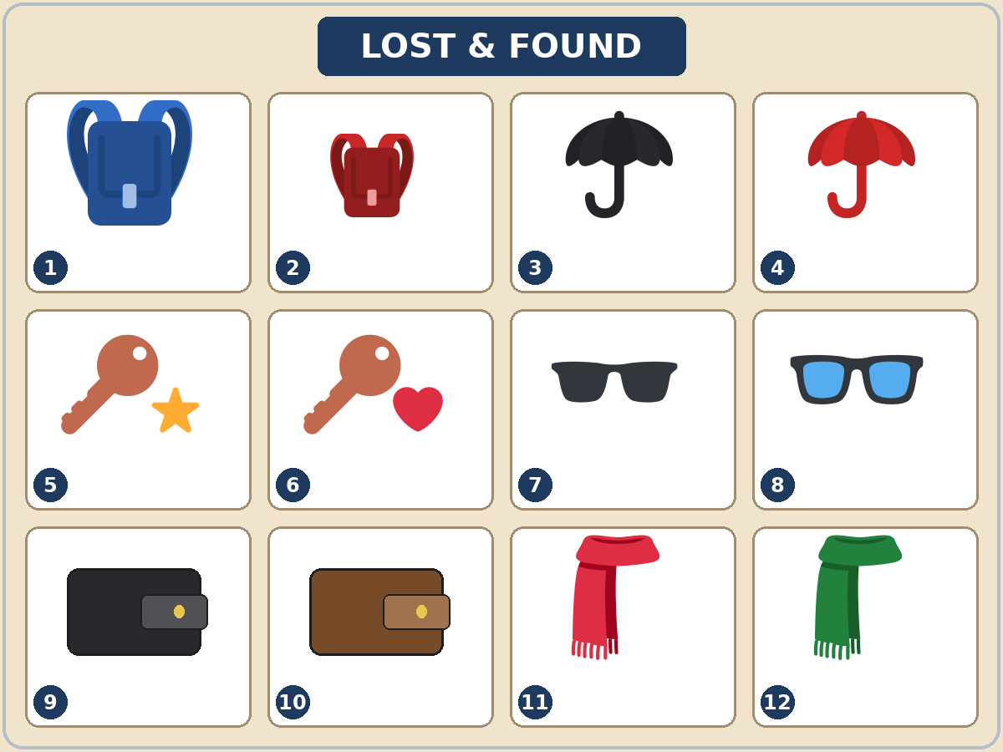

Lesson 8 (Week 9) · Talk Time: Owner Cards
Your teacher gives you a card number. Read your card. Fill in the form. Then describe the item to the clerk.
Owner Cards
1. You lost a big blue backpack. You were waiting for the bus. | 2. You lost a red umbrella. You were shopping.
3. You lost your keys. They have a red heart. You were running in the park. | 4. You lost a brown wallet. You were eating lunch.
5. You lost a green scarf. You were walking to work. | 6. You lost your glasses. They have blue lenses. You were reading at the library.
7. You lost a small red backpack. You were riding your bike. | 8. You lost a black wallet. You were paying for coffee.

My Lost-Item Form
Item
Size
Color
Details (with…)
What were you doing when you lost it?
The clerk found it. It was number…

Round 2: In a group of 3–4, look at the picture together. Say whose each item is. Number 9 is mine. Number 3 is Maria's. It's hers. Number 11 isn't ours. Maybe it's theirs.
Lesson 8 (Week 9) · Homework
Homework (about 15 minutes). Bring it next week!
1. Write the sentence again. Use mine, yours, his, hers, ours, or theirs.
Example: It's my phone. → It's mine.
1. It's my umbrella. → ______________________________________________
2. They're her gloves. → ______________________________________________
3. It's our car. → ______________________________________________
4. Are they your keys? → ______________________________________________
2. Describe 2 things: a bag, a jacket, a phone case, or something you can invent. Use size → color → item → with….
Example: It's a big black bag with two pockets.
1. ______________________________________________________________
2. ______________________________________________________________
3. At home, find 3 things. Write whose they are.
Example: The blue cup is mine. The big shoes are my son's. They're his.
1. ______________________________________________________________
2. ______________________________________________________________
3. ______________________________________________________________
4. Review (Lesson 7): Write 2 sentences with I'd like to…. Add a reason with because.
______________________________________________________________
______________________________________________________________
Lesson 8 (Week 9) · Read & Write
A. Read the FOUND notice and the lost-item report.
FOUND! (on the board at the community center)
I found a set of keys on Saturday, May 9, at Lincoln Park, near the basketball courts. They have a blue star key chain. Are they yours? Please call or text me. Tell me about the key chain and where you lost them, so I know they're yours. Sam, 555-0137

CITY BUS LOST-ITEM REPORT
Name | Rosa Diaz
Phone | 555-0162
Item | an umbrella
Size and color | big, black
Details | a wooden handle
Date and time | Monday, May 11, about 6:00 p.m.
What were you doing when you lost it? | I was reading on the number 4 bus. I left it under my seat.
ID number | Never write an ID number on this form.

B. Answer the questions.
1. What did Sam find? ______________________________________________
2. Where did he find it? ______________________________________________
3. When did he find it? ______________________________________________
4. What should the owner tell Sam? ______________________________________________
5. What did Rosa lose? Describe it. ______________________________________________
C. Choose one item from the Lost and Found picture. Write a FOUND notice. Say what you found, where, when, and how to contact you. Use an invented first name and a 555 number.
Example: FOUND! A small red backpack at the library on Tuesday, May 12. Is it yours? Please describe it. Call Lin, 555-0148.
FOUND!

D. Check your notice with a partner.
 | Yes | Not yet
It describes the item (size → color → item). | ☐ | ☐
It says where and when you found it. | ☐ | ☐
It asks Is it yours? or Are they yours? | ☐ | ☐
It has an invented name and a 555 number (no real numbers). | ☐ | ☐

Lesson 8 (Week 9) · Progress Check
Name: ______________________________ Date: ________________
A. Listen to the teacher. Circle a or b.
1. a. They're the speaker's keys. b. They're someone else's keys.
2. a. It's his umbrella. b. It's her umbrella.
3. a. a small black wallet b. a big brown wallet
4. a. The gloves are ours. b. The gloves are theirs.
B. Circle the right words.
1. (Whose / Who's) keys are these?
2. It's (mine / my).
3. (Their / Theirs) car is red.
4. Is this umbrella (yours / your)?
C. Write.
1. Describe a lost item. ______________________________________________
2. Whose pen is this? ______________________________________________
Score: A ______ / 4 B ______ / 4 C ______ / 2
D. How do you feel? Check ✓ one face for each line.
I can… | 😀 I can do it. | 🙂 With a little help. | 😐 Not yet.
I can ask Whose… is this? | ☐ | ☐ | ☐
I can say It's mine / It's hers. | ☐ | ☐ | ☐
I can describe a lost item. | ☐ | ☐ | ☐
I can fill out a lost-item report. | ☐ | ☐ | ☐

Picture Credits
Pictures use Twemoji graphics by Twitter, Inc. and other contributors (https://github.com/jdecked/twemoji), licensed under CC BY 4.0 (https://creativecommons.org/licenses/by/4.0/). The graphics were resized and combined, some were recolored (backpacks, umbrellas, a scarf), and drawings (wallets, a box, tiles, bubbles, arrows) and labels were added. The file-by-file list is in images/CREDITS.md.
Listening audio: synthetic voices made with Chatterbox TTS (Resemble AI, MIT License), cloned from synthetic reference clips made with Kokoro-82M (Apache License 2.0). No recordings of real people were used. Each file carries an inaudible Perth watermark marking it as AI-generated. The names and the story are invented.
Course materials: © 2026 the authors, licensed under CC BY-NC-SA 4.0 (https://creativecommons.org/licenses/by-nc-sa/4.0/).

