Level 1 Adult ESL Curriculum · Lesson 3 (Week 3): My Phone Number and Address
Status: Complete lesson (all 13 Level 1 lessons are published).
Date: October 2026
Audience: Program coordinators and volunteer teachers
Companion files: audio/L1_L3_listening.mp3, images/ (12 vocabulary pictures + images/CREDITS.md)
Topic: personal information and forms: phone numbers, addresses, ZIP codes, email, and a signature. Learners ask What's your phone number? What's your address?, use my / your / his / her / our / their, and fill out a simple form. Letters & Numbers: numbers to 100, -teen and -ty (13 / 30), phone numbers, and capital letters on forms.

How this lesson is organized
Part | What's inside | Who uses it
Teacher Plan | At a glance, clock-time plan, step-by-step boxes, Letters & Numbers script, listening script, answer key, teacher notes | Volunteer teachers
Student Pages | Hello + Review, New Words, Listening, Grammar, Talk Time (Student A and Student B pages), Homework, Letters & Numbers, Progress Check. Print this part for learners | Learners
Picture Credits | Picture sources and licenses | Coordinators

What Lesson 3 gives Level 2
Level 2 uses… | Where in Level 2 | Lesson 3 starts it with…
my / your / his / her / our / their | Lesson 2 (his routine, her job) and every lesson | What's her phone number? His address is… (Grammar Boxes 1–2, Talk Time)
Phone numbers, addresses, and simple forms; Could you repeat that? | Lesson 12 (service phone call, forms) | It's 555-0142. Can you repeat, please? (the listening, Talk Time information gap)
Numbers to 100 | Lessons 2 and 4 (times), 7 and 9 (prices) | Numbers 0–100, -teen / -ty (Letters & Numbers block)
be short answers (Is it…? No, it isn't.) | Lesson 1 review | Is your phone number 555-0124? No, it isn't. (Grammar Box 3)
First name, last name, signature on a form | Lesson 12 | The form in the listening, the practice ID cards, the homework form

TEACHER PLAN
Lesson 3 (Week 3)

My Phone Number and Address
At a glance · Clock-time plan · Step by step · Letters & Numbers · Script and answer key

How to Use This Plan
You don't need to speak Spanish or any other language. Teach in English. Show, point, and gesture. The student pages have a Spanish line and a "My language" line for every task. Learners read those on their own. You never need to read, translate, or explain them.

Instruction rule: Model it (do it with one learner while everyone watches), check it (ask: "Listen or write?"), then go. Say less, show more. Use the same short words every time: Listen. Repeat. Point. Circle. Write. Partner. Group.

Grouping toolkit: Pairs: turn to a neighbor; with an odd number, make one group of 3. Groups: 3–4 learners. Mingle: everyone stands and talks to many classmates. The teacher joins a pair only if one learner is left over.

When a learner is stuck or speaks another language to you: (1) show it: the picture, a gesture, or the board; (2) give one more short English example; (3) point to the instruction and the grammar box on their page; (4) a classmate can help for a few seconds, then back to English. You don't need to understand what classmates say to each other.

Privacy this week: learners never need to give a real phone number or address. Every activity works with the practice ID cards and practice numbers (555-0100 to 555-0199). Say this at the start of class.

Lesson 3 (Week 3): My Phone Number and Address
At a glance
Objectives: learners can…
• say and understand a phone number (It's 555-0142. Five-five-five, oh-one-four-two.)
• say an address (It's 210 Pine Street, Apartment 3.)
• ask What's your phone number? What's your address? and Can you repeat, please?
• use my / your / his / her / our / their (Her phone number is… His address is…)
• fill out a simple form in capital letters and sign it
• say and write numbers to 100, and hear 13 vs. 30 (Letters & Numbers block)

Materials
• Student Pages for Lesson 3 (print for the number expected + 3 spares). Talk Time: print the Student A page for half the class and the Student B page for the other half.
• one real paper form to show (a library card or clinic sign-in form, with no one's information on it)
• mini whiteboards or scrap paper for Letters & Numbers
• number cards 13–19 and 30–90 (or write them on the board)
• baseline snapshot checklist (in the answer key; finish it this week)
• phone + small speaker, L1_L3_listening.mp3
• Prep time: 30 min.

Key vocabulary (with pictures on the New Words page)
★ phone number • ★ address • ★ street • apartment (Apt.) • ★ city • ★ ZIP code • ★ email • ★ form • ★ signature • ID card • ★ zero ("oh") • numbers 21–100

Review from Lessons 1–2
How do you spell it? Can you repeat, please? • Where are you from? Is she from Mexico? Yes, she is. • How old is he? • numbers 0–20

Clock-time plan
Times are loose. If a step runs long, take the time from Grammar or Talk Time. The last 15 minutes are the Letters & Numbers block.
Time | Step | Min | Grouping (15 / 7–8) | If running behind
6:00–6:10 | Hello + Review (Lesson 2 questions) + homework check | 10 | Pairs, then new pairs | One partner only
6:10–6:20 | New Words (picture page) + pair picture game | 10 | Whole class, then pairs | Teach the ★ words only
6:20–6:32 | Listening (audio) + "Say it" | 12 | Individuals, then pairs check | Play the audio 2 times, not 3
6:32–6:45 | Grammar Q&A: What's your / his / her phone number? + my / your / his / her + pair drill | 13 | Whole class, then pairs | Skip the pair drill; it becomes homework
6:45–7:00 | BREAK | 15
7:00–7:10 | Talk Time: Information gap with practice ID cards + baseline snapshot | 10 | A–B pairs / A–B pairs | Skip Part 3 (tell the group)
7:10–7:15 | Exit Ticket + Homework | 5 | Individuals | Never skip
7:15–7:25 | Letters & Numbers: numbers to 100, -teen / -ty, phone numbers, forms | 10 | Whole class, then pairs | Do Tasks A and B only
7:25–7:30 | Progress Check | 5 | Individuals | Do it in Week 4 at 6:00, while people arrive

Skip order if you're running behind: (1) the third play of the audio; (2) the pair drill at the end of Grammar; (3) half of Talk Time. Never skip: the listening tasks, the grammar boxes, and the exit ticket.

Attendance (15 → 7–8): every step lists both sizes. Print for the number you expect, plus 3 spares. Late arrivals join any pair right away. In Talk Time, an A always works with a B; with an odd number, two Bs share one A.

Step by step
Step 1 · 6:00–6:10 · Hello + Review · 10 min
• Grouping: pairs. 15 learners: 7 pairs + 1 group of 3. 7–8 learners: 3–4 pairs. Late arrivals join any pair.
• Before class: write on the board: Where are you from? What city? Where is he / she from? Is he / she from ___?
• Model with one learner: "Where are you from?" → "Guatemala." "What city?" → "Antigua." Then point to another learner: "Where is she from?" → "She's from Mexico."
• Do: pairs use the Hello + Review page. A asks; B answers. Then they ask about a classmate (Where is he from? Is she from Honduras?). Switch. Then find a new partner.
• Homework check (last 3 min): partners show each other their Lesson 2 homework. Walk around and look at item 2 (am / is / are).
• New learners: pair them with a strong partner. They can do the Lesson 1–2 Progress Checks at home.
• If behind: one partner only.

Step 2 · 6:10–6:20 · New Words · 10 min
• Grouping: whole class, then pairs.
• Say first: "This is practice. You don't need your real phone number or your real address."
• Show: a real paper form (no one's information on it). Point to the lines: "This is a form. First name. Last name. Phone number. Address."
• Do: point to each picture and say the word. Learners repeat twice. Act out signature (sign your name in the air) and email (type on a phone).
• zero = "oh": write 555-0142 on the board. Say it slowly in groups: "five-five-five… oh-one-four-two." Point to the 0: "Oh. In phone numbers, 0 is often oh."
• numbers 21–100: point to the tiles and say them. Learners repeat. (Letters & Numbers practices them more.)
• Pairs (4 min): A points to a picture, B says the word. Then switch. Then: A points to a line on the form picture, B says the word (city, ZIP code…).
• If behind: teach the ★ words only.

Step 3 · 6:20–6:32 · Listening + "Say it" · 12 min
• Grouping: individuals, then pairs check.
• Before you listen (1 min): say: "This is Ana. She's at a clinic. She's a new patient. The receptionist asks: What's your phone number? What's your address?" Point to the form in Task B.
• Listen 1 → Task A (circle the right number: phone, street, apartment, ZIP code).
• Listen 2 → Task B (fill out Ana's form). Listen 3 → Task C (check what Ana writes) and finish Task B.
• Pairs compare after each task: "Show your partner." Then write the answers on the board.
• "Say it" (2 min): no student page needed. Write 2 lines on the board (they are also in Grammar Box 3): "What's your phone number?" and "Can you repeat, please?" The class repeats each line twice. Then pairs ask and answer with a practice number.
• The audio plays the conversation once. Press play again for the next listen.
• If behind: play the audio 2 times, and do Task C together.

Step 4 · 6:32–6:45 · Grammar Q&A · 13 min
• Grouping: whole class, then pairs.
• Show: the Grammar page. The left side is the question. The right side is the answer. Point left, then right.
• Box 1: you read a question; the class reads an answer.
• Box 2 (the key point): point to a man: "his phone number." Point to a woman: "her phone number." Point to yourself: "my." To a learner: "your." To the class and you: "our class." To two learners: "their city." Write on the board: he → his. she → her.
• Box 3: read a wrong number on purpose: "Is your phone number 555-0124?" → "No, it isn't. It's 555-0142."
• Box 4: read the left side; the class reads the right side. Say the groups with a small stop: 555 … 0142.
• Check questions: point to a man: "What's ___ name?" (his) • to a woman: (her) • "I'm Ana. ___ last name is Ruiz." (My)
• Pair drill (last 3–4 min): A asks from the left side about a person in the pictures (Ana, Carlos); B answers from the right side. Then switch.
• If behind: skip the pair drill. It becomes homework, and Talk Time practices the same questions.

Break · 6:45–7:00 · 15 min
• Put the Student A and Student B pages in two piles. Write on the board: What's your phone number? What's your address? Can you repeat, please? How do you spell it?

Step 5 · 7:00–7:10 · Talk Time: Information Gap with Practice ID Cards · 10 min
• Grouping: A–B pairs. Give half the class the Student A page and half the Student B page. With an odd number, two Bs share one A. Partners don't show their pages.
• Model with one learner (you are A): "What's your first name?" → "Marco." "How do you spell your last name?" → "S-I-L-V-A." Write it on the board as you hear it. "What's your phone number?" → "555-0163." "Can you repeat, please?"
• Part 1 (5 min): A asks and writes B's information on the form. Then B asks and writes A's information.
• Part 2 (2 min): partners show their pages and check: is the form the same as the ID card? Fix any mistakes together.
• Part 3 (2 min): pairs join another pair. Each learner says 2 sentences about the partner's card: "Her name is Rosa Diaz. Her phone number is 555-0187." / "His address is 1850 Lake Avenue."
• Fast pairs: do it again with their own information only if they want to, or with an invented card.
• Baseline snapshot: while pairs work, call the last learners you haven't checked, one at a time, for 2 minutes. Use the checklist in the answer key. This is the last week of the baseline.
• If behind: skip Part 3.

Step 6 · 7:10–7:15 · Exit Ticket + Homework · 5 min · NEVER SKIP
• Exit ticket: each learner says a phone number (a practice number is fine: "My phone number is 555-01__.") or writes one sentence with his or her (Her phone number is 555-0187.). Copying is fine.
• Homework: open the Homework page. Do item 1 together (the first two lines of the form). Point to each instruction so learners know what to do at home.

Letters & Numbers · 7:15–7:25 · Numbers to 100, -teen / -ty, Forms · 10 min
• Grouping: whole class, then pairs. Use the Letters & Numbers page.
• See it (1 min): point to 20, 30, 40… 100 on the page and say each one.
• Say it (3 min): go to the -teen / -ty box. Say each pair 3 times: "thir-TEEN… THIR-ty." Clap on the strong part. -teen is long and strong at the end; -ty is short and strong at the start. Learners show 1 finger + 3 for 13 and 3 fingers + a circle (0) for 30.
• Quick check (1 min): say 14 or 40, 15 or 50… Learners point on the page.
• Write it (4 min): Task B: say the 5 numbers in the answer key, 2 times each. Learners circle. Task C: read the 2 practice phone numbers in groups (five-five-five… oh-one-six-three). Learners write them. Task D: learners copy the card into the form in CAPITAL letters.
• Partners: A says a practice phone number (555-01__), B writes it. A checks. Switch.
• Learners who can't read or write yet: they say the numbers with everyone and point. In Task D they copy only the first name and last name. A helper, if you have one, sits with them.
• If behind: do Tasks A and B only.

Progress Check · 7:25–7:30 · 5 min
• Grouping: individuals. Open the Progress Check page.
• Part A: read the 5 numbers (answer key), slowly, 2 times each. Learners circle.
• Parts B and C: learners match and write on their own. Walk around and help with the instructions only.
• Part D: read each "I can…" line aloud and point to the 3 faces: 😀 "I can do it." 🙂 "A little." 😐 "Not yet." Learners check one.
• Collect the pages (or check them at the start of Week 4). Part A shows who still mixes up -teen and -ty.
• If behind: do the Progress Check in Week 4 at 6:00, while learners arrive.

Listening script: L1_L3_listening.mp3 (about 1:05; the conversation plays once, so play the audio again if needed)
Audio: play from a phone + small speaker. No speaker? Read the script with a volunteer. Read the numbers slowly, in groups, with a short stop: five-five-five… oh-one-four-two.

Narrator: Lesson three. Listening. Ana is at a clinic. She is a new patient. Listen.
Receptionist: Good morning. Can I help you?
Ana: Hi. I'm a new patient. My name is Ana Ruiz.
Receptionist: OK, Ana. What's your phone number?
Ana: It's 555-0142. (five-five-five, oh-one-four-two)
Receptionist: Sorry. Can you repeat, please?
Ana: Sure. 555-0142.
Receptionist: Thank you. And what's your address?
Ana: It's 210 Pine Street, Apartment 3. (two-ten Pine Street)
Receptionist: 210 Pine Street, Apartment 3. What's the city?
Ana: Riverside. The ZIP code is 54107. (five-four-one-oh-seven)
Receptionist: Thank you. Please write your email here. And sign here, please.
Ana: OK. Here you go.
Receptionist: Thank you, Ana. Please sit down.
Narrator: That's the end of the listening.

Answer key
• Listening Task A: 1 555-0142, 2 210, 3 3, 4 54107.
• Listening Task B (Ana's form): Last name: RUIZ • Phone number: 555-0142 • Address: 210 Pine Street, Apt. 3 • City: RIVERSIDE • ZIP code: 54107.
• Listening Task C: ✓ email, ✓ signature (not an ID card).
• Grammar practice (Write my, your, his, or her): 1 my, 2 His, 3 Her, 4 your, 5 her.
• Homework 2 (my, your, his, her, our, their): 1 My, 2 His, 3 Her, 4 Our, 5 Their.
• Homework 3 (write the number): 1 30, 2 14, 3 50, 4 99, 5 100.
• Letters & Numbers Task B (the teacher says): 1 30, 2 14, 3 50, 4 16, 5 90. Say each number 2 times.
• Letters & Numbers Task C (the teacher says): 1 555-0163 ("five-five-five, oh-one-six-three"), 2 555-0118 ("five-five-five, oh-one-one-eight"). Say each one 2 times, in groups.
• Letters & Numbers Task D: FIRST NAME: ROSA • LAST NAME: DIAZ • STREET: 46 OAK STREET • CITY: RIVERSIDE.
• Progress Check Part A (the teacher says): 1 13, 2 40, 3 15, 4 70, 5 80. Say each number 2 times.
• Progress Check Part B: 1 b, 2 d, 3 a, 4 c.
• Progress Check Part C: 1 His, 2 Her, 3 My.
• Progress Check scoring: Part A /5 + Part B /4 + Part C /3 = /12. This is not a test grade. Part A shows who needs more help with -teen / -ty; Part C shows his / her.
Baseline snapshot checklist (Weeks 1–3, last week)
Use the same sheet as Weeks 1–2, or this copy. Ask the 6 prompts, in this order. Check ✓ if the learner answers without help. Write ~ if they answer with help. Leave it empty if not yet. The final exam uses the same prompts.
Learner | What's your name? | How do you spell it? | Where are you from? | What's your phone number? | Do you have kids? | What do you do?

Learners can give a practice phone number (555-0100 to 555-0199) instead of a real one. Never write down real phone numbers.
Teacher notes
• Privacy: never ask for or write down a real phone number, address, or email. The practice ID cards and the 555-01__ numbers are for class. If a learner wants to use real information, that's their choice, but don't collect it.
• The big mistake this week: his and her. Spanish uses su for both. In English, his is for a man and her is for a woman; the word depends on the person, not the thing. Correct by pointing to the person: "Carlos… his." Learners can read the Spanish note on their Grammar page; you don't need to explain it.
• Phone numbers: say one digit at a time, in groups (3 + 4), with a short stop between the groups. 0 is usually "oh." 555-0100 = "five-five-five, oh-one-hundred" is also common, but teach digit by digit for now.
• Street numbers: usually in pairs: 210 = "two-ten," 1850 = "eighteen-fifty," 46 = "forty-six." The number comes before the street name: 210 Pine Street (not Pine Street 210).
• -teen or -ty? This is the hardest number pair for everyone. When a learner says 13 and you hear 30 (or the opposite), ask: "One-three or three-zero?" and write both on the board.
• Spelling review: in Talk Time, learners spell names and streets. Point to the Lesson 1 tricky letters (A / E / I, G / J) when you hear a mistake.
• Mixed levels: strong learners add the email and spell it (a-n-a at mail dot com). New learners use the box What's your ___? It's ___. for every line of the form.
• Learners who can't read or write yet: they take part fully in the speaking. On forms, they copy their first and last name and a practice number from the card. Don't make them read aloud.
• Looking ahead: Lesson 4 uses his / her with family (This is my sister. Her name is Ana.) and the first do question: Do you have kids?

STUDENT WORKBOOK
Lesson 3 (Week 3)

My Phone Number and Address
Hello + Review · New Words · Listening · Grammar · Talk Time · Homework · Letters & Numbers · Progress Check

Lesson 3 (Week 3): My Phone Number and Address
Student Page 1 · Week 3
Name: ______________________________ Date: ________________
Hello + Review: ask your partner. Then switch.
Español: Pregunta a tu compañero. Después cambien.
My language: ______________________________________________
A: Where are you from? B: I'm from ___.
A: What city? B: ___.
A: (point to a classmate) Where is he / she from? B: He's / She's from ___.
A: Is he / she from Mexico? B: Yes, he / she is. / No, he / she isn't.
Help: Can you repeat, please? How do you spell it?

This is practice. You don't need your real phone number or address in class.

Español: Esto es práctica. No necesitas tu número de teléfono ni tu dirección reales en clase.
My language: ______________________________________________
Lesson 3 (Week 3) · New Words
New Words
Look. Listen. Repeat. ★ = most important words.
Español: Mira. Escucha. Repite.
My language: ______________________________________________
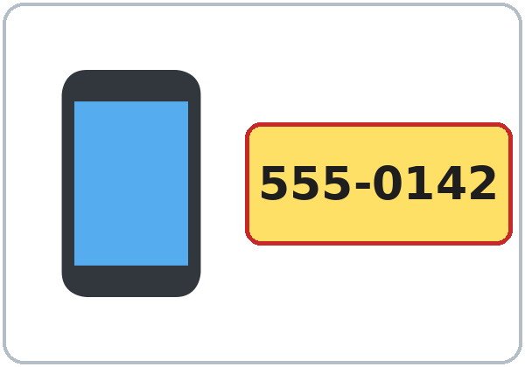  ★ phone number | 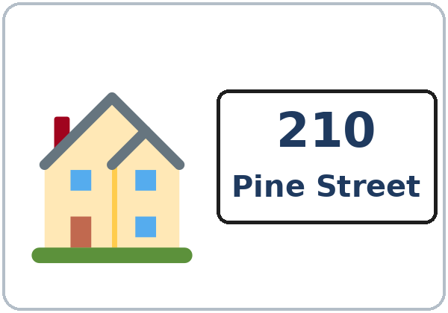  ★ address | 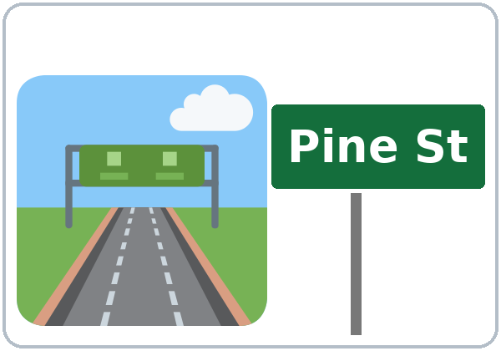  ★ street | 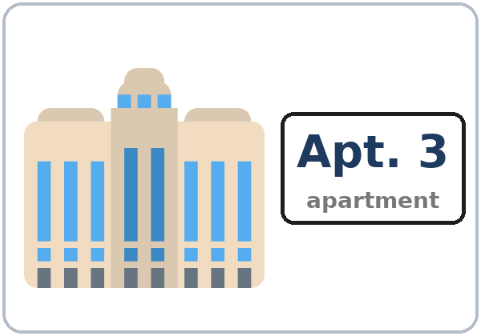  apartment (Apt.)
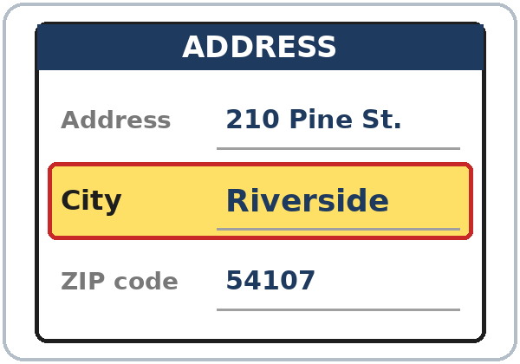  ★ city | 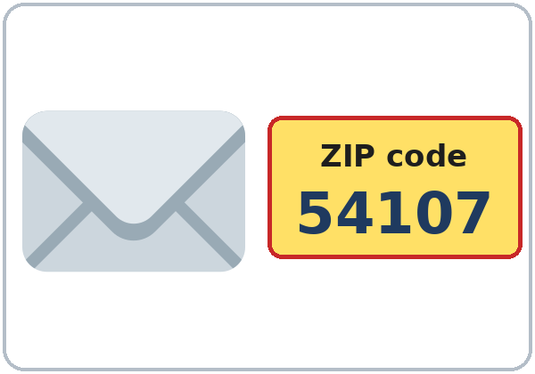  ★ ZIP code |   ★ email | 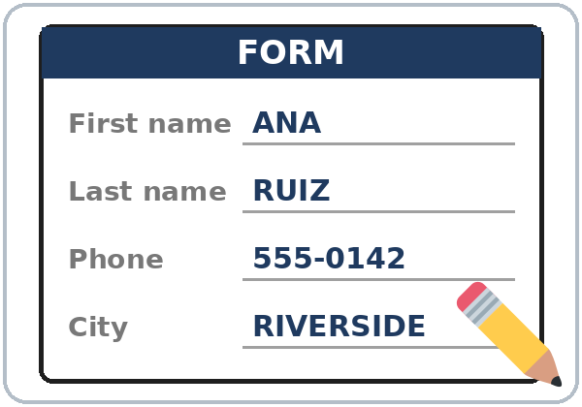  ★ form
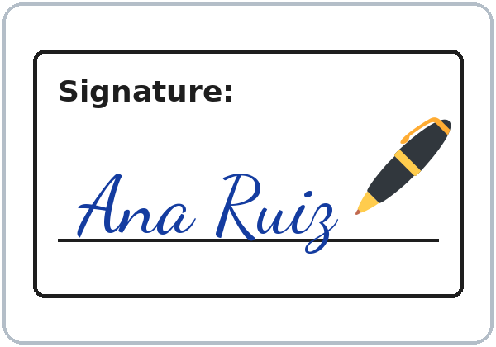  ★ signature | 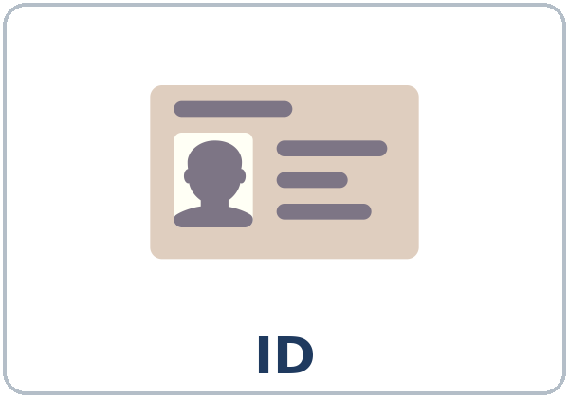  ID card | 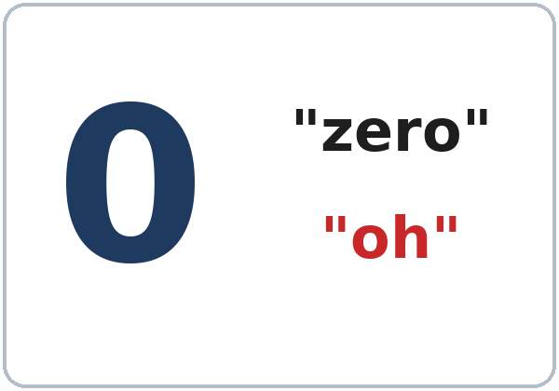  ★ zero ("oh") | 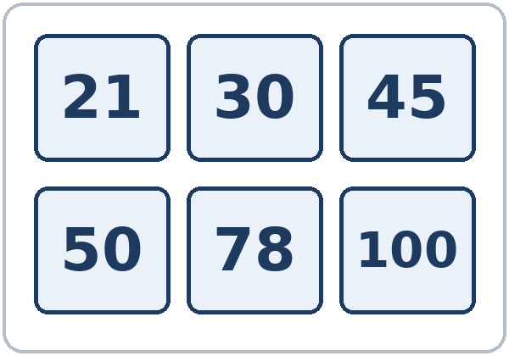  numbers 21–100

Partner game: A points. B says the word.
Español: Con un compañero: A señala una imagen. B dice la palabra. Después cambien.
My language: ______________________________________________
Lesson 3 (Week 3) · Listening
A. Listen to Ana at a clinic. Circle the right one.
Español: Escucha a Ana en una clínica. Encierra en un círculo la respuesta correcta.
My language: ______________________________________________
What? | Circle one.
1. Phone number | 555-0142 | 555-0124 | 555-0412
2. Street number | 201 | 210 | 120
3. Apartment | 3 | 13 | 30
4. ZIP code | 54107 | 54170 | 45107

B. Listen again. Fill out Ana's form.
Español: Escucha otra vez. Completa el formulario de Ana.
My language: ______________________________________________
NEW PATIENT FORM
First name | ANA | Last name
Phone number |  | City
Address | ______ Pine Street, Apt. ______ | ZIP code

C. Listen again. What does Ana write? Check ✓.
Español: Escucha otra vez. ¿Qué escribe Ana? Marca ✓.
My language: ______________________________________________
☐ her email ☐ her signature ☐ her ID card number
Lesson 3 (Week 3) · Grammar
With a partner: read across. A reads a question (left). B reads an answer (right). Choose one word from each column.
Español: Con un compañero: lee de izquierda a derecha. A lee una pregunta (izquierda). B lee una respuesta (derecha). Elige una palabra de cada columna.
My language: ______________________________________________
Grammar Box 1: What's your phone number?
QUESTION |  |  |  | ANSWER
What's | your  his  her | phone number? |  | It's | 555-0142.  555-0163.
What's | your  his  her | address? |  | It's | 210 Pine Street.  46 Oak Street.
What's | your  his  her | ZIP code?  email? |  | It's | 54107.  ana@mail.com.

Grammar Box 2: my, your, his, her…
PERSON |  | WHOSE?
I |  | my | phone number
you |  | your | address
he (Carlos) |  | his | phone number
she (Ana) |  | her | address
we |  | our | class
they |  | their | city

Grammar Box 3: Is your phone number 555-0124?
QUESTION |  |  |  | ANSWER
Is | your  his  her | phone number 555-0124? |  | Yes, | it | is.
Is | your  his  her | phone number 555-0124? |  | No, | it | isn't. It's 555-0142.
Can you | repeat, please?  spell it, please? |  |  | Sure. 555-0142.  Sure. P-I-N-E.

Grammar Box 4: How do I say it?
WRITE |  | SAY
555-0142 |  | five-five-five, oh-one-four-two
210 Pine Street |  | two-ten Pine Street
1850 Lake Avenue |  | eighteen-fifty Lake Avenue
Apt. 3 |  | apartment three
54107 (ZIP code) |  | five-four-one-oh-seven

Questions and answers
Q: his or her?
A: Look at the person. A man → his: Carlos… his phone number. A woman → her: Ana… her phone number.
Q: How do I say a phone number?
A: One number at a time, in groups: 555 … 0142 = "five-five-five … oh-one-four-two." 0 = "oh."
Q: How do I say a street number?
A: Usually two at a time: 210 = "two-ten." 1850 = "eighteen-fifty." The number comes first: 210 Pine Street.
Q: I don't want to say my real phone number. What do I say?
A: Use a practice number: 555-0100 to 555-0199.
Q: How do I write on a form?
A: Use CAPITAL letters: ANA RUIZ. Sign with your normal writing.
Practice: Write my, your, his, or her.
Español: Escribe my, your, his o her.
My language: ______________________________________________
1. I'm Rosa. ________ last name is Diaz.
2. This is Carlos. ________ phone number is 555-0163.
3. This is Ana. ________ address is 210 Pine Street.
4. What's ________ phone number? It's 555-0187.
5. Kim is a student. ________ email is kim@mail.com.
Common mistakes
✗ Don't say | ✓ Say
Carlos… her phone number. | Carlos… his phone number.
What is you phone number? | What's your phone number?
five hundred fifty-five… | five-five-five…
Pine Street 210. | 210 Pine Street.
My phone number 555-0142. | My phone number is 555-0142.
Is 555-0142. | It's 555-0142.

Nota para hispanohablantes: En español su puede ser de él, de ella, de usted o de ellos. En inglés hay una palabra para cada persona: his (de él), her (de ella), your (tu / su de usted), their (de ellos). Mira a la persona, no a la cosa: Carlos… his phone number. Ana… her phone number. Los números de teléfono se dicen uno por uno, y el 0 se dice «oh». En la dirección, el número va primero: 210 Pine Street (no «Pine Street 210»).

Tip for speakers of other languages: his = for a man, her = for a woman. Say phone numbers one number at a time, in groups: 555 … 0142. In an address, the number comes first: 210 Pine Street.

Lesson 3 (Week 3) · Talk Time · Student A
1. The middle column is your practice ID card. Don't show it. Ask your partner. Write in the last column.
Español: La columna del medio es tu tarjeta de práctica. No la muestres. Pregunta a tu compañero. Escribe en la última columna.
My language: ______________________________________________
A: What's your first name? What's your last name? How do you spell it?
A: What's your phone number? What's your address? What's your ZIP code?
Help: Can you repeat, please?

 | MY CARD (Student A) | MY PARTNER (Student B)
First name | ROSA
Last name | DIAZ
Phone number | 555-0187
Address | 46 Oak Street, Apt. 12
City | RIVERSIDE
ZIP code | 54110

2. Check: show your cards. Then tell a group about your partner.
Español: Revisen: muestren sus tarjetas. Después habla de tu compañero con un grupo.
My language: ______________________________________________
His / Her name is ___. His / Her phone number is ___. His / Her address is ___.

Lesson 3 (Week 3) · Talk Time · Student B
1. The middle column is your practice ID card. Don't show it. Ask your partner. Write in the last column.
Español: La columna del medio es tu tarjeta de práctica. No la muestres. Pregunta a tu compañero. Escribe en la última columna.
My language: ______________________________________________
B: What's your first name? What's your last name? How do you spell it?
B: What's your phone number? What's your address? What's your ZIP code?
Help: Can you repeat, please?

 | MY CARD (Student B) | MY PARTNER (Student A)
First name | MARCO
Last name | SILVA
Phone number | 555-0163
Address | 1850 Lake Avenue, Apt. 4
City | RIVERSIDE
ZIP code | 54108

2. Check: show your cards. Then tell a group about your partner.
Español: Revisen: muestren sus tarjetas. Después habla de tu compañero con un grupo.
My language: ______________________________________________
His / Her name is ___. His / Her phone number is ___. His / Her address is ___.

Lesson 3 (Week 3) · Homework
Homework (10 minutes). Bring it next week!
Español: Tarea (10 minutos). ¡Tráela la próxima semana!
My language: ______________________________________________
1. Fill out the form in CAPITAL letters. Use your information or the practice ID card. Then sign.
Español: Completa el formulario con letras MAYÚSCULAS. Usa tu información o la tarjeta de práctica. Después firma.
My language: ______________________________________________
FORM
First name
Last name
Phone number
Address
City
ZIP code
Signature

2. Write my, his, her, our, or their.
Español: Escribe my, his, her, our o their.
My language: ______________________________________________
1. I'm Ana. ________ last name is Ruiz.
2. This is Carlos. ________ phone number is 555-0163.
3. This is Rosa. ________ address is 46 Oak Street.
4. We are students. ________ teacher is from the United States.
5. They're from Honduras. ________ city is San Pedro Sula.
3. Write the number.
Español: Escribe el número.
My language: ______________________________________________
1. thirty ________ 2. fourteen ________ 3. fifty ________ 4. ninety-nine ________ 5. one hundred ________
4. Say a phone number 3 times (a practice number is OK). Say it in groups: 555 … 01 … 42.
Español: Di un número de teléfono 3 veces (puede ser de práctica). Dilo en grupos: 555 … 01 … 42.
My language: ______________________________________________
5. Review: write about you.
Español: Repaso: escribe sobre ti.
My language: ______________________________________________
I'm from ______________________________ . I'm from ______________________________ . (city)
Lesson 3 (Week 3) · Letters & Numbers
A. Look. Listen. Say the numbers.
Español: Mira. Escucha. Di los números.
My language: ______________________________________________
20  twenty | 30  thirty | 40  forty | 50  fifty | 60  sixty | 70  seventy
80  eighty | 90  ninety | 100  one hundred | 21  twenty-one | 35  thirty-five | 99  ninety-nine

-teen or -ty? Say them slowly.
Español: ¿-teen o -ty? Dílos despacio.
My language: ______________________________________________
-teen (strong end) | -ty (strong start)
13 thir-TEEN | 30 THIR-ty
14 four-TEEN | 40 FOR-ty
15 fif-TEEN | 50 FIF-ty
16 six-TEEN | 60 SIX-ty
17 seven-TEEN | 70 SEV-en-ty
18 eigh-TEEN | 80 EIGH-ty
19 nine-TEEN | 90 NINE-ty

B. Listen to the teacher. Circle the number.
Español: Escucha al profesor. Encierra el número en un círculo.
My language: ______________________________________________
1. | 13 | 30
2. | 14 | 40
3. | 15 | 50
4. | 16 | 60
5. | 19 | 90

C. Listen to the teacher. Write the phone number.
Español: Escucha al profesor. Escribe el número de teléfono.
My language: ______________________________________________
1. ________ - ______________ 2. ________ - ______________
D. Copy the card into the form. Use CAPITAL letters.
Español: Copia la tarjeta en el formulario. Usa letras MAYÚSCULAS.
My language: ______________________________________________
Card: Rosa Diaz • 46 Oak Street • Riverside
FIRST NAME | LAST NAME | STREET | CITY

Lesson 3 (Week 3) · Progress Check
Name: ______________________________ Date: ________________
A. Listen to the teacher. Circle the number.
Español: Escucha al profesor. Encierra el número en un círculo.
My language: ______________________________________________
1. | 13 | 30
2. | 14 | 40
3. | 15 | 50
4. | 17 | 70
5. | 18 | 80

B. Match the question and the answer. Draw a line.
Español: Une la pregunta con la respuesta. Dibuja una línea.
My language: ______________________________________________
Question | Draw a line. | Answer
1. What's your phone number? ● |  | ● a. It's 54107.
2. What's your address? ● |  | ● b. It's 555-0142.
3. What's your ZIP code? ● |  | ● c. No, it isn't.
4. Is your phone number 555-0124? ● |  | ● d. It's 210 Pine Street.

C. Write my, his, or her.
Español: Escribe my, his o her.
My language: ______________________________________________
1. This is Carlos. ________ phone number is 555-0163.
2. This is Ana. ________ address is 210 Pine Street.
3. I'm Rosa. ________ last name is Diaz.
D. How do you feel? Check ✓ one face for each line.
Español: ¿Cómo te sientes? Marca ✓ una cara en cada línea. 😀 = I can do it. 🙂 = I can do it with a little help. 😐 = Not yet.
My language: ______________________________________________
I can… | 😀 | 🙂 | 😐
I can say and understand a phone number. | ☐ | ☐ | ☐
I can say an address. | ☐ | ☐ | ☐
I can fill out a simple form. | ☐ | ☐ | ☐
I can ask What's your phone number? | ☐ | ☐ | ☐

Score: A ______ / 5 B ______ / 4 C ______ / 3
Picture Credits
Vocabulary pictures use Twemoji graphics by Twitter, Inc. and other contributors (https://github.com/jdecked/twemoji), licensed under CC BY 4.0 (https://creativecommons.org/licenses/by/4.0/). The graphics were resized and combined, and forms, signs, number tiles, and labels were added. The handwritten name on the signature picture uses the Dancing Script font (SIL Open Font License). All names, phone numbers, and addresses on the pages are invented. The file-by-file list is in images/CREDITS.md.
Other small pictures on the pages (the faces on the Progress Check) are standard emoji characters shown with the computer's emoji font. Listening audio: synthetic voices made with Chatterbox TTS (Resemble AI, MIT License); each file carries an inaudible Perth watermark marking it as AI-generated. The voices are copied from short reference clips made with Kokoro-82M (Apache 2.0); no recordings of real people were used. Course materials: © 2026 the authors, CC BY-NC-SA 4.0.

