Level 1 · Week 8: Midterm: Teacher Packet
Midterm Exam · Lessons 1–7 · Level 1 Adult ESL
Contents
• Step-by-step directions (for any teacher or volunteer)
• Clock-time plan
• Speaking interview and rubric
• Listening script
• Answer key and scoring guide
• Teacher notes
• Papers to copy: Speaking Interview Card (teacher), Speaking Task Cards, Speaking Score Sheet (teacher), Can-Do Self-Check, one-page Answer Key (teacher)
How to Use This Packet
• The test for learners is a separate file: Level1_Midterm_Student_Test.pdf (no answers). Print 1 per learner + 3 extra.
• This packet is for you: directions, the listening script, the answer key, and the speaking papers.
• Audio: audio/L1_Midterm_listening.mp3 (about 1:23). The conversation is in the file once. Press play again for the next listen.
• No Spanish needed. The Spanish lines on the test are for learners.
Week 8: Midterm: Step by Step
What the test has
Part | What learners do | Points | Time
A. Listening | Listen to a short conversation. Circle a picture or a word (7 items). Write one number (1 item). | 8 | 15 min (6:10–6:25)
B. Words | Look at a picture. Circle the word. | 6 | 20 min for B + C (6:25–6:45)
C. Grammar | Circle the correct word (2 choices). | 12 | (with B)
D. Form | Copy the information from a practice card onto a form. | 6 | 10 min (7:00–7:10)
Written total |  | 32 | 45 min
Speaking interview | Pairs (or one-on-one) with the teacher. Scored with the rubric, not added to the written total. | 3–9 | 3 min per pair

Covers Lessons 1–7. Every item uses only words and grammar from these lessons, and the same task types as the lessons (circle, check, write one number, copy onto a form, pair questions).
Before class (20 minutes)
1. Print the student test (1 per learner + 3). Print this packet's Speaking Task Cards (1 per pair), the Score Sheet, and the Self-Check (1 per learner).
2. Put L1_Midterm_listening.mp3 on a phone. Connect a small speaker. Play the first seconds to check the volume.
3. Set 2 chairs and 1 chair for you in a quiet corner (for the speaking interviews).
4. Have pencils and a clock or timer.
Step 1 · 6:00–6:10 · Warm-up + first interviews · 10 min
• Say: "Tonight is the test. Listening, then words and grammar, then a break, then a form. Don't worry. I read everything with you."
• Pairs ask and answer the questions on the Speaking Interview Card (write 4 of them on the board).
• You: call 2–3 pairs to the quiet corner for their speaking interview (3 minutes per pair).

Step 2 · 6:10–6:25 · Listening test (Part A) · 15 min · NEVER SKIP
• Hand out the test. Learners write their name.
• Read every item aloud and point to the pictures: "Number 1. Marco's last name is…" Learners only look; they don't write yet.
• Say: "Circle one answer. Number 8: write the number."
• Play 1: learners listen only. Play 2: learners circle and write. Play 3: learners check. Wait 30 seconds between plays.
• Learners who can't read yet: read the choices aloud and let them point; you circle for them.

Step 3 · 6:25–6:45 · Words and Grammar (Parts B and C) · 20 min · NEVER SKIP
• Part B: say "Look at the picture. Circle the word." Read both words for each picture aloud.
• Part C: read each sentence aloud with "blank" for the missing word, then read the two words: "Number 1. Blank you from Mexico? Are? Is?" Learners circle. About 1 minute per item.
• Do the first item of each part together on the board as an example (a different sentence, not a test item).

Break · 6:45–7:00 · 15 min
• Collect nothing. Learners keep their test face down.

Step 4 · 7:00–7:10 · Form (Part D) + interviews · 10 min · NEVER SKIP
• Say: "Look at the card. Write the information on the form." Point to the first line on the card and on the form.
• Learners work alone. They may copy letters one by one; that is OK.
• You: start the remaining speaking interviews in the quiet corner.

If time · 7:10–7:30 · Interviews, then the Self-Check
• ① Finish all interviews. Learners who are waiting do the Can-Do Self-Check, then practice the Task Cards with a partner.
• ② Collect the tests and the self-checks. Say "Thank you! Great work!"
• ③ Go over the listening (5 min, optional): play the audio once more and say the answers.

Clock-time plan
Time | Step | Min | Grouping | If running behind
6:00–6:10 | Warm-up (pair questions) + first speaking interviews | 10 | Pairs | Shorten the warm-up
6:10–6:25 | Part A: Listening (play 2–3 times) | 15 | Individuals | Never skip; 2 plays are OK
6:25–6:45 | Parts B + C: Words and Grammar | 20 | Individuals | Never skip; slow readers finish Part C after the break
6:45–7:00 | BREAK | 15
7:00–7:10 | Part D: Form + speaking interviews | 10 | Individuals | Never skip
7:10–7:30 | Finish interviews; Can-Do Self-Check; go over the listening | 20 |  | The self-check can go home

Written test time: 15 + 20 + 10 = 45 minutes. Interviews happen during the warm-up and after the break, while learners work alone.

Speaking interview (3 minutes per pair)
How to do it
• Pairs come to the quiet corner (or one learner, if there is an odd number; you are the partner).
• How many: 15 learners ≈ 8 pairs ≈ 24 minutes: about 3 pairs at 6:00–6:10 and 5 pairs at 7:00–7:30. 7–8 learners ≈ 4 pairs ≈ 12 minutes.
• Part 1 (1 minute): ask each learner 2 questions from the Speaking Interview Card. Use different questions for each partner.
• Part 2 (2 minutes): give the pair a Task Card: Shop role play: How much is it? Learner A asks; Learner B answers. Then switch.
• Score right away on the Score Sheet: 3 areas, 1–3 points each (total 3–9). Write one thing the learner did well.
• Be kind: smile, repeat a question once, point to the picture. Don't correct during the interview.
• Target grammar for this interview: be questions and short answers; How much is / are…?, this / these, It's / They're.

Speaking rubric (same 1–3 scale as Level 2, in beginner words):
Score | Communication | Target grammar | Pronunciation and fluency
3 | Answers every question; asks the partner questions | Uses the lesson phrases correctly most of the time | Easy to understand; few long stops
2 | Answers most questions; needs a little help (a repeat, a gesture) | Uses the phrases with mistakes, but the meaning is clear | Mostly easy to understand; some stops
1 | One-word answers or no answer, even with help | Few correct phrases, or mistakes hide the meaning | Hard to understand

A one-word answer that is correct (for example, "Guatemala.") is fine for Communication 2. Short answers like "Yes, I do." count as correct target grammar.
Listening script: L1_Midterm_listening.mp3 (about 1:23; the conversation is in the file once, so press play again for each listen)
Audio: play from a phone + small speaker. No speaker? Read the script slowly with a second adult (not a learner). Say numbers as words: five-five-five, oh-one-eight-six; six thirty; twelve dollars.

Narrator: This is the midterm listening. Marco is at the adult school. He talks to the receptionist. Listen.
Receptionist: Hello! Welcome to Riverside Adult School. What's your name?
Marco: Hi. My name is Marco Lima.
Receptionist: How do you spell your last name?
Marco: L, I, M, A.
Receptionist: Thank you. Where are you from, Marco?
Marco: I'm from Guatemala.
Receptionist: What's your phone number?
Marco: It's 555-0186.
Receptionist: Sorry. Can you repeat, please?
Marco: Sure. 555-0186.
Receptionist: Thank you. What do you do?
Marco: I'm a cook. I work at a restaurant.
Receptionist: Do you have kids?
Marco: Yes, I do. I have two kids.
Receptionist: OK. The English class is on Tuesday and Thursday, at six thirty.
Marco: Tuesday and Thursday, at six thirty. Great!
Receptionist: And here's your book. It's $12.
Marco: OK. Here's $20.
Receptionist: Thank you. Your change is $8. See you on Tuesday!
Marco: Thank you. Goodbye!
Narrator: That's the end of the listening.

Answer key
• Part A, Listening: 1 LIMA (choice 1 of 3); 2 Guatemala (choice 2 of 3); 3 555-0186 (choice 1 of 3); 4 cook (choice 1 of 3); 5 2 kids (choice 2 of 3); 6 Tuesday and Thursday (choice 2 of 3); 7 6:30 (choice 2 of 3); 8 12.
• Part B, Words: 1 teacher; 2 phone number; 3 daughter; 4 nurse; 5 morning; 6 shoes.
• Part C, Grammar: 1 Are; 2 is; 3 a; 4 an; 5 Her; 6 His; 7 am; 8 at; 9 on; 10 this; 11 these; 12 don't.
• Part D, Form: First name Rosa; Last name Diaz; Phone number 555-0173; Address 48 Lake Street; City Riverside; ZIP code 54107.
Where the answers are in the audio
# | Answer | The learner hears | Lesson
1 | LIMA | "L, I, M, A." | 1
2 | Guatemala | "I'm from Guatemala." | 2
3 | 555-0186 | "It's 555-0186." | 3
4 | cook | "I'm a cook." | 5
5 | 2 kids | "I have two kids." | 4
6 | Tuesday + Thursday | "on Tuesday and Thursday" | 6
7 | 6:30 | "at six thirty" | 6
8 | 12 | "It's $12." | 7

Scoring guide
• 1 point per item. Part A /8 + Part B /6 + Part C /12 + Part D /6 = /32.
• Listening item 8 (write): the number alone is enough (12 or $12).
• Circle items: one clear circle (or a check, a line, or pointing that you saw) = 1 point. Two answers circled = 0.
• Part D: 1 point per line. Copying mistakes of one letter or one number are OK if the word is clear (Rivrside = 1 point). Capital or small letters both OK.
• Suggested levels (written test): Meets 25–32 · Almost 17–24 · Not yet 0–16. (Same percentages as the Level 2 exams.)
• Speaking: Meets = 2 or more in all three rubric areas.
Teacher notes
• Read everything aloud. This is a test of English listening and words, not of reading speed. Reading items aloud is part of the test, not extra help.
• Learners who can't read or write yet: they point; you circle for them and write "oral" at the top. For Part D, they copy as much as they can; give 1 point for each line with the right first letters or numbers.
• Extra time is fine. Slow readers can finish Part C after the break.
• Absent learners: give the test next week at 7:10 (play the audio for them with earbuds, 2–3 times). The interview needs a teacher.
• Privacy: the form uses an invented practice card. Never ask for a learner's real address, phone number, or immigration information.
• Return the papers next week with one strength and one goal for each learner.
Week 8: Midterm · Speaking Interview Card (Teacher)
Part 1 · Each learner (1 minute)
Ask each learner 2 questions. Use different questions for each partner.
1. What's your name?
2. How do you spell your last name?
3. Where are you from?
4. What's your phone number? (a practice number is OK)
5. Do you have kids? / Do you have brothers or sisters?
6. What do you do? Where do you work?
Part 2 · Pair task (2 minutes): Shop role play: How much is it?
• Learner A: You are the shopper. Point and ask: How much is this shirt? How much are these shoes?
• Learner B: You are the cashier. Say the price: It's $15. / They're $30.
• Switch. Ask about the jacket and the pants.
Rubric
Score | Communication | Target grammar | Pronunciation and fluency
3 | Answers every question; asks the partner questions | Uses the lesson phrases correctly most of the time | Easy to understand; few long stops
2 | Answers most questions; needs a little help | Mistakes, but the meaning is clear | Mostly easy to understand; some stops
1 | One-word answers or no answer, even with help | Few correct phrases, or mistakes hide the meaning | Hard to understand

Week 8: Midterm · Speaking Task Card (cut apart: 1 per pair)
Learner A: You are the shopper. Point and ask: How much is this shirt? How much are these shoes?
Español: Eres el comprador. Señala y pregunta el precio.
My language: ______________________________________________
Learner B: You are the cashier. Say the price: It's $15. / They're $30.
Español: Eres el cajero. Di el precio.
My language: ______________________________________________
Switch. Ask about the jacket and the pants.
Español: Cambien. Pregunten por la chaqueta y los pantalones.
My language: ______________________________________________
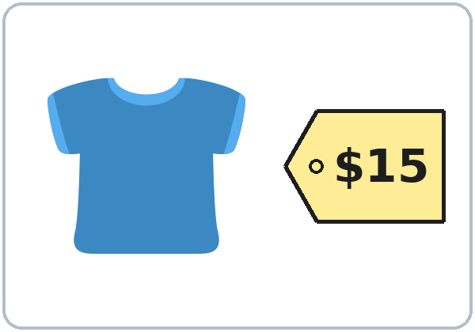  shirt $15 | 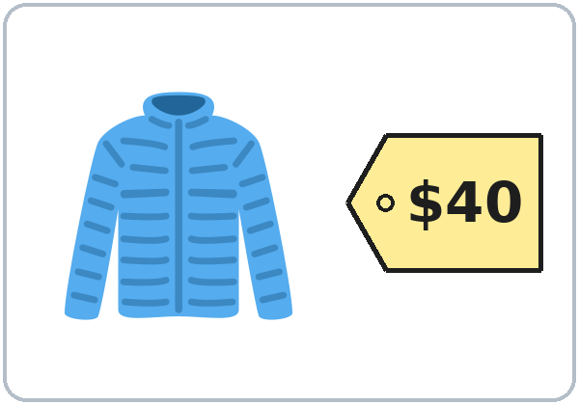  jacket $40 | 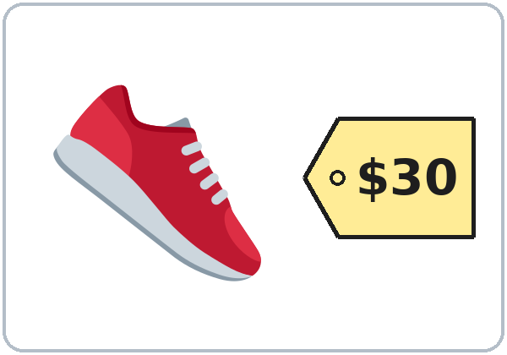  shoes $30 | 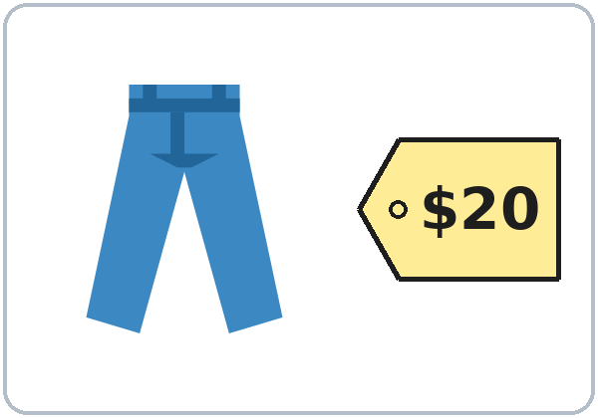  pants $20

Week 8: Midterm · Speaking Score Sheet (Teacher)
Teacher: ______________________ Date: ______________
Learner | Comm. (1–3) | Grammar (1–3) | Pron. (1–3) | Total (/9) | One thing done well

Comm. = Communication · Grammar = Target grammar · Pron. = Pronunciation and fluency. Meets = 2 or more in all three areas. Use a second sheet for more learners.
Week 8: Midterm · Can-Do Self-Check
Name: ______________________________ Date: ________________
Listen to the teacher. Check ✓ one box for each line.
Español: Escucha al profesor. Marca ✓ una casilla en cada línea.
My language: ______________________________________________
I can… | Yes | A little | Not yet
I can say and spell my name. (Lesson 1) | ☐ | ☐ | ☐
I can say where I am from. (Lesson 2) | ☐ | ☐ | ☐
I can say a phone number and an address. (Lesson 3) | ☐ | ☐ | ☐
I can talk about my family. (Lesson 4) | ☐ | ☐ | ☐
I can say my job. (Lesson 5) | ☐ | ☐ | ☐
I can tell the time and the day. (Lesson 6) | ☐ | ☐ | ☐
I can ask the price. (Lesson 7) | ☐ | ☐ | ☐

My goal for the next 7 weeks: write or draw one thing.
Español: Mi meta para las próximas 7 semanas: escribe o dibuja una cosa.
My language: ______________________________________________
______________________________________________________________
______________________________________________________________
Week 8: Midterm · Answer Key (Teacher)
Part A · Listening
# | Answer | # | Answer
1 | LIMA | 5 | 2 kids
2 | Guatemala | 6 | Tuesday + Thursday
3 | 555-0186 | 7 | 6:30
4 | cook | 8 | 12

Part B · Words
# | Answer | # | Answer | # | Answer
1 | teacher | 2 | phone number | 3 | daughter
4 | nurse | 5 | morning | 6 | shoes

Part C · Grammar
# | Answer | # | Answer | # | Answer
1 | Are | 5 | Her | 9 | on
2 | is | 6 | His | 10 | this
3 | a | 7 | am | 11 | these
4 | an | 8 | at | 12 | don't

Part D · Form
First name: Rosa · Last name: Diaz · Phone number: 555-0173 · Address: 48 Lake Street · City: Riverside · ZIP code: 54107
Total: A /8 + B /6 + C /12 + D /6 = /32. Meets 25–32 · Almost 17–24 · Not yet 0–16. The listening script is in this packet ("Listening script").
License and Credits
© 2026 the authors. The authors license these materials under CC BY-NC-SA 4.0 (https://creativecommons.org/licenses/by-nc-sa/4.0/). Program names and logos are not covered by this license.
Pictures: Twemoji graphics by Twitter, Inc. and other contributors (https://github.com/jdecked/twemoji), licensed under CC BY 4.0 (https://creativecommons.org/licenses/by/4.0/). The graphics were resized and combined; the clock faces, price tags, and practice cards are original drawings made in code. The file-by-file list is in images/CREDITS.md. All names, phone numbers, addresses, and prices are invented.
Listening audio: synthetic voices made with Chatterbox TTS (Resemble AI, MIT License), copied from short reference clips made with Kokoro-82M (Apache 2.0). No recordings of real people were used. Each file carries an inaudible Perth watermark that marks it as AI-generated.
These materials are provided as-is for educational use, without warranty of any kind.

