Level 4 Adult ESL Curriculum · Lesson 6 (Week 6): What Would You Do?
Status: Draft for review; not published.
Date: October 2026
Audience: Program coordinators and volunteer teachers
Companion files: images/ (12 vocabulary pictures + images/CREDITS.md). Listening audio: not recorded yet (coming soon); until then, read the listening script in this plan aloud.
Topic: Imagining situations and making choices: finding money, getting too much change, a free week, a magic wand, a dream job. Learners talk about imaginary situations with If I had / found / were…, I'd…, give reasons, and give advice with If I were you, I'd…. All situations are invented and everyday.

How this lesson is organized
Part | What's inside | Who uses it
Teacher Plan | At a glance, clock-time plan, step-by-step boxes, listening script, answer key, teacher notes | Volunteer teachers
Student Pages | Opening Talk, New Words, My Words, Listening, Grammar, Talk Time, Homework, Read & Write, Exit Ticket, Task Words (optional). Print this part for learners | Learners
Picture Credits | Picture and license credits | Coordinators

What Lesson 6 builds on and what it adds
Before (review only) | Where | New in Level 4 Lesson 6
If + present, will (possible future) | Level 3 Lesson 11 | If + past, would for imaginary situations: If I found $50, I'd give it back.
simple past forms (found, had, won) | Levels 2–3 | the same forms after if for "not real now": If I had a car…
suggestions (Why don't you…? / You could…) | Level 4 Lesson 4 | advice with If I were you, I'd…

TEACHER PLAN
Lesson 6 (Week 6)

What Would You Do?
At a glance · Clock-time plan · Step by step · Script and answer key

How to Use This Plan
You don't need to speak Spanish or any other language. Teach in English. Show, point, and gesture. Some Grammar pages have one short contrast tip, only where a common mix-up exists. Learners read it on their own. You never need to read, translate, or explain it.

Instructions: use the same short task words every week: Listen. Circle. Check. Write. Work with a partner. Work in a group. Ask a follow-up question. Give a reason. An optional Task Words page is at the back of the workbook for learners who want it.

Instruction rule: Model it (do it with one learner while everyone watches), check it (ask: "If it happened to you, what would you do?"), then go. Say less, show more.

Grouping toolkit: Pairs: turn to a neighbor; with an odd number, make one group of 3. Groups: 3–4 learners. Inside–outside circles: the inner circle faces out, the outer circle faces in; the outer circle moves one person to the right each round. Mingle: everyone stands and talks to many classmates. The teacher joins a pair only if one learner is left over.

When a learner is stuck or speaks another language to you: (1) show it: the picture, a gesture, or the board; (2) give one more short English example; (3) point to the grammar box on their page; (4) a classmate can help for a few seconds, then back to English. You don't need to understand what classmates say to each other.

Three sentences, not one: in Level 4, every Talk Time answer and every exit ticket has about three connected sentences: the answer, a reason, and a detail or example.

Lesson 6 (Week 6): What Would You Do?
At a glance
Objectives: learners can…
• ask and answer What would you do if…?
• talk about an imaginary situation with If I + past, I'd + verb
• give advice with If I were you, I'd… and a reason
• tell a possible situation (If it rains, I'll…) from an imaginary one (If I had…, I'd…)
• write a reply to an advice letter (5–8 sentences)

Materials
• Student Pages for Lesson 6 (print for the number expected + 3 spares)
• Board and markers
• Situation cards (in the workbook Talk Time page; copy them onto index cards, optional)
• A pencil or a stick as a "magic wand" (optional, for Talk Time)
• Listening: no recording yet. Read the listening script aloud (with a volunteer if you can), at a natural speed, two times.
• Prep time: 15 minutes (read the plan; practice reading the listening script; practice I'd and wouldn't).

Key vocabulary (with pictures on the New Words page)
★ imagine • ★ choose • ★ honest • ★ tell the truth • ★ keep (it) • ★ give back • ★ owner • ★ envelope • ★ extra money • ★ mistake • magic wand • dream job
Also: a situation, a cashier, change (money back), a caller, a radio show, a wallet, a lie, probably, feel bad, advice.

Clock-time plan
Times are loose. If the listening or Talk Time runs long, take the time from Read & Write.
Time | Step | Min | Grouping (15 / 7–8) | If running behind
6:00–6:08 | Opening Talk + Homework Check | 8 | Pairs (7 pairs + 1 trio / 3–4 pairs) | One card only
6:08–6:15 | New Words (picture page) + pair game (+ My Words) | 7 | Whole class, then pairs | Teach the ★ words only
6:15–6:30 | Listening: play 1 (Task A), play 2 (Tasks B and C) + "Hear it, say it" | 15 | Individuals, then pairs check | Do Task C together on the board
6:30–6:45 | Grammar Q&A: If I had…, I'd… / What would you do if…? + pair check | 15 | Whole class, then pairs | Skip the pair check; Talk Time practices it
6:45–7:00 | BREAK | 15
7:00–7:15 | Talk Time: What Would You Do? + Magic Wand Chain | 15 | Groups of 3–4, then a circle | Round 1 only
7:15–7:25 | Read & Write: An advice column; a reply to a letter | 10 | Pairs read, then individual writing | Reading questions only; the writing becomes homework
7:25–7:30 | Exit Ticket + Homework | 5 | Individuals | Never skip

Skip order if you're running behind: (1) the Read & Write writing task (it becomes homework); (2) the pair check at the end of Grammar; (3) the second round of Talk Time. Never skip: the listening tasks, the grammar boxes and the mistakes table, and the exit ticket.

Attendance (15 → 7–8 → 5 or fewer): every step lists the sizes. With 5 or fewer, do What Would You Do? as one group: you read the card and everyone answers. Do the Magic Wand Chain as one circle. Late arrivals join a group and answer the next card.

Step by step
Step 1 · 6:00–6:08 · Opening Talk · 8 min
• Grouping: pairs, the same partner for both parts. 15 learners: 7 pairs + 1 group of 3. 7–8 learners: 3–4 pairs. 5 or fewer: pairs, or one group with you.
• Before class: write on the board: favors: Would you mind…? / Do you mind if I…?
• Opening Talk (5 min): learners open the Opening Talk page. A asks a card question; B answers in 3 sentences (the answer, a reason, a detail); A asks one follow-up. Switch after each card.
• Model with one learner: you say, "Would you mind lending me a pen?" The learner answers, "No, not at all," or "Sorry, I can't, because…" Then they ask you a favor. Help them say 3 sentences.
• Homework Check (3 min): Pairs compare Homework item 1 (Would you mind + -ing) and ask each other their 3 favors (item 3). Then they fill in the box on the Opening Talk page. Walk around. Write 2 common errors on the board (often Would you mind to get…? (→ Would you mind getting…?) and Yes, I'll help as the answer (→ No, not at all)) and correct them together. Also put up 2 corrections from last week's exit tickets.
• Late arrivals: join any pair as a group of 3.
• If behind: one card only.

Step 2 · 6:08–6:15 · New Words · 7 min
• Grouping: whole class, then pairs. Show the New Words page.
• Do: point to each picture and say the word. Learners repeat once.
• Show the hard words: imagine (point to your head: a picture in your mind); choose (hold up two things: pick one); honest and tell the truth (you don't lie); keep it vs. give it back (mime with a coin); owner (the person it belongs to); envelope; extra money (more than you should get); mistake; magic wand (wave a pencil); dream job (the job you want most).
• Check meaning (1 min): ask "If a cashier gives you extra money, is it a mistake?" (yes) • "Is the owner the person who found it or the person it belongs to?" (it belongs to) • "If you tell the truth, are you honest?" (yes).
• Pairs (2 min): A says a word; B points to the picture and makes a sentence (If I found a wallet, I'd give it back to the owner.). Switch. 15 learners: finish with a quick team round (3 teams; you say a clue, the first team with the word gets a point). 7–8: 2 teams. 5 or fewer: one team against the clock.
• My Words: "Write any word you want in your language on the My Words page. It's your personal list. It's optional." Learners do it at home.
• If behind: teach the ★ words only.

Step 3 · 6:15–6:30 · Listening + "Hear it, say it" · 15 min
• Grouping: individuals, then pairs check. With 5 or fewer, check together as a group.
• Before you listen (2 min): say: "This is a radio show called What Would You Do? Mike is the host. He tells a situation, and two people call the show with their answers. Listen: what is the situation?"
• Play 1 → Task A (the main idea). Pairs compare. Check together.
• Read Tasks B and C together (1 min) so learners know what to listen for.
• Play 2 → Tasks B and C. Pairs compare. Then show the answers (answer key).
• "Hear it, say it" (3 min): Point to the script lines. wanna = want to: "I want to hear your ideas." gonna = going to: "If you're going to call, call early!" Then practice I'd (say the d): I'd give it back, and What would you DO? with the stress on do. The class repeats the two lines twice.
• No recording yet: read the script aloud with a volunteer (about 1:50), at a natural speed, two times. The script says going to and want to. People often say gonna and wanna; learners only need to recognize those words. When the audio is ready, it plays the conversation once; press play again for play 2. A third play is fine if the class needs it.
• If behind: do Task C together on the board, reading the lines yourself.

Step 4 · 6:30–6:45 · Grammar Q&A · 15 min
• Grouping: whole class, then pairs. Show the Grammar page. The left side is the question. The right side is the answer.
• Show it (2 min): hold up a pencil as a magic wand. Say, "I don't have a magic wand. But if I had a magic wand, I'd fix all the potholes in this city." Write it in two halves: If I had a magic wand, | I'd fix the potholes. Say: "It's not real. We use the past form after if and would in the other half."
• The boxes (5 min): Box 1: read across: What would you do if you found $50 at work? → If I found $50, I'd give it to my supervisor. Box 2: possible (If it rains, I'll…) vs. imaginary (If I had a car, I'd…). Box 3: I'd and wouldn't. Box 4: If I were you, I'd… for advice.
• Rule of thumb and Questions and answers (2 min): read the rule of thumb aloud. Read each Q and A; the class reads the right sentence after you.
• Check questions: "Do I have a magic wand?" (no) "So do I say If I have or If I had?" (If I had) • "If I would have time or If I had time?" (If I had time) • "If I were you or If I am you?" (If I were you).
• Practice A and B (3 min): learners write, then pairs check. Go over the answers. Read the Common mistakes table together: "Don't say… Say…".
• Pair check (last 3 min): A reads a situation from the pictures: "What would you do if you found an envelope with money?" B answers with If I found…, I'd… and a reason. Switch. 15 learners: swap partners once. 5 or fewer: you join one pair.
• If behind: skip the pair check. Talk Time practices it.

Break · 6:45–7:00 · 15 min
• Write on the board: What would you do if you found $50? → If I found $50, I'd give it back. • If I were you, I'd… • If it rains, I'll… (possible)

Step 5 · 7:00–7:15 · Talk Time: What Would You Do? + Magic Wand Chain · 15 min
• Model it first (1 min): read a card: "You find $50 on the floor at work. What would you do?" Help a learner say, "If I found $50, I'd give it to my supervisor because it isn't mine." Say: "Your answer, then because."
• Round 1 (7 min): What Would You Do? (groups of 3–4). One person reads a situation card. Each person answers with If I…, I'd… and a reason. The group writes the most common answer. Then the next person reads a card.
• Round 2 (6 min): Magic Wand Chain (circle). Pass the "magic wand." Each person says, "If I had a magic wand, I'd…" One more round: "If I had my dream job, I'd…" Classmates can ask one follow-up question.
• 15 learners: groups of 3–4 for round 1; then two circles for round 2.
• 7–8 learners: two groups for round 1; then one circle.
• 5 or fewer: one group for round 1: you read the cards. Then one circle.
• Every answer needs a reason; every partner asks a follow-up. Walk around and listen. Note 2 good sentences to praise and 1 common error for next week.
• If behind: round 1 only.

Step 6 · 7:15–7:25 · Read & Write: An advice column · 10 min
• Grouping: pairs read and answer; individual writing. With 5 or fewer, read the text aloud together.
• Read (4 min): Learners read a letter to an advice column and the answer on the Read & Write page and answer the questions. Say: "Read fast first. Then find the answers." Pairs answer questions 1–5 together.
• Check (1 min): go over the answers (answer key).
• Write (5 min): Learners read a short letter about a noisy neighbor and write a reply (5–8 sentences) with If I were you, I'd… because…. Show the example. Invented details are fine. Learners start in class and finish at home (Homework item 2).
• If behind: questions 1–5 only; the writing becomes homework.

Step 7 · 7:25–7:30 · Exit Ticket + Homework · 5 min · NEVER SKIP
• Exit ticket (3 min): learners open the Exit Ticket page and answer in 3 sentences with a reason: What would you do if you had a free week? Example on the board: If I had a free week, I'd visit my sister in Chicago. I'd also cook a big dinner for my family. I'd do that because I don't see them very often. With 5 or fewer, a learner can say it to you first and then write it.
• Collect the pages. After class, sort them into ✓ / almost / not yet. Start next week with 2 corrections on the board (no names).
• Homework (2 min): open the Homework page. Do item 1 together (item 1: if I / have / a free week, I / visit / my cousin → If I had a free week, I'd visit my cousin.). Say: "About 15–20 minutes. Finish your Read & Write writing at home."

Listening script (not recorded yet; about 1:50 when recorded; the conversation plays once, so press play again for the second listen)
Audio: the recording is coming soon. Until then, read the script aloud two times, with a volunteer if you can, at a natural, friendly speed. The script says going to and want to. People often say gonna and wanna; learners only need to recognize those words.

Narrator: Welcome to the show. Mike is the host. Two people call the show.
Mike: Good afternoon, and welcome to What Would You Do? Here's today's situation. You buy groceries, and the cashier gives you ten dollars too much change. You see it in the parking lot. What would you do?
Mike: Our first caller is Grace. Hi, Grace!
Grace: Hi, Mike. If that happened to me, I'd go back inside and give the money back.
Mike: Really? Why would you go back?
Grace: Because the cashier made a mistake. If I kept the money, she would have a problem at the end of her shift.
Mike: That is a very honest answer. Thanks, Grace. Our next caller is Teresa. Teresa, what would you do?
Teresa: Well, Mike, this really happened to me once. A cashier gave me twenty dollars too much.
Mike: Really? What did you do?
Teresa: I gave it back the next day. I was in a hurry, so I couldn't go back that day.
Mike: Was the cashier happy?
Teresa: Yes, she was very happy. She said thank you three times!
Mike: And what would you do if it were only one dollar?
Teresa: Hmm. If it were one dollar, I'd probably keep it. But I'd feel a little bad.
Mike: Ha! That's an honest answer, too. Thank you, Teresa.
Mike: Next week's question is this: what would you do if you found an envelope with money at work? I want to hear your ideas. And if you're going to call, call early!
Narrator: That's the end of the listening.

Answer key
• Listening Task A: a (A cashier gives you too much change.).
• Listening Task B: 1 give the money back, 2 made a mistake, 3 $20, 4 the next day, 5 probably keep it, 6 an envelope with money at work.
• Listening Task C: 1 would, 2 kept, 3 were, 4 I'd, 5 I'd, 6 found.
• Grammar Practice A: 1 found, 2 take, 3 were, 4 do, 5 had, 6 I'll.
• Grammar Practice B: 1 had, 2 would, 3 were, 4 rains, 5 wouldn't, 6 What would you do.
• Talk Time: answers will vary.
• Homework 1: 1 If I had a free week, I'd visit my cousin. 2 If I were you, I'd tell the truth. 3 What would you do if you won $500? 4 If she had a car, she'd drive to work. Homework 2 and 3: answers will vary. Homework 4: 1 watering, 2 if, 3 at, 4 mine, 5 covering.
• Read & Write B: 1 At a busy restaurant. • 2 30 minutes, not 15. • 3 She'd talk to Leo. • 4 Alone, not in front of other people. • 5 If Leo still took long breaks after that. • Writing (C): answers will vary.
• Exit ticket: answers will vary. A good answer: "If I had a free week, I'd visit my sister in Chicago. I'd also cook a big dinner for my family. I'd do that because I don't see them very often."
Teacher notes
• Past form, present meaning: If I had a car is about now, not the past. Say it: "I don't have a car. It's imaginary."
• If I were / If I was: teach If I were. Accept If I was in speaking. In writing, gently show If I were.
• Situation cards: all situations are invented and everyday. No answer is wrong. Learners choose and give a reason; never judge a learner's choice.
• Personal topics: learners never need to talk about real money problems. If I won $1,000 is just a game.
• I'd: learners often drop the d. Model I'd give slowly, then smoothly.
• Spanish and other languages: the contrast tip on the Grammar page is optional. Learners read it on their own. You never need to read, translate, or explain it.
• Reductions: the listening says going to and want to. People often say gonna and wanna. Learners only need to recognize the short forms; they can always say the full forms.

STUDENT WORKBOOK
Lesson 6 (Week 6)

What Would You Do?
Opening Talk · New Words · Listening · Grammar · Talk Time · Homework · Read & Write · Exit Ticket

Lesson 6 (Week 6) · Opening Talk
Name: ______________________________ Date: ________________
Work with a partner. A asks a question. B answers in 3 sentences: the answer, a reason, and a detail. A asks one follow-up question. Then switch.
A: Would you mind lending me a pen? | A: Would you mind opening the window?
A: Do you mind if I sit here? | A: Would you mind helping me with my homework?

Follow-ups: Answer No, not at all or Sorry, I can't, because… • Then switch.
Write your partner's name and one favor from Homework item 3.
My partner's name | A favor (Would you mind…?)

Lesson 6 (Week 6): What Would You Do?
Student Page 1 · Week 6
Name: ______________________________ Date: ________________
New Words
Look. Listen. Repeat. ★ = most important words.
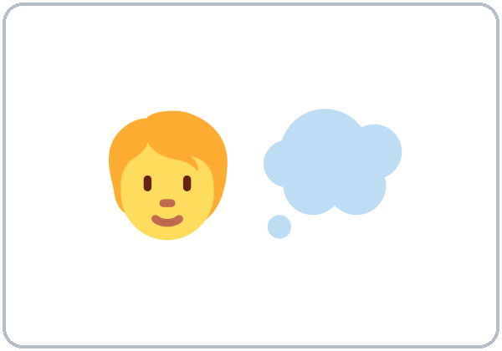  ★ imagine | 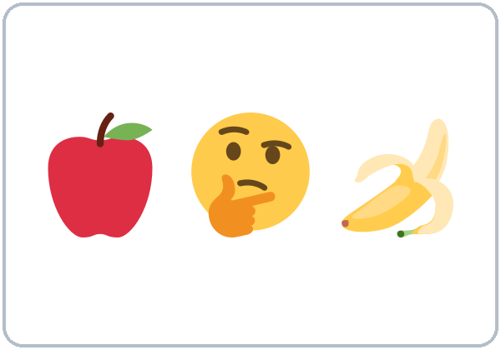  ★ choose | 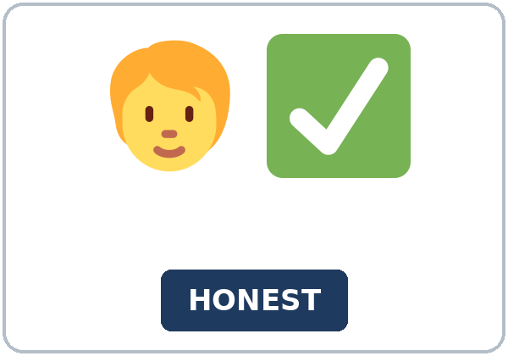  ★ honest | 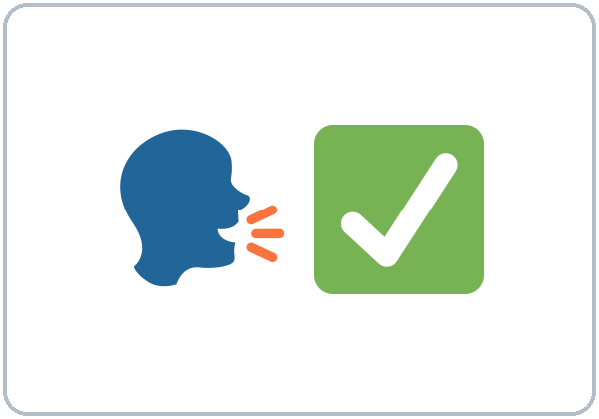  ★ tell the truth
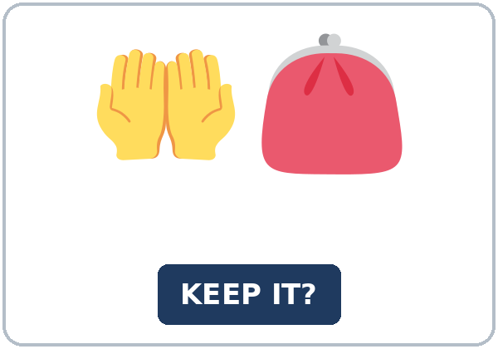  ★ keep (it) |   ★ give back | 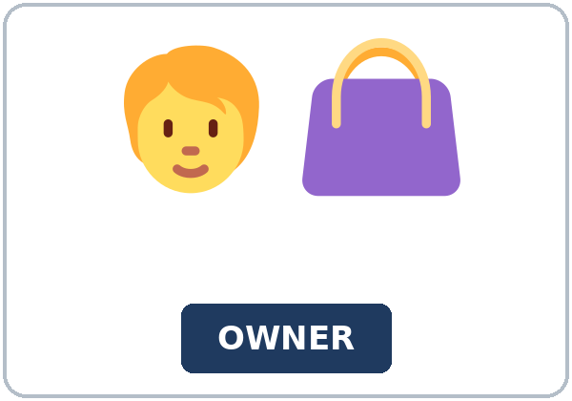  ★ owner |   ★ envelope
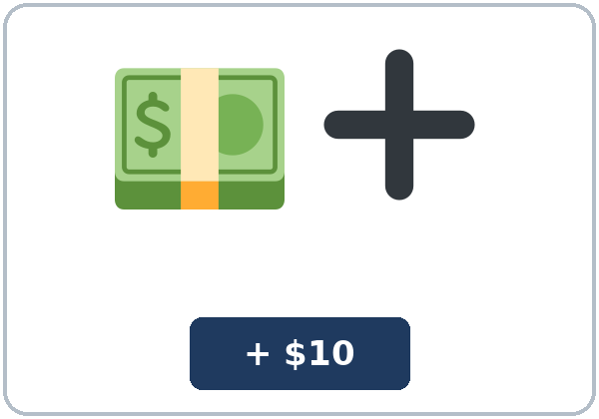  ★ extra money | 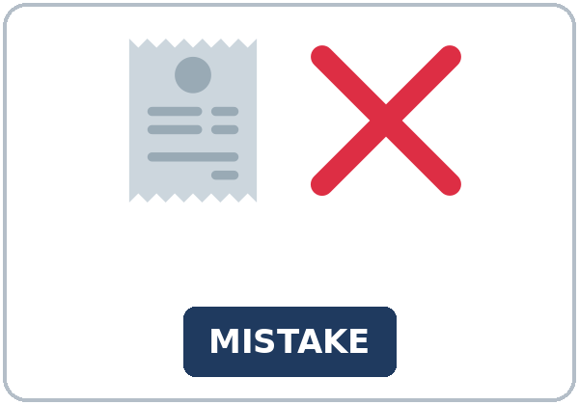  ★ mistake | 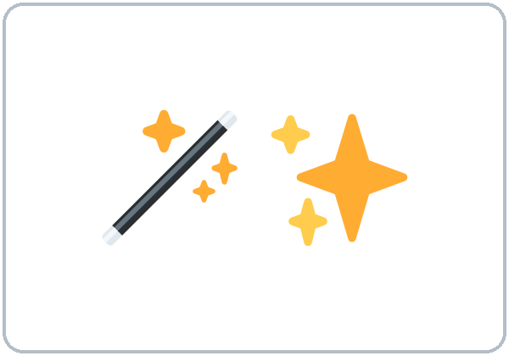  magic wand |   dream job

Partner game: What would you do?
Example: A points to a picture and asks, "What would you do if you found an envelope with money?" B answers, "If I found…, I'd…" and gives a reason. Switch.
Lesson 6 (Week 6) · My Words
My personal word list. Write each word in your language, if you want. Then write your own example.
Word | My language | My example
imagine
choose
honest
tell the truth
keep (it)
give back
owner
envelope
extra money
mistake
magic wand
dream job

Add 2 more words from tonight (from the listening, the reading, or your partner).
Lesson 6 (Week 6) · Listening
A radio show called What Would You Do?* The host, Mike, tells a situation. Two callers, Grace and Teresa, give their answers.
A. Listen. What is the situation? Circle.
a. A cashier gives you too much change. b. You find money on the floor at work. c. A friend asks you to tell a small lie.
B. Listen again. Who says it, and what? Circle the answer.
1. Grace would (give the money back / keep the money).
2. Grace's reason: the cashier (made a mistake / was her friend).
3. Teresa once got ($10 / $20) too much.
4. Teresa gave it back (the same day / the next day).
5. If it were one dollar, Teresa would (probably keep it / give it back).
6. Next week's situation: (an envelope with money at work / a lost phone on the bus).
C. Listen again. Write the missing word: would, were, I'd, or a past verb.
1. Really? Why ____________ you go back?
2. If I ____________ the money, she would have a problem at the end of her shift.
3. And what would you do if it ____________ only one dollar?
4. If it were one dollar, ____________ probably keep it.
5. But ____________ feel a little bad.
6. what would you do if you ____________ an envelope with money at work?
Hear it, say it
wanna = want to: "I want to hear your ideas." • gonna = going to: "If you're going to call, call early!" You can say want to and going to. Listen for I'd (= I would): the d is short but it is there. In What would you do?, the stress is on do.
Lesson 6 (Week 6) · Grammar
Read across. A reads from the left side. B answers from the right side. Choose one part from each column.
Grammar Box 1: What would you do if…?
QUESTION |  |  | ANSWER
What would you do | if you found $50 at work? |  | If I found $50, | I'd give it to my supervisor.
What would you do | if you had a free week? |  | If I had a free week, | I'd visit my cousin.
Would you keep | the extra money? |  | No, I wouldn't. | I'd give it back.
What would you do | if you were me? |  | If I were you, | I'd call the owner.

Grammar Box 2: possible or imaginary?
POSSIBLE (maybe it will happen) |  |  | IMAGINARY (not real now)
If it rains tomorrow, | I'll take the bus. |  | If I had a car, | I'd drive to work.
If I get the job, | I'll buy a new phone. |  | If I won $1,000, | I'd pay my bills.
If you find my keys, | will you call me? |  | If I found a wallet, | I'd look for the owner.

Rule of thumb: Imaginary: use the past form after if (found, had, were). Use would / 'd + base verb in the other half (I'd give, I'd visit). Never put would right after if.
Grammar Box 3: would short forms
LONG | SHORT | EXAMPLE
I would | I'd | I'd give it back.
she would | she'd | She'd keep it.
would not | wouldn't | I wouldn't keep it.

Grammar Box 4: advice with If I were you…
 | USE | EXAMPLE
If I were you, I'd… | advice | If I were you, I'd talk to the supervisor.
were for every person | imaginary | If it were one dollar, I'd keep it.
If I was… | you hear it in speaking; it's OK | in writing, use If I were

Questions and answers
Q: Can I say If I would have time, I'd take a class?
A: No. Never put would right after if: If I had time, I'd take a class.
Q: If I was you or If I were you?
A: Write If I were you. In speaking, many people say If I was you. That's OK.
Q: If it rains or If it rained?
A: Possible (maybe tomorrow): If it rains, I'll stay home. Imaginary (not real now): If I had a car, I'd drive.
Practice A: Write the correct form of the verb.
1. If I ____________ a wallet, I'd look for the owner. (find)
2. If I had more time, I'd ____________ a computer class. (take)
3. If I ____________ you, I'd tell the truth. (be)
4. What would you ____________ if you won $500? (do)
5. If she ____________ a car, she'd drive to work. (have)
6. If it rains tomorrow, ____________ take the bus. (I'll / I'd)
Practice B: Circle the correct words.
1. If I (had / have) a magic wand, I'd fix all the potholes.
2. If I found $50, I (would / will) give it back.
3. If I (were / would be) you, I'd call the owner.
4. If it (rains / rained) tomorrow, I'll stay home.
5. Would you keep it? No, I (wouldn't / don't).
6. (What would you do / What you would do) if you had a free week?
Common mistakes
✗ Don't say | ✓ Say
If I would have time, I'd take a class. | If I had time, I'd take a class.
If I found $50, I will give it back. | If I found $50, I'd give it back.
What you would do? | What would you do?
If I am you, I'd call. | If I were you, I'd call.
I'd to give it back. | I'd give it back.

Contrast tip (optional): Spanish says Si tuviera…, haría… with special verb forms. English is easier: use the past after if (If I had…) and would in the other half (I'd go). Never put would after if. What does your language do?

Lesson 6 (Week 6) · Talk Time: What Would You Do?
Round 1. Work in groups of 3–4. One person reads a situation card. Each person answers with If I…, I'd… and a reason. Write your group's most common answer.
SITUATION CARDS (invented)
1. You find $50 on the floor at work. | 2. A cashier gives you too much change.
3. Your neighbor's door is open late at night. | 4. A friend asks you to tell a small lie.
5. A coworker is late every day. | 6. You find a phone on the bus.
7. A restaurant forgets to charge you for a drink. | 8. A friend asks, "Do you like my new haircut?" You don't.

Example: A: What would you do if you found $50 on the floor at work? B: If I found $50, I'd give it to my supervisor because it isn't mine. C: I'd ask my coworkers first.
Card | Our most common answer (We'd…) | Our reason (because…)

Lesson 6 (Week 6) · Talk Time: Magic Wand Chain
Round 2. Sit in a circle. Pass the "magic wand." Each person says one sentence: If I had a magic wand, I'd… Then do one more round: If I had my dream job, I'd… Classmates can ask one question: Why?
Example: "If I had a magic wand, I'd fix all the potholes in this city." "Why?" "Because my car hates them!" • "If I had my dream job, I'd be a chef, and I'd cook food from my country."
My magic wand sentence | My dream job sentence
If I had a magic wand, I'd | If I had my dream job, I'd

A classmate's idea I liked | Their name

Useful: If I had…, I'd… • I'd also… • because… • Why? • Me too! • That's a great idea.
Lesson 6 (Week 6) · Homework
Homework (about 15–20 minutes). Bring it next week!
1. Write the sentence. Use the words.
Example: if I / find / a wallet, I / call / the owner → If I found a wallet, I'd call the owner.
1. if I / have / a free week, I / visit / my cousin → ______________________________________________
2. if I / be / you, I / tell / the truth → ______________________________________________
3. what / you / do / if you / win / $500? → ______________________________________________
4. if she / have / a car, she / drive / to work → ______________________________________________
2. Finish your writing from Read & Write C (your reply). Read it one more time. Check ✓ the list in D.
☐ I finished it. ☐ I checked it with the list.
3. Write 3 sentences about your dreams. Use If I had…, I'd… and a reason.
If I had… | I'd… because…
1.
2.
3.

4. Review (Lesson 5). Write one word.
1. Would you mind ____________ my plants? (water)
2. Do you mind ____________ I open the window?
3. A: Would you mind helping me? B: No, not ____________ all.
4. Could I borrow your pen? I forgot ____________.
5. Would you mind ____________ my shift on Friday? (cover)
Lesson 6 (Week 6) · Read & Write
A. Read the notice. Read fast first. Then read again and answer the questions.
ADVICE COLUMN · Ask Gloria: Work and Life
Dear Gloria, I work at a busy restaurant. My coworker, Leo, is very friendly, and everyone likes him. But he takes long breaks every day. Sometimes his break is 30 minutes, not 15. When he's on break, I do his work and mine. I don't want to make him angry. What would you do? Tired in Texas
Dear Tired, You are a good coworker, but you shouldn't do two jobs every day. If I were you, I'd talk to Leo first. I'd be friendly, and I'd talk to him alone, not in front of other people. You could say, "When you take a long break, I have a lot of extra work. Could you come back after 15 minutes?" Maybe he doesn't know there is a problem. If he still took long breaks after that, I'd talk to the supervisor. I wouldn't be angry. I'd just explain the problem. Good luck! Gloria

B. Answer the questions.
1. Where does the writer work? ______________________________________________
2. How long are Leo's breaks sometimes? ______________________________________________
3. What would Gloria do first? ______________________________________________
4. Where would she talk to him? ______________________________________________
5. When would she talk to the supervisor? ______________________________________________
C. Read this letter: "Dear Gloria, My neighbor plays loud music every night until midnight. I start work at 6:00 a.m. What would you do? Sleepy" Write a reply (5–8 sentences). Use If I were you, I'd… because…
Example: Dear Sleepy, I'm sorry you can't sleep. If I were you, I'd talk to your neighbor first. I'd be friendly because maybe he doesn't know about the problem. You could say, "I start work very early. Could you turn the music down after 10:00?" If he didn't stop, I'd write a note to the building manager. Good luck! Gloria
My reply

D. Check your writing with a partner.
 | Yes | Not yet
It has 5–8 sentences. | ☐ | ☐
It has If I were you, I'd…. | ☐ | ☐
It has a reason with because. | ☐ | ☐
It has a polite idea and a second idea. | ☐ | ☐

Lesson 6 (Week 6) · Exit Ticket
Name: ______________________________ Date: ________________
Answer in 3 sentences. Give a reason. Then give this page to your teacher.
What would you do if you had a free week?
Sentence 1: an if-sentence (If I had a free week, I'd…) • Sentence 2: a second idea (I'd also…) • Sentence 3: the reason, with because
My answer
1.
2.
3.

For the teacher | ✓ | almost | not yet
3 sentences, today's grammar, a reason | ☐ | ☐ | ☐

Lesson 6 (Week 6) · Task Words (optional)
This page is for you if you want it. You can skip it. Write each task word in your language, if you want.
Task word | What you do | My language
Listen. | Use your ears. Don't write yet.
Circle. | Draw a circle around the answer.
Check ✓. | Make a ✓ in the box.
Write. | Write words or sentences.
Number. | Write 1, 2, 3… to show the order.
Match. | Find the two parts that go together.
Work with a partner. | Work with one classmate.
Work in a group. | Work with 2 or 3 classmates.
Switch. | Change roles: A is B now.
Ask a follow-up question. | Ask one more question about the answer.
Give a reason. | Say why, with because or so.
Compare. | Look at your partner's answers. Are they the same?

Picture Credits
Pictures use Twemoji graphics by Twitter, Inc. and other contributors (https://github.com/jdecked/twemoji), licensed under CC BY 4.0 (https://creativecommons.org/licenses/by/4.0/). The graphics were resized and combined, and signs and labels were added. The file-by-file list is in images/CREDITS.md.
Listening audio: not recorded yet. When it is made, it will use synthetic voices made with Chatterbox TTS (Resemble AI, MIT License), cloned from synthetic reference clips made with Kokoro-82M (Apache License 2.0), with no recordings of real people. The names and the story are invented.
Course materials: © 2026 the authors, licensed under CC BY-NC-SA 4.0 (https://creativecommons.org/licenses/by-nc-sa/4.0/).

