Level 1 Adult ESL Curriculum · Lesson 5 (Week 5): What's Your Job?
Status: Draft for review (all 13 Level 1 lessons are built).
Date: October 2026
Audience: Program coordinators and volunteer teachers
Companion files: audio/L1_L5_listening.mp3, images/ (14 vocabulary pictures, 2 sign pictures + images/CREDITS.md)
Topic: jobs and workplaces. Learners say their job with a / an (I'm a cook. I'm an office worker.), say where they work (I work at a restaurant.), ask What do you do? Where do you work? Do you work at night?, and say I don't…. A short preview shows Does he / she work…? Yes, she does. (Level 2 teaches it). Letters & Numbers: a or an, the sh sound in cashier, and job signs (NOW HIRING, EMPLOYEES ONLY).

How this lesson is organized
Part | What's inside | Who uses it
Teacher Plan | At a glance, clock-time plan, step-by-step boxes, Letters & Numbers script, listening script, answer key, teacher notes | Volunteer teachers
Student Pages | Hello + Review, New Words, Listening, Grammar (with a Does he / she…? preview), Talk Time (job guessing game + Find Someone Who), Homework, Letters & Numbers, Progress Check. Print this part for learners | Learners
Picture Credits | Picture sources and licenses | Coordinators

What Lesson 5 gives Level 2
Level 2 uses… | Where in Level 2 | Lesson 5 starts it with…
Jobs with a / an (I'm a cook) | Lesson 1 | What do you do? I'm a cashier. (Grammar Box 1, New Words)
Do you work…? Yes, I do. / No, I don't.; I don't… | Lesson 1 (review of do) | Do you work at night? I don't work in the morning. (Boxes 3–4, listening, Find Someone Who)
Does he / she…? and he / she works | Lesson 1 (Grammar Box 2), Lesson 2 | Preview only: Does your wife work? Yes, she does. (listening + preview box). Learners listen and repeat; no test
work, live, job | Lesson 1 | Where do you work? I work at a store.

TEACHER PLAN
Lesson 5 (Week 5)

What's Your Job?
At a glance · Clock-time plan · Step by step · Letters & Numbers · Script and answer key

How to Use This Plan
You don't need to speak Spanish or any other language. Teach in English. Show, point, and gesture. The student pages have a Spanish line and a "My language" line for every task. Learners read those on their own. You never need to read, translate, or explain them.

Instruction rule: Model it (do it with one learner while everyone watches), check it (ask: "Listen or write?"), then go. Say less, show more. Use the same short words every time: Listen. Repeat. Point. Circle. Write. Partner. Group.

Grouping toolkit: Pairs: turn to a neighbor; with an odd number, make one group of 3. Groups: 3–4 learners. Mingle: everyone stands and talks to many classmates. The teacher joins a pair only if one learner is left over.

When a learner is stuck or speaks another language to you: (1) show it: the picture, a gesture, or the board; (2) give one more short English example; (3) point to the instruction and the grammar box on their page; (4) a classmate can help for a few seconds, then back to English. You don't need to understand what classmates say to each other.

Everyone has an answer. Some learners don't work now, work at home, or are students. Teach these answers on the first day of the topic: I'm a student. I'm a homemaker. I don't work now. Learners can also say a job they want or a job they had. Never ask where someone works if they don't offer it, and never ask about pay or work papers.

Lesson 5 (Week 5): What's Your Job?
At a glance
Objectives: learners can…
• say a job with a / an (I'm a cook. I'm an office worker.), or I'm a student / I'm a homemaker / I don't work now
• ask and answer What do you do? and Where do you work? I work at a restaurant.
• ask and answer Do you work at night / on weekends? Yes, I do. / No, I don't.
• say I don't work…
• understand (not produce) the preview Does she work? Yes, she does.
• choose a or an, say the sh sound, and read two job signs (Letters & Numbers block)

Materials
• Student Pages for Lesson 5 (print for the number expected + 3 spares)
• job picture cards: cut out one copy of the New Words page (one set for each group of 3–4), or point to the page
• mini whiteboards or scrap paper for Letters & Numbers
• phone + small speaker, L1_L5_listening.mp3
• Prep time: 30 min (cutting the cards takes 10).

Key vocabulary (with pictures on the New Words page)
★ cook • ★ cleaner (housekeeper) • ★ construction worker • ★ cashier • ★ driver • ★ mechanic • ★ server • nurse • painter • ★ factory • ★ office • ★ restaurant • student • homemaker

Review from Lessons 1–4
Do you have kids? Yes, I do. / No, I don't. • This is my wife. Her name is… • Where are you from? • What's your phone number?

Clock-time plan
Times are loose. If a step runs long, take the time from Grammar or Talk Time. The last 15 minutes are the Letters & Numbers block.
Time | Step | Min | Grouping (15 / 7–8) | If running behind
6:00–6:10 | Hello + Review (Lesson 4 family questions) + homework check | 10 | Pairs, then new pairs | One partner only
6:10–6:20 | New Words (picture page) + pair picture game | 10 | Whole class, then pairs | Teach the ★ words only
6:20–6:32 | Listening (audio): two neighbors talk about their jobs | 12 | Individuals, then pairs check | Play the audio 2 times, not 3
6:32–6:45 | Grammar Q&A: What do you do? Where do you work? Do you work…? + preview + pair drill | 13 | Whole class, then pairs | Skip the pair drill; it becomes homework
6:45–7:00 | BREAK | 15
7:00–7:10 | Talk Time: job guessing game + Find Someone Who | 10 | Groups of 3–4, then mingle / groups of 3–4, then mingle | Do only the guessing game
7:10–7:15 | Exit Ticket + Homework | 5 | Individuals | Never skip
7:15–7:25 | Letters & Numbers: a / an, the sh sound, job signs | 10 | Whole class, then pairs | Do Tasks A and B only
7:25–7:30 | Progress Check | 5 | Individuals | Do it in Week 6 at 6:00, while people arrive

Skip order if you're running behind: (1) the third play of the audio; (2) the pair drill at the end of Grammar; (3) Find Someone Who. Never skip: the listening tasks, the grammar boxes, and the exit ticket.

Attendance (15 → 7–8): every step lists both sizes. Print for the number you expect, plus 3 spares. Late arrivals join any pair or group right away. With 7–8 learners, the mingle works the same way: each learner talks to everyone.

Step by step
Step 1 · 6:00–6:10 · Hello + Review · 10 min
• Grouping: pairs. 15 learners: 7 pairs + 1 group of 3. 7–8 learners: 3–4 pairs. Late arrivals join any pair.
• Before class: write on the board: Do you have kids? Do you have brothers or sisters? Who's this?
• Model with one learner: "Do you have brothers or sisters?" → "Yes, I do. I have two brothers." Then show the picture-card family from Lesson 4 (or the board tree): "Who's this?" → "This is my mother."
• Do: pairs use the Hello + Review page. Learners can use their family or Ana's family. Switch. Then find a new partner.
• Homework check (last 3 min): partners show each other their Lesson 4 homework. Walk around and look at item 2 (do / don't).
• New learners: pair them with a strong partner. They can do the Lesson 1–4 Progress Checks at home.
• If behind: one partner only.

Step 2 · 6:10–6:20 · New Words · 10 min
• Grouping: whole class, then pairs.
• Say first: "Today: jobs. What do you do? You can say: I'm a student. I'm a homemaker. I don't work now." Write these 3 answers on the board and leave them there.
• Do: point to each picture and say the word. Learners repeat twice. Act out each job (cook: stir a pot; cleaner: sweep; driver: turn a wheel; cashier: scan and count money). Learners copy the action.
• Places: factory, office, restaurant are places. Say: "A cook works at a restaurant."
• Pairs (4 min): A acts out a job, B says it. Then switch. Then A points to a picture, B says it.
• If behind: teach the ★ words only.

Step 3 · 6:20–6:32 · Listening · 12 min
• Grouping: individuals, then pairs check.
• Before you listen (1 min): say: "This is Rosa. This is Marco. They are neighbors." Point to two houses on the board, side by side. "They talk about their jobs."
• Listen 1 → Task A: learners match each person to a job picture (write the letter).
• Listen 2 → Task B: learners circle Yes or No.
• Listen 3 → Task C: learners write do, don't, or does.
• Pairs compare after each task: "Show your partner." Then write the answers on the board.
• The preview line: after Task C, play the end again or read it: "Does your wife work, too? Yes, she does. She's a nurse." Say: "Does = a question about he or she. Level 2 practices it. Today: only listen."
• The audio plays the conversation once. Press play again for the next listen.
• If behind: play the audio 2 times, and do Task C together.

Step 4 · 6:32–6:45 · Grammar Q&A · 13 min
• Grouping: whole class, then pairs.
• Show: the Grammar page. The left side is the question. The right side is the answer. Point left, then right.
• Box 1 (the key point): "What do you do?" → "I'm a cook." Write on the board: a cook, a driver / an office worker. Say: before a, e, i, o, u → an. Point to the 3 "everyone" answers.
• Box 2: "Where do you work?" → "I work at a restaurant." Point to the place pictures.
• Box 3: "Do you work at night?" Nod: "Yes, I do." Shake: "No, I don't." (The same as Do you have kids? in Lesson 4.)
• Box 4: "I work at night. I don't work in the morning." Use the board: ✓ work / ✗ don't work.
• Preview box (1–2 min, no practice needed): read it once; the class repeats once. "Level 2. Only listen today."
• Check questions: "I'm ___ cook." (a) • "I'm ___ office worker." (an) • "Do you work on weekends?" (Yes, I do. / No, I don't.)
• Pair drill (last 3–4 min): A asks from the left side; B answers from the right side about a picture card (or about themselves). Then switch.
• If behind: skip the pair drill. It becomes homework, and Talk Time practices the same questions.

Break · 6:45–7:00 · 15 min
• Cut or stack the job picture cards (one set per group). Write on the board: Are you a cook? Yes, I am. / No, I'm not. and Do you work at night? Do you work on weekends?

Step 5 · 7:00–7:10 · Talk Time: Job Guessing Game + Find Someone Who · 10 min
• Part 1, guessing game (4 min): groups of 3–4. One learner takes a card (don't show it) and acts out the job. The others ask: "Are you a cook?" → "No, I'm not." / "Yes, I am!" The winner takes the next card. Model it first: you act out "driver"; the class guesses.
• Part 2, Find Someone Who (6 min): everyone stands with the Talk Time page. Learners ask the questions and write a name when someone says Yes, I do (or No, I don't for the last line). One name per line; a different person for each line if possible.
• Model Part 2: "Do you work at night?" → "No, I don't." → ask someone else → "Yes, I do." → write that name.
• Finish: 2–3 learners report one line: "Ana works at night." (This is a preview of works; accept "Ana work at night" too.)
• If behind: do only the guessing game.

Step 6 · 7:10–7:15 · Exit Ticket + Homework · 5 min · NEVER SKIP
• Exit ticket: each learner says one sentence about work: "I'm a cook." / "I work at a factory." / "I'm a student." / "I don't work now." or writes a or an for two words on the board (___ cook, ___ office worker).
• Homework: open the Homework page. Do item 1 together (the first sentence). Point to each instruction so learners know what to do at home.

Letters & Numbers · 7:15–7:25 · A / An, the Sh Sound, Job Signs · 10 min
• Grouping: whole class, then pairs. Use the Letters & Numbers page.
• See it (2 min): Task A. Point to the vowel letters a e i o u. Read the a column, then the an column. Learners repeat. An goes before a vowel sound: an office, an apartment.
• Write it (2 min): Task B. Learners write a or an. Check on the board.
• Say it (2 min): Task C. Say sh like "Quiet!" (finger on lips). Then: she, shoe, cashier, English, wash. Learners repeat each word twice. Spanish speakers often say ch (as in chair): show the difference with a long, soft shhh.
• Read it (3 min): Task D. Point to each sign and read it. Learners circle Yes or No. Ask: "Where do you see this sign?" (a store window; a door at work).
• Partners: A says a job, B says a or an + the job. Switch.
• Learners who can't read or write yet: they say the words with everyone and point. In Task D, read the signs aloud for them and let them answer by pointing.
• If behind: do Tasks A and B only.

Progress Check · 7:25–7:30 · 5 min
• Grouping: individuals. Open the Progress Check page.
• Part A: read the 5 words (answer key), slowly, 2 times each. Learners circle.
• Parts B and C: learners match and write on their own. Walk around and help with the instructions only.
• Part D: read each "I can…" line aloud and point to the 3 faces: 😀 "I can do it." 🙂 "A little." 😐 "Not yet." Learners check one.
• Collect the pages (or check them at the start of Week 6). Part C shows a / an and do / don't.
• If behind: do the Progress Check in Week 6 at 6:00, while learners arrive.

Listening script: L1_L5_listening.mp3 (about 1:10; the conversation plays once, so play the audio again if needed)
Audio: play from a phone + small speaker. No speaker? Read the script with a volunteer.

Narrator: Lesson five. Listening. Rosa and Marco are neighbors. They talk about their jobs. Listen.
Rosa: Good morning, Marco!
Marco: Hi, Rosa. How are you?
Rosa: I'm fine, thanks. Marco, what do you do?
Marco: I'm a cook. I work at a restaurant on Main Street.
Rosa: Do you work at night?
Marco: Yes, I do. I don't work in the morning. And you? What do you do?
Rosa: I'm a cashier. I work at a store.
Marco: Do you work on weekends?
Rosa: Yes, I do. I work on Saturday and Sunday.
Marco: Oh, that's a lot of work!
Rosa: Yes, it is. Does your wife work, too?
Marco: Yes, she does. She's a nurse.
Rosa: Nice. My husband is a mechanic.
Marco: Great! OK, see you later, Rosa.
Rosa: Bye, Marco!
Narrator: That's the end of the listening.

Answer key
• Listening Task A: 1 Rosa b (cashier), 2 Marco a (cook), 3 Marco's wife d (nurse), 4 Rosa's husband c (mechanic).
• Listening Task B: 1 Yes, 2 Yes, 3 No (he doesn't work in the morning), 4 No (at a store), 5 Yes.
• Listening Task C: 1 do, 2 don't, 3 do, 4 does (preview).
• Grammar practice: 1 a, 2 an, 3 at, 4 do, 5 don't.
• Homework 2 (a / an): 1 a, 2 an, 3 a, 4 an, 5 a.
• Homework 3 (do / don't): answers can be do or don't, if they match the learner's Yes / No.
• Letters & Numbers Task B: 1 a, 2 an, 3 a, 4 an, 5 a, 6 an.
• Letters & Numbers Task D: 1 Yes, 2 No, 3 No, 4 Yes.
• Progress Check Part A (the teacher says): 1 cashier, 2 mechanic, 3 nurse, 4 factory, 5 server. Say each word 2 times.
• Progress Check Part B: 1 c, 2 a, 3 d, 4 b.
• Progress Check Part C: 1 a, 2 an, 3 don't.
• Progress Check scoring: Part A /5 + Part B /4 + Part C /3 = /12. This is not a test grade. Part A shows the job words; Part C shows a / an and don't.
Teacher notes
• Respect: I'm a student, I'm a homemaker and I don't work now are full, correct answers. Learners can also say a job they want ("I want to be a nurse" is too hard for now; accept "Nurse!" with a smile). Never ask about pay, hours in detail, bosses, or work papers.
• The big mistake this week: I'm cook. Spanish says Soy cocinero with no article. In English a job needs a / an: I'm a cook. Correct by holding up one finger: "a cook."
• Questions need do: Where do you work? (not Where you work?). It is the same do as Do you have kids? in Lesson 4.
• at for workplaces: I work at a restaurant / at a factory / at home. (in an office is also fine; don't correct it.)
• The Does he / she…? preview: learners only hear and repeat it this week: Does your wife work? Yes, she does. She works at a hospital. Don't test it and don't explain the -s in works; Level 2 Lesson 1 teaches it. If a learner says She work at a hospital, just repeat it correctly: "Yes, she works at a hospital."
• Jobs from home countries: many learners had a different job before. Accept "In Mexico, I'm a teacher" (past tense comes later).
• Mixed levels: strong learners add a place and a time: I'm a cook. I work at a restaurant. I work at night. New learners use only I'm a ___. with a picture.
• Learners who can't read or write yet: they play the guessing game fully and, in Find Someone Who, ask the questions while a partner writes names (or they draw a check).
• Looking ahead: Lesson 6 (time and days) uses I work on Monday… at 6:00 and When do you work?.

STUDENT WORKBOOK
Lesson 5 (Week 5)

What's Your Job?
Hello + Review · New Words · Listening · Grammar · Talk Time · Homework · Letters & Numbers · Progress Check

Lesson 5 (Week 5): What's Your Job?
Student Page 1 · Week 5
Name: ______________________________ Date: ________________
Hello + Review: ask your partner. Then switch.
Español: Pregunta a tu compañero. Después cambien.
My language: ______________________________________________
A: Do you have kids? B: Yes, I do. I have ___. / No, I don't.
A: Do you have brothers or sisters? B: Yes, I do. I have ___. / No, I don't.
A: (point to a photo or Ana's family) Who's this? B: This is my ___. His / Her name is ___.
Help: Can you repeat, please? How do you spell it?

Everyone has an answer. You can say: I'm a student. I'm a homemaker. I don't work now.

Español: Todos tienen una respuesta. Puedes decir: Soy estudiante. Me ocupo de la casa. No trabajo ahora.
My language: ______________________________________________
Lesson 5 (Week 5) · New Words
New Words
Look. Listen. Repeat. Then partners: A acts out or points, B says the word. ★ = most important words.
Español: Mira. Escucha. Repite. Después en parejas: A actúa o señala, B dice la palabra.
My language: ______________________________________________
  ★ cook |   ★ cleaner (housekeeper) | 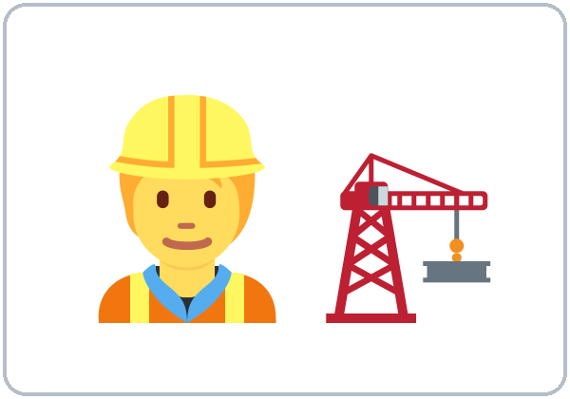  ★ construction worker |   ★ cashier
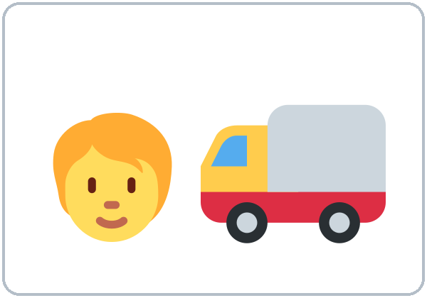  ★ driver |   ★ mechanic | 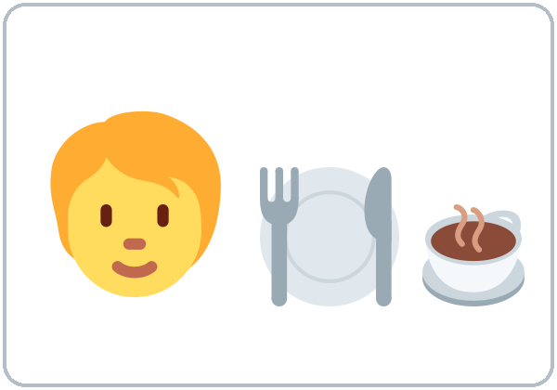  ★ server |   nurse
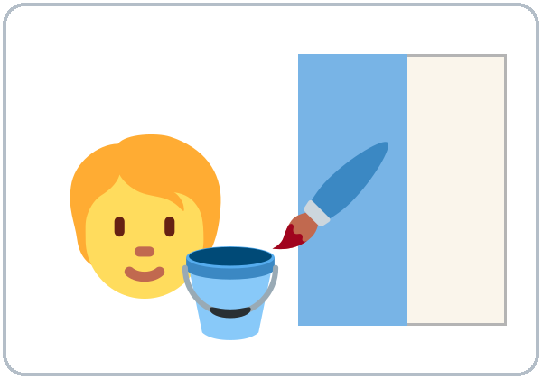  painter |   ★ factory |   ★ office | 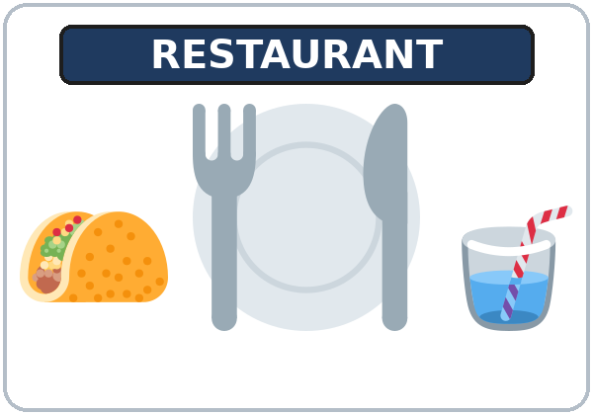  ★ restaurant
  student | 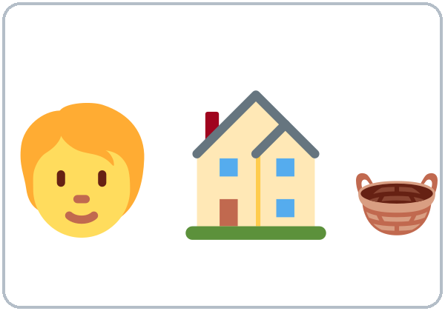  homemaker

Lesson 5 (Week 5) · Listening
A. Rosa and Marco are neighbors. Listen. Write the letter of the job.
Español: Rosa y Marco son vecinos. Escucha. Escribe la letra del trabajo.
My language: ______________________________________________
a. cook | b. cashier | c. mechanic | d. nurse

1. Rosa ______ 2. Marco ______ 3. Marco's wife ______ 4. Rosa's husband ______
B. Listen again. Circle Yes or No.
Español: Escucha otra vez. Encierra Yes (sí) o No.
My language: ______________________________________________
1. Marco works at a restaurant. | Yes | No
2. Marco works at night. | Yes | No
3. Marco works in the morning. | Yes | No
4. Rosa works at a factory. | Yes | No
5. Rosa works on weekends. | Yes | No

C. Listen again. Write do, don't, or does.
Español: Escucha otra vez. Escribe do, don't o does.
My language: ______________________________________________
1. Do you work at night? Yes, I ________. 2. I ________ work in the morning.
3. Do you work on weekends? Yes, I ________. 4. Does your wife work, too? Yes, she ________. (preview)
Lesson 5 (Week 5) · Grammar
With a partner: read across. A reads a question (left). B reads an answer (right). Choose one word from each column.
Español: Con un compañero: lee de izquierda a derecha. A lee una pregunta (izquierda). B lee una respuesta (derecha). Elige una palabra de cada columna.
My language: ______________________________________________
Grammar Box 1: What do you do?
QUESTION |  | ANSWER
What do you do? |  | I'm | a | cook.  cashier.  driver.  nurse.
What do you do? |  | I'm | an | office worker.
What do you do? |  | I'm a student.  I'm a homemaker.  I don't work now.

Grammar Box 2: Where do you work?
QUESTION |  | ANSWER
Where do you work? |  | I work | at | a restaurant.  a factory.  a store.
Where do you work? |  | I work | at | an office.  home.

Grammar Box 3: Do you work at night?
QUESTION |  |  | ANSWER
Do you work | at night?  on weekends?  in the morning? |  | Yes, I do.
Do you work | at night?  on weekends?  in the morning? |  | No, I don't.

Grammar Box 4: I work… I don't work…
PERSON |  | YES ✓ | ‖ | NO ✗
I  You |  | work at night. | ‖ | don't work at night.
We  They |  | work on weekends. | ‖ | don't work on weekends.

Preview (Level 2 teaches this): Does she work?
Just listen and repeat. You don't need to write it.
Español: Solo escucha y repite. No necesitas escribirlo.
My language: ______________________________________________
QUESTION |  |  | ANSWER
Does | your wife  your husband |  | ‖ | Yes, she does.  Yes, he does.
Does | your wife  your husband |  | ‖ | No, she doesn't.  No, he doesn't.

Questions and answers
Q: a or an?
A: Listen to the first sound. a cook, a driver. Before a, e, i, o, u: an office worker, an apartment.
Q: I don't work now. What do I say?
A: I don't work now. Or: I'm a student. I'm a homemaker. These are good answers.
Q: Why Does? Why works?
A: For he and she, English uses does and -s (she works). Level 2 teaches it. Today, just listen.
Practice: Write a, an, at, do, or don't.
Español: Escribe a, an, at, do o don't.
My language: ______________________________________________
1. I'm ________ cashier.
2. She's ________ office worker.
3. I work ________ a factory.
4. Do you work at night? Yes, I ________.
5. I ________ work on weekends.
Common mistakes
✗ Don't say | ✓ Say
I'm cook. | I'm a cook.
I'm a office worker. | I'm an office worker.
Where you work? | Where do you work?
Do you work at night? Yes, I work. | Yes, I do.
I no work on Sunday. | I don't work on Sunday.
I work in a restaurant at night in Main Street. | I work at a restaurant on Main Street.

Nota para hispanohablantes: En inglés un trabajo lleva a o an: I'm a cook (no «I'm cook»). Antes de vocal (a, e, i, o, u) se usa an: an office worker. Las preguntas llevan do: Where do you work? (no «Where you work?»). Para decir «no» se usa don't: I don't work on Sunday (no «I no work»). Does she work? es solo una vista previa; se estudia en el Nivel 2.

Tip for speakers of other languages: A job needs a or an: I'm a cook. I'm an office worker. Questions use do: Where do you work? "No" is don't: I don't work on Sunday.

Lesson 5 (Week 5) · Talk Time
1. Job guessing game. Groups of 3–4: take a card. Act out the job. The group asks.
Español: Juego de adivinar trabajos. En grupos de 3–4: toma una tarjeta. Actúa el trabajo. El grupo pregunta.
My language: ______________________________________________
Group: Are you a cook? You: No, I'm not. / Yes, I am!
Group: Are you a driver? You: Yes, I am!

2. Find someone who… Stand up. Ask your classmates. Write a name.
Español: Busca a alguien que… Levántate. Pregunta a tus compañeros. Escribe un nombre.
My language: ______________________________________________
Find someone who… | Ask | Name
works at night. | Do you work at night?
works on weekends. | Do you work on weekends?
works at a restaurant. | Do you work at a restaurant?
works in the morning. | Do you work in the morning?
is a student. | Are you a student?
doesn't work now. (No, I don't.) | Do you work now?

Lesson 5 (Week 5) · Homework
Homework (10 minutes). Bring it next week!
Español: Tarea (10 minutos). ¡Tráela la próxima semana!
My language: ______________________________________________
1. Write about you. Choose one answer for each line.
Español: Escribe sobre ti. Elige una respuesta para cada línea.
My language: ______________________________________________
I'm a / an ______________________. or I'm a student. or I'm a homemaker. or I don't work now.
I work at ______________________. or I don't work now.
2. Write a or an.
Español: Escribe a o an.
My language: ______________________________________________
1. ______ driver 2. ______ office 3. ______ nurse 4. ______ apartment 5. ______ server
3. Answer. Write do or don't.
Español: Responde. Escribe do o don't.
My language: ______________________________________________
1. Do you work at night? ________ Yes, I ________. / No, I ________.
2. Do you work on weekends? ________ Yes, I ________. / No, I ________.
4. Ask a family member or a friend: What do you do? Where do you work?
Español: Pregunta a un familiar o a un amigo: What do you do? Where do you work?
My language: ______________________________________________
5. Review: write one sentence about your family (or Ana's family).
Español: Repaso: escribe una oración sobre tu familia (o la familia de Ana).
My language: ______________________________________________
This is my ______________________. His / Her name is ______________________.
Lesson 5 (Week 5) · Letters & Numbers
A. Look. Listen. Say. a or an?
Español: Mira. Escucha. Repite. ¿a o an?
My language: ______________________________________________
a + consonant sound | an + vowel sound (a, e, i, o, u)
a cook | an office
a cashier | an apartment
a driver | an address
a nurse | an email
a server | an ID card

B. Write a or an.
Español: Escribe a o an.
My language: ______________________________________________
1. ______ mechanic 2. ______ office worker 3. ______ factory
4. ______ apartment 5. ______ painter 6. ______ email
C. Say sh. Listen and repeat.
Español: Di «sh». Escucha y repite.
My language: ______________________________________________
sh: she • shoe • cashier • English • wash
D. Read the signs. Circle Yes or No.
Español: Lee los letreros. Encierra Yes (sí) o No.
My language: ______________________________________________
 | 

1. NOW HIRING: the store wants new workers. | Yes | No
2. NOW HIRING: the store wants doctors. | Yes | No
3. EMPLOYEES ONLY: customers can go in. | Yes | No
4. EMPLOYEES ONLY: workers can go in. | Yes | No

Lesson 5 (Week 5) · Progress Check
Name: ______________________________ Date: ________________
A. Listen to the teacher. Circle the word.
Español: Escucha al profesor. Encierra la palabra en un círculo.
My language: ______________________________________________
1. | cook | cashier
2. | mechanic | painter
3. | nurse | driver
4. | office | factory
5. | server | cleaner

B. Match the question and the answer. Draw a line.
Español: Une la pregunta con la respuesta. Dibuja una línea.
My language: ______________________________________________
Question | Draw a line. | Answer
1. What do you do? ● |  | ● a. I work at a factory.
2. Where do you work? ● |  | ● b. No, I'm not.
3. Do you work on weekends? ● |  | ● c. I'm a driver.
4. Are you a cook? ● |  | ● d. No, I don't.

C. Write a, an, or don't.
Español: Escribe a, an o don't.
My language: ______________________________________________
1. I'm ________ server.
2. I'm ________ office worker.
3. I ________ work in the morning.
D. How do you feel? Check ✓ one face for each line.
Español: ¿Cómo te sientes? Marca ✓ una cara en cada línea. 😀 = I can do it. 🙂 = I can do it with a little help. 😐 = Not yet.
My language: ______________________________________________
I can… | 😀 | 🙂 | 😐
I can say my job (or I'm a student / I don't work now). | ☐ | ☐ | ☐
I can say where I work. | ☐ | ☐ | ☐
I can ask What do you do? Where do you work? | ☐ | ☐ | ☐
I can say I don't… | ☐ | ☐ | ☐

Score: A ______ / 5 B ______ / 4 C ______ / 3
Picture Credits
Vocabulary pictures use Twemoji graphics by Twitter, Inc. and other contributors (https://github.com/jdecked/twemoji), licensed under CC BY 4.0 (https://creativecommons.org/licenses/by/4.0/). The graphics were resized and combined, and signs, a register screen, a painted wall, and labels were added. The two job signs are drawn in code. All names on the pages are invented. The file-by-file list is in images/CREDITS.md.
Other small pictures on the pages (the faces on the Progress Check) are standard emoji characters shown with the computer's emoji font. Listening audio: synthetic voices made with Chatterbox TTS (Resemble AI, MIT License); each file carries an inaudible Perth watermark marking it as AI-generated. The voices are copied from short reference clips made with Kokoro-82M (Apache 2.0); no recordings of real people were used. Course materials: © 2026 the authors, CC BY-NC-SA 4.0.

