Level 1 Adult ESL Curriculum · Lesson 4 (Week 4): This Is My Family
Status: Draft for review (Lessons 1–4 built; Lessons 5–13 are coming soon).
Date: October 2026
Audience: Program coordinators and volunteer teachers
Companion files: audio/L1_L4_listening.mp3, images/ (14 vocabulary pictures, 3 family-tree pages + images/CREDITS.md)
Topic: family. Learners name family members, show a family tree or a photo (Who's this? This is my son. His name is Daniel. He's ten.), ask the first do question (Do you have kids? Yes, I do. I have two. / No, I don't.), and use 's (Ana's husband). Letters & Numbers: short vowel sounds in family words (dad, mom, son, kids), plural -s (brothers, sisters), and the sight words this, is, my.

How this lesson is organized
Part | What's inside | Who uses it
Teacher Plan | At a glance, clock-time plan, step-by-step boxes, Letters & Numbers script, listening script, answer key, teacher notes | Volunteer teachers
Student Pages | Hello + Review, New Words, Listening, Grammar, Talk Time (family tree + picture-card family), Homework, Letters & Numbers, Progress Check. Print this part for learners | Learners
Picture Credits | Picture sources and licenses | Coordinators

What Lesson 4 gives Level 2
Level 2 uses… | Where in Level 2 | Lesson 4 starts it with…
Family words (brother, sister, kids, married) | Lesson 1 (introductions) and later lessons | The New Words page, the family tree, Talk Time
Do you have…? Yes, I do. / No, I don't. | Lesson 1 (review of do questions), Lesson 2 | Do you have kids? Do you have brothers or sisters? (Grammar Box 2). Lesson 5 adds Do you work…?
his / her, 's | Lesson 2 (his routine, her job) | This is my son. His name is Daniel. • Ana's husband (Grammar Boxes 1 and 3)
be short answers, age with be | Lesson 1 (review) | Is she your daughter? Yes, she is. • She's six. (listening, Box 1)
Are you married? Yes, I am. | Lesson 1 | Optional: one Q&A line on the Grammar page (never required)

TEACHER PLAN
Lesson 4 (Week 4)

This Is My Family
At a glance · Clock-time plan · Step by step · Letters & Numbers · Script and answer key

How to Use This Plan
You don't need to speak Spanish or any other language. Teach in English. Show, point, and gesture. The student pages have a Spanish line and a "My language" line for every task. Learners read those on their own. You never need to read, translate, or explain them.

Instruction rule: Model it (do it with one learner while everyone watches), check it (ask: "Listen or write?"), then go. Say less, show more. Use the same short words every time: Listen. Repeat. Point. Circle. Write. Partner. Group.

Grouping toolkit: Pairs: turn to a neighbor; with an odd number, make one group of 3. Groups: 3–4 learners. Mingle: everyone stands and talks to many classmates. The teacher joins a pair only if one learner is left over.

When a learner is stuck or speaks another language to you: (1) show it: the picture, a gesture, or the board; (2) give one more short English example; (3) point to the instruction and the grammar box on their page; (4) a classmate can help for a few seconds, then back to English. You don't need to understand what classmates say to each other.

Family can be a sensitive topic. Some learners have family far away, have lost family members, or don't want to talk about their family. Every activity works with the picture-card family (Ana's family), and you say this at the start: "You can talk about your family or Ana's family." Married / single is optional: never ask a learner directly if they are married.

Lesson 4 (Week 4): This Is My Family
At a glance
Objectives: learners can…
• name family members (mother, father, son, daughter, brother, sister…)
• say This is my brother. His name is Luis. He's 25.
• ask and answer Who's this? and How old is he / she?
• ask and answer Do you have kids? Yes, I do. I have two. / No, I don't.
• use 's (Ana's husband, Carlos's son)
• hear and say short vowels (dad, mom, son, kids) and write plural -s (Letters & Numbers block)

Materials
• Student Pages for Lesson 4 (print for the number expected + 3 spares)
• optional: one photo of your own family (or of a family from a magazine). Learners may show a photo on their phone, but never ask them to.
• a big family tree drawn on the board (copy the blank tree on the Talk Time page)
• mini whiteboards or scrap paper for Letters & Numbers
• phone + small speaker, L1_L4_listening.mp3
• Prep time: 30 min.

Key vocabulary (with pictures on the New Words page)
★ mother • ★ father • ★ parents • ★ husband • ★ wife • ★ son • ★ daughter • ★ children (kids) • baby • grandmother • grandfather • family • brother • sister

Review from Lessons 1–3
What's your / his / her phone number? It's… • How old is he? He's 12. • Is she from Mexico? Yes, she is. • numbers 0–100

Clock-time plan
Times are loose. If a step runs long, take the time from Grammar or Talk Time. The last 15 minutes are the Letters & Numbers block.
Time | Step | Min | Grouping (15 / 7–8) | If running behind
6:00–6:10 | Hello + Review (Lesson 3 questions) + homework check | 10 | Pairs, then new pairs | One partner only
6:10–6:20 | New Words (picture page) + pair picture game | 10 | Whole class, then pairs | Teach the ★ words only
6:20–6:32 | Listening (audio): Carlos shows Kim his family photos | 12 | Individuals, then pairs check | Play the audio 2 times, not 3
6:32–6:45 | Grammar Q&A: Who's this? Do you have kids? 's + pair drill | 13 | Whole class, then pairs | Skip the pair drill; it becomes homework
6:45–7:00 | BREAK | 15
7:00–7:10 | Talk Time: My family tree (own family or picture-card family) | 10 | Groups of 3 / groups of 3 (or 2 pairs) | Each person says 2 sentences, not 3
7:10–7:15 | Exit Ticket + Homework | 5 | Individuals | Never skip
7:15–7:25 | Letters & Numbers: short vowels, plural -s, this / is / my | 10 | Whole class, then pairs | Do Tasks A and B only
7:25–7:30 | Progress Check | 5 | Individuals | Do it in Week 5 at 6:00, while people arrive

Skip order if you're running behind: (1) the third play of the audio; (2) the pair drill at the end of Grammar; (3) the questions in Talk Time. Never skip: the listening tasks, the grammar boxes, and the exit ticket.

Attendance (15 → 7–8): every step lists both sizes. Print for the number you expect, plus 3 spares. Late arrivals join any pair or group right away. With 7–8 learners, Talk Time groups can be 2 groups of 3 + 1 pair, or 2 groups of 4.

Step by step
Step 1 · 6:00–6:10 · Hello + Review · 10 min
• Grouping: pairs. 15 learners: 7 pairs + 1 group of 3. 7–8 learners: 3–4 pairs. Late arrivals join any pair.
• Before class: write on the board: What's your phone number? What's your address? What's his / her name?
• Model with one learner: "What's your phone number?" → "555-0163." "Can you repeat, please?" Then point to another learner: "What's her name?" → "Her name is Rosa."
• Do: pairs use the Hello + Review page. Practice numbers (555-01__) are fine. Then they ask about a classmate (What's his name? Where is she from?). Switch. Then find a new partner.
• Homework check (last 3 min): partners show each other their Lesson 3 homework. Walk around and look at item 2 (my / his / her / our / their).
• New learners: pair them with a strong partner. They can do the Lesson 1–3 Progress Checks at home.
• If behind: one partner only.

Step 2 · 6:10–6:20 · New Words · 10 min
• Grouping: whole class, then pairs.
• Say first: "Today: family. You can talk about your family or Ana's family." Point to the picture-card family page.
• Show: draw a simple family tree on the board (stick figures are fine), or show one photo of a family. Point and say: "This is the mother. This is the father. They are the parents."
• Do: point to each picture and say the word. Learners repeat twice. The person with the blue circle is the word. For husband / wife, point to the ring.
• kids = children: write kids = children on the board. "Kids" is everyday English. Also write 1 child → 2 children.
• Pairs (4 min): A points to a picture, B says the word. Then switch. Then A says a word, B points.
• If behind: teach the ★ words only.

Step 3 · 6:20–6:32 · Listening · 12 min
• Grouping: individuals, then pairs check.
• Before you listen (1 min): say: "This is Carlos. This is Kim. Carlos has photos of his family on his phone." Hold up your phone and pretend to show photos: "This is my wife… This is my son…"
• Listen 1 → Task A: learners point to each person they hear, then write 1, 2, 3, 4 under the pictures in the order they hear them.
• Listen 2 → Task B: learners write the names on Carlos's family tree (the names are in the box).
• Listen 3 → Task C: learners write the numbers (how many children, ages).
• Pairs compare after each task: "Show your partner." Then write the answers on the board.
• The audio plays the conversation once. Press play again for the next listen.
• If behind: play the audio 2 times, and do Task C together.

Step 4 · 6:32–6:45 · Grammar Q&A · 13 min
• Grouping: whole class, then pairs.
• Show: the Grammar page. The left side is the question. The right side is the answer. Point left, then right.
• Box 1: point to the picture-card family. "Who's this?" → "This is my mother. Her name is Lucia." A man → his. A woman → her. (The same as Lesson 3.)
• Box 2 (the key point): "Do you have kids?" Nod: "Yes, I do." Shake your head: "No, I don't." Write on the board: Yes, I do. ✓ / Yes, I have. ✗. Then add the number: "Yes, I do. I have two."
• Box 3: hold up a learner's pen: "This is Maria's pen." Then: "Ana's husband" = the husband of Ana. Say Carlos's = "CAR-los-iz".
• Box 4: one son → two sons. Clap on the -s. Point to children and babies: these are different.
• Check questions: "Do you have kids?" (Yes, I do. / No, I don't.) • point to a boy in a picture: "___ name is Daniel." (His) • "Ana has a husband. He's ___ husband." (Ana's)
• Pair drill (last 3–4 min): A asks from the left side about the picture-card family (Who's this? How old is he?); B answers from the right side. Then switch.
• If behind: skip the pair drill. It becomes homework, and Talk Time practices the same questions.

Break · 6:45–7:00 · 15 min
• Write on the board: This is my ___. His / Her name is ___. He's / She's ___. and Who's this? How old is he / she? Do you have kids?
• Draw the blank family tree on the board.

Step 5 · 7:00–7:10 · Talk Time: My Family Tree · 10 min
• Grouping: groups of 3. 15 learners: 5 groups. 7–8 learners: 2 groups of 3 + 1 pair (or 2 groups of 4).
• Say again: "Your family or Ana's family. You choose." Don't ask who chooses what.
• Model (2 min): fill in the board tree with your family or an invented family. Say 3 sentences: "This is my sister. Her name is Laura. She's 30." Then a learner asks you one question: "How old is he?"
• Part 1 (3 min): each learner fills in the blank tree with names (and ages if they want), or uses the picture-card family page. Learners who can't write yet can draw faces or point to the pictures.
• Part 2 (5 min): in the group, each person shows the tree and says 3 sentences. The others ask one question each (Who's this? How old is he? Do you have kids?).
• Fast groups: they say one sentence about a partner's family with 's: "Rosa's son is 12."
• If behind: each person says 2 sentences, and skip the questions.

Step 6 · 7:10–7:15 · Exit Ticket + Homework · 5 min · NEVER SKIP
• Exit ticket: each learner says one sentence about a family member (or a person in Ana's family): "This is my son. His name is…" or writes Yes, I do. / No, I don't. for "Do you have kids?". Copying is fine.
• Homework: open the Homework page. Do item 1 together (the first sentence). Point to each instruction so learners know what to do at home.

Letters & Numbers · 7:15–7:25 · Short Vowels, Plural -s, This / Is / My · 10 min
• Grouping: whole class, then pairs. Use the Letters & Numbers page.
• See it (1 min): point to the 4 columns in Task A: a (dad), o (mom), u sound (son), i (kids).
• Say it (3 min): say each column, top to bottom. Learners repeat. The vowels are short: say them quickly. Point out: son and mother are spelled with o, but sound like u in but.
• Quick check (1 min): say dad or kids… Learners point to the column.
• Write it (4 min): Task B: say the 5 words in the answer key, 2 times each. Learners circle. Task C: one → two: learners add -s. Show child → children (no -s). Task D: learners copy the 2 sentences. Point to the capital T and the period.
• Partners: A points to a word in Task A, B reads it. Switch.
• Learners who can't read or write yet: they say the words with everyone and point. In Task D they copy one sentence. A helper, if you have one, sits with them.
• If behind: do Tasks A and B only.

Progress Check · 7:25–7:30 · 5 min
• Grouping: individuals. Open the Progress Check page.
• Part A: read the 5 words (answer key), slowly, 2 times each. Learners circle.
• Parts B and C: learners match and write on their own. Walk around and help with the instructions only.
• Part D: read each "I can…" line aloud and point to the 3 faces: 😀 "I can do it." 🙂 "A little." 😐 "Not yet." Learners check one.
• Collect the pages (or check them at the start of Week 5). Part C shows who still mixes up his and her.
• If behind: do the Progress Check in Week 5 at 6:00, while learners arrive.

Listening script: L1_L4_listening.mp3 (about 1:15; the conversation plays once, so play the audio again if needed)
Audio: play from a phone + small speaker. No speaker? Read the script with a volunteer. Hold up your phone at "Look."

Narrator: Lesson four. Listening. Carlos and Kim are at English class. Carlos has photos of his family on his phone. Listen.
Kim: Carlos, are those photos of your family?
Carlos: Yes, they are. Look. This is my wife. Her name is Elena.
Kim: Oh, nice. And who's this?
Carlos: This is my son. His name is Daniel. He's ten.
Kim: And this girl? Is she your daughter?
Carlos: Yes, she is. This is my daughter, Sofia. She's six.
Kim: Oh, and who's this? A baby!
Carlos: That's our baby, Leo. He's one.
Kim: So you have three children!
Carlos: Yes, I do. I have three kids. And these are my parents, Carmen and Pedro.
Kim: Your parents are here, too?
Carlos: No. They're in Colombia. What about you, Kim? Do you have kids?
Kim: No, I don't. But I have two brothers.
Narrator: That's the end of the listening.

Answer key
• Listening Task A (order you hear): a son 2, b baby 4, c wife 1, d daughter 3.
• Listening Task B (Carlos's family tree): mother Carmen, father Pedro, wife Elena, son Daniel, daughter Sofia, baby Leo.
• Listening Task C: 1 3 (three children), 2 10, 3 6, 4 0 (Kim: "No, I don't."), 5 2 (two brothers).
• Grammar practice: 1 do, 2 don't, 3 Her, 4 His, 5 Carlos's.
• Homework 2 (do / don't): 1 do, 2 don't, 3 do, 4 don't.
• Homework 3 ('s): 1 Carlos's son, 2 Kim's brothers, 3 Rosa's daughter.
• Letters & Numbers Task B (the teacher says): 1 mom, 2 dad, 3 kids, 4 his, 5 big. Say each word 2 times.
• Letters & Numbers Task C: brothers, sisters, sons, daughters, parents (and child → children).
• Progress Check Part A (the teacher says): 1 father, 2 daughter, 3 wife, 4 brother, 5 grandmother. Say each word 2 times.
• Progress Check Part B: 1 c, 2 d, 3 a, 4 b.
• Progress Check Part C: 1 Her, 2 His, 3 Ana's.
• Progress Check scoring: Part A /5 + Part B /4 + Part C /3 = /12. This is not a test grade. Part A shows the family words; Part C shows his / her and 's.
Teacher notes
• Sensitive topic: always offer the picture-card family. Never ask "Where is your husband?" or "Why don't you have kids?" Accept No, I don't and move on. Married / single is optional (one Q&A line on the Grammar page): don't ask it to a learner in front of the class.
• The big mistake this week: Yes, I have. Spanish answers Sí, tengo. In English the short answer uses do: Yes, I do. / No, I don't. Then learners can add the number: I have two. Correct by nodding and saying "Yes, I do."
• his / her again: many learners say my sister… his name. Point to the person in the picture: "A woman… her." Learners can read the Spanish note on their Grammar page; you don't need to explain it.
• 's: Ana's husband (not the husband of Ana). Names that end in s add 's too: Carlos's ("CAR-los-iz").
• parents is not "relatives": parents = mother and father only. For "all my family" say my family (or my relatives, for strong learners).
• Plurals: most words add -s (brothers); child → children and baby → babies are different. Kids is common and easy: use it.
• Ages: learners don't have to say their own age or their family's ages. Ana's family has ages for practice.
• Mixed levels: strong learners add 's and a question (How old is Rosa's son?). New learners use only This is my ___. and point.
• Learners who can't read or write yet: they take part fully in the speaking. On the tree they can draw faces instead of names. Don't make them read aloud.
• Looking ahead: Lesson 5 (jobs) uses do again (Do you work at night?) and I don't…, and previews Does he / she…?.

STUDENT WORKBOOK
Lesson 4 (Week 4)

This Is My Family
Hello + Review · New Words · Listening · Grammar · Talk Time · Homework · Letters & Numbers · Progress Check

Lesson 4 (Week 4): This Is My Family
Student Page 1 · Week 4
Name: ______________________________ Date: ________________
Hello + Review: ask your partner. Then switch.
Español: Pregunta a tu compañero. Después cambien.
My language: ______________________________________________
A: What's your phone number? B: It's 555-01___.
A: What's your address? B: It's ___ Street.
A: (point to a classmate) What's his / her name? B: His / Her name is ___.
A: Where is he / she from? B: He's / She's from ___.
Help: Can you repeat, please? How do you spell it?

You choose. In class, you can talk about your family or Ana's family (the picture-card family).

Español: Tú decides. En clase puedes hablar de tu familia o de la familia de Ana (la familia de las tarjetas).
My language: ______________________________________________
Lesson 4 (Week 4) · New Words
New Words
Look. Listen. Repeat. Then partners: A points, B says the word. ★ = most important words. The person in the blue circle is the word.
Español: Mira. Escucha. Repite. Después en parejas: A señala, B dice la palabra. La persona en el círculo azul es la palabra.
My language: ______________________________________________
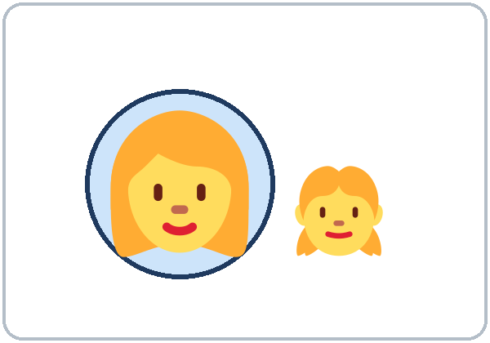  ★ mother | 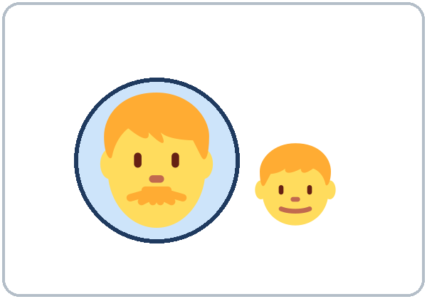  ★ father | 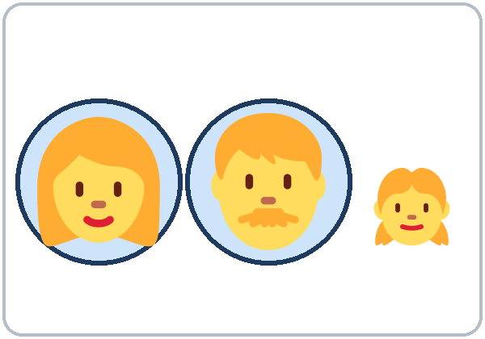  ★ parents | 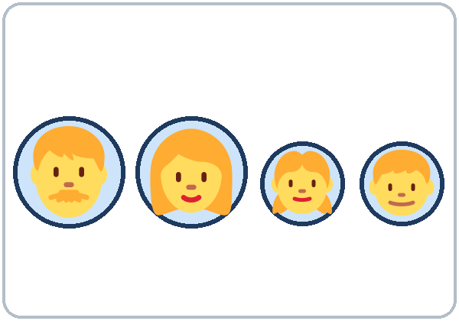  family
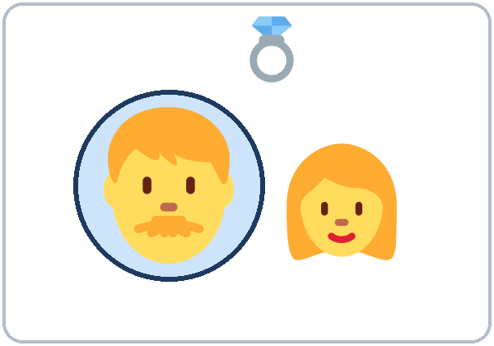  ★ husband | 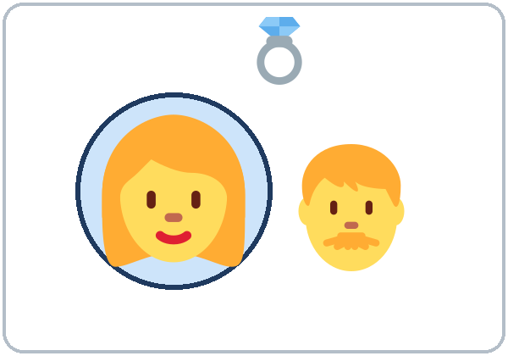  ★ wife | 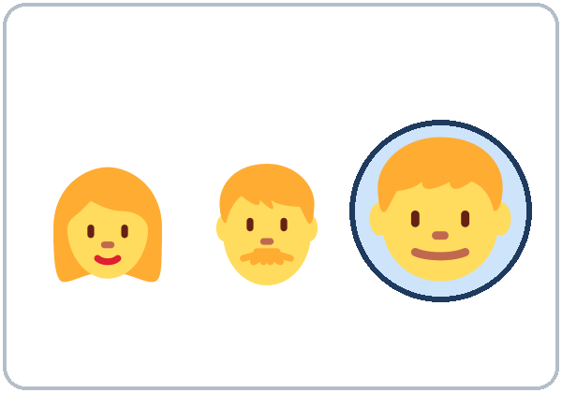  ★ son | 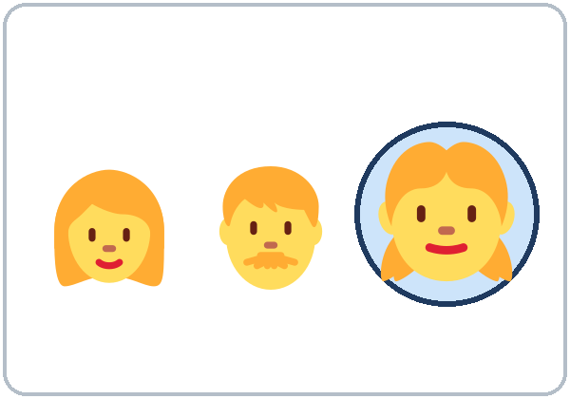  ★ daughter
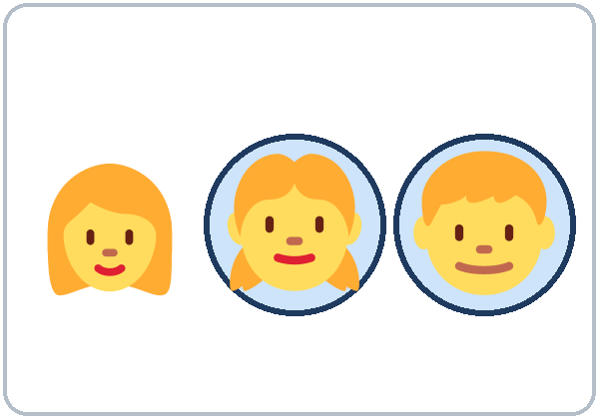  ★ children (kids) | 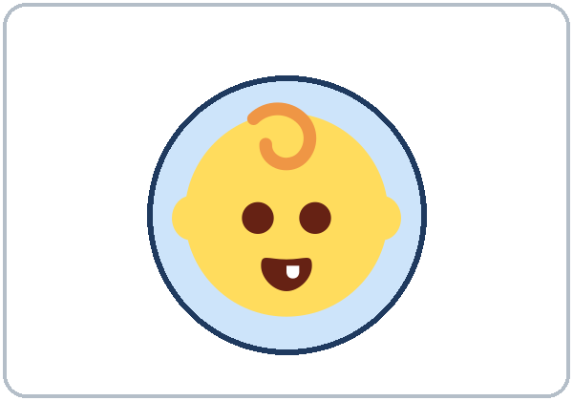  baby | 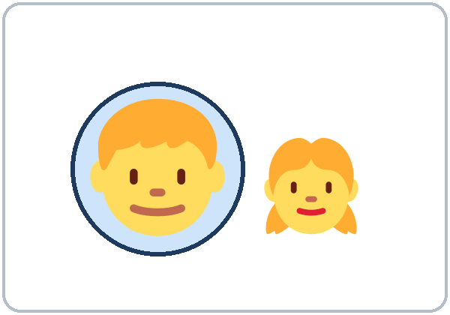  brother | 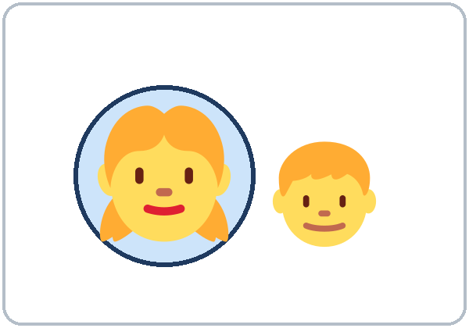  sister
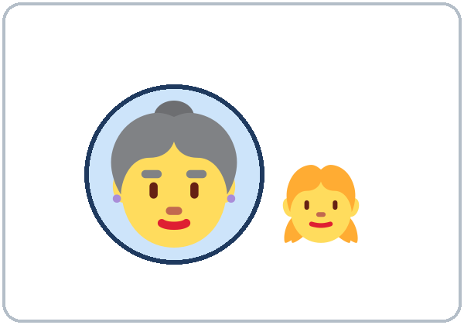  grandmother | 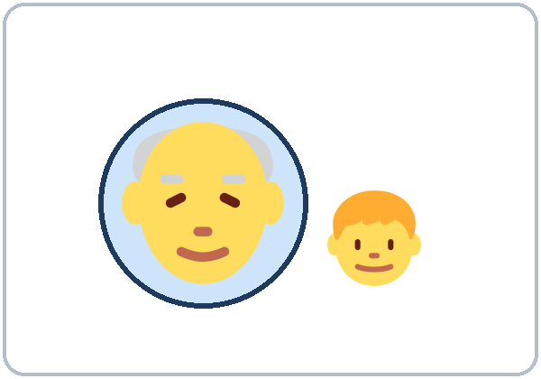  grandfather

Lesson 4 (Week 4) · Listening
A. Carlos shows Kim photos. Listen. Point to the person. Write 1, 2, 3, 4.
Español: Carlos le muestra fotos a Kim. Escucha. Señala a la persona. Escribe 1, 2, 3, 4.
My language: ______________________________________________
a. ______ | b. ______ | c. ______ | d. ______

C. Listen again. Write the number.
Español: Escucha otra vez. Escribe el número.
My language: ______________________________________________
1. Carlos has ______ children. 2. Daniel is ______. 3. Sofia is ______.
4. Kim has ______ kids. 5. Kim has ______ brothers.
B. Listen again. Write the names on Carlos's family tree.
Español: Escucha otra vez. Escribe los nombres en el árbol familiar de Carlos.
My language: ______________________________________________
Names: Elena • Daniel • Sofia • Leo • Carmen • Pedro

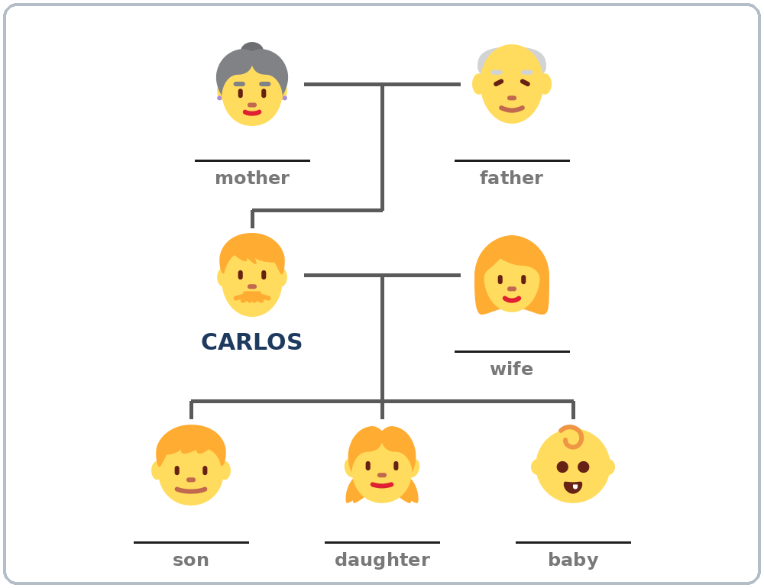

Lesson 4 (Week 4) · Grammar
With a partner: read across. A reads a question (left). B reads an answer (right). Choose one word from each column.
Español: Con un compañero: lee de izquierda a derecha. A lee una pregunta (izquierda). B lee una respuesta (derecha). Elige una palabra de cada columna.
My language: ______________________________________________
Grammar Box 1: Who's this?
QUESTION |  | ANSWER
Who's this? |  | This is my | mother.  wife.  sister. | Her name is Elena.
Who's this? |  | This is my | father.  son.  brother. | His name is Daniel.
How old is she?  How old is he? |  | She's  He's | 6.  70.

Grammar Box 2: Do you have kids?
QUESTION |  |  | ANSWER
Do you have | kids? |  | Yes, I do. | I have | one.  two.
Do you have | kids? |  | No, I don't.
Do you have | brothers or sisters? |  | Yes, I do. | I have | two brothers.  one sister.
Do you have | brothers or sisters? |  | No, I don't.

Grammar Box 3: Ana's husband
PERSON |  | WHOSE?
Ana |  | Ana's | husband
Carlos |  | Carlos's | wife  kids
Kim |  | Kim's | brothers
my mother |  | my mother's | name

Grammar Box 4: one → two
ONE |  | TWO OR MORE
a son |  | two sons
a brother |  | three brothers
a baby |  | two babies
a child |  | two children (kids)

Questions and answers
Q: Do you have kids? Can I say "Yes, I have"?
A: No. Say Yes, I do. or No, I don't. Then you can add the number: Yes, I do. I have two.
Q: What are parents?
A: Mother and father. Only 2 people. All the people in your family = my family.
Q: I don't want to talk about my family. What do I do?
A: Use Ana's family (the picture-card family). It's OK.
Practice: Write do, don't, his, her, or 's.
Español: Escribe do, don't, his, her o 's.
My language: ______________________________________________
1. Do you have kids? Yes, I ________.
2. Do you have brothers? No, I ________.
3. This is my sister. ________ name is Ana.
4. This is my father. ________ name is Tomas.
5. Elena is Carlos________ wife.
Common mistakes
✗ Don't say | ✓ Say
Do you have kids? Yes, I have. | Yes, I do. (I have two.)
You have kids? | Do you have kids?
the husband of Ana | Ana's husband
This is my sister. His name is Ana. | Her name is Ana.
I have two son. | I have two sons.
I have many parents in Mexico. | I have a big family in Mexico.

Optional. Q: Are you married?
A: Yes, I am. / No, I'm not. You don't have to answer this question.
Nota para hispanohablantes: En inglés se dice Ana's husband (no «the husband of Ana»). Para preguntar se usa do: Do you have kids? La respuesta corta es Yes, I do. o No, I don't. (no «Yes, I have»). Se dice I have two kids (no «I have two kids of me»). Parents significa solo padre y madre; no significa «parientes».

Tip for speakers of other languages: Questions with have start with Do: Do you have kids? Answer Yes, I do. or No, I don't. Ana's husband = the husband of Ana. Parents = mother and father.

Lesson 4 (Week 4) · Talk Time: My Family Tree
1. Write names on the tree: your family or an invented family. Or use Ana's family (next page).
Español: Escribe nombres en el árbol: tu familia o una familia inventada. O usa la familia de Ana (página siguiente).
My language: ______________________________________________
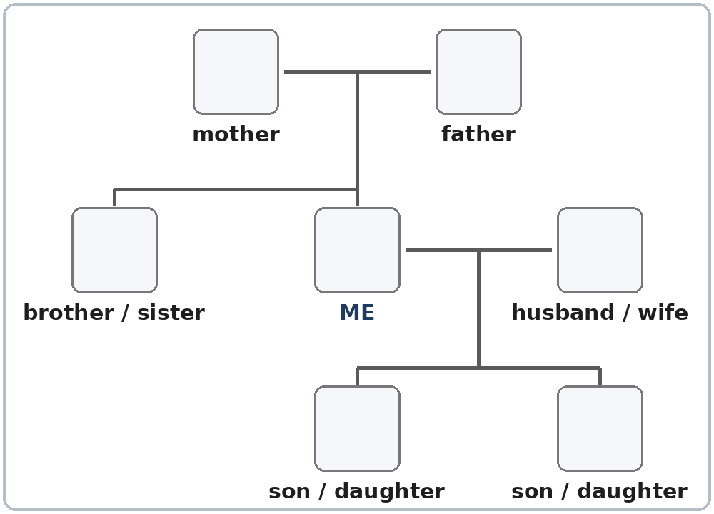

2. Groups of 3: say 3 sentences. Then the group asks you 1 question.
Español: En grupos de 3: di 3 oraciones. Después el grupo te hace 1 pregunta.
My language: ______________________________________________
You: This is my ___. His / Her name is ___. He's / She's ___.
Group: Who's this? How old is he / she? Do you have kids?

Lesson 4 (Week 4) · Talk Time: Picture-Card Family
You can be Ana. Point to a person. Say 3 sentences.
Español: Puedes ser Ana. Señala a una persona. Di 3 oraciones.
My language: ______________________________________________
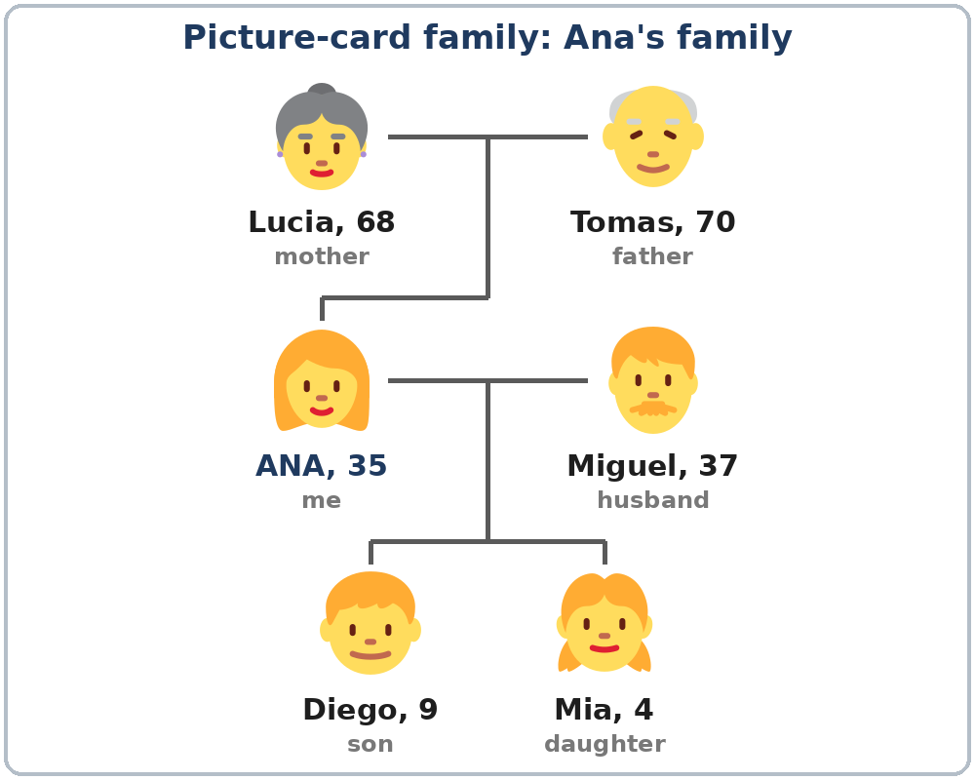

Example: This is my mother. Her name is Lucia. She's 68.
Example: I have two kids. This is my son. His name is Diego. He's 9.

Lesson 4 (Week 4) · Homework
Homework (10 minutes). Bring it next week!
Español: Tarea (10 minutos). ¡Tráela la próxima semana!
My language: ______________________________________________
1. Write 3 sentences about your family or Ana's family.
Español: Escribe 3 oraciones sobre tu familia o la familia de Ana.
My language: ______________________________________________
This is my ______________________. His / Her name is ______________________.
This is my ______________________. His / Her name is ______________________.
He's / She's ______________________.
2. Write do or don't.
Español: Escribe do o don't.
My language: ______________________________________________
1. Do you have kids? Yes, I ________. I have two.
2. Do you have sisters? No, I ________.
3. Do you have brothers? Yes, I ________. I have one brother.
4. Do you have a baby? No, I ________.
3. Write 's.
Español: Escribe 's.
My language: ______________________________________________
Example: Ana + husband → Ana's husband
1. Carlos + son → ______________________ 2. Kim + brothers → ______________________
3. Rosa + daughter → ______________________
4. Ask a family member or a friend: Do you have kids? Do you have brothers or sisters?
Español: Pregunta a un familiar o a un amigo: Do you have kids? Do you have brothers or sisters?
My language: ______________________________________________
5. Review: write a phone number (a practice number is OK).
Español: Repaso: escribe un número de teléfono (puede ser de práctica).
My language: ______________________________________________
My phone number is ________ - ______________.
Lesson 4 (Week 4) · Letters & Numbers
A. Look. Listen. Say. Short sounds.
Español: Mira. Escucha. Repite. Sonidos cortos.
My language: ______________________________________________
a (dad) | o (mom) | u sound (son) | i (kids)
dad | mom | son | kids
has | not | mother | sister
man | job | brother | six
family | stop | but | this

son, mother, brother: the letter is o, the sound is u (like but).
B. Listen to the teacher. Circle the word.
Español: Escucha al profesor. Encierra la palabra en un círculo.
My language: ______________________________________________
1. | mom | man
2. | dad | did
3. | kids | cats
4. | has | his
5. | big | bag

C. One → two. Write -s.
Español: Uno → dos. Escribe -s.
My language: ______________________________________________
ONE | TWO
brother | two ______________________
sister | two ______________________
son | two ______________________
daughter | two ______________________
parent | two ______________________
child | two children (no -s!)

D. Read. Copy. this • is • my
Español: Lee. Copia.
My language: ______________________________________________
This is my mom. ______________________________________________
This is my dad. ______________________________________________
Lesson 4 (Week 4) · Progress Check
Name: ______________________________ Date: ________________
A. Listen to the teacher. Circle the word.
Español: Escucha al profesor. Encierra la palabra en un círculo.
My language: ______________________________________________
1. | mother | father
2. | son | daughter
3. | husband | wife
4. | brother | sister
5. | grandmother | grandfather

B. Match the question and the answer. Draw a line.
Español: Une la pregunta con la respuesta. Dibuja una línea.
My language: ______________________________________________
Question | Draw a line. | Answer
1. Who's this? ● |  | ● a. He's ten.
2. Do you have kids? ● |  | ● b. His name is Daniel.
3. How old is he? ● |  | ● c. This is my son.
4. What's his name? ● |  | ● d. Yes, I do. I have two.

C. Write his, her, or 's.
Español: Escribe his, her o 's.
My language: ______________________________________________
1. This is my mother. ________ name is Carmen.
2. This is my son. ________ name is Leo.
3. Ana has a husband. He's Ana________ husband.
D. How do you feel? Check ✓ one face for each line.
Español: ¿Cómo te sientes? Marca ✓ una cara en cada línea. 😀 = I can do it. 🙂 = I can do it with a little help. 😐 = Not yet.
My language: ______________________________________________
I can… | 😀 | 🙂 | 😐
I can name family members. | ☐ | ☐ | ☐
I can say This is my brother. | ☐ | ☐ | ☐
I can ask and answer Do you have kids? | ☐ | ☐ | ☐
I can say how many children I have (or No, I don't.). | ☐ | ☐ | ☐

Score: A ______ / 5 B ______ / 4 C ______ / 3
Picture Credits
Vocabulary pictures and family trees use Twemoji graphics by Twitter, Inc. and other contributors (https://github.com/jdecked/twemoji), licensed under CC BY 4.0 (https://creativecommons.org/licenses/by/4.0/). The graphics were resized and combined, and highlight circles, family-tree lines, boxes, and labels were added. All names and ages on the pages are invented. The file-by-file list is in images/CREDITS.md.
Other small pictures on the pages (the faces on the Progress Check) are standard emoji characters shown with the computer's emoji font. Listening audio: synthetic voices made with Chatterbox TTS (Resemble AI, MIT License); each file carries an inaudible Perth watermark marking it as AI-generated. The voices are copied from short reference clips made with Kokoro-82M (Apache 2.0); no recordings of real people were used. Course materials: © 2026 the authors, CC BY-NC-SA 4.0.

