Level 4 Adult ESL Curriculum · Lesson 12 (Week 13): Is It a Scam?
Status: Draft for review; not published.
Date: October 2026
Audience: Program coordinators and volunteer teachers
Companion files: images/ (12 vocabulary pictures + images/CREDITS.md). Listening audio: not recorded yet (coming soon); until then, read the listening script in this plan aloud.
Topic: Consumer protection, calm and practical: recognizing common scams by phone, text, and email (a fake prize, a fake bank text, a fake "pay your bill today" call, payment with gift cards) and what to do: stop, don't pay, check with the real company, and tell someone. Learners describe people and messages with who / that. All messages, names, and numbers are invented.

How this lesson is organized
Part | What's inside | Who uses it
Teacher Plan | At a glance, clock-time plan, step-by-step boxes, listening script, answer key, teacher notes | Volunteer teachers
Student Pages | Opening Talk, New Words, My Words, Listening, Grammar, Talk Time, Homework, Read & Write, Exit Ticket, Task Words (optional). Print this part for learners | Learners
Picture Credits | Picture and license credits | Coordinators

What Lesson 12 builds on and what it adds
Before (review only) | Where | New in Level 4 Lesson 12
something / anyone | Level 3 Lesson 12 | Never give your PIN to anyone.
must / mustn't, should | Level 3 | You mustn't share your password. You should tell someone.
describing people and things | Levels 2–3 | who / that: a man who called, a text that came

TEACHER PLAN
Lesson 12 (Week 13)

Is It a Scam?
At a glance · Clock-time plan · Step by step · Script and answer key

How to Use This Plan
You don't need to speak Spanish or any other language. Teach in English. Show, point, and gesture. Some Grammar pages have one short contrast tip, only where a common mix-up exists. Learners read it on their own. You never need to read, translate, or explain it.

Instructions: use the same short task words every week: Listen. Circle. Check. Write. Work with a partner. Work in a group. Ask a follow-up question. Give a reason. An optional Task Words page is at the back of the workbook for learners who want it.

Instruction rule: Model it (do it with one learner while everyone watches), check it (ask: "Is it real or is it a scam? What should you do?"), then go. Say less, show more.

Grouping toolkit: Pairs: turn to a neighbor; with an odd number, make one group of 3. Groups: 3–4 learners. Inside–outside circles: the inner circle faces out, the outer circle faces in; the outer circle moves one person to the right each round. Mingle: everyone stands and talks to many classmates. The teacher joins a pair only if one learner is left over.

When a learner is stuck or speaks another language to you: (1) show it: the picture, a gesture, or the board; (2) give one more short English example; (3) point to the grammar box on their page; (4) a classmate can help for a few seconds, then back to English. You don't need to understand what classmates say to each other.

Three sentences, not one: in Level 4, every Talk Time answer and every exit ticket has about three connected sentences: the answer, a reason, and a detail or example.

Lesson 12 (Week 13): Is It a Scam?
At a glance
Objectives: learners can…
• describe a person or a message with who / that (a caller who asks for gift cards)
• name 4 warning signs of a scam
• say what to do with a suspicious call or text (stop, don't pay, check, tell someone)
• give a safe answer on the phone (I don't give information on the phone. Goodbye.)
• write a message (5–8 sentences) to warn a family member about a scam

Materials
• Student Pages for Lesson 12 (print for the number expected + 3 spares)
• Board and markers
• The 10 message cards on the Talk Time page (copy and cut them, optional)
• A local consumer-help phone number for the "Keep practicing" sheet (check it locally)
• Listening: no recording yet. Read the listening script aloud (with a volunteer if you can), at a natural speed, two times.
• Prep time: 15 minutes (read the plan; practice reading the listening script; find and check a local consumer-help number).

Key vocabulary (with pictures on the New Words page)
★ scam • ★ warning sign • ★ suspicious • ★ fake • ★ official • ★ gift card • ★ prize • ★ link • ★ PIN • ★ hang up • ★ block (a number) • trust
Also: a trick, a caller, information, a password, an account, pushy, hurry, a package, a real bill, a consumer.

Clock-time plan
Times are loose. If the listening or Talk Time runs long, take the time from Read & Write.
Time | Step | Min | Grouping (15 / 7–8) | If running behind
6:00–6:08 | Opening Talk + Homework Check | 8 | Pairs (7 pairs + 1 trio / 3–4 pairs) | One card only
6:08–6:15 | New Words (picture page) + pair game (+ My Words) | 7 | Whole class, then pairs | Teach the ★ words only
6:15–6:30 | Listening: play 1 (Task A), play 2 (Tasks B and C) + "Hear it, say it" | 15 | Individuals, then pairs check | Do Task C together on the board
6:30–6:45 | Grammar Q&A: who / that + pair check | 15 | Whole class, then pairs | Skip the pair check; Talk Time practices it
6:45–7:00 | BREAK | 15
7:00–7:15 | Talk Time: Real or Scam? + Safe Answer | 15 | Pairs, then groups of 4, then pairs | Round 1 only
7:15–7:25 | Read & Write: A consumer tips flyer + a sample text; a message | 10 | Pairs read, then individual writing | Reading questions only; the writing becomes homework
7:25–7:30 | Exit Ticket + Homework | 5 | Individuals | Never skip

Skip order if you're running behind: (1) the Read & Write writing task (it becomes homework); (2) the pair check at the end of Grammar; (3) the second round of Talk Time. Never skip: the listening tasks, the grammar boxes and the mistakes table, and the exit ticket.

Attendance (15 → 7–8 → 5 or fewer): every step lists the sizes. With 5 or fewer, sort the message cards together as one group, then do Safe Answer in pairs (you are the caller if needed). Late arrivals join the sort and take a caller card in round 2.

Step by step
Step 1 · 6:00–6:08 · Opening Talk · 8 min
• Grouping: pairs, the same partner for both parts. 15 learners: 7 pairs + 1 group of 3. 7–8 learners: 3–4 pairs. 5 or fewer: pairs, or one group with you.
• Before class: write on the board: to + verb (why); enjoy + -ing
• Opening Talk (5 min): learners open the Opening Talk page. A asks a card question; B answers in 3 sentences (the answer, a reason, a detail); A asks one follow-up. Switch after each card.
• Model with one learner: you say, "Where would you like to go on a trip?" The learner answers with to + verb (I'd like to go to Chicago to see the lake.). Then you ask, "What do you enjoy doing there?" Help them say 3 sentences.
• Homework Check (3 min): Pairs compare Homework item 1 (to / -ing) and read their trip plan (item 3) to each other. Then they fill in the box on the Opening Talk page. Walk around. Write 2 common errors on the board (often for see (→ to see) and enjoy to travel (→ enjoy traveling)) and correct them together. Also put up 2 corrections from last week's exit tickets.
• Late arrivals: join any pair as a group of 3.
• If behind: one card only.

Step 2 · 6:08–6:15 · New Words · 7 min
• Grouping: whole class, then pairs. Show the New Words page.
• Do: point to each picture and say the word. Learners repeat once.
• Show the hard words: scam (a trick that takes your money); warning sign (something that tells you to be careful); suspicious (strange, maybe not true); fake (not real); official (real, from the company); gift card; prize; link (you click it in a text or email); PIN (your secret number); hang up (end the call); block (a number); trust.
• Check meaning (1 min): ask "Is a fake message real or not real?" (not real) • "Do you give your PIN to a caller or to nobody?" (nobody) • "When a call is suspicious, do you hang up or pay?" (hang up).
• Pairs (2 min): A says a word; B points to the picture and makes a sentence (Never give your PIN to anyone.). Switch. 15 learners: finish with a quick team round (3 teams; you say a clue, the first team with the word gets a point). 7–8: 2 teams. 5 or fewer: one team against the clock.
• My Words: "Write any word you want in your language on the My Words page. It's your personal list. It's optional." Learners do it at home.
• If behind: teach the ★ words only.

Step 3 · 6:15–6:30 · Listening + "Hear it, say it" · 15 min
• Grouping: individuals, then pairs check. With 5 or fewer, check together as a group.
• Before you listen (2 min): say: "Mrs. Lopez gets a phone call from a man who says he's from the electric company. Later, she talks to her son, Daniel. Listen: was it a scam?"
• Play 1 → Task A (the main idea). Pairs compare. Check together.
• Read Tasks B and C together (1 min) so learners know what to listen for.
• Play 2 → Tasks B and C. Pairs compare. Then show the answers (answer key).
• "Hear it, say it" (3 min): Point to the script line. gonna = going to: "We're going to turn off your power." Then practice the weak that (it sounds like "thut"): a text that asks. Stress the key words: NEVER, GIFT cards. Practice a calm, firm voice: No, thank you. Goodbye. The class repeats the two lines twice.
• No recording yet: read the script aloud with a volunteer (about 1:57), at a natural speed, two times. The script says going to and want to. People often say gonna and wanna; learners only need to recognize those words. When the audio is ready, it plays the conversation once; press play again for play 2. A third play is fine if the class needs it.
• If behind: do Task C together on the board, reading the lines yourself.

Step 4 · 6:30–6:45 · Grammar Q&A · 15 min
• Grouping: whole class, then pairs. Show the Grammar page. The left side is the question. The right side is the answer.
• Show it (2 min): hold up your phone and say, "This morning I got a text. The text said I won a prize. → I got a text that said I won a prize." Then: "A man called. The man wanted my PIN. → A man who called wanted my PIN." Write: who = people, that = things (and people). Cross out a man who he called.
• The boxes (5 min): Box 1: read across: What's a scam? → It's a trick that takes your money. Box 2: what to do: Hang up on a caller who asks for gift cards. Box 3: never… anyone, must / should. Box 4: the 4 steps.
• Rule of thumb and Questions and answers (2 min): read the rule of thumb aloud. Read each Q and A; the class reads the right sentence after you.
• Check questions: "who or that for a text?" (that) • "a man who he called or a man who called?" (a man who called) • "Are most calls scams?" (no, most are real).
• Practice A and B (3 min): learners write, then pairs check. Go over the answers. Read the Common mistakes table together: "Don't say… Say…".
• Pair check (last 3 min): A points to a picture and asks, "What's a gift card scam?" B answers with who / that: "It's a call that asks you to pay with gift cards." Switch. 15 learners: swap partners once. 5 or fewer: you join one pair.
• If behind: skip the pair check. Talk Time practices it.

Break · 6:45–7:00 · 15 min
• Write on the board: It's a trick that takes your money. • Don't trust a caller who asks for gift cards. • Stop. Don't pay. Check. Tell someone.

Step 5 · 7:00–7:15 · Talk Time: Real or Scam? + Safe Answer · 15 min
• Model it first (1 min): read card 1: "Your package is late. Click this link and pay $2.99 today." Say, "I think it's probably a scam. It's a text that has a strange link, and it asks for money today." Then model a safe answer: a learner reads caller card 1, and you say calmly, "I don't give information on the phone. I'll call the number on my card. Goodbye."
• Round 1 (7 min): Real or Scam? (pairs). Pairs sort the 10 invented message cards into probably real and probably a scam and explain with It's a text that… / It's from someone who… Then they compare with another pair.
• Round 2 (6 min): Safe Answer (pairs). A is a caller with a pushy (but polite) card. B gives a safe answer. Switch.
• 15 learners: pairs; then groups of 4 to compare; then pairs.
• 7–8 learners: pairs; then one group to compare.
• 5 or fewer: the whole group sorts together; then pairs.
• Every answer needs a reason; every partner asks a follow-up. Walk around and listen. Note 2 good sentences to praise and 1 common error for next week.
• If behind: round 1 only.

Step 6 · 7:15–7:25 · Read & Write: A consumer tips flyer + a sample scam text · 10 min
• Grouping: pairs read and answer; individual writing. With 5 or fewer, read the text aloud together.
• Read (4 min): Learners read the invented flyer and the sample text on the Read & Write page and answer the questions. Say: "Read fast first. Then find the answers." Pairs answer questions 1–5 together.
• Check (1 min): go over the answers (answer key).
• Write (5 min): Learners write a message (5–8 sentences) to a family member about a scam text, with that / who and Don't…. Show the example. Learners start in class and finish at home (Homework item 2).
• If behind: questions 1–5 only; the writing becomes homework.

Step 7 · 7:25–7:30 · Exit Ticket + Homework · 5 min · NEVER SKIP
• Exit ticket (3 min): learners open the Exit Ticket page and answer in 3 sentences with a reason: What is one warning sign of a scam, and what should you do? Example on the board: A caller who asks for gift cards is a warning sign. You should hang up and call the real company. Don't pay, because real companies don't take gift cards. With 5 or fewer, a learner can say it to you first and then write it.
• Collect the pages. After class, sort them into ✓ / almost / not yet. Start next week with 2 corrections on the board (no names).
• Homework (2 min): open the Homework page. Do item 1 together (item 1: don't trust / a caller / ask for gift cards (who) → Don't trust a caller who asks for gift cards.). Say: "About 15–20 minutes. Finish your Read & Write writing at home."

Listening script (not recorded yet; about 1:57 when recorded; the conversation plays once, so press play again for the second listen)
Audio: the recording is coming soon. Until then, read the script aloud two times, with a volunteer if you can, at a natural, friendly speed. The script says going to and want to. People often say gonna and wanna; learners only need to recognize those words.

Narrator: Lesson twelve. Mrs. Lopez gets a phone call. Later, she talks to her son, Daniel.
Caller: Hello, is this Mrs. Lopez? This is Mike from the electric company. Your bill is late. You must pay today, or we're going to turn off your power in one hour.
Mrs. Lopez: What? My bill is late? I paid it last week.
Caller: No. You owe $200. Go to the store and buy gift cards. Then call me back and read me the numbers.
Mrs. Lopez: Gift cards? That sounds very strange to me.
Caller: Please hurry. This is your last chance. Don't tell anyone.
Mrs. Lopez: No, thank you. I'm going to call the number that is on my real bill. Goodbye.
Daniel: Hi, Mom. You look worried. What's wrong?
Mrs. Lopez: The man who called me knew my name. He said he was from the electric company. He wanted me to pay with gift cards.
Daniel: Gift cards? That's a warning sign. A company that asks for gift cards is a scam. What did you do?
Mrs. Lopez: I said no, and I hung up.
Daniel: Good! You did the right thing. Scammers are people who want your money. Did you give him any information?
Mrs. Lopez: No. I didn't tell him anything.
Daniel: Great. Let's check your account on the City Power website. OK, here it is. Your account is fine. You don't owe any money.
Mrs. Lopez: Oh, good. I'm glad I didn't pay.
Daniel: Me too. Next time, you can block the number. Be careful with texts that ask for your password, too. And never trust a caller who tells you to hurry.
Mrs. Lopez: You're right. Thanks, Daniel.
Narrator: That's the end of the listening.

Answer key
• Listening Task A: a (Yes, it was a scam.).
• Listening Task B: 1 today, 2 gift cards, 3 Don't tell anyone., 4 one hour, 5 hung up, 6 fine.
• Listening Task C: 1 that, 2 who, 3 that, 4 who, 5 that, 6 who.
• Grammar Practice A: 1 that, 2 who, 3 that, 4 anyone, 5 something, 6 mustn't.
• Grammar Practice B: 1 that, 2 who, 3 who called, 4 that, 5 should, 6 Hang up.
• Talk Time: answers will vary.
• Homework 1: 1 Don't trust a caller who asks for gift cards. 2 Be careful with texts that ask for your password. 3 Never give your PIN to anyone. 4 A warning sign is something that tells you to be careful. Homework 2 and 3: answers will vary. Homework 4: 1 to, 2 traveling, 3 to, 4 to, 5 covering.
• Read & Write B: 1 No. Most are real. • 2 No, they don't. • 3 Stop. Don't answer or click right away. • 4 The number on your real bill or card. • 5 It asks for your PIN, and it says you must hurry (30 minutes). • Writing (C): answers will vary.
• Exit ticket: answers will vary. A good answer: "A caller who asks for gift cards is a warning sign. You should hang up and call the real company. Don't pay, because real companies don't take gift cards."
Teacher notes
• Keep it calm and practical: "Most calls and texts are real. A few are scams. Stop, check, and ask." No scary stories.
• Never ask learners whether they lost money or got a scam call. Learners can share if they want to.
• All messages are invented, with no real numbers or links. List a local consumer-help line on the "Keep practicing" sheet (check it locally first).
• Teacher-only: if a learner asks about "legal help" or "immigration help" services that ask for money, point only to local legal aid. Don't give advice yourself.
• Listening: in the scope, a real utility agent confirms the account. To keep 3 speakers, Daniel checks the account on the company website instead. The message is the same: no money is lost.
• Spanish and other languages: the contrast tip on the Grammar page is optional. Learners read it on their own. You never need to read, translate, or explain it.
• Reductions: the listening says going to. People often say gonna. Learners only need to recognize it; they can always say the full form.

STUDENT WORKBOOK
Lesson 12 (Week 13)

Is It a Scam?
Opening Talk · New Words · Listening · Grammar · Talk Time · Homework · Read & Write · Exit Ticket

Lesson 12 (Week 13) · Opening Talk
Name: ______________________________ Date: ________________
Work with a partner. A asks a question. B answers in 3 sentences: the answer, a reason, and a detail. A asks one follow-up question. Then switch.
A: Where would you like to go on a trip? | A: What do you enjoy doing on the weekend?
A: Why do people take time off? | A: What do you need to pack for a short trip?

Follow-ups: Why? • What do you enjoy doing there?
Write your partner's name and their trip from Homework item 3.
My partner's name | Their trip (where and why)

Lesson 12 (Week 13): Is It a Scam?
Student Page 1 · Week 13
Name: ______________________________ Date: ________________
New Words
Look. Listen. Repeat. ★ = most important words.
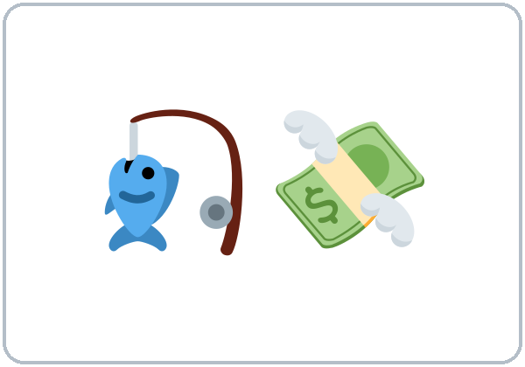  ★ scam | 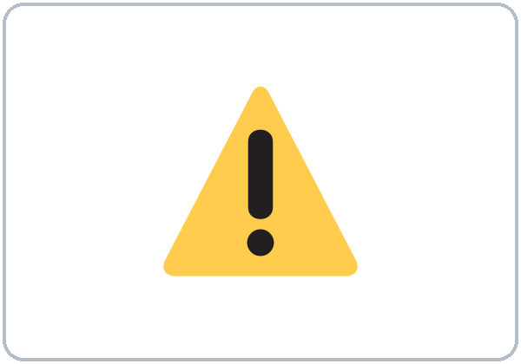  ★ warning sign | 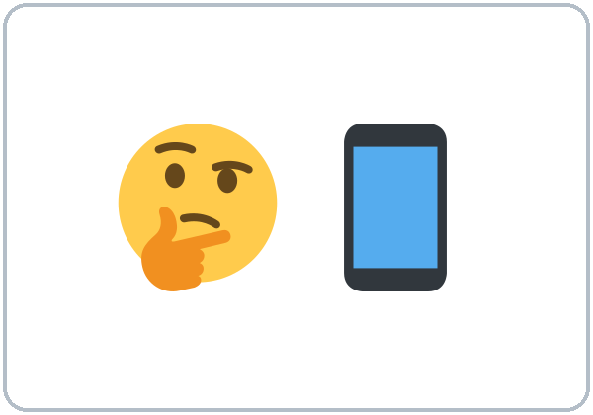  ★ suspicious | 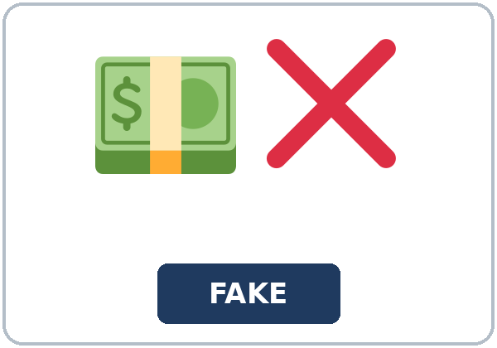  ★ fake
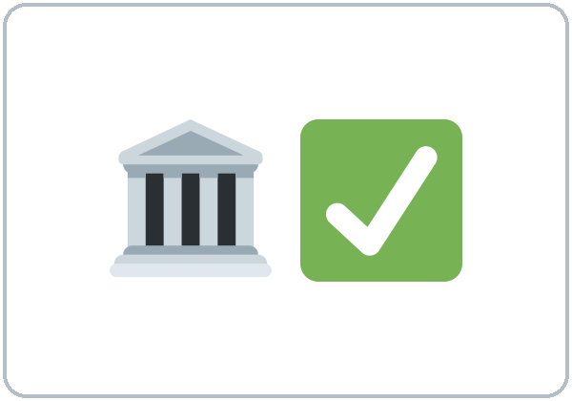  ★ official | 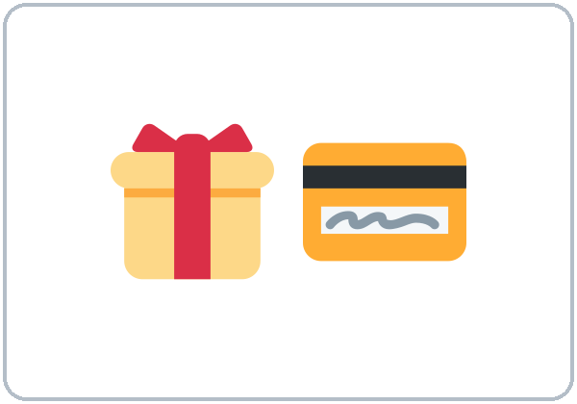  ★ gift card | 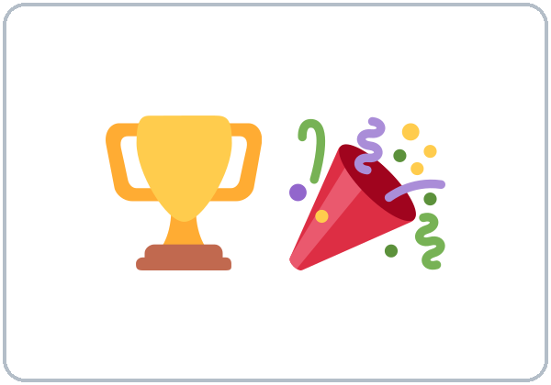  ★ prize | 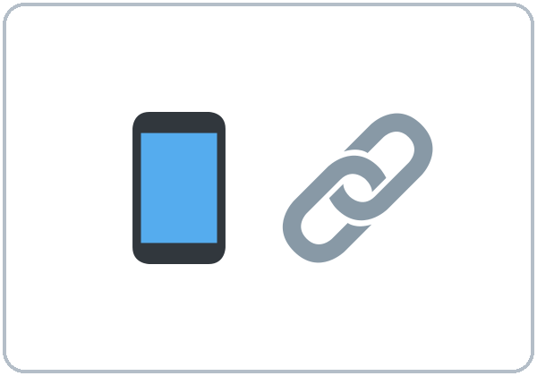  ★ link
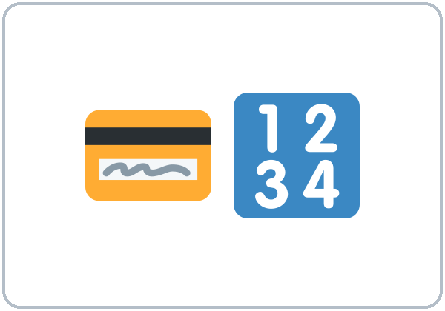  ★ PIN | 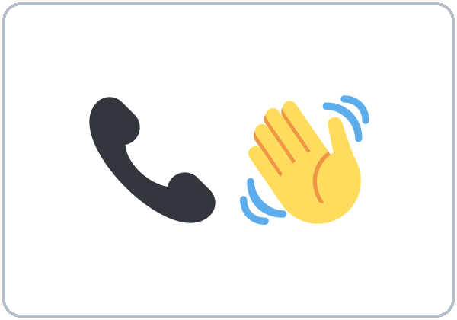  ★ hang up | 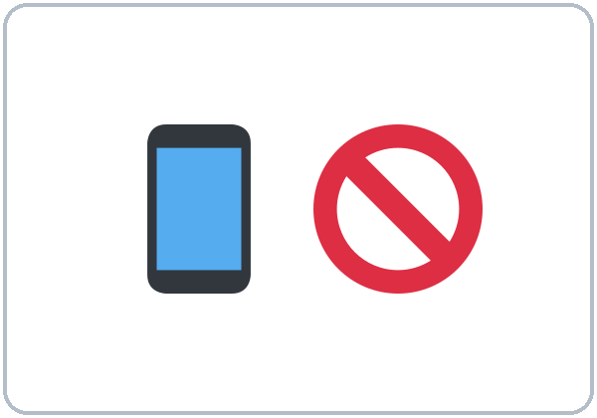  ★ block (a number) | 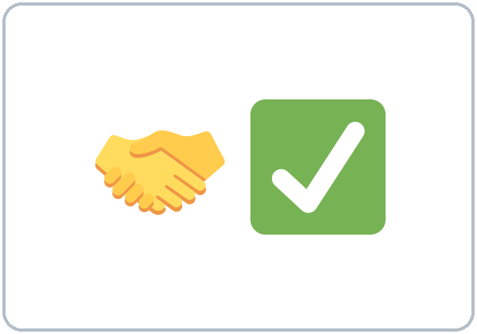  trust

Partner game: Who or that?
Example: A points to a picture and asks, "What's a fake prize?" B answers with who / that: "It's a message that says you won, but you must pay." Switch.
Lesson 12 (Week 13) · My Words
My personal word list. Write each word in your language, if you want. Then write your own example.
Word | My language | My example
scam
warning sign
suspicious
fake
official
gift card
prize
link
PIN
hang up
block (a number)
trust

Add 2 more words from tonight (from the listening, the reading, or your partner).
Lesson 12 (Week 13) · Listening
A man calls Mrs. Lopez and says he is from the electric company. She must pay today with gift cards. She says no and hangs up. Then she tells her adult son, and they check her real account. No money is lost.
A. Listen. Was it a scam? Circle.
a. Yes, it was a scam. b. No, the bill was really late. c. We don't know.
B. Listen again. Which warning signs did you hear? Circle the answer.
1. The caller said she must pay (today / next month).
2. He wanted her to pay with (gift cards / a check).
3. He said, "(Don't tell anyone. / Call your son.)"
4. He said they would turn off her power in (one hour / one week).
5. Mrs. Lopez (hung up / paid $200).
6. Her real account is (fine / late).
C. Listen again. Write who or that.
1. I'm going to call the number ____________ is on my real bill.
2. The man ____________ called me knew my name.
3. A company ____________ asks for gift cards is a scam.
4. Scammers are people ____________ want your money.
5. Be careful with texts ____________ ask for your password, too.
6. never trust a caller ____________ tells you to hurry.
Hear it, say it
gonna = going to: "We're going to turn off your power." You can say going to. The word that is short and weak: a text that asks ("thut"). Stress the key words: NEVER, GIFT cards. Say No, thank you. Goodbye. in a calm, firm voice.
Lesson 12 (Week 13) · Grammar
Read across. A reads from the left side. B answers from the right side. Choose one part from each column.
Grammar Box 1: describing with who / that
QUESTION |  |  | ANSWER
What's | a scam? |  | It's a trick | that takes your money.
Who | called you? |  | A man | who said he was from the bank.
What's | a warning sign? |  | It's something | that tells you to be careful.

Grammar Box 2: what to do
QUESTION |  |  | ANSWER
What about | a text that wants my PIN? |  | Don't answer texts | that ask for your PIN.
What about | a caller who wants gift cards? |  | Hang up on a caller | who asks for gift cards.
Who | can I trust? |  | Call the company | at the number that is on your card.

Rule of thumb: who for people; that for things (and also people). The who / that part tells you which person or thing. Don't add he / it after it: a man who called (not a man who he called).
Grammar Box 3: anyone, something, must, should
WORDS | EXAMPLE
Never… anyone | Never give your PIN to anyone.
If something… | If something sounds too good to be true, it probably is.
mustn't / should | You mustn't share your password. You should tell someone you trust.

Grammar Box 4: 4 steps
STEP | WHAT TO DO
Stop. | Don't answer or click right away.
Don't pay. | Never pay with gift cards.
Check. | Call the number on your real bill or card.
Tell someone. | Talk to a family member or friend you trust.

Questions and answers
Q: who or that?
A: who for people, that for things. that is OK for people too: a man who called / a text that came.
Q: a man who he called or a man who called?
A: a man who called. Don't add he or it after who / that.
Q: Are all calls and texts scams?
A: No. Most calls and texts are real. A few are scams. Stop, check, and ask.
Practice A: Write one word.
1. A scam is a trick ____________ takes your money.
2. Don't trust a caller ____________ asks for gift cards.
3. Be careful with links ____________ look strange.
4. Never give your PIN to ____________.
5. If ____________ sounds too good to be true, it probably is.
6. You ____________ share your password. (must / mustn't)
Practice B: Circle the correct words.
1. I got a text (that / who) said I won a prize.
2. The woman (who / what) called was from my bank.
3. A man (who called / who he called) asked for my PIN.
4. Don't click on links (that / who) look strange.
5. You (should / shouldn't) tell someone you trust.
6. (Hang up / Hang on) if the caller is pushy.
Common mistakes
✗ Don't say | ✓ Say
the man who he called | the man who called
a text who said | a text that said
Never give your PIN to nobody. | Never give your PIN to anyone.
Don't trust a caller asks for money. | Don't trust a caller who asks for money.
You must to call the bank. | You must call the bank.

Contrast tip (optional): Spanish uses que for people and things: el hombre que llamó, el mensaje que llegó. English uses who (or that) for people and that for things: the man who called, the message that came. Many languages repeat the pronoun (the man who he called); English doesn't. What do you say in your language?

Lesson 12 (Week 13) · Talk Time: Real or Scam?
Round 1. Work with a partner. Read the 10 invented messages. Is each one probably real or probably a scam? Say why with It's a text that… / It's from someone who…
MESSAGE CARDS (invented)
1. Text: Your package is late. Click this link and pay $2.99 today. | 2. Email: Hi, this is your son's school. Parent conferences are on May 3.
3. Call: You won a free trip! Just pay $100 for taxes. | 4. Text: Your bank account is locked. Send your PIN to unlock it.
5. Text: Reminder: your dentist appointment is Friday at 10:00. Reply C to confirm. | 6. Call: This is the electric company. Pay with gift cards in one hour.
7. Email: Your library book is due tomorrow. | 8. Text: Hi Grandma, it's me. I lost my phone. Send money now and don't tell Mom.
9. Call: This is the pharmacy. Your prescription is ready. | 10. Email: You got the job! Send $50 for training.

Example: "Card 1 is probably a scam. It's a text that has a strange link, and it wants money today."
Probably real (numbers) | Probably a scam (numbers) | One reason

Lesson 12 (Week 13) · Talk Time: Safe Answer
Round 2. Work with a partner. A is the caller: read a card in a pushy but polite voice. B gives a safe answer. Then switch.
CALLER CARDS (invented)
1. "Hello, I'm from your bank. There's a problem with your account. Please tell me your PIN."
2. "Congratulations! You won a $1,000 prize! I just need your address and $50 for shipping."
3. "This is the water company. Pay today with gift cards, or we'll shut off your water."

SAFE ANSWERS (choose one or two)
"I don't give information on the phone."
"I'll call the number on my card."
"No, thank you. Goodbye." (Then hang up.)

Card | The warning sign (It's a caller who…) | My safe answer

Remember: a calm, firm voice. You don't need to explain. You can hang up.
Lesson 12 (Week 13) · Homework
Homework (about 15–20 minutes). Bring it next week!
1. Write the sentence. Use who or that.
Example: a scam / a trick / take your money (that) → A scam is a trick that takes your money.
1. don't trust / a caller / ask for gift cards (who) → ______________________________________________
2. be careful with / texts / ask for your password (that) → ______________________________________________
3. never / give / your PIN / anyone → ______________________________________________
4. a warning sign / something / tell you to be careful (that) → ______________________________________________
2. Finish your writing from Read & Write C (your message). Read it one more time. Check ✓ the list in D.
☐ I finished it. ☐ I checked it with the list.
3. Write 3 warning signs of a scam. What should you do?
Warning sign (a caller who… / a text that…) | What to do
1.
2.
3.

4. Review (Lesson 11). Write one word.
1. I'm going to the store ____________ buy milk.
2. I enjoy ____________ by bus. (travel)
3. We decided ____________ leave on Friday.
4. Don't forget ____________ pack your charger.
5. Would you mind ____________ my shift? (cover)
Lesson 12 (Week 13) · Read & Write
A. Read the notice. Read fast first. Then read again and answer the questions.
RIVERSIDE COMMUNITY OFFICE · A flyer + a sample text (invented)
SMART CONSUMER TIPS. Most calls, texts, and emails are real. But some are scams: tricks that take your money or your information. Here are 5 warning signs. 1. Someone says you must pay today, or something bad will happen. 2. A caller wants you to pay with gift cards. Real companies don't take gift cards for bills. 3. A message says you won a prize, but you must pay to get it. 4. A text has a strange link and asks for your password or PIN. 5. Someone tells you, "Don't tell anyone." What should you do? Stop: don't answer or click right away. Don't pay. Check: call the company at the number that is on your real bill or card. Tell someone you trust. You can also block the number.
SAMPLE TEXT (a scam). "ALERT! Your bank card is locked. Click the link and enter your PIN in 30 minutes, or you will lose your money."

B. Answer the questions.
1. Are most calls and texts scams? ______________________________________________
2. Do real companies take gift cards for bills? ______________________________________________
3. What is the first step? ______________________________________________
4. Which number should you call to check? ______________________________________________
5. What are two warning signs in the sample text? ______________________________________________
C. Write a message (5–8 sentences) to a family member about a scam text. Use who or that and Don't….
Example: Hi Mom, I want to tell you about a scam. Some people get texts that say their bank card is locked. The texts ask for your PIN. Don't click on the link, and don't answer. If you aren't sure, call the number that is on your bank card. Also, never trust a caller who asks for gift cards. Love, Ana
My message

D. Check your writing with a partner.
 | Yes | Not yet
It has 5–8 sentences. | ☐ | ☐
It has who or that. | ☐ | ☐
It has Don't…. | ☐ | ☐
It says what to do. | ☐ | ☐

Lesson 12 (Week 13) · Exit Ticket
Name: ______________________________ Date: ________________
Answer in 3 sentences. Give a reason. Then give this page to your teacher.
What is one warning sign of a scam, and what should you do?
Sentence 1: a warning sign, with who or that • Sentence 2: what to do • Sentence 3: a reason, with because
My answer
1.
2.
3.

For the teacher | ✓ | almost | not yet
3 sentences, today's grammar, a reason | ☐ | ☐ | ☐

Lesson 12 (Week 13) · Task Words (optional)
This page is for you if you want it. You can skip it. Write each task word in your language, if you want.
Task word | What you do | My language
Listen. | Use your ears. Don't write yet.
Circle. | Draw a circle around the answer.
Check ✓. | Make a ✓ in the box.
Write. | Write words or sentences.
Number. | Write 1, 2, 3… to show the order.
Match. | Find the two parts that go together.
Work with a partner. | Work with one classmate.
Work in a group. | Work with 2 or 3 classmates.
Switch. | Change roles: A is B now.
Ask a follow-up question. | Ask one more question about the answer.
Give a reason. | Say why, with because or so.
Compare. | Look at your partner's answers. Are they the same?

Picture Credits
Pictures use Twemoji graphics by Twitter, Inc. and other contributors (https://github.com/jdecked/twemoji), licensed under CC BY 4.0 (https://creativecommons.org/licenses/by/4.0/). The graphics were resized and combined, and signs and labels were added. The file-by-file list is in images/CREDITS.md.
Listening audio: not recorded yet. When it is made, it will use synthetic voices made with Chatterbox TTS (Resemble AI, MIT License), cloned from synthetic reference clips made with Kokoro-82M (Apache License 2.0), with no recordings of real people. The names and the story are invented.
Course materials: © 2026 the authors, licensed under CC BY-NC-SA 4.0 (https://creativecommons.org/licenses/by-nc-sa/4.0/).

