Level 4 Adult ESL Curriculum · Lesson 11 (Week 12): Time Off
Status: Complete lesson (all 13 Level 4 lessons are published).
Date: October 2026
Audience: Program coordinators and volunteer teachers
Companion files: images/ (12 vocabulary pictures + images/CREDITS.md). Audio: audio/L4_L11_listening.mp3.
Topic: Asking for time off at work, planning a short trip to visit family or see a new place, packing, and leaving a detailed voicemail. Learners say why with to + verb and use verbs + to or + -ing. The company, the policy, the trips, and the phone numbers are invented.

How this lesson is organized
Part | What's inside | Who uses it
Teacher Plan | At a glance, clock-time plan, step-by-step boxes, listening script, answer key, teacher notes | Volunteer teachers
Student Pages | Opening Talk, New Words, My Words, Listening, Grammar, Talk Time, Homework, Read & Write, Exit Ticket, Task Words (optional). Print this part for learners | Learners
Picture Credits | Picture, audio, and license credits | Coordinators

What Lesson 11 builds on and what it adds
Before (review only) | Where | New in Level 4 Lesson 11
enjoy / don't mind + -ing; hope to / plan to | Level 3 | one chart: verbs + to and verbs + -ing
Would you mind…? | Level 4 Lesson 5 | Would you mind covering my shift?
already / yet; going to | Level 3 and Level 4 | I've already filled out the form. I'm going to leave on Friday.

TEACHER PLAN
Lesson 11 (Week 12)

Time Off
At a glance · Clock-time plan · Step by step · Script and answer key

How to Use This Plan
You don't need to speak Spanish or any other language. Teach in English. Show, point, and gesture. Some Grammar pages have one short contrast tip, only where a common mix-up exists. Learners read it on their own. You never need to read, translate, or explain it.

Instructions: use the same short task words every week: Listen. Circle. Check. Write. Work with a partner. Work in a group. Ask a follow-up question. Give a reason. An optional Task Words page is at the back of the workbook for learners who want it.

Instruction rule: Model it (do it with one learner while everyone watches), check it (ask: "Why do you need time off? What do you enjoy doing on a trip?"), then go. Say less, show more.

Grouping toolkit: Pairs: turn to a neighbor; with an odd number, make one group of 3. Groups: 3–4 learners. Inside–outside circles: the inner circle faces out, the outer circle faces in; the outer circle moves one person to the right each round. Mingle: everyone stands and talks to many classmates. The teacher joins a pair only if one learner is left over.

When a learner is stuck or speaks another language to you: (1) show it: the picture, a gesture, or the board; (2) give one more short English example; (3) point to the grammar box on their page; (4) a classmate can help for a few seconds, then back to English. You don't need to understand what classmates say to each other.

Three sentences, not one: in Level 4, every Talk Time answer and every exit ticket has about three connected sentences: the answer, a reason, and a detail or example.

Lesson 11 (Week 12): Time Off
At a glance
Objectives: learners can…
• ask for time off and give a reason
• say why with to + verb (I'm going to Houston to see my sister.)
• use verbs + to (want, need, plan, decide, hope, forget, would like) and verbs + -ing (enjoy, don't mind, finish, avoid, keep)
• leave a detailed voicemail and take voicemail notes
• write an email (5–8 sentences) to a supervisor asking for time off

Materials
• Student Pages for Lesson 11 (print for the number expected + 3 spares)
• Board and markers
• A phone or a toy phone for Voicemail Relay (optional)
• A timer (a phone is fine)
• Listening: phone + small speaker, L4_L11_listening.mp3 (about 1:44). No speaker? Read the script aloud with a volunteer.
• Prep time: 15 minutes (read the plan; practice reading the listening script; write the two verb lists on the board).

Key vocabulary (with pictures on the New Words page)
★ time off • ★ vacation days • ★ request form • ★ approve • ★ pack • ★ suitcase • ★ carry-on bag • ★ round-trip ticket • ★ boarding pass • ★ toiletries • ★ voicemail • itinerary
Also: a supervisor, a shift, cover (a shift), a coworker, a policy, ahead, deny, a callback number, a bus station, a surprise.

Clock-time plan
Times are loose. If the listening or Talk Time runs long, take the time from Read & Write.
Time | Step | Min | Grouping (15 / 7–8) | If running behind
6:00–6:08 | Opening Talk + Homework Check | 8 | Pairs (7 pairs + 1 trio / 3–4 pairs) | One card only
6:08–6:15 | New Words (picture page) + pair game (+ My Words) | 7 | Whole class, then pairs | Teach the ★ words only
6:15–6:30 | Listening: play 1 (Task A), play 2 (Tasks B and C) + "Hear it, say it" | 15 | Individuals, then pairs check | Do Task C together on the board
6:30–6:45 | Grammar Q&A: to + verb (why); verbs + to / + -ing + pair check | 15 | Whole class, then pairs | Skip the pair check; Talk Time practices it
6:45–7:00 | BREAK | 15
7:00–7:15 | Talk Time: Trip Planner + Voicemail Relay | 15 | Pairs, then back-to-back pairs | Round 1 only
7:15–7:25 | Read & Write: A time-off policy + a packing list; an email | 10 | Pairs read, then individual writing | Reading questions only; the writing becomes homework
7:25–7:30 | Exit Ticket + Homework | 5 | Individuals | Never skip

Skip order if you're running behind: (1) the Read & Write writing task (it becomes homework); (2) the pair check at the end of Grammar; (3) the second round of Talk Time. Never skip: the listening tasks, the grammar boxes and the mistakes table, and the exit ticket.

Attendance (15 → 7–8 → 5 or fewer): every step lists the sizes. With 5 or fewer, do both rounds in pairs (you are a partner if needed) and check the voicemail notes yourself. Late arrivals join a pair for Trip Planner and leave a voicemail in round 2.

Step by step
Step 1 · 6:00–6:08 · Opening Talk · 8 min
• Grouping: pairs, the same partner for both parts. 15 learners: 7 pairs + 1 group of 3. 7–8 learners: 3–4 pairs. 5 or fewer: pairs, or one group with you.
• Before class: write on the board: phrasal verbs + it / them
• Opening Talk (5 min): learners open the Opening Talk page. A asks a card question; B answers in 3 sentences (the answer, a reason, a detail); A asks one follow-up. Switch after each card.
• Model with one learner: you say, "What do you turn off before you go to bed?" The learner answers with it / them (I turn the TV off. I turn it off at 10:00.). Then you ask, "What do you put on when it's cold?" Help them say 3 sentences.
• Homework Check (3 min): Pairs compare Homework item 1 (it / them) and read their 3 home tips (item 3) to each other. Then they fill in the box on the Opening Talk page. Walk around. Write 2 common errors on the board (often turn off it (→ turn it off) and close the light (→ turn off the light)) and correct them together. Also put up 2 corrections from last week's exit tickets.
• Late arrivals: join any pair as a group of 3.
• If behind: one card only.

Step 2 · 6:08–6:15 · New Words · 7 min
• Grouping: whole class, then pairs. Show the New Words page.
• Do: point to each picture and say the word. Learners repeat once.
• Show the hard words: time off (days you don't work); vacation days (paid days off); request form; approve (say yes); pack (put things in a bag); suitcase; carry-on bag (a small bag on the plane or bus); round-trip ticket (there and back); boarding pass; toiletries (toothbrush, soap); voicemail (a phone message); itinerary (the plan for a trip, with times).
• Check meaning (1 min): ask "Does a supervisor approve or pack a request?" (approve) • "Is a round-trip ticket for one way or there and back?" (there and back) • "Is a toothbrush a toiletry or a boarding pass?" (a toiletry).
• Pairs (2 min): A says a word; B points to the picture and makes a sentence (I need to pack my toiletries.). Switch. 15 learners: finish with a quick team round (3 teams; you say a clue, the first team with the word gets a point). 7–8: 2 teams. 5 or fewer: one team against the clock.
• My Words: "Write any word you want in your language on the My Words page. It's your personal list. It's optional." Learners do it at home.
• If behind: teach the ★ words only.

Step 3 · 6:15–6:30 · Listening + "Hear it, say it" · 15 min
• Grouping: individuals, then pairs check. With 5 or fewer, check together as a group.
• Before you listen (2 min): say: "Luis asks his supervisor, Ms. Adams, for time off. Then he leaves a voicemail for his sister, Rosa, and she calls back. Listen: why does he need time off?"
• Play 1 → Task A (the main idea). Pairs compare. Check together.
• Read Tasks B and C together (1 min) so learners know what to listen for.
• Play 2 → Tasks B and C. Pairs compare. Then show the answers (answer key).
• "Hear it, say it" (3 min): Point to the script lines. wanna = want to: "When do you want to take it?" gonna = going to: "I'm going to take the bus." Then practice the phone number in groups with pauses: 555 · 214 · 8830. The class repeats the two lines twice.
• The audio plays the conversation once (about 1:44). Press play again for play 2. A third play is fine if the class needs it. The script says going to and want to. People often say gonna and wanna; learners only need to recognize those words.
• If behind: do Task C together on the board, reading the lines yourself.

Step 4 · 6:30–6:45 · Grammar Q&A · 15 min
• Grouping: whole class, then pairs. Show the Grammar page. The left side is the question. The right side is the answer.
• Show it (2 min): say, "I'm going to the store." Ask, "Why?" Answer, "To buy milk." Write: Why? → To + verb. Then say, "I enjoy cooking. I want to cook for my family." Write two lists on the board: + to: want, need, plan, decide, hope, forget, would like; + -ing: enjoy, don't mind, finish, avoid, keep.
• The boxes (5 min): Box 1: read across: Why are you taking time off? → To visit my sister. Box 2: verbs + to and verbs + -ing. Box 3: the two lists. Box 4: review (already, Would you mind…?, going to).
• Rule of thumb and Questions and answers (2 min): read the rule of thumb aloud. Read each Q and A; the class reads the right sentence after you.
• Check questions: "for see or to see?" (to see) • "enjoy to travel or enjoy traveling?" (enjoy traveling) • "want to visit or want visiting?" (want to visit).
• Practice A and B (3 min): learners write, then pairs check. Go over the answers. Read the Common mistakes table together: "Don't say… Say…".
• Pair check (last 3 min): A points to a picture and asks, "Why do you need a suitcase?" B answers with to + verb: "To pack my clothes." Then B asks, "What do you enjoy doing on a trip?" Switch. 15 learners: swap partners once. 5 or fewer: you join one pair.
• If behind: skip the pair check. Talk Time practices it.

Break · 6:45–7:00 · 15 min
• Write on the board: Why are you taking time off? → To visit my sister. • I want to go. I enjoy traveling. • I'm calling to ask about my vacation days.

Step 5 · 7:00–7:15 · Talk Time: Trip Planner + Voicemail Relay · 15 min
• Model it first (1 min): read trip card A: "Visit family in another state for 4 days." Say, "I'm going to Dallas to visit my cousins. I want to see the new baby. I enjoy cooking with my aunt." Then model a voicemail: "Hi, it's Ms. Lee. I'm calling to tell you about my trip. I'm leaving on Friday. Call me back at 555 · 301 · 7720."
• Round 1 (7 min): Trip Planner (pairs). Pairs choose a trip card. They plan why (to…), what they want to do and enjoy doing, and what to pack. Then they fill in the time-off request.
• Round 2 (6 min): Voicemail Relay (back to back). A leaves a voicemail of 30–45 seconds: name, reason for calling (to…), dates, and an invented callback number. B takes notes and reads them back. Switch.
• 15 learners: pairs; then back-to-back rows.
• 7–8 learners: pairs; then one rotation.
• 5 or fewer: pairs; you check the notes.
• Every answer needs a reason; every partner asks a follow-up. Walk around and listen. Note 2 good sentences to praise and 1 common error for next week.
• If behind: round 1 only.

Step 6 · 7:15–7:25 · Read & Write: A time-off policy + a packing list · 10 min
• Grouping: pairs read and answer; individual writing. With 5 or fewer, read the text aloud together.
• Read (4 min): Learners read the invented company policy and Luis's packing list on the Read & Write page and answer the questions. Say: "Read fast first. Then find the answers." Pairs answer questions 1–5 together.
• Check (1 min): go over the answers (answer key).
• Write (5 min): Learners write an email (5–8 sentences) to a supervisor asking for time off: the dates, the reason (to…), who can cover, and thanks. Show the example. Writing check 4: collect this email and write one strength and one fix. Learners start in class and finish at home (Homework item 2).
• If behind: questions 1–5 only; the writing becomes homework.

Step 7 · 7:25–7:30 · Exit Ticket + Homework · 5 min · NEVER SKIP
• Exit ticket (3 min): learners open the Exit Ticket page and answer in 3 sentences with a reason: Where would you like to go on a trip, and why? Example on the board: I would like to go to the beach to relax. I enjoy swimming in the ocean. It's also a good place for my family, because my kids love the water. With 5 or fewer, a learner can say it to you first and then write it.
• Collect the pages. After class, sort them into ✓ / almost / not yet. Start next week with 2 corrections on the board (no names).
• Homework (2 min): open the Homework page. Do item 1 together (item 1: I / enjoy / travel / by bus → I enjoy traveling by bus.). Say: "About 15–20 minutes. Finish your Read & Write writing at home."

Listening script: L4_L11_listening.mp3 (about 1:44; the conversation plays once, so press play again for the second listen)
Audio: play L4_L11_listening.mp3 from a phone + small speaker. No speaker? Read the script with a volunteer, at a natural, friendly speed. The script says going to and want to. People often say gonna and wanna; learners only need to recognize those words.

Narrator: Lesson eleven. Luis asks his supervisor for time off. Then he leaves a voicemail for his sister.
Luis: Ms. Adams, do you have a minute? I'd like to ask for some time off.
Ms. Adams: Sure. When do you want to take the time off?
Luis: I need June fifth to June seventh. That's three days.
Ms. Adams: And why are you taking time off?
Luis: To visit my mother in San Antonio. She is turning seventy.
Ms. Adams: How nice! Did you fill out the request form?
Luis: Yes, I've already filled it out. Here it is.
Ms. Adams: Thanks. Who can cover your shifts?
Luis: Anna has agreed to cover Thursday and Friday. I'm still looking for someone for Saturday.
Ms. Adams: Ask Ben. He doesn't mind working on weekends. Then I can approve it.
Luis: Great. Thank you, Ms. Adams.
Luis: Hi, Rosa, it's Luis. I'm calling to tell you about my trip. I'm going to take the bus on Thursday, June fifth. It's bus number forty-two, and it gets to San Antonio at six thirty in the evening. Can you pick me up at the bus station? Also, don't forget to bring Mom's birthday card. I want everyone to sign it. Call me back at five five five, two one four, eight eight three zero. Bye!
Rosa: Hi, Luis! I got your message. Yes, I can pick you up at six thirty.
Luis: Thanks, Rosa. Mom doesn't know I'm coming, right?
Rosa: No, it's a surprise. She's going to be so happy. I enjoy planning surprises!
Luis: Me too. See you on Thursday!
Narrator: That's the end of the listening.

Answer key
• Listening Task A: a (to visit his mother).
• Listening Task B: 1 5 to 7, 2 birthday, 3 Thursday and Friday, 4 Ben, 5 42, 6 6:30 p.m..
• Listening Task C: 1 to, 2 working, 3 to, 4 to, 5 to, 6 planning.
• Grammar Practice A: 1 to, 2 traveling, 3 to, 4 to, 5 working, 6 already.
• Grammar Practice B: 1 to ask, 2 to visit, 3 packing, 4 to see, 5 taking, 6 covering.
• Talk Time: answers will vary.
• Homework 1: 1 I enjoy traveling by bus. 2 We're planning to leave on Friday. 3 I'm calling to ask about my vacation days. 4 Don't forget to pack your charger. Homework 2 and 3: answers will vary. Homework 4: 1 them, 2 it, 3 up, 4 sure, 5 to.
• Read & Write B: 1 At least two weeks ahead. • 2 From your supervisor or in the break room. • 3 Within three days. • 4 5. • 5 A birthday card. • Writing (C): answers will vary.
• Exit ticket: answers will vary. A good answer: "I would like to go to the beach to relax. I enjoy swimming in the ocean. It's also a good place for my family, because my kids love the water."
Teacher notes
• Trips can be invented: don't assume learners can travel or have paid vacation days. A day trip in the city is always fine.
• No passport, visa, or immigration topics. Keep trips to visiting family, a lake, or a city.
• Time-off rules vary by employer: the policy is invented. Learners can check their own workplace rules.
• Writing check 4 (Week 12): collect the time-off email. Write one strength and one fix on each. Learners keep them in their writing folder.
• Phone numbers are invented and use 555. Practice saying them in groups with pauses (3-3-4).
• Spanish and other languages: the contrast tip on the Grammar page is optional. Learners read it on their own. You never need to read, translate, or explain it.
• Reductions: the listening says going to and want to. Tell learners: people often say gonna and wanna, and they will hear them a lot. The short forms are fine in casual talk; in writing or at a job interview, use the full forms.

STUDENT WORKBOOK
Lesson 11 (Week 12)

Time Off
Opening Talk · New Words · Listening · Grammar · Talk Time · Homework · Read & Write · Exit Ticket

Lesson 11 (Week 12) · Opening Talk
Name: ______________________________ Date: ________________
Work with a partner. A asks a question. B answers in 3 sentences: the answer, a reason, and a detail. A asks one follow-up question. Then switch.
A: What do you turn off before you go to bed? | A: What do you put on when it's cold?
A: Did you take out the trash this week? | A: What can you do to save energy at home?

Follow-ups: When? • Why? • Did you turn it off?
Write your partner's name and one home tip from Homework item 3.
My partner's name | A home tip (Turn… / Unplug…)

Lesson 11 (Week 12): Time Off
Student Page 1 · Week 12
Name: ______________________________ Date: ________________
New Words
Look. Listen. Repeat. ★ = most important words.
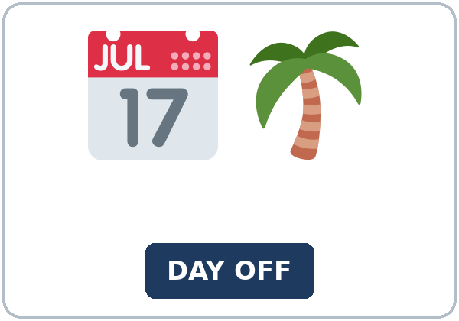  ★ time off | 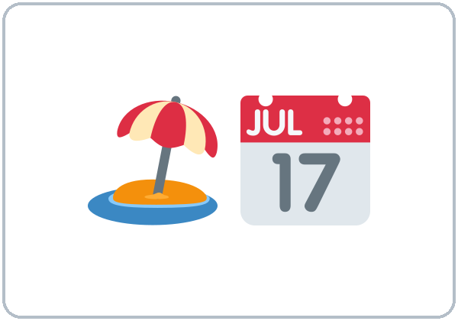  ★ vacation days | 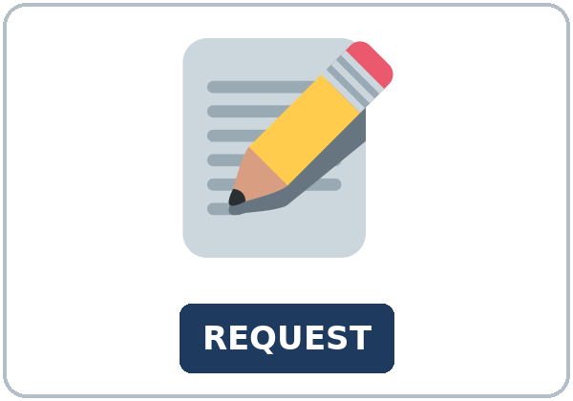  ★ request form | 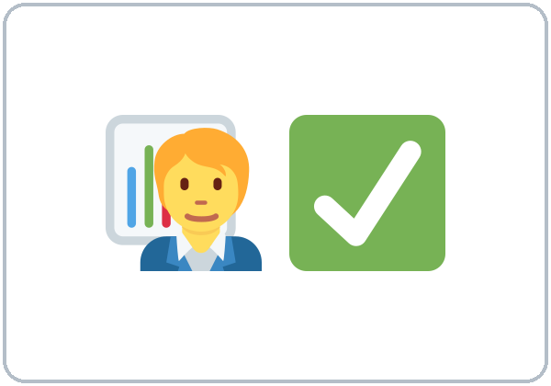  ★ approve
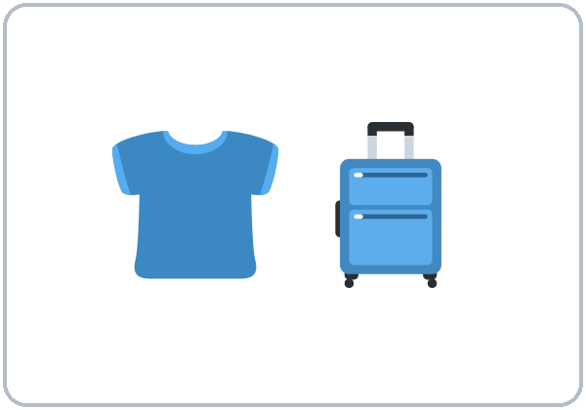  ★ pack | 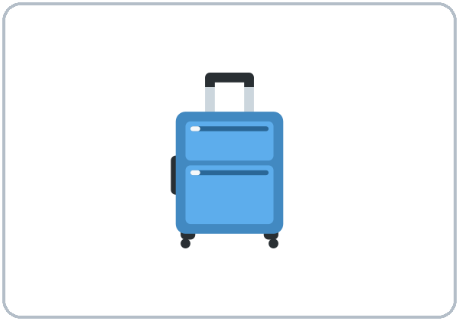  ★ suitcase | 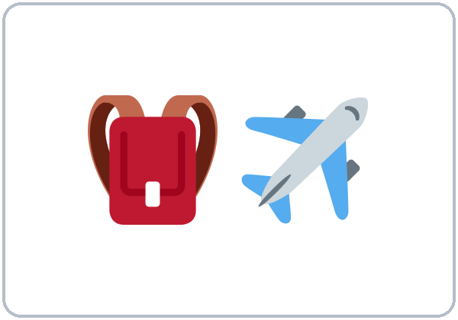  ★ carry-on bag | 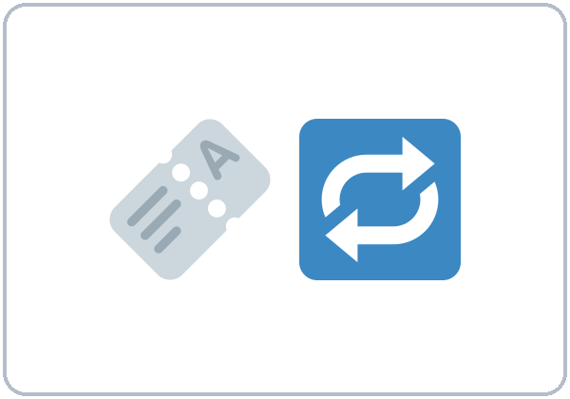  ★ round-trip ticket
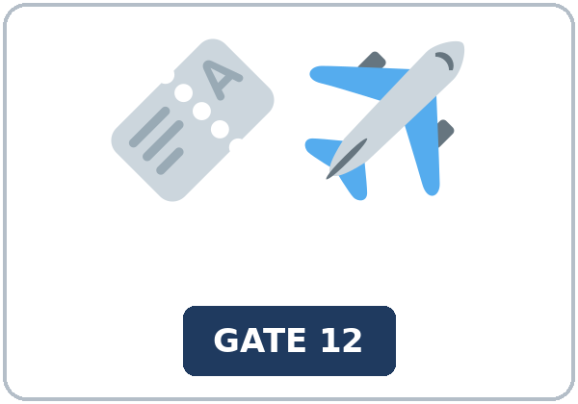  ★ boarding pass | 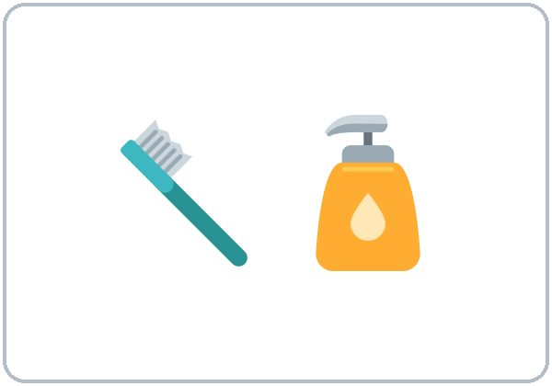  ★ toiletries | 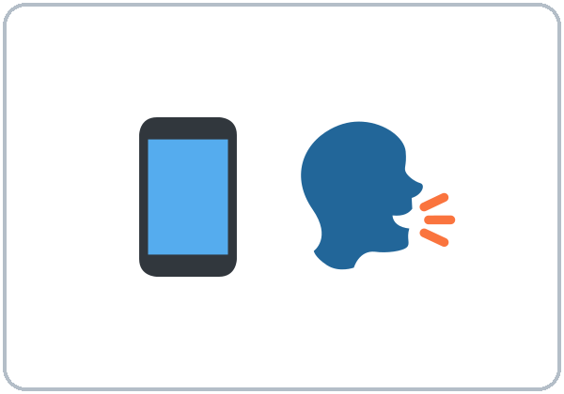  ★ voicemail |   itinerary

Partner game: Why do you need it?
Example: A points to a picture and asks, "Why do you need a boarding pass?" B answers with to + verb: "To get on the plane." Then B asks, "What do you enjoy doing on a trip?" Switch.
Lesson 11 (Week 12) · My Words
My personal word list. Write each word in your language, if you want. Then write your own example.
Word | My language | My example
time off
vacation days
request form
approve
pack
suitcase
carry-on bag
round-trip ticket
boarding pass
toiletries
voicemail
itinerary

Add 2 more words from tonight (from the listening, the reading, or your partner).
Lesson 11 (Week 12) · Listening
(1) Luis asks his supervisor for three days off to visit his mother, and they check who can cover his shifts. (2) He leaves a voicemail for his sister, and she calls back.
A. Listen. Why does Luis need time off? Circle.
a. to visit his mother b. to see a doctor c. to move to a new apartment
B. Listen again. Complete the notes. Circle the answer.
1. Dates: June (5 to 7 / 15 to 17)
2. Reason: his mother's (birthday / wedding)
3. Anna will cover (Thursday and Friday / Saturday).
4. For Saturday, Ms. Adams says to ask (Ben / Rosa).
5. Bus number: (42 / 24)
6. Arrival time: (6:30 p.m. / 7:30 p.m.)
C. Listen again. Write to or the -ing form of the verb.
1. I'd like ____________ ask for some time off.
2. He doesn't mind ____________ on weekends.
3. I'm calling ____________ tell you about my trip.
4. don't forget ____________ bring Mom's birthday card.
5. I want everyone ____________ sign it.
6. I enjoy ____________ surprises!
Hear it, say it
wanna = want to: "When do you want to take it?" • gonna = going to: "I'm going to take the bus." People often say gonna (going to) and wanna (want to), and you will hear them a lot. They are fine with friends; in writing or at a job interview, use going to and want to. Phone numbers come in groups with pauses: 555 · 214 · 8830.
Lesson 11 (Week 12) · Grammar
Read across. A reads from the left side. B answers from the right side. Choose one part from each column.
Grammar Box 1: to + verb answers Why?
QUESTION |  |  | ANSWER
Why are you taking | time off? |  | To visit | my sister in Houston.
Why are you going | to Houston? |  | I'm going there to see | my family.
Why are you | calling? |  | I'm calling to ask | about my vacation days.

Grammar Box 2: verbs + to and verbs + -ing
QUESTION |  |  | ANSWER
What do you want | to do? |  | I want to visit | the lake.
What do you enjoy | doing on a trip? |  | I enjoy taking | pictures.
What did you decide | to do? |  | We decided to take | the bus.
Do you mind | driving? |  | No, I don't mind driving. | It's fine.

Rule of thumb: There is no rule for which verbs take to and which take -ing: learn the two short lists in Box 3. to + verb also answers Why? (To visit my sister.)
Grammar Box 3: the two lists
+ to + verb | + -ing
want, need, plan, decide | enjoy, don't mind
hope, forget, would like | finish, avoid, keep
I'm planning to leave on Friday. | I enjoy traveling by bus.

Grammar Box 4: review
WORDS | EXAMPLE
already / yet | I've already packed. Have you packed yet?
Would you mind + -ing? | Would you mind covering my shift?
going to | I'm going to leave on Friday.

Questions and answers
Q: for see or to see?
A: Use to: I'm going to Houston to see my sister. (not for see, not for to see)
Q: enjoy to travel or enjoy traveling?
A: enjoy traveling. After enjoy, use -ing.
Q: How do I know: to or -ing?
A: Look at the two lists in Box 3. Learn them like vocabulary.
Practice A: Write one word.
1. I'm taking a day off ____________ see the doctor.
2. I enjoy ____________ by train. (travel)
3. We decided ____________ stay for 3 days.
4. Don't forget ____________ pack your charger.
5. She doesn't mind ____________ on Saturday. (work)
6. I've ____________ filled out the request form.
Practice B: Circle the correct words.
1. I'm calling (to ask / for ask) about my vacation days.
2. I want (to visit / visiting) my aunt.
3. Did you finish (packing / to pack)?
4. I hope (to see / seeing) you soon.
5. Try to avoid (taking / to take) too many bags.
6. Would you mind (covering / to cover) my shift?
Common mistakes
✗ Don't say | ✓ Say
I went to Houston for see my sister. | I went to Houston to see my sister.
I enjoy to travel. | I enjoy traveling.
I want visit my family. | I want to visit my family.
I'm planning leave on Friday. | I'm planning to leave on Friday.
Don't forget pack your toiletries. | Don't forget to pack your toiletries.

Contrast tip (optional): Spanish uses para for purpose: Voy a Houston para ver a mi hermana. English uses only to: I'm going to Houston to see my sister (not for see, not for to see). After enjoy, use -ing: I enjoy traveling (not enjoy to travel). How do you say why in your language?

Lesson 11 (Week 12) · Talk Time: Trip Planner
Round 1. Work with a partner. Choose a trip card. Plan the trip together. Then fill in the time-off request.
TRIP CARDS (invented)
A. Visit family in another state for 4 days (by bus). | B. A weekend at a lake (by car).
C. A day in a big city (by train). | D. Visit a friend for 3 days (by plane).

Example: "We're going to the lake to relax. We want to go fishing. I enjoy swimming. Don't forget to pack sunscreen!"
Why? (to…) | We want to… | We enjoy… | We need to pack…

TIME-OFF REQUEST (invented)
Name: | Dates:
Reason (to…): | Who can cover my shift:

Lesson 11 (Week 12) · Talk Time: Voicemail Relay
Round 2. Sit back to back. A leaves a voicemail (30–45 seconds). B takes notes and reads them back. Then switch.
Say: your name • why you are calling (I'm calling to…) • the dates or time • an invented callback number (555 · ___ · ____)
Example: "Hi, this is Carla. I'm calling to ask about Saturday. I want to switch my shift to Sunday. Call me back at 555 · 301 · 7720. Thanks!"
VOICEMAIL NOTES | 1 | 2
Name
Why are they calling?
Dates or time
Callback number

Useful: Hi, this is… • I'm calling to… • I'd like to… • Could you call me back at…? • Thanks. Bye! • (Reading back:) So, your name is… and your number is…
Lesson 11 (Week 12) · Homework
Homework (about 15–20 minutes). Bring it next week!
1. Write the sentence. Use to or -ing.
Example: go / Houston / see my sister → I'm going to Houston to see my sister.
1. I / enjoy / travel / by bus → ______________________________________________
2. we / plan / leave / on Friday (be + -ing) → ______________________________________________
3. I / call / ask / about my vacation days (be + -ing) → ______________________________________________
4. don't forget / pack / your charger → ______________________________________________
2. Finish your writing from Read & Write C (your email). Read it one more time. Check ✓ the list in D.
☐ I finished it. ☐ I checked it with the list.
3. Plan a short trip (real or invented). Write where, why (to…), and 3 things to pack.
Where? | Why? (to…)

3 things to pack
1.
2.
3.

4. Review (Lesson 10). Write one word.
1. The lights are on. Please turn ____________ off.
2. Did you take out the trash? Yes, I took ____________ out.
3. It's cold. Please turn ____________ the heat.
4. Make ____________ you lock the deadbolt.
5. Don't forget ____________ unplug the charger.
Lesson 11 (Week 12) · Read & Write
A. Read the notice. Read fast first. Then read again and answer the questions.
GREENLEAF FOODS · A policy + a packing list (invented)
TIME-OFF POLICY. All workers can ask for time off. Please follow these steps. First, ask at least two weeks ahead. For example, to take time off on June 5, ask before May 22. Second, fill out a time-off request form. You can get the form from your supervisor or in the break room. Write the dates and the reason. Third, find a coworker who can cover your shifts, if possible. Your supervisor will approve or deny the request within three days. Full-time workers get 10 vacation days each year. Part-time workers get 5. If you are sick, call your supervisor before your shift starts. You don't need a form for a sick day. Do you have questions? Ask your supervisor, or call Human Resources at extension 210.
LUIS'S PACKING LIST. Carry-on bag · 3 shirts and 1 pair of pants · toiletries (toothbrush, toothpaste) · phone charger · Mom's birthday card · round-trip bus ticket.

B. Answer the questions.
1. How early should you ask for time off? ______________________________________________
2. Where can you get the form? ______________________________________________
3. When will the supervisor answer? ______________________________________________
4. How many vacation days do part-time workers get? ______________________________________________
5. What is Luis bringing for his mother? ______________________________________________
C. Write an email (5–8 sentences) to your supervisor. Ask for time off. Write the dates, the reason (to…), who can cover your shift, and thanks.
Example: Dear Ms. Adams, I would like to ask for three days off, from June 5 to June 7. I need the time off to visit my mother in San Antonio. It's her 70th birthday. I have already filled out the request form. Anna has agreed to cover my shifts on Thursday and Friday. Ben doesn't mind working on Saturday. Thank you for your time. Luis Ortega
My email

D. Check your writing with a partner.
 | Yes | Not yet
It has 5–8 sentences. | ☐ | ☐
It has the dates. | ☐ | ☐
It has a reason with to + verb. | ☐ | ☐
It says who can cover and says thank you. | ☐ | ☐

Lesson 11 (Week 12) · Exit Ticket
Name: ______________________________ Date: ________________
Answer in 3 sentences. Give a reason. Then give this page to your teacher.
Where would you like to go on a trip, and why?
Sentence 1: where and why, with to + verb • Sentence 2: something you enjoy, with enjoy + -ing • Sentence 3: one more reason, with because
My answer
1.
2.
3.

For the teacher | ✓ | almost | not yet
3 sentences, today's grammar, a reason | ☐ | ☐ | ☐

Lesson 11 (Week 12) · Task Words (optional)
This page is for you if you want it. You can skip it. Write each task word in your language, if you want.
Task word | What you do | My language
Listen. | Use your ears. Don't write yet.
Circle. | Draw a circle around the answer.
Check ✓. | Make a ✓ in the box.
Write. | Write words or sentences.
Number. | Write 1, 2, 3… to show the order.
Match. | Find the two parts that go together.
Work with a partner. | Work with one classmate.
Work in a group. | Work with 2 or 3 classmates.
Switch. | Change roles: A is B now.
Ask a follow-up question. | Ask one more question about the answer.
Give a reason. | Say why, with because or so.
Compare. | Look at your partner's answers. Are they the same?

Picture Credits
Pictures use Twemoji graphics by Twitter, Inc. and other contributors (https://github.com/jdecked/twemoji), licensed under CC BY 4.0 (https://creativecommons.org/licenses/by/4.0/). The graphics were resized and combined, and signs and labels were added. The file-by-file list is in images/CREDITS.md.
Listening audio: synthetic voices made with Chatterbox TTS (Resemble AI, MIT License), cloned from synthetic reference clips made with Kokoro-82M (Apache License 2.0). No recordings of real people were used. Each file carries an inaudible Perth watermark marking it as AI-generated. The names and the story are invented.
Course materials: © 2026 the authors, licensed under CC BY-NC-SA 4.0 (https://creativecommons.org/licenses/by-nc-sa/4.0/).

