Level 5 Adult ESL Curriculum · Lesson 5 (Week 5): It Was Posted on Tuesday
Status: Published. Listening audio, lesson pages, and teacher slides are ready.
Date: October 2026
Audience: Program coordinators and volunteer teachers
Companion files: images/ (12 vocabulary pictures + images/CREDITS_L5_L5.md). Listening audio: L5_L5_listening.mp3 (1:43).
Topic: Read a simple phone statement. Say what was charged, what was paid, and what was credited. Credit means money back on a statement. Then write a three-line budget with invented numbers.

How this lesson is organized
Part | What's inside | Who uses it
Teacher Plan | At a glance, the clock, steps, the listening script, the answer key | Volunteer teachers
Student Pages | Opening Talk, New Words, Listening, Grammar, Talk Time, Homework, Read & Write, Exit Ticket | Learners
Picture Credits | Picture and license lines | Coordinators

TEACHER PLAN
Lesson 5 (Week 5)

It Was Posted on Tuesday
At a glance · Clock · Steps · Script and answer key

How to Use This Plan
Teach in English. You do not need to speak the learners' languages. Show the picture and point to the grammar box. There is no contrast-tip box.

One main point tonight. Model it, check it, then go.

This lesson is not financial advice. Credit means money back on a statement. Do not recommend a loan, a card, or a bank.

Lesson 5 (Week 5): It Was Posted on Tuesday
At a glance
By the end of class, you can do these things.
Objectives: learners can…
• I can say what is done with is or are and was or were plus a participle.
• I can add by when the doer matters.
• I can find the amount due, the due date, and one charge.
• I can write a three-line budget with invented numbers.

Materials
• Student pages for Lesson 5 (print the number you expect + 3 spares)
• Board and markers
• Listening: L5_L5_listening.mp3 (1:43). Play it two times. No speaker? Read the script aloud with a volunteer.
• Prep time: 15 minutes

Key vocabulary (with pictures on the New Words page)
★ statement • ★ charge • ★ payment • ★ balance • ★ fee • ★ receipt • ★ refund • ★ budget • ★ deposit • ★ due date • account number • credit

Clock-time plan
Time | Step | Min
6:00–6:06 | Opening Talk | 6
6:06–6:12 | New Words | 6
6:12–6:32 | Listening. Task A on play 1. Tasks B and C on play 2. | 20
6:32–6:45 | Grammar | 13
6:45–7:00 | Break | 15
7:00–7:18 | Talk Time | 18
7:18–7:25 | Read & Write | 7
7:25–7:30 | Exit ticket and homework | 5

Step by step
• 6:00 Opening. Work with a partner. Ask about a mild regret from last week. Then switch.
• 6:06 New words. Look, listen, repeat. Then the partner game.
• Check the meaning: "Is a statement a bill you can read?" (yes) • "What do you keep to show you paid?" (a receipt) • "What word means money back on this page?" (credit).
• 6:12 Listening. Diego calls customer service about a statement. Ms. Brooks explains which fee was added and which payment was posted. Nothing is due today. Play 1: Task A. Play 2: Tasks B and C.
• Hear it. gonna and wanna are short forms. This listening uses the full forms. Say going to and want to.
• 6:32 Grammar. Read across. A reads the question. B says the answer.
• Pair check. A says a line from the statement. B says it again with was or were and a participle. Then switch.
• 7:00 Talk Time. Round 1, then round 2. Stop at 7:18.
• Class size. 15 learners: 7 pairs + 1 group of 3. 7–8 learners: 3–4 pairs. 5 or fewer: pairs, or one group with you.
• 7:18 Read & Write. Read once. Then answer. Start the writing in class.
• 7:25 Exit. Explain one line from a statement. Four sentences. Collect the page.
• This lesson is not financial advice. Credit means money back on a statement. Do not recommend a loan, a card, or a bank.
Listening script
Audio is recorded (about 1:43). Read it with volunteers at a natural, friendly speed. The spoken lines use going to and want to. gonna and wanna are short forms. This listening uses the full forms.
Narrator: Lesson five. Diego calls Northline Phone about a practice statement. Nothing on this call is a real bill.
Diego: Hello. I want to understand my statement. A fee was added, and I am going to ask about it.
Ms. Brooks: I can help. The fee was added on Tuesday. The fee was $6.
Diego: Was the payment received?
Ms. Brooks: Yes, it was. The payment was received on Friday. The payment was forty dollars.
Diego: And the credit? I want to know what that word means.
Ms. Brooks: The credit was posted by the phone company. Credit means money back. It is not a new phone.
Diego: Was the fee removed?
Ms. Brooks: No, it wasn't. The six dollars was credited. That is the money back.
Diego: Are the calls listed?
Ms. Brooks: Yes, they are. They are listed on page 2. The bill is mailed on the first of the month.
Diego: What is due today?
Ms. Brooks: Nothing is due today. Due today is $0. The due date on the statement is the 20th.
Diego: Thank you. I am going to read the due date again at home. The balance is $28.
Ms. Brooks: That is right. For a real charge, call the number on your own statement. This call is practice.
Narrator: Diego writes two lines: the fee was added on Tuesday, and the payment was received on Friday.
Narrator: That's the end of the listening.

Answer key
• Check the meaning: 1 yes, 2 a receipt, 3 credit.
• Listening Task A: b (A fee was added, and a payment was posted.)
• Listening Task B: 1 on Tuesday, 2 on Friday, 3 $6, 4 money back, 5 $0.
• Listening Task C: 1 was added, 2 was received, 3 was posted, 4 is mailed, 5 are listed, 6 wasn't removed.
• Grammar Practice A: 1 added, 2 received, 3 posted, 4 mailed, 5 listed, 6 high.
• Grammar Practice B: 1 was added, 2 was received, 3 posted the payment, 4 by the phone company, 5 Yes, they are., 6 No, it wasn't..
• Read & Write B: 1 On Tuesday., 2 On Friday., 3 $6., 4 Money back., 5 $0..
• Exit ticket: answers will vary. A good answer uses tonight's grammar.
Teacher notes
• This lesson is not financial advice. Credit means money back on a statement. Do not recommend a loan, a card, or a bank.
• Never ask what learners earn, owe, or spend. All amounts are on the page. If a real charge looks wrong, call the number on your own statement.
• Reductions: the listening says going to and want to. People often say gonna and wanna. Learners only need to recognize the short forms.
• All names, places, and numbers are invented.

STUDENT WORKBOOK
Lesson 5 (Week 5)

It Was Posted on Tuesday
Opening Talk · New Words · Listening · Grammar · Talk Time · Homework · Read & Write · Exit Ticket

Lesson 5 (Week 5) · Opening Talk
Name: ______________________________ Date: ________________
Work with a partner. Ask about a mild regret from last week. Then switch.
1. Say one I wish I had sentence from Lesson 3.
2. Say one next step you wrote.
3. Which wish was about now?
4. Homework check: read one sentence from your note.
Lesson 5 (Week 5): It Was Posted on Tuesday
Name: ______________________________ Date: ________________
New Words
Look. Listen. Repeat. ★ = most important words.
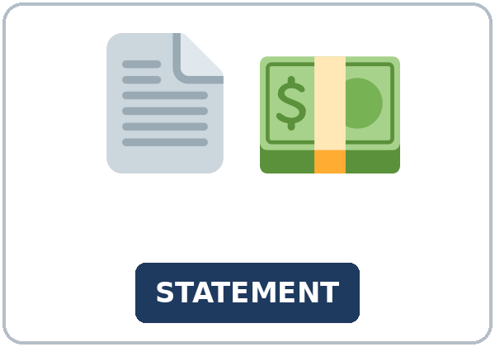  ★ statement | 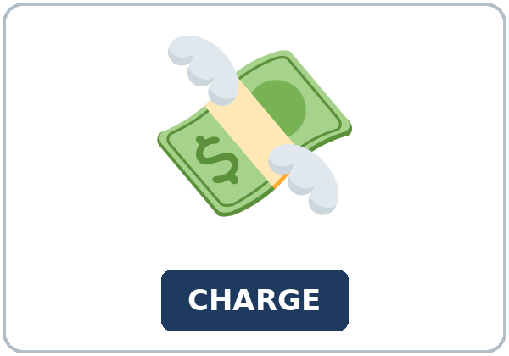  ★ charge | 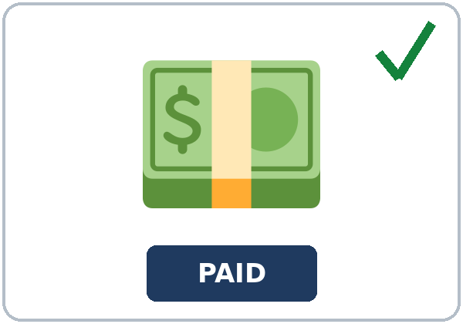  ★ payment | 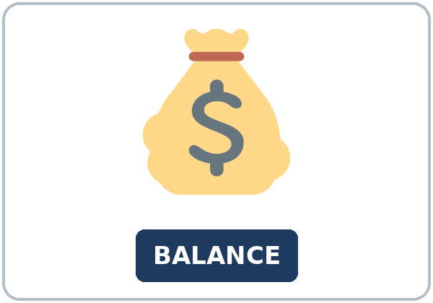  ★ balance
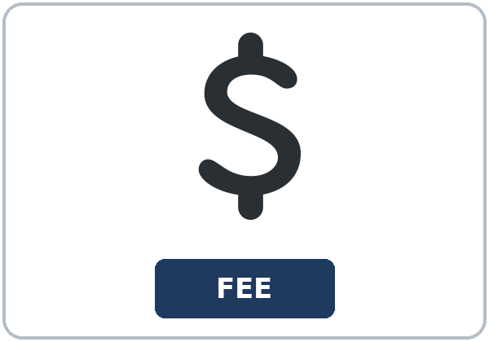  ★ fee | 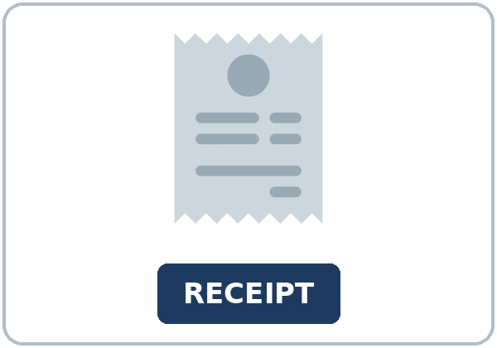  ★ receipt | 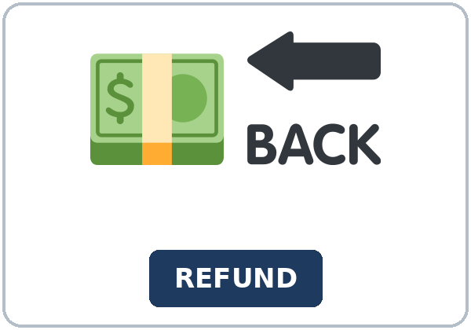  ★ refund |   ★ budget
  ★ deposit | 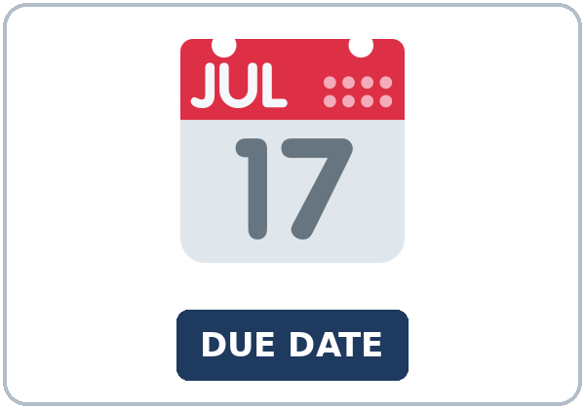  ★ due date | 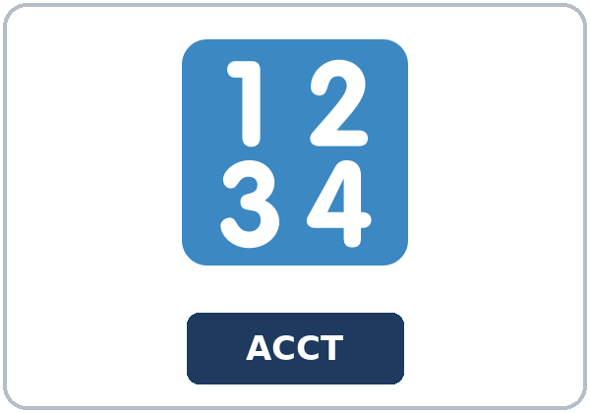  account number | 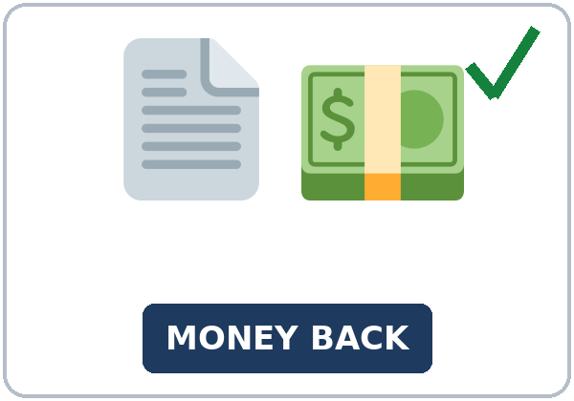  credit

Partner game: Point and say the word
Example: A points to a picture. B names it and uses it in one sentence. Then switch.
Lesson 5 (Week 5) · Listening
Diego calls customer service about a statement. Ms. Brooks explains which fee was added and which payment was posted. Nothing is due today.
A. Listen. Why is he calling? Circle.
a. The store is closed. b. A fee was added, and a payment was posted. c. His phone was lost.
B. Listen again. Circle the amount or the day.
1. The fee was added (on Tuesday / on Friday / in May)
2. The payment was received (on Friday / on Tuesday / not yet)
3. The fee was ($6 / $60 / $600)
4. Credit on this page means (money back / a new phone / a late day)
5. Due today ($0 / $40 / $90)
C. Listen again. Write the passive verb.
1. The fee ____________ on Tuesday.
2. The payment ____________ on Friday.
3. The credit ____________ by the phone company.
4. The bill ____________ on the first of the month.
5. The calls ____________ on the statement.
6. No, the fee ____________.
Hear it, say it
gonna and wanna are short forms. This listening uses the full forms. You can say going to and want to.
The word was is quiet. Stress the participle: posted, added, received. Say each line two times.
1. I want to understand this statement.
2. I am going to check the due date.
3. The fee was added on Tuesday.
4. The payment was received on Friday.
Lesson 5 (Week 5) · Grammar
Read across. A reads the question. B says the answer.
Grammar Box 1: is, are, was, were
SENTENCE | FORM
The bill is mailed on the first. | present passive
The fee was added on Tuesday. | past passive
The payment was received on Friday. | past passive

Grammar Box 2: add by when you need the name
SENTENCE | WHY
The credit was posted by the phone company. | by names the doer
The fee was added by the company. | use by when you need the name
The payment was received. | no by: start with the thing

Grammar Box 3: yes and no
QUESTION | ANSWER
Are the calls listed? | Yes, they are.
Was the fee removed? | No, it wasn't.
Was the payment received? | Yes, it was.

Grammar Box 4: start with the thing
SAY THIS | NOT THIS IDEA
The fee is too high. | one review line
The payment was posted. | start with the thing
The company posted the payment. | active, when the person matters

Rule of thumb: When the paper cares about the thing, start with the thing. The verb is a form of be plus the past participle. Add by only when you need the name.
Practice A: Write the missing word.
1. The fee was ____________ on Tuesday.
2. The payment was ____________ on Friday.
3. The credit was ____________ by the phone company.
4. The bill is ____________ on the first.
5. The calls are ____________.
6. The fee is too ____________.
Practice B: Circle the correct words.
1. The fee (was added / was add)
2. The payment (was received / received)
3. The company (posted the payment / was posted the payment)
4. The credit was posted (by the phone company / for the phone company)
5. Are the calls listed? (Yes, they are. / Yes, they listed.)
6. Was the fee removed? (No, it wasn't. / No, it didn't.)
Common mistakes
Don't say | Say
The fee was add on Tuesday. | The fee was added on Tuesday.
The company was posted the payment. | The payment was posted.
The credit was posted for the company. | The credit was posted by the company.

Pair check
A says a line from the statement. B says it again with was or were and a participle. Then switch.
Lesson 5 (Week 5) · Talk Time: Statement Gap
Round 1. Pairs. A has the statement. B asks. Then switch.
1. What was charged?
2. When was the payment received?
3. What was posted by the phone company?
Lesson 5 (Week 5) · Talk Time: Three Lines
Round 2. Pairs. Write an invented budget and read two passive sentences.
1. Money in, two bills, and what is left.
2. The rent was paid.
3. The fee was not included.
Lesson 5 (Week 5) · Homework
Homework (about 20–25 minutes). Bring it next week!
1. Write two passive sentences about the practice statement.
2. Finish the note and the three-line budget. This is writing check 2.
3. Read one passive sentence to a friend.
4. Review: I wish I had. Write one sentence from Lesson 3.
Lesson 5 (Week 5) · Read & Write
A. Read. Read once. Then find the answers.
Northline Phone · practice statement
This page is a practice phone statement. It is not a real bill. It is not financial advice. Do not use your own account number, and do not tell the class what you earn or what you owe. Every amount below is invented.
Northline Phone mailed the bill on the first of the month. The bill is mailed on the first, every month. On this statement, a fee was added on Tuesday. The fee was $6. The payment was received on Friday. The payment was $40. A credit was posted by the phone company. Credit on this page means money back. It is not a loan, and it is not a new phone.
The credit was $6, the same amount as the fee. The balance on the statement is $28. The due date is the 20th. Nothing is due today. Due today is $0. The calls are listed on the second page of the statement. The fee was not removed. It was credited, which means the money came back as a line on the statement.
Read the lines in this order. First find the fee. Then find the payment. Then find the credit. Then find the due date. If you need the name of the company, add by: the credit was posted by the phone company. If the paper cares about the payment, and not about a person, start with the payment: the payment was received.
Here is a three-line budget with invented numbers. Money in: $800. Bills: $500. Left: $300. You can say two passive sentences about it. The rent was paid. The fee was not included in the rent. You can also say, the fee is too high, if $6 feels high for this practice bill. Too high is a review from an earlier level. It is one line, not the main point.
If a charge looks wrong on a real statement, call the number on your own statement. Do not practice that call with a real account number. Tonight, Diego calls a practice desk. Ms. Brooks tells him the fee was added on Tuesday and the payment was received on Friday. She tells him that nothing is due today.
When you write, use six sentences and a three-line budget. Two of the sentences should be passive. Use invented numbers only. Name the fee, the payment, and the credit. Say what credit means on this page: money back.

B. Answer the questions.
1. When was the fee added? ______________________________________________
2. When was the payment received? ______________________________________________
3. How much was the fee? ______________________________________________
4. What does credit mean here? ______________________________________________
5. What is due today? ______________________________________________
C. Write a 6-sentence note about the statement, plus a three-line budget with invented numbers. Use two passive sentences. This is writing check 2.
Lesson 5 (Week 5) · Exit Ticket
Name: ______________________________ Date: ________________
Explain one line from a statement. Four sentences.
Use two passive sentences, and say one reason you would call the company. Then give this page to your teacher.
My answer

Picture Credits
Pictures use Twemoji graphics by Twitter, Inc. and other contributors (https://github.com/jdecked/twemoji), licensed under CC BY 4.0 (https://creativecommons.org/licenses/by/4.0/). The graphics were resized and combined, and signs and labels were added. The file-by-file list is in images/CREDITS_L5_L5.md.
Listening audio: L5_L5_listening.mp3 (1:43). The voices are computer-generated. No recordings of real people. The names and the story are invented.
Course materials: © 2026 the authors, licensed under CC BY-NC-SA 4.0 (https://creativecommons.org/licenses/by-nc-sa/4.0/).

