Level 4 Adult ESL Curriculum · Lesson 8 (Week 9): In the News
Status: Draft for review; not published.
Date: October 2026
Audience: Program coordinators and volunteer teachers
Companion files: images/ (12 vocabulary pictures + images/CREDITS.md). Listening audio: not recorded yet (coming soon); until then, read the listening script in this plan aloud.
Topic: Understanding short local news reports and city notices: a road closure, a bus detour, a water pipe repair, a new bus route, a new store. Learners say what might or may happen and ask Do you know where / when / why…?. All stories, streets, and cities are invented and neutral.

How this lesson is organized
Part | What's inside | Who uses it
Teacher Plan | At a glance, clock-time plan, step-by-step boxes, listening script, answer key, teacher notes | Volunteer teachers
Student Pages | Opening Talk, New Words, My Words, Listening, Grammar, Talk Time, Homework, Read & Write, Exit Ticket, Task Words (optional). Print this part for learners | Learners
Picture Credits | Picture and license credits | Coordinators

What Lesson 8 builds on and what it adds
Before (review only) | Where | New in Level 4 Lesson 8
maybe, probably; will for predictions | Level 3 | might / may / could + base verb for possibility: It might open next week.
Where is…? / When does…? questions | Levels 1–3 | Do you know where the meeting is? (statement order; a first look)
past continuous + when | Level 3 Lesson 4 | news language: Workers were fixing a pipe when…

TEACHER PLAN
Lesson 8 (Week 9)

In the News
At a glance · Clock-time plan · Step by step · Script and answer key

How to Use This Plan
You don't need to speak Spanish or any other language. Teach in English. Show, point, and gesture. Some Grammar pages have one short contrast tip, only where a common mix-up exists. Learners read it on their own. You never need to read, translate, or explain it.

Instructions: use the same short task words every week: Listen. Circle. Check. Write. Work with a partner. Work in a group. Ask a follow-up question. Give a reason. An optional Task Words page is at the back of the workbook for learners who want it.

Instruction rule: Model it (do it with one learner while everyone watches), check it (ask: "Are you sure, or is it maybe?"), then go. Say less, show more.

Grouping toolkit: Pairs: turn to a neighbor; with an odd number, make one group of 3. Groups: 3–4 learners. Inside–outside circles: the inner circle faces out, the outer circle faces in; the outer circle moves one person to the right each round. Mingle: everyone stands and talks to many classmates. The teacher joins a pair only if one learner is left over.

When a learner is stuck or speaks another language to you: (1) show it: the picture, a gesture, or the board; (2) give one more short English example; (3) point to the grammar box on their page; (4) a classmate can help for a few seconds, then back to English. You don't need to understand what classmates say to each other.

Three sentences, not one: in Level 4, every Talk Time answer and every exit ticket has about three connected sentences: the answer, a reason, and a detail or example.

Lesson 8 (Week 9): In the News
At a glance
Objectives: learners can…
• understand the main points of a short local news report
• say what might or may happen, and what will happen
• ask Do you know where / when / why…? with statement order
• tell a classmate about a local news story
• write a text or email (5–8 sentences) telling a friend the news

Materials
• Student Pages for Lesson 8 (print for the number expected + 3 spares)
• Board and markers
• News cards A and B and a headline (in the workbook Talk Time pages; copy them onto index cards, optional)
• A local map or a drawing of streets (optional, for the warm-up)
• Listening: no recording yet. Read the listening script aloud (with a volunteer if you can), at a natural speed, two times.
• Prep time: 15 minutes (read the plan; practice reading the listening script; practice the news reader's pauses).

Key vocabulary (with pictures on the New Words page)
★ news • ★ reporter • ★ headline • ★ road closure • ★ detour • ★ construction • ★ water pipe • ★ bus route • ★ delay • ★ announce • ★ update • local
Also: a rider, a stop, a schedule, a website, a transit office, service, replace, connect, expect, post (online).

Clock-time plan
Times are loose. If the listening or Talk Time runs long, take the time from Read & Write.
Time | Step | Min | Grouping (15 / 7–8) | If running behind
6:00–6:08 | Opening Talk + Homework Check | 8 | Pairs (7 pairs + 1 trio / 3–4 pairs) | One card only
6:08–6:15 | New Words (picture page) + pair game (+ My Words) | 7 | Whole class, then pairs | Teach the ★ words only
6:15–6:30 | Listening: play 1 (Task A), play 2 (Tasks B and C) + "Hear it, say it" | 15 | Individuals, then pairs check | Do Task C together on the board
6:30–6:45 | Grammar Q&A: might / may / could; Do you know where…? + pair check | 15 | Whole class, then pairs | Skip the pair check; Talk Time practices it
6:45–7:00 | BREAK | 15
7:00–7:15 | Talk Time: News Swap + What Might Happen? | 15 | Pairs, then groups | Round 1 only
7:15–7:25 | Read & Write: A local news article; a text to a friend | 10 | Pairs read, then individual writing | Reading questions only; the writing becomes homework
7:25–7:30 | Exit Ticket + Homework | 5 | Individuals | Never skip

Skip order if you're running behind: (1) the Read & Write writing task (it becomes homework); (2) the pair check at the end of Grammar; (3) the second round of Talk Time. Never skip: the listening tasks, the grammar boxes and the mistakes table, and the exit ticket.

Attendance (15 → 7–8 → 5 or fewer): every step lists the sizes. With 5 or fewer, do News Swap in pairs (you take a card if there is an odd number), then What Might Happen? as one group. Late arrivals get news card A or B and join a pair.

Step by step
Step 1 · 6:00–6:08 · Opening Talk · 8 min
• Grouping: pairs, the same partner for both parts. 15 learners: 7 pairs + 1 group of 3. 7–8 learners: 3–4 pairs. 5 or fewer: pairs, or one group with you.
• Before class: write on the board: too / enough; must / mustn't / don't have to
• Opening Talk (5 min): learners open the Opening Talk page. A asks a card question; B answers in 3 sentences (the answer, a reason, a detail); A asks one follow-up. Switch after each card.
• Model with one learner: you say, "Is 6:55 early enough for a 7:00 shift?" The learner answers with too or enough and a reason. Then you ask, "What must you wear at your job or school?" Help them say 3 sentences.
• Homework Check (3 min): Pairs compare Homework item 1 (too / enough / mustn't) and read their 3 rules (item 3) to each other. Then they fill in the box on the Opening Talk page. Also return the midterm and go over 2 common mistakes. Walk around. Write 2 common errors on the board (often It's enough big (→ It's big enough) and You don't have to smoke here for a rule (→ You mustn't smoke here)) and correct them together. Also put up 2 corrections from last week's exit tickets.
• Late arrivals: join any pair as a group of 3.
• If behind: one card only.

Step 2 · 6:08–6:15 · New Words · 7 min
• Grouping: whole class, then pairs. Show the New Words page.
• Do: point to each picture and say the word. Learners repeat once.
• Show the hard words: news, local (in our city); reporter (the person who tells the news); headline (the big words at the top); road closure and detour (draw a street with an X and an arrow around it); construction; water pipe; bus route; delay (the bus is late); announce (say it to everyone); update (new information).
• Check meaning (1 min): ask "If the road is closed, does the bus take a detour?" (yes) • "Is a headline long or short?" (short) • "If there is a delay, is the bus early or late?" (late).
• Pairs (2 min): A says a word; B points to the picture and makes a sentence (The road might be closed until Friday.). Switch. 15 learners: finish with a quick team round (3 teams; you say a clue, the first team with the word gets a point). 7–8: 2 teams. 5 or fewer: one team against the clock.
• My Words: "Write any word you want in your language on the My Words page. It's your personal list. It's optional." Learners do it at home.
• If behind: teach the ★ words only.

Step 3 · 6:15–6:30 · Listening + "Hear it, say it" · 15 min
• Grouping: individuals, then pairs check. With 5 or fewer, check together as a group.
• Before you listen (2 min): say: "First, you'll hear a short local news report on the radio. Then two coworkers, Marco and Joy, talk about the news. Listen: what is the news?"
• Play 1 → Task A (the main idea). Pairs compare. Check together.
• Read Tasks B and C together (1 min) so learners know what to listen for.
• Play 2 → Tasks B and C. Pairs compare. Then show the answers (answer key).
• "Hear it, say it" (3 min): Point to the script lines. gonna = going to: "The bus is gonna take a detour." Then practice might (the last t is very short: It migh' be late) and Do you know…? with the voice going up at the end. Listen to the reporter's pauses. The class repeats the two lines twice.
• No recording yet: read the script aloud with a volunteer (about 1:59), at a natural speed, two times. Say gonna and wanna where the script has them. When the audio is ready, it plays the conversation once; press play again for play 2. A third play is fine if the class needs it.
• If behind: do Task C together on the board, reading the lines yourself.

Step 4 · 6:30–6:45 · Grammar Q&A · 15 min
• Grouping: whole class, then pairs. Show the Grammar page. The left side is the question. The right side is the answer.
• Show it (2 min): draw a cloud. Say, "Will it rain tomorrow? I'm not sure. It might rain. It may rain." Draw a sign ROAD CLOSED MONDAY: "The road will close on Monday. I'm sure." Then ask a learner, "Do you know where the library is?" Write it and underline the library is: "Statement order."
• The boxes (5 min): Box 1: read across: Will the road be closed tomorrow? → It might be. / It may be closed until Friday. Box 2: Do you know where / when / what time / why…? Box 3: will (sure) vs. might (maybe). Box 4: from a question to Do you know…?
• Rule of thumb and Questions and answers (2 min): read the rule of thumb aloud. Read each Q and A; the class reads the right sentence after you.
• Check questions: "It might rains or It might rain?" (might rain) • "Do you know where is the bank or where the bank is?" (where the bank is) • "The sign says Closed Monday. will or might?" (will).
• Practice A and B (3 min): learners write, then pairs check. Go over the answers. Read the Common mistakes table together: "Don't say… Say…".
• Pair check (last 3 min): A points to a picture and asks, "Do you know when the construction ends?" B answers with a fact or I'm not sure. It might… Switch. 15 learners: swap partners once. 5 or fewer: you join one pair.
• If behind: skip the pair check. Talk Time practices it.

Break · 6:45–7:00 · 15 min
• Write on the board: It might / may / could + base verb (maybe) • It will… (sure) • Do you know where the meeting is? (statement order)

Step 5 · 7:00–7:15 · Talk Time: News Swap + What Might Happen? · 15 min
• Model it first (1 min): hold news card A. Ask a learner, "Do you know when the library will open on Sundays?" Help them find it and answer, "Yes, starting March 3." Then ask, "Do you know why?" Say: "Ask with Do you know…? Answer with a fact, or say I'm not sure. It might…"
• Round 1 (7 min): News Swap (pairs). A and B have different news cards. Partners ask Do you know when / where / why…? and write the facts. Then they change partners and retell their partner's story.
• Round 2 (6 min): What Might Happen? (groups). Groups choose a headline and write 4 predictions with might, may, and will probably. Then they read them to the class.
• 15 learners: pairs with one rotation for round 1; then groups of 4.
• 7–8 learners: pairs for round 1; then 2 groups.
• 5 or fewer: pairs for round 1 (you take a card if there is an odd number); then one group.
• Every answer needs a reason; every partner asks a follow-up. Walk around and listen. Note 2 good sentences to praise and 1 common error for next week.
• If behind: round 1 only.

Step 6 · 7:15–7:25 · Read & Write: A local news article · 10 min
• Grouping: pairs read and answer; individual writing. With 5 or fewer, read the text aloud together.
• Read (4 min): Learners read the news article on the Read & Write page, find the main idea, and answer the questions. Say: "Read fast first. Then find the answers." Pairs answer questions 1–5 together.
• Check (1 min): go over the answers (answer key).
• Write (5 min): Learners write a text or email to a friend about the news (5–8 sentences) with one might or may and one Do you know…?. Show the example. Learners start in class and finish at home (Homework item 2).
• If behind: questions 1–5 only; the writing becomes homework.

Step 7 · 7:25–7:30 · Exit Ticket + Homework · 5 min · NEVER SKIP
• Exit ticket (3 min): learners open the Exit Ticket page and answer in 3 sentences with a reason: What might change in your neighborhood or at your job next year? Example on the board: A new store might open near my house. My job may change my schedule. I think so because there's construction on my street and my company is very busy. With 5 or fewer, a learner can say it to you first and then write it.
• Collect the pages. After class, sort them into ✓ / almost / not yet. Start next week with 2 corrections on the board (no names).
• Homework (2 min): open the Homework page. Do item 1 together (item 1: the store / may / open / in June → The store may open in June.). Say: "About 15–20 minutes. Finish your Read & Write writing at home."

Listening script (not recorded yet; about 1:59 when recorded; the conversation plays once, so press play again for the second listen)
Audio: the recording is coming soon. Until then, read the script aloud two times, with a volunteer if you can, at a natural, friendly speed. Say gonna and wanna where the script has them.

Narrator: Lesson eight. First, listen to a short news report on the radio. Then two coworkers talk about the news.
Diane Lee: Good morning. This is Diane Lee with your local news. Starting Monday, Oak Street will be closed between First and Fifth Avenue. Workers are going to replace an old water pipe under the street.
Diane Lee: The city says the construction might take two weeks. It may take longer if it rains.
Diane Lee: During the road closure, the number twelve bus will take a detour on Pine Street. Riders should expect delays of about fifteen minutes. The city will post updates on its website. I'm Diane Lee, and that's the news.
Narrator: Later that morning, at work, Marco and Joy talk about the news.
Marco: Joy, did you hear the news? They're closing Oak Street on Monday.
Joy: Oh no. I take the number twelve bus on Oak Street every day.
Marco: The bus is gonna take a detour on Pine Street. It might be fifteen minutes late.
Joy: Fifteen minutes? I might be late for work. Do you know when the bus leaves Pine Street?
Marco: I'm not sure. You could check the city website.
Joy: Good idea. Do you know how long the closure is?
Marco: They said two weeks. But it might take longer if it rains.
Joy: Hmm. Maybe I'll take the earlier bus. I don't want to be late.
Marco: Or I could give you a ride. I drive past your street.
Joy: Really? That would be great. Do you know where the detour starts?
Marco: I think it starts at First Avenue. I'm gonna look at the map tonight.
Joy: Thanks, Marco!
Narrator: That's the end of the listening.

Answer key
• Listening Task A: a (Oak Street will close for a water pipe repair.).
• Listening Task B: 1 Fifth, 2 Monday, 3 water pipe, 4 two weeks, 5 Pine Street, 6 fifteen.
• Listening Task C: 1 might, 2 will, 3 when, 4 how, 5 might, 6 where.
• Grammar Practice A: 1 might, 2 will, 3 open, 4 is, 5 leaves, 6 be.
• Grammar Practice B: 1 take, 2 where the meeting is, 3 might not, 4 opens, 5 will, 6 may.
• Talk Time: answers will vary.
• Homework 1: 1 The store may open in June. 2 It might not rain this weekend. 3 Do you know where the meeting is? 4 Do you know when the bus leaves? Homework 2 and 3: answers will vary. Homework 4: 1 enough, 2 many, 3 mustn't, 4 too, 5 much.
• Read & Write B: 1 A new bus route, Route 9, will start on May 6. • 2 Every 20 minutes. • 3 $1.50 (and free for the first week). • 4 Sunday service. • 5 On the city website or at the library. • Writing (C): answers will vary.
• Exit ticket: answers will vary. A good answer: "A new store might open near my house. My job may change my schedule. I think so because there's construction on my street and my company is very busy."
Teacher notes
• Class stories only: all news is invented and neutral (roads, buses, a library, a store). No politics, crime, injuries, or real current events. If a learner brings up real news, say, "Let's keep to our class stories."
• After the midterm: this is Week 9. Return the midterm in the Opening Talk and put 2 common mistakes on the board.
• Do you know where…? is a first look: practice it with where / when / what time / why only. Don't teach if / whether (Level 5).
• might + base verb: learners often add to or -s. Point to the rule: no to, no -s.
• News Swap: learners keep their card hidden. If a partner can't find a fact, they say, "I'm not sure. It might…"
• Spanish and other languages: the contrast tip on the Grammar page is optional. Learners read it on their own. You never need to read, translate, or explain it.
• Reductions: the listening has gonna. Learners need to understand it; they can always say going to.

STUDENT WORKBOOK
Lesson 8 (Week 9)

In the News
Opening Talk · New Words · Listening · Grammar · Talk Time · Homework · Read & Write · Exit Ticket

Lesson 8 (Week 9) · Opening Talk
Name: ______________________________ Date: ________________
Work with a partner. A asks a question. B answers in 3 sentences: the answer, a reason, and a detail. A asks one follow-up question. Then switch.
A: Is 6:55 early enough for a 7:00 shift? | A: What must you wear at your job or school?
A: Are jeans OK for a job interview? | A: What is too expensive in this city?

Follow-ups: Why? • Is it the same in your hometown? • What don't you have to do?
Write your partner's name and one rule from Homework item 3.
My partner's name | A rule (must / mustn't / don't have to)

Lesson 8 (Week 9): In the News
Student Page 1 · Week 9
Name: ______________________________ Date: ________________
New Words
Look. Listen. Repeat. ★ = most important words.
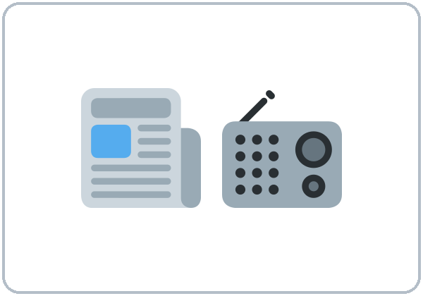  ★ news | 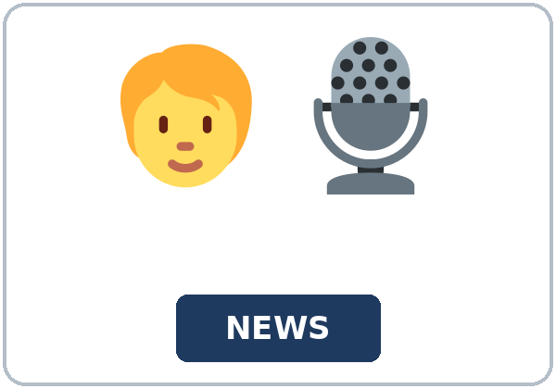  ★ reporter |   ★ headline | 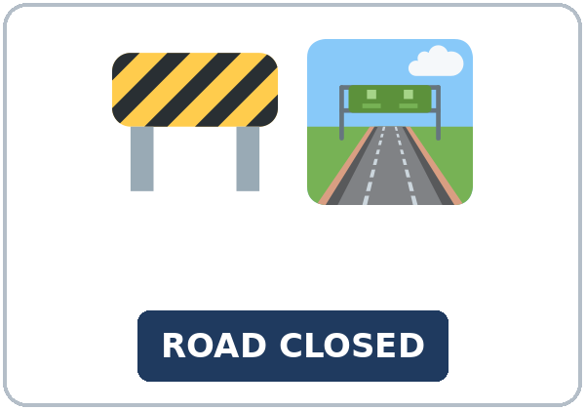  ★ road closure
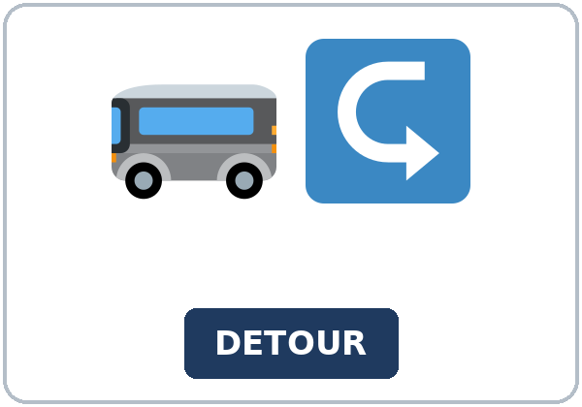  ★ detour | 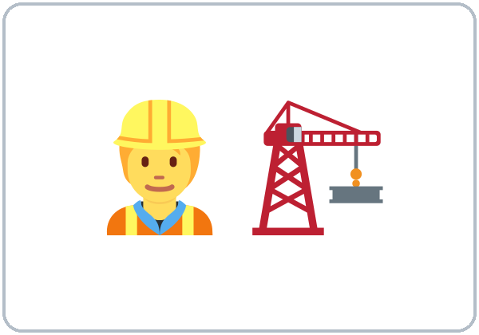  ★ construction | 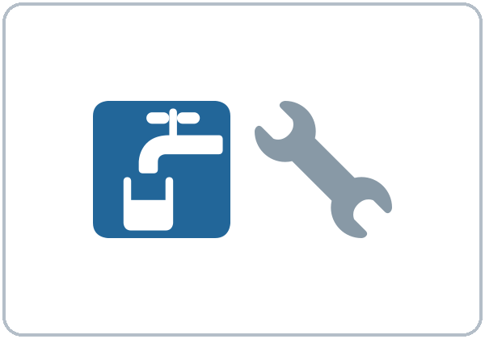  ★ water pipe | 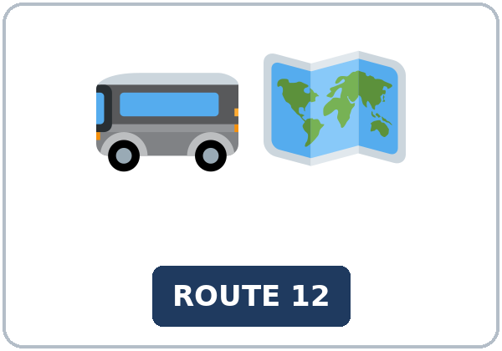  ★ bus route
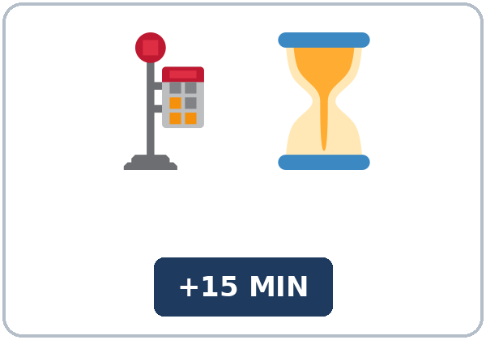  ★ delay | 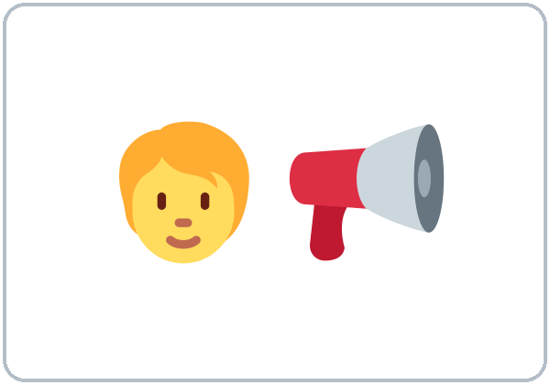  ★ announce | 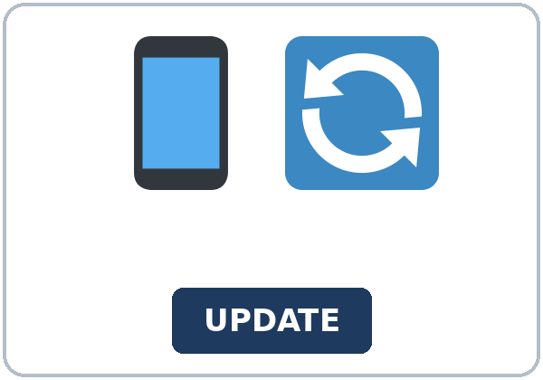  ★ update | 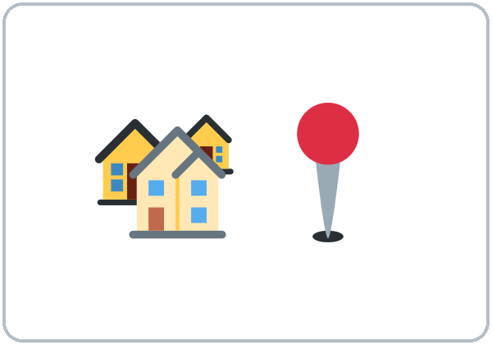  local

Partner game: Do you know…?
Example: A points to a picture and asks, "Do you know when the construction ends?" B answers with a fact or "I'm not sure. It might end in May." Switch.
Lesson 8 (Week 9) · My Words
My personal word list. Write each word in your language, if you want. Then write your own example.
Word | My language | My example
news
reporter
headline
road closure
detour
construction
water pipe
bus route
delay
announce
update
local

Add 2 more words from tonight (from the listening, the reading, or your partner).
Lesson 8 (Week 9) · Listening
A short local radio news report about a road closure and a bus detour. Then, at work, two coworkers, Marco and Joy, talk about how it might change their commute.
A. Listen. What is the news? Circle.
a. Oak Street will close for a water pipe repair. b. A new grocery store is opening. c. The bus will be free next week.
B. Listen again. Complete the notes. Circle the answer.
1. Where: Oak Street, between First and (Fifth / Ninth) Avenue
2. When: starting (Monday / Friday)
3. Why: workers will replace an old (water pipe / bus stop)
4. How long: maybe (two weeks / two days)
5. The bus detour: on (Pine Street / Main Street)
6. Delays: about (fifteen / fifty) minutes
C. Listen again. Write the missing word: might, will, or a question word.
1. The city says the construction ____________ take two weeks.
2. The city ____________ post updates on its website.
3. Do you know ____________ the bus leaves Pine Street?
4. Do you know ____________ long the closure is?
5. But it ____________ take longer if it rains.
6. Do you know ____________ the detour starts?
Hear it, say it
gonna = going to: "The bus is gonna take a detour." • "I'm gonna look at the map tonight." You can say going to. In might, the last t is very short. In Do you know…?, the voice goes up at the end. Listen to the reporter: she pauses after each fact.
Lesson 8 (Week 9) · Grammar
Read across. A reads from the left side. B answers from the right side. Choose one part from each column.
Grammar Box 1: might / may / could (maybe)
QUESTION |  |  | ANSWER
Will the road | be closed tomorrow? |  | It might be. | I'm not sure.
Will the repair | take two weeks? |  | It may take longer. | It depends on the rain.
When will the road | open? |  | I'm not sure. | It could open next week.
Will the bus | be on time? |  | It might not be. | It might be 15 minutes late.

Grammar Box 2: Do you know where…? (a first look)
QUESTION |  |  | ANSWER
Do you know | where the meeting is? |  | Yes, it's | at the library.
Do you know | when the new bus route starts? |  | I think | it starts in May.
Do you know | what time the store opens? |  | I'm not sure. | It might open at 8:00.
Do you know | why the street is closed? |  | Yes. Workers | are fixing a water pipe.

Rule of thumb: might / may / could + base verb: never to, never -s (It might rain). After Do you know where / when / why, use statement order: where the meeting is (not where is the meeting).
Grammar Box 3: will (sure) or might (maybe)?
 | HOW SURE? | EXAMPLE
will | sure | The road will close at 8:00 on Monday.
will probably | almost sure | It will probably take two weeks.
might / may / could | maybe | It might open early.
might not / may not | maybe not | The bus might not be on time.

Grammar Box 4: from a question to Do you know…?
QUESTION | DO YOU KNOW…?
Where is the meeting? | Do you know where the meeting is?
When does the bus leave? | Do you know when the bus leaves? (no does; add -s)
Why is the street closed? | Do you know why the street is closed?

Questions and answers
Q: It might rains or It might rain?
A: might + base verb: It might rain. Never -s, never to.
Q: Can I say Do you know where is the meeting?
A: Use statement order: Do you know where the meeting is?
Q: will or might?
A: will = I'm sure. might = maybe. The road will close on Monday. It might open early.
Practice A: Write the correct word or form.
1. It's very cloudy. It ____________ rain later. (might / will)
2. The sign says the road ____________ close at 8:00 on Monday. (might / will)
3. The store might ____________ next month. (open)
4. Do you know where the library ____________? (be)
5. Do you know when the bus ____________? (leave)
6. I'm not sure. The bus may ____________ late. (be)
Practice B: Circle the correct words.
1. The repair might (take / to take) two weeks.
2. Do you know (where the meeting is / where is the meeting)?
3. It (might not / doesn't might) rain tomorrow.
4. Do you know what time the store (opens / does open)?
5. The schedule says the bus (will / might) leave at 7:05. (sure)
6. I'm not sure. It (may / will) open in June. (maybe)
Common mistakes
✗ Don't say | ✓ Say
It might rains tomorrow. | It might rain tomorrow.
The road might to close. | The road might close.
Do you know where is the bank? | Do you know where the bank is?
Do you know when does the bus leave? | Do you know when the bus leaves?
I'm sure. The road might close at 8:00. | I'm sure. The road will close at 8:00.

Contrast tip (optional): Spanish Puede que cierren la calle uses a special verb form; English uses might + base verb: They might close the street (not might to close, not might closes). Spanish ¿Sabes dónde está…? keeps the verb right after dónde; English moves it: Do you know where the meeting is? What does your language do?

Lesson 8 (Week 9) · Talk Time: News Swap
Round 1. Work with a partner. A reads card A, and B reads card B. Don't show your card. Ask Do you know when / where / why…? and write your partner's facts. Then change partners and retell the story.
NEWS CARD A (invented) | NEWS CARD B (invented)
Hill Street Library open on Sundays | Main Street bus stop is moving
When: starting March 3 | When: next Monday
Hours: 12:00 to 5:00 | Where: from 2nd Street to 4th Street
Why: many families asked for weekend hours | Why: construction on a new grocery store
Maybe: free computer classes might start in April | How long: about 6 months
Where to learn more: the library website | Maybe: there may be a new crosswalk

Example: A: Do you know when the bus stop is moving? B: Yes, next Monday. A: Do you know why? B: Because there's construction on a new grocery store.
My partner's news | Facts
When?
Where?
Why?
Maybe…? (might / may)

Lesson 8 (Week 9) · Talk Time: What Might Happen?
Round 2. Work in groups. Choose a headline. Write 4 predictions with might, may, and will probably. Then read them to the class.
HEADLINE 1 (invented) | HEADLINE 2 (invented)
New Grocery Store Opening on Main Street | Big Snowstorm Coming This Weekend

Example (headline 1): "There might be more traffic on Main Street. Food prices may go down. The store will probably need workers. Some small stores might close."
Our predictions | ✓
1. ___ might ___ | ☐
2. ___ may ___ | ☐
3. ___ will probably ___ | ☐
4. | ☐

A prediction from another group that I liked

Useful: There might be… • People may… • It will probably… • I'm not sure, but… • I think so too. • Maybe, but…
Lesson 8 (Week 9) · Homework
Homework (about 15–20 minutes). Bring it next week!
1. Write the sentence or question. Use the words.
Example: the road / might / close / tomorrow → The road might close tomorrow.
1. the store / may / open / in June → ______________________________________________
2. it / might not / rain / this weekend → ______________________________________________
3. Do you know / where / the meeting / be? → ______________________________________________
4. Do you know / when / the bus / leave? → ______________________________________________
2. Finish your writing from Read & Write C (your text or email). Read it one more time. Check ✓ the list in D.
☐ I finished it. ☐ I checked it with the list.
3. Write 3 things that might change in your neighborhood or city. Then write why you think so.
What might change? (might / may) | Why do you think so?
1.
2.
3.

4. Review (Lesson 7). Write one word.
1. Is 6:55 early ____________ for a 7:00 shift?
2. There are too ____________ people here.
3. You ____________ use your phone in the kitchen. (It's a rule.)
4. Jeans are ____________ casual for an interview.
5. I have too ____________ work today.
Lesson 8 (Week 9) · Read & Write
A. Read the notice. Read fast first: what is the main idea? Then read again and answer the questions.
MAPLE FALLS NEWS · New Bus Route Will Connect Hospital and College (invented city)
Starting May 6, Maple Falls will have a new bus route, Route 9. The route will go from Riverside Hospital to Maple Falls Community College, with stops at the library, the West Side Market, and the train station. Buses will run every 20 minutes from 6:00 a.m. to 10:00 p.m., Monday to Saturday. A ride will cost $1.50, the same as other city buses.
"Many people asked for this route," said Ana Ruiz from the city transit office. "Nurses and students wanted an easier way to get to work and class." Students are happy too. "Now I don't have to take two buses," said one student.
The city might add Sunday service in the fall. It may also add two more stops near the new apartments on Elm Road, but this isn't decided yet.
Riders can see the map and the schedule on the city website or at the library. For the first week, all rides on Route 9 will be free.

B. Answer the questions.
1. What is the main idea? ______________________________________________
2. How often will the buses run? ______________________________________________
3. How much will a ride cost? ______________________________________________
4. What might the city add in the fall? ______________________________________________
5. Where can riders see the map? ______________________________________________
C. Write a text or email to a friend about the news (5–8 sentences). Use one might or may and one Do you know…?
Example: Hi, Lina! Did you hear the news? There's a new bus route, Route 9. It starts on May 6, and it goes to the college. You could take it to class! The city might add Sunday service in the fall. Do you know when your classes start? Talk soon, Joy
My text or email

D. Check your writing with a partner.
 | Yes | Not yet
It has 5–8 sentences. | ☐ | ☐
It tells the main news. | ☐ | ☐
It has might or may. | ☐ | ☐
It has a Do you know…? question. | ☐ | ☐

Lesson 8 (Week 9) · Exit Ticket
Name: ______________________________ Date: ________________
Answer in 3 sentences. Give a reason. Then give this page to your teacher.
What might change in your neighborhood or at your job next year?
Sentence 1: one change, with might or may • Sentence 2: another change, with might or may • Sentence 3: a reason, with because
My answer
1.
2.
3.

For the teacher | ✓ | almost | not yet
3 sentences, today's grammar, a reason | ☐ | ☐ | ☐

Lesson 8 (Week 9) · Task Words (optional)
This page is for you if you want it. You can skip it. Write each task word in your language, if you want.
Task word | What you do | My language
Listen. | Use your ears. Don't write yet.
Circle. | Draw a circle around the answer.
Check ✓. | Make a ✓ in the box.
Write. | Write words or sentences.
Number. | Write 1, 2, 3… to show the order.
Match. | Find the two parts that go together.
Work with a partner. | Work with one classmate.
Work in a group. | Work with 2 or 3 classmates.
Switch. | Change roles: A is B now.
Ask a follow-up question. | Ask one more question about the answer.
Give a reason. | Say why, with because or so.
Compare. | Look at your partner's answers. Are they the same?

Picture Credits
Pictures use Twemoji graphics by Twitter, Inc. and other contributors (https://github.com/jdecked/twemoji), licensed under CC BY 4.0 (https://creativecommons.org/licenses/by/4.0/). The graphics were resized and combined, and signs and labels were added. The file-by-file list is in images/CREDITS.md.
Listening audio: not recorded yet. When it is made, it will use synthetic voices made with Chatterbox TTS (Resemble AI, MIT License), cloned from synthetic reference clips made with Kokoro-82M (Apache License 2.0), with no recordings of real people. The names and the story are invented.
Course materials: © 2026 the authors, licensed under CC BY-NC-SA 4.0 (https://creativecommons.org/licenses/by-nc-sa/4.0/).

