Level 1 Adult ESL Curriculum · Lesson 2 (Week 2): Where Are You From?
Status: Draft for review (all 13 Level 1 lessons are built).
Date: October 2026
Audience: Program coordinators and volunteer teachers
Companion files: audio/L1_L2_listening.mp3, images/ (12 vocabulary pictures + images/CREDITS.md)
Topic: countries, cities, and age; meeting classmates. Learners use be with every person (I'm, you're, he's, she's, we're, they're), ask Where are you from?, answer Yes, she is. / No, he isn't., and say an age with be (I'm 35). Letters & Numbers: numbers 0–20.

How this lesson is organized
Part | What's inside | Who uses it
Teacher Plan | At a glance, clock-time plan, step-by-step boxes, Letters & Numbers script, listening script, answer key, teacher notes | Volunteer teachers
Student Pages | Hello + Review, New Words, Listening, Grammar, Talk Time: Class Map, Homework, Letters & Numbers, Progress Check. Print this part for learners | Learners
Picture Credits | Picture sources and licenses | Coordinators

What Lesson 2 gives Level 2
Level 2 uses… | Where in Level 2 | Lesson 2 starts it with…
be statements, questions, and short answers with all persons (Are you married? Yes, I am.) | Lesson 1 review, all lessons | I'm / you're / he's / she's / we're / they're • Is she from Mexico? No, she isn't. (Grammar Boxes 1–3)
Where are you from? I'm from… and country words | Lesson 1 | Where are you from? I'm from Honduras. What city? (New Words, the listening, Talk Time)
Age with be: I'm 35 | Lesson 1 | How old are you? I'm 35. How old is he? He's 12. (Grammar Box 4)
he / she as the person in a sentence (Level 2 Lesson 2 adds -s: she works) | Lesson 2 | He's from Mexico. She's from El Salvador. (Talk Time: introduce a partner)
Numbers | Lessons 2 and 4 (times, prices) | Numbers 0–20 (Letters & Numbers block)

TEACHER PLAN
Lesson 2 (Week 2)

Where Are You From?
At a glance · Clock-time plan · Step by step · Letters & Numbers · Script and answer key

How to Use This Plan
You don't need to speak Spanish or any other language. Teach in English. Show, point, and gesture. The student pages have a Spanish line and a "My language" line for every task. Learners read those on their own. You never need to read, translate, or explain them.

Instruction rule: Model it (do it with one learner while everyone watches), check it (ask: "Listen or write?"), then go. Say less, show more. Use the same short words every time: Listen. Repeat. Point. Circle. Write. Partner. Group.

Grouping toolkit: Pairs: turn to a neighbor; with an odd number, make one group of 3. Groups: 3–4 learners. Mingle: everyone stands and talks to many classmates. The teacher joins a pair only if one learner is left over.

When a learner is stuck or speaks another language to you: (1) show it: the picture, a gesture, or the board; (2) give one more short English example; (3) point to the instruction and the grammar box on their page; (4) a classmate can help for a few seconds, then back to English. You don't need to understand what classmates say to each other.

Lesson 2 (Week 2): Where Are You From?
At a glance
Objectives: learners can…
• say where they are from (I'm from Mexico. I'm from Guadalajara.)
• ask where someone is from (Where are you from? Where is she from? What city?)
• answer yes/no questions with be (Is he from Honduras? Yes, he is. / No, he isn't.)
• say an age with be (I'm 35. He's 12.), not with have
• say, understand, and write the numbers 0–20 (Letters & Numbers block)

Materials
• Student Pages for Lesson 2 (print for the number expected + 3 spares)
• a world map (paper, or on a screen) and small sticky notes or stickers
• name tags from Week 1 (and markers for new learners)
• mini whiteboards or scrap paper for Letters & Numbers
• number cards 0–20 (or write 0–20 on the board before class)
• baseline snapshot checklist (in the answer key; continue from Week 1)
• phone + small speaker, L1_L2_listening.mp3
• Prep time: 30 min.

Key vocabulary (with pictures on the New Words page)
★ country • ★ city • ★ Mexico • ★ Guatemala • ★ Honduras • ★ El Salvador • Colombia • ★ the United States • ★ he • ★ she • ★ they • ★ How old?

Review from Lesson 1
What's your name? How do you spell it? How are you? Can you repeat, please? • Are you a student? Yes, I am.

Clock-time plan
Times are loose. If a step runs long, take the time from Grammar or Talk Time. The last 15 minutes are the Letters & Numbers block.
Time | Step | Min | Grouping (15 / 7–8) | If running behind
6:00–6:10 | Hello + Review (Lesson 1 questions) + homework check | 10 | Pairs, then new pairs | One partner only
6:10–6:20 | New Words (picture page) + pair picture game | 10 | Whole class, then pairs | Teach the ★ words only
6:20–6:32 | Listening (audio) + "Say it" | 12 | Individuals, then pairs check | Play the audio 2 times, not 3
6:32–6:45 | Grammar Q&A: Where are you from? Is she from…? How old…? + pair drill | 13 | Whole class, then pairs | Skip the pair drill; it becomes homework
6:45–7:00 | BREAK | 15
7:00–7:10 | Talk Time: Class Map (interview, introduce a partner, map) + baseline snapshot | 10 | Pairs, then groups of 3–4 / pairs, then one group | Skip the map stickers
7:10–7:15 | Exit Ticket + Homework | 5 | Individuals | Never skip
7:15–7:25 | Letters & Numbers: numbers 0–20 (See it → Say it → Write it) | 10 | Whole class, then pairs | Do Tasks A and B only
7:25–7:30 | Progress Check | 5 | Individuals | Do it in Week 3 at 6:00, while people arrive

Skip order if you're running behind: (1) the third play of the audio; (2) the pair drill at the end of Grammar; (3) half of Talk Time. Never skip: the listening tasks, the grammar boxes, and the exit ticket.

Attendance (15 → 7–8): every step lists both sizes. Print for the number you expect, plus 3 spares. Late arrivals join any pair right away. New learners this week: give them a name tag and pair them with a strong partner.

Step by step
Step 1 · 6:00–6:10 · Hello + Review · 10 min
• Grouping: pairs. 15 learners: 7 pairs + 1 group of 3. 7–8 learners: 3–4 pairs. Late arrivals join any pair.
• Before class: write on the board: What's your name? How do you spell it? How are you? Are you a student?
• Model with one learner: "Hello! What's your name?" → "Rosa." "How do you spell it?" → "R-O-S-A." "How are you?" → "I'm fine, thanks. And you?"
• Do: pairs use the Hello + Review page. A asks the 4 questions; B answers. Then switch. Then find a new partner and do it again.
• Homework check (last 3 min): partners show each other their Lesson 1 homework (the name, the friend's name, the 4 words). Walk around and look. Collect any Lesson 1 Progress Checks that were not done.
• New learners: pair them with a strong partner. They can do the Lesson 1 Progress Check at home.
• If behind: one partner only.

Step 2 · 6:10–6:20 · New Words · 10 min
• Grouping: whole class, then pairs.
• Show: the New Words page (or the world map). Point to a country on the map, then to the flag on the page: "Mexico. This is a country."
• Do: point to each picture and say the word. Learners repeat twice. Stress the strong part of each word: MEX-i-co, gua-te-MA-la, hon-DU-ras, el SAL-va-dor, co-LOM-bi-a, the u-NI-ted STATES.
• country / city: "Mexico is a country. Guadalajara is a city." Say two more: "Honduras: country. Tegucigalpa: city."
• he / she / they: point to a man in the room: "he." A woman: "she." A group: "they." Learners point as you say the word (fast, like a game).
• How old?: point to the cake. "How old? … 12. 20. 35." Hold up fingers.
• Pairs (4 min): A points to a picture, B says the word. Then switch. Then: A points to a classmate, B says he or she.
• Learners from other countries: write their country on the board and say it together. Every country is welcome; the page has the 6 most common in this program.
• If behind: teach the ★ words only.

Step 3 · 6:20–6:32 · Listening + "Say it" · 12 min
• Grouping: individuals, then pairs check.
• Before you listen (1 min): say: "This is Rosa. This is Marco. They are new students. It's the break." Point to the flags in Task A: "Where are they from? Listen."
• Listen 1 → Task A (match the person and the flag; write the letter).
• Listen 2 → Task B (Yes or No, 4 pictures). Listen 3 → Task C (write the age).
• Pairs compare after each task: "Show your partner." Then show the answers on the board.
• "Say it" (2 min): read 2 lines: "Where are you from?" and "How old is he?" The class repeats each line twice. Then pairs ask and answer each other.
• The audio plays the conversation once. Press play again for the next listen.
• If behind: play the audio 2 times, and do Task C together on the board.

Step 4 · 6:32–6:45 · Grammar Q&A · 13 min
• Grouping: whole class, then pairs.
• Show: the Grammar page. The left side is the question. The right side is the answer. Point left, then right.
• Box 1: you read a question; the class reads an answer. Point to a learner: "Where is he from?" → "He's from…".
• Box 2: ask about learners in the room: "Is Rosa from Mexico?" → "No, she isn't. She's from Guatemala." Stress the short answers: Yes, she is. No, she isn't.
• Box 3 (2 min): read the long form; the class reads the short form. Write on the board: I → am. he, she, it → is. you, we, they → are.
• Box 4: "How old are you?" Answer for yourself (a real or a practice age). Write: I'm 35. Then write I have 35 years and draw a big ✗ on it.
• Check questions: "She ___ from Colombia." (is) • "Where ___ they from?" (are) • "Is he from Mexico? No, he ___." (isn't)
• Pair drill (last 3–4 min): A asks from the left side about B or about a classmate; B answers from the right side. Then switch.
• If behind: skip the pair drill. It becomes homework, and Talk Time practices the same questions.

Break · 6:45–7:00 · 15 min
• Put up the world map. Write on the board: Where are you from? What city? This is ___. He's / She's from ___.

Step 5 · 7:00–7:10 · Talk Time: Class Map · 10 min
• Grouping: pairs, then groups of 3–4. 7–8 learners: pairs, then one group (the whole class).
• Model with one learner: "Where are you from?" → "Honduras." "What city?" → "San Pedro Sula." Write it in the table on the board. Then turn to the class: "This is Marco. He's from Honduras. He's from San Pedro Sula."
• Part 1 (3 min): pairs interview each other and write the partner's name, country, and city on the Talk Time page.
• Part 2 (4 min): each pair joins another pair. Each learner introduces the partner: "This is ___. He's / She's from ___." The group asks one question: "What city?" or "Is she from ___?"
• Part 3 (2 min): each learner puts a sticky note with their name on the map (or the teacher writes the names on the board under each country).
• Any country is OK. Learners can choose a city or country they like. Never ask how or why someone came here.
• Baseline snapshot: while groups talk, call about 5 learners you didn't check in Week 1, one at a time, for 2 minutes. Use the checklist in the answer key.
• If behind: skip Part 3.

Step 6 · 7:10–7:15 · Exit Ticket + Homework · 5 min · NEVER SKIP
• Exit ticket: each learner says one sentence to you at the door ("I'm from ___." or "This is ___. She's from ___.") or writes one sentence on a slip. Copying from the grammar box is fine.
• Homework: open the Homework page. Do item 1 together. Point to each instruction so learners know what to do at home.

Letters & Numbers · 7:15–7:25 · Numbers 0–20 · 10 min
• Grouping: whole class, then pairs. Use the Letters & Numbers page and the numbers on the board.
• See it (2 min): point to each number, 0 to 20, and say it once. Hold up fingers for 0–10.
• Say it (3 min): learners repeat 0–10, then 11–20. Then go to the tricky numbers box. Say each one 3 times. Spend the most time on 3 (th: tongue between the teeth), 13 / 14…19 (stress the end: thir-TEEN), 12 / 20 (twelve, twenty), and 7 (v, not b).
• Quick check (1 min): say a number; learners hold up fingers or point on the page.
• Write it (3 min): Task B: say the 5 numbers in the answer key, 2 times each. Learners circle. Task C: read the 3 ages (answer key). Learners write numbers, not words. Task D: learners write the sentence again with capital letters (Maria, Colombia).
• Partners: Task E: A says a number from 0 to 20; B writes it. A checks. Switch.
• Learners who can't read or write yet: they say the numbers with everyone, hold up fingers, and point instead of circle. A helper, if you have one, sits with them.
• If behind: do Tasks A and B only.

Progress Check · 7:25–7:30 · 5 min
• Grouping: individuals. Open the Progress Check page.
• Part A: read the 5 numbers (answer key), slowly, 2 times each. Learners circle.
• Parts B and C: learners match and write on their own. Walk around and help with the instructions only.
• Part D: read each "I can…" line aloud and point to the 3 faces: 😀 "I can do it." 🙂 "A little." 😐 "Not yet." Learners check one.
• Collect the pages (or check them at the start of Week 3). Part A shows who needs more help with numbers.
• If behind: do the Progress Check in Week 3 at 6:00, while learners arrive.

Listening script: L1_L2_listening.mp3 (about 1:17; the conversation plays once, so play the audio again if needed)
Audio: play from a phone + small speaker. No speaker? Read the script with a volunteer. Read slowly, with a short stop between speakers.

Narrator: Lesson two. Listening. It's the break at English class. Rosa and Marco are new students. Listen.
Rosa: Hi! I'm Rosa. What's your name?
Marco: Hi, Rosa. I'm Marco. Nice to meet you.
Rosa: Nice to meet you, too. Where are you from, Marco?
Marco: I'm from Mexico.
Rosa: Oh, nice! What city?
Marco: Guadalajara. And you? Are you from Mexico, too?
Rosa: No, I'm not. I'm from El Salvador.
Marco: Oh, OK. What city?
Rosa: San Salvador. My son is here, too. He's in the kids' class.
Marco: Oh, how old is he?
Rosa: He's twelve years old.
Marco: Twelve? That's great. My friends are here, too. They're from Honduras.
Rosa: Is the teacher from Mexico?
Marco: No, she isn't. She's from the United States.
Rosa: OK. Time for class! See you later, Marco.
Marco: See you later!
Narrator: That's the end of the listening.

Answer key
• Listening Task A: 1 Rosa b (El Salvador), 2 Marco a (Mexico), 3 the friends d (Honduras), 4 the teacher c (the United States).
• Listening Task B: 1 Yes, 2 No (Rosa is from El Salvador), 3 Yes, 4 No (the teacher is from the United States).
• Listening Task C: 12 (twelve).
• Grammar practice (Write am, is, or are): 1 am, 2 is, 3 are, 4 Is / is, 5 are, 6 are.
• Homework 2 (am, is, are): 1 am, 2 is, 3 are, 4 is, 5 are.
• Homework 3 (the country): 1 Mexico, 2 Colombia, 3 Honduras, 4 the United States.
• Letters & Numbers Task B (the teacher says): 1 12, 2 3, 3 15, 4 7, 5 20. Say each number 2 times.
• Letters & Numbers Task C (the teacher says): 1 "He's 9." 2 "She's 14." 3 "They're 18 and 20." Say each one 2 times.
• Letters & Numbers Task D: Maria is from Colombia.
• Progress Check Part A (the teacher says): 1 13, 2 6, 3 20, 4 11, 5 17. Say each number 2 times.
• Progress Check Part B: 1 c, 2 d, 3 a, 4 b.
• Progress Check Part C: 1 am, 2 is, 3 are.
• Progress Check scoring: Part A /5 + Part B /4 + Part C /3 = /12. This is not a test grade. It shows who needs help with numbers (Part A) and with am / is / are (Parts B and C).
Baseline snapshot checklist (Weeks 1–3, continued)
Use the same sheet as Week 1, or this copy. Ask the 6 prompts, in this order. Check ✓ if the learner answers without help. Write ~ if they answer with help. Leave it empty if not yet. The final exam uses the same prompts.
Learner | What's your name? | How do you spell it? | Where are you from? | What's your phone number? | Do you have kids? | What do you do?

Learners can give a practice phone number (555-0100 to 555-0199) instead of a real one. Never write down real phone numbers.
Teacher notes
• Countries and privacy: learners can talk about any country or city: where they were born, where they lived, or a place they like. Never ask about immigration, papers, or how or why someone came to the U.S. If a learner doesn't want to answer, "I'm from (this city)" is a fine answer.
• Age is optional: some adults don't like to say their age. In Box 4 and in the listening, practice with children's ages and invented ages. Say: "You can say a practice age."
• The big mistake this week: Spanish can leave out the person (Es de México). English can't. Listen for Is from Mexico and give back She's from Mexico. The second big mistake is I have 35 years → I'm 35. Learners can read the Spanish note on their Grammar page; you don't need to explain it.
• the United States: say the United States (or the U.S.). Other countries on the page have no the: Mexico, Honduras.
• Short answers: Yes, she is. (never Yes, she's.) • No, she isn't. or No, she's not. Both are correct; the page teaches isn't.
• Mixed levels: strong learners add the city (I'm from Mexico. I'm from Puebla.) and ask a second question in Talk Time. New learners use the grammar box as a script.
• Learners who can't read or write yet: they take part fully in the speaking. In writing tasks, they point and circle, and copy the country from the New Words page. Don't make them read aloud.
• Looking ahead: Lesson 3 adds his / her (Her name is Rosa. His phone number is…) and numbers to 100. Lesson 4 adds Do you have kids?

STUDENT WORKBOOK
Lesson 2 (Week 2)

Where Are You From?
Hello + Review · New Words · Listening · Grammar · Talk Time · Homework · Letters & Numbers · Progress Check

Lesson 2 (Week 2): Where Are You From?
Student Page 1 · Week 2
Name: ______________________________ Date: ________________
Hello + Review: ask your partner. Then switch.
Español: Pregunta a tu compañero. Después cambien.
My language: ______________________________________________
A: Hello! What's your name? B: My name is ___.
A: How do you spell it? B: ___-___-___.
A: How are you? B: I'm fine, thanks. And you?
A: Are you a student? B: Yes, I am.
Help: Can you repeat, please? I don't understand.

Lesson 2 (Week 2) · New Words
New Words
Look. Listen. Repeat. ★ = most important words.
Español: Mira. Escucha. Repite.
My language: ______________________________________________
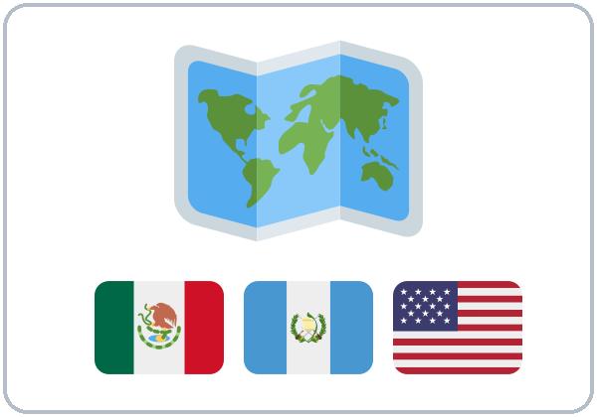  ★ country |   ★ city | 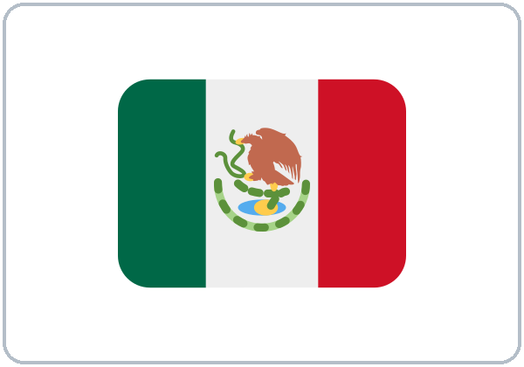  ★ Mexico | 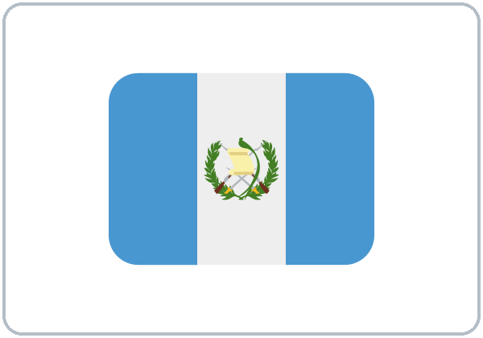  ★ Guatemala
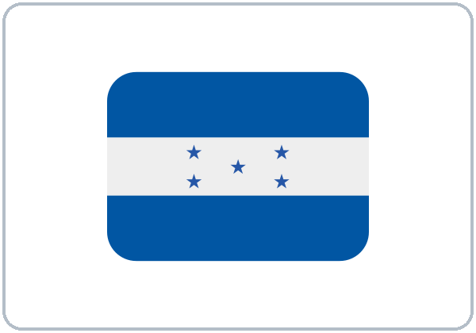  ★ Honduras | 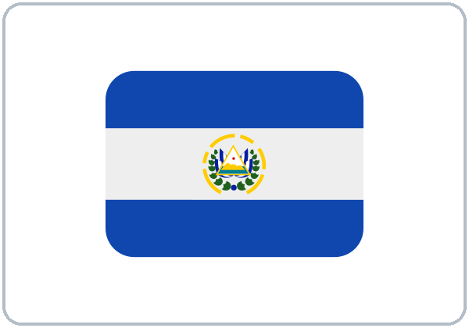  ★ El Salvador | 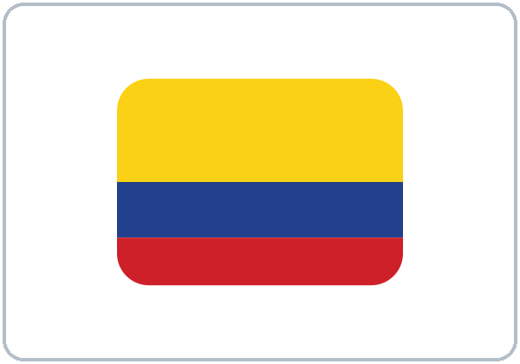  Colombia |   ★ the United States
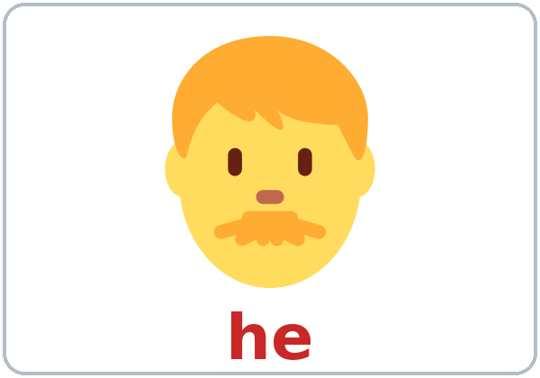  ★ he | 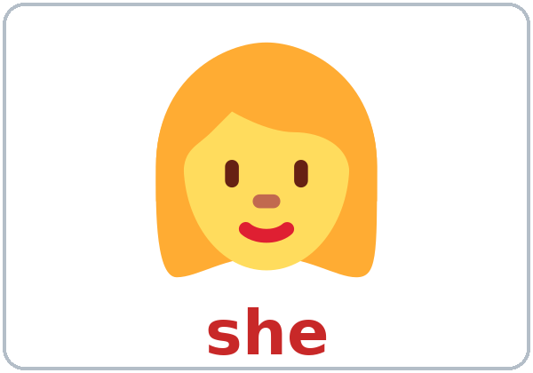  ★ she | 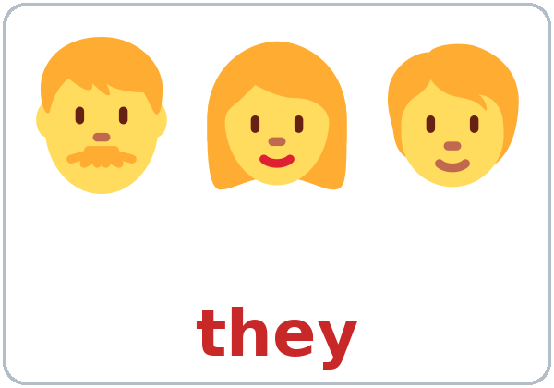  ★ they | 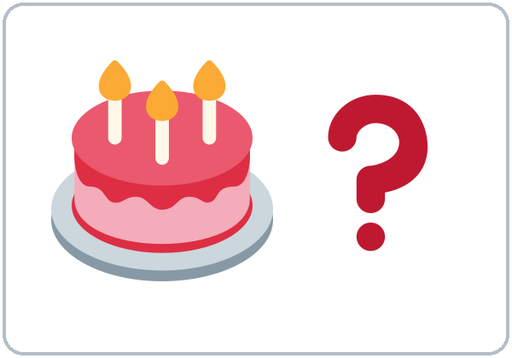  ★ How old?

Partner game: A points. B says the word.
Español: Con un compañero: A señala una imagen. B dice la palabra. Después cambien.
My language: ______________________________________________
My country: ______________________________ My city: ______________________________
Lesson 2 (Week 2) · Listening
Listen to Rosa and Marco. They are new students. It's the break.
A. Listen. Where are they from? Write the letter.
Español: Escucha. ¿De dónde son? Escribe la letra.
My language: ______________________________________________
a. Mexico | b. El Salvador | c. the United States | d. Honduras

1. Rosa | 2. Marco | 3. Marco's friends | 4. The teacher

B. Listen again. Yes or No? Check ✓.
Español: Escucha otra vez. ¿Sí o no? Marca ✓.
My language: ______________________________________________
1. Marco is from Mexico.  ☐ Yes ☐ No | 2. Rosa is from Mexico.  ☐ Yes ☐ No | 3. Marco's friends are from Honduras.  ☐ Yes ☐ No | 4. The teacher is from Mexico.  ☐ Yes ☐ No

C. Listen again. How old is Rosa's son? Write the number.
Español: Escucha otra vez. ¿Cuántos años tiene el hijo de Rosa? Escribe el número.
My language: ______________________________________________
Rosa's son is ________ years old.
Say it: Where are you from? • How old is he?
Español: Escucha y repite. My language: ______________________________
Lesson 2 (Week 2) · Grammar
With a partner: read across. A reads a question (left). B reads an answer (right). Choose one word from each column.
Español: Con un compañero: lee de izquierda a derecha. A lee una pregunta (izquierda). B lee una respuesta (derecha). Elige una palabra de cada columna.
My language: ______________________________________________
Grammar Box 1: Where are you from?
QUESTION |  |  |  | ANSWER
Where are | you  they | from? |  | I'm  They're | from | Mexico.  Honduras.
Where is | he  she | from? |  | He's  She's | from | Guatemala.  Colombia.
What | city? |  |  | Guadalajara.  San Salvador.

Grammar Box 2: Is she from Mexico?
QUESTION |  |  |  | ANSWER
Are | you | from Mexico? |  | Yes, | I | am.
Are | you | from Mexico? |  | No, | I'm | not.
Is | he  she | from Mexico? |  | Yes, | he  she | is.
Is | he  she | from Mexico? |  | No, | he  she | isn't.
Are | they | from Mexico? |  | Yes, | they | are.
Are | they | from Mexico? |  | No, | they | aren't.

Grammar Box 3: I'm, you're, he's… (long and short)
LONG |  | SHORT | NOT
I am |  | I'm | I'm not
You are |  | You're | You aren't
He is  She is |  | He's  She's | He isn't  She isn't
It is |  | It's | It isn't
We are |  | We're | We aren't
They are |  | They're | They aren't

Grammar Box 4: How old are you?
QUESTION |  |  |  | ANSWER
How old | are | you? |  | I'm | 35.  20.
How old | is | he?  she? |  | He's  She's | 12.  9.

Questions and answers
Q: am, is, or are?
A: I → am. he, she, it → is. you, we, they → are.
Q: Can I say Is from Mexico?
A: No. English always needs the person: She's from Mexico. He's from Honduras.
Q: How do I say my age?
A: I'm 35. or I'm 35 years old. Not I have 35 years.
Q: How do I make a question?
A: Put is or are first. She is from Peru. → Is she from Peru?
Q: How do I answer Yes or No?
A: Yes, she is. No, she isn't. (Not Yes, she's.)
Practice: Write am, is, or are.
Español: Escribe am, is o are.
My language: ______________________________________________
1. I ________ from Honduras.
2. She ________ from Colombia.
3. Where ________ you from?
4. ________ he from Mexico? Yes, he ________.
5. They ________ from El Salvador.
6. How old ________ you? I'm 30.
Common mistakes
✗ Don't say | ✓ Say
Is from Mexico. | She's from Mexico.
I have 35 years. | I'm 35.
Where you are from? | Where are you from?
She are from Peru. | She is from Peru.
Yes, she's. | Yes, she is.
I'm from mexico. | I'm from Mexico.

Nota para hispanohablantes: En inglés siempre se dice la persona: She's from Mexico (no «Is from Mexico»). La edad usa be, no have: I'm 35 (no «I have 35 years»). He = él, she = ella, they = ellos / ellas. Para preguntar, pon is o are primero: Is she from Mexico? Los países y las ciudades empiezan con mayúscula: Mexico, Colombia.

Tip for speakers of other languages: English always needs a person word: I, you, he, she, we, they. Age uses be: I'm 35. Short answers repeat the person and be: Yes, I am. No, she isn't.

Lesson 2 (Week 2) · Talk Time: Class Map
1. Ask your partner. Write.
Español: Pregunta a tu compañero. Escribe.
My language: ______________________________________________
A: What's your name? B: ___.
A: Where are you from? B: I'm from ___.
A: What city? B: ___.
Help: Can you repeat, please? How do you spell it?

# | Name | Country | City
1
2
3

2. In a group: say who your partner is.
Español: En un grupo: presenta a tu compañero.
My language: ______________________________________________
This is ___. He's / She's from ___. He's / She's from (city) ___.
Group: What city? / Is she from ___? You: Yes, she is. / No, she isn't.

3. Put your name on the class map.
Español: Pon tu nombre en el mapa de la clase.
My language: ______________________________________________
You can choose any country or city.
Lesson 2 (Week 2) · Homework
Homework (10 minutes). Bring it next week!
Español: Tarea (10 minutos). ¡Tráela la próxima semana!
My language: ______________________________________________
1. Write about you.
Español: Escribe sobre ti.
My language: ______________________________________________
My name is ______________________________ .
I'm from ______________________________ . (country)
I'm from ______________________________ . (city)
2. Write am, is, or are.
Español: Escribe am, is o are.
My language: ______________________________________________
1. I ________ a student.
2. He ________ from Guatemala.
3. We ________ from Honduras.
4. Where ________ she from?
5. ________ they from Colombia?
3. Look. Write the country.
Español: Mira. Escribe el país.
My language: ______________________________________________
Words: Mexico • Colombia • Honduras • the United States
1. ____________ | 2. ____________ | 3. ____________ | 4. ____________

4. Ask a friend or a family member. Write.
Español: Pregunta a un amigo o a un familiar. Escribe.
My language: ______________________________________________
You: What's your name? Where are you from?

______________________________ is from ______________________________ .
He's / She's from ______________________________ . (city)
5. Review: spell your name to a family member.
Español: Repaso: deletrea tu nombre a un familiar.
My language: ______________________________________________
Lesson 2 (Week 2) · Letters & Numbers
A. Look. Listen. Say the numbers.
Español: Mira. Escucha. Di los números.
My language: ______________________________________________
0  zero | 1  one | 2  two | 3  three | 4  four | 5  five | 6  six
7  seven | 8  eight | 9  nine | 10  ten | 11  eleven | 12  twelve | 13  thirteen
14  fourteen | 15  fifteen | 16  sixteen | 17  seventeen | 18  eighteen | 19  nineteen | 20  twenty

Tricky numbers: say them slowly.
Español: Números difíciles: dílos despacio.
My language: ______________________________________________
Number | Say it like… | Tip
3 | "three" | th: tongue between your teeth
7 | "seven" | v: top teeth on your lip (not b)
12 | "twelve" | not "twenty"
13–19 | "thir-TEEN, four-TEEN…" | say the end strong: TEEN
20 | "TWEN-ty" | say the start strong

B. Listen to the teacher. Circle the number.
Español: Escucha al profesor. Encierra el número en un círculo.
My language: ______________________________________________
1. | 2 | 12 | 20
2. | 3 | 13 | 8
3. | 5 | 15 | 9
4. | 7 | 11 | 17
5. | 20 | 12 | 2

C. Listen to the teacher. Write the age.
Español: Escucha al profesor. Escribe la edad.
My language: ______________________________________________
1. He's ________ . 2. She's ________ . 3. They're ________ and ________ .
D. Countries and names start with a CAPITAL letter. Write the sentence again.
Español: Los países y los nombres empiezan con MAYÚSCULA. Escribe la oración otra vez.
My language: ______________________________________________
maria is from colombia. → ______________________________________
E. Say a number (0–20). Your partner writes it on paper.
Español: Di un número (0–20). Tu compañero lo escribe en papel.
My language: ______________________________________________
Lesson 2 (Week 2) · Progress Check
Name: ______________________________ Date: ________________
A. Listen to the teacher. Circle the number.
Español: Escucha al profesor. Encierra el número en un círculo.
My language: ______________________________________________
1. | 3 | 13 | 18
2. | 6 | 16 | 7
3. | 2 | 12 | 20
4. | 11 | 7 | 17
5. | 7 | 17 | 19

B. Match the question and the answer. Draw a line.
Español: Une la pregunta con la respuesta. Dibuja una línea.
My language: ______________________________________________
Question | Draw a line. | Answer
1. Where are you from? ● |  | ● a. He's 12.
2. Is she from Mexico? ● |  | ● b. They're from Colombia.
3. How old is he? ● |  | ● c. I'm from Honduras.
4. Where are they from? ● |  | ● d. No, she isn't.

C. Write am, is, or are.
Español: Escribe am, is o are.
My language: ______________________________________________
1. I ________ from Guatemala.
2. She ________ 20.
3. They ________ from Mexico.
D. How do you feel? Check ✓ one face for each line.
Español: ¿Cómo te sientes? Marca ✓ una cara en cada línea. 😀 = I can do it. 🙂 = I can do it with a little help. 😐 = Not yet.
My language: ______________________________________________
I can… | 😀 | 🙂 | 😐
I can say where I'm from. | ☐ | ☐ | ☐
I can ask Where are you from? | ☐ | ☐ | ☐
I can say my age (I'm 35). | ☐ | ☐ | ☐
I can understand the numbers 0–20. | ☐ | ☐ | ☐

Score: A ______ / 5 B ______ / 4 C ______ / 3
Picture Credits
Vocabulary pictures use Twemoji graphics by Twitter, Inc. and other contributors (https://github.com/jdecked/twemoji), licensed under CC BY 4.0 (https://creativecommons.org/licenses/by/4.0/). The graphics were resized and combined, and labels were added. The file-by-file list is in images/CREDITS.md.
Other small pictures on the pages (the faces on the Progress Check) are standard emoji characters shown with the computer's emoji font. Listening audio: synthetic voices made with Chatterbox TTS (Resemble AI, MIT License); each file carries an inaudible Perth watermark marking it as AI-generated. The voices are copied from short reference clips made with Kokoro-82M (Apache 2.0); no recordings of real people were used. Course materials: © 2026 the authors, CC BY-NC-SA 4.0.

