Level 1 Adult ESL Curriculum · Lesson 6 (Week 6): What Time Is It?
Status: Draft for review (all 13 Level 1 lessons are built).
Date: October 2026
Audience: Program coordinators and volunteer teachers
Companion files: audio/L1_L6_listening.mp3, images/ (12 vocabulary pictures, 4 clock faces, 1 store-hours sign + images/CREDITS.md)
Topic: clock times, days of the week, schedules, and opening hours. Learners ask and tell the time (What time is it? It's six thirty.), say when things happen with at (time), on (day), in (the morning), ask Is the store open on Sunday?, and say when they work (When do you work? On Monday and Tuesday.). Letters & Numbers: reading and writing times (6:15, 6:30, 6:45), days with capital letters and short forms (Mon., Tue.), and an OPEN / CLOSED sign.

How this lesson is organized
Part | What's inside | Who uses it
Teacher Plan | At a glance, clock-time plan, step-by-step boxes, Letters & Numbers script, listening script, answer key, teacher notes | Volunteer teachers
Student Pages | Hello + Review, New Words, Listening, Grammar, Talk Time (Student A and Student B schedule pages), Homework, Letters & Numbers, Progress Check. Print this part for learners | Learners
Picture Credits | Picture sources and licenses | Coordinators

What Lesson 6 gives Level 2
Level 2 uses… | Where in Level 2 | Lesson 6 starts it with…
Clock times (It's five forty-five) | Lessons 2 and 4 (time is only reviewed there) | What time is it? It's 6:30. (Grammar Box 1, Letters & Numbers)
Days; at 7:00, on weekends | Lessons 2 and 4 | at / on / in (Grammar Boxes 2–4)
Opening hours, schedules | Lesson 7 (stores), Lesson 12 (calls) | The store message in the listening; the schedule information gap
When do you work? (do questions) | Lesson 1 (review) | When do you work? On Monday and Tuesday. (Box 3, Talk Time Part 2)

TEACHER PLAN
Lesson 6 (Week 6)

What Time Is It?
At a glance · Clock-time plan · Step by step · Letters & Numbers · Script and answer key

How to Use This Plan
You don't need to speak Spanish or any other language. Teach in English. Show, point, and gesture. The student pages have a Spanish line and a "My language" line for every task. Learners read those on their own. You never need to read, translate, or explain them.

Instruction rule: Model it (do it with one learner while everyone watches), check it (ask: "Listen or write?"), then go. Say less, show more. Use the same short words every time: Listen. Repeat. Point. Circle. Write. Partner. Group.

Grouping toolkit: Pairs: turn to a neighbor; with an odd number, make one group of 3. Groups: 3–4 learners. Mingle: everyone stands and talks to many classmates. The teacher joins a pair only if one learner is left over.

When a learner is stuck or speaks another language to you: (1) show it: the picture, a gesture, or the board; (2) give one more short English example; (3) point to the instruction and the grammar box on their page; (4) a classmate can help for a few seconds, then back to English. You don't need to understand what classmates say to each other.

Bring a clock you can move. A paper plate with two paper hands and a pin works well. (Any clock with hands works; a phone shows only numbers.) Teach :00 and :30 first, then :15 and :45.

Lesson 6 (Week 6): What Time Is It?
At a glance
Objectives: learners can…
• ask and tell the time: What time is it? It's six o'clock / six thirty / six fifteen / six forty-five.
• say the days of the week, and the time and day of class: It's at 6:00. It's on Monday.
• use at (a time), on (a day), in (the morning / the afternoon / the evening)
• understand store hours: Is it open on Sunday? No, it isn't. It's closed. • It's open from 9:00 to 5:00.
• say when they work: When do you work? On Monday and Tuesday, in the morning.
• read and write times and short day names; read an OPEN sign (Letters & Numbers block)

Materials
• Student Pages for Lesson 6 (print for the number expected + 3 spares). Talk Time: print the Student A page for half the class and the Student B page for the other half.
• a clock with hands you can move (a paper-plate clock is fine)
• mini whiteboards or scrap paper for Letters & Numbers
• phone + small speaker, L1_L6_listening.mp3
• Prep time: 30 min (15 if you already have a clock).

Key vocabulary (with pictures on the New Words page)
★ clock • ★ o'clock • ★ thirty (half past) • ★ morning • ★ afternoon • ★ evening / night • ★ day • ★ week • ★ weekend • ★ open • ★ closed • days of the week (Monday–Sunday)

Review from Lessons 1–5
What do you do? I'm a cook. • Where do you work? I work at a restaurant. • Do you work at night? Yes, I do. / No, I don't. • numbers 1–60

Clock-time plan
Times are loose. If a step runs long, take the time from Grammar or Talk Time. The last 15 minutes are the Letters & Numbers block.
Time | Step | Min | Grouping (15 / 7–8) | If running behind
6:00–6:10 | Hello + Review (Lesson 5 job questions) + homework check | 10 | Pairs, then new pairs | One partner only
6:10–6:20 | New Words (picture page) + the class clock | 10 | Whole class, then pairs | Teach :00 and :30 only
6:20–6:32 | Listening (audio): a store message and a call to a school | 12 | Individuals, then pairs check | Play the audio 2 times, not 3
6:32–6:45 | Grammar Q&A: What time is it? at / on / in, Is it open…? + pair drill | 13 | Whole class, then pairs | Skip the pair drill; it becomes homework
6:45–7:00 | BREAK | 15
7:00–7:10 | Talk Time: schedule information gap (A–B), then When do you work? | 10 | A–B pairs / A–B pairs | Skip Part 2
7:10–7:15 | Exit Ticket + Homework | 5 | Individuals | Never skip
7:15–7:25 | Letters & Numbers: times, days, short forms, a store-hours sign | 10 | Whole class, then pairs | Do Tasks A and B only
7:25–7:30 | Progress Check | 5 | Individuals | Do it in Week 7 at 6:00, while people arrive

Skip order if you're running behind: (1) the third play of the audio; (2) the pair drill at the end of Grammar; (3) Talk Time Part 2. Never skip: the listening tasks, the grammar boxes, and the exit ticket.

Attendance (15 → 7–8): every step lists both sizes. Print for the number you expect, plus 3 spares. Late arrivals join any pair right away. In Talk Time, an A always works with a B; with an odd number, two Bs share one A.

Step by step
Step 1 · 6:00–6:10 · Hello + Review · 10 min
• Grouping: pairs. 15 learners: 7 pairs + 1 group of 3. 7–8 learners: 3–4 pairs. Late arrivals join any pair.
• Before class: write on the board: What do you do? Where do you work? Do you work at night? and the 3 "everyone" answers: I'm a student. I'm a homemaker. I don't work now.
• Model with one learner: "What do you do?" → "I'm a cashier." "Where do you work?" → "I work at a store."
• Do: pairs use the Hello + Review page. Switch. Then find a new partner.
• Homework check (last 3 min): partners show each other their Lesson 5 homework. Walk around and look at item 2 (a / an).
• New learners: pair them with a strong partner. They can do the Lesson 1–5 Progress Checks at home.
• If behind: one partner only.

Step 2 · 6:10–6:20 · New Words · 10 min
• Grouping: whole class, then pairs.
• Show the class clock: set it to 9:00. "What time is it? It's nine o'clock." Move to 9:30: "It's nine thirty." Write both on the board: 9:00 = nine o'clock, 9:30 = nine thirty = half past nine.
• Do: point to each picture and say the word. Learners repeat twice. For morning / afternoon / evening, point to the sun moving (low, high, gone) with your arm.
• Days: say Monday–Sunday. Learners repeat. Then: "Week = 7 days. Weekend = Saturday and Sunday."
• Pairs (4 min): A sets a time on the class clock (or draws hands on paper), B says it. Then A points to a picture, B says the word.
• If behind: teach :00 and :30 only.

Step 3 · 6:20–6:32 · Listening · 12 min
• Grouping: individuals, then pairs check.
• Before you listen (1 min): say: "Kim calls a laundromat." Mime washing clothes. "She hears a message. Then she calls a school." Hold up your phone.
• Listen 1 → Task A: learners circle the times.
• Listen 2 → Task B: learners check the days.
• Listen 3 → Task C: learners write the times and the word.
• Pairs compare after each task: "Show your partner." Then write the answers on the board.
• The audio plays the message and the call once. Press play again for the next listen.
• If behind: play the audio 2 times, and do Task C together.

Step 4 · 6:32–6:45 · Grammar Q&A · 13 min
• Grouping: whole class, then pairs.
• Show: the Grammar page. The left side is the question. The right side is the answer. Point left, then right.
• Box 1: move the class clock: 6:00, 6:30, 6:15, 6:45. The class answers "It's…" each time.
• Boxes 2 and 4 (the key point): draw 3 boxes on the board: at 6:00 (a clock), on Monday (a calendar), in the morning (a sun). Say: "at + time. on + day. in + the morning." Exception to say once: at night.
• Box 3: "When do you work?" → "On Monday and Tuesday." "In the morning." Learners who don't work: "When is English class?" → "On Monday, at 6:00."
• Box 5: point to a store picture: "Is the store open on Sunday?" → "No, it isn't. It's closed." "What time is it open?" → "From 9:00 to 5:00."
• Check questions: "Class is ___ 6:00." (at) • "Class is ___ Monday." (on) • "I work ___ the morning." (in)
• Pair drill (last 3–4 min): A asks from the left side; B answers from the right side. Then switch.
• If behind: skip the pair drill. It becomes homework, and Talk Time practices the same questions.

Break · 6:45–7:00 · 15 min
• Put the Student A and Student B pages in two piles. Write on the board: Is the ___ open on ___? What time is it open? From ___ to ___.

Step 5 · 7:00–7:10 · Talk Time: Schedule Information Gap · 10 min
• Grouping: A–B pairs. Give half the class the Student A page and half the Student B page. Partners don't show their pages.
• Model with one learner (you are A): "Is the library open on Monday?" → "No, it isn't." "Is it open on Tuesday?" → "Yes, it is." "What time is it open?" → "From 10:00 to 6:00." Write it in the empty table on the board.
• Part 1 (6 min): A asks about B's 3 places and writes the days and times. Then B asks about A's places.
• Check (1 min): partners show their pages and compare.
• Part 2 (3 min): new question: "When do you work?" (or "When do you study? When is English class?"). Each learner says one sentence: "I work on Monday and Friday, in the morning." / "I don't work now. English class is on ___, at 6:00."
• If behind: skip Part 2.

Step 6 · 7:10–7:15 · Exit Ticket + Homework · 5 min · NEVER SKIP
• Exit ticket: set the class clock to a time. Each learner says the time ("It's seven fifteen.") or writes one sentence: Class is on ___, at ___. Copying is fine.
• Homework: open the Homework page. Do item 1 together (the first line). Point to each instruction so learners know what to do at home.

Letters & Numbers · 7:15–7:25 · Times, Days, Short Forms, a Store Sign · 10 min
• Grouping: whole class, then pairs. Use the Letters & Numbers page.
• See it (2 min): Task A: point to each clock and the time under it. Say: six o'clock, six fifteen, six thirty, six forty-five. Learners repeat. Show the : (two dots) between the hour and the minutes.
• Write it (3 min): Task B: say the 4 times in the answer key, 2 times each. Learners write them with numbers (7:30).
• Days (2 min): Task C: days start with a capital letter. The short form is 3 letters + a period: Mon. Learners write the short forms.
• Read it (2 min): Task D: read the sign together. Say: "AM = morning. PM = afternoon and night." Learners circle Yes / No and write the time.
• Partners: A says a time, B writes it. Switch.
• Learners who can't read or write yet: they say the times with everyone and point to the clocks. In Task C they copy Mon. and Sat. only. A helper, if you have one, sits with them.
• If behind: do Tasks A and B only.

Progress Check · 7:25–7:30 · 5 min
• Grouping: individuals. Open the Progress Check page.
• Part A: read the 5 times (answer key), slowly, 2 times each. Learners circle.
• Parts B and C: learners match and write on their own. Walk around and help with the instructions only.
• Part D: read each "I can…" line aloud and point to the 3 faces: 😀 "I can do it." 🙂 "A little." 😐 "Not yet." Learners check one.
• Collect the pages (or check them at the start of Week 7). Part C shows at / on / in.
• If behind: do the Progress Check in Week 7 at 6:00, while learners arrive.

Listening script: L1_L6_listening.mp3 (about 1:00; the message and the call play once, so play the audio again if needed)
Audio: play from a phone + small speaker. No speaker? Read the script with a volunteer (one person reads the message and the receptionist; the other reads Kim).

Narrator: Lesson six. Listening. Part one. Kim calls a laundromat. She hears a message. Listen.
Message: Thank you for calling City Laundromat. We are open Monday to Saturday, from seven in the morning to nine at night. We are closed on Sunday. Thank you.
Narrator: Part two. Kim calls the adult school. Listen.
Receptionist: Good afternoon. Riverside Adult School.
Kim: Hi. What time is the English class?
Receptionist: It's at six o'clock.
Kim: Six o'clock. OK. What day is the class?
Receptionist: It's on Monday and Wednesday.
Kim: Is the school open on Friday?
Receptionist: Yes, it is. It's open from nine to three. It's closed on the weekend.
Kim: OK. Thank you!
Receptionist: You're welcome. Bye!
Narrator: That's the end of the listening.

Answer key
• Listening Task A: 1 7:00, 2 9:00, 3 6:00.
• Listening Task B: laundromat: ✓ Mon., Tue., Wed., Thu., Fri., Sat. (not Sun.) • English class: ✓ Mon., ✓ Wed.
• Listening Task C: 1 9:00 to 3:00, 2 weekend.
• Grammar practice: 1 at, 2 on, 3 in, 4 at, 5 on.
• Talk Time (both pages): Clinic Mon.–Fri. 8:00–5:00 • Store every day 7:00–10:00 • Laundromat Mon.–Sat. 6:00–9:00 • Library Tue.–Sat. 10:00–6:00 • Restaurant every day 11:00–9:00 • Bank Mon.–Fri. 9:00–4:00.
• Homework 2 (at / on / in): 1 on, 2 at, 3 in, 4 on, 5 at.
• Homework 3: 1 7:00, 2 8:30, 3 4:15, 4 5:45.
• Letters & Numbers Task B (the teacher says): 1 7:30, 2 8:00, 3 9:15, 4 10:45. Say each time 2 times.
• Letters & Numbers Task C: Mon., Tue., Wed., Thu., Fri., Sat., Sun.
• Letters & Numbers Task D: 1 Yes, 2 No, 3 9:00 (9 AM) to 5:00 (5 PM).
• Progress Check Part A (the teacher says): 1 6:30, 2 7:15, 3 3:00, 4 9:45, 5 11:30. Say each time 2 times.
• Progress Check Part B: 1 c, 2 a, 3 d, 4 b.
• Progress Check Part C: 1 at, 2 on, 3 in.
• Progress Check scoring: Part A /5 + Part B /4 + Part C /3 = /12. This is not a test grade. Part A shows who can hear times; Part C shows at / on / in.
Teacher notes
• The big mistake this week: They are six. Spanish says Son las seis. In English: It's six o'clock (never They are). Correct by tapping the clock: "It's six."
• at / on / in: Spanish uses a las 6 and el lunes. In English: at 6:00, on Monday (not the Monday), in the morning, but at night. Learners can read the Spanish note on their Grammar page.
• Times: teach :00 and :30 first. :15 and :45 are said as numbers (six fifteen, six forty-five). Quarter past / quarter to is Level 2; accept it if a learner knows it.
• -teen / -ty again: 7:15 and 7:50 sound alike. Say "fif-TEEN" and "FIF-ty" with a clap, as in Lesson 3.
• AM / PM: say once: AM = morning, PM = afternoon and night. Signs use them; learners don't need to say them.
• Days: days always start with a capital letter: Monday. Short forms: Mon., Tue., Wed., Thu., Fri., Sat., Sun.
• Work schedules: don't ask about real hours if a learner doesn't offer them. English class is on Monday at 6:00 is always a good answer.
• Mixed levels: strong learners add from… to… (I work from 8:00 to 4:00). New learners use only It's ___. with the clock.
• Learners who can't read or write yet: they set the class clock and say times. In Talk Time, they ask the questions while a partner writes, or they point to the days.
• Looking ahead: Lesson 7 (money and clothes) uses numbers again for prices (It's $12) and this / these.

STUDENT WORKBOOK
Lesson 6 (Week 6)

What Time Is It?
Hello + Review · New Words · Listening · Grammar · Talk Time · Homework · Letters & Numbers · Progress Check

Lesson 6 (Week 6): What Time Is It?
Student Page 1 · Week 6
Name: ______________________________ Date: ________________
Hello + Review: ask your partner. Then switch.
Español: Pregunta a tu compañero. Después cambien.
My language: ______________________________________________
A: What do you do? B: I'm a / an ___. / I'm a student. / I don't work now.
A: Where do you work? B: I work at ___.
A: Do you work at night? B: Yes, I do. / No, I don't.
Help: Can you repeat, please? How do you spell it?

Lesson 6 (Week 6) · New Words
New Words
Look. Listen. Repeat. Then partners: A points, B says the word. ★ = most important words.
Español: Mira. Escucha. Repite. Después en parejas: A señala, B dice la palabra.
My language: ______________________________________________
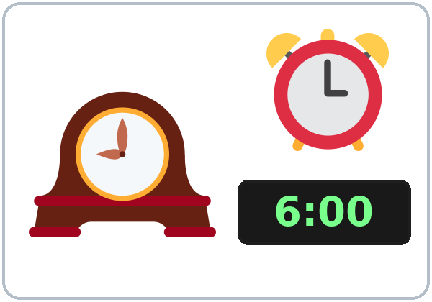  ★ clock | 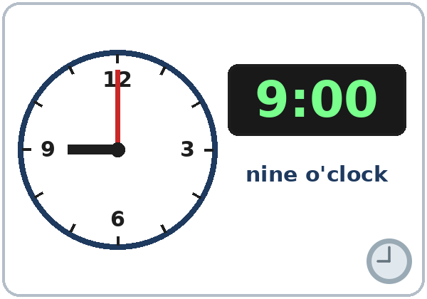  ★ o'clock | 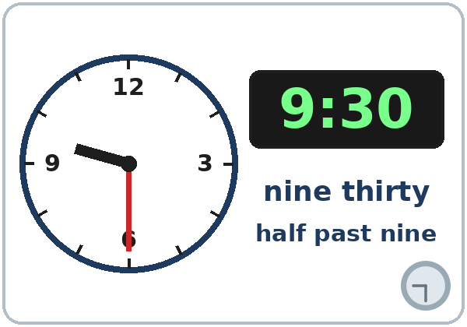  ★ thirty (half past) | 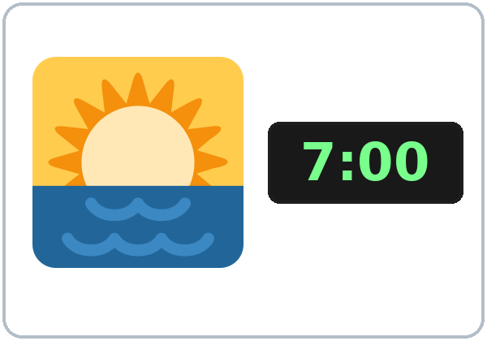  ★ morning
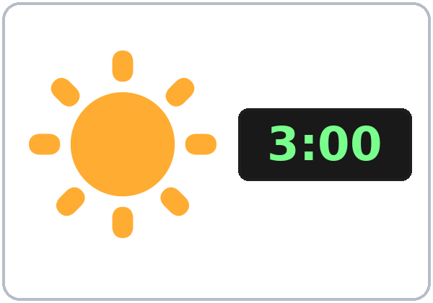  ★ afternoon | 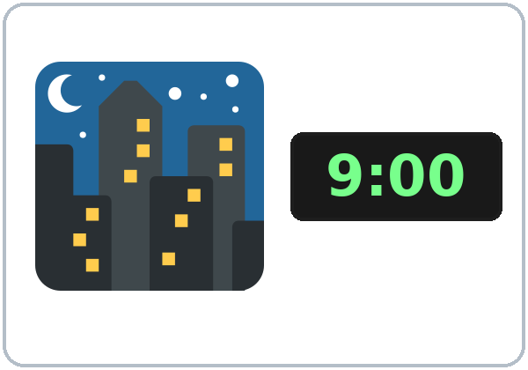  ★ evening / night | 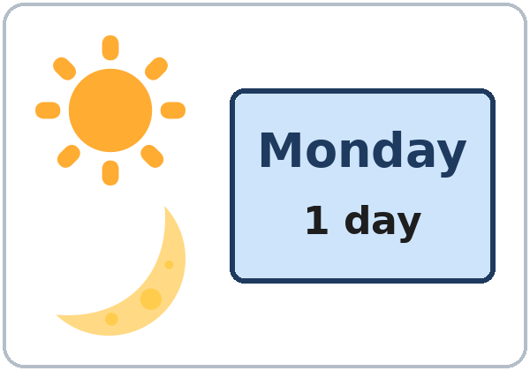  ★ day | 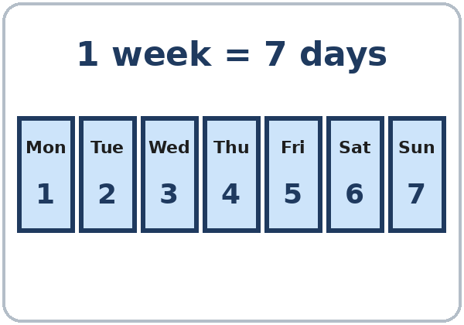  ★ week
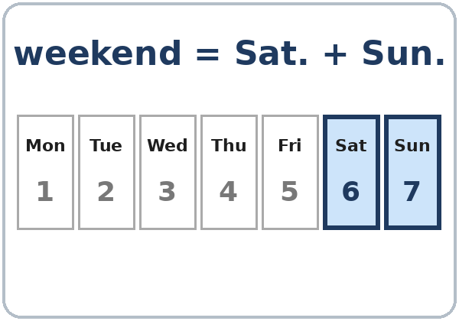  ★ weekend | 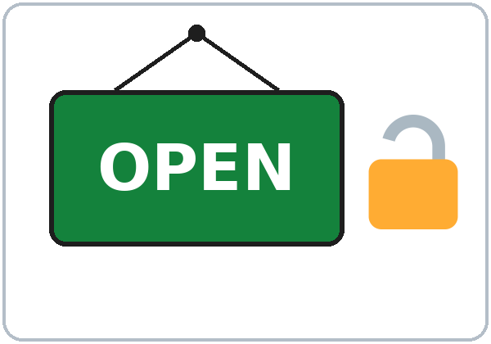  ★ open | 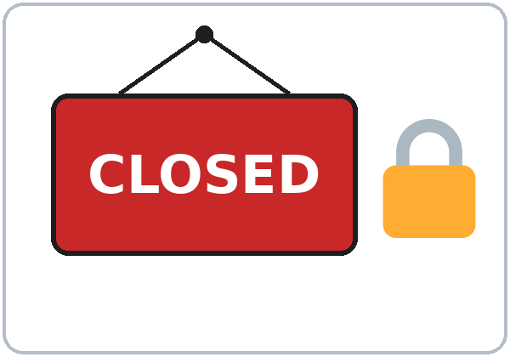  ★ closed | 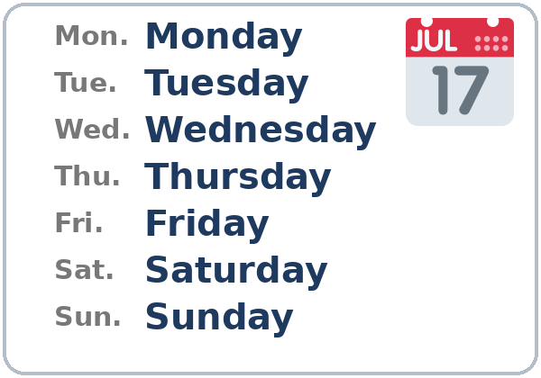  days of the week

Lesson 6 (Week 6) · Listening
A. Kim calls a laundromat and a school. Listen. Circle the time.
Español: Kim llama a una lavandería y a una escuela. Escucha. Encierra la hora.
My language: ______________________________________________
What? | Circle one.
1. The laundromat opens at… | 7:00 | 8:00 | 9:00
2. The laundromat closes at… | 7:00 | 9:00 | 10:00
3. The English class is at… | 6:00 | 6:30 | 7:00

B. Listen again. Check ✓ the days.
Español: Escucha otra vez. Marca ✓ los días.
My language: ______________________________________________
 | Mon. | Tue. | Wed. | Thu. | Fri. | Sat. | Sun.
The laundromat is open. | ☐ | ☐ | ☐ | ☐ | ☐ | ☐ | ☐
The English class is on… | ☐ | ☐ | ☐ | ☐ | ☐ | ☐ | ☐

C. Listen again. Write.
Español: Escucha otra vez. Escribe.
My language: ______________________________________________
1. On Friday, the school is open from ________ to ________.
2. The school is closed on the ________________.
Lesson 6 (Week 6) · Grammar
With a partner: read across. A reads a question (left). B reads an answer (right). Choose one word from each column.
Español: Con un compañero: lee de izquierda a derecha. A lee una pregunta (izquierda). B lee una respuesta (derecha). Elige una palabra de cada columna.
My language: ______________________________________________
Grammar Box 1: What time is it?
QUESTION |  | ANSWER
What time is it? |  | It's | 6:00. (six o'clock)  6:30. (six thirty)
What time is it? |  | It's | 6:15. (six fifteen)  6:45. (six forty-five)

Grammar Box 2: What time is class? What day is class?
QUESTION |  | ANSWER
What time is class? |  | It's | at | 6:00.  7:30.
What day is class? |  | It's | on | Monday.  Monday and Wednesday.

Grammar Box 3: When do you work?
QUESTION |  | ANSWER
When do you work? |  | On | Monday and Tuesday.  the weekend.
When do you work? |  | In | the morning.  the afternoon.  the evening.
When do you work? |  | At | night.  8:00.

Grammar Box 4: at, on, in
WORD |  | USE IT WITH… | ‖ | EXAMPLES
at |  | a time | ‖ | at 6:00 • at 7:30 • at night
on |  | a day | ‖ | on Monday • on the weekend
in |  | part of the day | ‖ | in the morning • in the afternoon • in the evening

Grammar Box 5: Is the store open on Sunday?
QUESTION |  |  | ANSWER
Is the store | open on Sunday?  open on Monday? |  | Yes, it is.
Is the store | open on Sunday?  open on Monday? |  | No, it isn't. | It's closed.
What time is it open? |  |  | From 9:00 to 5:00.

Questions and answers
Q: It's six or They are six?
A: Always It's: It's six o'clock.
Q: How do I say 6:15 and 6:45?
A: Say the numbers: six fifteen, six forty-five.
Q: on Monday or the Monday?
A: on Monday. No the.
Q: in the night?
A: Say at night. But: in the morning, in the afternoon, in the evening.
Practice: Write at, on, or in.
Español: Escribe at, on o in.
My language: ______________________________________________
1. Class is ________ 6:00.
2. Class is ________ Monday and Wednesday.
3. I work ________ the morning.
4. I work ________ night.
5. The store is closed ________ Sunday.
Common mistakes
✗ Don't say | ✓ Say
They are six. | It's six.
Class is in 6:00. | Class is at 6:00.
I work the Monday. | I work on Monday.
I work in the night. | I work at night.
monday | Monday (capital letter)
The store is close. | The store is closed.

Nota para hispanohablantes: En inglés la hora usa It's: It's six o'clock (no «They are six»). a las 6 = at 6:00. el lunes = on Monday (sin the). en la mañana = in the morning, pero en la noche = at night. Los días de la semana empiezan con mayúscula: Monday.

Tip for speakers of other languages: at + a time (at 6:00), on + a day (on Monday), in + the morning / the afternoon / the evening, and at night. Days start with a capital letter.

Lesson 6 (Week 6) · Talk Time · Student A
1. Don't show your page. Ask your partner about the library, the restaurant, and the bank. Write the days and times.
Español: No muestres tu página. Pregunta a tu compañero por la biblioteca, el restaurante y el banco. Escribe los días y las horas.
My language: ______________________________________________
A: Is the library open on Monday? B: Yes, it is. / No, it isn't. It's closed.
A: What time is it open? B: From ___ to ___.
Help: Can you repeat, please?

MY PLACES (Student A) | Days | Open
Clinic | Mon.–Fri. | 8:00 to 5:00
Store | every day | 7:00 to 10:00
Laundromat | Mon.–Sat. (closed Sun.) | 6:00 to 9:00

MY PARTNER'S PLACES | Days | Open
Library
Restaurant
Bank

2. When do you work? (Or: When is English class?) Tell your partner.
Español: ¿Cuándo trabajas? (O: ¿Cuándo es la clase de inglés?) Díselo a tu compañero.
My language: ______________________________________________
I work on ___ and ___, in the ___. / I don't work now. English class is on ___, at ___.

Lesson 6 (Week 6) · Talk Time · Student B
1. Don't show your page. Ask your partner about the clinic, the store, and the laundromat. Write the days and times.
Español: No muestres tu página. Pregunta a tu compañero por la clínica, la tienda y la lavandería. Escribe los días y las horas.
My language: ______________________________________________
B: Is the clinic open on Saturday? A: Yes, it is. / No, it isn't. It's closed.
B: What time is it open? A: From ___ to ___.
Help: Can you repeat, please?

MY PLACES (Student B) | Days | Open
Library | Tue.–Sat. (closed Sun., Mon.) | 10:00 to 6:00
Restaurant | every day | 11:00 to 9:00
Bank | Mon.–Fri. | 9:00 to 4:00

MY PARTNER'S PLACES | Days | Open
Clinic
Store
Laundromat

2. When do you work? (Or: When is English class?) Tell your partner.
Español: ¿Cuándo trabajas? (O: ¿Cuándo es la clase de inglés?) Díselo a tu compañero.
My language: ______________________________________________
I work on ___ and ___, in the ___. / I don't work now. English class is on ___, at ___.

Lesson 6 (Week 6) · Homework
Homework (10 minutes). Bring it next week!
Español: Tarea (10 minutos). ¡Tráela la próxima semana!
My language: ______________________________________________
1. Write about your week.
Español: Escribe sobre tu semana.
My language: ______________________________________________
English class is on ______________________, at ____________.
I work on ______________________. or I don't work now.
2. Write at, on, or in.
Español: Escribe at, on o in.
My language: ______________________________________________
1. ______ Saturday 2. ______ 9:30 3. ______ the afternoon 4. ______ the weekend 5. ______ night
3. Write the time with numbers.
Español: Escribe la hora con números.
My language: ______________________________________________
1. seven o'clock ________ 2. eight thirty ________ 3. four fifteen ________ 4. five forty-five ________
4. Ask a family member or a friend 3 times this week: What time is it?
Español: Pregunta a un familiar o a un amigo 3 veces esta semana: What time is it?
My language: ______________________________________________
5. Review: write about a job (yours or a family member's).
Español: Repaso: escribe sobre un trabajo (el tuyo o el de un familiar).
My language: ______________________________________________
I'm a / an ______________________. or My mother is a / an ______________________.
Lesson 6 (Week 6) · Letters & Numbers
A. Look. Listen. Say the time.
Español: Mira. Escucha. Di la hora.
My language: ______________________________________________
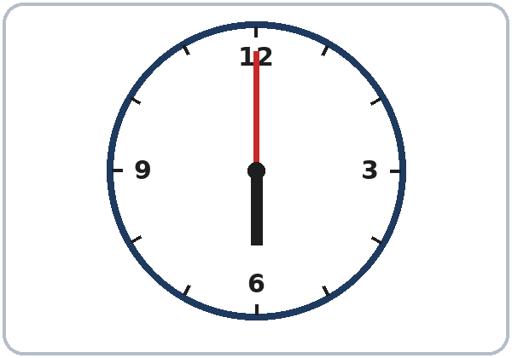  6:00 six o'clock | 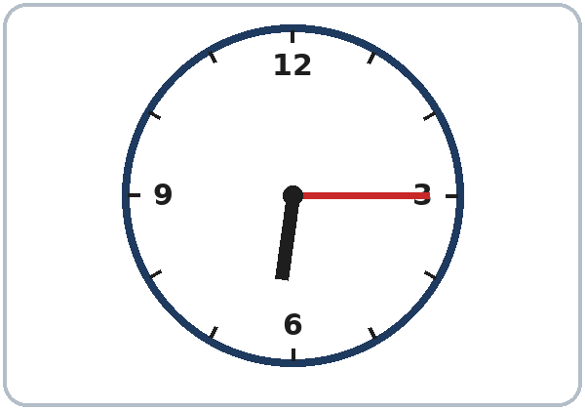  6:15 six fifteen | 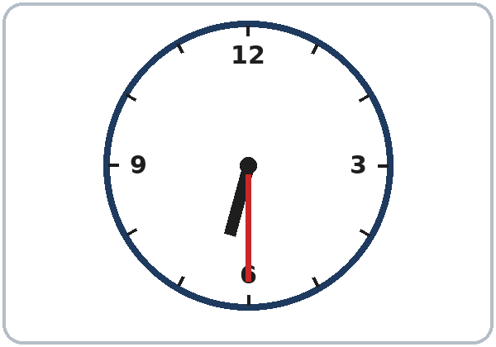  6:30 six thirty | 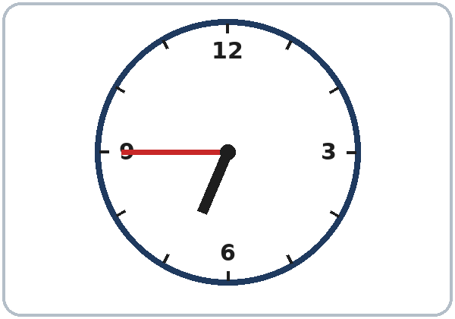  6:45 six forty-five

B. Listen to the teacher. Write the time.
Español: Escucha al profesor. Escribe la hora.
My language: ______________________________________________
1. ______ : ______ 2. ______ : ______ 3. ______ : ______ 4. ______ : ______
C. Days start with a capital letter. Write the short form.
Español: Los días empiezan con mayúscula. Escribe la forma corta.
My language: ______________________________________________
Monday | Tuesday | Wednesday | Thursday | Friday | Saturday | Sunday
Mon.

D. Read the sign. Circle Yes or No. Write the time.
Español: Lee el letrero. Encierra Yes (sí) o No. Escribe la hora.
My language: ______________________________________________
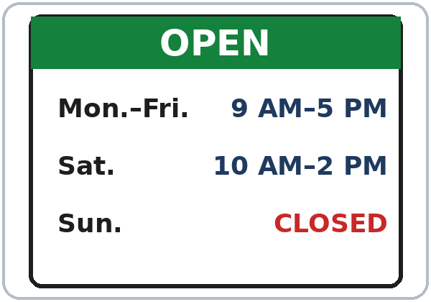

AM = morning. PM = afternoon and night.
1. The store is open on Saturday. | Yes | No
2. The store is open on Sunday. | Yes | No

3. On Monday, the store is open from ________ to ________.
Lesson 6 (Week 6) · Progress Check
Name: ______________________________ Date: ________________
A. Listen to the teacher. Circle the time.
Español: Escucha al profesor. Encierra la hora.
My language: ______________________________________________
1. | 6:00 | 6:30
2. | 7:15 | 7:50
3. | 3:00 | 3:30
4. | 9:15 | 9:45
5. | 11:30 | 12:30

B. Match the question and the answer. Draw a line.
Español: Une la pregunta con la respuesta. Dibuja una línea.
My language: ______________________________________________
Question | Draw a line. | Answer
1. What time is it? ● |  | ● a. It's on Monday.
2. What day is class? ● |  | ● b. From 9:00 to 5:00.
3. Is the bank open on Sunday? ● |  | ● c. It's 7:30.
4. What time is it open? ● |  | ● d. No, it isn't. It's closed.

C. Write at, on, or in.
Español: Escribe at, on o in.
My language: ______________________________________________
1. Class is ________ 6:00.
2. I work ________ Friday.
3. I study ________ the evening.
D. How do you feel? Check ✓ one face for each line.
Español: ¿Cómo te sientes? Marca ✓ una cara en cada línea. 😀 = I can do it. 🙂 = I can do it with a little help. 😐 = Not yet.
My language: ______________________________________________
I can… | 😀 | 🙂 | 😐
I can ask and tell the time. | ☐ | ☐ | ☐
I can say the days of the week. | ☐ | ☐ | ☐
I can understand store hours. | ☐ | ☐ | ☐
I can say when I work (or when class is). | ☐ | ☐ | ☐

Score: A ______ / 5 B ______ / 4 C ______ / 3
Picture Credits
Vocabulary pictures use Twemoji graphics by Twitter, Inc. and other contributors (https://github.com/jdecked/twemoji), licensed under CC BY 4.0 (https://creativecommons.org/licenses/by/4.0/). The graphics were resized and combined, and clock faces, digital clocks, week strips, OPEN / CLOSED signs, and labels were added. The four clock faces in Letters & Numbers and the store-hours sign are drawn in code. All names, places, and hours on the pages are invented. The file-by-file list is in images/CREDITS.md.
Other small pictures on the pages (the faces on the Progress Check) are standard emoji characters shown with the computer's emoji font. Listening audio: synthetic voices made with Chatterbox TTS (Resemble AI, MIT License); each file carries an inaudible Perth watermark marking it as AI-generated. The voices are copied from short reference clips made with Kokoro-82M (Apache 2.0); no recordings of real people were used. Course materials: © 2026 the authors, CC BY-NC-SA 4.0.

