Level 1 Adult ESL Curriculum · Lesson 7 (Week 7): How Much Is It?
Status: Draft for review (all 13 Level 1 lessons are built).
Date: October 2026
Audience: Program coordinators and volunteer teachers
Companion files: audio/L1_L7_listening.mp3, images/ (12 vocabulary pictures, grammar pictures, listening and store pictures, a play-money page, a receipt + images/CREDITS.md)
Topic: money and shopping for clothes. Learners ask and understand prices (How much is this shirt? It's $12. How much are these shoes? They're $30.), use this / that / these / those, put the color before the noun (a blue shirt, black shoes), and pay and check their change in a store role play. Letters & Numbers: reading prices ($4.99 = "four ninety-nine"), the short i in this and the long ee in these, and reading a receipt.

How this lesson is organized
Part | What's inside | Who uses it
Teacher Plan | At a glance, clock-time plan, step-by-step boxes, Letters & Numbers script, listening script, answer key, teacher notes | Volunteer teachers
Student Pages | Hello + Review, New Words, Listening, Grammar, Talk Time (Student A and Student B store pages + play money), Homework, Letters & Numbers, Progress Check. Print this part for learners | Learners
Picture Credits | Picture sources and licenses | Coordinators

What Lesson 7 gives Level 2
Level 2 uses… | Where in Level 2 | Lesson 7 starts it with…
Prices and money | Lessons 7 and 9 (shopping, food prices) | How much is it? It's $12. (Grammar Boxes 1–2, Talk Time store role play)
this / that / these / those | Lesson 7 | Grammar Box 3 with pictures (near / far, one / two or more)
Plural nouns; is / are | All lessons | How much is this shirt? How much are these shoes? • pants, shoes are always plural
Adjective before the noun | Lessons 3 and 7 (describing things) | a blue shirt, black shoes (Grammar Box 4)
receipt | Lesson 12 (returns and problems) | The New Words page, the listening, and the receipt in Letters & Numbers

TEACHER PLAN
Lesson 7 (Week 7)

How Much Is It?
At a glance · Clock-time plan · Step by step · Letters & Numbers · Script and answer key

How to Use This Plan
You don't need to speak Spanish or any other language. Teach in English. Show, point, and gesture. The student pages have a Spanish line and a "My language" line for every task. Learners read those on their own. You never need to read, translate, or explain them.

Instruction rule: Model it (do it with one learner while everyone watches), check it (ask: "Listen or write?"), then go. Say less, show more. Use the same short words every time: Listen. Repeat. Point. Circle. Write. Partner. Group.

Grouping toolkit: Pairs: turn to a neighbor; with an odd number, make one group of 3. Groups: 3–4 learners. Mingle: everyone stands and talks to many classmates. The teacher joins a pair only if one learner is left over.

When a learner is stuck or speaks another language to you: (1) show it: the picture, a gesture, or the board; (2) give one more short English example; (3) point to the instruction and the grammar box on their page; (4) a classmate can help for a few seconds, then back to English. You don't need to understand what classmates say to each other.

Money is private. Use only play money and the invented prices on the pages. Never ask what learners earn, spend, or pay for rent, and never ask them to show real money or real cards.

Lesson 7 (Week 7): How Much Is It?
At a glance
Objectives: learners can…
• ask the price: How much is this shirt? How much are these shoes?
• understand and say prices: It's $12. They're $30. It's $4.99 ("four ninety-nine").
• use this / that (one) and these / those (two or more)
• name clothes and colors, with the color before the noun: a blue shirt, black shoes
• pay and check the change: Cash or credit card? Cash, please. Here's $20. Your change is $5.
• read prices and a simple receipt (Letters & Numbers block)

Materials
• Student Pages for Lesson 7 (print for the number expected + 3 spares). Talk Time: print the Student A page for half the class and the Student B page for the other half.
• play money: print the play-money page (one per pair is enough) and cut it before class. Put each pair's money in an envelope.
• 2 or 3 real clothes you can hold up (a shirt or a jacket, a pair of shoes), and one far away on a chair (for that / those)
• mini whiteboards or scrap paper for Letters & Numbers
• phone + small speaker, L1_L7_listening.mp3
• Prep time: 40 min (printing and cutting the play money).

Key vocabulary (with pictures on the New Words page)
★ dollar • ★ cent • coin • ★ cash • ★ credit card • receipt • ★ shirt • ★ pants • ★ shoes • ★ jacket • ★ dress • colors (red, blue, black, white, green, yellow)

Review from Lessons 1–6
What time is it? It's 6:30. • at 6:00, on Monday, in the morning • Is the store open on Sunday? • numbers 1–100

Clock-time plan
Times are loose. If a step runs long, take the time from Grammar or Talk Time. The last 15 minutes are the Letters & Numbers block.
Time | Step | Min | Grouping (15 / 7–8) | If running behind
6:00–6:10 | Hello + Review (Lesson 6 time questions) + homework check | 10 | Pairs, then new pairs | One partner only
6:10–6:20 | New Words (picture page) + real clothes | 10 | Whole class, then pairs | Teach the ★ words only
6:20–6:32 | Listening (audio): Ana at a clothing store | 12 | Individuals, then pairs check | Play the audio 2 times, not 3
6:32–6:45 | Grammar Q&A: How much is / are…? this / that / these / those, color + noun + pair drill | 13 | Whole class, then pairs | Skip the pair drill; it becomes homework
6:45–7:00 | BREAK | 15
7:00–7:10 | Talk Time: Store role play with play money (A–B, then switch) | 10 | A–B pairs / A–B pairs | One round only (Part 1)
7:10–7:15 | Exit Ticket + Homework | 5 | Individuals | Never skip
7:15–7:25 | Letters & Numbers: prices, this / these sounds, a receipt | 10 | Whole class, then pairs | Do Tasks A and B only
7:25–7:30 | Progress Check | 5 | Individuals | Do it in Week 8 before the midterm, or at 6:00

Skip order if you're running behind: (1) the third play of the audio; (2) the pair drill at the end of Grammar; (3) Talk Time Part 2. Never skip: the listening tasks, the grammar boxes, and the exit ticket.

Attendance (15 → 7–8): every step lists both sizes. Print for the number you expect, plus 3 spares. Late arrivals join any pair right away. In Talk Time, an A always works with a B; with an odd number, two Bs share one A (one is the shopper, one helps count the money).

Step by step
Step 1 · 6:00–6:10 · Hello + Review · 10 min
• Grouping: pairs. 15 learners: 7 pairs + 1 group of 3. 7–8 learners: 3–4 pairs. Late arrivals join any pair.
• Before class: write on the board: What time is it? What time is class? What day is class? Is the store open on Sunday?
• Model with one learner: "What time is it?" → "It's six o'clock." "What day is class?" → "It's on Monday."
• Do: pairs use the Hello + Review page. Switch. Then find a new partner.
• Homework check (last 3 min): partners show each other their Lesson 6 homework. Walk around and look at item 2 (at / on / in).
• New learners: pair them with a strong partner. They can do the Lesson 1–6 Progress Checks at home.
• If behind: one partner only.

Step 2 · 6:10–6:20 · New Words · 10 min
• Grouping: whole class, then pairs.
• Show: hold up a real shirt: "This is a shirt. It's blue." Hold up shoes: "Shoes. Two shoes." Point to colors in the room: "Red. Black. White."
• Do: point to each picture and say the word. Learners repeat twice. For cash, show the play money; for credit card, mime paying with a card. 100 cents = 1 dollar (write it on the board).
• pants, shoes: say "pants" and hold up 2 fingers: one item, but the word is always plural.
• Pairs (4 min): A points to a picture, B says the word. Then A says a color, B points to something in the room with that color.
• If behind: teach the ★ words only.

Step 3 · 6:20–6:32 · Listening · 12 min
• Grouping: individuals, then pairs check.
• Before you listen (1 min): say: "Ana is at a clothing store. She asks: How much is it?" Point to the shirts and shoes in Task A.
• Listen 1 → Task A: learners circle the color of the shirt and the shoes Ana buys.
• Listen 2 → Task B: learners write the 2 prices.
• Listen 3 → Task C: learners check the total, cash or card, and write the change.
• Pairs compare after each task: "Show your partner." Then write the answers on the board.
• The audio plays the conversation once. Press play again for the next listen.
• If behind: play the audio 2 times, and do Task C together.

Step 4 · 6:32–6:45 · Grammar Q&A · 13 min
• Grouping: whole class, then pairs.
• Show: the Grammar page. The left side is the question. The right side is the answer. Point left, then right.
• Boxes 1–2: hold up the shirt: "How much is this shirt?" → "It's $12." Hold up the shoes: "How much are these shoes?" → "They're $30." Write on the board: one → is / it's. two or more → are / they're.
• Box 3 (the key point): stand next to the shirt: "this shirt." Walk away and point to the far chair: "that shirt." Same with shoes: "these shoes… those shoes." Learners point near and far as they say the words.
• Box 4: write a shirt blue on the board and cross it out with an ✗. Write a blue shirt ✓. Then black shoes ✓ and blacks shoes ✗: colors never take -s.
• Box 5: model paying with play money: "That's $8." → give $10 → "Your change is $2."
• Check questions: hold up one shirt: "How much ___ this shirt?" (is) • hold up shoes: "How much ___ these shoes?" (are) • "shirt / red / a" (a red shirt)
• Pair drill (last 3–4 min): A points to a picture on the New Words page and asks; B invents a price. Then switch.
• If behind: skip the pair drill. It becomes homework, and Talk Time practices the same questions.

Break · 6:45–7:00 · 15 min
• Put the Student A and Student B pages in two piles, and one envelope of play money per pair. Write on the board: How much is this ___? It's $___. How much are these ___? They're $___. Cash or credit card? Here's $___. Your change is $___.

Step 5 · 7:00–7:10 · Talk Time: Store Role Play · 10 min
• Grouping: A–B pairs. Give half the class the Student A page and half the Student B page, and each pair one envelope of play money. Partners don't show their pages.
• Model with one learner (you are the shopper): point to the dress on your page. "How much is this red dress?" → "It's $25." "OK. Here's $30." → "Your change is $5." Write the price and the change on the board.
• Part 1 (4 min): A is the cashier (Store 1, with prices). B is the shopper: B gets the play money, asks the price of the 3 things, writes the prices, buys one thing, pays, and checks the change.
• Part 2 (4 min): switch. B is the cashier (Store 2). A is the shopper.
• Check (2 min): partners show their pages. Are the prices the same?
• Fast pairs: buy 2 things and say the total: "That's $43."
• If behind: one round only (Part 1).

Step 6 · 7:10–7:15 · Exit Ticket + Homework · 5 min · NEVER SKIP
• Exit ticket: hold up a picture or a real item. Each learner asks "How much is this ___?" / "How much are these ___?" or writes one color + noun (a red dress). Copying is fine.
• Homework: open the Homework page. Do item 1 together (the first line). Point to each instruction so learners know what to do at home.
• Collect the play money for next time.

Letters & Numbers · 7:15–7:25 · Prices, This / These, a Receipt · 10 min
• Grouping: whole class, then pairs. Use the Letters & Numbers page.
• See it (2 min): Task A: point to each price and say it. $4.99 = "four ninety-nine"; $12.50 = "twelve fifty"; $20.00 = "twenty dollars". The dot is a period; the numbers after it are cents.
• Hear it (2 min): Task B: say the 5 prices in the answer key, 2 times each. Learners circle.
• Say it (2 min): Task C: this has a short i (like six); these has a long ee (like three). Smile wide for ee. Say the pairs; learners repeat.
• Read it (3 min): Task D: read the receipt together. Learners answer the 3 questions.
• Partners: A says a price from Task A, B points to it. Switch.
• Learners who can't read or write yet: they say the prices with everyone and point. In Task D they find and circle the TOTAL. A helper, if you have one, sits with them.
• If behind: do Tasks A and B only.

Progress Check · 7:25–7:30 · 5 min
• Grouping: individuals. Open the Progress Check page.
• Part A: read the 5 prices (answer key), slowly, 2 times each. Learners circle.
• Parts B and C: learners match and write on their own. Walk around and help with the instructions only.
• Part D: read each "I can…" line aloud and point to the 3 faces: 😀 "I can do it." 🙂 "A little." 😐 "Not yet." Learners check one.
• Collect the pages. Week 8 is the midterm; Parts A and C show who needs a quick review of prices and is / are.
• If behind: do the Progress Check in Week 8 at 6:00, before the midterm.

Listening script: L1_L7_listening.mp3 (about 1:10; the conversation plays once, so play the audio again if needed)
Audio: play from a phone + small speaker. No speaker? Read the script with a volunteer. Say the prices as words: twelve dollars, thirty dollars.

Narrator: Lesson seven. Listening. Ana is at a clothing store. She talks to the cashier. Listen.
Cashier: Hi! Can I help you?
Ana: Yes, please. How much is this shirt?
Cashier: The blue shirt? It's $12.
Ana: Do you have this shirt in red?
Cashier: No, sorry. Only blue and white.
Ana: OK, blue is good. And how much are these shoes?
Cashier: The black shoes? They're $30.
Ana: Good. The blue shirt and the black shoes, please.
Cashier: OK. That's $42. Cash or credit card?
Ana: Cash, please. Here's $50.
Cashier: Thank you. Your change is $8.
Ana: Thank you. Can I have the receipt, please?
Cashier: Sure. Here's your receipt. Have a nice day!
Ana: You too. Bye!
Narrator: That's the end of the listening.

Answer key
• Listening Task A: the shirt: b (blue) • the shoes: a (black).
• Listening Task B: 1 $12, 2 $30.
• Listening Task C: 1 ✓ $42, 2 ✓ cash, 3 $8, 4 ✓ the receipt.
• Grammar practice: 1 is, 2 are, 3 this, 4 these, 5 a red shirt.
• Talk Time: Store 1: red dress $25, black pants $18, white shoes $35 • Store 2: green jacket $40, yellow shirt $9, blue pants $22.
• Homework 1: 1 is, 2 are, 3 are, 4 is.
• Homework 2: 1 a green jacket, 2 black shoes, 3 a white dress.
• Letters & Numbers Task B (the teacher says): 1 $4.99 ("four ninety-nine"), 2 $13 ("thirteen dollars"), 3 $15.50 ("fifteen fifty"), 4 $60 ("sixty dollars"), 5 $2.25 ("two twenty-five"). Say each price 2 times.
• Letters & Numbers Task D: 1 $40.00, 2 $83.00, 3 $17.00.
• Progress Check Part A (the teacher says): 1 $12, 2 $40, 3 $5.99 ("five ninety-nine"), 4 $18, 5 $70. Say each price 2 times.
• Progress Check Part B: 1 c, 2 a, 3 d, 4 b.
• Progress Check Part C: 1 are, 2 is, 3 a red dress.
• Progress Check scoring: Part A /5 + Part B /4 + Part C /3 = /12. This is not a test grade. Part A shows who can hear prices (and -teen / -ty again); Part C shows is / are and color + noun.
Teacher notes
• Money is private: only play money and invented prices. If a learner talks about real prices or real money problems, listen kindly and move back to the activity.
• The big mistake this week: the color after the noun. Spanish says una camisa azul. In English the color comes first: a blue shirt. And colors never take -s: black shoes (not blacks shoes). Correct by pointing at the word order on the board. Learners can read the Spanish note on their Grammar page.
• is / are: one thing → How much is this shirt? It's $12. Two or more → How much are these shoes? They're $30. Pants and shoes always use are.
• this / that / these / those: near / far + one / more than one. Use your body: stand next to the thing for this / these, point far away for that / those.
• Saying prices: $4.99 = "four ninety-nine" (people don't say the word dollars or cents here). $12 = "twelve dollars". $12.50 = "twelve fifty". -teen / -ty matter again: $13 or $30?
• this and these: many learners say both the same. this = short i (sit); these = long ee (see). Don't over-correct; the grammar (is / are) helps listeners understand.
• Mixed levels: strong learners buy 2 things, say the total, and use Do you have this in ___? New learners use only How much is this? and point.
• Learners who can't read or write yet: in Talk Time they are good cashiers: they say the price from the tag and count the play money.
• Looking ahead: Week 8 is the midterm (Lessons 1–7). Lesson 8 (food) uses How much is…? again and adds I like… / I don't like….

STUDENT WORKBOOK
Lesson 7 (Week 7)

How Much Is It?
Hello + Review · New Words · Listening · Grammar · Talk Time · Homework · Letters & Numbers · Progress Check

Lesson 7 (Week 7): How Much Is It?
Student Page 1 · Week 7
Name: ______________________________ Date: ________________
Hello + Review: ask your partner. Then switch.
Español: Pregunta a tu compañero. Después cambien.
My language: ______________________________________________
A: What time is it? B: It's ___.
A: What time is English class? B: It's at ___.
A: What day is English class? B: It's on ___ and ___.
A: Is the store open on Sunday? B: Yes, it is. / No, it isn't. It's closed.
Help: Can you repeat, please? How do you spell it?

Lesson 7 (Week 7) · New Words
New Words
Look. Listen. Repeat. Then partners: A points, B says the word. ★ = most important words.
Español: Mira. Escucha. Repite. Después en parejas: A señala, B dice la palabra.
My language: ______________________________________________
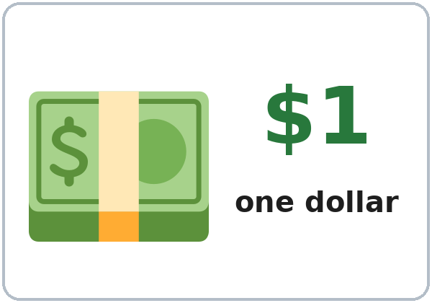  ★ dollar | 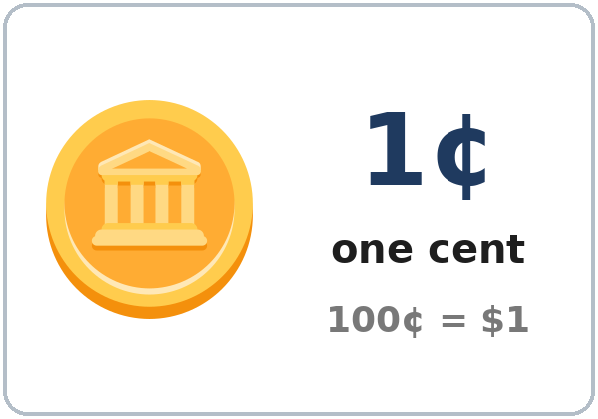  ★ cent | 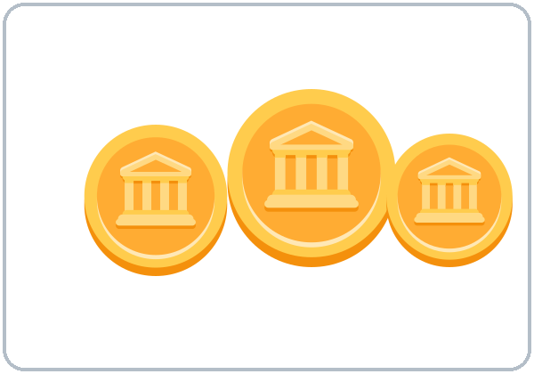  coin | 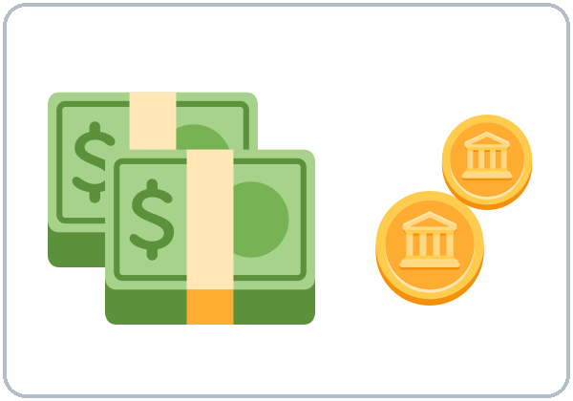  ★ cash
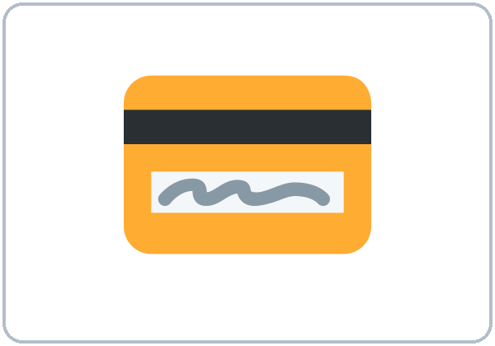  ★ credit card | 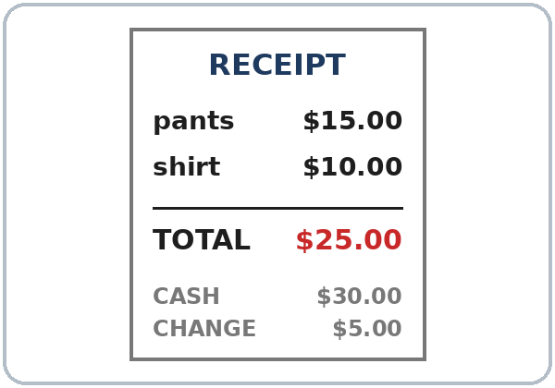  receipt | 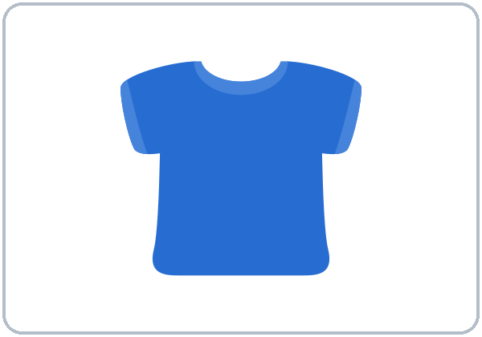  ★ shirt | 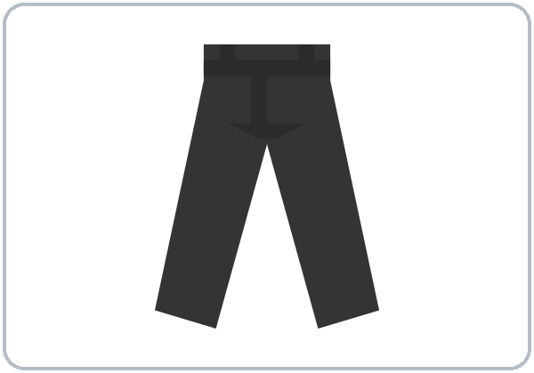  ★ pants
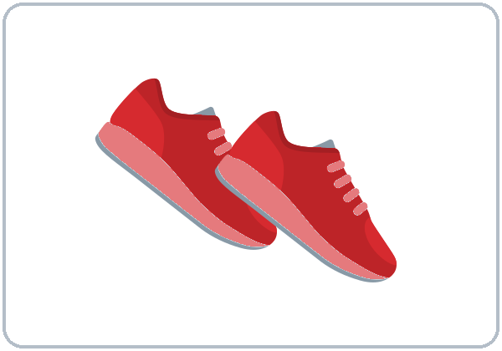  ★ shoes | 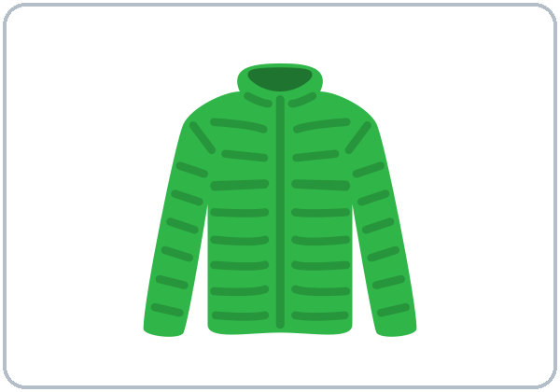  ★ jacket | 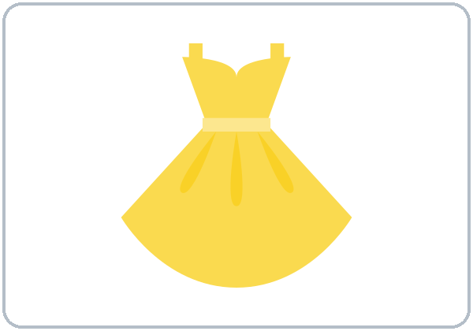  ★ dress | 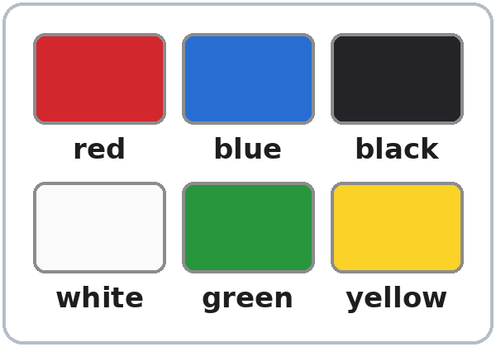  colors

Lesson 7 (Week 7) · Listening
A. Ana is at a clothing store. Listen. Circle what she buys.
Español: Ana está en una tienda de ropa. Escucha. Encierra lo que compra.
My language: ______________________________________________
 | a | b | c
1. the shirt | 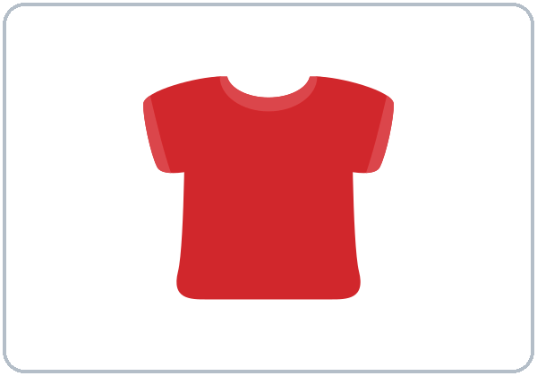  red | 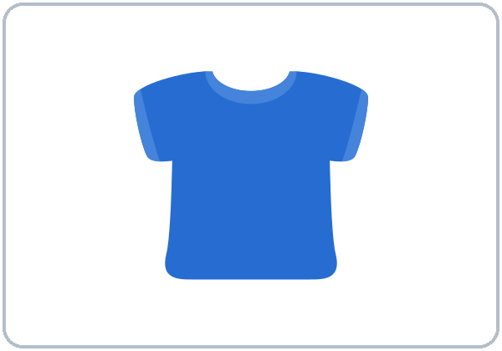  blue | 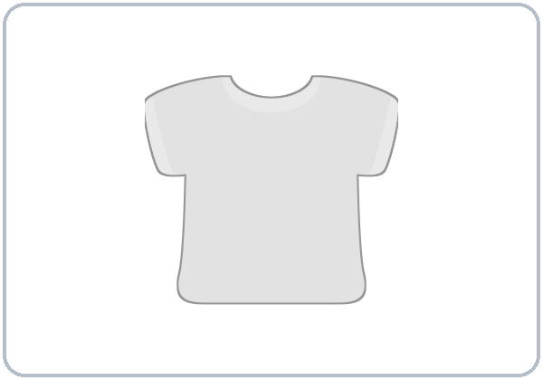  white
2. the shoes | 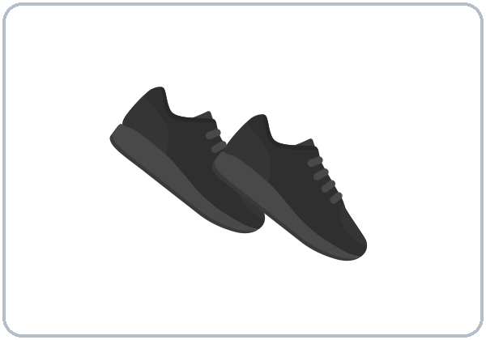  black | 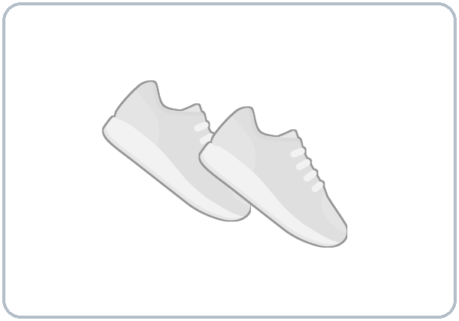  white | 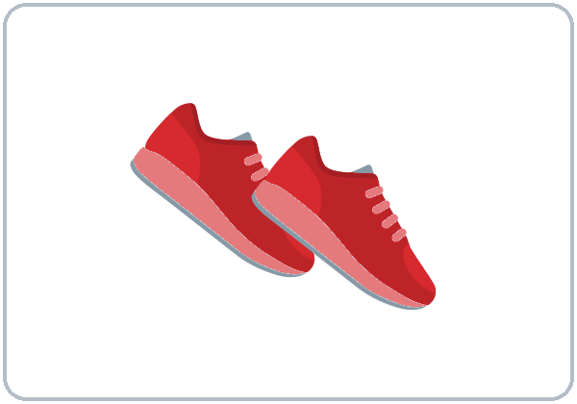  red

B. Listen again. Write the price.
Español: Escucha otra vez. Escribe el precio.
My language: ______________________________________________
1. The shirt is $________. 2. The shoes are $________.
C. Listen again. Check ✓ or write.
Español: Escucha otra vez. Marca ✓ o escribe.
My language: ______________________________________________
1. The total is: ☐ $32 ☐ $42 ☐ $52 2. Ana pays with: ☐ cash ☐ a credit card
3. Her change is $________. 4. Ana asks for: ☐ a bag ☐ the receipt
Lesson 7 (Week 7) · Grammar
With a partner: read across. A reads a question (left). B reads an answer (right). Choose one word from each column.
Español: Con un compañero: lee de izquierda a derecha. A lee una pregunta (izquierda). B lee una respuesta (derecha). Elige una palabra de cada columna.
My language: ______________________________________________
Grammar Box 1: How much is this shirt? (one)
QUESTION |  |  |  | ANSWER
How much is | this  that | shirt?  dress?  jacket? |  | It's | $12.  $25.  $40.

Grammar Box 2: How much are these shoes? (two or more)
QUESTION |  |  |  | ANSWER
How much are | these  those | shoes?  pants? |  | They're | $30.  $18.

Grammar Box 3: this, that, these, those
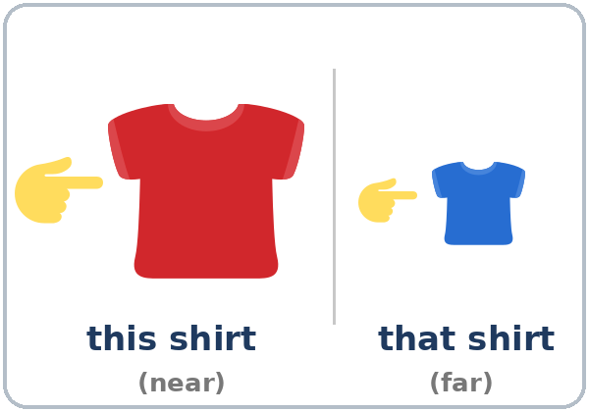  one: this (near) • that (far) | 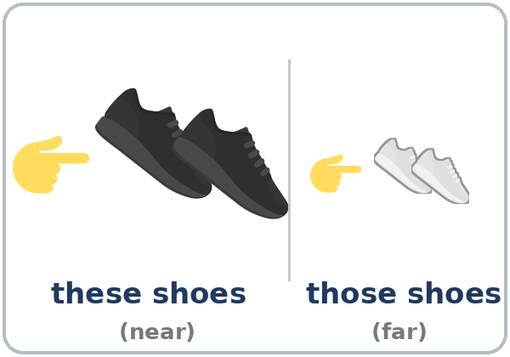  two or more: these (near) • those (far)

Grammar Box 4: color + noun
✓ SAY |  | ✗ DON'T SAY
a blue shirt |  | a shirt blue
black shoes |  | shoes black • blacks shoes
a red dress |  | a dress red

Grammar Box 5: Cash or credit card?
CASHIER |  | SHOPPER
That's $42. Cash or credit card? |  | Cash, please. Here's $50.  Credit card, please.
Your change is $8. |  | Thank you. Can I have the receipt, please?

Questions and answers
Q: is or are?
A: One thing → is (How much is this shirt? It's $12.). Two or more → are (How much are these shoes? They're $30.). Pants and shoes → always are.
Q: this or that?
A: Near → this / these. Far → that / those.
Q: Where does the color go?
A: Before the thing: a blue shirt. Colors never add -s: black shoes.
Practice: Write is, are, this, or these. Then put the words in order.
Español: Escribe is, are, this o these. Después ordena las palabras.
My language: ______________________________________________
1. How much ________ this jacket?
2. How much ________ these pants?
3. How much is ________ dress? (near, one)
4. How much are ________ shoes? (near, two)
5. shirt / red / a → ______________________________
Common mistakes
✗ Don't say | ✓ Say
How much is these shoes? | How much are these shoes?
How much cost this? | How much is this?
a shirt blue | a blue shirt
blacks shoes | black shoes
this shoes | these shoes

Nota para hispanohablantes: En inglés el color va antes de la cosa: a blue shirt (no «a shirt blue»). Los colores nunca llevan -s: red shoes (no «shoes reds»). Pants y shoes siempre son plurales: these pants are… Para preguntar el precio: How much is…? (una cosa) o How much are…? (dos o más), no «How much cost…?».

Tip for speakers of other languages: Color first: a blue shirt. Colors don't change: red shoes. One thing → is / this / that. Two or more → are / these / those.

Lesson 7 (Week 7) · Talk Time · Student A
1. Store 1: you are the cashier. Your partner asks. Say the price (It's $__. / They're $__.). Take the money. Give the change.
Español: Tienda 1: eres el cajero. Tu compañero pregunta. Di el precio. Recibe el dinero. Da el cambio.
My language: ______________________________________________
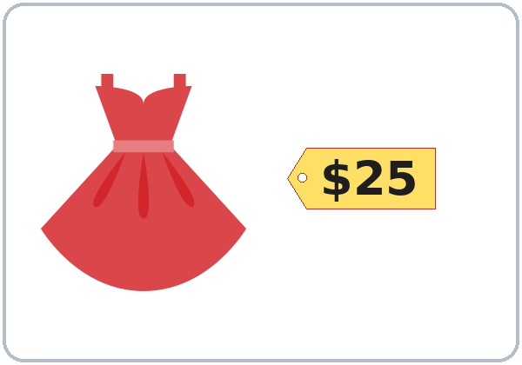  a red dress | 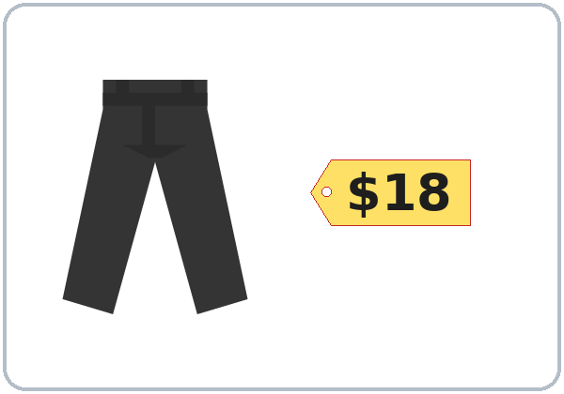  black pants | 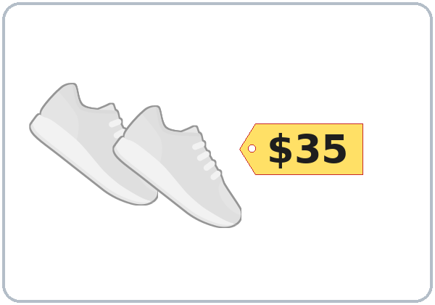  white shoes

2. Store 2: switch. You are the shopper. Ask the prices. Write them. Buy one thing.
Español: Tienda 2: Cambien. Eres el comprador. Pregunta los precios. Escríbelos. Compra una cosa.
My language: ______________________________________________
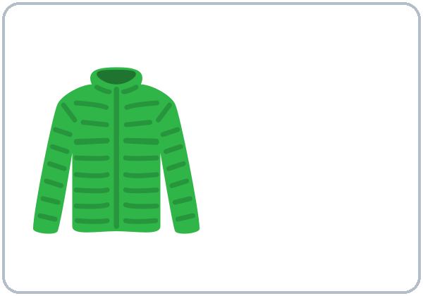  green jacket: $______ | 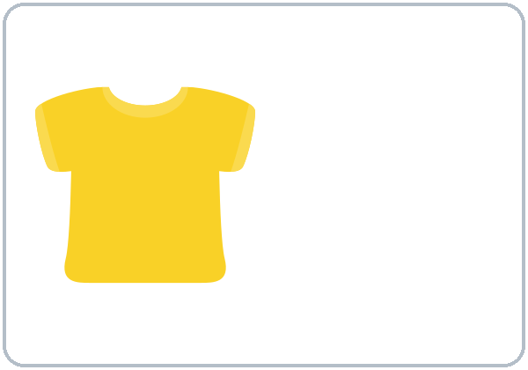  yellow shirt: $______ | 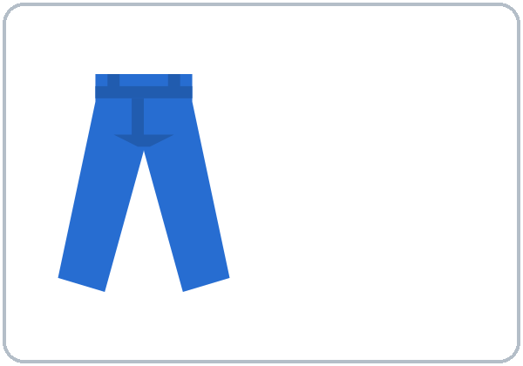  blue pants: $______

Shopper: How much is this green jacket? • How much are these blue pants? • Here's $___. • My change is $______.

Lesson 7 (Week 7) · Talk Time · Student B
1. Store 1: you are the shopper. Ask the prices. Write them. Buy one thing.
Español: Tienda 1: Eres el comprador. Pregunta los precios. Escríbelos. Compra una cosa.
My language: ______________________________________________
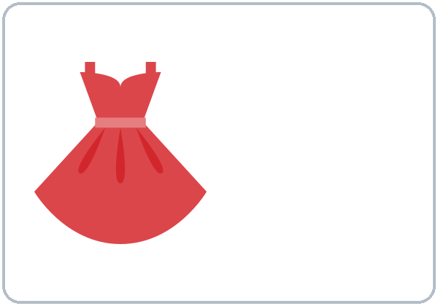  red dress: $______ | 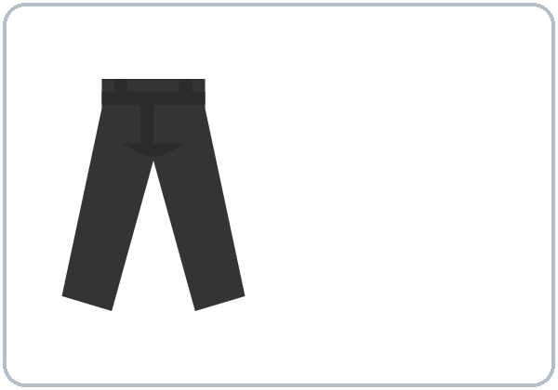  black pants: $______ | 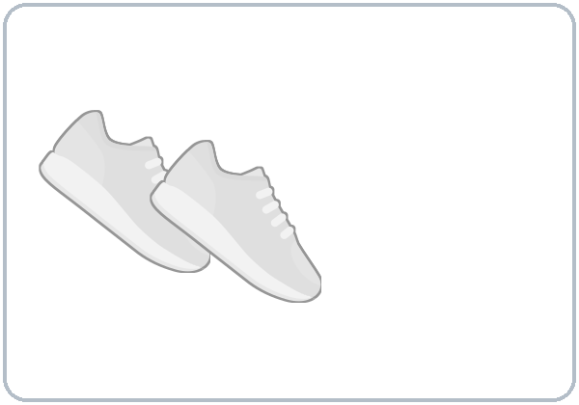  white shoes: $______

Shopper: How much is this red dress? • How much are these white shoes? • Here's $___. • My change is $______.

2. Store 2: switch. You are the cashier. Your partner asks. Say the price (It's $__. / They're $__.). Take the money. Give the change.
Español: Tienda 2: Cambien. Eres el cajero. Tu compañero pregunta. Di el precio. Recibe el dinero. Da el cambio.
My language: ______________________________________________
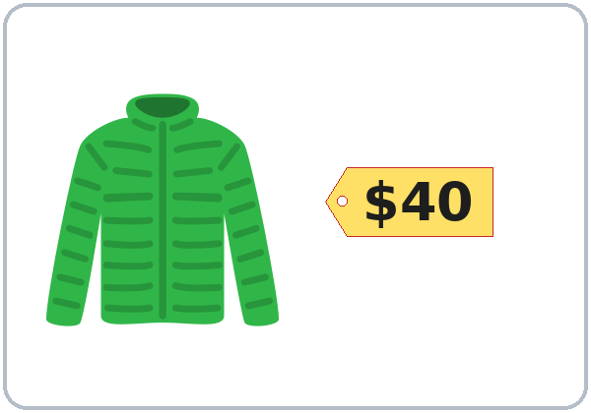  a green jacket | 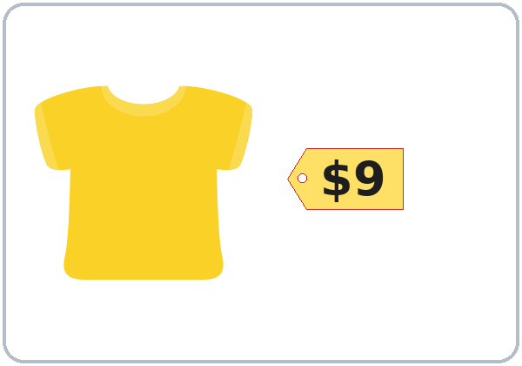  a yellow shirt | 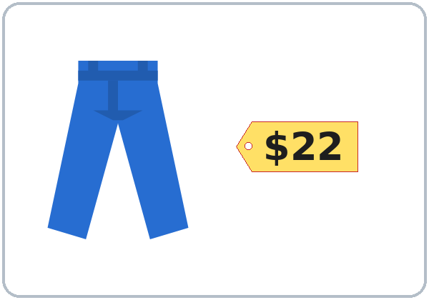  blue pants

Lesson 7 (Week 7) · Talk Time · Play Money
Cut out the money. Use it in the store. (Play money only: never real money.)
Español: Recorta el dinero. Úsalo en la tienda. (Solo dinero de juego: nunca dinero real.)
My language: ______________________________________________
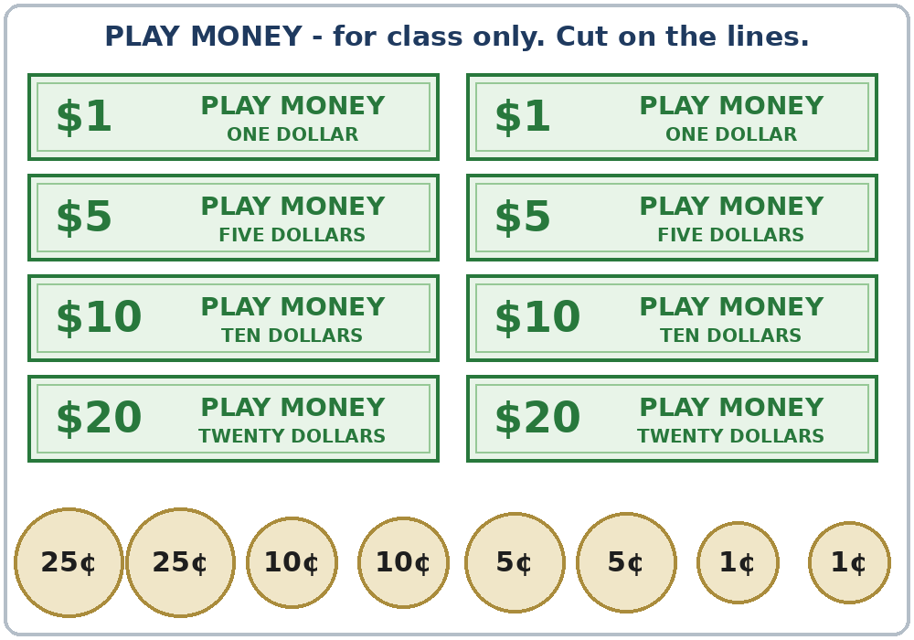

Lesson 7 (Week 7) · Homework
Homework (10 minutes). Bring it next week!
Español: Tarea (10 minutos). ¡Tráela la próxima semana!
My language: ______________________________________________
1. Write is or are.
Español: Escribe is o are.
My language: ______________________________________________
1. How much ______ this dress? 2. How much ______ these shoes?
3. How much ______ those pants? 4. How much ______ that jacket?
2. Put the words in order.
Español: Ordena las palabras.
My language: ______________________________________________
1. jacket / green / a → ______________________________
2. shoes / black → ______________________________
3. dress / a / white → ______________________________
3. Look at 3 price tags in a store (or in an ad). Write them.
Español: Mira 3 etiquetas de precio en una tienda (o en un anuncio). Escríbelas.
My language: ______________________________________________
1. ______________ $______ 2. ______________ $______ 3. ______________ $______
4. Say the prices to a family member or a friend: "It's four ninety-nine."
Español: Di los precios a un familiar o a un amigo.
My language: ______________________________________________
5. Review: write the time and the day of English class.
Español: Repaso: escribe la hora y el día de la clase de inglés.
My language: ______________________________________________
English class is on ______________________, at ____________.
Lesson 7 (Week 7) · Letters & Numbers
A. Look. Listen. Say the prices.
Español: Mira. Escucha. Di los precios.
My language: ______________________________________________
WRITE | ‖ | SAY
$4.99 | ‖ | four ninety-nine
$12.50 | ‖ | twelve fifty
$20.00 | ‖ | twenty dollars
$0.25 (25¢) | ‖ | twenty-five cents

B. Listen to the teacher. Circle the price.
Español: Escucha al profesor. Encierra el precio.
My language: ______________________________________________
1. | $4.99 | $9.49
2. | $13 | $30
3. | $15.50 | $50.15
4. | $16 | $60
5. | $2.25 | $2.52

C. this or these? Say them. Short i or long ee.
Español: ¿this o these? Dilos. i corta o ee larga.
My language: ______________________________________________
short i (like six) | long ee (like three)
this shirt | these shoes
it is | they're green
six | three

D. Read the receipt. Write.
Español: Lee el recibo. Escribe.
My language: ______________________________________________
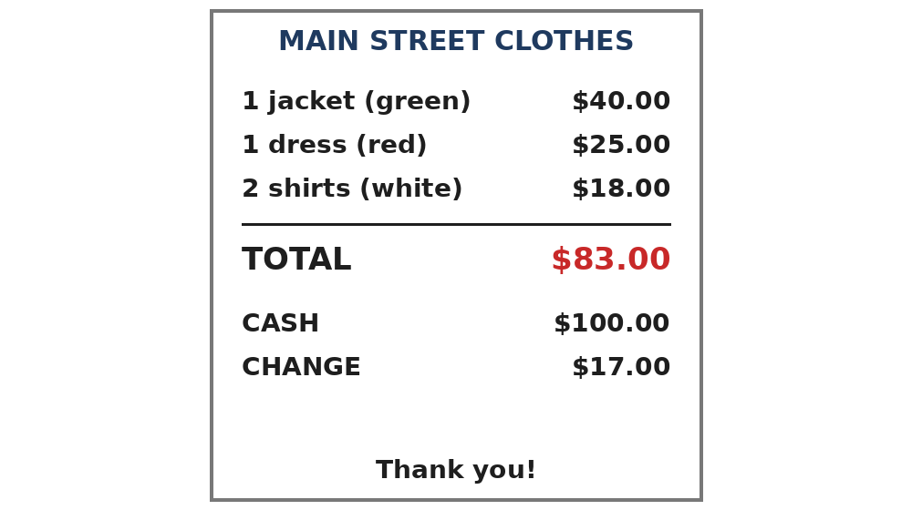

1. The jacket is $________. 2. The total is $________. 3. The change is $________.
Lesson 7 (Week 7) · Progress Check
Name: ______________________________ Date: ________________
A. Listen to the teacher. Circle the price.
Español: Escucha al profesor. Encierra el precio.
My language: ______________________________________________
1. | $12 | $20
2. | $14 | $40
3. | $5.99 | $9.55
4. | $18 | $80
5. | $17 | $70

B. Match the question and the answer. Draw a line.
Español: Une la pregunta con la respuesta. Dibuja una línea.
My language: ______________________________________________
Question | Draw a line. | Answer
1. How much is this shirt? ● |  | ● a. They're $30.
2. How much are these shoes? ● |  | ● b. It's blue.
3. Cash or credit card? ● |  | ● c. It's $12.
4. What color is the shirt? ● |  | ● d. Cash, please.

C. Write is or are. Then put the words in order.
Español: Escribe is o are. Después ordena las palabras.
My language: ______________________________________________
1. How much ________ these pants?
2. How much ________ that jacket?
3. dress / red / a → ______________________________
D. How do you feel? Check ✓ one face for each line.
Español: ¿Cómo te sientes? Marca ✓ una cara en cada línea. 😀 = I can do it. 🙂 = I can do it with a little help. 😐 = Not yet.
My language: ______________________________________________
I can… | 😀 | 🙂 | 😐
I can ask the price. | ☐ | ☐ | ☐
I can understand prices. | ☐ | ☐ | ☐
I can name clothes and colors. | ☐ | ☐ | ☐
I can pay and check my change. | ☐ | ☐ | ☐

Score: A ______ / 5 B ______ / 4 C ______ / 3
Picture Credits
Vocabulary, grammar, listening, and store pictures use Twemoji graphics by Twitter, Inc. and other contributors (https://github.com/jdecked/twemoji), licensed under CC BY 4.0 (https://creativecommons.org/licenses/by/4.0/). The graphics were resized and combined, the clothes were recolored to match the color words, and price tags, color swatches, near / far labels, and other labels were added. The receipts and the play-money page are drawn in code; the play money is marked PLAY MONEY and does not copy any real bill or coin. All prices and store names are invented. The file-by-file list is in images/CREDITS.md.
Other small pictures on the pages (the faces on the Progress Check) are standard emoji characters shown with the computer's emoji font. Listening audio: synthetic voices made with Chatterbox TTS (Resemble AI, MIT License); each file carries an inaudible Perth watermark marking it as AI-generated. The voices are copied from short reference clips made with Kokoro-82M (Apache 2.0); no recordings of real people were used. Course materials: © 2026 the authors, CC BY-NC-SA 4.0.

