Level 4 Adult ESL Curriculum · Lesson 2 (Week 2): How Long Have You Lived Here?
Status: Draft for review; not published.
Date: October 2026
Audience: Program coordinators and volunteer teachers
Companion files: images/ (12 vocabulary pictures + images/CREDITS.md). Listening audio: not recorded yet (coming soon); until then, read the listening script in this plan aloud.
Topic: Housing and job applications: addresses, how long, previous jobs, references, and a lease. Learners answer How long…? with for and since and fill in an application.

How this lesson is organized
Part | What's inside | Who uses it
Teacher Plan | At a glance, clock-time plan, step-by-step boxes, listening script, answer key, teacher notes | Volunteer teachers
Student Pages | Opening Talk, New Words, My Words, Listening, Grammar, Talk Time, Homework, Read & Write, Exit Ticket, Task Words (optional). Print this part for learners | Learners
Picture Credits | Picture and license credits | Coordinators

What Lesson 2 builds on and what it adds
Before (review only) | Where | New in Level 4 Lesson 2
Dates and years: in 2020, in March, on May 5 | Level 3 Lessons 2, 8 | since + a starting point: since 2020, since March, since I was 18
How long…? with a length: It takes 20 minutes. | Level 3 Lesson 6 | for + a length of time with the present perfect: I've lived here for two years.
used to for past habits | Level 3 Lesson 12 | Still true or finished? I've worked here since 2022 vs. I worked at a bakery for two years.

TEACHER PLAN
Lesson 2 (Week 2)

How Long Have You Lived Here?
At a glance · Clock-time plan · Step by step · Script and answer key

How to Use This Plan
You don't need to speak Spanish or any other language. Teach in English. Show, point, and gesture. Some Grammar pages have one short contrast tip, only where a common mix-up exists. Learners read it on their own. You never need to read, translate, or explain it.

Instructions: use the same short task words every week: Listen. Circle. Check. Write. Work with a partner. Work in a group. Ask a follow-up question. Give a reason. An optional Task Words page is at the back of the workbook for learners who want it.

Instruction rule: Model it (do it with one learner while everyone watches), check it (ask: "Is it still true now? Is it a length of time or a starting point?"), then go. Say less, show more.

Grouping toolkit: Pairs: turn to a neighbor; with an odd number, make one group of 3. Groups: 3–4 learners. Inside–outside circles: the inner circle faces out, the outer circle faces in; the outer circle moves one person to the right each round. Mingle: everyone stands and talks to many classmates. The teacher joins a pair only if one learner is left over.

When a learner is stuck or speaks another language to you: (1) show it: the picture, a gesture, or the board; (2) give one more short English example; (3) point to the grammar box on their page; (4) a classmate can help for a few seconds, then back to English. You don't need to understand what classmates say to each other.

Three sentences, not one: in Level 4, every Talk Time answer and every exit ticket has about three connected sentences: the answer, a reason, and a detail or example.

Lesson 2 (Week 2): How Long Have You Lived Here?
At a glance
Objectives: learners can…
• ask How long have you lived / worked…?
• answer with for + a length of time and since + a starting point
• choose the present perfect (still true) or the simple past (finished)
• give an address, an employer, a position, and a start date on an application
• write 5–8 sentences about how long you have done three things, with one used to

Materials
• Student Pages for Lesson 2 (print for the number expected + 3 spares)
• Board and markers; a timeline across the board ("2020 → now")
• One copy of a real-looking blank rental application (optional; the Talk Time page works)
• Index cards with times: 2020, March, six months, Monday, ten years, a long time, I was 18, three weeks
• Listening: no recording yet. Read the listening script aloud (with a volunteer if you can), at a natural speed, two times.
• Prep time: 15 minutes (read the plan; draw the timeline; write the time cards; practice reading the listening script).

Key vocabulary (with pictures on the New Words page)
★ application • ★ current address • ★ previous address • ★ employer • ★ position (job title) • ★ start date • ★ end date • ★ reference (a person) • ★ for (two years) • ★ since (2020) • roommate • lease
Also: apply, fill out, a leasing office, an agent, move in, a supervisor, a photo ID, a fee, refundable, a medical assistant, a mechanic.

Clock-time plan
Times are loose. If the listening or Talk Time runs long, take the time from Read & Write.
Time | Step | Min | Grouping (15 / 7–8) | If running behind
6:00–6:08 | Opening Talk + Homework Check | 8 | Pairs (7 pairs + 1 trio / 3–4 pairs) | One card only
6:08–6:15 | New Words (picture page) + pair game (+ My Words) | 7 | Whole class, then pairs | Teach the ★ words only
6:15–6:30 | Listening: play 1 (Task A), play 2 (Tasks B and C) + "Hear it, say it" | 15 | Individuals, then pairs check | Do Task C together on the board
6:30–6:45 | Grammar Q&A: How long have you…? with for and since + pair check | 15 | Whole class, then pairs | Skip the pair check; Talk Time practices it
6:45–7:00 | BREAK | 15
7:00–7:15 | Talk Time: Timeline Interviews + At the Leasing Office | 15 | Pairs, then groups of 3 / pairs, then 2 groups | Round 1 only
7:15–7:25 | Read & Write: A rental application + sentences about you | 10 | Pairs read, then individual writing | Reading questions only; the writing becomes homework
7:25–7:30 | Exit Ticket + Homework | 5 | Individuals | Never skip

Skip order if you're running behind: (1) the Read & Write writing task (it becomes homework); (2) the pair check at the end of Grammar; (3) the second round of Talk Time. Never skip: the listening tasks, the grammar boxes and the mistakes table, and the exit ticket.

Attendance (15 → 7–8 → 5 or fewer): every step lists the sizes. With 5 or fewer, sit at one table. Do Timeline Interviews as one group (each person interviews the person on their left), then pairs for the leasing office. Late arrivals join any pair right away and take the applicant (B) role.

Step by step
Step 1 · 6:00–6:08 · Opening Talk · 8 min
• Grouping: pairs, the same partner for both parts. 15 learners: 7 pairs + 1 group of 3. 7–8 learners: 3–4 pairs. 5 or fewer: pairs, or one group with you.
• Before class: write on the board: How long have you…? and Have you ever…?
• Opening Talk (5 min): learners open the Opening Talk page. A asks a card question; B answers in 3 sentences (the answer, a reason, a detail); A asks one follow-up. Switch after each card.
• Model with one learner: you ask, "Have you ever tried a new food?" The learner answers. Then you ask, "When did you try it? How was it?" Help them say 3 sentences: the experience, when, and how it was.
• Homework Check (3 min): Pairs compare Homework item 1 (sentences with have / has + a past participle) and read one answer from item 3 to each other. Then they fill in the box on the Opening Talk page. Walk around. Write 2 common errors on the board (often I have seen it last year (→ I saw it last year) and a missing participle (I've never eat → eaten)) and correct them together. Also put up 2 corrections from last week's exit tickets.
• Late arrivals: join any pair as a group of 3.
• If behind: one card only.

Step 2 · 6:08–6:15 · New Words · 7 min
• Grouping: whole class, then pairs. Show the New Words page.
• Do: point to each picture and say the word. Learners repeat once.
• Show the hard words: current address (now) vs. previous address (before); employer (the company) vs. position (your job title); start date and end date (point to two dates on the board); reference (a person who knows you at work; not family). Show for as a length (from one date to another) and since as a starting point (one date).
• Check meaning (1 min): ask "Is your employer a company or a person?" (a company, usually) • "Can your mother be your reference?" (no, usually not) • "Is 2020 a length or a starting point?" (a starting point → since).
• Pairs (2 min): A says a word; B points to the picture and makes a sentence (What's your current address? → It's four eighteen Elm Street.). Switch. 15 learners: finish with a quick team round (3 teams; you say a clue, the first team with the word gets a point). 7–8: 2 teams. 5 or fewer: one team against the clock.
• My Words: "Write any word you want in your language on the My Words page. It's your personal list. It's optional." Learners do it at home.
• If behind: teach the ★ words only.

Step 3 · 6:15–6:30 · Listening + "Hear it, say it" · 15 min
• Grouping: individuals, then pairs check. With 5 or fewer, check together as a group.
• Before you listen (2 min): say: "Marisol is at a leasing office. She wants to rent an apartment. Mr. Chen helps her with the application. Listen: what is she applying for?"
• Play 1 → Task A (the main idea). Pairs compare. Check together.
• Read Tasks B and C together (1 min) so learners know what to listen for.
• Play 2 → Tasks B and C. Pairs compare. Then show the answers (answer key).
• "Hear it, say it" (3 min): Point to the script lines. wanna = want to: "I want to fill out an application." gonna = going to: "My mother is going to live with me." Then practice the weak, short for (it sounds like "fer"): for two years • for three years, and link the words: How long have you lived here? The class repeats the two lines twice.
• No recording yet: read the script aloud with a volunteer (about 1:46), at a natural speed, two times. The script says going to and want to. People often say gonna and wanna; learners only need to recognize those words. When the audio is ready, it plays the conversation once; press play again for play 2. A third play is fine if the class needs it.
• If behind: do Task C together on the board, reading the lines yourself.

Step 4 · 6:30–6:45 · Grammar Q&A · 15 min
• Grouping: whole class, then pairs. Show the Grammar page. The left side is the question. The right side is the answer.
• Show it (2 min): draw a timeline: "2020 ———————→ now." Say: "I moved here in 2020. I still live here. I've lived here since 2020. That's six years. I've lived here for six years." Point to 2020 (since) and the whole line (for).
• The boxes (5 min): Box 1: read across: How long have you lived here? → I've lived here for two years / since 2024. Box 2: still true or finished? I've worked at the hotel since 2022 (still true) vs. I worked at a bakery for two years (finished). Box 3: sort the time words. Box 4: which one?
• Rule of thumb and Questions and answers (2 min): read the rule of thumb aloud. Read each Q and A; the class reads the right sentence after you.
• Check questions: "I live here since 2020. Right or wrong?" (wrong: I've lived here since 2020.) • "since three years or for three years?" (for) • "I worked at a bakery for two years. Do I work there now?" (no).
• Practice A and B (3 min): learners write, then pairs check. Go over the answers. Read the Common mistakes table together: "Don't say… Say…".
• Pair check (last 3 min): Use the time cards. A picks a card and says it (March). B makes a sentence with for or since: I've lived here since March. Switch. 15 learners: swap partners once. 5 or fewer: you join one pair.
• If behind: skip the pair check. Talk Time practices it.

Break · 6:45–7:00 · 15 min
• Write on the board: How long have you lived / worked…? → I've… for (two years). / I've… since (2020).

Step 5 · 7:00–7:15 · Talk Time: Timeline Interviews + At the Leasing Office · 15 min
• Model it first (1 min): ask one learner, "How long have you lived in this city?" When they answer, ask, "Where did you live before? How long did you live there?" Write the answers on the board on a timeline. Say: "Still true → have lived. Finished → lived."
• Round 1 (7 min): Timeline Interviews (pairs). Learners mark 4 points on their own timeline on the first Talk Time page (moved to this city, started a job or class, a hobby, a phone or car). Then they interview a partner: How long have you…? Since when? and write 3 sentences about the partner.
• Round 2 (6 min): At the Leasing Office (pairs). A is the agent and asks the questions on the role card. B is the applicant and answers (invented answers are fine). A fills in the application form. Then switch.
• 15 learners: pairs for both rounds; rotate once between rounds.
• 7–8 learners: pairs for both rounds; one rotation between rounds.
• 5 or fewer: one group for round 1 (each person interviews the person on their left); pairs or one group of 3 for round 2.
• Every answer needs a reason; every partner asks a follow-up. Walk around and listen. Note 2 good sentences to praise and 1 common error for next week.
• If behind: round 1 only.

Step 6 · 7:15–7:25 · Read & Write: A rental application + sentences about you · 10 min
• Grouping: pairs read and answer; individual writing. With 5 or fewer, read the text aloud together.
• Read (4 min): Learners read the rental application on the Read & Write page and answer the questions. Say: "Read fast first. Then find the answers." Pairs answer questions 1–5 together.
• Check (1 min): go over the answers (answer key).
• Write (5 min): Learners write 5–8 sentences about how long they (or an invented person) have done three things, with for and since and one used to. Show the example. Invented details are fine. Learners start in class and finish at home (Homework item 2).
• If behind: questions 1–5 only; the writing becomes homework.

Step 7 · 7:25–7:30 · Exit Ticket + Homework · 5 min · NEVER SKIP
• Exit ticket (3 min): learners open the Exit Ticket page and answer in 3 sentences with a reason: How long have you lived in this city (or worked at your job)? Example on the board: I've lived in this city for four years. I moved here in 2022. I moved here because my sister lives here. With 5 or fewer, a learner can say it to you first and then write it.
• Collect the pages. After class, sort them into ✓ / almost / not yet. Start next week with 2 corrections on the board (no names).
• Homework (2 min): open the Homework page. Do item 1 together (item 1: she / work / at the hotel / ___ / March → She's worked at the hotel since March.). Say: "About 15–20 minutes. Finish your Read & Write writing at home."

Listening script (not recorded yet; about 1:46 when recorded; the conversation plays once, so press play again for the second listen)
Audio: the recording is coming soon. Until then, read the script aloud two times, with a volunteer if you can, at a natural, friendly speed. The script says going to and want to. People often say gonna and wanna; learners only need to recognize those words.

Narrator: Lesson two. Marisol is at a leasing office. She wants to rent an apartment, and Mr. Chen helps her.
Mr. Chen: Good afternoon. Welcome to Parkview Apartments. How can I help you?
Marisol: Hi. I'm here about the two-bedroom apartment. I want to fill out an application.
Mr. Chen: Great. Let's do it together. What's your current address?
Marisol: It's four eighteen Elm Street, apartment 3.
Mr. Chen: And how long have you lived there?
Marisol: I've lived there for two years.
Mr. Chen: OK. And your previous address?
Marisol: Before that, I lived on Lake Road with my cousins. I lived there for three years.
Mr. Chen: Why are you moving?
Marisol: My apartment is too small. My mother is going to live with me.
Mr. Chen: I see. Now, your job. Who's your employer?
Marisol: Green Valley Clinic. I'm a medical assistant.
Mr. Chen: How long have you worked there?
Marisol: Since March 2022. Before that, I worked at a bakery for two years.
Mr. Chen: And what day in March did you start at the clinic?
Marisol: March fifteenth.
Mr. Chen: Thank you. We also need one reference. Not a family member, please.
Marisol: Can I give my supervisor's name? She's known me since I started.
Mr. Chen: Sure, that's fine. And will you have a roommate?
Marisol: No, just my mother. When can we move in?
Mr. Chen: The apartment is ready on June first. The lease is for one year.
Narrator: That's the end of the listening.

Answer key
• Listening Task A: b (an apartment).
• Listening Task B: 1 two years, 2 Lake Road, 3 Green Valley Clinic, 4 medical assistant, 5 March 15, 2022, 6 no.
• Listening Task C: 1 for, 2 for, 3 Since, 4 for, 5 since, 6 for.
• Grammar Practice A: 1 since, 2 for, 3 since, 4 for, 5 since, 6 for.
• Grammar Practice B: 1 have you lived, 2 worked, 3 's had, 4 did you move, 5 moved, 6 since.
• Talk Time: answers will vary.
• Homework 1: 1 She's worked at the hotel since March. 2 We've known our neighbors for five years. 3 He's had his car since 2023. 4 I worked at a bakery for two years. Homework 2 and 3: answers will vary. Homework 4: 1 used to, 2 used to, 3 use to, 4 didn't use to, 5 used to.
• Read & Write B: 1 Since August 2023. • 2 For four years (2019–2023). • 3 City Bus Company. • 4 Ana Ruiz, his supervisor. • 5 He needs a bigger apartment for his family. • Writing (C): answers will vary.
• Exit ticket: answers will vary. A good answer: "I've lived in this city for four years. I moved here in 2022. I moved here because my sister lives here."
Teacher notes
• Learners choose what to share. Always ask about this city or this job, never this country. Never ask about income, rent, or immigration papers. Invented addresses and answers are fine in every activity.
• The timeline: keep "2020 → now" on the board all night. The starting point = since; the length = for. Still true now → have lived; finished → lived.
• Real forms: a rental application often asks for 3–5 years of addresses and a reference who is not family. Learners can write N/A (not applicable) when a line doesn't fit them.
• Spelling and numbers: in the leasing office role play, the agent asks Can you spell that? Encourage learners to say street numbers in pairs: 418 = "four eighteen."
• Spanish and other languages: the contrast tip on the Grammar page is optional. Learners read it on their own. You never need to read, translate, or explain it.
• Reductions: the listening says going to and want to. People often say gonna and wanna. Learners only need to recognize the short forms; they can always say the full forms.

STUDENT WORKBOOK
Lesson 2 (Week 2)

How Long Have You Lived Here?
Opening Talk · New Words · Listening · Grammar · Talk Time · Homework · Read & Write · Exit Ticket

Lesson 2 (Week 2) · Opening Talk
Name: ______________________________ Date: ________________
Work with a partner. A asks a question. B answers in 3 sentences: the answer, a reason, and a detail. A asks one follow-up question. Then switch.
A: Have you ever tried a new food? What was it? | A: Have you ever seen the ocean? Where?
A: What have you never done, but you want to try? | A: Have you ever won a prize?

Follow-ups: When did you…? • How was it? • Why?
Write your partner's name and one thing your partner has done.
My partner's name | One thing my partner has done

Lesson 2 (Week 2): How Long Have You Lived Here?
Student Page 1 · Week 2
Name: ______________________________ Date: ________________
New Words
Look. Listen. Repeat. ★ = most important words.
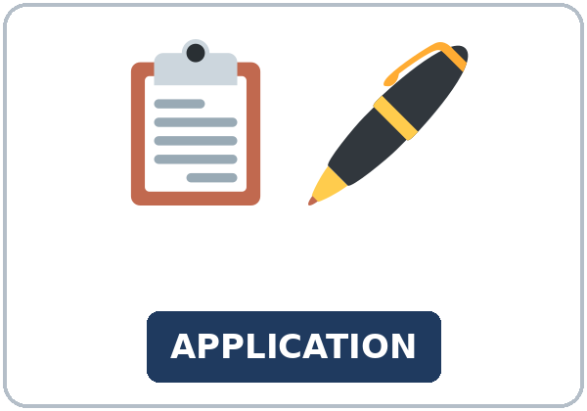  ★ application | 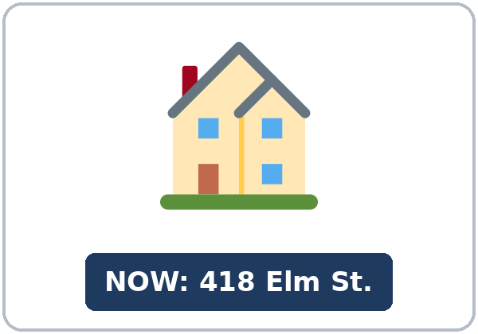  ★ current address | 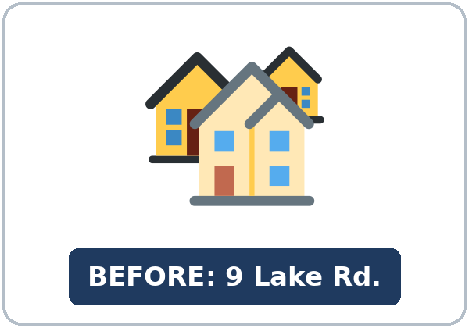  ★ previous address | 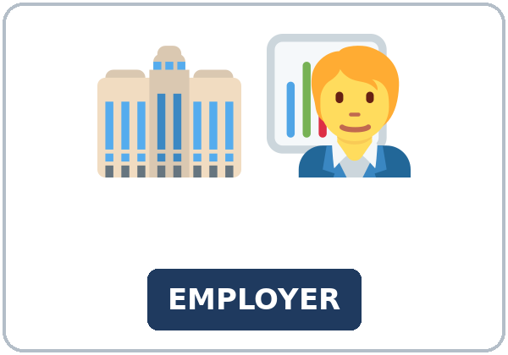  ★ employer
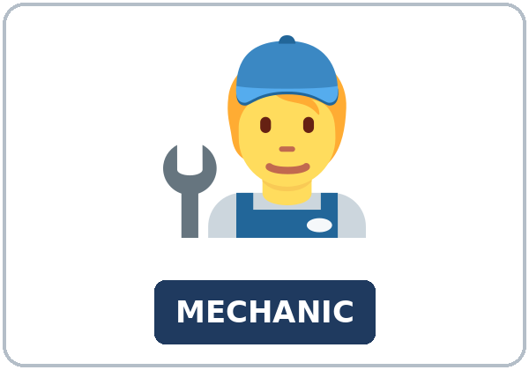  ★ position (job title) | 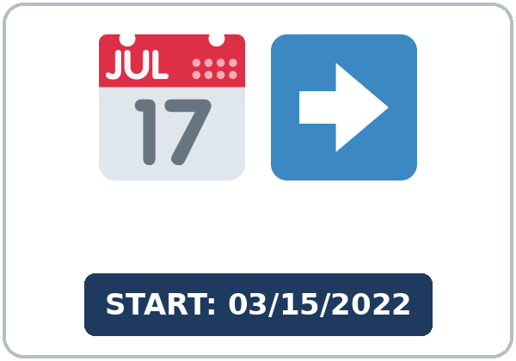  ★ start date | 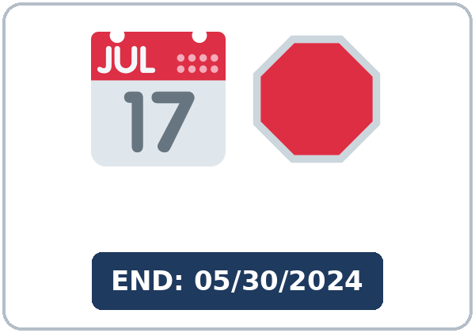  ★ end date | 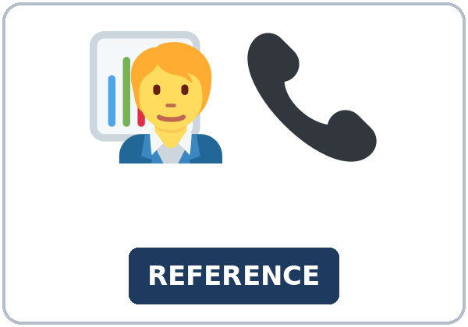  ★ reference (a person)
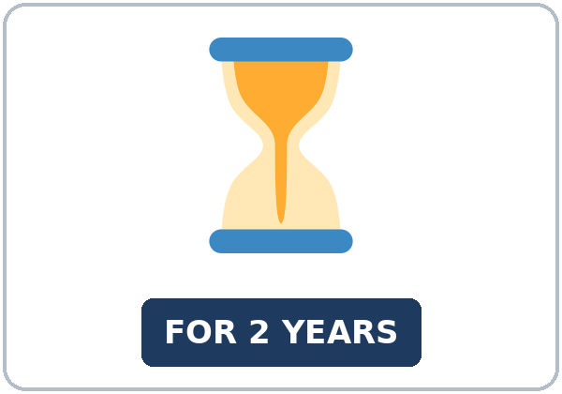  ★ for (two years) | 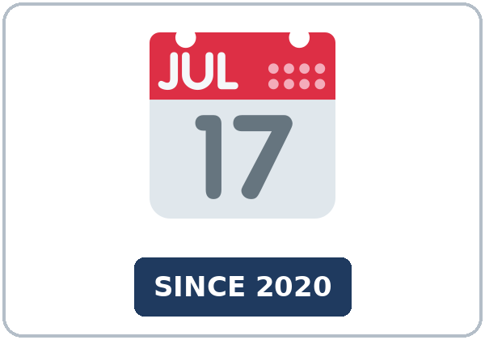  ★ since (2020) | 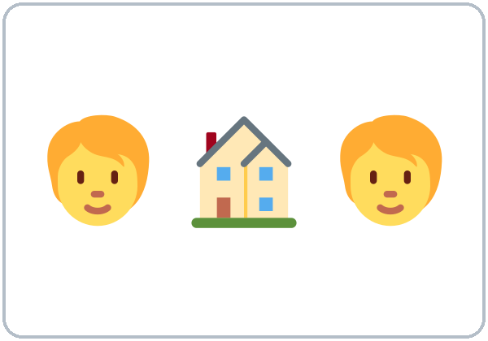  roommate | 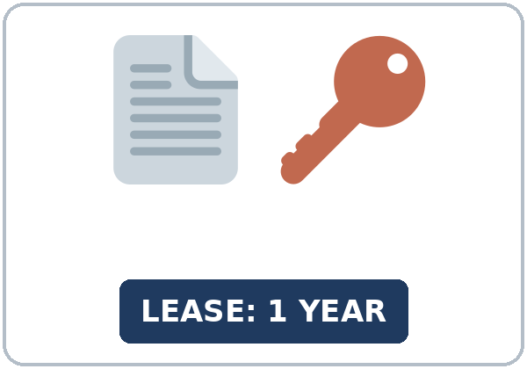  lease

Partner game: Fill out the form!
Example: A points to a picture and asks a question: "employer: Who's your employer?" B answers: "I work for City Hospital." Switch.
Lesson 2 (Week 2) · My Words
My personal word list. Write each word in your language, if you want. Then write your own example.
Word | My language | My example
application
current address
previous address
employer
position (job title)
start date
end date
reference (a person)
for (two years)
since (2020)
roommate
lease

Add 2 more words from tonight (from the listening, the reading, or your partner).
Lesson 2 (Week 2) · Listening
Marisol is at a leasing office. She wants to rent an apartment. Mr. Chen helps her with the application.
A. Listen. What is Marisol applying for? Circle.
a. a job at a clinic b. an apartment c. a class at a bakery
B. Listen again. Complete Marisol's application. Circle the answers.
1. How long at the current address: (two years / three years / since 2022)
2. Previous address: (Elm Street / Lake Road / Parkview)
3. Employer: (a bakery / Green Valley Clinic / Parkview Apartments)
4. Position: (medical assistant / supervisor / baker)
5. Start date: (March 5, 2022 / March 15, 2022 / June 1, 2022)
6. Roommate: (yes / no)
C. Listen again. Write for or since.
1. I've lived there ____________ two years.
2. I lived there ____________ three years.
3. ____________ March 2022.
4. Before that, I worked at a bakery ____________ two years.
5. She's known me ____________ I started.
6. The lease is ____________ one year.
Hear it, say it
wanna = want to: "I want to fill out an application." • gonna = going to: "My mother is going to live with me." You can say want to and going to. Say it with a short for ("fer"): I've lived there for two years. • How long have you lived here?
Lesson 2 (Week 2) · Grammar
Read across. A reads from the left side. B answers from the right side. Choose one part from each column.
Grammar Box 1: How long…? with for and since
QUESTION |  |  | ANSWER
How long have you | lived here? |  | I've lived here | for two years.
How long have you | lived here? |  | I've lived here | since 2024.
How long has she | worked at the clinic? |  | She's worked there | since March.
How long has he | known his supervisor? |  | He's known her | since he started.

Grammar Box 2: still true or finished?
QUESTION |  |  | ANSWER
How long have you | worked at the hotel? |  | I've worked there | since 2022. (still true)
How long did you | work at the bakery? |  | I worked there | for two years. (finished)
When did you | move here? |  | I moved here | in 2021.  five years ago.
Did you | use to live with family? |  | Yes. I used to live with my cousins. | Now I live with my mother.

Rule of thumb: still true now → have / has + past participle (I've lived here since 2020). finished → simple past (I lived there for three years). for + a length of time; since + a starting point.
Grammar Box 3: for or since?
for + a length of time | since + a starting point
for two years • for six months | since 2020 • since March
for ten days • for a week | since Monday • since last summer
for a long time • for 20 minutes | since I was 18 • since I started

Grammar Box 4: Which one?
 | WHEN? | EXAMPLE
have / has + past participle | it started in the past and it is still true now | I've worked at the clinic since 2022.
simple past | it is finished | I worked at a bakery for two years.
simple past + in / ago | when it started | I moved here in 2021. / five years ago.

Questions and answers
Q: Can I say I live here since 2020?
A: No. Use the present perfect: I've lived here since 2020.
Q: For or since with March?
A: March is a starting point: since March. Three months is a length: for three months.
Q: I've worked or I worked at the bakery?
A: Do you work there now? Yes → I've worked there for two years. No → I worked there for two years.
Practice A: Write for or since.
1. I've lived in this city ____________ 2021.
2. She's worked at the clinic ____________ six months.
3. We've had our car ____________ January.
4. He's been a cook ____________ ten years.
5. They've known each other ____________ they were kids.
6. I've studied English ____________ a long time.
Practice B: Circle the correct words.
1. How long (have you lived / do you live) here?
2. I (worked / 've worked) at a bakery for two years. Then I changed jobs.
3. She ('s had / has) her car since 2022.
4. When (did you move / have you moved) here?
5. I (moved / 've moved) here three years ago.
6. He's lived here (since / for) last summer.
Common mistakes
✗ Don't say | ✓ Say
I live here since 2020. | I've lived here since 2020.
I've lived here since three years. | I've lived here for three years.
I've moved here in 2021. | I moved here in 2021.
How long you have worked there? | How long have you worked there?
I am here for two years. (still true) | I've been here for two years.

Contrast tip (optional): Spanish says Vivo aquí desde 2020 (present tense). English uses have / has + past participle: I've lived here since 2020 (not I live here since 2020). What does your language do?

Lesson 2 (Week 2) · Talk Time: Timeline Interviews
Round 1. Mark 4 points on your timeline. Then interview a partner. Ask How long have you…? and Since when? Write 3 sentences about your partner.
Example: A: How long have you lived in this city? B: Since 2021. A: Where did you live before? B: In Dallas. I lived there for three years. → Ana has lived in this city since 2021.
My timeline | When did it start? (in 2021 / three years ago) | for or since?
1. I moved to this city.
2. I started my job (or this class).
3. I started a hobby: ______________
4. I got my phone (or car).

Questions: How long have you…? • Since when? • When did you start? • Where did you… before? • How long did you… there?
3 sentences about my partner (… has… for / since…)
1.
2.
3.

Lesson 2 (Week 2) · Talk Time: At the Leasing Office
Round 2. A is the agent. B is the applicant. A asks the questions and fills in the application. Then switch. Invented answers are fine.
Role card (A, the agent): What's your current address? • How long have you lived there? • What's your previous address? • How long did you live there? • Who's your employer? • What's your position? • What's your start date? • Who's your reference? • Will you have a roommate?
RENTAL APPLICATION
Name
Current address
How long? (for / since)
Previous address
How long?
Employer and position
Start date
Reference (not family)
Roommate? | ☐ yes ☐ no

Useful: Can you spell that, please? • Is that with an e or an i? • Sorry, how long?
Lesson 2 (Week 2) · Homework
Homework (about 15–20 minutes). Bring it next week!
1. Write the sentence. Use for or since.
Example: I / live / here / ___ / 2022 → I've lived here since 2022.
1. she / work / at the hotel / ___ / March → ______________________________________________
2. we / know / our neighbors / ___ / five years → ______________________________________________
3. he / have / his car / ___ / 2023 → ______________________________________________
4. I / work / at a bakery / ___ / two years (finished) → ______________________________________________
2. Finish your writing from Read & Write C (your sentences). Read it one more time. Check ✓ the list in D.
☐ I finished it. ☐ I checked it with the list.
3. Ask a family member or a friend 3 questions with How long have you…? Write the answers with for or since.
Question | Answer (… for… / … since…)
1.
2.
3.

4. Review (used to). Write used to, use to, or didn't use to.
1. I ____________ live with my cousins. Now I have my own apartment.
2. She ____________ work at night. Now she works in the day.
3. Did you ____________ play soccer?
4. We ____________ have a car. We took the bus.
5. He ____________ take the bus. Now he drives.
Lesson 2 (Week 2) · Read & Write
A. Read the form. Read fast first. Then read again and answer the questions.
PARK VIEW APARTMENTS · Rental Application
Please read: Fill out every part. Write your addresses for the last five years. If you need more space, use the back of the page. Bring a photo ID. We will call your references, so please check the phone numbers. The application fee is $35, and it is not refundable.
1. Applicant: David Morales • Phone: (555) 201-3388
2. Current address: 77 River Avenue, Apt. 12 • How long? Since August 2023 • Reason for moving: I need a bigger apartment for my family.
3. Previous address: 1520 Hill Street • How long? For four years (2019–2023)
4. Employer: City Bus Company • Position: mechanic • Start date: 05/2021 • I've worked here for five years.
5. Previous employer: Quick Lube Auto Shop • Position: oil change technician • 2017–2021
6. Reference (not a family member): Ana Ruiz, my supervisor • She has known me since 2021.
7. Roommates: none • People in the apartment: 3 (me, my wife, and my son)

B. Answer the questions.
1. How long has David lived at his current address? ______________________________________________
2. How long did he live on Hill Street? ______________________________________________
3. Who is his employer? ______________________________________________
4. Who is his reference? ______________________________________________
5. Why is he moving? ______________________________________________
C. Write about how long you (or an invented person) have done three things (5–8 sentences). Use for and since. Add one sentence with used to.
Example: I've lived in this city since 2021. I've worked at a hotel for three years. I used to work at a bakery, but I've worked at the hotel since 2023. I've studied English since last fall. I've had my car for six months, so I don't take the bus now.
My sentences

D. Check your writing with a partner.
 | Yes | Not yet
It has 5–8 sentences. | ☐ | ☐
It has for + a length of time. | ☐ | ☐
It has since + a starting point. | ☐ | ☐
It has one sentence with used to. | ☐ | ☐

Lesson 2 (Week 2) · Exit Ticket
Name: ______________________________ Date: ________________
Answer in 3 sentences. Give a reason. Then give this page to your teacher.
How long have you lived in this city (or worked at your job)?
Sentence 1: how long (for or since) • Sentence 2: when you started (I moved / started… in…) • Sentence 3: why, with because
My answer
1.
2.
3.

For the teacher | ✓ | almost | not yet
3 sentences, today's grammar, a reason | ☐ | ☐ | ☐

Lesson 2 (Week 2) · Task Words (optional)
This page is for you if you want it. You can skip it. Write each task word in your language, if you want.
Task word | What you do | My language
Listen. | Use your ears. Don't write yet.
Circle. | Draw a circle around the answer.
Check ✓. | Make a ✓ in the box.
Write. | Write words or sentences.
Number. | Write 1, 2, 3… to show the order.
Match. | Find the two parts that go together.
Work with a partner. | Work with one classmate.
Work in a group. | Work with 2 or 3 classmates.
Switch. | Change roles: A is B now.
Ask a follow-up question. | Ask one more question about the answer.
Give a reason. | Say why, with because or so.
Compare. | Look at your partner's answers. Are they the same?

Picture Credits
Pictures use Twemoji graphics by Twitter, Inc. and other contributors (https://github.com/jdecked/twemoji), licensed under CC BY 4.0 (https://creativecommons.org/licenses/by/4.0/). The graphics were resized and combined, and signs and labels were added. The file-by-file list is in images/CREDITS.md.
Listening audio: not recorded yet. When it is made, it will use synthetic voices made with Chatterbox TTS (Resemble AI, MIT License), cloned from synthetic reference clips made with Kokoro-82M (Apache License 2.0), with no recordings of real people. The names and the story are invented.
Course materials: © 2026 the authors, licensed under CC BY-NC-SA 4.0 (https://creativecommons.org/licenses/by-nc-sa/4.0/).

