Level 4 Adult ESL Curriculum · Lesson 1 (Week 1): Have You Ever…?
Status: Draft for review; not published.
Date: October 2026
Audience: Program coordinators and volunteer teachers
Companion files: images/ (12 vocabulary pictures + images/CREDITS.md). Listening audio: not recorded yet (coming soon); until then, read the listening script in this plan aloud.
Topic: First night: getting to know classmates through life experiences (places, foods, jobs, things you've tried). Orientation, the personal word list, the first can-do self-check, and the baseline snapshot.

How this lesson is organized
Part | What's inside | Who uses it
Teacher Plan | At a glance, clock-time plan, step-by-step boxes, listening script, answer key, teacher notes | Volunteer teachers
Student Pages | Opening Talk, New Words, My Words, Listening, Grammar, Talk Time, Homework, Read & Write, Exit Ticket, Can-Do Self-Check, Task Words (optional). Print this part for learners | Learners
Picture Credits | Picture and license credits | Coordinators

What Lesson 1 builds on and what it adds
Before (review only) | Where | New in Level 4 Lesson 1
Simple past questions and answers: What did you do last weekend? → I went to the park. | Level 3 Lessons 2–4 | The present perfect for experiences: Have you ever worked in a restaurant? → Yes, I have. / No, I've never…
Irregular past forms: went, saw, ate, ran | Level 3 Lessons 2, 4 | Past participles (been, seen, eaten, ridden, flown…) with a list of 20
-ed / -ing adjectives: It was exciting. | Level 3 Lesson 11 | Present perfect → simple past for the details: Yes, I have. I went there in 2022. → How was it?

TEACHER PLAN
Lesson 1 (Week 1)

Have You Ever…?
At a glance · Clock-time plan · Step by step · Script and answer key

How to Use This Plan
You don't need to speak Spanish or any other language. Teach in English. Show, point, and gesture. Some Grammar pages have one short contrast tip, only where a common mix-up exists. Learners read it on their own. You never need to read, translate, or explain it.

Instructions: use the same short task words every week: Listen. Circle. Check. Write. Work with a partner. Work in a group. Ask a follow-up question. Give a reason. An optional Task Words page is at the back of the workbook for learners who want it.

Instruction rule: Model it (do it with one learner while everyone watches), check it (ask: "Do you ask or answer first? How many sentences do you say?"), then go. Say less, show more.

Grouping toolkit: Pairs: turn to a neighbor; with an odd number, make one group of 3. Groups: 3–4 learners. Inside–outside circles: the inner circle faces out, the outer circle faces in; the outer circle moves one person to the right each round. Mingle: everyone stands and talks to many classmates. The teacher joins a pair only if one learner is left over.

When a learner is stuck or speaks another language to you: (1) show it: the picture, a gesture, or the board; (2) give one more short English example; (3) point to the grammar box on their page; (4) a classmate can help for a few seconds, then back to English. You don't need to understand what classmates say to each other.

Three sentences, not one: in Level 4, every Talk Time answer and every exit ticket has about three connected sentences: the answer, a reason, and a detail or example.

Lesson 1 (Week 1): Have You Ever…?
At a glance
Objectives: learners can…
• ask Have you ever…? and answer Yes, I have. / No, I haven't. / No, never.
• say I've never… / She's lived… with have / has + a past participle
• ask a follow-up in the simple past (When did you…? How was it?)
• tell a classmate about one experience in 3 sentences (the experience, when, how it was)
• write a short introduction email to the teacher (5–8 sentences)

Materials
• Student Pages for Lesson 1 (print for the number expected + 3 spares)
• Board and markers; tape for a timeline across the board
• Name tags or folded paper and markers
• Can-Do Self-Check page (in the workbook) and the baseline snapshot notes (see Teacher notes)
• Listening: no recording yet. Read the listening script aloud (with a volunteer if you can), at a natural speed, two times.
• Prep time: 15 minutes (read the plan; draw the "my life → now" timeline on the board; practice reading the listening script).

Key vocabulary (with pictures on the New Words page)
★ try (a new food) • ★ travel • ★ fly • ★ snow • ★ ocean • ★ mountain • ★ desert • ★ win a prize • ★ ride a horse • ★ run a race • go camping • see a famous person
Also: ever, never, in common, both, a goal, a tent, sushi, a 5K (a 5-kilometer race), exciting, boring.

Clock-time plan
Times are loose. If the listening or Talk Time runs long, take the time from Read & Write.
Time | Step | Min | Grouping (15 / 7–8) | If running behind
6:00–6:08 | Opening Talk + Homework Check (+ welcome and orientation, 2 min) | 8 | Pairs (7 pairs + 1 trio / 3–4 pairs) | One card only
6:08–6:15 | New Words (picture page) + pair game (+ My Words and the Task Words page) | 7 | Whole class, then pairs | Teach the ★ words only
6:15–6:30 | Listening: play 1 (Task A), play 2 (Tasks B and C) + "Hear it, say it" | 15 | Individuals, then pairs check | Do Task C together on the board
6:30–6:45 | Grammar Q&A: Have you ever…? and the simple past for details + pair check | 15 | Whole class, then pairs | Skip the pair check; Talk Time practices it
6:45–7:00 | BREAK | 15
7:00–7:15 | Talk Time: Find Someone Who Has… + Two True, One Invented (+ baseline snapshot, 5 learners) | 15 | Mingle, then groups of 3 / one circle, then 2 groups | Round 1 only
7:15–7:25 | Read & Write: Meet Our Class + an email to the teacher (+ Can-Do Self-Check, 3 min) | 10 | Pairs read, then individual writing | Reading questions only; the writing becomes homework
7:25–7:30 | Exit Ticket + Homework | 5 | Individuals | Never skip

Skip order if you're running behind: (1) the Read & Write writing task (it becomes homework); (2) the pair check at the end of Grammar; (3) the second round of Talk Time. Never skip: the listening tasks, the grammar boxes and the mistakes table, and the exit ticket.

Attendance (15 → 7–8 → 5 or fewer): every step lists the sizes. With 5 or fewer, sit at one table and do Talk Time as one group (each person asks every other person 2 prompts). Late arrivals join any pair or group right away, and you show them the workbook after class.

Step by step
Step 1 · 6:00–6:08 · Welcome, orientation, and Opening Talk · 8 min
• Grouping: pairs, the same partner for both parts. 15 learners: 7 pairs + 1 group of 3. 7–8 learners: 3–4 pairs. 5 or fewer: pairs, or one group with you.
• Before class: write on the board: Welcome! Level 4 · 6:00–7:30 · Break 6:45 · Homework every week (15–20 minutes) and the question What did you do last weekend?
• Opening Talk (5 min): learners open the Opening Talk page. A asks a card question; B answers in 3 sentences (the answer, a reason, a detail); A asks one follow-up. Switch after each card.
• Model with one learner: you ask, "What did you do last weekend?" The learner answers. Help them add a reason and a detail: "I went to the park. I went because it was sunny. My kids played soccer." Then you ask a follow-up: "How was it?"
• Then (3 min): Pairs fill in the box at the bottom of the Opening Talk page: the partner's name and one thing the partner did last weekend. Two or three pairs introduce their partner to the class: "This is Rosa. She went to a birthday party."
• Welcome and orientation (2 min, first): say your name and write it on the board. Show the workbook: "This is your book for tonight. Every week has the same parts." Point to the times on the board. Say: "We speak English in class. It's OK to make mistakes. Mistakes help us learn." Give out name tags.
• Late arrivals: join any pair as a group of 3.
• If behind: one card only.

Step 2 · 6:08–6:15 · New Words · 7 min
• Grouping: whole class, then pairs. Show the New Words page.
• Do: point to each picture and say the word. Learners repeat once.
• Show the hard words: ocean (a wave, very big water) vs. a lake; desert (hot, dry, sand); win a prize (first place, a trophy); ride a horse (sit on it). Mime fly, run a race, and ride.
• Check meaning (1 min): ask "Is the ocean salty or sweet?" (salty) • "Is a desert hot and dry or cold and wet?" (hot and dry) • "Do you sleep in a tent when you go camping?" (yes).
• Pairs (2 min): A says a word; B points to the picture and makes a sentence (I've seen the ocean. / I've never ridden a horse.). Switch. 15 learners: finish with a quick team round (3 teams; you say a clue, the first team with the word gets a point). 7–8: 2 teams. 5 or fewer: one team against the clock.
• My Words: "Write any word you want in your language on the My Words page. It's your personal list. It's optional." Learners do it at home.
• Show the two new pages (1 min): the My Words page (a personal word list, optional) and the Task Words page at the back (optional). Say: "These pages are for you. Use them if you want."
• If behind: teach the ★ words only.

Step 3 · 6:15–6:30 · Listening + "Hear it, say it" · 15 min
• Grouping: individuals, then pairs check. With 5 or fewer, check together as a group.
• Before you listen (2 min): say: "This is the first night of an English class. Lucía and Ahmed meet. Then the teacher, Ms. Grant, gives them a job. Listen: what have they both done?"
• Play 1 → Task A (the main idea). Pairs compare. Check together.
• Read Tasks B and C together (1 min) so learners know what to listen for.
• Play 2 → Tasks B and C. Pairs compare. Then show the answers (answer key).
• "Hear it, say it" (3 min): Point to the script lines. gonna = going to: "Tonight we're going to find things we have in common." wanna = want to: "I want to go camping." Say: "People often say gonna and wanna. This listening uses going to and want to." Then practice the weak, short have (it sounds like "h'v"): Have you ever seen snow? and the contraction: I've never ridden a horse. The class repeats the two lines twice.
• No recording yet: read the script aloud with a volunteer (about 2:06), at a natural speed, two times. The script says going to and want to. People often say gonna and wanna; learners only need to recognize those words. When the audio is ready, it plays the conversation once; press play again for play 2. A third play is fine if the class needs it.
• If behind: do Task C together on the board, reading the lines yourself.

Step 4 · 6:30–6:45 · Grammar Q&A · 15 min
• Grouping: whole class, then pairs. Show the Grammar page. The left side is the question. The right side is the answer.
• Show it (2 min): draw a long line on the board: "my life → now." Put three X's on the line with no dates: "I've seen snow. I've run a race. I've never ridden a horse." Then write a date under one X: "I ran a race in 2023." Say: "No time → have + past participle. A time → simple past."
• The boxes (5 min): Box 1: read across: Have you ever worked in a restaurant? → Yes, I have. / No, I haven't. Point out Has with he / she. Box 2: the follow-up in the simple past: When did you go there? → I went in 2022. How was it? → It was exciting. Box 3: read the 20 verbs together once; learners circle 5 they want to learn first. Box 4: which one? No time or a time.
• Rule of thumb and Questions and answers (2 min): read the rule of thumb aloud. Read each Q and A; the class reads the right sentence after you.
• Check questions: "I have seen snow in 2022. Right or wrong?" (wrong: I saw snow in 2022.) • "Have you ever eat sushi? Right or wrong?" (wrong: eaten) • "She's lived in three cities. She's = she is or she has?" (she has).
• Practice A and B (3 min): learners write, then pairs check. Go over the answers. Read the Common mistakes table together: "Don't say… Say…".
• Pair check (last 3 min): A asks Have you ever…? with a word from the New Words page. B answers Yes, I have + a past detail (I… in…), or No, never. A asks How was it? Switch. 15 learners: swap partners once. 5 or fewer: you join one pair.
• If behind: skip the pair check. Talk Time practices it.

Break · 6:45–7:00 · 15 min
• Write on the board: Have you ever…? → Yes, I have. I… (last year). / No, I've never… and When did you…? How was it?

Step 5 · 7:00–7:15 · Talk Time: Find Someone Who Has… + Two True, One Invented · 15 min
• Model it first (1 min): take the sheet and ask one learner, "Have you ever flown in a plane?" When they say yes, ask two follow-ups: "When did you fly? How was it?" Write their name on your sheet. Say: "Two follow-ups. Then write the name."
• Round 1 (7 min): Find Someone Who Has… (mingle). Learners stand with the Talk Time sheet and ask classmates. When someone says Yes, they ask two follow-ups in the past (When? Where? How was it?) and write the name and a short note. One name per classmate, then move on.
• Round 2 (6 min): Two True, One Invented (groups). Each learner writes three sentences on the second Talk Time page: two true and one invented (I've… / I've never…). The others in the group ask follow-up questions and then guess the invented one.
• 15 learners: whole-room mingle for round 1; then 5 groups of 3 for round 2.
• 7–8 learners: mingle in one circle for round 1; then 2 groups for round 2.
• 5 or fewer: one group. In round 1, each person asks every other person 2 prompts. Round 2 in the same group.
• Every answer needs a reason; every partner asks a follow-up. Walk around and listen. Note 2 good sentences to praise and 1 common error for next week.
• Baseline snapshot (during Talk Time): listen to about 5 learners for 1 minute each (a different 5 each week until you have heard everyone). For each one, note: 3 connected sentences? a follow-up question? any present perfect? Use the snapshot notes in the Teacher notes. This is not a test; don't tell learners a score.
• If behind: round 1 only.

Step 6 · 7:15–7:25 · Read & Write: Meet Our Class + an email to the teacher (+ Can-Do Self-Check) · 10 min
• Grouping: pairs read and answer; individual writing. With 5 or fewer, read the text aloud together.
• Read (4 min): Learners read the three profiles on the Read & Write page. Say: "Read fast first. Then find the answers." Pairs answer questions 1–5 together.
• Check (1 min): go over the answers (answer key).
• Write (5 min): Learners write an email to you (5–8 sentences): who they are, two things they've done, one thing they've never done, and one goal for this class with a reason. Show the example email. Invented details are fine. Learners start in class and finish at home (Homework item 2).
• Can-Do Self-Check (3 min, 7:22–7:25): read each line on the Can-Do Self-Check page aloud. Learners check one face for each line and write one goal. Collect it with the exit ticket. This page comes back in Weeks 8 and 15.
• If behind: questions 1–5 only; the writing becomes homework.

Step 7 · 7:25–7:30 · Exit Ticket + Homework · 5 min · NEVER SKIP
• Exit ticket (3 min): learners open the Exit Ticket page and answer in 3 sentences with a reason: Tell me about something you have done (or never done). Example on the board: I've ridden a horse. I rode one in 2015 on my uncle's farm. It was exciting, but I was scared because the horse was big. With 5 or fewer, a learner can say it to you first and then write it.
• Collect the pages. After class, sort them into ✓ / almost / not yet. Start next week with 2 corrections on the board (no names).
• Homework (2 min): open the Homework page. Do item 1 together (item 1: I / never / see / the ocean → I've never seen the ocean.). Say: "About 15–20 minutes. Finish your Read & Write writing at home."

Listening script (not recorded yet; about 2:06 when recorded; the conversation plays once, so press play again for the second listen)
Audio: the recording is coming soon. Until then, read the script aloud two times, with a volunteer if you can, at a natural, friendly speed. The script says going to and want to. People often say gonna and wanna; learners only need to recognize those words.

Narrator: Lesson one. It's the first night of an English class at a community center. Lucía and Ahmed meet before class.
Ahmed: Hi, I'm Ahmed. Is this seat free?
Lucía: Sure. I'm Lucía. Nice to meet you. Is this your first class here?
Ahmed: Yes, it is. Have you ever taken a class at this center?
Lucía: No, I haven't. But my sister has. What kind of work do you do?
Ahmed: I work at a warehouse. Have you ever worked in a restaurant?
Lucía: Yes, I have. I worked in a pizza restaurant in 2019. It was hard, but I liked it.
Ms. Grant: Good evening! I'm Ms. Grant, your teacher. Tonight we're going to find things we have in common.
Ms. Grant: Lucía and Ahmed, find two things you've both done.
Lucía: OK. Ahmed, have you ever seen snow?
Ahmed: Yes! I saw snow for the first time last winter. It was cold, but beautiful.
Lucía: Me too. I've seen snow two times. Have you ever ridden a horse?
Ahmed: No, never. I've never ridden a horse. Have you?
Lucía: Yes, I have.
Ahmed: Really? When did you do that?
Lucía: When I was ten, on my uncle's farm. OK, snow is one thing. Have you ever run a race?
Ahmed: Yes, I ran a 5k last year. I didn't win, but I finished!
Lucía: I've run a race, too. My company has a race every summer.
Ahmed: Great. So we have both seen snow, and we have both run a race.
Ms. Grant: Good job! Now, what have you never done, but you want to try?
Ahmed: I want to go camping. I've never slept in a tent.
Lucía: And I want to try sushi. I've never eaten it.
Narrator: That's the end of the listening.

Answer key
• Listening Task A: b (seen snow and run a race).
• Listening Task B: 1 False (No, she hasn't; her sister has) • 2 True • 3 True • 4 False (he has never ridden a horse) • 5 False (he didn't win, but he finished) • 6 True.
• Listening Task C: 1 Have, 2 has, 3 Have, 4 did, 5 have, 6 has.
• Grammar Practice A: 1 eaten, 2 ridden, 3 lived, 4 flown, 5 seen, 6 won.
• Grammar Practice B: 1 Have, 2 went, 3 have, 4 did you go, 5 has never, 6 saw.
• Talk Time: answers will vary.
• Homework 1: 1 I've never seen the ocean. 2 Has she ever ridden a horse? 3 We've flown to Miami two times. 4 He went camping last summer. Homework 2 and 3: answers will vary. Homework 4: 1 went, 2 ate, 3 didn't work, 4 Did / watch, 5 was.
• Read & Write B: 1 For six years. • 2 In a hospital kitchen. • 3 Because he drives a truck. • 4 He's never flown in a plane. • 5 She ran her first race (a 5K). • Writing (C): answers will vary.
• Exit ticket: answers will vary. A good answer: "I've ridden a horse. I rode one in 2015 on my uncle's farm. It was exciting, but I was scared because the horse was big."
Teacher notes
• Learners choose what to share. Places, foods, and jobs are always safe topics. Never ask how or when learners came to the U.S. Invented answers are fine in every activity.
• The timeline: keep the "my life → now" line on the board all night. X's with no dates = present perfect; a date under an X = simple past.
• Participles: learners don't need all 20 tonight. Ask them to circle 5 in Box 3 and learn those first. The list comes back in Lessons 2 and 3.
• Baseline snapshot: for each learner you hear (about 5 tonight), note three things: (1) 3 connected sentences? (2) a follow-up question? (3) any present perfect? Keep the notes private. Hear everyone by Week 3. The same notes help in Weeks 8 and 15.
• Can-Do Self-Check: the faces are 😀 I can do it, 🙂 with a little help, 😐 not yet. Read each line aloud. Keep the pages; learners compare in Week 8.
• Spanish and other languages: the contrast tip on the Grammar page is optional. Learners read it on their own. You never need to read, translate, or explain it.
• Reductions: the listening says going to and want to. People often say gonna and wanna. Learners only need to recognize the short forms; they can always say the full forms.

STUDENT WORKBOOK
Lesson 1 (Week 1)

Have You Ever…?
Opening Talk · New Words · Listening · Grammar · Talk Time · Homework · Read & Write · Exit Ticket

Lesson 1 (Week 1) · Opening Talk
Name: ______________________________ Date: ________________
Work with a partner. A asks a question. B answers in 3 sentences: the answer, a reason, and a detail. A asks one follow-up question. Then switch.
A: What did you do last weekend? | A: What did you eat last night?
A: Where did you go yesterday? | A: What did you do last summer?

Follow-ups: How was it? • Who did you go with? • Why?
Write your partner's name and one thing your partner did last weekend.
My partner's name | One thing my partner did last weekend

Lesson 1 (Week 1): Have You Ever…?
Student Page 1 · Week 1
Name: ______________________________ Date: ________________
New Words
Look. Listen. Repeat. ★ = most important words.
  ★ try (a new food) |   ★ travel |   ★ fly |   ★ snow
  ★ ocean |   ★ mountain | 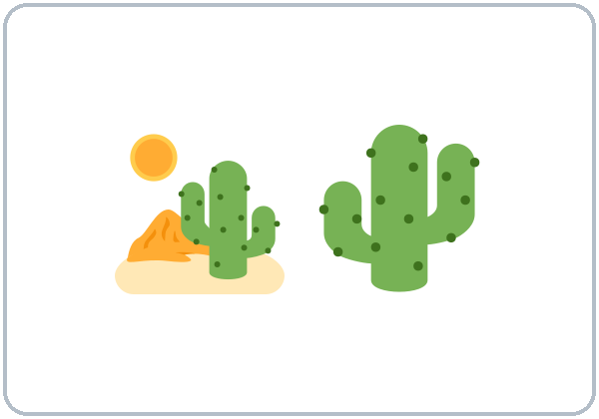  ★ desert | 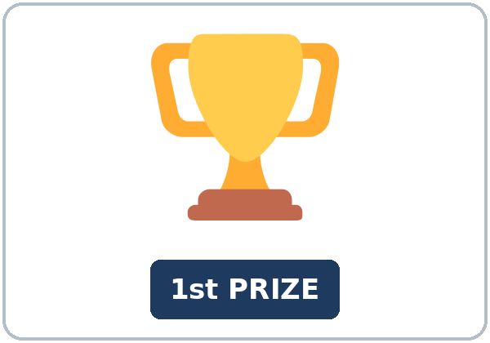  ★ win a prize
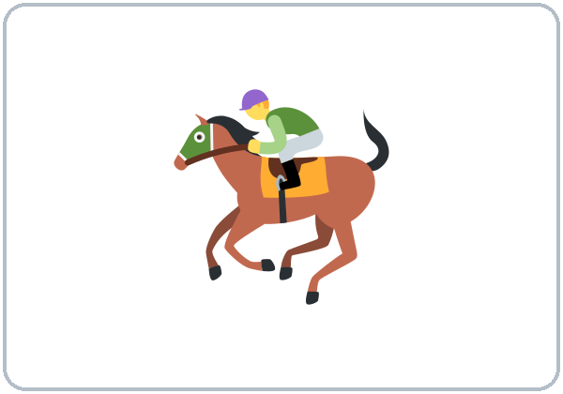  ★ ride a horse | 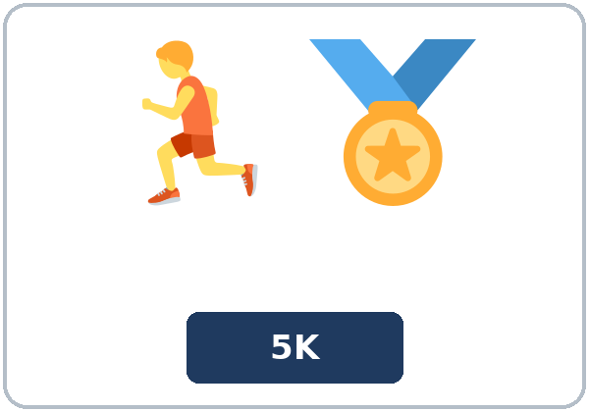  ★ run a race | 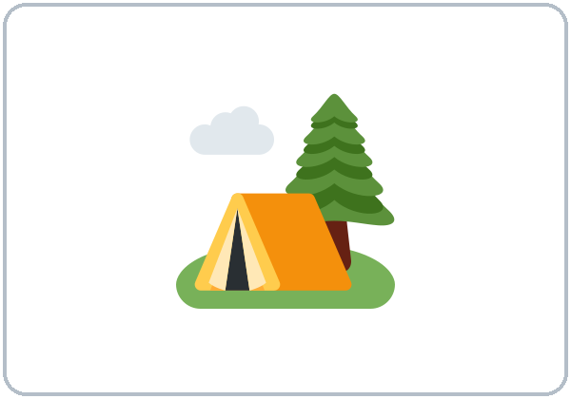  go camping | 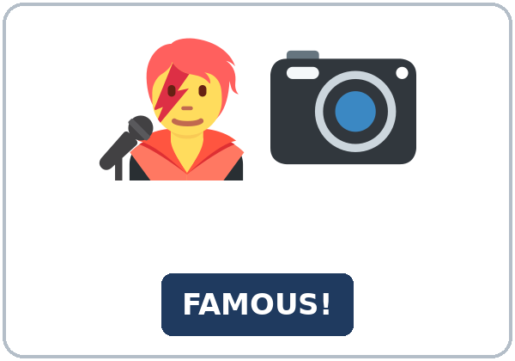  see a famous person

Partner game: Yes, I have! / No, never!
Example: A points to a picture and asks, "Have you ever run a race?" B answers, "Yes, I have. I ran one in 2021." or "No, never." Switch.
Lesson 1 (Week 1) · My Words
My personal word list. Write each word in your language, if you want. Then write your own example.
Word | My language | My example
try (a new food)
travel
fly
snow
ocean
mountain
desert
win a prize
ride a horse
run a race
go camping
see a famous person

Add 2 more words from tonight (from the listening, the reading, or your partner).
Lesson 1 (Week 1) · Listening
It's the first night of an evening English class. Lucía and Ahmed meet. Then the teacher, Ms. Grant, gives them a job.
A. Listen. What have Lucía and Ahmed both done? Circle.
a. ridden a horse and gone camping b. seen snow and run a race c. worked in a restaurant and eaten sushi
B. Listen again. Check ✓ True or False.
 | True | False
1. Lucía has taken a class at this center before. | ☐ | ☐
2. Lucía worked in a pizza restaurant in 2019. | ☐ | ☐
3. Ahmed saw snow for the first time last winter. | ☐ | ☐
4. Ahmed has ridden a horse. | ☐ | ☐
5. Ahmed won his race. | ☐ | ☐
6. Lucía has never eaten sushi. | ☐ | ☐

C. Listen again. Write have, has, or did.
1. ____________ you ever taken a class at this center?
2. No, I haven't. But my sister ____________.
3. ____________ you ever worked in a restaurant?
4. Really? When ____________ you do that?
5. Ahmed, ____________ you ever seen snow?
6. I've run a race, too. My company ____________ a race every summer.
Hear it, say it
gonna = going to: "Tonight we're going to find things we have in common." • wanna = want to: "I want to go camping." You can say going to and want to. Say it: Have you ever seen snow? • I've never ridden a horse.
Lesson 1 (Week 1) · Grammar
Read across. A reads from the left side. B answers from the right side. Choose one part from each column.
Grammar Box 1: Have you ever…? (sometime in your life)
QUESTION |  |  | ANSWER
Have you ever | worked in a restaurant? |  | Yes, I have. | I've worked in two restaurants.
Have you ever | worked in a restaurant? |  | No, I haven't.  No, never. | I've never worked in a restaurant.
Has she ever | seen snow? |  | Yes, she has. | She's seen snow two times.
Has he ever | lived in a big city? |  | No, he hasn't. | He's never lived in a big city.

Grammar Box 2: the details (simple past)
QUESTION |  |  | ANSWER
Have you ever | been to Chicago? |  | Yes, I have. | I went there in 2022.
When did you | go there? |  | I went | last summer.  in 2022.
How was | it? |  | It was | exciting.  a little boring.
Did you | like it? |  | Yes, I did.  No, I didn't. | It was too cold!

Rule of thumb: sometime in your life, no time → have / has + past participle (I've seen snow). Add a time (in 2022, last year, when I was ten) → simple past (I saw snow last year).
Grammar Box 3: 20 verbs to know (verb → past → past participle)
be → was / were → been | go → went → gone / been | ride → rode → ridden | travel → traveled → traveled
do → did → done | have → had → had | run → ran → run | try → tried → tried
drive → drove → driven | live → lived → lived | see → saw → seen | win → won → won
eat → ate → eaten | make → made → made | swim → swam → swum | work → worked → worked
fly → flew → flown | meet → met → met | take → took → taken | write → wrote → written

Regular verbs (live, work, travel): past participle = past form (-ed). • I've = I have. • She's lived = she has lived (not she is).
Grammar Box 4: Which one?
 | WHEN? | EXAMPLE
have / has + past participle | sometime in your life; no time | I've ridden a horse. She's never flown.
simple past | a finished time (in 2015, last year, when I was ten) | I rode a horse in 2015. She flew to Texas last year.

Questions and answers
Q: Can I say I have seen snow in 2022?
A: No. With a finished time, use the simple past: I saw snow in 2022.
Q: Why eaten, not eat?
A: After have / has, use the past participle: Have you ever eaten sushi? Look at Box 3.
Q: How do I answer Have you ever…? short?
A: Yes, I have. or No, I haven't. or No, never. Then add a detail in the past: Yes, I have. I went there in 2022.
Practice A: Write the past participle.
1. Have you ever ____________ sushi? (eat)
2. I've never ____________ a horse. (ride)
3. She has ____________ in three cities. (live)
4. Have you ever ____________ in a plane? (fly)
5. We've ____________ the ocean two times. (see)
6. He's never ____________ a prize. (win)
Practice B: Circle the correct words.
1. (Have / Did) you ever tried Thai food?
2. I (went / have gone) to Texas last year.
3. Have you ever seen the ocean? Yes, I (have / have seen).
4. When (did you go / have you gone) there?
5. She (has never / never have) eaten sushi.
6. I (saw / 've seen) a famous person in 2023.
Common mistakes
✗ Don't say | ✓ Say
I have seen snow last year. | I saw snow last year.
Have you ever eat sushi? | Have you ever eaten sushi?
Yes, I have seen. | Yes, I have. (+ a detail: I saw it in 2022.)
She have lived in two cities. | She has lived in two cities.
I never have flown. | I've never flown. / I have never flown.

Contrast tip (optional): Spanish has a similar form (¿Alguna vez has trabajado…?), but English never uses a finished time with it: I worked there in 2020 (not I've worked there in 2020). What does your language do?

Lesson 1 (Week 1) · Talk Time: Find Someone Who Has…
Round 1. Stand up. Ask your classmates. When someone says Yes, ask two follow-up questions. Write the name and a short note.
Example: A: Have you ever flown in a plane? B: Yes, I have. A: When did you fly? B: Last year. A: How was it? B: It was exciting! → Name: Ana Note: last year, exciting
Question | Name | Note (When? Where? How was it?)
1. Have you ever tried a food from another country?
2. Have you ever flown in a plane?
3. Have you ever seen the ocean?
4. Have you ever run a race?
5. Have you ever gone camping?
6. Have you ever won a prize?
7. Have you ever ridden a horse?
8. Have you ever worked at night?
9. Have you ever cooked for 20 people?
10. Have you ever seen a famous person?

Follow-ups: When did you…? • Where did you…? • How was it? • Did you like it? • Why?
Lesson 1 (Week 1) · Talk Time: Two True, One Invented
Round 2. Work in a group. Write 3 sentences: 2 are true and 1 is invented. Read them. Your group asks follow-up questions. Then they guess the invented one.
Example: 1. I've ridden a horse. 2. I've never seen snow. 3. I've won a prize for cooking. → When did you win it? What did you cook?
My 3 sentences (I've… / I've never…)
1.
2.
3.

Write two follow-up questions you asked a classmate.
My follow-up questions (When did you…? How was it?)
1.
2.

Write one thing you and a classmate have both done.
Example: Ana and I have both seen the ocean.
______________________________________________________________
Lesson 1 (Week 1) · Homework
Homework (about 15–20 minutes). Bring it next week!
1. Write the sentence. Use the words.
Example: you / ever / try / Thai food? → Have you ever tried Thai food?
1. I / never / see / the ocean → ______________________________________________
2. she / ever / ride / a horse? → ______________________________________________
3. we / fly / to Miami / two times → ______________________________________________
4. he / go / camping / last summer → ______________________________________________
2. Finish your writing from Read & Write C (your email to the teacher). Read it one more time. Check ✓ the list in D.
☐ I finished it. ☐ I checked it with the list.
3. Ask a family member or a friend 3 questions with Have you ever…? When the answer is Yes, ask When? and How was it? Write the answers.
Question | Answer (Yes, I have. I… / No, never.)
1.
2.
3.

4. Review (simple past). Write the past form.
1. I ____________ to the park last weekend. (go)
2. We ____________ at my cousin's house on Sunday. (eat)
3. She ____________ last Saturday. (not work)
4. ____________ you ____________ the game? (watch)
5. The movie ____________ exciting. (be)
Lesson 1 (Week 1) · Read & Write
A. Read the class page. Read fast first. Then read again and answer the questions.
MEET OUR CLASS · Evening English, Room 4
Marta: Hi! I'm Marta. I've lived in this city for six years. I've worked in a bakery, a school cafeteria, and now a hospital kitchen. I've never seen the ocean, but I want to see it next summer. I'm in this class because I want to talk more with the nurses at work.
Joseph: Hello, my name is Joseph. I drive a truck, so I've traveled to many states. I've seen mountains, deserts, and a lot of snow! I've never flown in a plane. My kids say I need to try it. I want better English for my job and for my kids' school.
Linh: Hi, everyone. I'm Linh. I've had many jobs. I've cleaned offices, and I've worked in a nail salon. Last year, I ran my first race, a 5K for a children's hospital. It was hard, but I finished. I've never gone camping. This year, I want to read a whole book in English.

B. Answer the questions.
1. How long has Marta lived in this city? ______________________________________________
2. Where does Marta work now? ______________________________________________
3. Why has Joseph traveled to many states? ______________________________________________
4. What has Joseph never done? ______________________________________________
5. What did Linh do last year? ______________________________________________
C. Write an email to your teacher (5–8 sentences). Say who you are, two things you've done, one thing you've never done, and one goal for this class with a reason.
Example: Hi, Ms. Grant. My name is Sara. I've worked in a hotel for four years. I've also traveled to New York and Texas. I've never ridden a horse. My goal is to speak English at the doctor's office because I want to understand my children's doctor. See you next week! Sara
My email

D. Check your writing with a partner.
 | Yes | Not yet
It has 5–8 sentences. | ☐ | ☐
It has two things I've done (I've…). | ☐ | ☐
It has one thing I've never done. | ☐ | ☐
It has a goal and a reason (because…). | ☐ | ☐

Lesson 1 (Week 1) · Exit Ticket
Name: ______________________________ Date: ________________
Answer in 3 sentences. Give a reason. Then give this page to your teacher.
Tell me about something you have done (or never done).
Sentence 1: the experience (I've… / I've never…) • Sentence 2: when it happened (I… in 2020), or why not • Sentence 3: how it was, with because or so
My answer
1.
2.
3.

For the teacher | ✓ | almost | not yet
3 sentences, today's grammar, a reason | ☐ | ☐ | ☐

Lesson 1 (Week 1) · Can-Do Self-Check
Name: ______________________________ Date: ________________
Listen to the teacher. Check ✓ one face for each line.
I can… | 😀 I can do it. | 🙂 With a little help. | 😐 Not yet.
I can ask Have you ever…? | ☐ | ☐ | ☐
I can answer Yes, I have. / No, I've never… | ☐ | ☐ | ☐
I can ask a follow-up in the past (When did you…? How was it?). | ☐ | ☐ | ☐
I can tell a classmate about one experience in 3 sentences. | ☐ | ☐ | ☐
I can write a short email about myself. | ☐ | ☐ | ☐

My goal for this class: write one sentence.
______________________________________________________________
Lesson 1 (Week 1) · Task Words (optional)
This page is for you if you want it. You can skip it. Write each task word in your language, if you want.
Task word | What you do | My language
Listen. | Use your ears. Don't write yet.
Circle. | Draw a circle around the answer.
Check ✓. | Make a ✓ in the box.
Write. | Write words or sentences.
Number. | Write 1, 2, 3… to show the order.
Match. | Find the two parts that go together.
Work with a partner. | Work with one classmate.
Work in a group. | Work with 2 or 3 classmates.
Switch. | Change roles: A is B now.
Ask a follow-up question. | Ask one more question about the answer.
Give a reason. | Say why, with because or so.
Compare. | Look at your partner's answers. Are they the same?

Picture Credits
Pictures use Twemoji graphics by Twitter, Inc. and other contributors (https://github.com/jdecked/twemoji), licensed under CC BY 4.0 (https://creativecommons.org/licenses/by/4.0/). The graphics were resized and combined, and signs and labels were added. The file-by-file list is in images/CREDITS.md.
Listening audio: not recorded yet. When it is made, it will use synthetic voices made with Chatterbox TTS (Resemble AI, MIT License), cloned from synthetic reference clips made with Kokoro-82M (Apache License 2.0), with no recordings of real people. The names and the story are invented.
Course materials: © 2026 the authors, licensed under CC BY-NC-SA 4.0 (https://creativecommons.org/licenses/by-nc-sa/4.0/).

